**Module: UVM-1**

**Section:** UVM Concepts **Task:** UVM Factory

**UVM Factory**

Task

* **Question 1:**
  1. **Overriding animal_h2:**

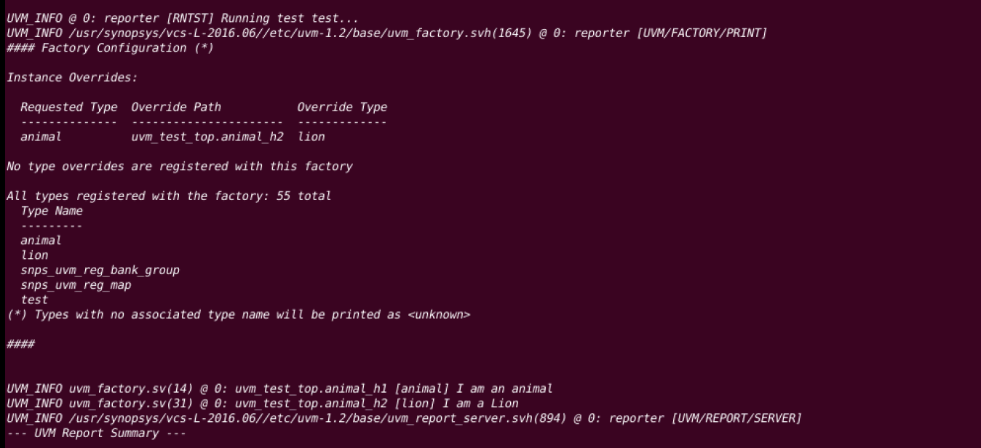

* 1. **Overriding animal_h1:**

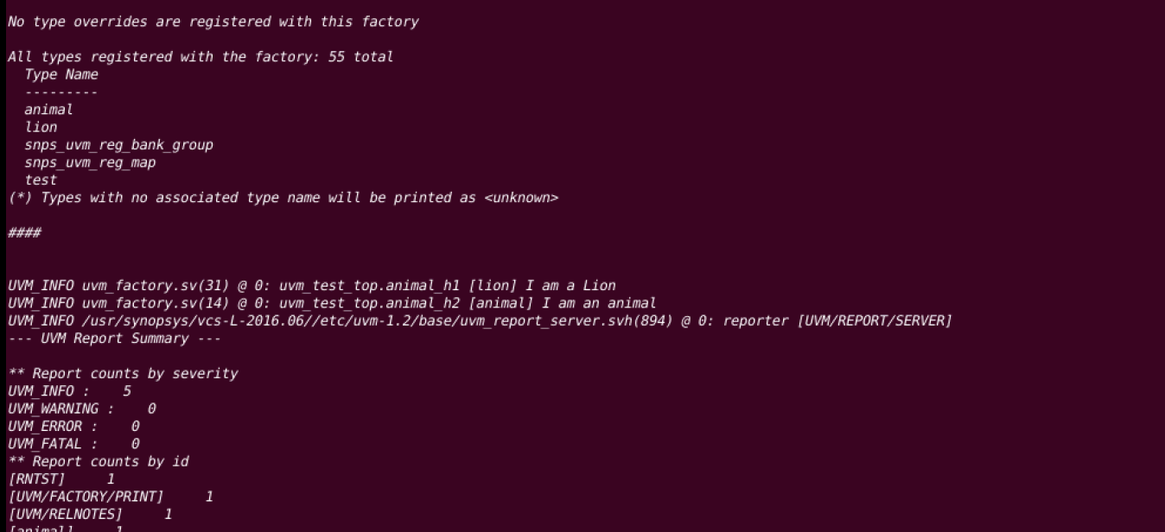

* 1. **Overriding both using set_type_override_by_name:**

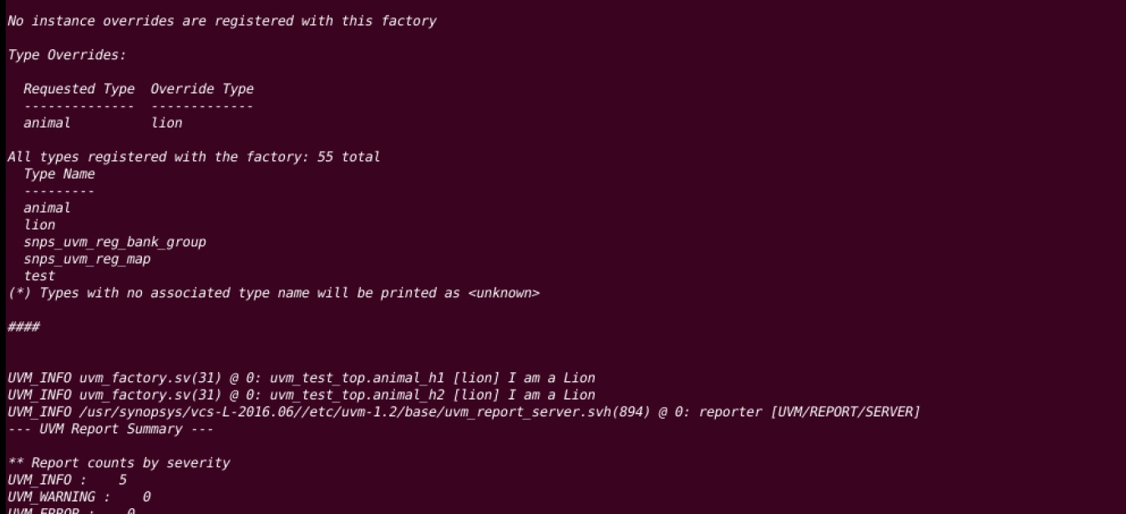

* 1. **Overriding both using set_type_override_by_type:**

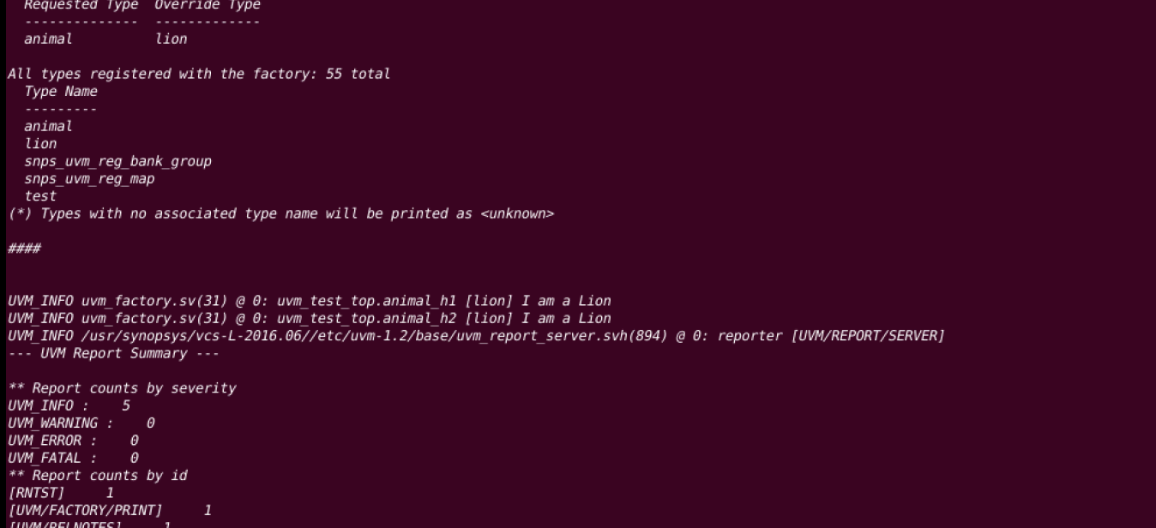

* **Question 2: What is the difference between type override and instance override? Explain in your own words when we should use which method.**

In UVM, the main difference between type override and instance override lies in their scope:

* **Type Override:** A global replacement of all instances of a class throughout the testbench with a new class. Use this when you want to change every occurrence of a class (e.g., replacing all drivers).
* **Instance Override:** A local replacement for a specific instance of a class, without affecting other instances. Use this when you need to modify only a particular component (e.g., a specific driver for one interface).

In short, use type override for broad changes across the entire environment and instance override for more targeted, specific modifications.