**Module: UVM-2**

**Register Abstraction Layer**

**RAL**

UVM RAL - [EDA Link](https://www.edaplayground.com/x/UURE)

* **Predefined Sequences:**

| **uvm_reg_hw_reset_seq** |
| --- |

* + **Reset Sequence:**
    - **Console Output:**

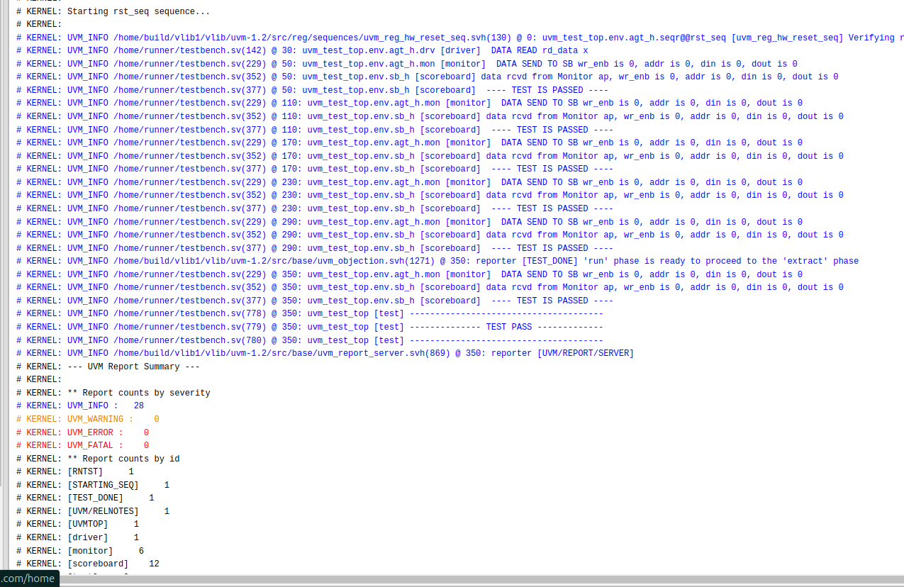

* + **Bit Bash Sequence:**
    - **Console Output:**

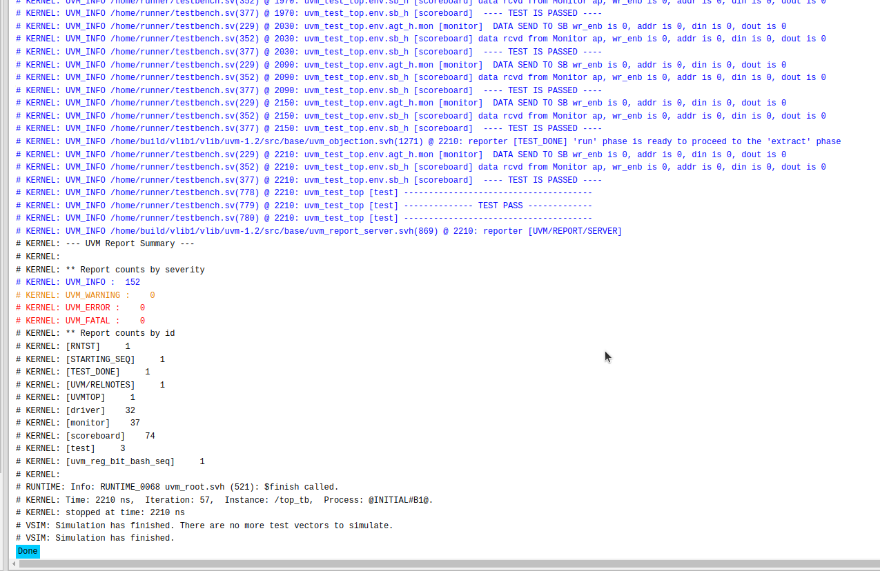

* + - **Waveform:**

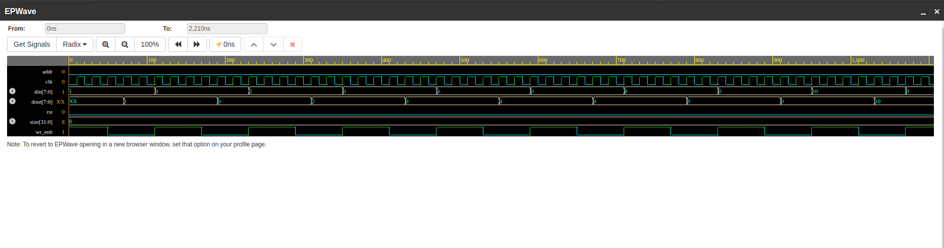

* + **Access Sequence:**
    - **Console Output:**

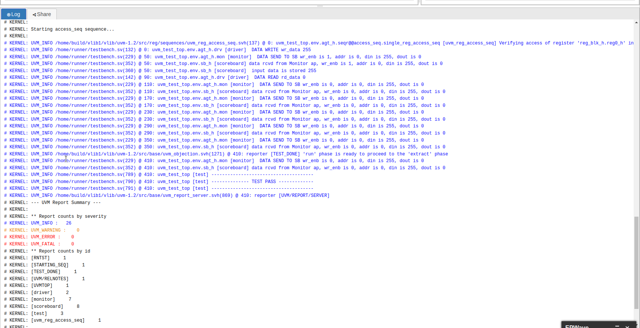

* + - **Waveform:**

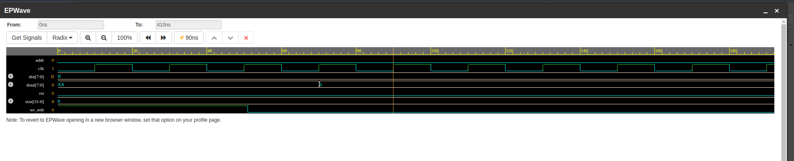

* **User-Defined Sequence:**

| **wr_rd_sequence** |
| --- |

* + - **Console Output:**

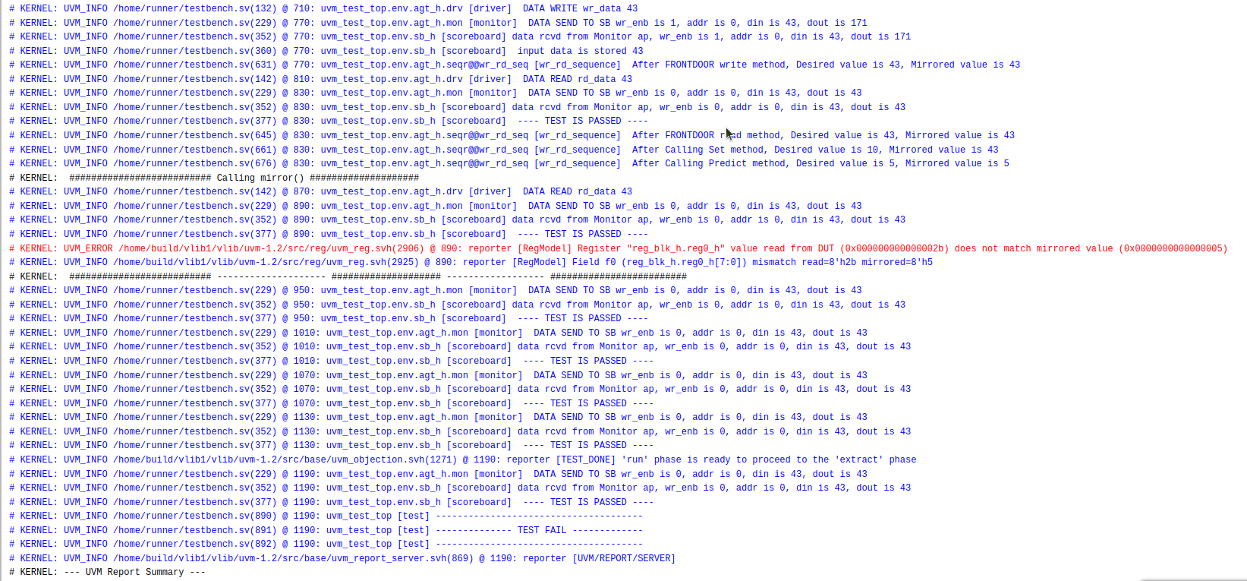

* + - **Waveform:**

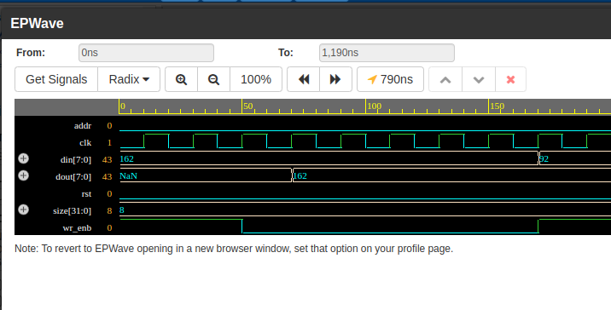

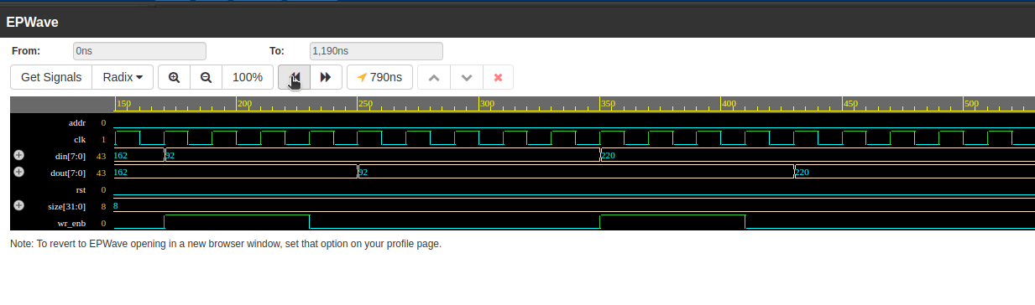

* **Introspection Methods:**
  + **Output:**

