**Cause of Environmental Degradation**

Today, as people in developed countries generally enjoy a high standard of living, at the other end of the spectrum, the people in developing countries like Bangladesh are struggling to make ends meet. In this discussion, by looking at the case study of Bangladesh, we will get a deeper insight into why the people put great pressure on the environment.

**Introduction:**

The environment is anything that surrounds us, trees, plants, air, forests etc. all form the part of our environment and are very useful for us in one way or the other. Environmental Degradation comes about due to erosion and decline of the quality of the natural environment. It is caused directly or indirectly by anthropogenic activities that extract various environmental resources at a faster rate than they are replaced, and thus depleting them. On this regard, degradation means damage or reduction in quality of environmental features, primarily influenced by human activities. Some natural events such as landslides and earthquakes may also degrade the nature of our environments.

**Discussion:**

Bangladesh faces a series of environmental problems including deforestation, land degradation, air pollution, water shortage and contamination, as well as loss of biodiversity. Environmental degradation can be a result of the dynamic interplay of socio-economic, institutional and technological activities carried out by the human. It would not be wrong to say that rising human demands, as well as hunger, is also a major factor driving the environmental degradation. Environmental changes may be driven by many factors including economic growth, population growth, urbanization, intensification of agriculture, rising energy use and transportation. There are a lot environmental problems in Bangladesh. Such as:

[Air pollution](https://en.m.wikipedia.org/wiki/Air_pollution) — [Environmental impact of the coal industry](https://en.m.wikipedia.org/wiki/Environmental_impact_of_the_coal_industry) • [Environmental impact of hydraulic fracturing](https://en.m.wikipedia.org/wiki/Hydraulic_fracturing#Environmental_impact) • [Indoor air quality](https://en.m.wikipedia.org/wiki/Indoor_air_quality) • [Smog](https://en.m.wikipedia.org/wiki/Smog) • [Tropospheric ozone](https://en.m.wikipedia.org/wiki/Tropospheric_ozone) • [Volatile organic compound](https://en.m.wikipedia.org/wiki/Volatile_organic_compound) [Atmospheric particulate matter](https://en.m.wikipedia.org/wiki/Atmospheric_particulate_matter) [CFC](https://en.m.wikipedia.org/wiki/Chlorofluorocarbon) • [Biological effects of UV exposure](https://en.m.wikipedia.org/wiki/Ozone_depletion#Biological_effects)

[Light pollution](https://en.m.wikipedia.org/wiki/Light_pollution) • [Visual pollution](https://en.m.wikipedia.org/wiki/Visual_pollution)

[Noise pollution](https://en.m.wikipedia.org/wiki/Noise_pollution)

[Soil pollution](https://en.m.wikipedia.org/wiki/Soil_pollution) — [Alkali soil](https://en.m.wikipedia.org/wiki/Alkali_soil) • [Brownfield](https://en.m.wikipedia.org/wiki/Brownfield) • [Residual Sodium Carbonate Index](https://en.m.wikipedia.org/wiki/Residual_Sodium_Carbonate_Index) • [Soil conservation](https://en.m.wikipedia.org/wiki/Soil_conservation) • [Soil erosion](https://en.m.wikipedia.org/wiki/Soil_erosion) • [Soil contamination](https://en.m.wikipedia.org/wiki/Soil_contamination) • [Soil salination](https://en.m.wikipedia.org/wiki/Soil_salination) • [Superfund](https://en.m.wikipedia.org/wiki/Superfund) • [Superfund sites](https://en.m.wikipedia.org/wiki/Superfund_sites)

[Water pollution](https://en.m.wikipedia.org/wiki/Water_pollution) — [Acid rain](https://en.m.wikipedia.org/wiki/Acid_rain) • [Agricultural runoff](https://en.m.wikipedia.org/wiki/Agricultural_runoff) • [Algal bloom](https://en.m.wikipedia.org/wiki/Algal_bloom) • [Environmental impact of the coal industry](https://en.m.wikipedia.org/wiki/Environmental_impact_of_the_coal_industry) • [Environmental impact of hydraulic fracturing](https://en.m.wikipedia.org/wiki/Hydraulic_fracturing#Environmental_impact)• [Eutrophication](https://en.m.wikipedia.org/wiki/Eutrophication) • [Fish kill](https://en.m.wikipedia.org/wiki/Fish_kill) • [Groundwater pollution](https://en.m.wikipedia.org/wiki/Groundwater_pollution) • [Groundwater recharge](https://en.m.wikipedia.org/wiki/Groundwater_recharge) • [Marine debris](https://en.m.wikipedia.org/wiki/Marine_debris) • [Marine pollution](https://en.m.wikipedia.org/wiki/Marine_pollution) • [Mercury in fish](https://en.m.wikipedia.org/wiki/Mercury_in_fish) • [Microplastics](https://en.m.wikipedia.org/wiki/Microplastics) • [Nutrient pollution](https://en.m.wikipedia.org/wiki/Nutrient_pollution) • [Ocean acidification](https://en.m.wikipedia.org/wiki/Ocean_acidification) • [Ocean dumping](https://en.m.wikipedia.org/wiki/Ocean_dumping) • [Oil spills](https://en.m.wikipedia.org/wiki/Oil_spills)• [Soda lake](https://en.m.wikipedia.org/wiki/Soda_lake) • [Ship pollution](https://en.m.wikipedia.org/wiki/Ship_pollution) • [Thermal pollution](https://en.m.wikipedia.org/wiki/Thermal_pollution) • [Urban runoff](https://en.m.wikipedia.org/wiki/Urban_runoff) • [Wastewater](https://en.m.wikipedia.org/wiki/Wastewater)

[Space debris](https://en.m.wikipedia.org/wiki/Space_debris) • [Interplanetary contamination](https://en.m.wikipedia.org/wiki/Interplanetary_contamination) * [Ozone depletion](https://en.m.wikipedia.org/wiki/Ozone_depletion)

**1.Air Pollution**

[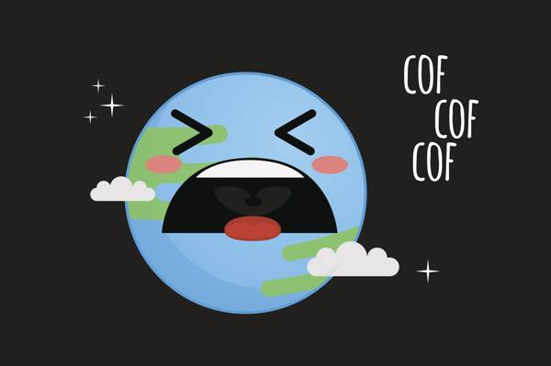](https://media.buzzle.com/media/images-en/gallery/conceptual/1200-500368456-sad-earth.jpg)

Air pollution is probably one of the most dangerous anthropogenic effects on the environment, since we cannot control the air we breathe (though we may be able to control the quality of drinking water, food, etc.). Vehicular traffic, smog created by smoke emitted by vehicles and factories, aerosols (suspended particulate matter), VOCs (volatile organic compounds) present primarily in paints, varnishes, and refrigerants, all con tribute to air pollution.

### 2.Water Pollution

### https://upload.wikimedia.org/wikipedia/commons/thumb/8/8a/Nrborderborderentrythreecolorsmay05-1-.JPG/300px-Nrborderborderentrythreecolorsmay05-1-.JPG

### Water pollution is the contamination of [water bodies](https://en.m.wikipedia.org/wiki/Body_of_water), usually as a result of human activities. Water bodies include for example [lakes](https://en.m.wikipedia.org/wiki/Lake), [rivers](https://en.m.wikipedia.org/wiki/River), [oceans](https://en.m.wikipedia.org/wiki/Marine_pollution), [aquifers](https://en.m.wikipedia.org/wiki/Aquifer) and [groundwater](https://en.m.wikipedia.org/wiki/Groundwater). Water pollution results when [contaminants](https://en.m.wikipedia.org/wiki/Contaminant) are introduced into the natural environment. For example, releasing inadequately treated [wastewater](https://en.m.wikipedia.org/wiki/Wastewater) into natural water bodies can lead to [degradation](https://en.m.wikipedia.org/wiki/Environmental_degradation) of [aquatic ecosystems](https://en.m.wikipedia.org/wiki/Aquatic_ecosystems)

### 3.Soil Pollution

Soil pollution is a part of land pollution but with even more serious consequences, in the form of poor quality land for agriculture. Rainwater collects and deposits all land pollutants to water bodies, so there is a two-fold entry of pollutants in our food. To add to this, not only do these chemicals harm us, they show adverse effects on all living forms. In fact, more so on wild animals and plants. We can still find a way to make spoiled water potable, but what about animals?

**4.Desertification**

[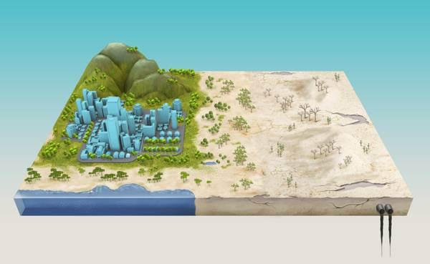](https://media.buzzle.com/media/images-en/gallery/earth-science/1200-495273554-desertification.jpg)

Desertification is when an ordinary piece of land is converted into a desert. To me, it is one of the scariest prospects of human development; to convert a beautiful garden, a park, a forest, into a desert! Did you know that more than 2 billion people actually live in dryland regions? To add to this is the fact that drylands occupy more than 40% of the Earth; we are adding to the mess through our actions.

5.Noise Pollution:

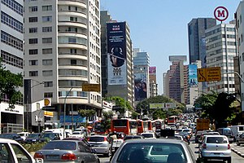

Noise pollution, also known as [environmental noise](https://en.m.wikipedia.org/wiki/Environmental_noise) or sound [pollution](https://en.m.wikipedia.org/wiki/Pollution), is the propagation of noise with ranging impacts on the activity of human or animal life, most of them harmful to a degree. The source of outdoor noise worldwide is mainly caused by machines, transport, and propagation systems.