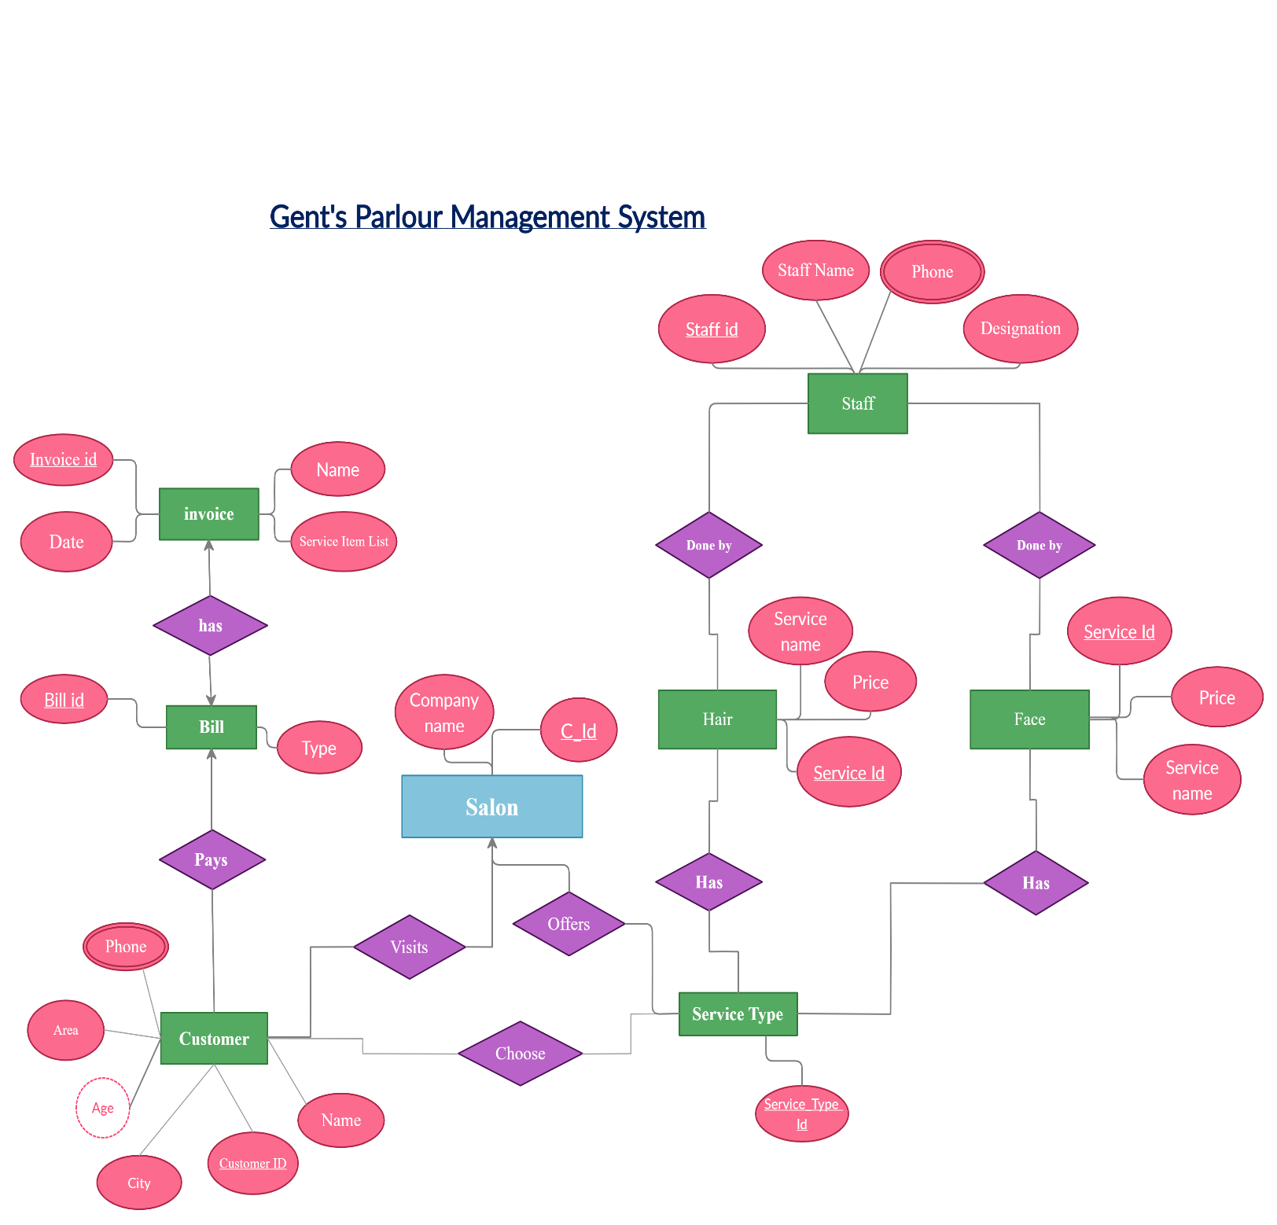

**Has**

**UNF**

Has (invoice id, service item list, name, date, bill id, type)

**1NF**

No multi-valued attribute.

1. invoice id, service item list, name, date, bill id, type

**2NF**

1. invoice id, service item list, date

2. bill id, type

**3NF**

There is no transitive dependency

1. invoice id, service item list, date

2. bill id, type

**Table Creation**

1. invoice id, service item list, date

2. bill id, type, **invoice id**

**Pays**

**UNF**

Pays (bill id, type, customer id, name, area, city, phone, age)

**1NF**

phone is multi-valued attribute.

1. bill id, type, customer id, name, area, city, phone, age

**2NF**

1. bill id, type

2. customer id, name, area, city, phone, age

**3NF**

1. bill id, type

2. customer id, name, phone, age

3. area, city

**Table Creation**

1. bill id, type

2. customer id, name, phone, age, **bill id**, **a_id**

3. **a_id,** area, city

**Visit**

**UNF**

visit (customer id, name, area, city, phone, age, company name, c_id)

**1NF**

phone is multi-valued attribute.

1. customer id, name, area, city, phone, age, company name, c_id

**2NF**

1. customer id, name, area, city, phone, age

2. company name, c_id

**3NF**

1. customer id, name, phone, age

2. area, city

3. company name, c_id

**Table Creation**

1. customer id, name, phone, age, **a_id**

2. area, city, **a_id**

3. company name, c_id, **customer id**

**Choose**

**UNF**

choose (customer id, name, area, city, phone, age, service type id)

**1NF**

phone is multi-valued attribute.

1. customer id, name, area, city, phone, age, service type id

**2NF**

1. customer id, name, area, city, phone, age

2. service type id

**3NF**

1. customer id, name, phone, age

2. area, city

3. service type id

**Table Creation**

1. customer id, name, phone, age, **a_id**

2. area, city, **a_id**

3. service type id **, customer id**

**Offers**

**UNF**

offers (c_id, company name, service type id)

**1NF**

No multi-valued attribute.

1. c_id, company name, service type id

**2NF**

1. c_id, company name

2. service type id

**3NF**

No transitive dependancy

1. c_id, company name

2. service type id

**Table Creation**

1. c_id, company name

2. service type id, **c_id**

**Has**

**UNF**

has (service type id, service id, service name, price)

**1NF**

No multi-valued attribute.

1 service type id, service name, service id, price

**2NF**

1. service type id

2. service id, service name, price

**3NF**

No transitive dependency

1. service type id

2. service id, service name, price

**Table Creation**

1. service type id

2. service id, service name, price, **service type id**

**Has**

**UNF**

has (service type id, service id, service name, price)

**1NF**

No multi-valued attribute.

1 service type id, service name, service id, price

**2NF**

1. service type id

2. service id , service name, price

**3NF**

No transitive dependancy

1. service type id

2. service id, service name, price

**Table Creation**

1. service type id

2. service id, service name, price, **service type id**

**Done by**

**UNF**

Done by (service id, service name, price, staff id, staff name, phone, designation)

**1NF**

Phone is a multi-valued attribute.

1 service id, service name, price, staff id, staff name, phone, designation

**2NF**

1. service id, service name, price

2. staff id, staff name, phone, designation

**3NF**

No transitive dependency

1. service id, service name, price

2. staff id, staff name, phone, designation

**Table Creation**

1. service id, service name, price

2. staff id, staff name, phone, designation, **service id**

**Done by**

**UNF**

Done by (service id, service name, price, staff id, staff name, phone, designation)

**1NF**

Phone is a multi-valued attribute.

1 service id, service name, price, staff id, staff name, phone, designation

**2NF**

1. service id, service name, price

2. staff id, staff name, phone, designation

**3NF**

No transitive dependency

1. service id, service name, price

2. staff id, staff name, phone, designation

**Table Creation**

1. service id, service name, price

2. staff id, staff name, phone, designation, **service id**

**Temporary Tables**

1. invoice id, service item list, date

2. bill id, type, **invoice id**

3. bill id, type

4. customer id, name, phone, age, **bill id**, **a_id**

5. **a_id,** area, city

6. customer id, name, phone, age, **a_id**

7. area, city, **a_id**

8 company name, c_id, **customer id**

9. customer id, name, phone, age, **a_id**

10. area, city, **a_id**

11. service type id **, customer id**

12. c_id, company name

13. service type id, **c_id**

14. service type id

15. service id, service name, price, **service type id**

16. service type id

17. service id, service name, price, **service type id**

18. service id, service name, price

19. staff id, staff name, phone, designation, **service id**

20. service id, service name, price

21. staff id, staff name, phone, designation, **service id**

**Final Tables**

1. Invoice (invoice id, service item list, date)

2. Bill (bill id, type, **invoice id)**

3. Customer (customer id, name, phone1, phone 2, age, **bill id**, **a_id)**

4. Address (area, city, a_id**)**

5 Salon (company name, c_id**)**

6. Service Type (service type id**, customer id, c_id)**

7. Service (service id, service name, price, **service type id)**

8. Staff (staff id, staff name, phone1, phone2, designation, **service id)**

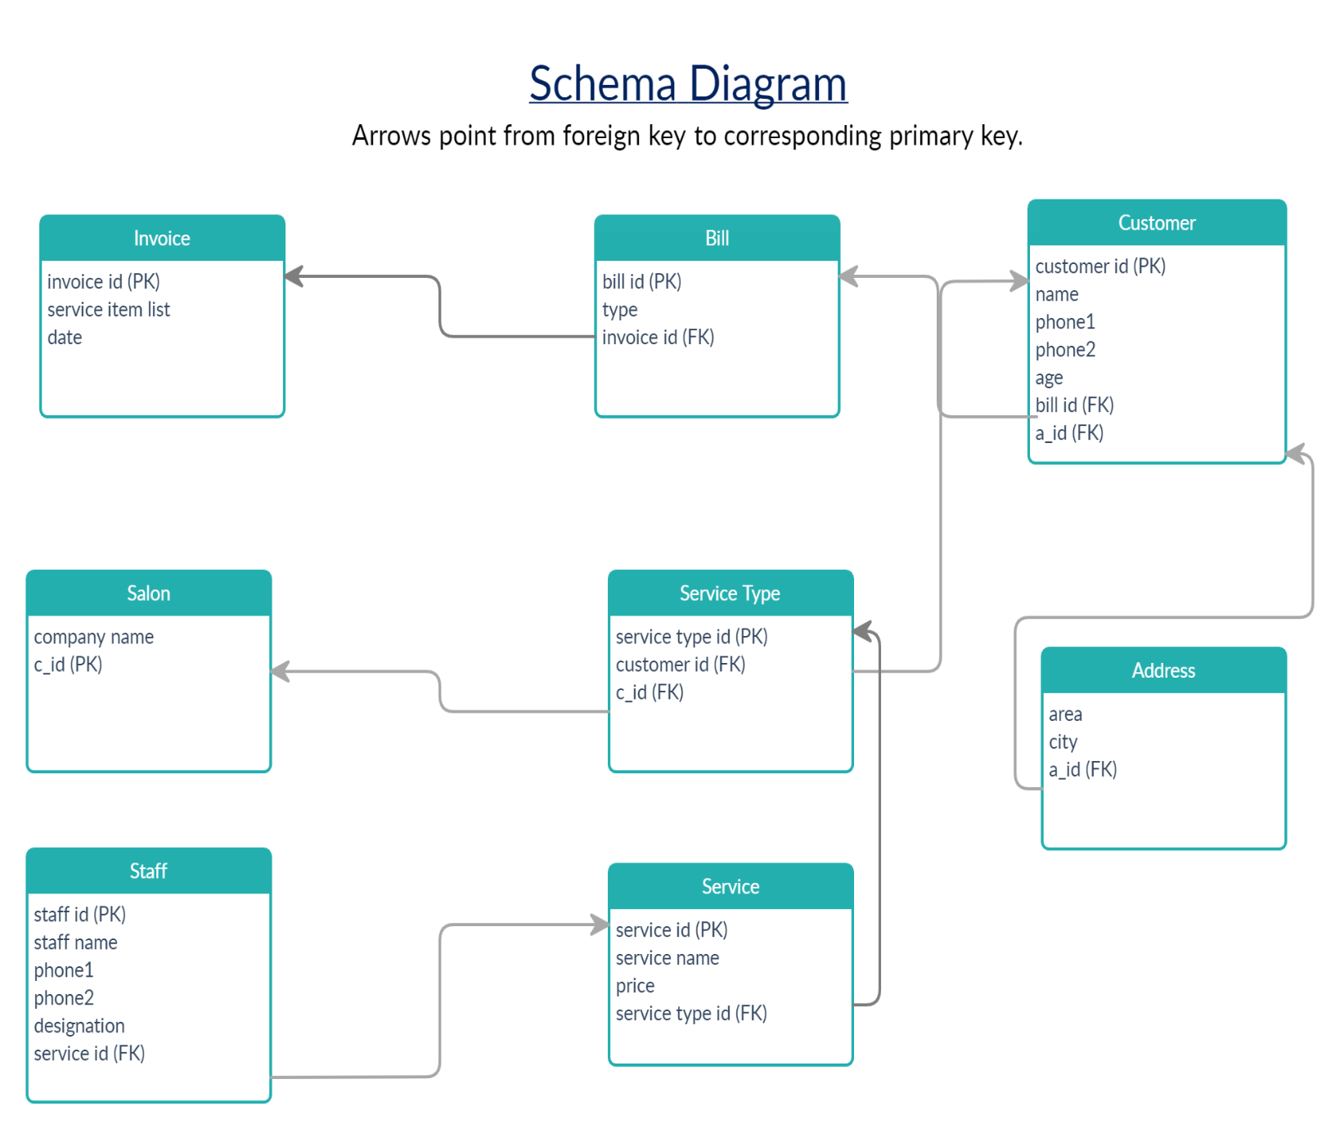

CREATE TABLE Invoice

(

invoice_id Number(10) primary key,

service_item_list varchar2(30),

date_no DATE

);

CREATE TABLE Salon

(

C_id number(10) primary key,

Company_name varchar2(40) not null

);

CREATE TABLE Bill

(

bill_id number(10) primary key,

bill_type varchar2(30),

invoice_id Number(10),

constraint fk_invoice_id foreign key(invoice_id) references Invoice(invoice_id)

);

CREATE TABLE Address

(

a_id number(10) primary key,

area varchar2(20),

city varchar2(20)

);

CREATE TABLE Customer

(

Customer_id number(10) primary key,

Name varchar2(30) not null,

phone_no1 number(16),

phone_no2 number(16),

bill_id number(10),

constraint fk_bill_id foreign key(bill_id) references Bill(bill_id),

a_id number(10),

constraint fk_a_id foreign key(a_id) references Address(a_id)

);

CREATE TABLE Service_type

(

service_type_id number(10) primary key,

Customer_id number(10),

constraint fk_Customer_id foreign key(Customer_id) references Customer(Customer_id),

C_id number(10),

constraint fk_C_id foreign key(C_id) references Salon(C_id)

);

CREATE TABLE Service

(

service_id number(10) primary key,

service_name varchar2(30) not null,

price float(24),

service_type_id number(10),

constraint fk_service_type_id foreign key(service_type_id) references Service_type(service_type_id)

);

CREATE TABLE Staff

(

staff_id number(10) primary key,

staff_name varchar2(30) not null,

phone_no1 number(16),

phone_no2 number(16),

designation varchar2(20),

service_id number(10),

constraint fk_service_id foreign key(service_id) references Service(service_id)

);