With The Name Of Allah Most Beneficial And Most Mercuiful

This is Vector Space Model for Information Retrieval

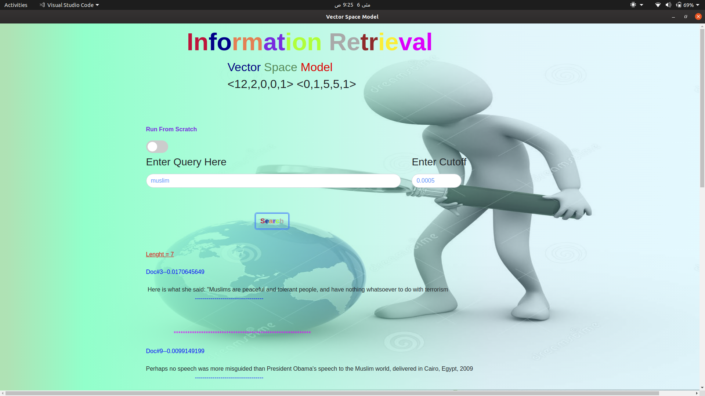

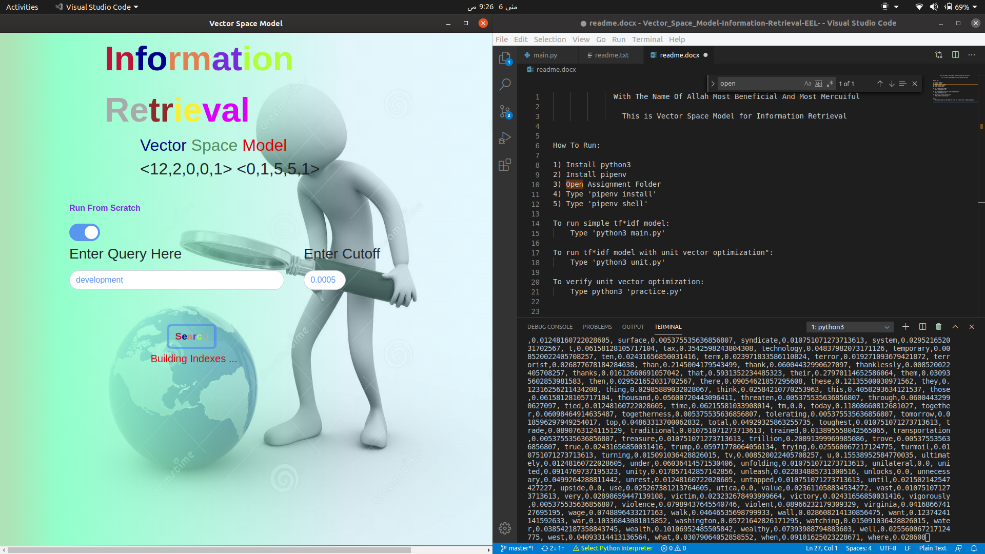

How To Run:

1) Install python3

2) Install pipenv

3) Open Assignment Folder

4) Type 'pipenv install'

5) Type 'pipenv shell'

To run simple tf\*idf model:

Type 'python3 main.py'

To run tf\*idf model with unit vector optimization":

Type 'python3 unit.py'

To verify unit vector optimization:

Type python3 'practice.py'

Note:

While Switching From One Model to Other Run From Scratch To Rebuild Indexes