HOSPITAL MANAGEMENT SYSTEM


Session: 2025 – 2029

Submitted by:
Noman Haider, 2025-GA-6

Supervised by:
Mr. Kamran Mustafa

Course:
CSC-102L Programming Fundamentals

Department of Computer Science

University of Engineering and Technology, Lahore
- Short Description OF My Project
- The problem I am trying to solve using my project is to provide an efficient and centralized back-end management system for a hospital. This system helps manage staff, patients, appointments, billing, and inventory by assigning specific roles and responsibilities to each user according to their designation.
- Users of Application
- My project contains five users and their roles are described as follows:
- Admin
- Doctor
- Patient
- Receptionist
- Pharmacist

Functional Requirements

THERE ARE FIVE USERS IN MY SYSTEM:
- ADMIN
- DOCTOR
- PATIENT
- RECEPTIONIST
- PHARMACIST

ADMIN:
The Admin will be the main authority of the Hospital Management System. The Admin will manage hospital staff, approve doctor registration requests, and generate revenue-related reports. The Admin will also be responsible for adding and removing staff members and handling overall system control.
FEATURES:
• Admin can add staff.
• Admin can remove staff.
• Admin can approve doctor signup requests.
• Admin can generate revenue bills.
• Admin can manage hospital records.
• Admin can view overall hospital data.

DOCTOR:
The Doctor will work under the hospital system and manage patient appointments and treatments. The Doctor will be able to view assigned appointments, update appointment status, and write prescriptions for patients.
FEATURES:
• Doctor can view appointments.
• Doctor can mark appointment status.
• Doctor can write prescriptions.
• Doctor can view patient details related to appointments.

PATIENT:
The Patient will be able to interact with the system to manage their medical appointments and billing. The Patient can book, cancel, and view appointment history and also generate bills when required. Emergency appointment booking is also available.
FEATURES:
• Patient can book appointments.
• Patient can cancel appointments.
• Patient can view appointment history.
• Patient can generate bills.
• Patient can book emergency appointments.

RECEPTIONIST:
The Receptionist will manage patient-related records and appointments at the hospital front desk. The Receptionist will be able to add, search, and remove patients and also assist in booking and viewing appointments.
FEATURES:
• Receptionist can add patients.
• Receptionist can search patients.
• Receptionist can remove patients.
• Receptionist can book appointments.
• Receptionist can view appointments.

PHARMACIST:
The Pharmacist will manage the medicine inventory and handle prescriptions provided by doctors. The Pharmacist ensures that medicines are available and dispensed according to prescriptions.
FEATURES:
• Pharmacist can manage medicine inventory.
• Pharmacist can view prescriptions.
• Pharmacist can update stock information.

WIREFRAMES

LOGIN SCREEN:
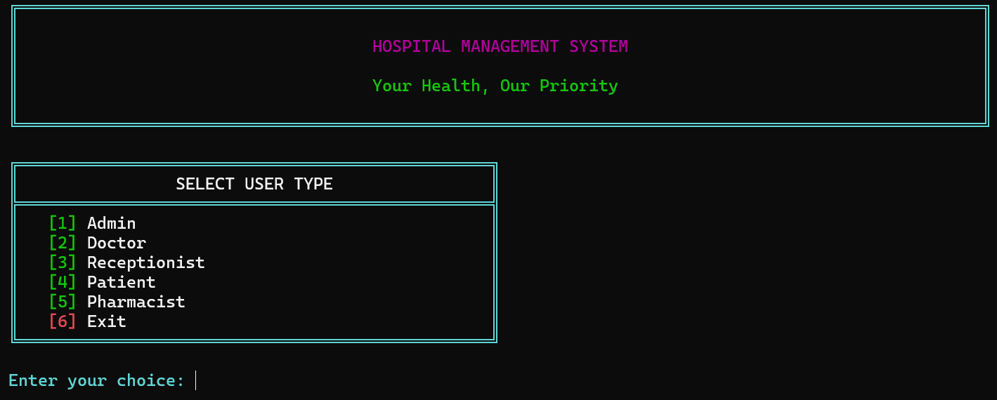

Figure 1: Login Screen
ADMIN FUNCTIONALITIES:
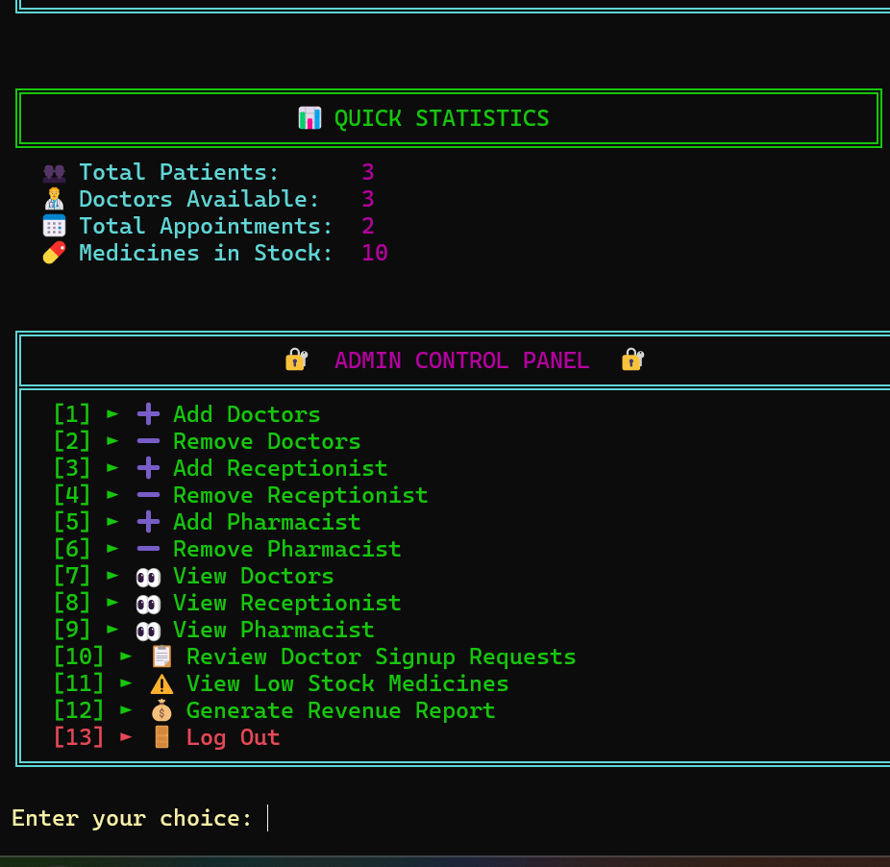

Figure 2: Admin Menu

ADD DOCTOR:
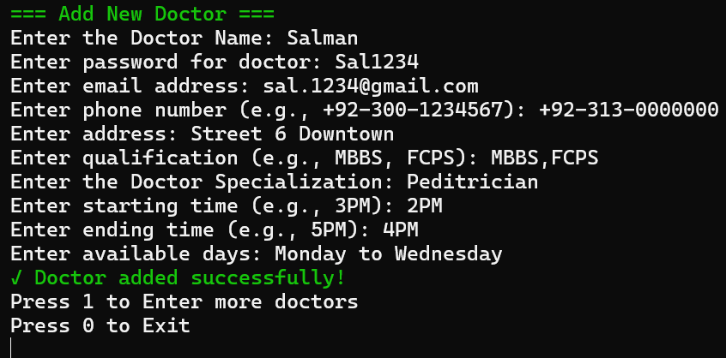
Figure 4: Add Doctor

RECORD OF DOCTORS
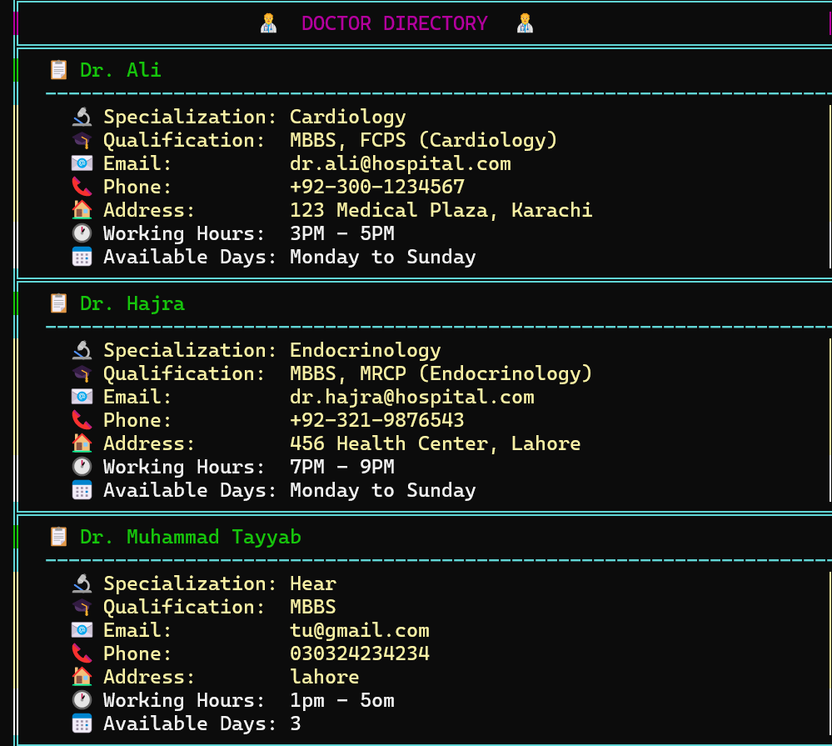

Figure 5: Record of Doctors

RECORD OF RECEPTIONIST :
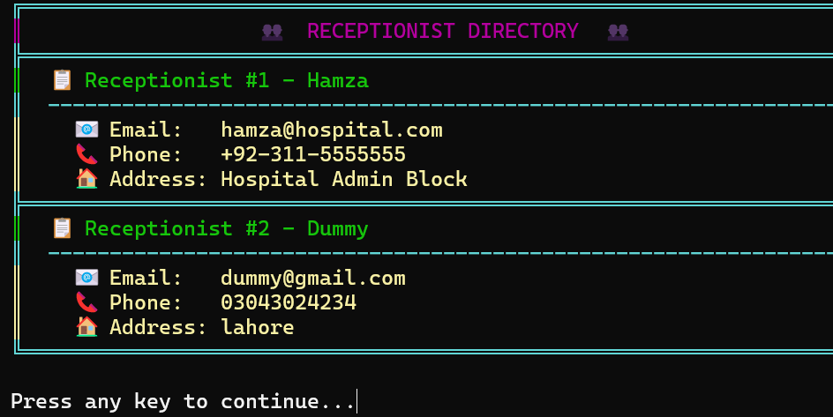

Figure 8: Record of Receptionist

VIEW MEDICINE STOCK:
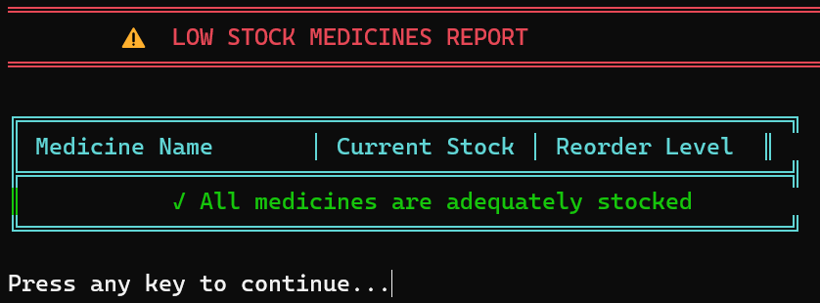
Figure 9: View Medicine Stock

DOCTOR FUNCTIONALITIES:
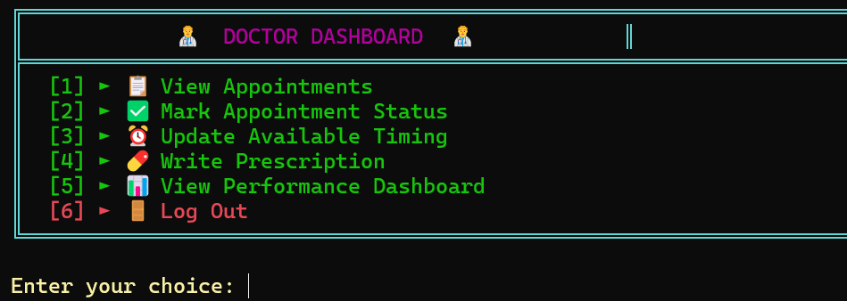
Figure 10: Doctor Functionalities

UPDATE TIMINGS:
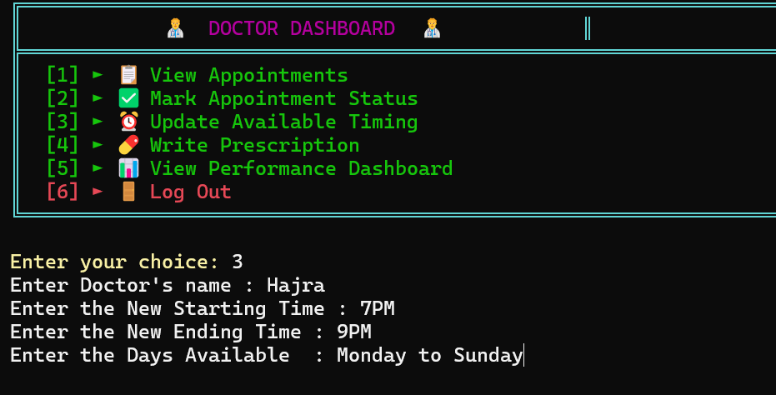

Figure 11: UPDATE TIMINGS

PERFORMANCE DASHBOARD:
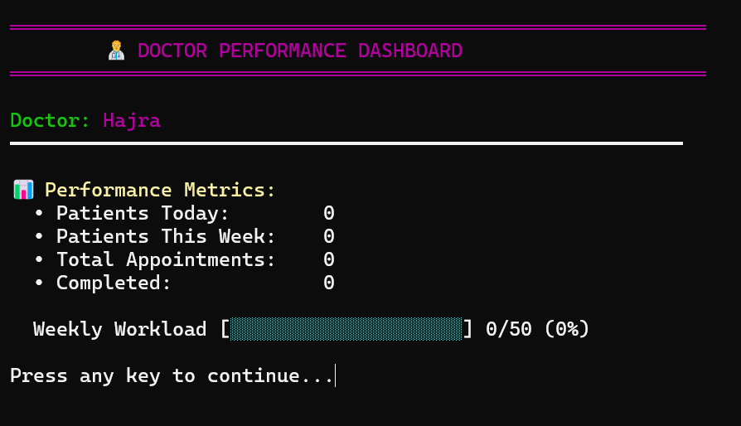
Figure 12: Performance Dashboard

VIEW APPOINTMENTS:
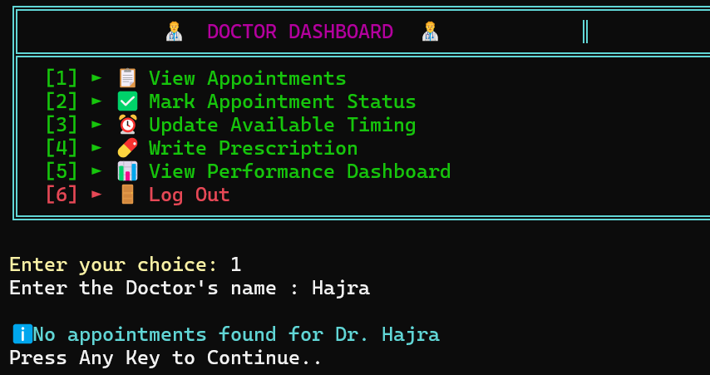
Figure 13: View Appointments
RECEPTIONIST FUNCIONALITIES:

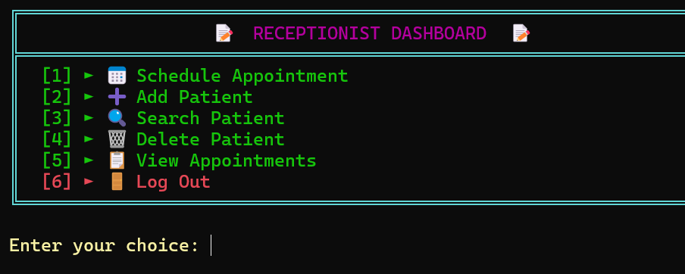
Figure 14: Print Bill

SEARCH PATIENTS:

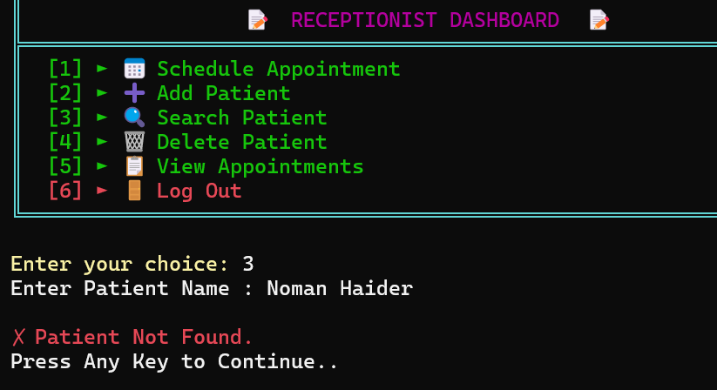
Figure 15: Search Patients

VIEW APPOINTMENTS:
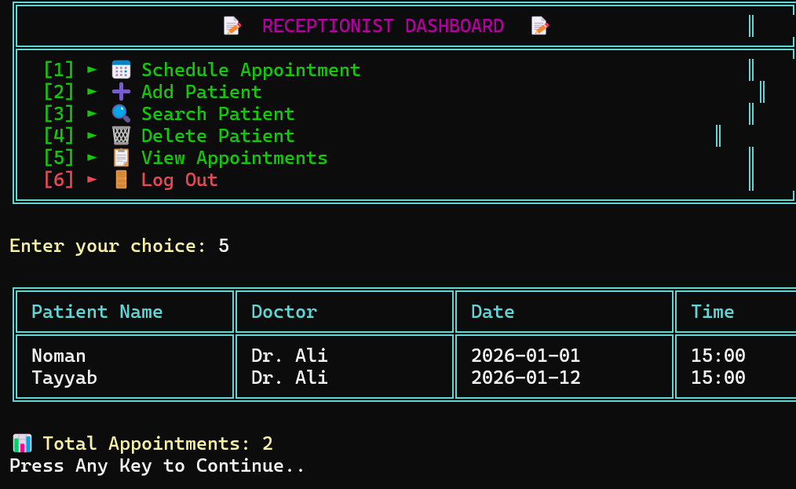
Figure 16: View Appointments

DELETE PATIENTS:
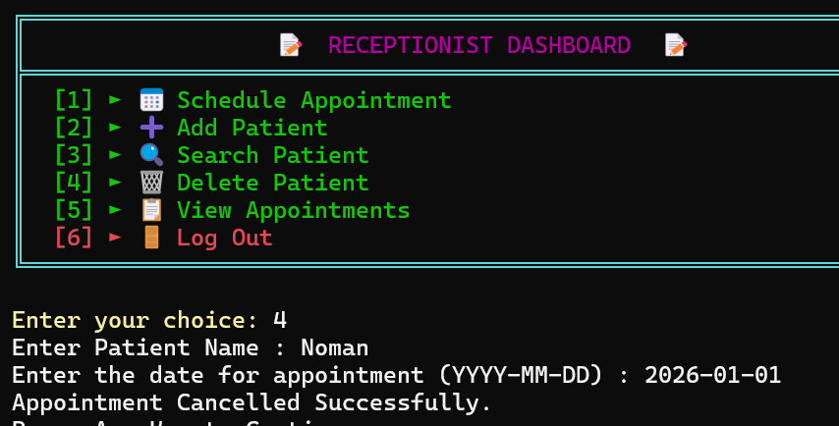
Figure 17: Delete Patients
ADD PATIENTS:
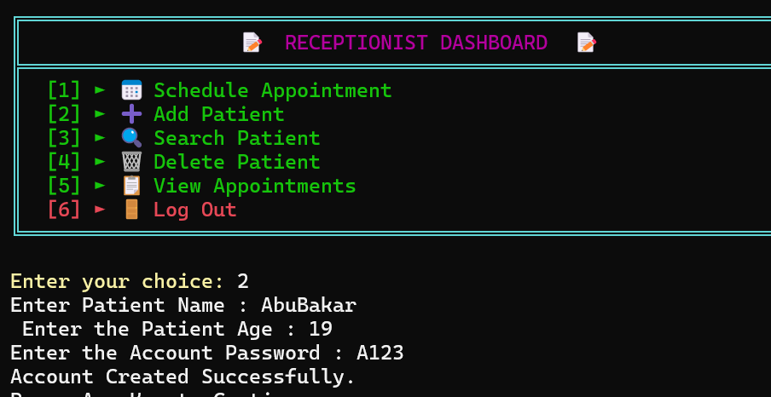
_{Figure 18: Add Patients}

PATIENT FUNCTIONALITIES:

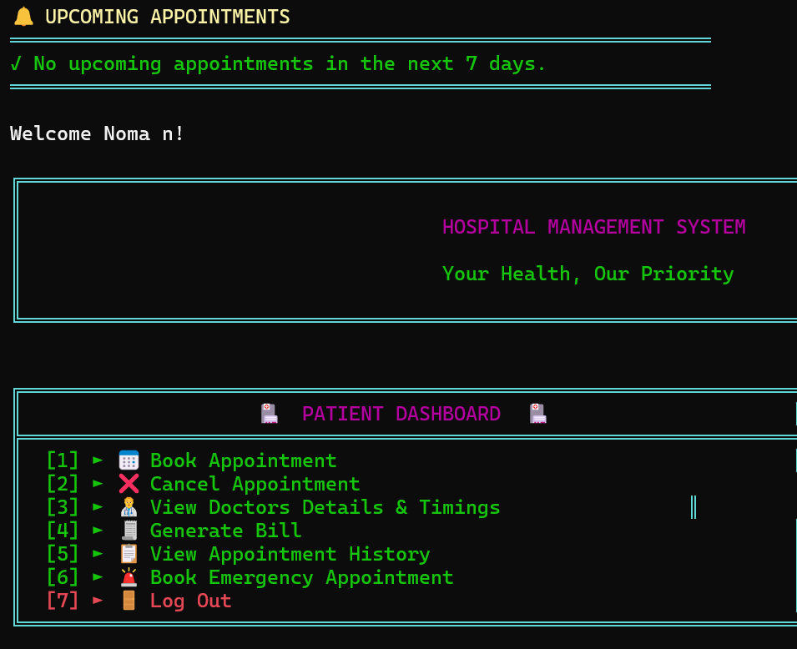
Figure 19: Patient Menu

BOOK APPOINTMENTS:

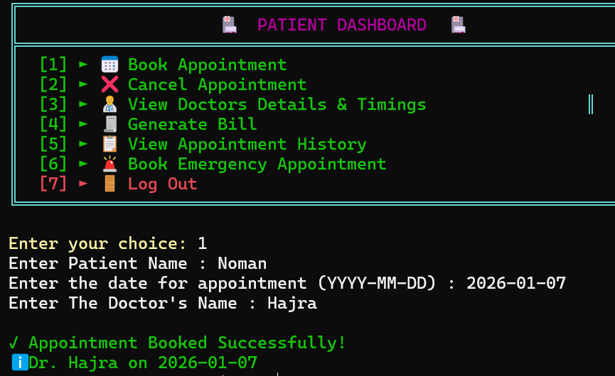

Figure 20: Book Appointments

VIEW DOCTOR DETAILS :

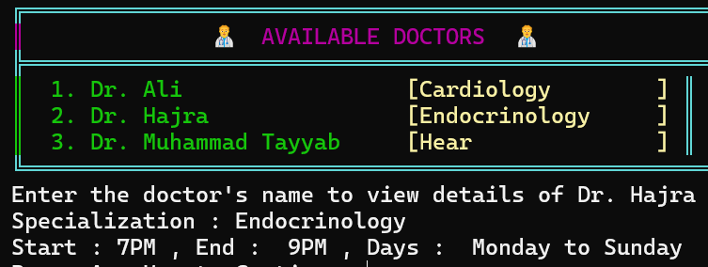
Figure 21: Doctor Details

BILL GENERATION:
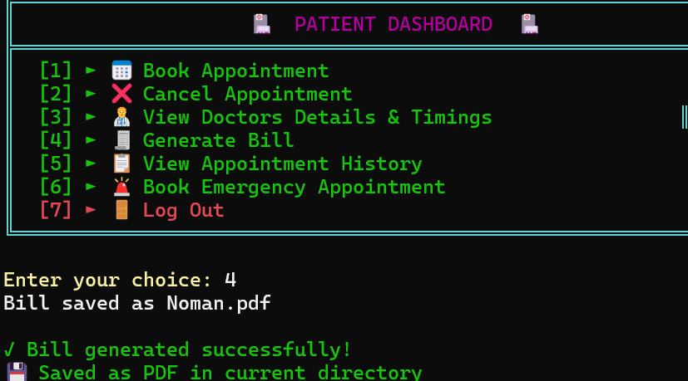

Figure 22: Bill Generation

BOOK EMERGENCY APPOINTMENT:

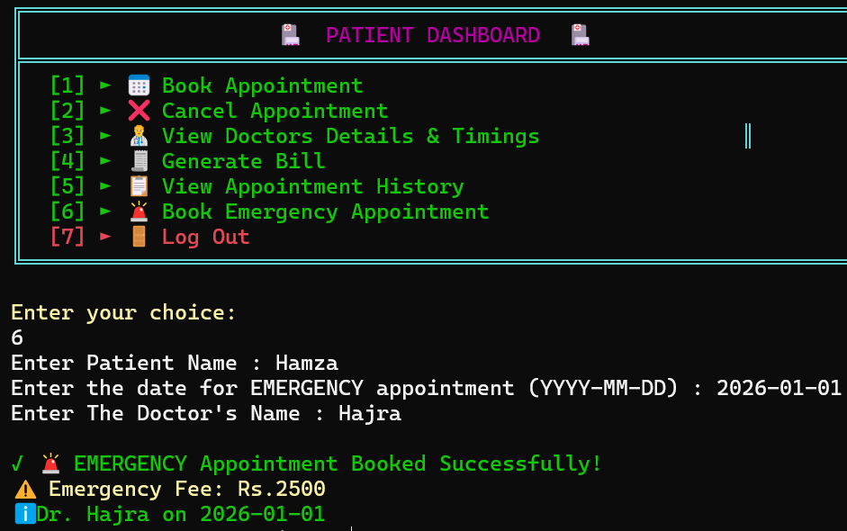
Figure 23: Emergency Appointment

PHARMACIST FUNCTIONALITIES:
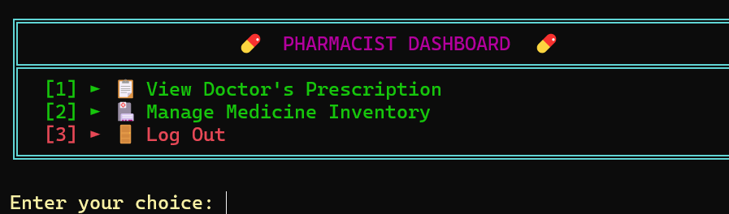

Figure 24: Pharmacist Functionalities

INVENTORY MANAGEMENT:

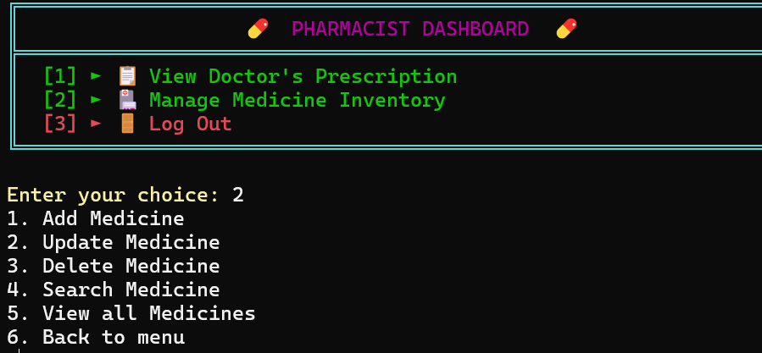

Figure 25: Inventory Management.

CODE FOR APPLICATION:

LIBRARIES:

#include <iostream>
#include <windows.h>
#include <conio.h>
#include <string>
#include <fstream>
#include <cctype>
#include <limits>
#include <sstream>
#include <iomanip>
#include <ctime>
#include <thread>
#include <chrono>

using namespace std;

MAX USER SIZE:
// Maximum number of users supported by the system
const int UserSize = 100;

FUNCTIONS:

int SplitFields(const string &line, string fields[], int maxFields)
{
int actualCount = 0;
string current;
for (char c : line)
{
if (c == FIELD_DELIMITER)
{
if (actualCount < maxFields)
{
fields[actualCount] = current;
}
current.clear();
actualCount++;
}
else
{
current += c;
}
}

if (actualCount < maxFields)
{
fields[actualCount] = current;
}
actualCount++;

if (actualCount > maxFields)
{
actualCount = maxFields;
}

return actualCount;
}

string GetField(const string fields[], int count, int index)
{
if (index < count)
{
return fields[index];
}
return "";
}

string ToUpper(const string &value)
{
string result = value;
for (char &c : result)
{
c = static_cast<char>(toupper(static_cast<unsigned char>(c)));
}
return result;
}

int FindDoctorIndex(const StrArray &Doctors, int DoctorCount, const string &doctorName)
{
for (int i = 0; i < DoctorCount; i++)
{
if (Doctors[i] == doctorName)
{
return i;
}
}
return -1;
}

int ParseTimeToMinutes(const string &timeStr)
{
string trimmed;
for (char c : timeStr)
{
if (!isspace(static_cast<unsigned char>(c)))
{
trimmed += c;
}
}
if (trimmed.empty())
{
return -1;
}

string suffix;
if (trimmed.size() >= 2)
{
char secondLast = static_cast<char>(toupper(static_cast<unsigned char>(trimmed[trimmed.size() - 2])));
char last = static_cast<char>(toupper(static_cast<unsigned char>(trimmed[trimmed.size() - 1])));
if ((secondLast == 'A' || secondLast == 'P') && last == 'M')
{
suffix = string(1, secondLast) + last;
trimmed.erase(trimmed.size() - 2);
}
}

int hours = 0;
int minutes = 0;
size_t colonPos = trimmed.find(':');
try
{
if (colonPos != string::npos)
{
hours = stoi(trimmed.substr(0, colonPos));
minutes = stoi(trimmed.substr(colonPos + 1));
}
else
{
hours = stoi(trimmed);
}
}
catch (...)
{
return -1;
}

hours = hours % 24;
minutes = minutes % 60;

if (suffix == "PM" && hours < 12)
{
hours += 12;
}
else if (suffix == "AM" && hours == 12)
{
hours = 0;
}

return hours * 60 + minutes;
}

StrArray &DoctorSpecialization, int DoctorCount,
const StrArray &PendingDoctorNames, const StrArray &PendingDoctorPasswords, int PendingDoctorRequestCount,
const StrArray &Receptionist, const StrArray &ReceptionistPassword, const StrArray &ReceptionistEmail,
const StrArray &ReceptionistPhone, const StrArray &ReceptionistAddress, int ReceptionistCount,
const StrArray &Pharmacist, const StrArray &PharmacistPassword, const StrArray &PharmacistEmail,
const StrArray &PharmacistPhone, const StrArray &PharmacistAddress, int PharmacistCount,
const StrArray &Medicines, const StrArray &MedicinePrices, const IntArray &MedicineStock, const IntArray &MedicineReorderLevel, int MedicineCount,
const StrArray &HistoryPatients, const StrArray &HistoryDetails, int HistoryCount)
{
SavePatientsToFile(PatientName, PatientPassword, PatientAge, Patientcount);
SaveAppointmentsToFile(appointmentPatient, appointmentDoctor, appointmentDate, appointmentTime, appointmentStatus,
appointmentEmergency, PrescriptionMed, MedicineTimes, PrescriptionDays, appointmentCount);
SaveDoctorsToFile(Doctors, DoctorPassword, DoctorEmail, DoctorPhone, DoctorAddress, DoctorQualification,
DoctorStartTime, DoctorEndTime, DocAvailableDays, DoctorSpecialization, DoctorCount);
SaveDoctorRequests(PendingDoctorNames, PendingDoctorPasswords, PendingDoctorRequestCount);
SaveReceptionistsToFile(Receptionist, ReceptionistPassword, ReceptionistEmail, ReceptionistPhone, ReceptionistAddress, ReceptionistCount);
SavePharmacistsToFile(Pharmacist, PharmacistPassword, PharmacistEmail, PharmacistPhone, PharmacistAddress, PharmacistCount);
SaveMedicinesToFile(Medicines, MedicinePrices, MedicineStock, MedicineReorderLevel, MedicineCount);
SavePatientHistory(HistoryPatients, HistoryDetails, HistoryCount);
}

return;
}

useCyanColour();
cout << "\n╔════════════════════════════════════════════════════════════════════════╗" << endl;
useMagentaColour();
cout << "║ 💊 PHARMACIST DIRECTORY 💊 ║" << endl;
useCyanColour();
cout << "╠════════════════════════════════════════════════════════════════════════╣" << endl;
useWhiteColour();

for (int i = 0; i < PharmacistCount; i++)
{
useGreenColour();
cout << "║ 📋 Pharmacist #" << (i + 1) << " - " << Pharmacist[i];
cout << string(52 - Pharmacist[i].length(), ' ') << "║" << endl;
useCyanColour();
cout << "║ " << string(70, '-') << "║" << endl;
useYellowColour();
cout << "║ 📧 Email: " << left << setw(53) << (PharmacistEmail[i].empty() ? "Not provided" : PharmacistEmail[i]) << "║" << endl;
cout << "║ 📞 Phone: " << left << setw(53) << (PharmacistPhone[i].empty() ? "Not provided" : PharmacistPhone[i]) << "║" << endl;
cout << "║ 🏠 Address: " << left << setw(53) << (PharmacistAddress[i].empty() ? "Not provided" : PharmacistAddress[i]) << "║" << endl;

if (i < PharmacistCount - 1)
{
useCyanColour();
cout << "╠════════════════════════════════════════════════════════════════════════╣" << endl;
}
}

useCyanColour();
cout << "╚════════════════════════════════════════════════════════════════════════╝" << endl;
useWhiteColour();
cout << "\nPress any key to continue...";
_getch();
}

// Show Receptionists
void ViewReceptionist(const StrArray &Receptionist, const StrArray &ReceptionistEmail,
const StrArray &ReceptionistPhone, const StrArray &ReceptionistAddress, int ReceptionistCount)
{

useWhiteColour();
cout << " ";
useGreenColour();
cout << "[5]";
useWhiteColour();
cout << " Pharmacist";
cout << string(width - 19, ' ');
useCyanColour();
cout << "║" << endl;

// Option 6
useCyanColour();
cout << "║";
useWhiteColour();
cout << " ";
useRedColour();
cout << "[6]";
useWhiteColour();
cout << " Exit";
cout << string(width - 13, ' ');
useCyanColour();
cout << "║" << endl;

drawBoxBottom(width);

useCyanColour();
cout << "\nEnter your choice: ";
useWhiteColour();
int option;
cin >> option;
return option;
}

// Book appointment with doctor and assign the next available slot
bool BookAppointment(StrArray &appointmentPatient, StrArray &appointmentDoctor, StrArray &appointmentDate,
StrArray &appointmentTime, StrArray &appointmentStatus, StrArray &appointmentEmergency,
StrArray &PrescriptionMed, StrArray &MedicineTimes, StrArray &PrescriptionDays, int &appointmentCount,
const StrArray &Doctors, const StrArray &DoctorStartTime, const StrArray &DoctorEndTime,
int DoctorCount, const string &name, const string &doctor, const string &date, bool isEmergency = false)
{
for (int i = 0; i < appointmentCount; i++)
{
if (appointmentPatient[i] == name && appointmentDate[i] == date)
{
return false; // already scheduled
}
}

r
id MarkStatus(const StrArray &appointmentDoctor, StrArray &appointmentStatus, const StrArray &appointmentPatient, int appointmentCount)
{
string name = PromptLine("Enter the Doctor's name : ");
for (int i = 0; i < appointmentCount; i++)
{
if (appointmentDoctor[i] == name)
{

appointmentStatus[i] = PromptLine("Mark the Status For Patient " + appointmentPatient[i] + ": ");
}
}
}

void ReviewDoctorSignupRequests(StrArray &PendingDoctorNames, StrArray &PendingDoctorPasswords, int &PendingDoctorRequestCount,
StrArray &Doctors, StrArray &DoctorPassword, StrArray &DoctorEmail, StrArray &DoctorPhone,
StrArray &DoctorAddress, StrArray &DoctorQualification, StrArray &DoctorStartTime,
StrArray &DoctorEndTime, StrArray &DocAvailableDays, StrArray &DoctorSpecialization, int &DoctorCount)
{
if (PendingDoctorRequestCount == 0)
{
cout << "No pending doctor signup requests." << endl;
return;
}

while (PendingDoctorRequestCount > 0)
{
cout << "Pending Doctor Signup Requests:" << endl;
for (int i = 0; i < PendingDoctorRequestCount; i++)
{
cout << i + 1 << ". " << PendingDoctorNames[i] << endl;
}

cout << "Enter request number to review (0 to exit): ";
int selection = 0;
cin >> selection;
if (selection == 0)
{
break;
}
if (selection < 1 || selection > PendingDoctorRequestCount)
{
cout << "Invalid selection." << endl;
continue;
}

int index = selection - 1;
cout << "1. Approve\n2. Reject\nChoose option: ";
int action = 0;
cin >> action;
if (action == 1)
{
if (DoctorCount >= UserSize)
{
cout << "Cannot approve request. Doctor limit reached." << endl;
continue;
}

useGreenColour();
cout << "\n=== Doctor Profile Setup ===" << endl;
useWhiteColour();

string email = PromptLine("Enter email address: ");
string phone = PromptLine("Enter phone number (e.g., +92-300-1234567): ");
string address = PromptLine("Enter address: ");
string qualification = PromptLine("Enter qualification (e.g., MBBS, FCPS): ");
string startTime = PromptLine("Enter starting time (e.g., 3PM): ");
string endTime = PromptLine("Enter ending time (e.g., 5PM): ");
string availableDays = PromptLine("Enter available days : ");
string specialization = PromptLine("Enter specialization : ");
if (specialization.empty())
{
specialization = "General Medicine";
}

Doctors[DoctorCount] = PendingDoctorNames[index];
DoctorPassword[DoctorCount] = PendingDoctorPasswords[index];
DoctorEmail[DoctorCount] = email;
DoctorPhone[DoctorCount] = phone;
DoctorAddress[DoctorCount] = address;
DoctorQualification[DoctorCount] = qualification;
DoctorStartTime[DoctorCount] = startTime;
DoctorEndTime[DoctorCount] = endTime;
DocAvailableDays[DoctorCount] = availableDays;
DoctorSpecialization[DoctorCount] = specialization;
DoctorCount++;

// Immediately save to file
SaveDoctorsToFile(Doctors, DoctorPassword, DoctorEmail, DoctorPhone, DoctorAddress, DoctorQualification,
DoctorStartTime, DoctorEndTime, DocAvailableDays, DoctorSpecialization, DoctorCount);

useGreenColour();
cout << "✓ Doctor signup approved successfully!" << endl;
useWhiteColour();

for (int i = index; i < PendingDoctorRequestCount - 1; i++)
{
PendingDoctorNames[i] = PendingDoctorNames[i + 1];
PendingDoctorPasswords[i] = PendingDoctorPasswords[i + 1];
}
PendingDoctorRequestCount--;
}
else if (action == 2)
{
for (int i = index; i < PendingDoctorRequestCount - 1; i++)
{
PendingDoctorNames[i] = PendingDoctorNames[i + 1];
PendingDoctorPasswords[i] = PendingDoctorPasswords[i + 1];
}
PendingDoctorRequestCount--;
cout << "Doctor signup request rejected." << endl;
}
else
{
cout << "Invalid option." << endl;
}
}
}

// Shows the Doctor's menu and all the features
void DoctorInterface(StrArray &Doctors, StrArray &DoctorPassword, StrArray &DoctorStartTime,
StrArray &DoctorEndTime, StrArray &DocAvailableDays, StrArray &DoctorSpecialization, int &DoctorCount,
StrArray &appointmentPatient, StrArray &appointmentDoctor, StrArray &appointmentDate,
StrArray &appointmentTime, StrArray &appointmentStatus, StrArray &PrescriptionMed, StrArray &MedicineTimes,
StrArray &PrescriptionDays, int appointmentCount,
StrArray &HistoryPatients, StrArray &HistoryDetails, int &HistoryCount,
StrArray &PendingDoctorNames, StrArray &PendingDoctorPasswords, int &PendingDoctorRequestCount)
{
int option1 = 0;
int option = 0;
while (option1 != 3)
{
cout << "1. Sign Up \n";
cout << "2. Log In \n";
cout << "3. Exit \n";
cin >> option1;
if (option1 == 1)
{
string Doctor = PromptLine("Enter Your Name : ");
string DP = PromptLine("Create Your Password : ");
if (DoctorSignup(PendingDoctorNames, PendingDoctorPasswords, PendingDoctorRequestCount,
Doctors, DoctorCount, Doctor, DP))
{
cout << "Signup request submitted. Await admin approval.\n ";
}
else
{
cout << "Sign up request failed. Name might already exist or request queue is full." << endl;
}
}
else if (option1 == 2)
{
string Doctor = PromptLine("Enter Your Name : ");
string DP = PromptLine("Enter Your Password : ");
if (DocLogin(Doctors, DoctorPassword, DoctorCount, Doctor, DP))
{

clearScreen();
int loggedInIndex = FindDoctorIndex(Doctors, DoctorCount, Doctor);
cout << "Welcome Dr. " << Doctor;
if (loggedInIndex != -1 && !DoctorSpecialization[loggedInIndex].empty())
{
cout << " (" << DoctorSpecialization[loggedInIndex] << ")";
}
cout << endl;
while (option != 6)
{
printHeader();
string doctorOptions[] = {
"📋 View Appointments",
"✅ Mark Appointment Status",
"⏰ Update Available Timing",
"💊 Write Prescription",
"📊 View Performance Dashboard",
"🚪 Log Out"
};
displayMenuBox("👨‍⚕️ DOCTOR DASHBOARD 👨‍⚕️", doctorOptions, 6);
cin >> option;
if (option == 1)
{
string name = PromptLine("Enter the Doctor's name : ");
int count = 0;
bool headerPrinted = false;

for (int i = 0; i < appointmentCount; i++)
{
if (appointmentDoctor[i] == name)
{
if (!headerPrinted)
{
drawTableHeader("Patient Name", "Date", "Time", "Status");
headerPrinted = true;
}
string time = appointmentTime[i].empty() ? "Not Set" : appointmentTime[i];
string status = appointmentStatus[i].empty() ? "Pending" : appointmentStatus[i];
drawTableRow(appointmentPatient[i], appointmentDate[i], time, status);
count++;
}
}

if (headerPrinted)
{
drawTableFooter();
useGreenColour();
cout << "\n📊 Total Appointments: " << count << endl;
useWhiteColour();
}
else
{
showInfo("No appointments found for Dr. " + name);
}
}

else if (option == 2)
{
MarkStatus(appointmentDoctor, appointmentStatus, appointmentPatient, appointmentCount);
}

else if (option == 3)
{
string name = PromptLine("Enter Doctor's name : ");
UpdateTiming(Doctors, DoctorStartTime, DoctorEndTime, DocAvailableDays, DoctorCount, name);
}
else if (option == 4)
{
Prescriptions(appointmentPatient, PrescriptionMed, MedicineTimes, PrescriptionDays, appointmentCount);
cin.ignore(numeric_limits<streamsize>::max(), '\n');
string patient;
cout << "Enter patient name to log history: ";
getline(cin, patient);
patient = ToUpper(patient);
for (int i = 0; i < appointmentCount; i++)
{
if (ToUpper(appointmentPatient[i]) == patient)
{
if (HistoryCount < UserSize)
{
HistoryPatients[HistoryCount] = appointmentPatient[i];
HistoryDetails[HistoryCount] = "Doctor: " + appointmentDoctor[i] +
" Date: " + appointmentDate[i] +
(appointmentTime[i].empty() ? "" : (" Time: " + appointmentTime[i])) +
" Prescription: " + PrescriptionMed[i] +
" Times: " + MedicineTimes[i] +
" Days: " + PrescriptionDays[i];
HistoryCount++;
}
break;
}
}
}

else if (option == 5)
{
// View Performance Dashboard
showDoctorPerformance(Doctor, appointmentDoctor, appointmentDate, appointmentStatus, appointmentCount);
}

else if (option == 6)
{
break;
}
clearScreen();
}

}
else
{
cout << "Invalid Username Password " << endl;
}
}
else if (option1 == 3)
{
cout << "Good Bye " << endl;
break;
}
}

}

// Shows the Patient' Menu with its Features
void PatientInterface(StrArray &PatientName, StrArray &PatientPassword, StrArray &PatientAge, int &Patientcount,
StrArray &appointmentPatient, StrArray &appointmentDoctor, StrArray &appointmentDate,
StrArray &appointmentTime, StrArray &appointmentStatus, StrArray &appointmentEmergency,
StrArray &PrescriptionMed, StrArray &MedicineTimes, StrArray &PrescriptionDays, int &appointmentCount,
StrArray &Doctors, StrArray &DoctorStartTime, StrArray &DoctorEndTime,
StrArray &DocAvailableDays, StrArray &DoctorSpecialization, int DoctorCount,
const StrArray &Medicines, const StrArray &MedicinePrices, int MedicineCount)
{

int option = 0;
while (option != 3)
{
printHeader();
cout << "1. Sign Up " << endl;
cout << "2. Log In " << endl;
cout << "3. Exit " << endl;
cin >> option;
if (option == 1)
{
string Patient = PromptLine("Enter Your Name : ");
string PTPassword = PromptLine("Create Your Password : ");
string Age = PromptLine("Enter Your Age : ");
if (SignUp(PatientName, PatientPassword, PatientAge, Patientcount, Patient, PTPassword, Age))
{
showSuccess("Account Created Successfully!");
useGreenColour();
cout << "🎉 Welcome " << Patient << "!" << endl;
useWhiteColour();
}
else
{
showError("Sign Up Failed - Account may already exist.");
}
}
else if (option == 2)
{
string Patient = PromptLine("Enter Your Name : ");
string PTPassword = PromptLine("Enter Your Password : ");
string result;
result = Login(PatientName, PatientPassword, Patientcount, Patient, PTPassword);
if (result != "Undefined")
{

clearScreen();

// Show reminders on login
showUpcomingAppointments(result, appointmentPatient, appointmentDoctor, appointmentDate,
appointmentTime, appointmentStatus, appointmentCount);

cout << "\nWelcome " << result << "!" << endl;

int option2 = 0;
while (option2 != 7)
{
printHeader();
string patientOptions[] = {
"📅 Book Appointment",
"❌ Cancel Appointment",
"👨‍⚕️ View Doctors Details & Timings",
"🧾 Generate Bill",
"📋 View Appointment History",
"🚨 Book Emergency Appointment",
"🚪 Log Out"
};
displayMenuBox("🏥 PATIENT DASHBOARD 🏥", patientOptions, 7);
cin >> option2;
if (option2 == 1)
{
string PTName = PromptLine("Enter Patient Name : ");
string date = PromptLine("Enter the date for appointment (YYYY-MM-DD) : ");
string DocName = PromptLine("Enter The Doctor's Name : ");
if (BookAppointment(appointmentPatient, appointmentDoctor, appointmentDate, appointmentTime,
appointmentStatus, appointmentEmergency, PrescriptionMed, MedicineTimes, PrescriptionDays,
appointmentCount,
Doctors, DoctorStartTime, DoctorEndTime, DoctorCount,
PTName, DocName, date, false))
{
showSuccess("Appointment Booked Successfully!");
useGreenColour();
cout << "ℹ Dr. " << DocName << " on " << date << endl;
useWhiteColour();
}
else
{
showError("Appointment already exists or invalid data.");
}
}
else if (option2 == 2)
{

string PTName = PromptLine("Enter Patient Name : ");
string date = PromptLine("Enter the date for appointment (YYYY-MM-DD) : ");
if (CancelAppointment(appointmentPatient, appointmentDoctor, appointmentDate, appointmentTime,
appointmentStatus, appointmentEmergency, PrescriptionMed, MedicineTimes, PrescriptionDays,
appointmentCount, PTName, date))
{
showSuccess("Appointment Cancelled Successfully!");
}
else
{
showError("Appointment Not Found.");
}
}
else if (option2 == 3)
{
// Simple doctor list for patients
useCyanColour();
cout << "\n╔════════════════════════════════════════════════════════╗" << endl;
useMagentaColour();
cout << "║ 👨‍⚕️ AVAILABLE DOCTORS 👨‍⚕️ ║" << endl;
useCyanColour();
cout << "╠════════════════════════════════════════════════════════╣" << endl;

for (int i = 0; i < DoctorCount; i++)
{
useGreenColour();
cout << "║ " << (i + 1) << ". Dr. " << left << setw(20) << Doctors[i];
useYellowColour();
string spec = DoctorSpecialization[i].empty() ? "General" : DoctorSpecialization[i];
cout << "[" << setw(18) << spec << "]";
useCyanColour();
cout << " ║" << endl;
}

useCyanColour();
cout << "╚════════════════════════════════════════════════════════╝" << endl;
useWhiteColour();

string name = PromptLine("Enter the doctor's name to view details of Dr. ");
for (int i = 0; i < DoctorCount; i++)
{
if (Doctors[i] == name)
{
cout << "Specialization : " << (DoctorSpecialization[i].empty() ? "General Medicine" : DoctorSpecialization[i]) << endl;
cout << "Start : " << DoctorStartTime[i] << " , End : " << DoctorEndTime[i] << " , Days : " << DocAvailableDays[i] << endl;
}
}
}
else if (option2 == 4)
{
if (GeneratePatientBillPDF(result, appointmentPatient, PrescriptionMed, appointmentCount,
Medicines, MedicinePrices, MedicineCount))
{
showSuccess("Bill generated successfully!");
useGreenColour();
cout << "💾 Saved as PDF in current directory" << endl;
useWhiteColour();
}
else
{
showError("Failed to generate bill.");
}
}
else if (option2 == 5)
{
// View Appointment History
showPatientHistory(result, appointmentPatient, appointmentDoctor, appointmentDate,
appointmentTime, appointmentStatus, appointmentEmergency, appointmentCount);
}
else if (option2 == 6)
{
// Book Emergency Appointment
string PTName = PromptLine("Enter Patient Name : ");
string date = PromptLine("Enter the date for EMERGENCY appointment (YYYY-MM-DD) : ");
string DocName = PromptLine("Enter The Doctor's Name : ");
if (BookAppointment(appointmentPatient, appointmentDoctor, appointmentDate, appointmentTime,
appointmentStatus, appointmentEmergency, PrescriptionMed, MedicineTimes, PrescriptionDays,
appointmentCount,
Doctors, DoctorStartTime, DoctorEndTime, DoctorCount,
PTName, DocName, date, true))
{
useRedColour();
showSuccess("🚨 EMERGENCY Appointment Booked Successfully!");
useYellowColour();
cout << "⚠️ Emergency Fee: Rs." << EMERGENCY_CONSULTATION_FEE << endl;
useGreenColour();
cout << "ℹ Dr. " << DocName << " on " << date << endl;
useWhiteColour();
}
else
{
showError("Emergency Appointment booking failed.");
}
}
else if (option2 == 7)
{
break;
}
clearScreen();
}
}
else
{
cout << "Invalid Username Password " << endl;
}
}
else if (option == 3)
{
cout << "Good Bye " << endl;
break;
}
clearScreen();
}
}

// Shows the Admin' menu And all the Features
void AdminInterface(StrArray &Doctors, StrArray &DoctorPassword, StrArray &DoctorEmail, StrArray &DoctorPhone,
StrArray &DoctorAddress, StrArray &DoctorQualification, StrArray &DoctorStartTime,
StrArray &DoctorEndTime, StrArray &DocAvailableDays, StrArray &DoctorSpecialization, int &DoctorCount,
StrArray &PendingDoctorNames, StrArray &PendingDoctorPasswords, int &PendingDoctorRequestCount,
StrArray &Receptionist, StrArray &ReceptionistPassword, StrArray &ReceptionistEmail,
StrArray &ReceptionistPhone, StrArray &ReceptionistAddress, int &ReceptionistCount,
StrArray &Pharmacist, StrArray &PharmacistPassword, StrArray &PharmacistEmail,
StrArray &PharmacistPhone, StrArray &PharmacistAddress, int &PharmacistCount,
const StrArray &Medicines, const IntArray &MedicineStock,
const IntArray &MedicineReorderLevel, int MedicineCount,
const StrArray &appointmentStatus, const StrArray &appointmentDate,
const StrArray &appointmentEmergency, int appointmentCount,
int patientCount)
{
int option = 0;
while (option != 13)
{
printHeader();

// Display quick stats
displayQuickStats(patientCount, appointmentCount, DoctorCount, MedicineCount, appointmentStatus, appointmentCount);

// Check and show low stock alert
checkLowStockMedicines(Medicines, MedicineStock, MedicineReorderLevel, MedicineCount);

string adminOptions[] = {
"➕ Add Doctors",
"➖ Remove Doctors",
"➕ Add Receptionist",
"➖ Remove Receptionist",
"➕ Add Pharmacist",
"➖ Remove Pharmacist",
"👀 View Doctors",
"👀 View Receptionist",
"👀 View Pharmacist",
"📋 Review Doctor Signup Requests",
"⚠️ View Low Stock Medicines",
"💰 Generate Revenue Report",
"🚪 Log Out"
};
displayMenuBox("🔐 ADMIN CONTROL PANEL 🔐", adminOptions, 13);
cin >> option;
if (option == 1)
{
for (int i = DoctorCount; i < UserSize; i++)
{
useGreenColour();
cout << "\n=== Add New Doctor ===" << endl;
useWhiteColour();

Doctors[i] = PromptLine("Enter the Doctor Name: ");
DoctorPassword[i] = PromptLine("Enter password for doctor: ");
DoctorEmail[i] = PromptLine("Enter email address: ");
DoctorPhone[i] = PromptLine("Enter phone number (e.g., +92-300-1234567): ");
DoctorAddress[i] = PromptLine("Enter address: ");
DoctorQualification[i] = PromptLine("Enter qualification (e.g., MBBS, FCPS): ");
DoctorSpecialization[i] = PromptLine("Enter the Doctor Specialization: ");
if (DoctorSpecialization[i].empty())
{
DoctorSpecialization[i] = "General Medicine";
}
DoctorStartTime[i] = PromptLine("Enter starting time (e.g., 3PM): ");
DoctorEndTime[i] = PromptLine("Enter ending time (e.g., 5PM): ");
DocAvailableDays[i] = PromptLine("Enter available days: ");
DoctorCount++;

// Immediately save to file
SaveDoctorsToFile(Doctors, DoctorPassword, DoctorEmail, DoctorPhone, DoctorAddress, DoctorQualification,
DoctorStartTime, DoctorEndTime, DocAvailableDays, DoctorSpecialization, DoctorCount);

useGreenColour();
cout << "✓ Doctor added successfully!" << endl;
useWhiteColour();

int option2;
cout << "Press 1 to Enter more doctors " << endl;
cout << "Press 0 to Exit " << endl;
cin >> option2;
if (option2 == 0)
{
break;
}
}
}
else if (option == 2)
{
string Name;
Name = PromptLine("Enter the Doctor Name : ");
for (int i = 0; i < DoctorCount; i++)
{
if (Doctors[i] == Name)
{
for (int j = i; j < DoctorCount - 1; j++)
{
Doctors[j] = Doctors[j + 1];
DoctorPassword[j] = DoctorPassword[j + 1];
DoctorEmail[j] = DoctorEmail[j + 1];
DoctorPhone[j] = DoctorPhone[j + 1];
DoctorAddress[j] = DoctorAddress[j + 1];
DoctorQualification[j] = DoctorQualification[j + 1];
DoctorStartTime[j] = DoctorStartTime[j + 1];
DoctorEndTime[j] = DoctorEndTime[j + 1];
DocAvailableDays[j] = DocAvailableDays[j + 1];
DoctorSpecialization[j] = DoctorSpecialization[j + 1];
}
DoctorCount--;

// Immediately save to file
SaveDoctorsToFile(Doctors, DoctorPassword, DoctorEmail, DoctorPhone, DoctorAddress, DoctorQualification,
DoctorStartTime, DoctorEndTime, DocAvailableDays, DoctorSpecialization, DoctorCount);

useGreenColour();
cout << "✓ Doctor removed successfully!" << endl;
useWhiteColour();
break;
}
}
}
else if (option == 3)
{
for (int i = ReceptionistCount; i < UserSize; i++)
{
useGreenColour();
cout << "\n=== Add New Receptionist ===" << endl;
useWhiteColour();

Receptionist[i] = PromptLine("Enter the Receptionist Name: ");
ReceptionistPassword[i] = PromptLine("Enter password for receptionist: ");
ReceptionistEmail[i] = PromptLine("Enter email address: ");
ReceptionistPhone[i] = PromptLine("Enter phone number (e.g., +92-300-1234567): ");
ReceptionistAddress[i] = PromptLine("Enter address: ");
ReceptionistCount++;

// Immediately save to file
SaveReceptionistsToFile(Receptionist, ReceptionistPassword, ReceptionistEmail, ReceptionistPhone, ReceptionistAddress, ReceptionistCount);

useGreenColour();
cout << "✓ Receptionist added successfully!" << endl;
useWhiteColour();

int option2;
cout << "Press 1 for Entering more Receptionists " << endl;
cout << "Press 0 to Exit " << endl;
cin >> option2;
if (option2 == 0)
{
break;
}
}
}
else if (option == 4)
{
string Name;
Name = PromptLine("Enter the Receptionist Name : ");
for (int i = 0; i < ReceptionistCount; i++)
{
if (Receptionist[i] == Name)
{
for (int j = i; j < ReceptionistCount - 1; j++)
{
Receptionist[j] = Receptionist[j + 1];
ReceptionistPassword[j] = ReceptionistPassword[j + 1];
ReceptionistEmail[j] = ReceptionistEmail[j + 1];
ReceptionistPhone[j] = ReceptionistPhone[j + 1];
ReceptionistAddress[j] = ReceptionistAddress[j + 1];
}
ReceptionistCount--;

// Immediately save to file
SaveReceptionistsToFile(Receptionist, ReceptionistPassword, ReceptionistEmail, ReceptionistPhone, ReceptionistAddress, ReceptionistCount);

useGreenColour();
cout << "✓ Receptionist removed successfully!" << endl;
useWhiteColour();
break;
}
}
}
else if (option == 5)
{
for (int i = PharmacistCount; i < UserSize; i++)
{
useGreenColour();
cout << "\n=== Add New Pharmacist ===" << endl;
useWhiteColour();

Pharmacist[i] = PromptLine("Enter the Pharmacist Name: ");
PharmacistPassword[i] = PromptLine("Enter password for pharmacist: ");
PharmacistEmail[i] = PromptLine("Enter email address: ");
PharmacistPhone[i] = PromptLine("Enter phone number (e.g., +92-300-1234567): ");
PharmacistAddress[i] = PromptLine("Enter address: ");
PharmacistCount++;

// Immediately save to file
SavePharmacistsToFile(Pharmacist, PharmacistPassword, PharmacistEmail, PharmacistPhone, PharmacistAddress, PharmacistCount);

useGreenColour();
cout << "✓ Pharmacist added successfully!" << endl;
useWhiteColour();

int option2;
cout << "Press 1 for Entering more Pharmacists " << endl;
cout << "Press 0 to Exit " << endl;
cin >> option2;
if (option2 == 0)
{
break;
}
}
}
else if (option == 6)
{
string Name;
Name = PromptLine("Enter the Pharmacist Name : ");
for (int i = 0; i < PharmacistCount; i++)
{
if (Pharmacist[i] == Name)
{
for (int j = i; j < PharmacistCount - 1; j++)
{
Pharmacist[j] = Pharmacist[j + 1];
PharmacistPassword[j] = PharmacistPassword[j + 1];
PharmacistEmail[j] = PharmacistEmail[j + 1];
PharmacistPhone[j] = PharmacistPhone[j + 1];
PharmacistAddress[j] = PharmacistAddress[j + 1];
}
PharmacistCount--;

// Immediately save to file
SavePharmacistsToFile(Pharmacist, PharmacistPassword, PharmacistEmail, PharmacistPhone, PharmacistAddress, PharmacistCount);

useGreenColour();
cout << "✓ Pharmacist removed successfully!" << endl;
useWhiteColour();
break;
}
}
}
else if (option == 7)
{
ViewDoctors(Doctors, DoctorEmail, DoctorPhone, DoctorAddress, DoctorQualification,
DoctorStartTime, DoctorEndTime, DocAvailableDays, DoctorSpecialization, DoctorCount);
}
else if (option == 8)
{
ViewReceptionist(Receptionist, ReceptionistEmail, ReceptionistPhone, ReceptionistAddress, ReceptionistCount);
}
else if (option == 9)
{
ViewPharmacist(Pharmacist, PharmacistEmail, PharmacistPhone, PharmacistAddress, PharmacistCount);
}
else if (option == 10)
{
ReviewDoctorSignupRequests(PendingDoctorNames, PendingDoctorPasswords, PendingDoctorRequestCount,
Doctors, DoctorPassword, DoctorEmail, DoctorPhone, DoctorAddress, DoctorQualification,
DoctorStartTime, DoctorEndTime, DocAvailableDays, DoctorSpecialization, DoctorCount);
}
else if (option == 11)
{
// View Low Stock Medicines
displayLowStockReport(Medicines, MedicineStock, MedicineReorderLevel, MedicineCount);
}
else if (option == 12)
{
// Generate Revenue Report
generateRevenueReport(appointmentStatus, appointmentDate, appointmentEmergency, appointmentCount);
}
else if (option == 13)
{
break;
}
clearScreen();
}
}

// Shows Receptionists menu
void ReceptionInterface(StrArray &appointmentPatient, StrArray &appointmentDoctor, StrArray &appointmentDate,
StrArray &appointmentTime, StrArray &appointmentStatus, StrArray &appointmentEmergency,
StrArray &PrescriptionMed, StrArray &MedicineTimes, StrArray &PrescriptionDays, int &appointmentCount,
StrArray &PatientName, StrArray &PatientPassword, StrArray &PatientAge, int &Patientcount,
StrArray &Doctors, StrArray &DoctorStartTime, StrArray &DoctorEndTime, int DoctorCount)
{
int option = 0;
while (option != 6)
{
printHeader();
string receptionOptions[] = {
"📅 Schedule Appointment",
"➕ Add Patient",
"🔍 Search Patient",
"🗑️ Delete Patient",
"📋 View Appointments",
"🚪 Log Out"
};
displayMenuBox("📝 RECEPTIONIST DASHBOARD 📝", receptionOptions, 6);
cin >> option;
if (option == 1)
{
string PTName = PromptLine("Enter Patient Name : ");
string date = PromptLine("Enter the date for appointment (YYYY-MM-DD) : ");
string DocName = PromptLine("Enter The Doctor's Name : ");
if (BookAppointment(appointmentPatient, appointmentDoctor, appointmentDate, appointmentTime,
appointmentStatus, appointmentEmergency, PrescriptionMed, MedicineTimes, PrescriptionDays,
appointmentCount,
Doctors, DoctorStartTime, DoctorEndTime, DoctorCount,
PTName, DocName, date, false))
{
cout << "Appointment Booked Successfully. " << endl;
}
else
{
cout << " Appointment already exist. " << endl;
}
}

if (option == 2)
{
string PTNAME = PromptLine("Enter Patient Name : ");
string PTAGE = PromptLine(" Enter the Patient Age : ");
string PP = PromptLine("Enter the Account Password : ");
if (SignUp(PatientName, PatientPassword, PatientAge, Patientcount, PTNAME, PP, PTAGE))
{
cout << "Account Created Successfully. " << endl;
}
else
{
cout << "Failed to create the account. " << endl;
}
}

if (option == 3)
{
string PTName = PromptLine("Enter Patient Name : ");
if (SearchPatient(appointmentPatient, appointmentCount, PTName))
{
showSuccess("Patient Found!");
useGreenColour();
cout << "✅ " << PTName << " has appointments in the system" << endl;
useWhiteColour();
}
else
{
showError("Patient Not Found.");
}
}

if (option == 4)
{
string PTName = PromptLine("Enter Patient Name : ");
string date = PromptLine("Enter the date for appointment (YYYY-MM-DD) : ");
if (CancelAppointment(appointmentPatient, appointmentDoctor, appointmentDate, appointmentTime,
appointmentStatus, appointmentEmergency, PrescriptionMed, MedicineTimes, PrescriptionDays,
appointmentCount, PTName, date))
{
cout << "Appointment Cancelled Successfully. " << endl;
}
else
{
cout << "Appointment Not Found. " << endl;
}
}
else if (option == 5)
{
ViewAppointments(appointmentPatient, appointmentDate, appointmentTime, appointmentDoctor, appointmentCount);
}
else if (option == 6)
{
break;
}
clearScreen();
}
}

// Shows Pharmacists Menu
void PharmacistInterface(const StrArray &PrescriptionMed, const StrArray &MedicineTimes, const StrArray &PrescriptionDays,
int appointmentCount,
StrArray &Medicines, StrArray &MedicinePrices, int &MedicineCount)
{
int option = 0;
while (option != 3)
{
printHeader();
string pharmacistOptions[] = {
"📋 View Doctor's Prescription",
"🏥 Manage Medicine Inventory",
"🚪 Log Out"
};
displayMenuBox("💊 PHARMACIST DASHBOARD 💊", pharmacistOptions, 3);
cin >> option;
if (option == 1)
{
ViewPrescriptions(PrescriptionMed, MedicineTimes, PrescriptionDays, appointmentCount);
}
else if (option == 2)
{
ManageInventory(Medicines, MedicinePrices, MedicineCount);
}
else if (option == 3)
{
break;
}
clearScreen();
}
}

// Shows a Login box
void loginScreen()
{
int width = 50;
int padding = getCenterPadding(width);
string pad = string(padding, ' ');

cout << pad;
drawBox(width);
cout << pad;
useGreenColour();
drawBoxSides("LOGIN CREDENTIALS", width);
useCyanColour();
cout << pad << "╚";
for (int i = 0; i < width - 2; i++)
cout << "═";
cout << "╝" << endl;
useWhiteColour();
cout << endl;
}

MAIN LOGIC:

/*____________________Main Code_______________________*/

// Includes all the main loops of the program
// Route the users to correct Interface
int main()
{
// Setup console for UTF-8 and colors
setupConsole();

StrArray PatientName = {};
StrArray PatientPassword = {};
StrArray PatientAge = {};
int Patientcount = 0;

StrArray appointmentPatient = {};
StrArray appointmentDate = {};
StrArray appointmentDoctor = {};
StrArray appointmentTime = {};
StrArray appointmentStatus = {};
StrArray appointmentEmergency = {}; // Track emergency appointments
StrArray PrescriptionMed = {};
StrArray MedicineTimes = {};
StrArray PrescriptionDays = {};
int appointmentCount = 0;

StrArray Doctors = {};
StrArray DoctorPassword = {};
StrArray DoctorEmail = {};
StrArray DoctorPhone = {};
StrArray DoctorAddress = {};
StrArray DoctorQualification = {};
StrArray DoctorStartTime = {};
StrArray DoctorEndTime = {};
StrArray DocAvailableDays = {};
StrArray DoctorSpecialization = {};
int DoctorCount = 0;

StrArray PendingDoctorNames = {};
StrArray PendingDoctorPasswords = {};
int PendingDoctorRequestCount = 0;

StrArray Receptionist = {};
StrArray ReceptionistPassword = {};
StrArray ReceptionistEmail = {};
StrArray ReceptionistPhone = {};
StrArray ReceptionistAddress = {};
int ReceptionistCount = 0;

StrArray Pharmacist = {};
StrArray PharmacistPassword = {};
StrArray PharmacistEmail = {};
StrArray PharmacistPhone = {};
StrArray PharmacistAddress = {};
int PharmacistCount = 0;

StrArray Medicines = {};
StrArray MedicinePrices = {};
IntArray MedicineStock = {};
IntArray MedicineReorderLevel = {};
int MedicineCount = 0;

StrArray HistoryPatients = {};
StrArray HistoryDetails = {};
int HistoryCount = 0;

InitializeDefaults(Doctors, DoctorPassword, DoctorEmail, DoctorPhone, DoctorAddress, DoctorQualification,
DoctorStartTime, DoctorEndTime, DocAvailableDays, DoctorSpecialization, DoctorCount,
Receptionist, ReceptionistPassword, ReceptionistEmail, ReceptionistPhone, ReceptionistAddress, ReceptionistCount,
Pharmacist, PharmacistPassword, PharmacistEmail, PharmacistPhone, PharmacistAddress, PharmacistCount,
Medicines, MedicinePrices, MedicineStock, MedicineReorderLevel, MedicineCount);

LoadAllData(PatientName, PatientPassword, PatientAge, Patientcount,
appointmentPatient, appointmentDoctor, appointmentDate, appointmentTime, appointmentStatus,
appointmentEmergency, PrescriptionMed, MedicineTimes, PrescriptionDays, appointmentCount,
Doctors, DoctorPassword, DoctorEmail, DoctorPhone, DoctorAddress, DoctorQualification,
DoctorStartTime, DoctorEndTime, DocAvailableDays, DoctorSpecialization, DoctorCount,
PendingDoctorNames, PendingDoctorPasswords, PendingDoctorRequestCount,
Receptionist, ReceptionistPassword, ReceptionistEmail, ReceptionistPhone, ReceptionistAddress, ReceptionistCount,
Pharmacist, PharmacistPassword, PharmacistEmail, PharmacistPhone, PharmacistAddress, PharmacistCount,
Medicines, MedicinePrices, MedicineStock, MedicineReorderLevel, MedicineCount,
HistoryPatients, HistoryDetails, HistoryCount);

int option = 0;

while (option != 6)
{
printHeader();
option = Menu();
clearScreen();
if (option == 1)
{
printHeader();
loginScreen();
string admin = "admin";
string AdminPass = PromptLine("Enter Password : ");
if (AdminPass == "123")
{
AdminInterface(Doctors, DoctorPassword, DoctorEmail, DoctorPhone, DoctorAddress, DoctorQualification,
DoctorStartTime, DoctorEndTime, DocAvailableDays, DoctorSpecialization, DoctorCount,
PendingDoctorNames, PendingDoctorPasswords, PendingDoctorRequestCount,
Receptionist, ReceptionistPassword, ReceptionistEmail, ReceptionistPhone, ReceptionistAddress, ReceptionistCount,
Pharmacist, PharmacistPassword, PharmacistEmail, PharmacistPhone, PharmacistAddress, PharmacistCount,
Medicines, MedicineStock, MedicineReorderLevel, MedicineCount,
appointmentStatus, appointmentDate, appointmentEmergency, appointmentCount, Patientcount);
SaveAllData(PatientName, PatientPassword, PatientAge, Patientcount,
appointmentPatient, appointmentDoctor, appointmentDate, appointmentTime, appointmentStatus,
appointmentEmergency, PrescriptionMed, MedicineTimes, PrescriptionDays, appointmentCount,
Doctors, DoctorPassword, DoctorEmail, DoctorPhone, DoctorAddress, DoctorQualification,
DoctorStartTime, DoctorEndTime, DocAvailableDays, DoctorSpecialization, DoctorCount,
PendingDoctorNames, PendingDoctorPasswords, PendingDoctorRequestCount,
Receptionist, ReceptionistPassword, ReceptionistEmail, ReceptionistPhone, ReceptionistAddress, ReceptionistCount,
Pharmacist, PharmacistPassword, PharmacistEmail, PharmacistPhone, PharmacistAddress, PharmacistCount,
Medicines, MedicinePrices, MedicineStock, MedicineReorderLevel, MedicineCount,
HistoryPatients, HistoryDetails, HistoryCount);
}
else
{
cout << "Wrong Credentials " << endl;
}
}
if (option == 2)
{
printHeader();
loginScreen();

DoctorInterface(Doctors, DoctorPassword, DoctorStartTime, DoctorEndTime, DocAvailableDays, DoctorSpecialization, DoctorCount,
appointmentPatient, appointmentDoctor, appointmentDate, appointmentTime, appointmentStatus,
PrescriptionMed, MedicineTimes, PrescriptionDays, appointmentCount,
HistoryPatients, HistoryDetails, HistoryCount,
PendingDoctorNames, PendingDoctorPasswords, PendingDoctorRequestCount);
SaveAllData(PatientName, PatientPassword, PatientAge, Patientcount,
appointmentPatient, appointmentDoctor, appointmentDate, appointmentTime, appointmentStatus,
appointmentEmergency, PrescriptionMed, MedicineTimes, PrescriptionDays, appointmentCount,
Doctors, DoctorPassword, DoctorEmail, DoctorPhone, DoctorAddress, DoctorQualification,
DoctorStartTime, DoctorEndTime, DocAvailableDays, DoctorSpecialization, DoctorCount,
PendingDoctorNames, PendingDoctorPasswords, PendingDoctorRequestCount,
Receptionist, ReceptionistPassword, ReceptionistEmail, ReceptionistPhone, ReceptionistAddress, ReceptionistCount,
Pharmacist, PharmacistPassword, PharmacistEmail, PharmacistPhone, PharmacistAddress, PharmacistCount,
Medicines, MedicinePrices, MedicineStock, MedicineReorderLevel, MedicineCount,
HistoryPatients, HistoryDetails, HistoryCount);
}

if (option == 3)
{
printHeader();
loginScreen();
string Reception = PromptLine("Enter user : ");
string ReceptionPass = PromptLine("Enter the Password : ");
if (ReceptionPass == "12345")
{
ReceptionInterface(appointmentPatient, appointmentDoctor, appointmentDate,
appointmentTime, appointmentStatus, appointmentEmergency, PrescriptionMed, MedicineTimes, PrescriptionDays,
appointmentCount,
PatientName, PatientPassword, PatientAge, Patientcount,
Doctors, DoctorStartTime, DoctorEndTime, DoctorCount);
SaveAllData(PatientName, PatientPassword, PatientAge, Patientcount,
appointmentPatient, appointmentDoctor, appointmentDate, appointmentTime, appointmentStatus,
appointmentEmergency, PrescriptionMed, MedicineTimes, PrescriptionDays, appointmentCount,
Doctors, DoctorPassword, DoctorEmail, DoctorPhone, DoctorAddress, DoctorQualification,
DoctorStartTime, DoctorEndTime, DocAvailableDays, DoctorSpecialization, DoctorCount,
PendingDoctorNames, PendingDoctorPasswords, PendingDoctorRequestCount,
Receptionist, ReceptionistPassword, ReceptionistEmail, ReceptionistPhone, ReceptionistAddress, ReceptionistCount,
Pharmacist, PharmacistPassword, PharmacistEmail, PharmacistPhone, PharmacistAddress, PharmacistCount,
Medicines, MedicinePrices, MedicineStock, MedicineReorderLevel, MedicineCount,
HistoryPatients, HistoryDetails, HistoryCount);
}
else
{
cout << "Wrong Credentials " << endl;
}
}
if (option == 4)
{
printHeader();
loginScreen();
PatientInterface(PatientName, PatientPassword, PatientAge, Patientcount,
appointmentPatient, appointmentDoctor, appointmentDate,
appointmentTime, appointmentStatus, appointmentEmergency,
PrescriptionMed, MedicineTimes, PrescriptionDays,
appointmentCount,
Doctors, DoctorStartTime, DoctorEndTime, DocAvailableDays, DoctorSpecialization, DoctorCount,
Medicines, MedicinePrices, MedicineCount);
SaveAllData(PatientName, PatientPassword, PatientAge, Patientcount,
appointmentPatient, appointmentDoctor, appointmentDate, appointmentTime, appointmentStatus,
appointmentEmergency, PrescriptionMed, MedicineTimes, PrescriptionDays, appointmentCount,
Doctors, DoctorPassword, DoctorEmail, DoctorPhone, DoctorAddress, DoctorQualification,
DoctorStartTime, DoctorEndTime, DocAvailableDays, DoctorSpecialization, DoctorCount,
PendingDoctorNames, PendingDoctorPasswords, PendingDoctorRequestCount,
Receptionist, ReceptionistPassword, ReceptionistEmail, ReceptionistPhone, ReceptionistAddress, ReceptionistCount,
Pharmacist, PharmacistPassword, PharmacistEmail, PharmacistPhone, PharmacistAddress, PharmacistCount,
Medicines, MedicinePrices, MedicineStock, MedicineReorderLevel, MedicineCount,
HistoryPatients, HistoryDetails, HistoryCount);
}
if (option == 5)
{
printHeader();
loginScreen();
string Pharma = PromptLine("Enter User : ");
string PharmaPass = PromptLine("Enter Password : ");
if (PharmaPass == "123456")
{
PharmacistInterface(PrescriptionMed, MedicineTimes, PrescriptionDays, appointmentCount,
Medicines, MedicinePrices, MedicineCount);
SaveAllData(PatientName, PatientPassword, PatientAge, Patientcount,
appointmentPatient, appointmentDoctor, appointmentDate, appointmentTime, appointmentStatus,
appointmentEmergency, PrescriptionMed, MedicineTimes, PrescriptionDays, appointmentCount,
Doctors, DoctorPassword, DoctorEmail, DoctorPhone, DoctorAddress, DoctorQualification,
DoctorStartTime, DoctorEndTime, DocAvailableDays, DoctorSpecialization, DoctorCount,
PendingDoctorNames, PendingDoctorPasswords, PendingDoctorRequestCount,
Receptionist, ReceptionistPassword, ReceptionistEmail, ReceptionistPhone, ReceptionistAddress, ReceptionistCount,
Pharmacist, PharmacistPassword, PharmacistEmail, PharmacistPhone, PharmacistAddress, PharmacistCount,
Medicines, MedicinePrices, MedicineStock, MedicineReorderLevel, MedicineCount,
HistoryPatients, HistoryDetails, HistoryCount);
}
else
{
cout << "Wrong Credentials " << endl;
}
}

if (option == 6)
{
cout << "Good Bye";
cout << endl;
SaveAllData(PatientName, PatientPassword, PatientAge, Patientcount,
appointmentPatient, appointmentDoctor, appointmentDate, appointmentTime, appointmentStatus,
appointmentEmergency, PrescriptionMed, MedicineTimes, PrescriptionDays, appointmentCount,
Doctors, DoctorPassword, DoctorEmail, DoctorPhone, DoctorAddress, DoctorQualification,
DoctorStartTime, DoctorEndTime, DocAvailableDays, DoctorSpecialization, DoctorCount,
PendingDoctorNames, PendingDoctorPasswords, PendingDoctorRequestCount,
Receptionist, ReceptionistPassword, ReceptionistEmail, ReceptionistPhone, ReceptionistAddress, ReceptionistCount,
Pharmacist, PharmacistPassword, PharmacistEmail, PharmacistPhone, PharmacistAddress, PharmacistCount,
Medicines, MedicinePrices, MedicineStock, MedicineReorderLevel, MedicineCount,
HistoryPatients, HistoryDetails, HistoryCount);
}
clearScreen();
}

return 0;
}

- Weakness In My Application:

There are potentially no weak links in my application, however, there is always room for improvement in everything. However, I think that its an great application that can be used by hospitals for their back end management.

- Future Direction:

The improvements that I want to made to my application are below:

  - Better User-Interface.
  - More Functionalities.
  - Reduced Run Time.
  - Improve Security & Privacy.

- Conclusion:
What I have learn from this project and application? I have learnt how to develop business application using C++.By making this application, I realized that I want to pursue my career as programmer and it motivates me to develop more applications like that. My aim is crystal clear and that is to become a good problem solve who can solve any type of problem whether its related to programming or not.

