**Register Page**

**Title:** password and repeat password should be matched

**Severity**: High

**Steps to reproduce:**

* Navigate to register page (<https://juice-shop.herokuapp.com/#/register>)
* Fill the user registration form
  + Email : “Test1@test.com”
  + Password: “Test1”
  + Repeat password: “Test1”
  + Security question : select any
  + Answer: asdfasdf
* Now change the Repeat password to “T”
* Hit the register button

**Actual Result:** User registration successfull

**Expected Result:** There should be an error message stating “Password should matched with repeat password field”

-------------------------------------------------------------------------------------------------------------------------------------

**Title**: Password characters limit and label are mismatched

**Severity**: Low

**Steps** **to** **reproduce**:

* Navigate to register page (<https://juice-shop.herokuapp.com/#/register>)
* Fill the user registration form
  + Email : “Test1@test.com”
  + Password: should be more than 20 character
  + Repeat password: “Test1”
  + Security question : select any
  + Answer: asdfasdf
* Observe the label below the password field “40/20”

**Actual** **Result**: Label appears like “40/20”  
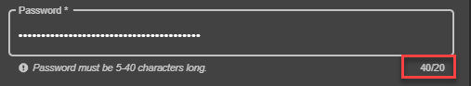

**Expected** **Result**: Label should be change to 40/40 as password field can accepts 40 characters long value.

**Title**: password is accepted with spaces

**Severity**: High

**Steps** **to** **reproduce**:

* Navigate to register page (<https://juice-shop.herokuapp.com/#/register>)
* Fill the user registration form
  + Email : “Test1@test.com”
  + Password: “ ” press space key for 5 times
  + Repeat password: “ ” press space key for 5 times
  + Security question : select any
  + Answer: asdfasdf
* Hit the register button

**Actual** **Result**: User registration successful

**Expected** **Result**: There should be an error message stating “Password cannot be empty” or there should be frontend validation which does not allow user to specify password with space

**Profile Page**

**Title**: Application crashed on upload picture without selecting any picture

**Severity**: High

**Steps** **to** **reproduce**:

* Navigate to profile page (https://juice-shop.herokuapp.com/profile) after successful login
* Hit the Upload button without selecting any file to upload

Actual Result: User redirected to this link (<https://juice-shop.herokuapp.com/profile/image/file>) with an Application error message

Expected Result: Upload button should be disabled by default and get enable on selection of file/image to upload

**Title**: Set Username should be disabled by default and gets enable on specifying the use name

**Steps** **to** **reproduce**:

* Navigate to profile page (https://juice-shop.herokuapp.com/profile) after successful login
* Hit the Set Username button without specifying the username

**Actual** **Result**: User is able to hit the set username button whether username is specified or not

**Expected** **Result**: Set Username button should be disabled by default and get enable on specifying the user name

**Title**: Application crashed on hit Link Image button

**Severity**: High

**Steps** **to** **reproduce**:

* Navigate to profile page (https://juice-shop.herokuapp.com/profile) after successful login
* Hit the Link Image button without specifying URL

**Actual** **Result**: User redirected to this link (https://juice-shop.herokuapp.com/profile/image/url) with 500 Application error message

**Expected** **Result**: Link Image button should be disabled by default and get enable on specifying the valid image URL

**Title**: File extension validation is missing on upload picture

**Severity**: Medium

**Steps** **to** **reproduce**:

* Navigate to profile page (https://juice-shop.herokuapp.com/profile) after successful login
* Click on Choose File button and select any file e.g. .pdf , .csv
* Hit the Upload button

**Actual** **Result**: User redirected to this link (<https://juice-shop.herokuapp.com/profile/image/file>) with 500 Application error message

**Expected** **Result**: There should be frontend validation which check the file extension before sending the request to server or handle it on server side without redirecting

**Add New Address Page**

**Title**: All fields accept space/empty values except mobile number

**Severity**: High

**Steps** **to** **reproduce**:

* Navigate to profile page (https://juice-shop.herokuapp.com/#/address/create) after successful login
* Specify the following fields with invalid value (space key)
  + Country
  + Name
  + Address
  + City
  + State
* Provide the valid phone number and zip code
* Hit the Submit button

**Actual** **Result**: User successfully added the address and redirected to select page (https://juice-shop.herokuapp.com/#/address/select)

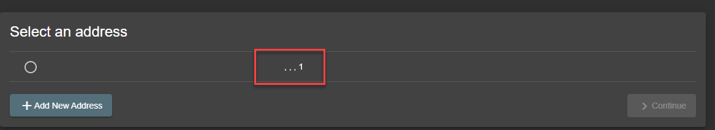

Expected Result: User should not be able to add/create address with incorrect or invalid values

**Title**: Continue button gets disable while address appeared as selected

**Severity**: Medium

**Steps** **to** **reproduce**:

* Navigate to profile page (https://juice-shop.herokuapp.com/#/address/select) after successful login and address creation (if no address is already added)
* Click on address radio button
* Observe the radio button and Continue button (radio button gets selected and continue button gets enabled)
* Now again hit the address radio button
* Observe the radio button and Continue button

**Actual** **Result**: Address radio button remain selected and continue button gets disable

**Expected** **Result**: Select Address button should be appeared as unselected on unselection

**Delivery Method**

**Title**: User is proceeding without selection of Delivery speed

**Severity**: High

**Steps** **to** **reproduce**:

* Navigate to profile page (https://juice-shop.herokuapp.com/#/search) after successful
* Add items in basket and navigate to baskets page
* Click on checkout button
* Select address (if available) or add new address and select that
* Click on continue button and user will navigate to (https://juice-shop.herokuapp.com/#/delivery-method)
* Click on any delivery speed radio button and observe the continue button
* For selected delivery speed click on the name of delivery speed (text right after the radio button)
* Observe the radio button and Continue button

**Actual** **Result**: Delivery speed radio button gets unselected and continue button remains enable

**Expected** **Result**: Continue button should be disabled if any of the delivery method is not selected and user should be able to proceed forward without selecting the delivery speed