

10/01/2022

Restaurant Management System

CSE-1222 Project Report

**Team members:**

Abdullah Al- Noman **– (**C211017)

**Team name- Alone**

**Supervisor:**

Md. Nazmul Arefin

Lecturer,

Dept. of CSE, IIUC

**Project Objective:**

* To make a suitable and secure system for restaurant to enter and store the information of Food and Customer.
* To upgrade from a paper-based system to computerized system.
* To make it easier to manage Food Menu by a manager.
* To make an user friendly digitalized system for manager and customer.
* To use e-commerce idea so that customer can order food from home.
* To lessen the risk of losing records and make it less time consuming in jotting data.
* To make it easier to calculate the bill of order.
* To implement overall idea of a complete restaurant application.

**Application:**

* The system allows only Manager to access the system.
* The system has food information. Such as, Food Name, Price, Quantity as well as Customer information.
* With this system the restaurant can store the food information as well as customer information.
* Manager can add items, edit items, delete items, add owner, edit owner and delete owner and see all food menu and see all owner from the system.
* The customer enters through signup and signup and only can access to the food menu and also order from it.
* Customer can see his profile with all of those info he/she entered and also see his total spend and available point.

**=======================**

**Welcome to Dakcil Restaurant**

**=======================**

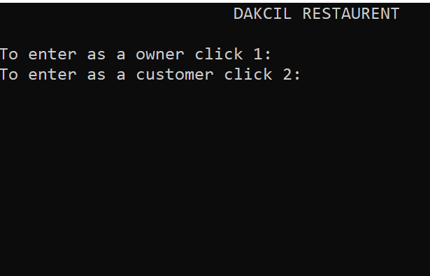

Online Restaurant management system is the system for managing the restaurant business. Welcome access the menu page with the listed according to the desired two most important part.

1. OWENER PANEL

2. CUSTOMER PANEL

**Main Menu:** 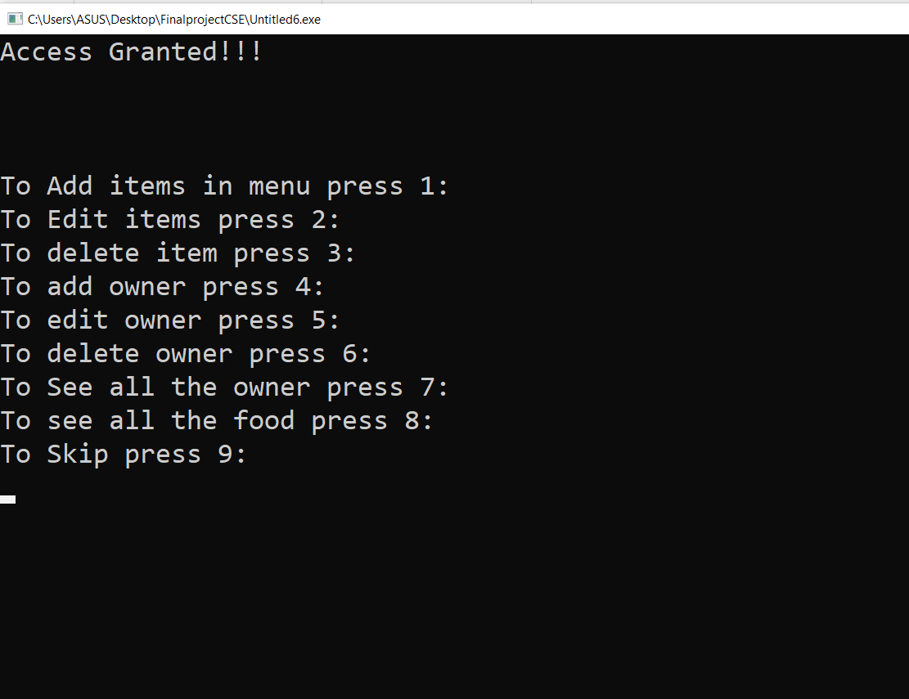

Here, the system will show a welcome screen and ask the user to give his primary command. If the user select Owner or Customer it will show Login Page. But if the user select-1 owner, it will show the info of name, id, number and if user select Exit, it will terminate the program.

**Login or Registration Owner Page:**

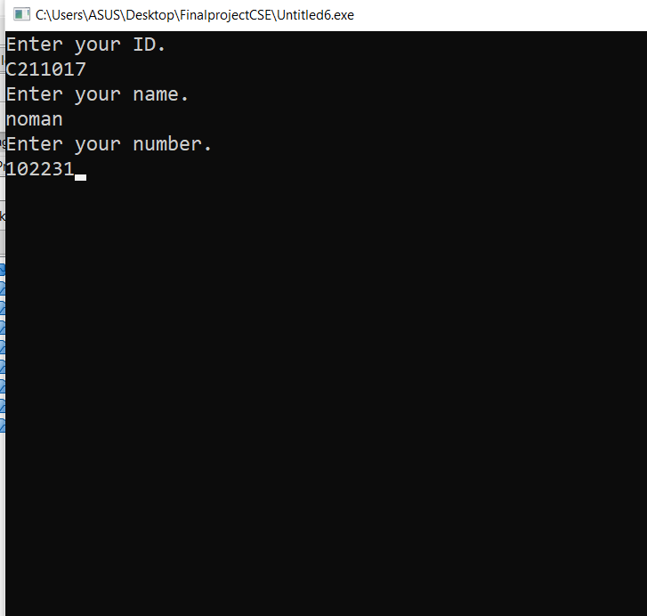Here, the system check will ask the user what he want to do. If the user select to login, it will show the login page.

**Manager Home Page:**



Here the manager can manage the food menu in different ways!

Here,

* Add Menu : Owner Add new food menu in the databse.
* Edit Menu : Manger can update available menu from here.
* Delete Menu: That will delete the old menu and help the manager to create a new one.
* Add owner: Main manager can add sub owner.
* Delete owner: Using the option, manager will be delete to sub- owner when they can close to partnership in the restaurant.
* See All Menu : Owner can see all menu from the available list.
* See All Sub owner: Main manager can see all partnership Owner.

All of the above provides clean, animated and attractive and assistive UI.

**Main owner can see all subowner:**

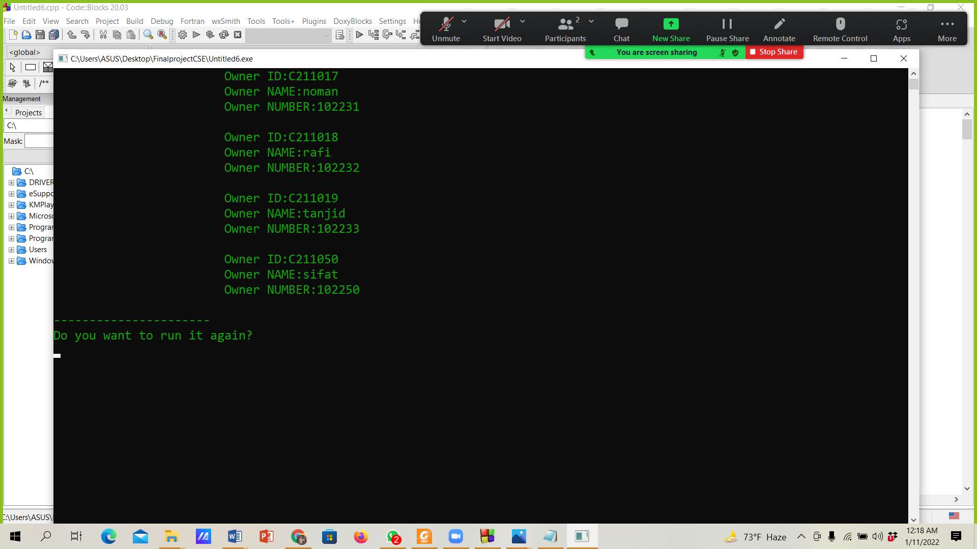

When Owner can click 7. He can see all sub-owner. Then main owner can dill all sub-owner.

**Manager Can See All food in Available:**

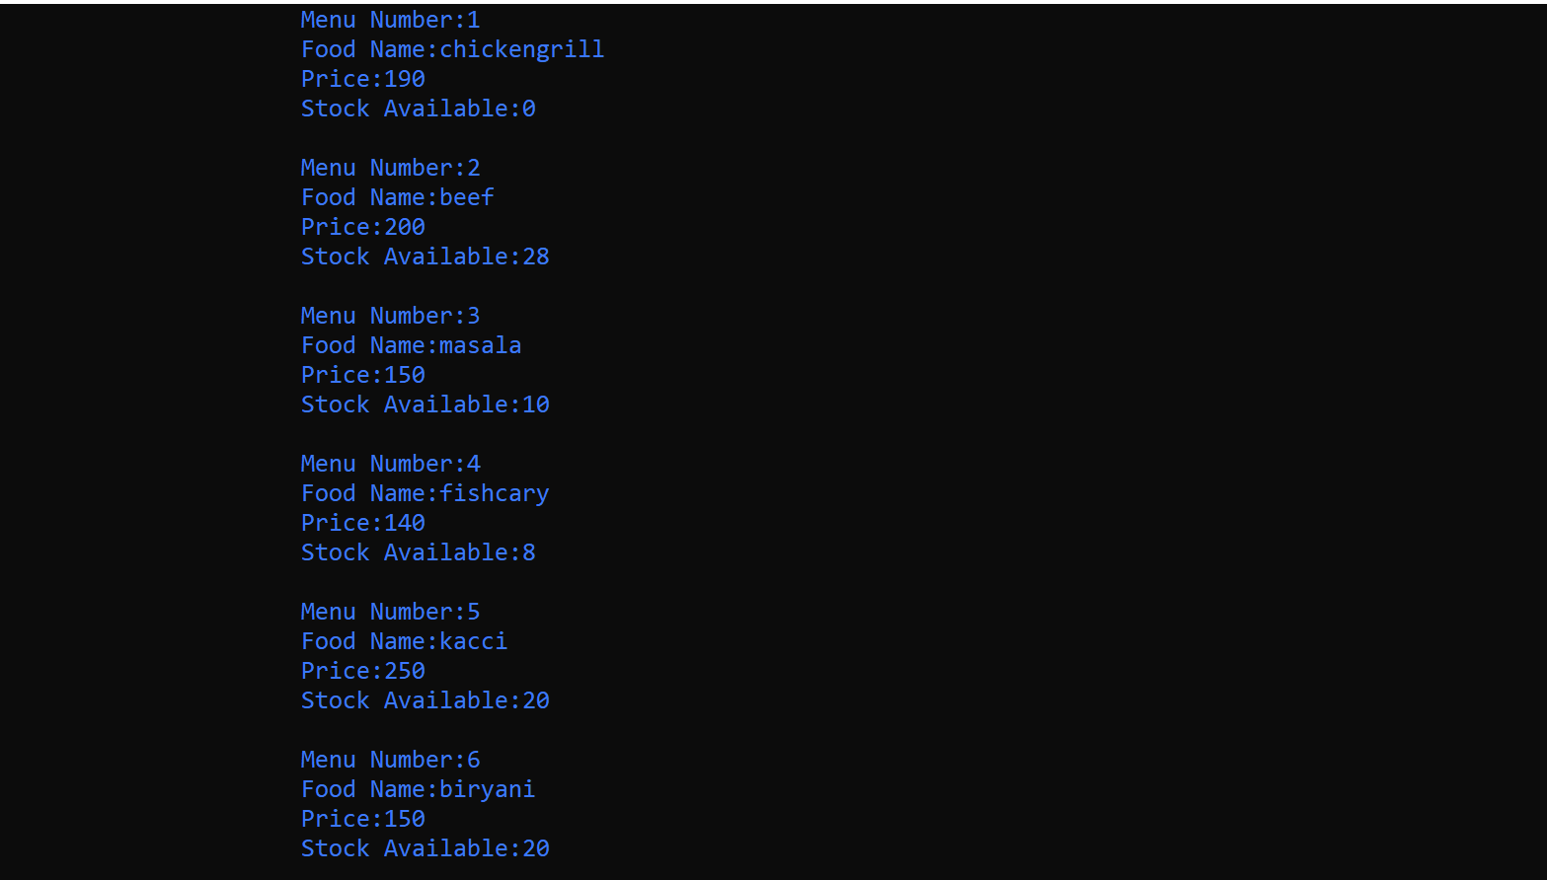

When main manager/owner can press 8. He can see all food in her page.

**Customer Login and resistration Page:**

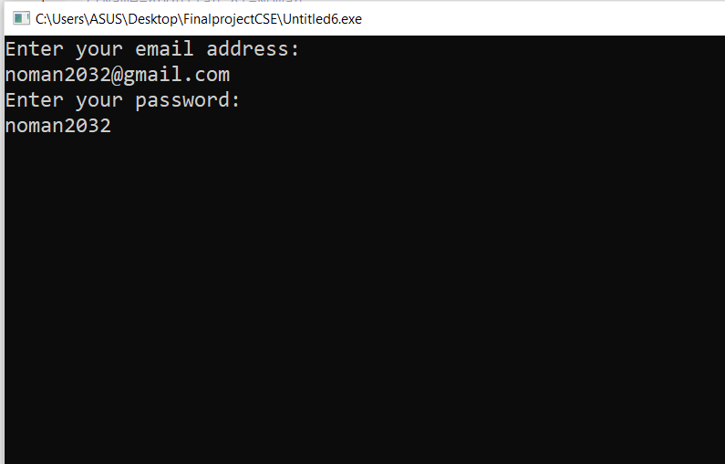

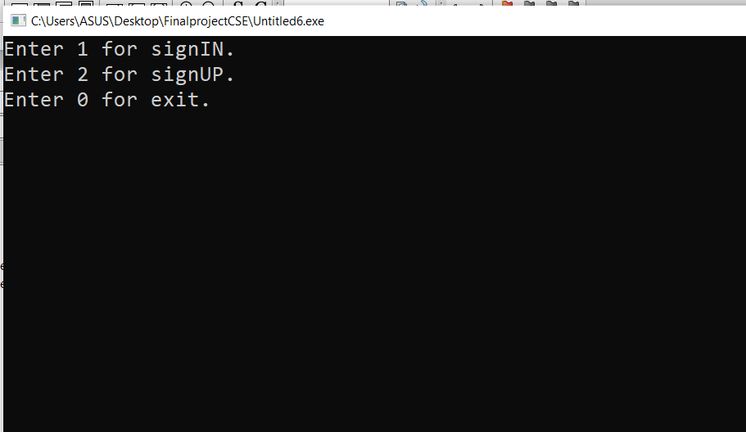

Here, the system check the user name and password is correct or not, if user name and password are not correct it will show a “Login unsuccessful. Check your User name or Password.” message . If the user name and and password is correct and then it will take user to the next page.

**Customer Home Page:**

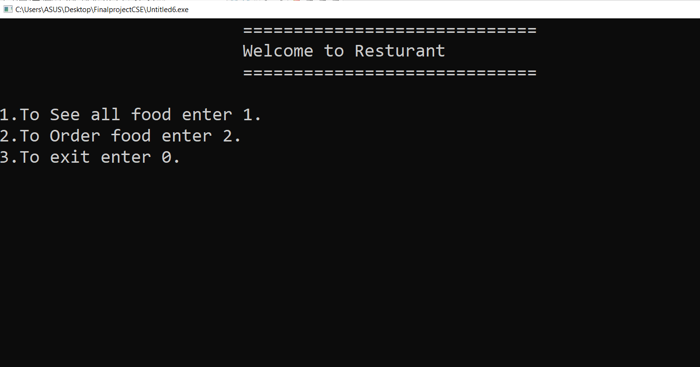

Here, the system will ask customer to enter his information. But if customer enter a user name that already available in the database that means a user already available with the same user name an then the new user will see a message that user name already exist. Please choice another User Name. an then new user must change his desired name and then he can complete the registration process. Here, The user name and password are the primary key. Customer can add additional info so that his profile become complete. Customer can see it after login to the profile.

**Customer can see food:**

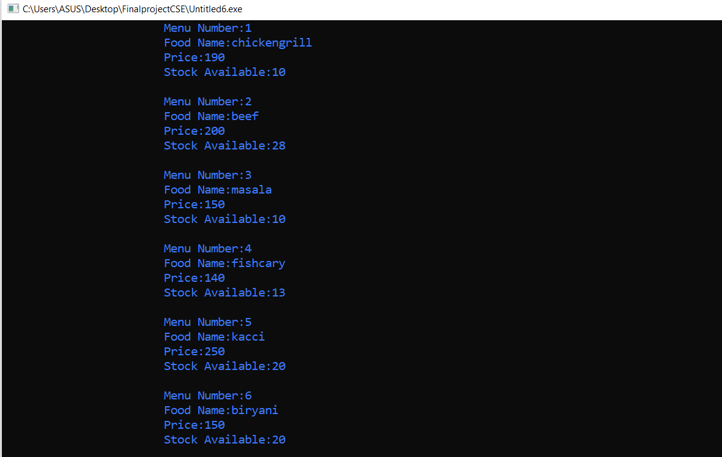

Here customer see all food and they can order food.

**Customer Can Order Food:**

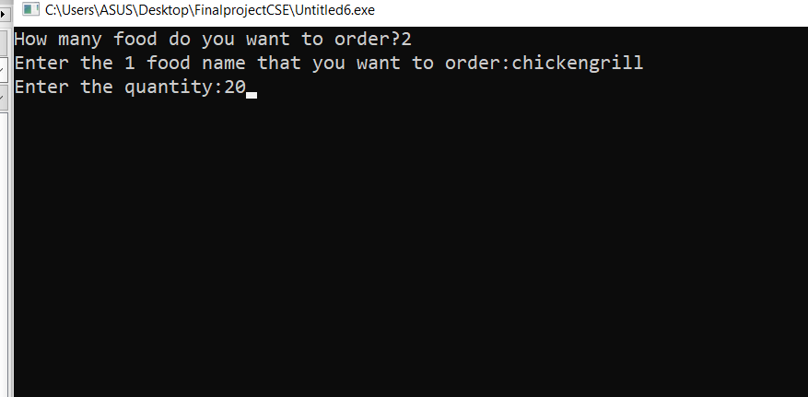

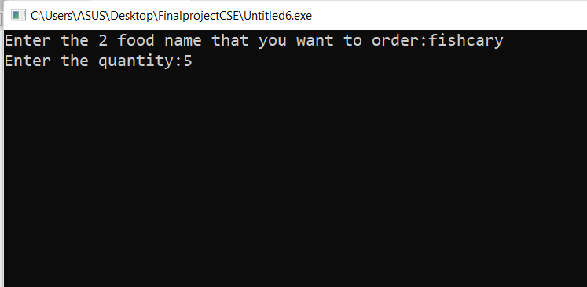

Here the customer can order food and he will get a user friendly and assistive UI. If the customer input wrong food code, it will give him second chance and so that for amount selection. If the customer select wrong amount or an amount of food that is not available on the menu, it will automatically assist him to order the correct one. And one more thing, customer can purcase multiple item at once and he can see bill for each item and left item after adding to the cart.

**Customer show bill:**

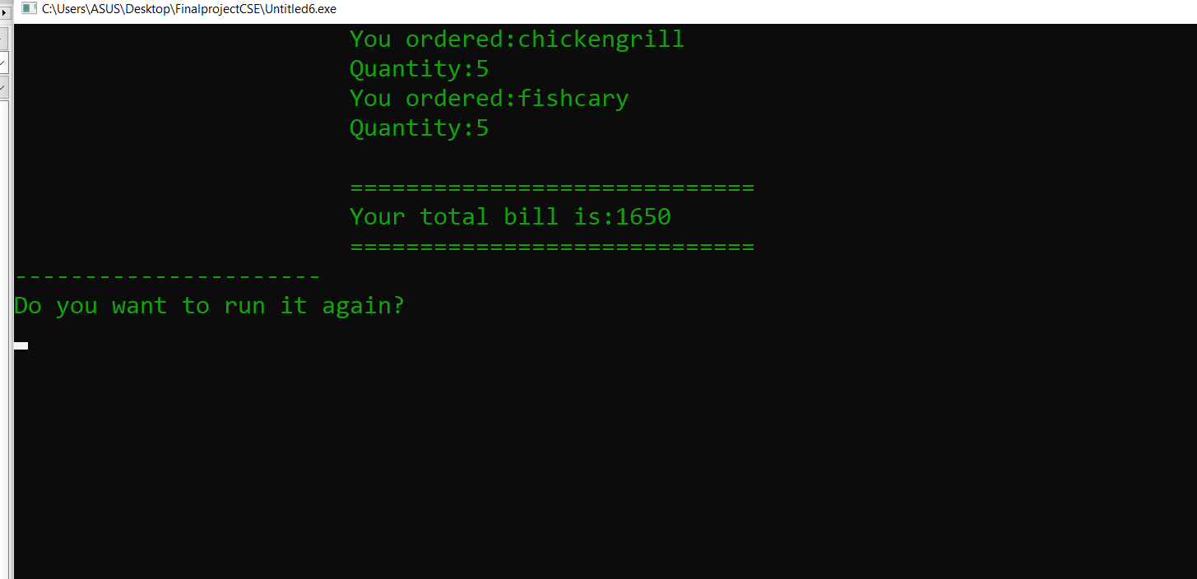

When customer order some food then he can see him select order food and shows full amount bill.

**Existing Menu Page:**

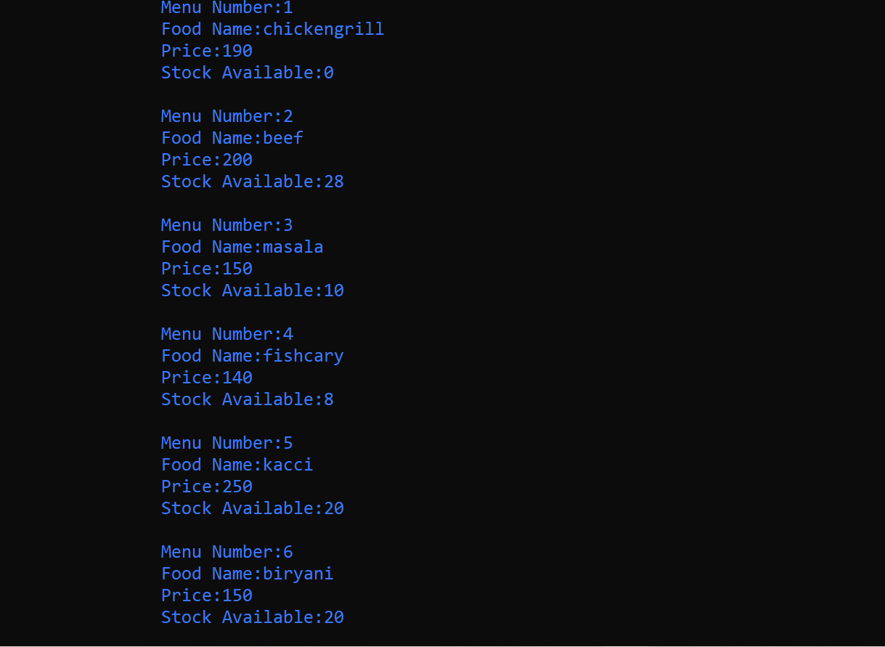

Here the manager can see available food menu in a organized and colorful ui.

Seeing the menu manager can decide what he should do next.

**New Menu Page:**

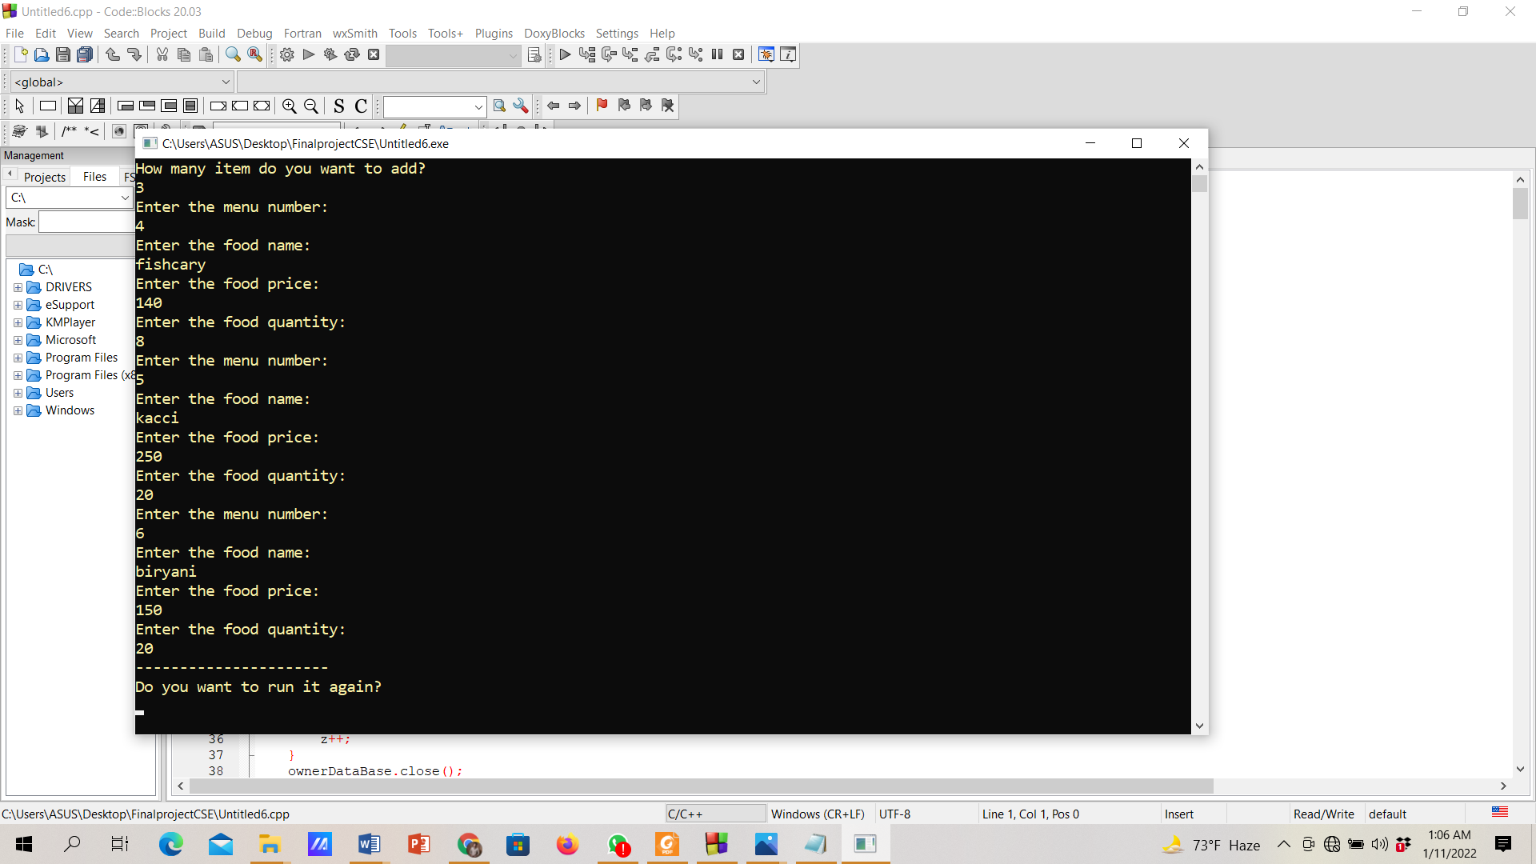

Here the manager can add a completely new food menu by deleting previous menu. When the manager press the option and complete new menu entry, the old menu will be replaced by the new one.

Successful operation will show a “Added Successfully” message.

**Update Add Menu Page:**

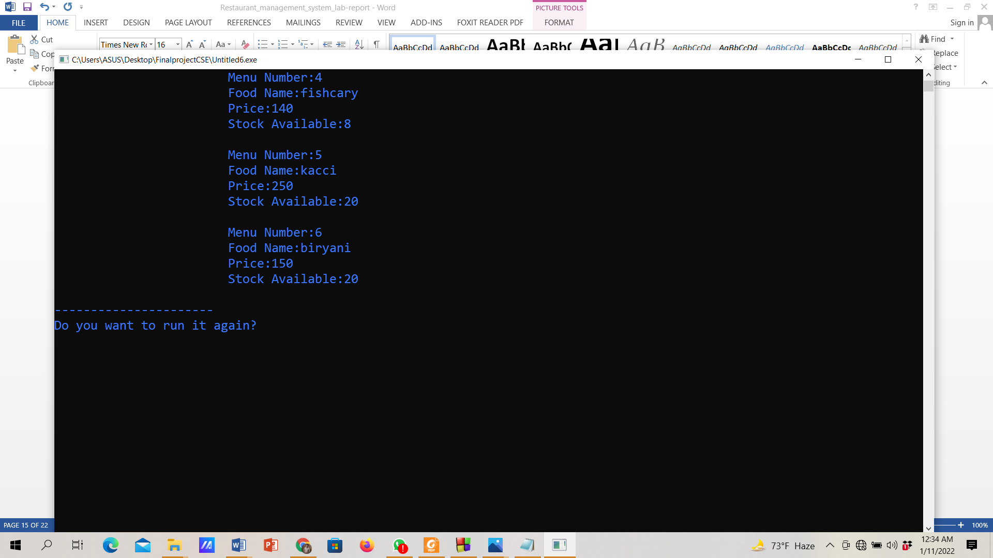

Here the manager can see available food menu in a organized and colorful ui.  
Seeing the menu manager can decide which item he should update.  
Which will make his work much easier and friendly.

Successful operation will show a “Updated Successfully” message.

**Delete Menu Page:**

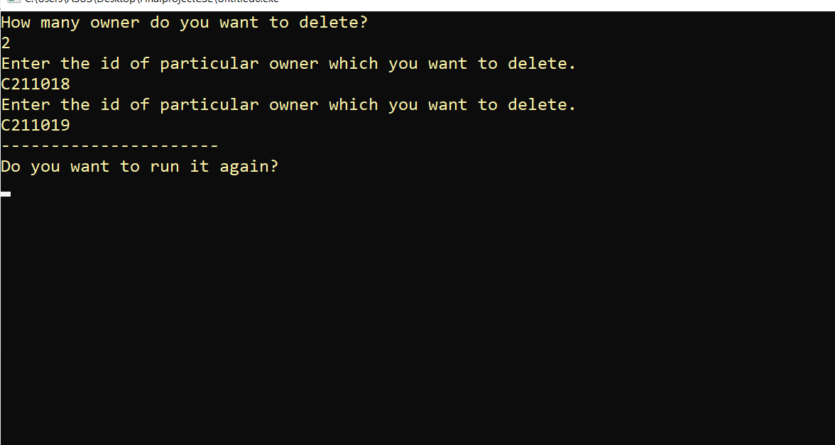

Here the manager can delete any item he want. All items will be shown in a nice and organized ui, so that manager can easily find the item he wants to delete. Wrong command will give warning and then he must submit the new one. Successful operation will show a “Deleted Successfully” message.

**New Customer Profile page**

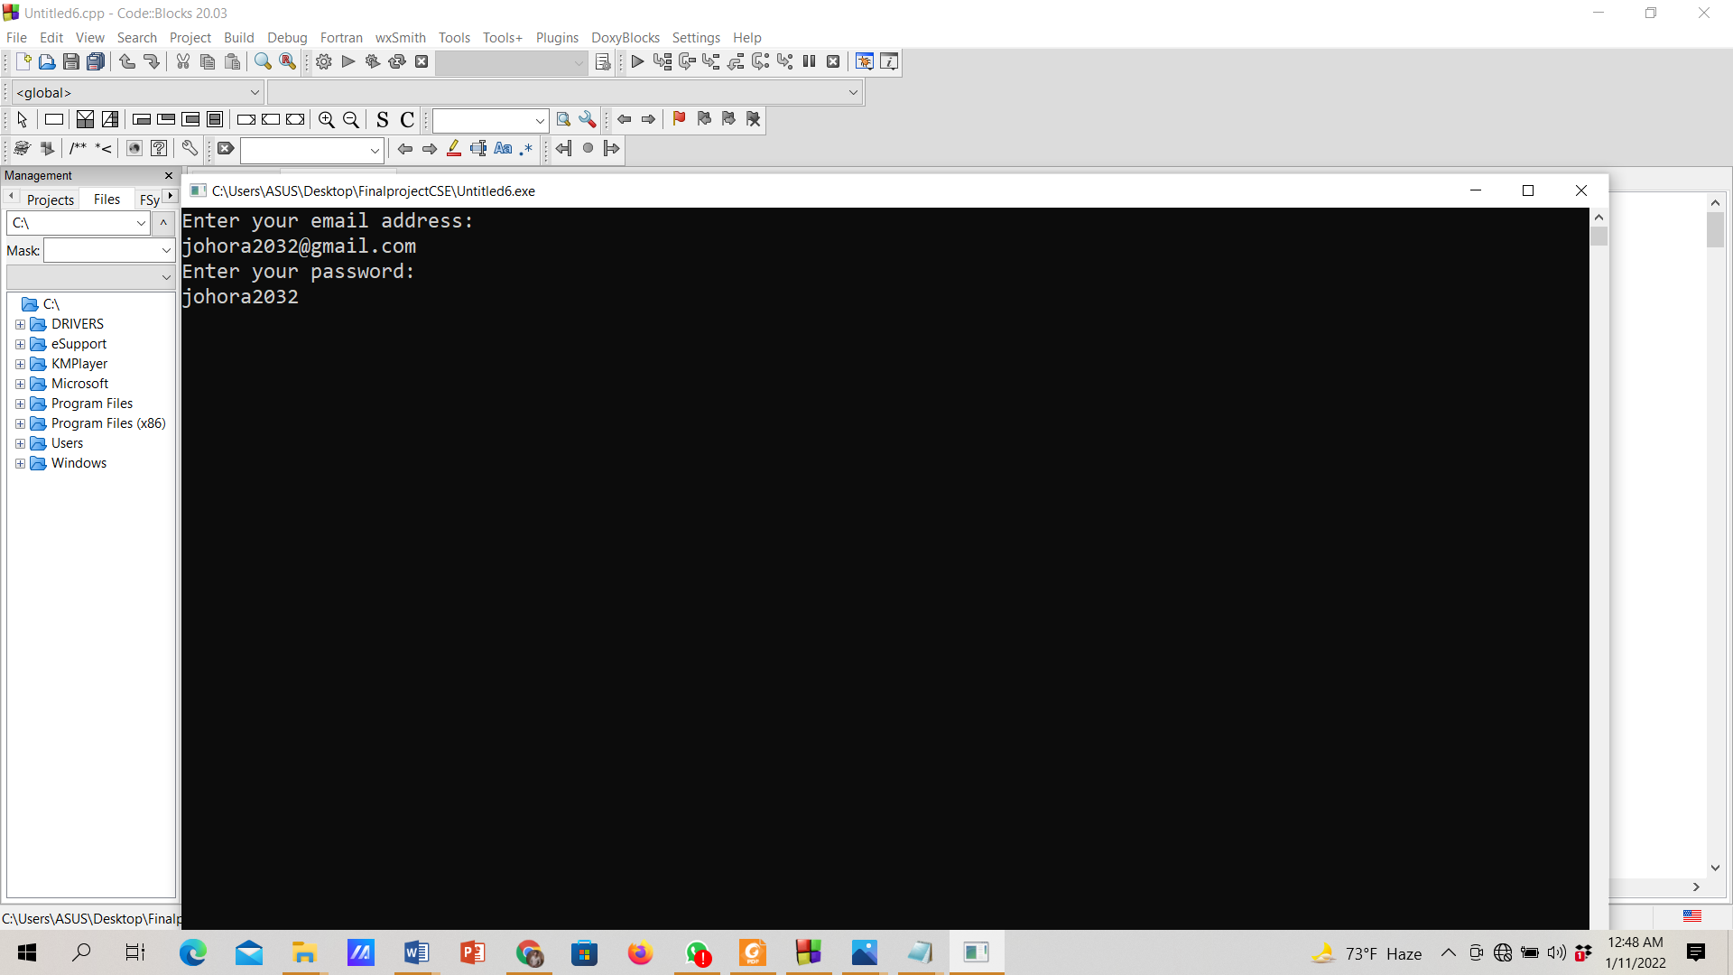

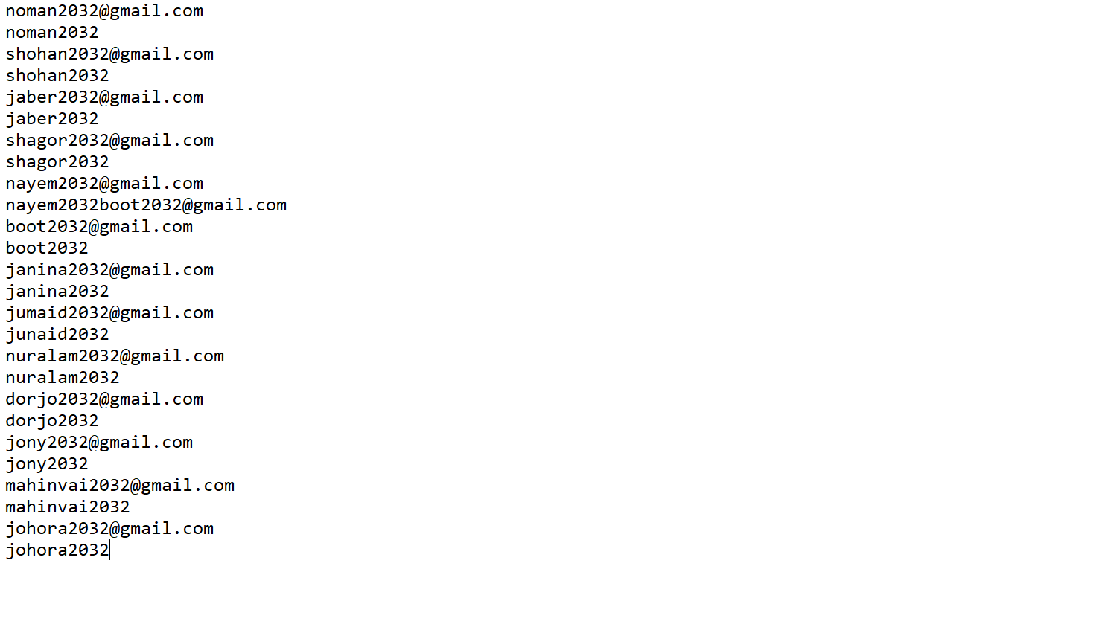

Here customer can see the details he/she entered the of registration. He/she also can see the total spend and available point. When the customer order something, the value of spend and point will change based on total bill. Here customer see a note on how point is calculated and how to use it.

**Owner Can record all customer bill:**

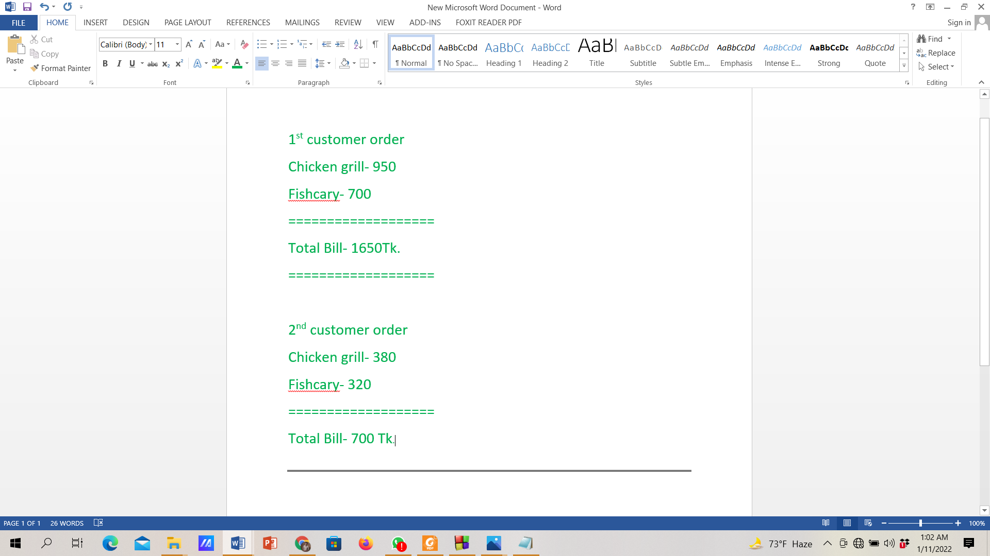

## ****Future Plan****

* **We will add more features to improve our project.**
* **There will be email verification system.**
* **We will add SSL security system.**
* **New product update newsletter will be added.**
* **SMS alert system is easier for the customer.**
* **We will also work on online payment gateway integration.**
* **Additionally, it is just beginning. Supplementary the system may be used in various other types of reviewing process.**

**Conclusion:**

The project is for the restaurant to store the food information and customer information. The main purpose of the project is to create a virtual environment for manager and customer so they can operate/order from the restaurant staying home. This is a console based project, where C++ programming language and Object Oriented Programming serves as the backbone to the project. The user interface is enough friendly that one can easily understand the how it work. This project can help the restaurant to work in online/digital system and it will help the restaurant to control and manage food menu and serve it to customer. It also help the customer to order food without going to the restaurant, which is a very good system for pandemic situation. To conclude, this project will help a restaurant to store the information of food and customer in the database. There should be more feature in it but I think it has enough feature right now. It can deal with the major customer interaction. We have that intention to add more feature in this software…