Design Chosen

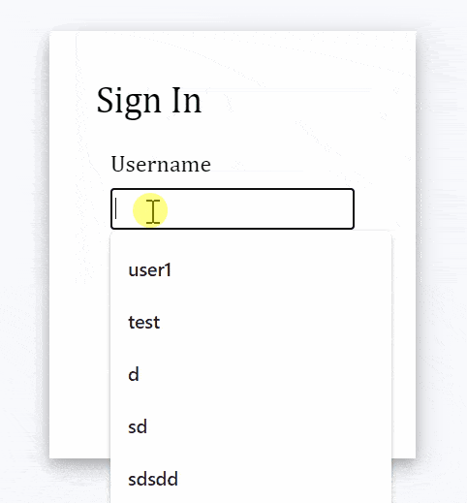

CODE

import React, { useState } from "react";

import ReactDOM from "react-dom";

export default function App() {

const renderForm = (

<div className="form">

<form onSubmit={handleSubmit}>

<div className="input-container">

<label>Username </label>

<input type="text" name="uname" required />

{renderErrorMessage("uname")}

</div>

<div className="input-container">

<label>Password </label>

<input type="password" name="pass" required />

{renderErrorMessage("pass")}

</div>

<div className="button-container">

<input type="submit" />

</div>

</form>

</div>

);

return (

<div className="app">

<div className="login-form">

<div className="title">Sign In</div>

{isSubmitted ? <div>User is successfully logged in</div> : renderForm}

</div>

</div>

);

}

//css code

.app {

font-family: sans-serif;

display: flex;

align-items: center;

justify-content: center;

flex-direction: column;

gap: 20px;

height: 100vh;

font-family: Cambria, Cochin, Georgia, Times, "Times New Roman", serif;

background-color: #f8f9fd;

}

input[type="text"],

input[type="password"] {

height: 25px;

border: 1px solid rgba(0, 0, 0, 0.2);

}

input[type="submit"] {

margin-top: 10px;

cursor: pointer;

font-size: 15px;

background: #01d28e;

border: 1px solid #01d28e;

color: #fff;

padding: 10px 20px;

}

input[type="submit"]:hover {

background: #6cf0c2;

}

.button-container {

display: flex;

justify-content: center;

}

.login-form {

background-color: white;

padding: 2rem;

box-shadow: 0 4px 8px 0 rgba(0, 0, 0, 0.2), 0 6px 20px 0 rgba(0, 0, 0, 0.19);

}

.list-container {

display: flex;

}

.error {

color: red;

font-size: 12px;

}

.title {

font-size: 25px;

margin-bottom: 20px;

}

.input-container {

display: flex;

flex-direction: column;

gap: 8px;

margin: 10px;

}

export default App;

Results

(1)

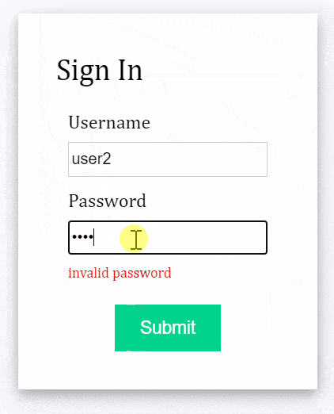

(2)

(3)

