1 Introduction and Overview

1.1 Background and Purpose
SonicSentinel AI helps users review sounds that may need attention, such as machinery faults, breaking glass, alarms and calls for help. Users can upload a recording or start microphone monitoring, then inspect the predicted event and its confidence. The current application runs a trained Python model. Independent Google Teachable Machine integration is still pending.

1.2 Proposed Solution

The application is designed to compare two independently trained models:
- Python model: a frozen YAMNet audio CNN with a trained SVM classifier.
- Google Teachable Machine audio model: training was in progress at the last review; its export is not yet installed.
The app checks audio quality, displays predictions and applies configurable alert rules. When GTM is unavailable, its result is shown as missing and the event is sent for review. Critical alerts require model agreement under the default settings, so the complete dual-model alert workflow is not yet ready for delivery.

The ten supported sound classes are:
- Machinery Fault
- Glass Breaking
- Alarm or Siren
- Vehicle Horn
- Animal Sound
- Gunshot
- Panic Scream
- Aggression or Violent Conflict
- Person Asking for Help
- Background Noise

1.3 Purpose of This Document
This document explains how SonicSentinel AI is currently built and used. It covers audio processing, the trained model, storage, alert rules, installation and testing. It also identifies work that remains before the system meets the full project requirements.

1.4 Project Scope
- Audio input: users can upload audio files or allow the browser to capture short microphone windows.
- Model comparison: the app stores separate Python and GTM results and compares them when both are available.
- Visual analysis: waveform and spectrogram images help users inspect each recording alongside audio playback.
- Alerts and review: confidence, quality, model agreement and repeated detections determine whether an event needs an alert or review.
- History and reports: users can search events and download HTML analysis reports. Administrators can export records as CSV.

1.5 Assumptions and Constraints
Input limits: files must contain mono or stereo audio, use a sample rate of at least 8 kHz, last between 0.2 and 30 seconds, and fit within the 25 MiB per-file limit.
Timing targets: the SRS allows eight seconds for an upload of up to 30 seconds and three seconds for a live window. Model loading adds startup time.
Microphone access requires browser permission and localhost or HTTPS. The app is a controlled-test prototype and does not replace emergency services.

2 Requirements and Current Behaviour

2.1 Functional Requirements
The current implementation provides the following functions. GTM-dependent behaviour remains subject to integration testing.
- FR-01 User accounts: registration and login support ordinary users, operators, reviewers, maintenance staff and administrators. Public registration creates ordinary users only.
- FR-02 Audio input: single and batch uploads accept WAV, MP3, FLAC, OGG and M4A. Microphone monitoring sends short WAV recordings to the server.
- FR-03 Validation: the app checks file format, size, duration and signal usability. It converts audio to mono, trims silence, normalizes amplitude and assesses clipping and signal strength.
- FR-04 Features: the classical extractor returns 260 values from 64 mel bands, 20 MFCCs, their derivatives and spectral statistics. The active model also uses YAMNet embeddings.
- FR-05 Model comparison: separate inference functions provide class scores and agreement information. The Python model is available; the GTM export and its input preprocessing still need validation.
- FR-06 Visual analysis: the app generates waveform and spectrogram images for a recording and makes them available with its analysis.
- FR-07 Alert rules: configurable confidence, top-two margin, audio quality, agreement and repeated-window checks control alerts for critical categories.
- FR-08 Manual review: unavailable models, disagreements, low confidence, a small top-two margin, poor quality or suspected overlap send an event for review.
- FR-09 Records and reports: event history, dashboard summaries, audit records, HTML analysis downloads and administrator CSV exports support follow-up work.

2.2 Non Functional Requirements
- Performance: local warm tests took 0.906 seconds for a 30-second upload and 0.107 seconds for a live request. These results meet the SRS timing targets on the tested host; cold loading and other hardware may differ.
- Accuracy: the Python benchmark reached 86.62% accuracy and 0.8596 macro-F1. Recall exceeded 85% for gunshot, glass breaking, panic scream, aggression and help requests. GTM accuracy has not yet been measured.
- Security and scale: the app uses Werkzeug password hashing, signed Flask sessions, CSRF checks and role-based access. A 20,000-record dashboard check passed; concurrent-user capacity and 99% uptime remain unverified.

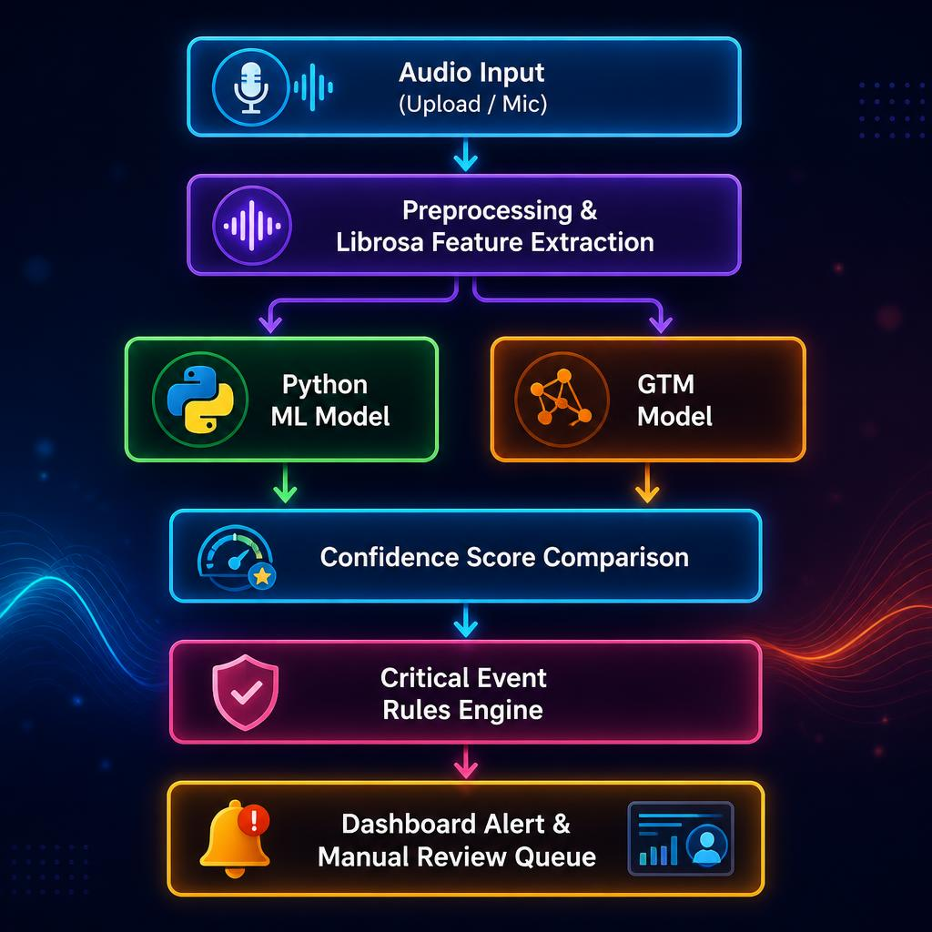

3 Audio Feature Pipeline
Uploaded files and live windows use the same server-side audio processing functions.
- Capture: uploaded files arrive through HTTP forms. The browser uses getUserMedia and the Web Audio API, then posts a WAV window about every three seconds.
- Preparation: Librosa loads audio as mono at 22,050 Hz, checks the signal, trims silence and normalizes its amplitude. YAMNet separately resamples its input to 16,000 Hz.
- Segmentation: audio is divided into non-overlapping three-second windows. A short final window is padded with zeros.
- Feature extraction combines the following information:
  - Mean and standard deviation of 20 MFCCs and their first and second derivatives.
  - Statistics from 64 log-mel bands, plus spectral centroid, bandwidth, roll-off and flatness.
  - Zero-crossing rate and RMS energy, together with pooled YAMNet embedding means and standard deviations for the active classifier.

4 Dataset and Augmentation

4.1 Dataset Structure
The transfer experiment contains 2,999 unique original recordings across ten classes. This is one recording below the SRS minimum of 3,000. Per-class counts and source permissions must also be checked before submission.
The deterministic split keeps each source recording and its segments in one partition:
- Training: 2,099 original recordings, producing 2,167 usable segments.
- Validation: 450 original recordings, producing 477 usable segments.
- Testing: 450 original recordings, producing 471 usable segments.

4.2 Augmentation
The classical preparation script creates time-shifted, noise-added and volume-adjusted copies of training audio. These do not count as new originals. The saved YAMNet transfer experiment used original segments without augmentation. Silent or unreadable material is excluded and logged.

5 Critical Event Rules
Gunshot, panic scream and person asking for help have Critical severity. Machinery fault, glass breaking, alarm or siren, and aggression have High severity.
The shared defaults require Python confidence of at least 65%, a top-two margin of at least 0.12, and Good or Acceptable audio quality without suspected overlap.
A critical category needs two consecutive eligible detections and agreement between both models before an alert is generated. An ineligible window resets the confirmation count.
Missing models, disagreement or uncertain results require manual review. Confidence difference is the absolute difference between the models' top scores; there is no separate 25% disagreement threshold in the current rules.

6 Setup and Execution

6.1 Requirements
- The saved model was tested with Python 3.13.9, TensorFlow 2.20.0, scikit-learn 1.7.2, NumPy 2.3.5 and joblib 1.5.2.
- Install requirements-trained-model.txt for the recorded model dependencies. The imageio-ffmpeg package provides the executable used to decode M4A.

6.2 Quick Setup on Windows
Run these commands from the repository root:
python -m venv .venv
.venv\Scripts\python.exe -m pip install -r requirements-trained-model.txt
.venv\Scripts\python.exe -m flask --app app create-user --role admin
.venv\Scripts\python.exe app.py
Follow the account prompts, then open http://127.0.0.1:5000 after model loading finishes. The database initializes automatically.
The existing system diagrams are shown below.
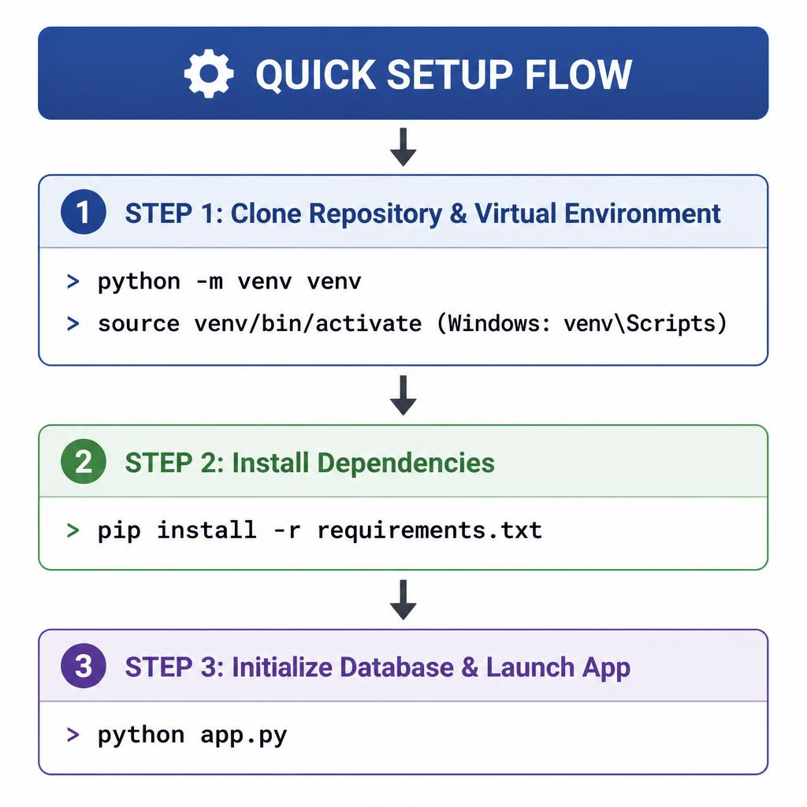

7 System Design and Database
- Storage: the application uses SQLite with foreign keys and write-ahead logging. The default database is data/sonic_sentinel.db; SONIC_DATABASE_PATH can select another location.
- Schema: users stores account and role details; audio_files stores recording metadata and hashes; detections stores segment predictions, scores, model versions, alerts and reviews; audit_log records user actions. Integer IDs link records, scores are stored as JSON text, and timestamps use UTC.

8 System Diagrams
- Data flow: audio moves through validation, preprocessing, feature extraction, prediction, rule evaluation and storage before the result is displayed.
- User access: ordinary users can access their own recordings. Trusted roles have wider access, with review, acknowledgement and administration restricted by role.
- Processing sequence: the server handles uploads or posted microphone windows, stores segment results and returns an analysis page or live response.
- Decision flow: the rules combine confidence, top-two margin, quality, agreement and consecutive eligible detections. A missing GTM result currently leads to review.

9 Model Design
Python model: a frozen YAMNet CNN produces audio embeddings. Their pooled statistics are combined with mel and MFCC features, standardized, and passed to an RBF SVM. The app loads yamnet_transfer.joblib through selection.json.
GTM model: the design calls for a separately trained audio model using the same training recordings. The current adapter expects model.keras and labels.json, but the actual export and preprocessing must be validated. Python predictions are not passed into GTM.

10 Model Training
- Python training: the classical pipeline compares Random Forest, Extra Trees, Gradient Boosting and scaled SVM candidates. The transfer experiment compares nine classifier candidates with frozen YAMNet features. Validation macro-F1 selects the winner before test evaluation.
- GTM training: prepare samples from the same training originals, preserve the class labels and keep validation and test recordings separate. Training was reported as in progress; the export, configuration and independent evaluation evidence remain pending.

11 Model Evaluation
Evaluation: the saved reports include accuracy, precision, recall, F1, macro-F1 and confusion matrices. Python test accuracy is 86.62% across 471 segments. This is an inspected project benchmark, not proof of performance on new devices or environments.
Noise check: a small diagnostic probe correctly classified 4 of 10 samples at 20 dB SNR and 1 of 10 at 10 dB SNR. Noise robustness needs improvement and a larger independent evaluation.
Error analysis: background noise had the lowest class recall at 62.22%. One real-route aggression sample was classified as panic scream. Full false-alert and missed-event analysis, including the required 100-recording dual-model comparison, remains to be completed.

12 Testing Strategy
Verification on 28 September 2026: 31 automated tests passed. Real-model route checks covered all ten classes, playback and analysis, warm upload and live timing, and a 20,000-record dashboard. Mocked predictions test alert logic only. Physical microphone capture and genuine GTM integration still need testing.

13 Security and Privacy
- Security: Werkzeug hashes passwords; signed Flask sessions identify users. POST requests require CSRF tokens, and recordings and actions have access checks. HTTPS must be configured for deployment; SONIC_HTTPS=1 enables secure session cookies.
- Privacy: microphone capture starts only after the user presses Start monitoring and grants permission. Stop releases the device. Administrators can configure retention and explicitly confirm cleanup. Recordings should be collected and shared only with appropriate permission.

14 Limitations and Future Work
- Current limits include the missing GTM export, weak noise robustness, possible confusion between similar or overlapping sounds, and no sound-source location tracking. Physical-device, concurrency and uptime checks remain open.
- Next steps are to integrate and evaluate GTM, close the dataset shortfall, improve noise validation, and finish the required comparison report and demonstration evidence. Multi-microphone location tracking could be explored later.
15 Installation Reference
- Prerequisites: install a compatible Python runtime and the project dependencies. Keep the selected classifier and the YAMNet base model available locally.
- Operating system: local verification was performed on Windows. Linux and macOS require their own dependency, audio and browser checks.
- Python version: use Python 3.13.9 to match the saved-model training environment. Do not assume the saved artifacts work with every older Python release.
- Virtual environment: run python -m venv .venv and use its Python executable for installation, setup and tests.
- Dependencies: run python -m pip install -r requirements-trained-model.txt inside the virtual environment to install the recorded model versions.
- Python model files: keep python_models/yamnet_transfer.joblib, selection.json and the complete yamnet_base/ folder together. The CNN base is excluded from Git, so a repository clone alone is insufficient.
- GTM files: the current adapter looks for gtm_model/model.keras and labels.json. Check the export format, label order and input signature before integration; renaming a different model format will not work.
- Environment: optional settings include SONIC_SECRET_KEY, SONIC_HTTPS, SONIC_DATABASE_PATH, SONIC_UPLOAD_DIR, SONIC_RUNTIME_DIR and SONIC_RULES_PATH. Set them in the process environment; the app does not explicitly load a .env file.
- Folders: data/, uploads/ and instance/ must be writable. Keep runtime storage private. The local model snapshot ZIP and its SHA-256 manifest are under deliverables/model_snapshot_20260927/.
- Launch: run python app.py. It warms the Python model before serving requests on localhost port 5000.
- Tests: run python -m pytest -q. For real-model route checks, run python scripts/verify_delivery.py with the local training manifest, source audio and CNN base available.
- Administrator: run python -m flask --app app create-user --role admin and enter the prompted account details. There is no default administrator password.
- Troubleshooting: check dependency versions and model paths first. For microphone access, use localhost or HTTPS and allow browser permission. For M4A errors, check imageio-ffmpeg and recording validity.
16 Using the Application
Getting started: complete installation and wait for the model to load. The installation guide in documentation/INSTALLATION.md provides the full local setup steps.
Accounts: register an ordinary account or sign in with a trusted account provisioned by the administrator.
Uploads: open the upload page and choose up to ten supported audio files. Each file must meet the duration, size and signal checks.
Playback: open a recording's analysis and use its audio player to listen to the stored recording.
Live monitoring: open the microphone page, select Start monitoring and allow access. Watch the status and results, then press Stop to release the microphone.
Metadata: inspect the recording duration, sample rate, channel count and other stored details on its analysis page.
Waveform: use the amplitude image to inspect changes in the recording over time.
Spectrogram: use the frequency image alongside playback and the waveform when reviewing an event.
Python result: inspect the predicted class and the ten class scores from the active YAMNet and SVM model.
GTM result: this will be available after the independent export is integrated. Until then, the app shows an unavailable result and requires review.
Confidence: class scores express the model's estimated probabilities. A high score does not guarantee a correct prediction; check quality and the margin between the leading classes.
Comparison: when both models are available, compare their labels, top confidence difference and agreement status. The missing GTM result must not be treated as agreement.
Quality: review the Good, Acceptable, Poor or Unusable assessment and its signal measurements. Authorized reviewers can add decisions and comments; administrators can export CSV records.
Alerts and reports: authorized roles can acknowledge alerts. Review event history, inspect flagged recordings and download HTML analysis reports. The current app does not generate a native PDF report.

