Department of Computer Science

BS-CS FINAL YEAR PROGRESS REPORT

Optimized Waste Collection and Management Using AI



Presented by:
Registration No: | Name:
22-cs-037 | Bibi Amna
22-cs-068 | Laiba Husna
22-cs-101 | Sajal Batool

HITEC UNIVERSITY
Heavy Industries Taxila Education City, Taxila Cantt, Pakistan

Project Title
Optimized Waste Collection and Management using AI

Project Advisor

Muhammad Hassnain
Particulars of the students:

Sr.No | Registration# | Name in Full  Use Block Letters | CGPA | Signatures
1 | 22-cs-037 | Bibi Amna | 3.45
2 | 22-cs-068 | Laiba Husna | 3.76
3 | 22-cs-101 | Sajal Batool | 3.64
Advisor’s Consent
I Mr.Muhammad Hasnain_am willing to guide these students in all phases of the above-mentioned project/thesis as advisor. I have carefully seen the Title and description of the project/thesis and believe that it is of an appropriate difficulty level for the number of students named above.
Note:  Advisor can’t be changed without prior permission of the project In-charge, and the duration for completion of the Research Project / Thesis is 10 months (approx.) from the date of Registration of the Research Project/Thesis. | Signatures and Date  Advisor

Co-Advisor
I have carefully read the project proposal and feel that the proposed project is a useful one and of a sufficient difficulty level to justify a one-year work load of above mentioned students.
Recommended |  | Signatures and Date
Yes |  | No

Dedication
Our final year project is dedicated to our parents all teachers and friends whose motivation made this work possible. we particularly appreciate the guidance and patience of [ADD PROJECT SUPERVISOR NAME] whose feedback helped us to shape the direction of the project from the initial idea to the final execution.
ACKNOWLEDGEMENT
We are thankful to Allah Almighty for giving us the ability to complete this final year project. We are truly thankful to our supervisor [Sir Muhammad Hasnain] for valuable guidance timely suggestions and steady support throughout the work. We grateful the encouragement of our teachers classmates and family members who helped us stay focused during the planning implementation testing and documentation stages.
This project became possible through a combination of technical learning patience and repeated revision. We especially appreciate every person who reviewed the idea discussed design decisions or helped us understand the practical direction of the system.

Abstract
Smart Waste Management System is an AI enabled web application developed to support day to day waste monitoring and operational coordination in a structured and traceable way. The project combines a browser based management dashboard with SQLite backed data storage role based access control and a waste level validation workflow that compares image based AI predictions with ultrasonic sensor readings. Instead of treating reporting task assignment alert handling and validation as separate activities the system brings them together in one interface for administrators city heads and field staff.
The application allows authorized users to manage bins assign work review alerts update profiles and generate filtered reports for users bins tasks and validation runs. A trained image classification model predicts whether a dustbin is at low medium or high fill level. During validation the predicted AI level is stored together with sensor distance calculated fill percentage sensor derived level confidence score and match result. This makes the system useful not only for daily operations but also for audit review and future model improvement.
The trained model uses transfer learning on MobileNetV2 with image augmentation global average pooling batch normalization dropout and a three class softmax output layer. Based on the available project summary the saved model achieved a final test accuracy of 86.16% on the waste level data set. The project is therefore positioned as a practical Smart City support tool rather than a purely academic prototype. It shows how a lightweight web platform a local database and an AI validation pipeline can work together to improve field visibility reduce manual guesswork and create more reliable waste management records.

Table of contents
Chapter 1 i
Introduction i
Background i
Problem Statement i
Project Overview i
Objectives ii
Significance ii
Project Scope ii
Data Security and Integrity iii
Technical Innovation iii
Chapter 2 iv
Existing System and Background Review iv
Conventional Waste Monitoring iv
Sensor Based Monitoring Approaches iv
Image Based Waste Level Detection iv
Gap in Existing Approaches iv
Summary v
Chapter 3 vi
Software Requirements Specifications vi
Purpose vi
Scope vi
Proposed Solution Overview vi
Modules of the Proposed Solution vi
Users and Roles vii
Proposed System Output vii
Main Features of Proposed Solution vii
Functional Requirements vii
Non Functional Requirements viii
Product Functions viii
General Requirements ix
Advantages ix
Chapter 4 x
System Design and Analysis x
System Design and Analysis x
Database Description x
Dataset Overview x
Preprocessing and Augmentation x
Use Cases xi
System Workflow xi
System Diagrams xi
Waste Level Model Architecture xii
Sensor Integration Design xii
Chapter 5 xiii
Implementation xiii
Implementation Overview xiii
Project Deliverables xiii
Backend Implementation xiii
Frontend Implementation xiii
Database Implementation xiv
AI Validation Implementation xiv
Reporting and Export xiv
Chapter 6 xix
Results of Project xix
Results xix
Web Application xix
AI Model Performance xix
Model Performance Summary xx
Operational Output xx
Appendices xxiii
Appendix A: Database Table Summary xxiii
Appendix B: Major API Endpoints xxiii

References xxii

Chapter 1

Introduction

Background

Waste management has become one of the most critical challenges faced by modern urban environments. As cities continue to grow rapidly the volume of waste produced daily has increased significantly. This rise in waste generation has put pressure on traditional waste management systems which were originally designed for smaller populations and simpler operational conditions.
In many regions waste collection and monitoring still rely heavily on manual processes. Workers are responsible for physically checking the status of waste bins reporting their condition and updating records. These updates are often communicated verbally or written in logbooks. While such methods may function in small scale environments they become inefficient and unreliable when applied to larger urban systems.
One major issue with manual systems is the delay in information flow. By the time a bin is reported as full it may already have overflowed. This not only creates environmental and hygiene problems but also negatively impacts public perception. Additionally inconsistencies in reporting can occur because different workers may interpret bin conditions differently.
To address these issues modern approaches have. Introduced the use of sensors and digital systems. Sensor based solutions can measure the fill level of bins using technologies such as ultrasonic sensors. These systems provide quicker updates compared to manual methods. However they are not always. Reliable due to environmental factors hardware limitations or incorrect calibration.
On the other hand image based systems use artificial intelligence to analyze pictures of waste bins and determine their fill level. These systems provide visual evidence and can detect patterns that sensors may miss. However they are also affected by lighting conditions camera quality and angle variations.
Because of these limitations there.is a growing need for a system that combines multiple approaches instead of relying.on a single method. A hybrid system that integrates management features sensor data and AI based validation can.provide more accurate and reliable results.
The Smart Waste Management System developed in this project is designed with this idea in mind. It combines operational management with AI validation to create a more practical and effective solution.

Problem Statement

Despite advancements in technology waste management systems still face several practical challenges. These challenges. are not only technical but also operational in nature.
One of the main problems. is the lack of centralized data management. Information about bins tasks alerts and cleaning activities is often. scattered across different platforms or stored in unstructured formats. This makes it difficult for. administrators to track activities and make informed decisions.
Another issue is delayed reporting. In many cases bins are only checked at fixed intervals which means that overflow situations may not be detected in time. This delay can lead to inefficient resource allocation and increased operational costs.
There is also a lack of accountability.in traditional systems. Without proper records it is difficult to determine who. performed a task when it was completed and whether it was done correctly. This lack of traceability reduces the overall. effectiveness of the system.
Furthermore existing systems often rely on a single source of information. Sensor based systems depend entirely on hardware readings while manual systems depend on human observation. Both approaches have limitations and can lead to inaccurate results.
Another important issue is the absence of validation mechanisms. If a system reports that a bin is full there should be a way to verify this information. Without validation the reliability of the system remains questionable.
Therefore there is a need for a comprehensive solution that:
- centralizes data management
- provides real time or near real time updates
- ensures accountability and traceability
- integrates multiple data sources
- includes a validation mechanism
The Smart Waste Management System aims to address these problems by combining management features with AI and sensor based validation.

Project Overview

The Smart Waste Management System is a web based final year project designed to improve the efficiency and reliability.of waste management operations. The system provides a centralized platform where all relevant.information can be stored managed and analyzed.
The application is built using a combination of modern technologies including Flask for backend development SQLite for database management and HTML/CSS/JavaScript for the frontend interface. The system is designed to run locally making it suitable for academic and small scale operational environments.
One of the key features of the system.is role based access control. Different users have different responsibilities and the system.ensures that each user can only access the features relevant to their role. The main roles include:
- Administrator
- City Head
- Staff
Administrators have full control.over the system including user management and system configuration. City heads are responsible for supervising.operations and reviewing data while staff members handle day to day tasks.
A major highlight of the system is the AI validation workflow. When a user uploads an image of a waste bin the system processes the image using a trained machine learning model. The model predicts whether the bin is low medium or high in terms of fill level.
At the same time the system can accept input from sensors or manual entries to calculate the fill level based on distance measurements. These two results are then compared to determine whether they match.
This comparison is saved.in the validation record, along with other related details
- AI prediction
- confidence score
- sensor value
- calculated fill level
- match or mismatch result
This approach provides a more reliable and transparent system.

Objectives

In our final year project the main objectives are
- To develop a centralized platform for managing waste related operations
- To implement role based access control for different users
- To integrate an AI model for waste level classification
- To compare AI predictions with sensor data
- To maintain structured records for future analysis
- To provide reporting and export features

Significance

The significance of this project lies in its ability to combine different technologies into a single system. Instead of treating management and prediction as separate components the system integrates them to provide a more complete solution.
From an academic perspective the project demonstrates the practical application of web development database management and machine learning. It shows how these technologies can be combined to solve real world problems.
From an operational perspective the system improves efficiency reduces manual effort and provides better visibility into waste management processes.

Project Scope

The scope of the project includes:
- development of a web based application
- implementation of database backed storage
- integration of AI validation
- support for sensor input
The system is designed for local deployment and does not include large scale cloud integration or mobile applications. These features can be added in future work.

Data Security and Integrity

Data security is an important.aspect of the system. User passwords are stored using hashing techniques and access to system features is controlled.through role based permissions.
The use of a structured database.ensures that records are stored consistently and can be retrieved when needed. This improves reliability.and makes the system easier to audit.

Technical Innovation

One of the main innovations of the project is the validation workflow. Instead of relying on a single source of information the system compares AI predictions with sensor data.
This approach improves accuracy and provides a way to verify results. It also creates a record that can be used for future analysis and model improvement.

Chapter 2

Existing System and Background Review

Introduction to existing system

Waste management has always been an essential part of urban planning and public health. Over time different methods have been developed to handle waste collection monitoring and disposal. However many of these systems were designed based on older requirements and have not fully adapted to modern challenges.
The increasing population rapid urbanization.and changing consumption patterns have significantly increased the volume.of waste produced daily. As a result traditional systems are now struggling to maintain efficiency.and reliability. To understand the need for a Smart Waste Management System it is.important to examine the existing approaches and identify their strengths and weaknesses.

Conventional Waste Monitoring

In many cities and towns waste management still depends heavily on conventional methods. These methods are mostly manual and involve human observation and reporting.
Typically waste collection workers follow fixed routes and schedules. They visit designated locations check the condition of bins and collect waste if needed. The status of bins is usually not recorded in a structured digital system. Instead information is either remembered communicated verbally or written in basic records.
While this approach may appear simple it has several limitations.
First it lacks real time monitoring. Since bins are only checked at specific times there is no continuous tracking of their status. A bin may become full shortly after it has been checked but the system will not detect it until the next scheduled visit.
Second there is a high possibility of human error. Workers may forget to report certain details misinterpret the condition of bins or provide inconsistent updates. Different individuals may describe the same situation in different ways leading to confusion.
Third conventional systems.do not provide proper traceability. If a problem occurs such as an overflowing bin or a missed collection it is difficult.to identify the cause. There is no clear record of who was responsible when the last check was.performed or what actions were taken.
Another important issue is inefficiency in.resource utilization. Fixed schedules do not consider the actual condition of bins. Some bins may.be emptied even when they are not full while others may overflow before they are serviced. This results in wasted time fuel and manpower.
Despite these limitations.conventional systems are still widely used because they are simple and do not require advanced technology. However they are not suitable for modern urban environments where efficiency and accuracy are critical.

Sensor Based Monitoring Approaches

With the advancement of technology sensor.based systems have been introduced to improve waste monitoring. These systems use devices such as ultrasonic.sensors to measure the fill level of bins.
Ultrasonic sensors work by sending sound waves and.measuring the time it takes for the waves to reflect back. Based on this time the distance.between the sensor and the waste surface is calculated. This distance can then be used to.estimate the fill level of the bin.
Sensor based systems offer several advantages over conventional methods.
One of the main benefits is.real time monitoring. Sensors can provide continuous or frequent updates about the status of bins. This allows authorities to.respond quickly when a bin is full.
Another advantage is automation. The system does not rely on manual observation which reduces human error. Data can be transmitted automatically to a central system where it can be analyzed and used for decision making.
Sensor data can also be used to optimize collection routes. Instead of following fixed schedules collection vehicles can be directed to bins that actually need service. This improves efficiency and reduces operational costs.
However sensor based systems also have several limitations.
One major issue is reliability. Sensors can be affected by environmental conditions such as temperature humidity and dust. In some cases objects inside the bin may interfere with the sensor readings leading to inaccurate results.
Hardware maintenance is another challenge. Sensors require proper installation calibration and regular maintenance. If a sensor fails the system may provide incorrect information or stop working entirely.
Cost is also a factor. Installing sensors in a large number of bins can be expensive especially when considering maintenance and connectivity requirements.
Additionally sensor data alone may not always provide a complete picture. For example a sensor may indicate that a bin is partially full but it cannot show the actual type or distribution of waste inside the bin.
These limitations highlight the need for additional methods to support sensor based monitoring.

Image Based Waste Level Detection

Another modern approach to waste monitoring is image based detection using artificial intelligence. In this method images of waste bins are analyzed using machine learning models to determine their fill level.
Deep learning models such as convolutional neural networks (CNNs) are commonly used for this purpose. These models are trained on datasets containing images of bins with different fill levels. Once trained the model can classify new images into categories such as low medium or high.
One of the main advantages of image based systems is that they provide visual evidence. Unlike sensor data which is numerical images allow users to see the actual condition of the bin. This makes the results easier to understand and verify.
Image based systems can also detect patterns that sensors cannot. For example they can identify uneven distribution of waste presence of large objects or unusual conditions inside the bin.
Another benefit is flexibility. Images can be captured using standard cameras or smartphones making the system easier to deploy in different environments.
However image based systems also have their own challenges.
Lighting conditions can.significantly affect the quality of images. Poor lighting shadows or glare can reduce the accuracy of predictions. Similarly camera angle and distance can impact the results.
The quality of the data set used for training is also important. If the data set is not diverse enough the model may not perform well in real world conditions.
Processing images requires computational resources which may not be available in all environments. In some cases images need to be uploaded to a server for processing which can introduce delays.
Another limitation is that image based systems usually require user interaction. Someone needs to capture and upload the image which means the system is not fully automated.
Despite these challenges image based detection is a powerful tool that can complement other monitoring methods.

Gap in Existing Approaches

After analyzing conventional sensor based and image based systems it becomes clear that each approach has its own strengths and weaknesses. However a common issue across all these methods is fragmentation.
Most existing systems focus on a single aspect of waste management such as
- Conventional systems focus on manual observation
- Sensor based systems focus on automated measurements
- Image based systems focus on visual analysis
Very few systems combine these approaches into a unified platform.
Another major gap is the lack of integration between operational management and monitoring. Many systems provide data about bin status but do not include features for managing users tasks or alerts. As a result the data cannot be effectively used for decision making.
There is also a lack of validation.mechanisms. Systems often rely on a single source of information.without verifying its accuracy. This can lead to incorrect decisions and reduced trust in the system.
Furthermore many systems. do not maintain proper records for future analysis. Without historical data it is difficult to identify trends evaluate. performance or improve the system.
These gaps highlight the need for a more comprehensive solution that integrates multiple technologies and provides a complete management framework.
Proposed Direction and Justification
The final year project proposed here aims to address the gaps identified in existing approaches.
Rather than relying on a single method the system combines:
- management features (users bins tasks alerts)
- sensor based data
- AI based image validation
This integrated approach provides a more reliable and practical solution.
The system also includes.a validation mechanism where AI predictions are compared with sensor data. This helps in identifying inconsistencies.and improving accuracy.
By storing all data in a centralized.database the system ensures traceability and accountability. Every action is recorded making it.easier to review and analyze operations.
The use of a web based platform makes the system.accessible and easy to use. Different users can access the system according.to their roles ensuring proper control and security.

Summary

In summary existing waste management systems have evolved.over time but still face significant challenges. Conventional methods.are simple but inefficient. Sensor based systems provide automation but may lack reliability. Image based systems offer.visual analysis but depend on external factors.
The main issue is that these systems.are often used independently without proper integration. This leads to incomplete solutions.that do not fully address the complexities of waste management.
The final year project presented in this project aims to overcome these limitations by combining multiple approaches into.a single platform. This integrated solution provides better accuracy improved efficiency and.enhanced traceability.

Chapter 3

Software Requirements Specifications

The Software Requirements Specification (SRS) defines the structure behavior and expectations of the Smart Waste Management System. It provides a clear understanding of what the system is designed to do how it will operate and the conditions under which it will function.
This chapter plays an important role in connecting the conceptual idea of the project with its actual implementation. By clearly defining requirements it becomes easier to ensure that development remains focused and consistent. It also helps in identifying potential limitations early and allows better planning for testing and future improvements.
The requirements presented here are based on the system design expected user interactions and the practical needs of waste management operations.

Purpose

The primary purpose of the Smart Waste Management System is to provide a centralized platform for managing waste related activities in a structured and efficient way.
In traditional systems different activities such as monitoring bins assigning tasks handling alerts and verifying conditions are often handled separately. This separation creates confusion and reduces efficiency. The purpose of this system is to bring all these operations together in a single interface.
Another important purpose is to introduce validation into the process. Instead of relying only on manual observation or sensor readings the system uses an AI model to analyze images and compares the results with sensor data. This helps in improving accuracy and reliability.
The system is also designed for academic demonstration as well as practical use. It shows how modern technologies like web development databases and machine learning can be combined to solve real world problems.

Scope

The scope of the Smart Waste Management System includes the development of a web based application that supports waste monitoring task management and validation processes.
The system covers the following main areas:
- User management with role based access
- Bin monitoring and record management
- Task assignment and tracking
- Alert handling and status updates
- AI based image classification
- Sensor based fill level estimation
- Validation comparison between AI and sensor results
- Reporting and data export
The system is designed to run locally using a Flask backend and SQLite database. This makes it suitable for academic environments and small scale deployments.
However the current scope does not include large scale cloud deployment mobile application development or advanced route optimization algorithms. These features can be considered as future enhancements.

Proposed Solution Overview

The final year project is structured as a web application with multiple modules working together. The system uses a client server architecture where the frontend interacts with the backend through defined routes and APIs.
The frontend is responsible for displaying data.handling user input and presenting the interface. It is developed using HTML CSS JavaScript and Bootstrap ensuring a responsive and user friendly design.
The backend is developed using Flask which handles business logic data processing authentication and communication with the database. SQLite is used as the database system to store all records in a structured format.
The system also integrates a machine learning model that is used for image classification. This model processes uploaded images and predicts the waste level.
Additionally a sensor integration layer is included to handle distance based measurements. These measurements are used to calculate fill levels and compare them with AI predictions.

Modules of the Proposed Solution

The system is divided into several modules each responsible for a specific set of functionalities.

1. Authentication and Role Management Module
This module handles user login session management and role based access control. It ensures that only authorized users can access the system.
Users are assigned roles such as administrator city head or staff. Based on the assigned role the system restricts access to certain features.
This module is important for maintaining security and ensuring that users only perform actions that they are allowed to.

2. User Management Module
The user management module allows administrators to create update and delete user accounts. It also stores user information such as name role and contact details.
This module helps in organizing users and assigning responsibilities. It also supports accountability by linking actions to specific users.

3. Bin Management Module
This module stores information about waste bins including their location identification code size and thresholds.
Users can add new bins update existing ones and view their status. This module plays a central role in the system because most operations are related to bins.

4. Task Management Module
The task management module is used to assign and track work related to waste collection.
Tasks can include activities such as cleaning bins responding to alerts or performing inspections. Each task is linked to a user and a bin.
The module allows users to update task status ensuring that progress can be tracked.

5. Alert Management Module
Alerts are generated when certain conditions are met such as a bin reaching a high fill level.
This module allows users to view alerts update their status and take necessary actions. Alerts help in prioritizing tasks and ensuring timely response.

6. AI Validation Module
The AI validation module is one of the most important parts of the system. It processes uploaded images and predicts the waste level using a trained model.
The module also calculates confidence scores and stores probabilities for each class.

7. Sensor Integration Module
This module handles input from sensors or manual entries. It converts distance values into fill percentages and categories.
The results are then compared with AI predictions to determine whether they match.

8. Reporting Module
The reporting module provides filtered views of system data. Users can generate reports based on different criteria and export them in formats such as CSV or Excel.
This module is useful for analysis and documentation.

Users and Roles
The system defines three main types of users:

Administrator
The administrator has full control over the system. This includes managing users bins tasks alerts and validation records.

City Head
The city head supervises operations and reviews data. This role focuses more on monitoring rather than configuration.

Staff
Staff members perform day to day tasks. They interact with assigned bins and update task status.
This role based structure ensures that responsibilities are clearly defined and managed.

Proposed System Output
The major outputs of the system are operational records rather than only visual screens. These include updated user profiles bin status records task lists alert histories exported reports and validation records containing AI level confidence score probabilities sensor values and match result.

Main Features of Proposed Solution
• Role based login with controlled access to backend routes
• CRUD operations for users bins tasks and alerts
• Image based waste level prediction for low medium and high categories
• Ultrasonic distance handling through serial HTTP or manual input modes
• Automatic comparison of AI level and sensor derived level
• SQLite backed persistence for traceability and local deployment
• Exportable reports with date range filtering in the frontend

Functional Requirements
- The system shall allow authorized users to log in according to their assigned role.
- The system shall allow administrators to create edit and remove user accounts.
- The system shall allow administrators and city heads to create edit and remove bins tasks and alerts.
- The system shall allow staff users to view assigned bins and tasks and update task status where permitted.
- The system shall allow an authorized user to upload a dustbin image for AI validation.
- The system shall classify the uploaded image into low medium or high waste level.
- The system shall accept sensor distance from live snapshot manual entry or HTTP update.
- The system shall calculate fill percentage and sensor derived level from the supplied distance.
- The system shall compare AI level and sensor level and save the result as Match Mismatch or Unavailable.
- The system shall store validation records with image timestamp user bin confidence probabilities and review status.
- The system shall provide report views for users bins tasks and validation runs.
- The system shall support CSV Excel copy and print style exports through the reporting interface.

Non Functional Requirements
- The interface should remain understandable for non technical operational users.
- The application should run on standard desktop hardware using a local web browser.
- Operational records should persist reliably in SQLite between sessions.
- The system should protect passwords through hashing instead of plain text storage.
- The codebase should remain maintainable through modular files such as app database config and sensor utilities.
- The validation workflow should provide traceable outputs instead of only transient predictions.
- The model input pipeline should use consistent image size and preprocessing settings.
- The system should tolerate different sensor input modes to fit varied deployment conditions.

Product Functions
At product level the application acts as an.integrated operational dashboard. It authenticates users loads live or stored data from.SQLite presents role appropriate pages receives sensor updates stores uploaded files performs.AI inference and displays reportable outcomes. The frontend and backend therefore work together as.one coordinated system rather than isolated utilities.

General Requirements
Software Requirements: Python Flask SQLite TensorFlow/Keras NumPy pandas scikit learn Pillow pyserial and a modern web browser are part of the working environment. The frontend also uses Bootstrap 5 DataTables Chart.js jQuery and related assets.
Hardware Requirements: A standard laptop or desktop environment is sufficient for local demonstration. Optional ultrasonic sensing requires compatible serial or HTTP connected hardware such as an ESP8266 / NodeMCU based setup.

Advantages
• Combines management records and AI validation in one place
• Supports local deployment without forcing cloud dependency
• Creates reviewable evidence by storing both image based and sensor based results
• Improves accountability through role based records and timestamps
• Reduces manual coordination effort across bins tasks alerts and reports
Summary
This chapter defined the requirements of the Smart Waste Management System in detail. It explained the purpose, scope, modules, and functionalities of the system.
By clearly defining these requirements, the project ensures that development remains structured and focused. The SRS also provides a foundation for testing and future improvements.

Chapter 4

System Design and Analysis

System Design and Analysis
System design and analysis is one of the most important stages in the development of any software project. It acts as a bridge between the requirements defined earlier and the actual implementation of the system. A well designed system not only ensures that all requirements are fulfilled but also makes the application easier to maintain extend and understand.
In the case of the Smart Waste Management System the design focuses on simplicity clarity and practical usability. Instead of creating an overly complex architecture the system is built using a structured yet straightforward approach. This makes it suitable for both academic demonstration and real world adaptation.

This chapter explains how the system is organized how different components interact with each other and how data flows within the system.
The Smart Waste Management System follows a layered architecture which separates the system into different logical components. This separation helps in managing complexity and ensures that each part of the system performs a specific role.
The main layers of the system include:
- Presentation Layer (Frontend)
- Application Layer (Backend / Flask)
- Data Layer (SQLite Database)
- Validation Layer (AI Model + Sensor Logic)
Each of these layers works together to provide a complete system.
The presentation layer is responsible for interacting with the user. It displays information collects input and sends requests to the backend. The application layer processes these requests applies business logic and communicates with the database. The data layer stores all the records in a structured format. The validation layer handles AI predictions and sensor based calculations.
This layered approach makes the system easier to understand and debug. If an issue occurs it can be traced to a specific layer.
The frontend of the system is designed to be simple and user friendly. Since the system may be used by individuals with different levels of technical knowledge the interface avoids unnecessary complexity.
The frontend is developed using HTML CSS JavaScript and Bootstrap. Bootstrap helps in creating responsive layouts that work on different screen sizes. The design focuses on clarity with clearly labeled sections and consistent navigation.
The system uses a dashboard style layout where users can access different modules such as users bins tasks alerts validations and reports. Each module is presented in a structured format usually in the form of tables or forms.
Interactive tables are implemented using DataTables which allows features like sorting searching and exporting data. This improves usability and makes it easier for users to handle large amounts of data.
Another important aspect of the frontend design is role based visibility. Users only see the options that are relevant to their role. For example staff members cannot access user management features while administrators have full access.

Overall the frontend design aims to provide a smooth and consistent user experience.
The backend of the system is developed using Flask a lightweight web framework in Python. Flask is chosen because it is simple flexible and suitable for small to medium sized applications.
The backend handles several important responsibilities:
- Processing user requests
- Managing authentication and sessions
- Applying business logic
- Interacting with the database
- Handling file uploads
- Running AI predictions
- Managing sensor data

The backend is structured into different routes each corresponding to a specific function. For example:
- Login route for authentication
- User routes for managing users
- Bin routes for managing bins
- Validation route for processing images
Each route performs specific tasks and returns data in a structured format usually JSON.
To maintain security role based checks are applied before executing certain actions. This ensures that users cannot access or modify data beyond their permissions.
The backend also includes error handling mechanisms. If something goes wrong the system provides appropriate messages instead of crashing.

Database Description
The system uses SQLite as its database. SQLite is a lightweight database system that does not require a separate server making it ideal for local deployment.
The database is designed to store all system data in a structured and organized way. The main tables include:
- Users Table
Stores user information such as username password (hashed) role and profile details.
- Bins Table
Stores information about waste bins including location dimensions thresholds and assigned staff.
- Tasks Table
Stores details of tasks assigned to users including status priority and deadlines.
- Alerts Table
Stores alert information including type priority and resolution status.
- Validation Runs Table
Stores data related to AI validation including image path prediction confidence score sensor values and comparison results.
Relationships between tables are maintained using foreign keys. For example tasks are linked to users and bins and validation records are linked to both users and bins.
This relational structure ensures data consistency and makes it easier to retrieve related information.

Dataset Overview
The trained waste level model works with three classes: high low and medium. The recorded image size is 224 x 224 pixels. According to the saved training summary the dataset contains 1049 labeled images distributed across train validation and test sets.
Dataset Split | Count and Percentage
Training set | 732 images (69.78%)
Validation set | 158 images (15.06%)
Testing set | 159 images (15.16%)
Table 4.2 1 Dataset Split Summary

Preprocessing and Augmentation
The saved model configuration shows that the training pipeline includes horizontal flipping small random rotation random zoom and random contrast adjustment. These augmentations improve robustness by exposing the model to slightly different viewing conditions during training. Images are resized to the required input dimensions and then passed through the MobileNetV2 based classification network.

Use Cases
Administrator: Log in manage users maintain bins create tasks create alerts review validations and generate reports.
City Head: Log in review operational records manage bins and tasks monitor alerts and review AI validation history.
Staff: Log in view assigned bins update task status read alerts and update personal profile information.

Validation Operator: Upload a dustbin image optionally select a linked bin provide or use a sensor value and store the result.

System Workflow
The overall workflow begins when a user logs in through the web interface. Based on the role the dashboard loads only the pages and actions that user should access. Operational data is fetched from Flask APIs and rendered in the frontend. For AI validation the user uploads an image optionally chooses a bin and provides or reuses sensor information. The backend stores the uploaded image runs model inference calculates sensor derived fill percentage and level compares both levels stores the result in validation_runs and updates the linked bin where appropriate.
For reporting the frontend pulls filtered datasets from the backend and enables export actions through the table tools. This keeps the user experience consistent because management validation and reporting all occur within one application shell.

System Diagrams
The following visual materials should be inserted in the final submission to keep the design chapter aligned with the sample document style.

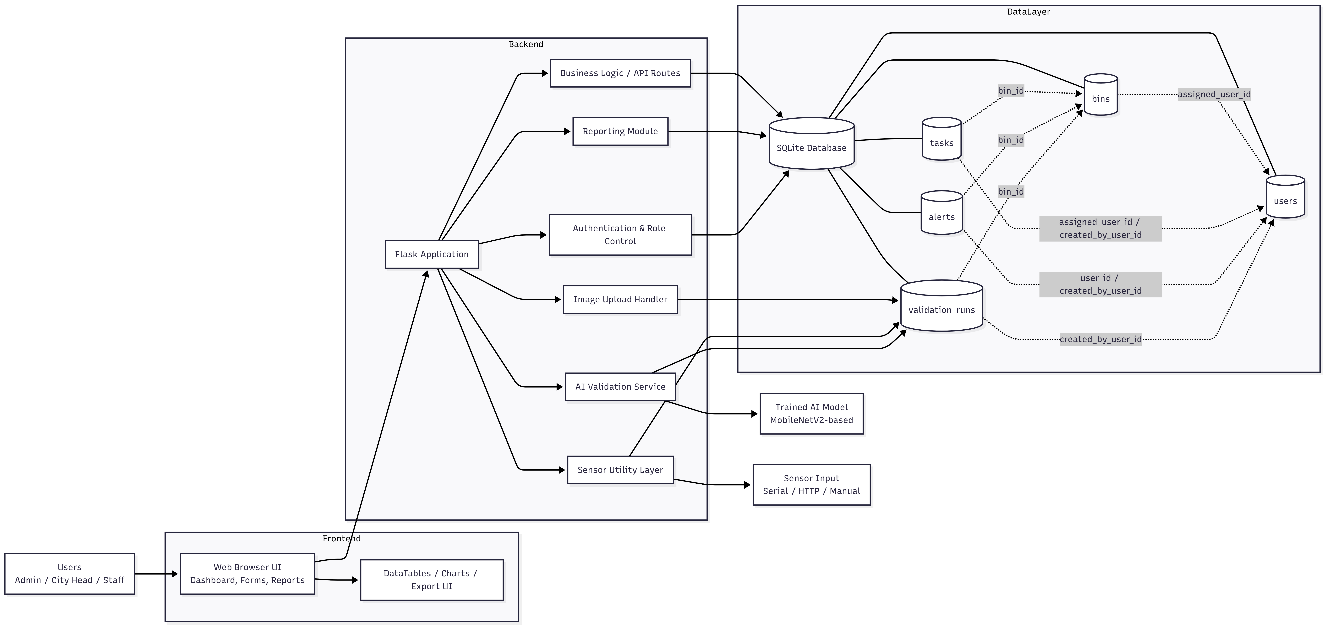

Figure 4.4 1 System Architecture of SmartWaste Management System

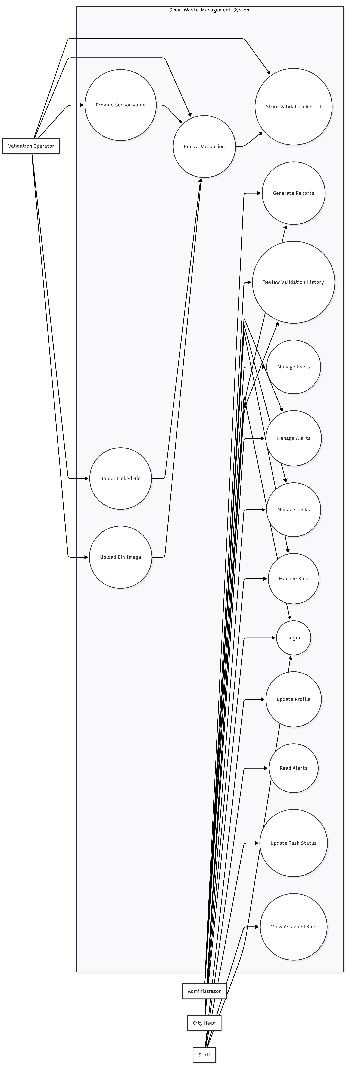

Figure 4.4 2 Use Case Diagram of SmartWaste Management System
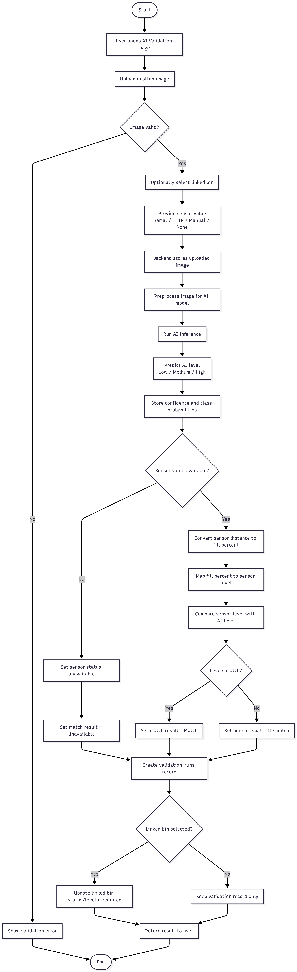
Figure 4.4 3 Activity Diagram of AI Validation Workflow

Figure 4.4 4 Sequence Diagram of Validation Request Processing

Behavioral Design Sequence diagram:
Admin:
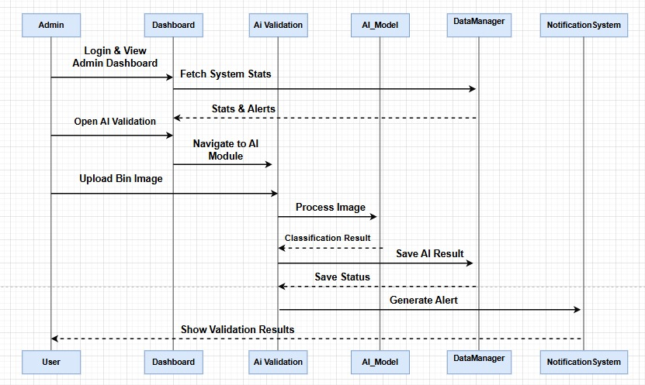
Figure 4 Sequence Diagram/ Admin

City head:
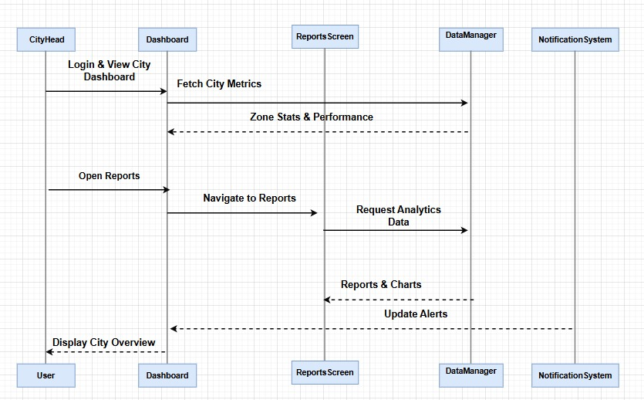
Figure 5 Sequence Diagram/ City Head

Staff:
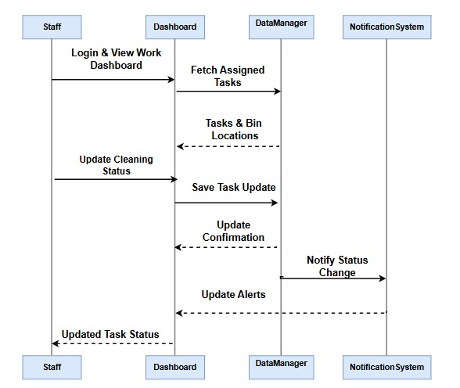
Figure 6 Sequence Diagram/ Staff

Waste Level Model Architecture
The saved Keras model shows a transfer learning design based on MobileNetV2. The visible top level flow is: input layer augmentation block input normalization MobileNetV2 backbone global average pooling batch normalization dropout (rate 0.25) and a dense softmax layer with three outputs. The stored compile configuration shows sparse categorical crossentropy as the loss function and Adam as the optimizer.
This design is suitable for the project because it reduces training cost compared with building a large custom network from scratch while still supporting a practical image classification workflow.

Sensor Integration Design
Sensor handling is implemented as a flexible utility layer rather than a hard coded dependency on one device. The application supports serial mode HTTP mode automatic fallback and manual value entry. Distance is converted to fill percentage using bin height then mapped to low medium or high according to configured thresholds. This result is stored beside the AI output so the final validation record remains comparable and reviewable.

Chapter 5

Implementation

Implementation Overview
The implementation phase is where the theoretical design of the system is transformed into a working application. It involves converting system requirements and design into actual code integrating different components and ensuring that the system performs as expected.
For the Smart Waste Management System the implementation has been carried out in a structured and step by step manner. The focus was not only on completing features but also on keeping the system understandable and manageable. Since this project is both academic and practical the implementation avoids unnecessary complexity while still demonstrating important technical concepts.
This chapter explains how different parts of the system were developed how they interact with each other and how the final system operates.
The system is implemented using a combination of backend frontend database and AI components. Each part is developed separately and then integrated to form a complete application.
The backend is built using Flask which handles routing logic and communication between different modules. The frontend is created using HTML CSS JavaScript and Bootstrap providing a clean and responsive interface. SQLite is used for storing all system data ensuring persistence and easy access.
The AI model is integrated into the system to perform image classification. Sensor logic is also implemented to process distance values and convert them into meaningful outputs.
All these components are combined to create a system that is functional interactive and capable of handling real world scenarios.
The development of the project followed a gradual approach rather than building everything at once. This made it easier to test each part individually and fix issues early.
Initially the basic structure of the application was created. This included setting up the Flask application defining routes and creating a simple frontend layout.
Next the database structure was implemented. Tables were created for users bins tasks alerts and validation records. Basic CRUD (Create Read Update Delete) operations were then developed for each module.

After the core functionality was ready additional features such as authentication role based access and reporting were added.
The AI model was trained separately and then integrated into the system. Finally sensor logic and validation comparison were implemented.
This step by step approach helped in maintaining stability and ensuring that each feature worked correctly before moving on to the next.

Backend Implementation
The backend is the core part of the system and is responsible for handling all operations.
Flask is used as the main framework because it is lightweight and flexible. The backend code is organized into routes and functions that handle specific tasks.
Some key backend functionalities include:
- Authentication Handling
The system verifies user credentials and creates sessions after successful login. Passwords are stored securely using hashing.
- Route Management
Each feature of the system is accessed through specific routes. For example there are routes for users bins tasks alerts and validations.
- Data Processing
The backend processes input data validates it and stores it in the database.
- File Handling
Uploaded images are stored in a designated folder and their paths are saved in the database.
- AI Integration
The backend loads the trained model and uses it to process images.
- Sensor Handling
Distance values are received and converted into fill levels.
The backend ensures that all operations are performed correctly and securely.

Frontend Implementation
The frontend is designed to provide a smooth and user friendly experience.
The interface is built using HTML and styled using CSS and Bootstrap. Bootstrap helps in creating responsive layouts that adapt to different screen sizes.
JavaScript is used to add interactivity such as handling form submissions and updating data dynamically.
The system uses a dashboard layout where users can navigate between different modules. Each module is displayed as a separate page or section.
Tables are used extensively to display data. DataTables is integrated to provide features like sorting searching and exporting.
Forms are used for data entry such as adding users bins and tasks. These forms are designed to be simple and easy to use.
Overall the frontend focuses on clarity and ease of use rather than complex design.

Database Implementation
The database plays a crucial role in storing and managing system data.
SQLite is used because it is lightweight and does not require a separate server. This makes the system easier to deploy and maintain.
The database is implemented using a structured schema with multiple tables. Each table represents a different entity in the system.
For example:
- The users table stores user information
- The bins table stores bin details
- The tasks table stores task records
- The alerts table stores alerts
- The validation table stores AI validation results
Relationships between tables are maintained using foreign keys. This ensures that data remains consistent and meaningful.
Database operations are handled through helper functions that execute queries and return results.

Models:
Three pre-trained transfer learning models, MobileNetV2, EfficientNetB0, and ResNet50, were evaluated for the three-class classification task. The models were compared using accuracy, precision, recall, and F1-score on the test dataset.
EfficientNetB0 achieved an overall test accuracy of 82% with comparatively lower performance on the medium and low classes. Although the model showed stable learning behavior, its classification performance was weaker than the other architectures. ResNet50 achieved the highest test accuracy of 88% along with strong precision and recall values. However, due to its deeper architecture and larger number of parameters, the model required higher computational resources and longer inference time.
MobileNetV2 achieved a test accuracy of 86.16%, weighted precision of 87.89%, weighted recall of 86.16%, and weighted F1-score of 86.58%. The model demonstrated balanced classification performance across all classes while maintaining low computational complexity and faster processing speed. Despite having slightly lower accuracy than ResNet50, MobileNetV2 provided a better trade-off between performance and efficiency.
Therefore, MobileNetV2 was selected as the final model for the proposed system because of its lightweight architecture, efficient computation, faster inference, and strong overall classification performance, making it more suitable for practical real-world deployment.

AI Validation Implementation
The AI model is one of the key components of the system.
The model is trained using a dataset of waste bin images. It is designed to classify images into three categories: low medium and high.
A transfer learning approach is used with MobileNetV2 as the base model. This reduces training time and improves performance.
The model includes additional layers such as pooling normalization dropout and a final classification layer.
Once trained the model is saved and loaded into the system during runtime.
When an image is uploaded it is preprocessed to match the input requirements of the model. The model then predicts the waste level and returns a confidence score.
These results are stored in the database as part of the validation record.
Sensor integration is implemented in a flexible way to support different input methods.
The system can accept sensor data through:
- Serial communication
- HTTP requests
- Manual input
The sensor value represents the distance between the sensor and the waste surface. This value is used to calculate the fill percentage.
The calculation is based on the height of the bin. The fill percentage is then categorized into low medium or high based on predefined thresholds.
This result is used for comparison with the AI prediction.
The validation workflow is one of the most important features of the system.
The process starts when a user uploads an image. The backend saves the image and processes it using the AI model.
At the same time sensor data is either received or entered manually. The system calculates the fill level based on this data.
The AI prediction and sensor result are then compared. If both results match it is recorded as a match. Otherwise it is recorded as a mismatch.
The final validation record includes:
- Image path
- AI prediction
- Confidence score
- Sensor value
- Fill percentage
- Match result
This record is stored in the database and can be viewed later.

Reporting and Export
The reporting feature allows users to view and export system data.
Reports can be generated for:
- Users
- Bins
- Tasks
- Alerts
- Validation records
DataTables is used to display data in a structured format. It also provides options to export data as CSV Excel or print.
Filters can be applied to narrow down results based on date or other criteria.
This feature is useful for analysis and documentation.
Challenges Faced During Implementation
During implementation several challenges were encountered.
One challenge was integrating the AI model with the web application. Ensuring that the model loads correctly and processes images efficiently required careful handling.
Another challenge was managing different types of data such as images sensor values and database records.
Handling user roles and permissions also required attention to ensure security.
Despite these challenges the system was successfully implemented by following a structured approach.
Summary
This chapter explained how the Smart Waste Management System was implemented. It covered backend frontend database AI model and sensor integration.
The implementation focuses on simplicity functionality and clarity. All components are integrated to form a complete system that meets the project requirements.

Chapter 6:
Results
Frontend:
Login screen: (select role) 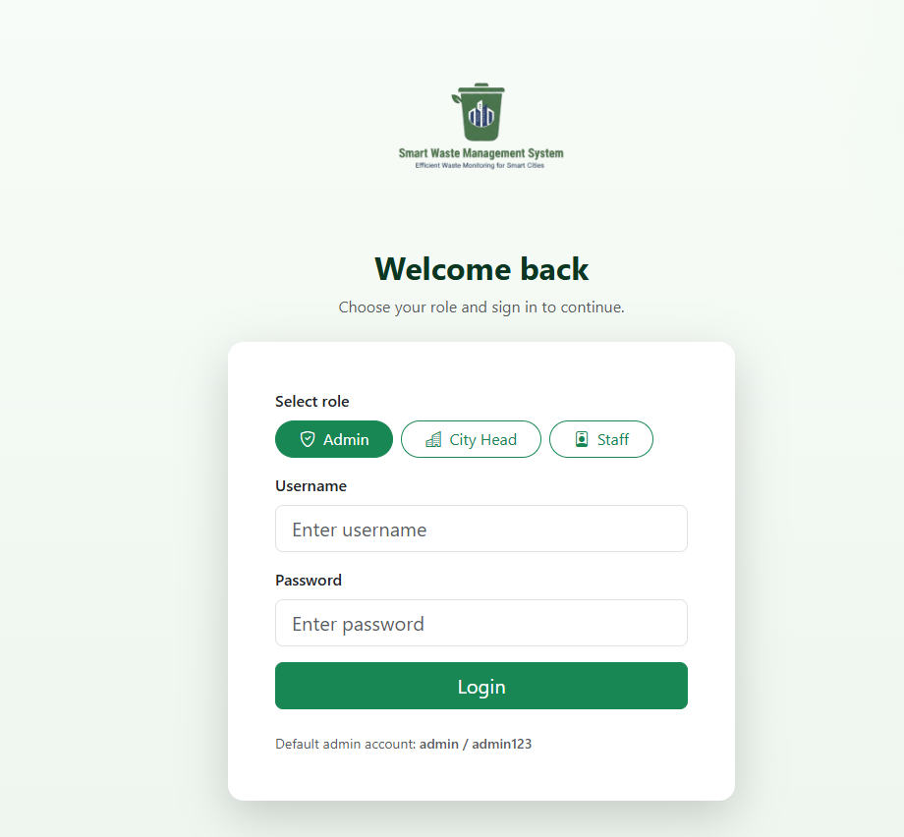
Figure 8 login screen

Admin dashboard:
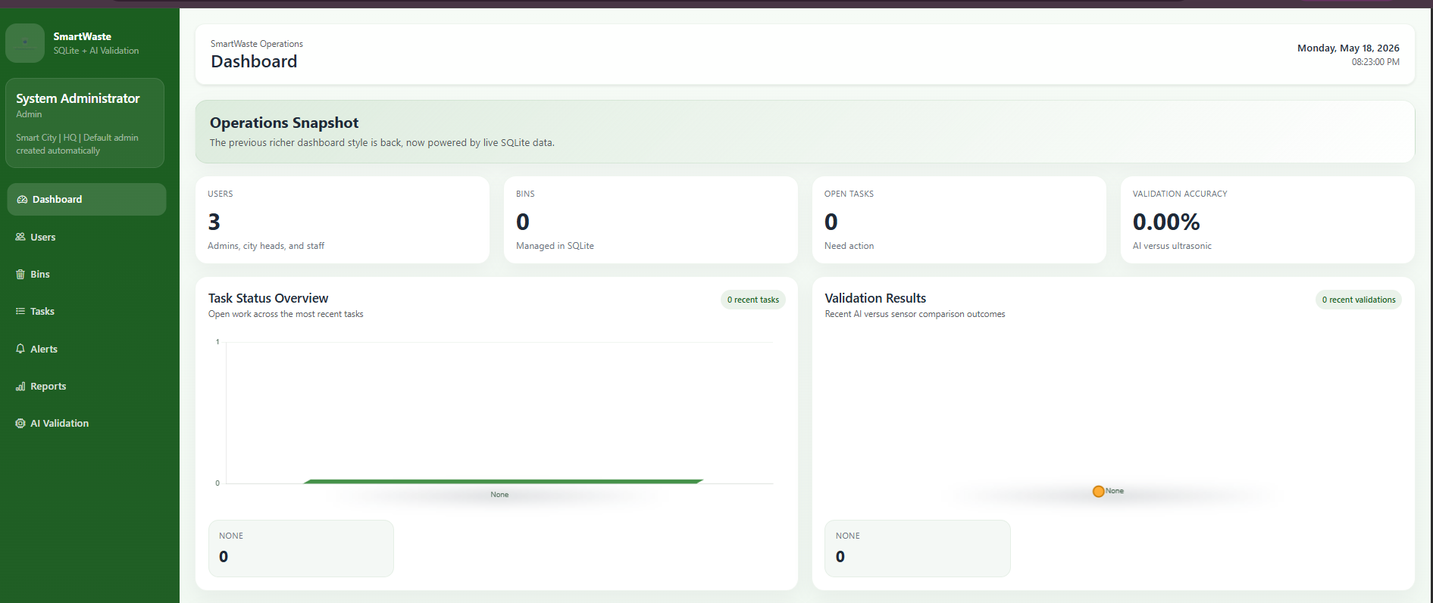
Figure 9 Admin Dashboard

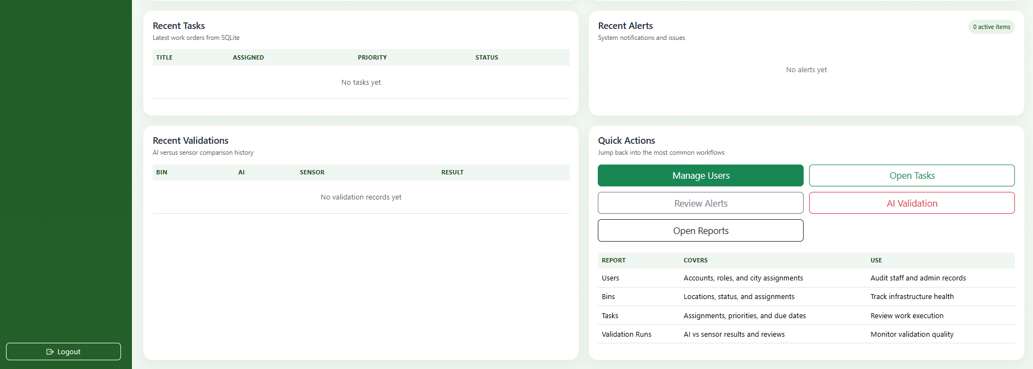
Figure 10.1 Admin Dashboard

Bins and Routes:

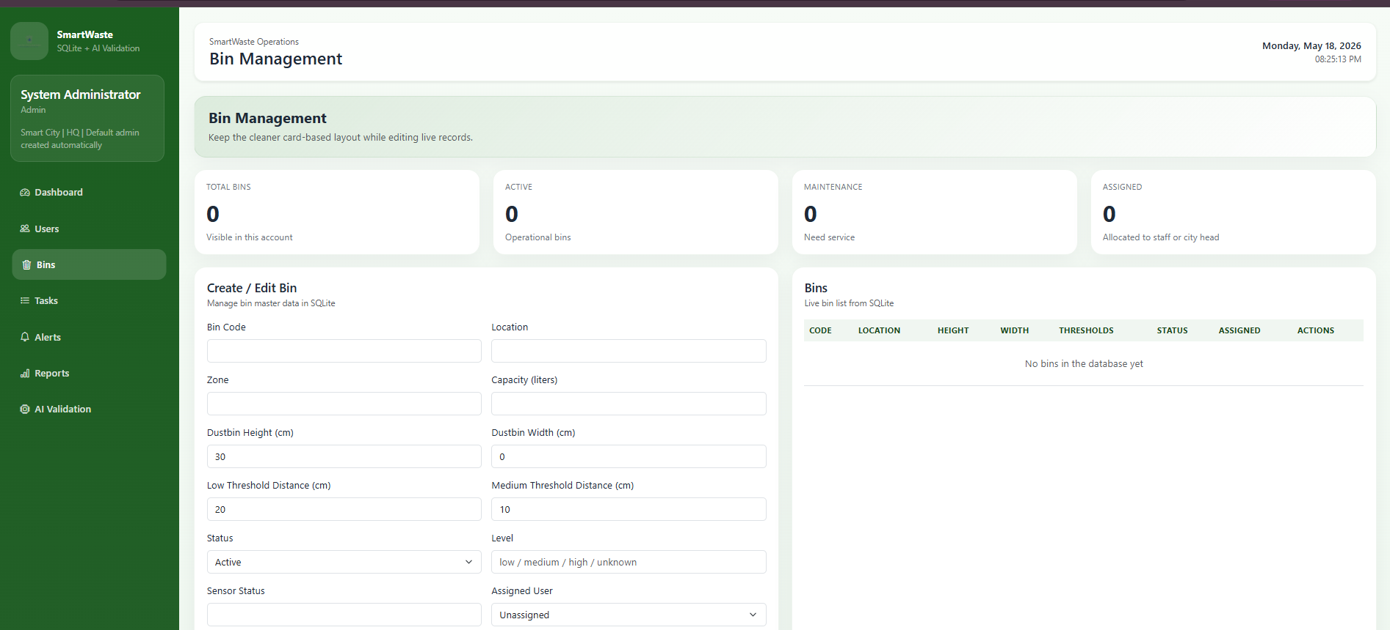
Figure 10 Admin Dashboard/ bins and routes

AI validation:
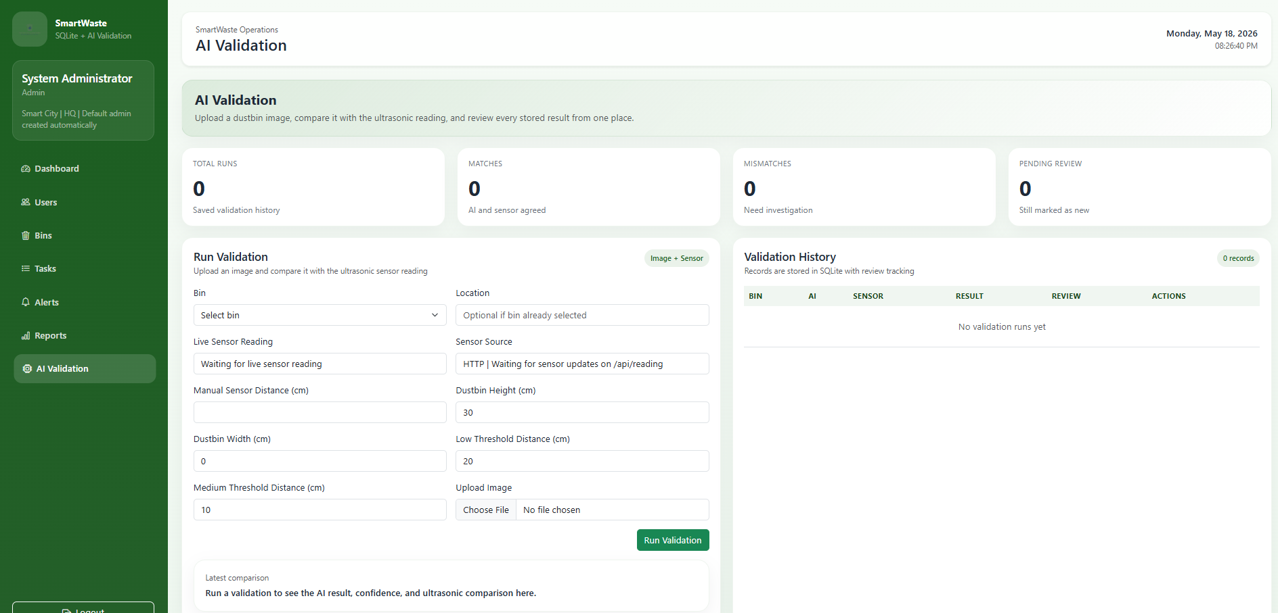
Figure 11Admin Dashboard/AI validation

Upload image:
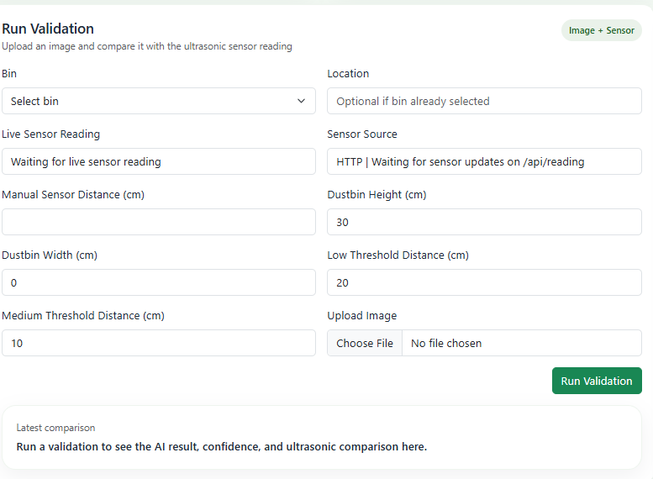
Figure 13 Admin Dashboard / AI validation / upload image
User management:
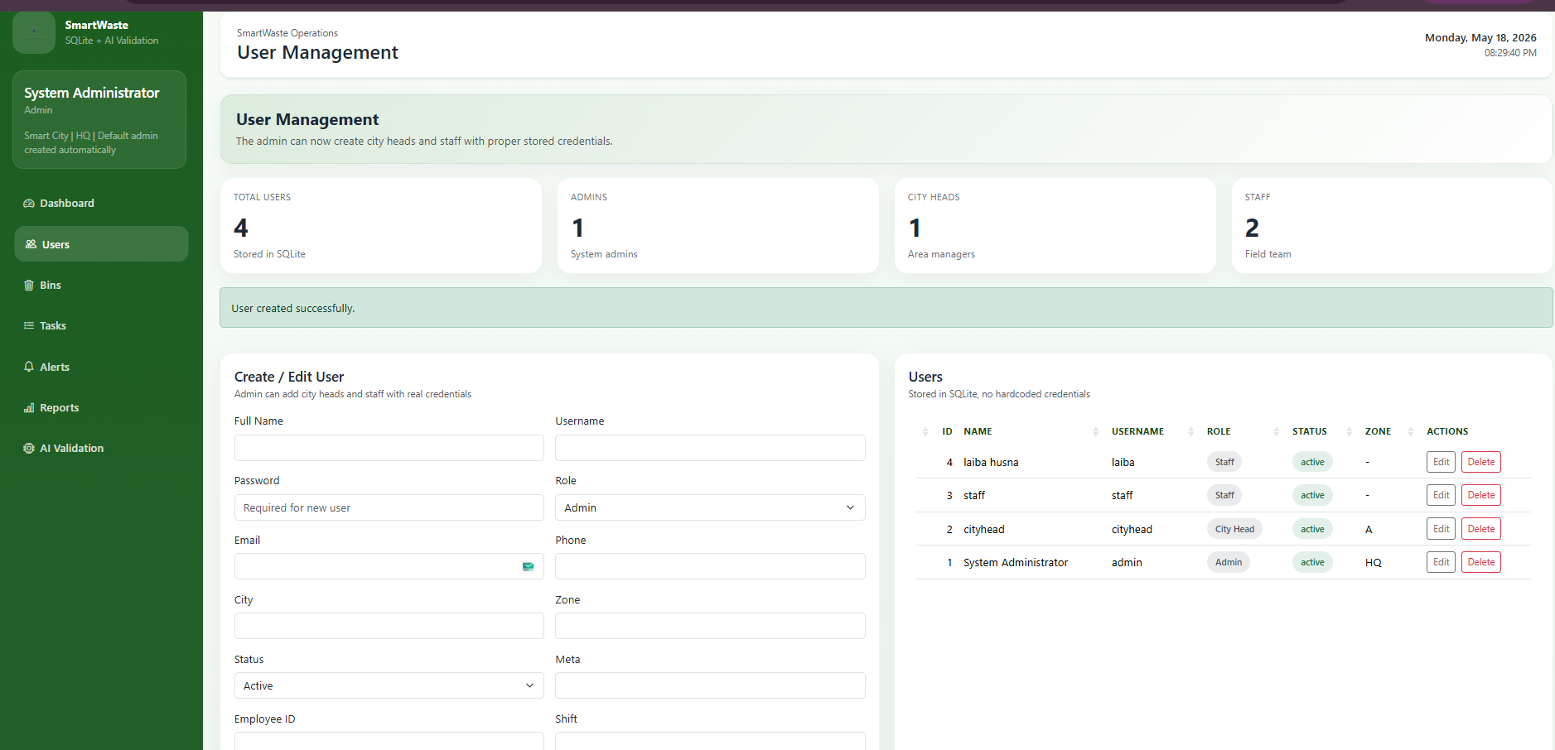
Figure 16 Admin Dashboard / user management

Add user:
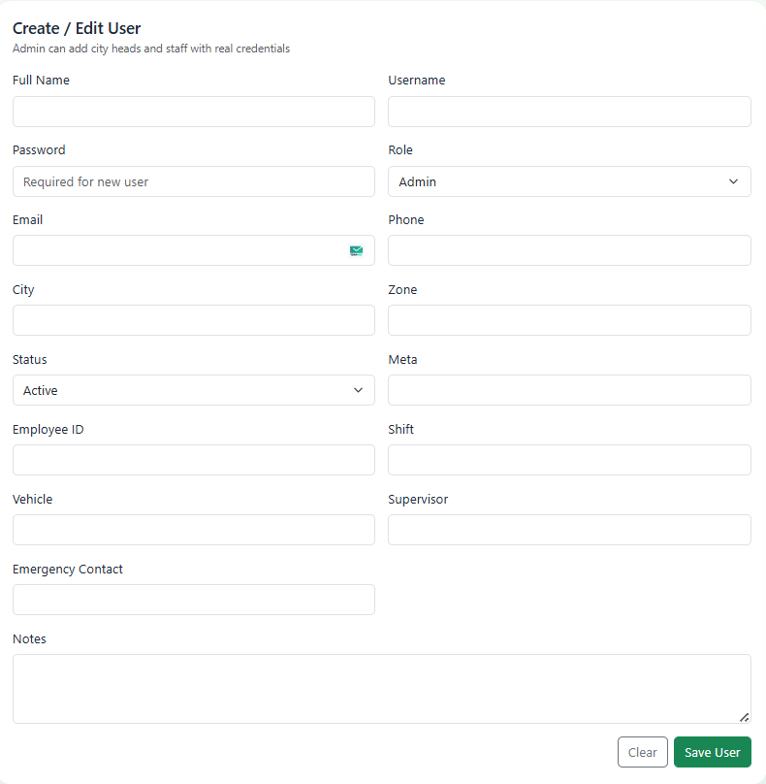
Figure 17 Admin Dashboard / user management / Add user
Delete user and Edit user:
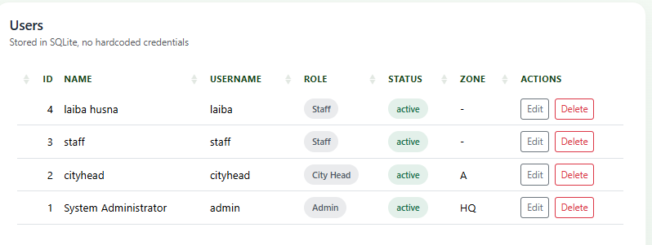
Figure 19 Admin Dashboard / user management / Add and edit user

Reports and analytics:
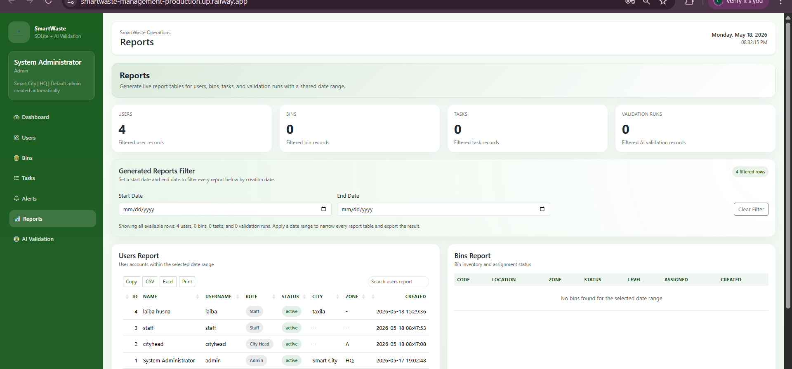
Figure 20 Admin Dashboard / reports and analytics
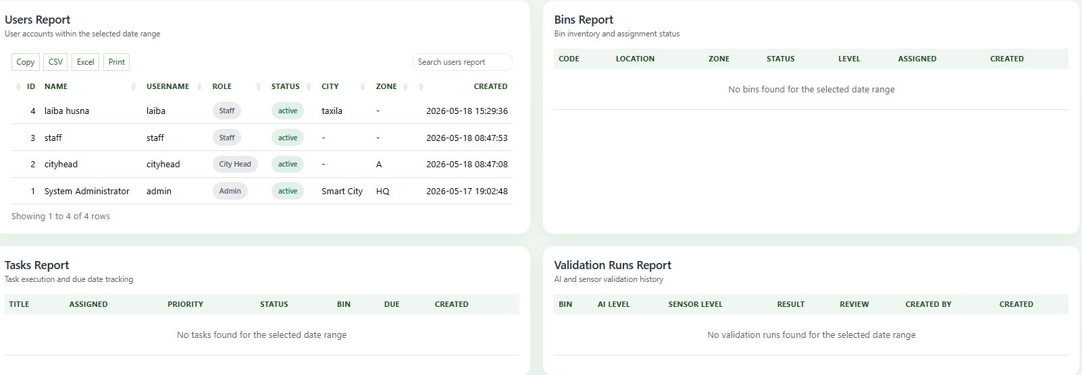
Figure 20.1 Admin Dashboard / reports and analytics

City head dashboard:
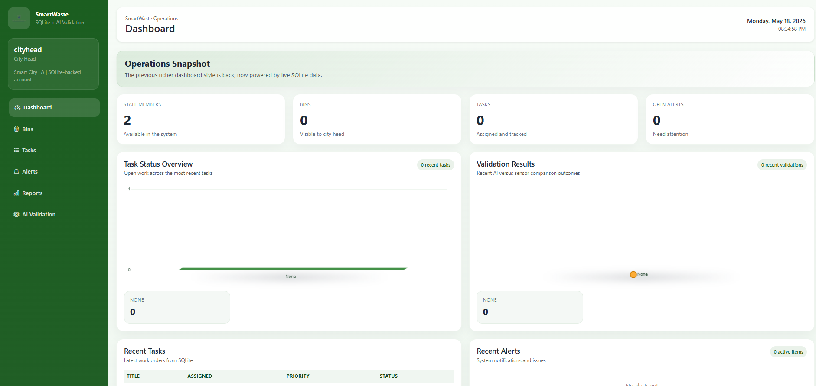
Figure 21 City head dashboard
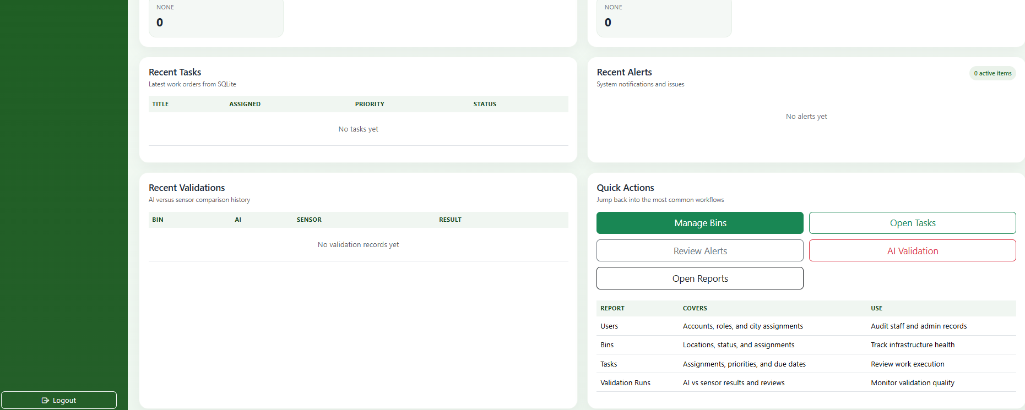
Figure 21.1 City head dashboard

Bin monitoring:
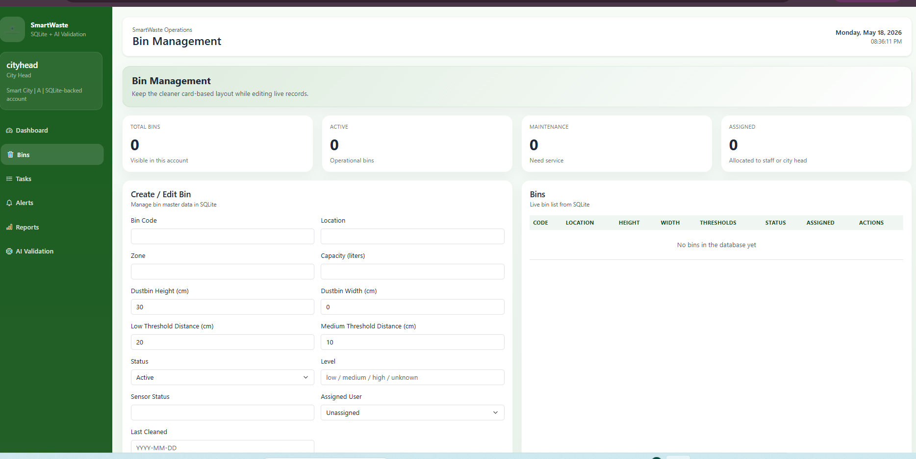
Figure 22 City head dashboard / bin monitoring
Task management:
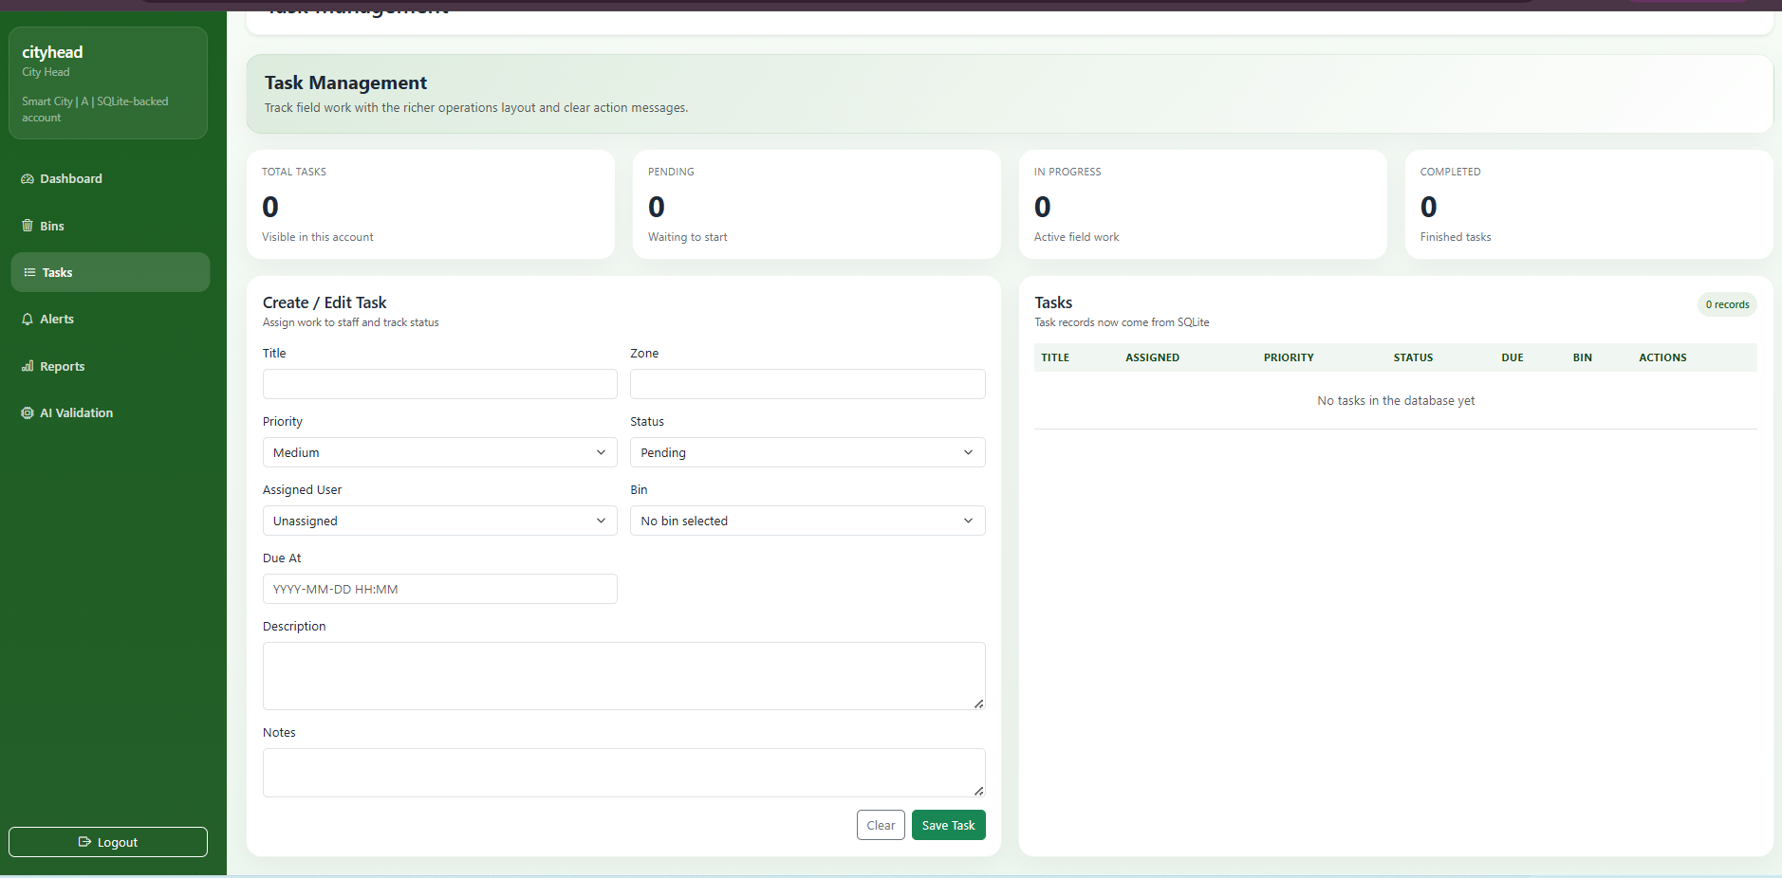
Figure 23 City head dashboard / task management

Alerts:
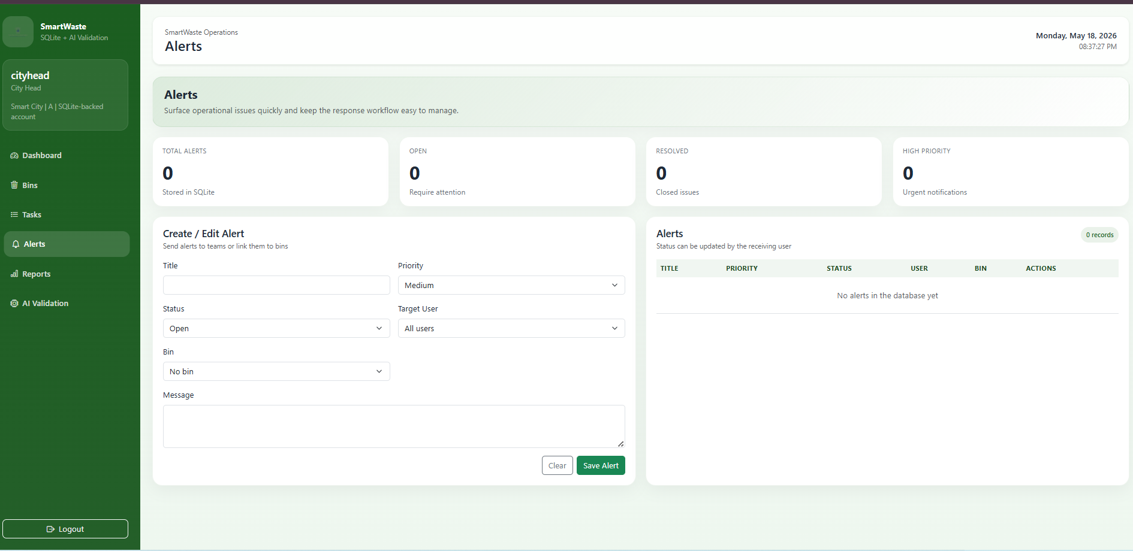
Figure 24 City head dashboard / alerts
Reports: 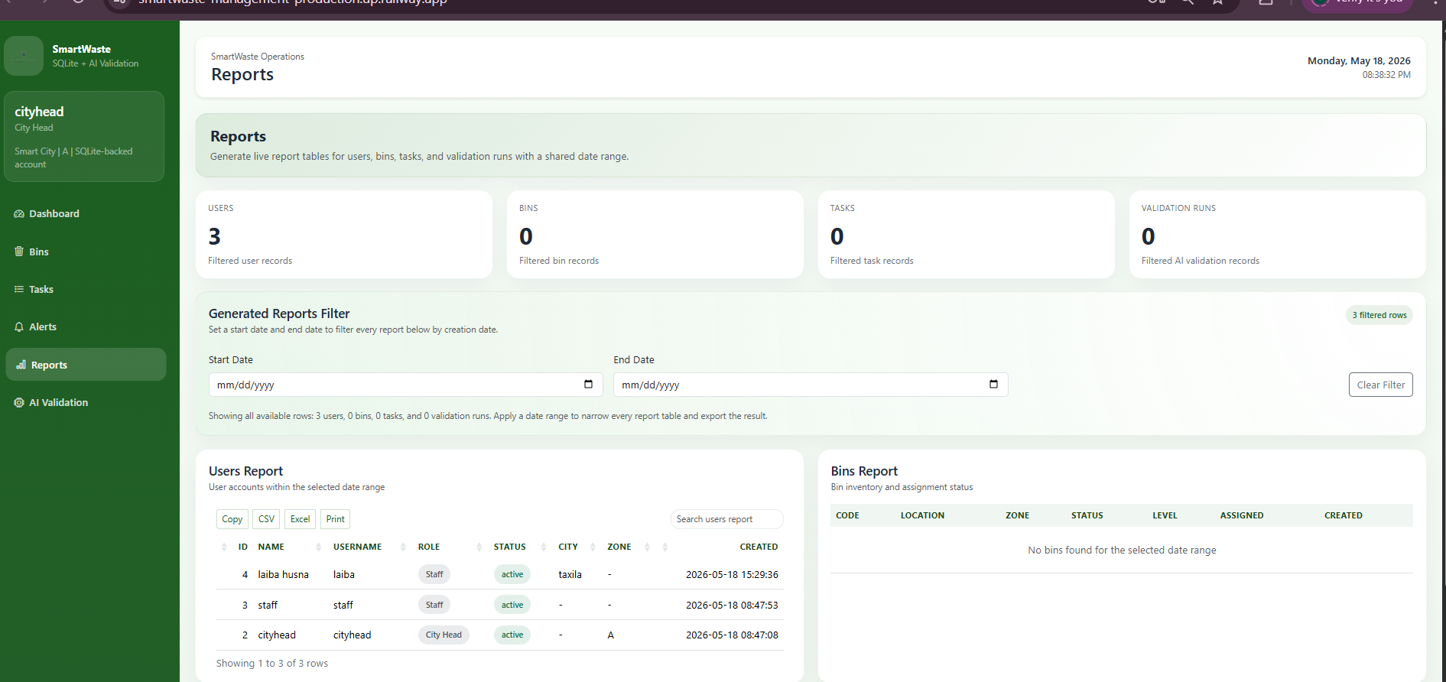
Figure 25 City head dashboard / reports

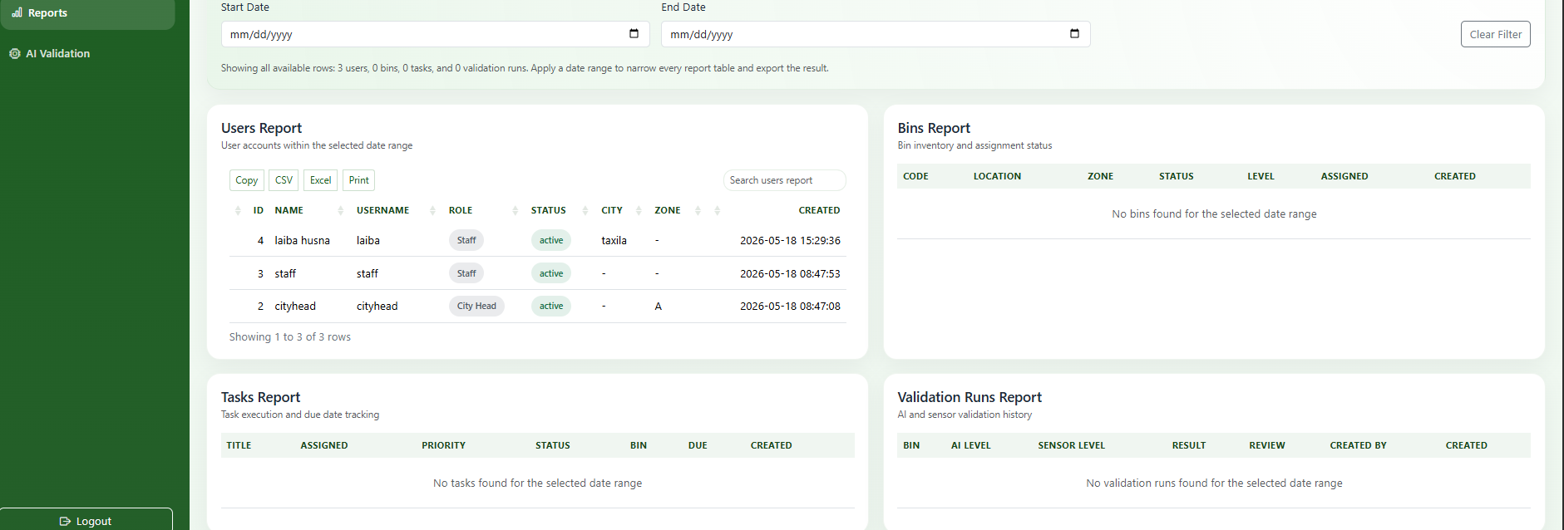
Figure 25.1 City head dashboard / reports
Staff dashboard:
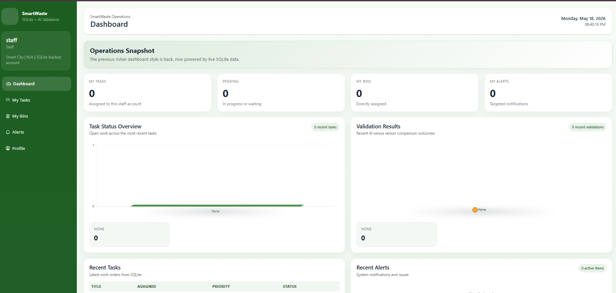
Figure 27 staff dashboard
Notifications:
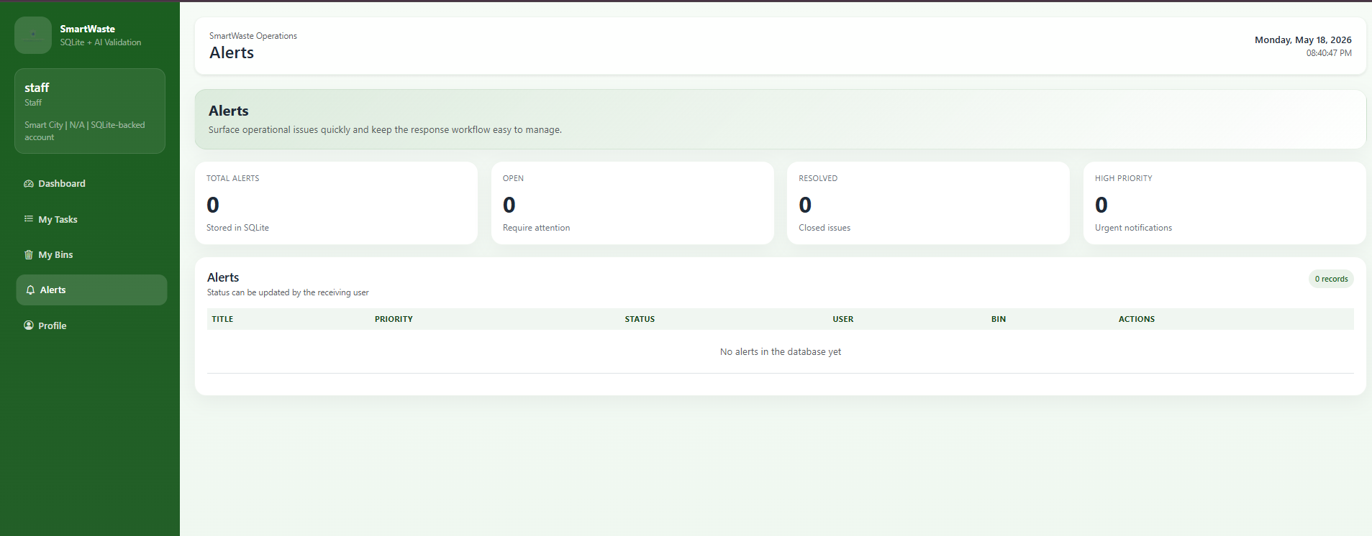
Figure 28 staff dashboard / notifications
Tasks:
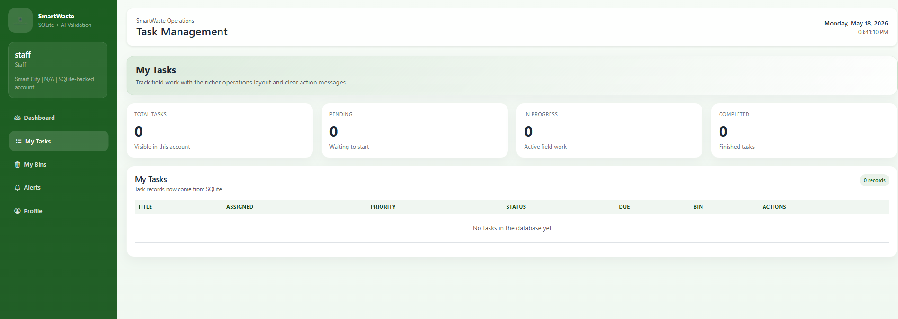
Figure 29 staff dashboard / tasks

Bins:
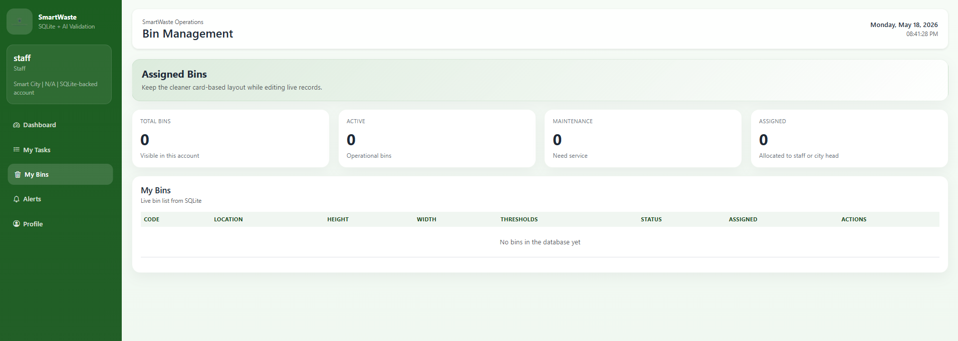
Figure 30 staff dashboard / bins
Profile: 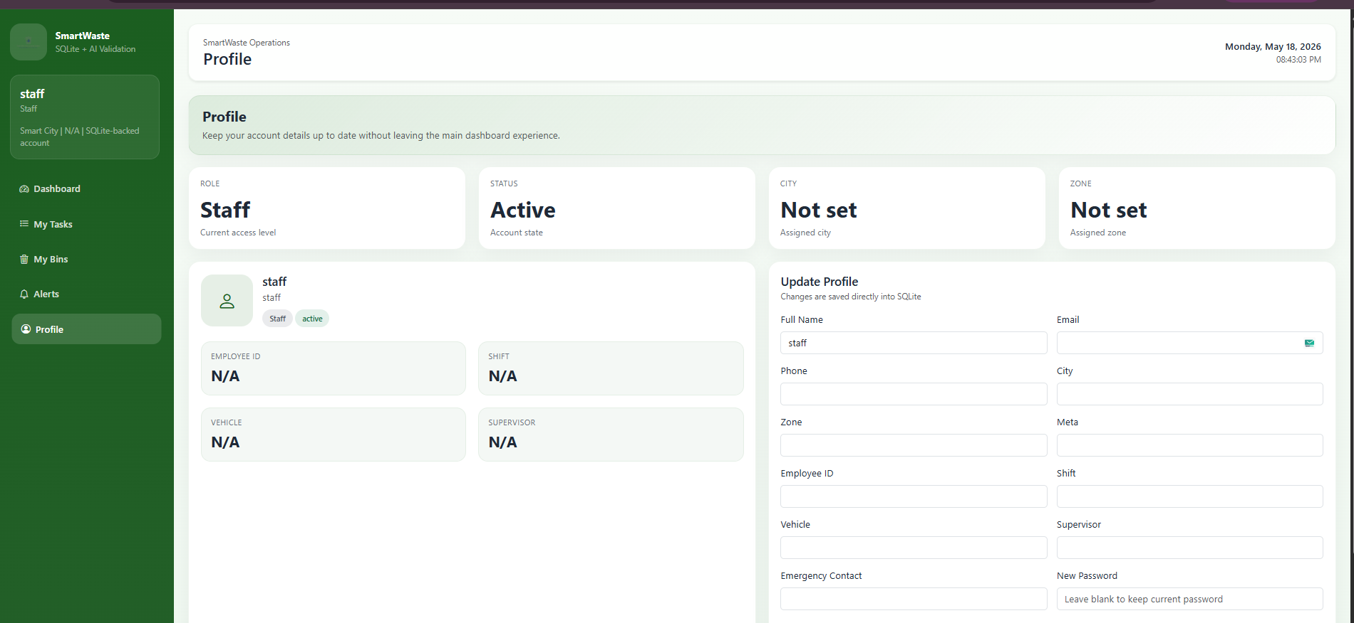

Figure 31 staff dashboard / profile

Dataset:

Dataset Preparation and Customization:
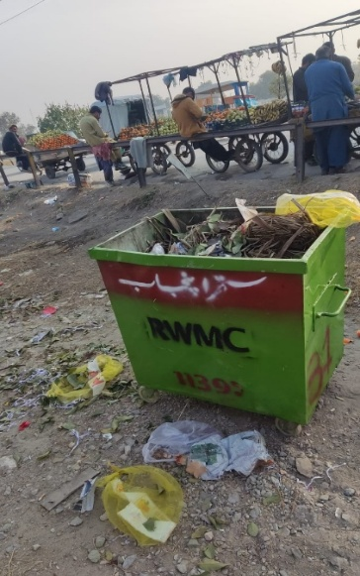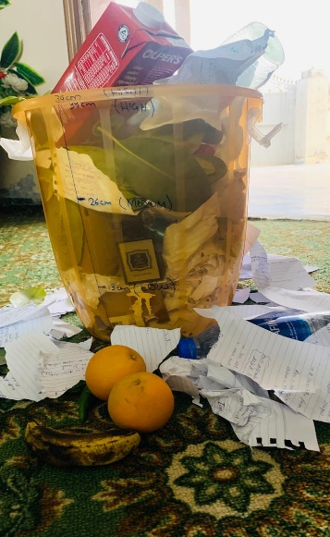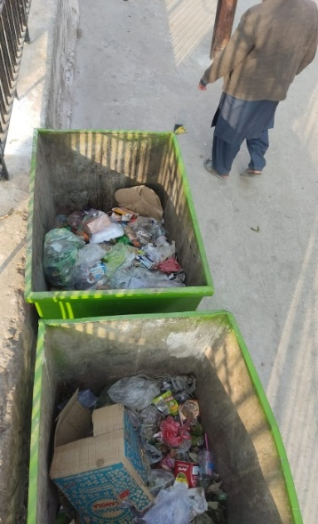
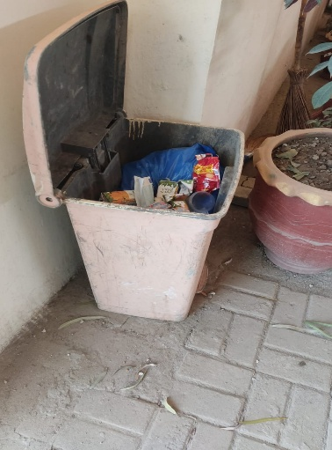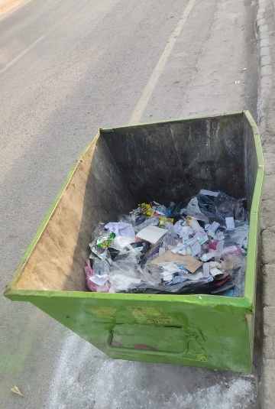
Figure 33 sample data

Folder structure:
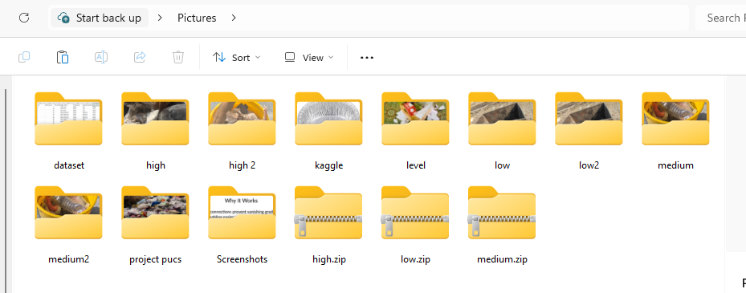
Figure 34 folder structure
Dataset generate:
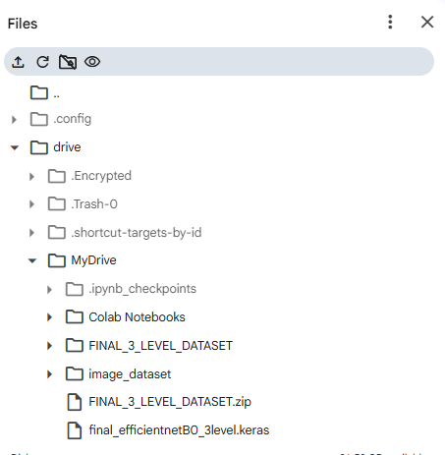
Figure 37 dataset generated

Dataset Splitting Strategy
To ensure fair evaluation and avoid data leakage, the dataset was split into three subsets using the following ratio:
- 70% Training data
- 15% Validation data
- 15% Testing data
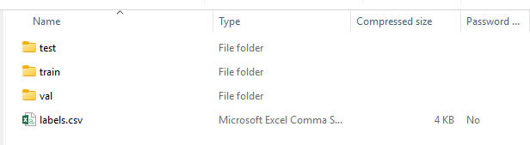
Models performance:
mobileNetV2, EfficientNetB0, ResNet50
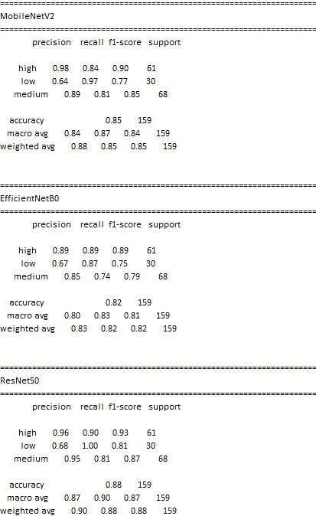

Class Distribution:
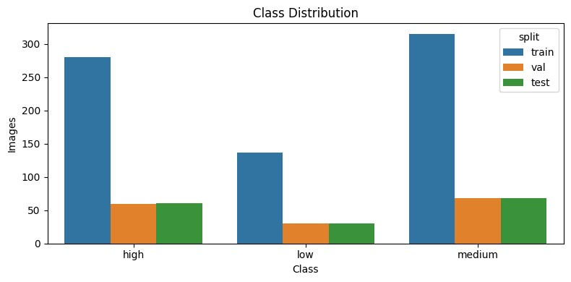Comparison of results using our three models:
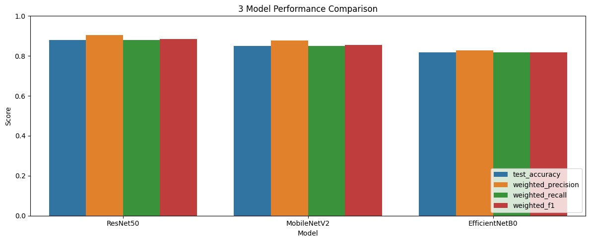

AI-Based result:
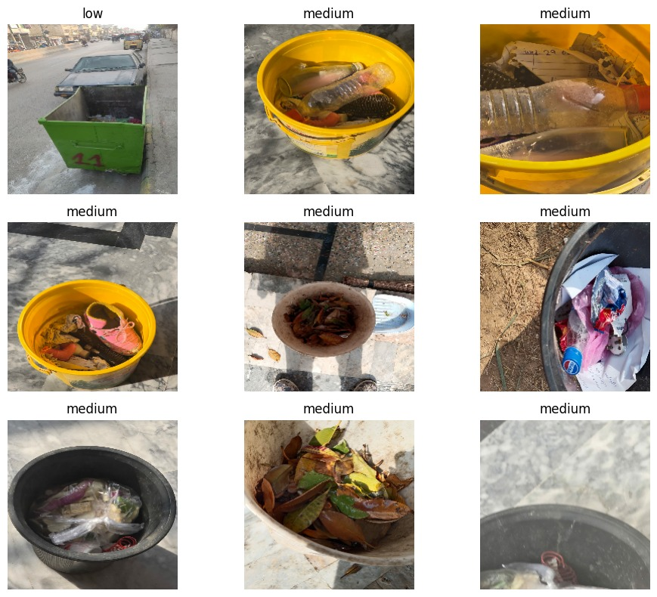
Confusion matrix:
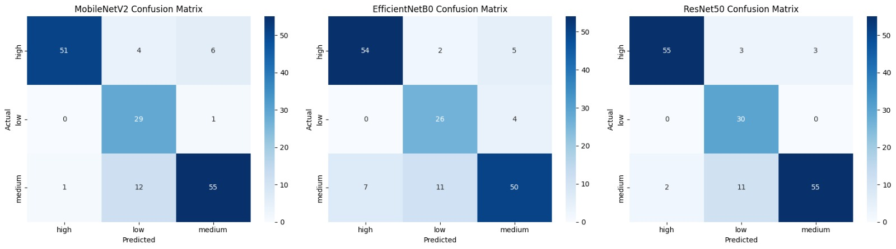

Appendices

Appendix A: Database Table Summary
Table | Purpose
users | Stores login credentials role contact and profile information
bins | Stores bin identity location status dimensions thresholds and assignment
tasks | Stores work items priority status due date and linked bin / user
alerts | Stores operational notifications priority resolution status and linked entities
validation_runs | Stores uploaded image details sensor values AI prediction confidence probabilities and review status
Table A 1 Database Table Summary

Appendix B: Major API Endpoints
Endpoint | Purpose
/api/auth/login | Authenticate a user and create a session
/api/dashboard | Load role based dashboard data
/api/users | Create list update or delete user records where permitted
/api/bins | Create list update or delete bin records
/api/tasks | Create list update or delete tasks
/api/alerts | Create list update or delete alerts
/api/reports | Fetch report datasets for filtered operational views
/api/validations | List and manage stored validation records
/api/validate | Upload a dustbin image and create a new AI validation record
/api/sensor/latest | Expose the latest sensor snapshot
/api/reading | Receive HTTP based sensor updates
Table B 1 Major API Endpoints

References
- Shahab, S. and Anjum, M. (2022) ‘Solid waste management scenario in India and illegal
dump detection using Deep Learning: An AI approach towards the Sustainable Waste
Management’, Sustainability, 14(23), p. 15896. doi:10.3390/su142315896.
- Dawar, I. et al. (2025a) ‘A systematic literature review on Municipal Solid Waste
Management using machine learning and Deep Learning’, Artificial Intelligence Review,
58(6). doi:10.1007/s10462-025-11196-9.
- Lopriore, L. (2022) ‘Password systems: Problems and Solutions’, International Journal of Advanced Computer Science and Applications, 13(6). doi:10.14569/ijacsa.2022.01306113.
- Alsubaei, F.S., Al-Wesabi, F.N. and Hilal, A.M. (2022) ‘Deep learning-based small object detection and classification model for Garbage Waste Management in Smart Cities and IOT Environment’, Applied Sciences, 12(5), p. 2281. doi:10.3390/app12052281.
- Mohd Yusof, N. et al. (2018a) ‘Smart waste bin with real-time monitoring system’, International Journal of Engineering &amp; Technology, 7(2.29), p. 725. doi:10.14419/ijet.v7i2.29.14006.
- Reno, J. (2015) ‘Waste and waste management’, Annual Review of Anthropology, 44(1),

