TASK NO 1

Xamp is installed:

OUTPUT:

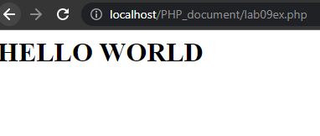

TASK NO 2

<html>

     <head>

  <title>chess board</title>

  <link rel="stylesheet" type="text/css" href="index.css">

  </head>

  <body>

  <div class="header">

    <center><h1>CHESS BOARD</h1></center>

</div>

   <table width="250px" cellspacing="0px" cellpadding="0px" border="3px">

      <?php

      for($row=1;$row<=6;$row++)

      {

          echo "<tr>";

          for($col=1;$col<=6;$col++)

          {

          $total=$row+$col;

          if($total%2==0)

          {

             echo "<td id=first></td>";

          }

          else

          {

          echo "<td id=second></td>";

          }

          }

          echo "</tr>";

    }

          ?>

  </table>

  <div class="footer">

    <center><h1></h1></center>

</div>

</body>

  </html>

**Index.css**

        .header

        {

            width: 100%;

            height: 10%;

            background-color: lightgrey;

        }

        .footer

        {

            width: 100%;

            height: 10%;

            background-color: green;

            position: absolute;

            bottom: 0%;

        }

        #first{

            height:30px;

            width:20px;

            background-color:white;

        }

        #second{

            height:30px;

            width:20px;

            background-color:black;

        }

**Output:**

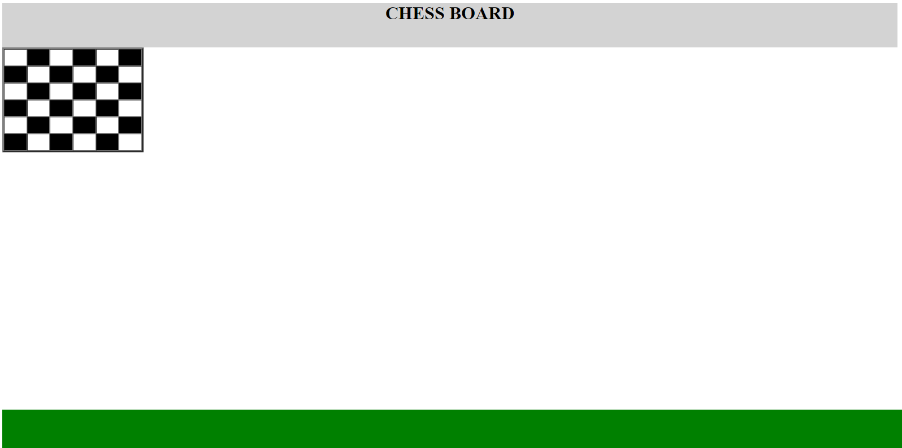

TASK NO 3

<!DOCTYPE html>

<html>

<body>

<?php

include "header.php";

?>

<?php

class Account

{

    public static $final_balance;

    public function __construct()

    {

    }

    public function set_balance(int $amount)

    {

      $GLOBALS['final_balance']=$amount;

    }

    public function withdrawal(int $amount)

    {

        if($amount > $GLOBALS['final_balance'])

        {

            echo "Amount Entered is not in your account:<br>";

        }

        else if($amount < $GLOBALS['final_balance'])

        {

           echo "Amount ".$amount. " deducted from your account <br>";

            $GLOBALS['final_balance']= $GLOBALS['final_balance']-$amount;

        }

           //var_dump($amount);

    }

    public function deposite(int $amount)

    {

        echo "Amount ".$amount." added to your account <br>";

        $GLOBALS['final_balance']= $GLOBALS['final_balance']+$amount;

        //var_dump($oamount);

    }

    public function final_Balance()

    {

        echo "Your balance is :".$GLOBALS['final_balance'];

    }

}

$balance= new Account();

echo $balance->set_balance(1000);

echo $balance->withdrawal(500);

echo $balance->deposite(5000);

echo $balance->final_balance();

?>

<?php

include "footer.php";

?>

</body>

</html>

**Header.php**

<html>

<head>

    <link rel="stylesheet" type="text/css" href="index.css">

    </head>

<body>

<div class="header">

    <center><h1>This is the header.</h1></center>

</div>

**Footer.php**

<html>

<head>

    <link rel="stylesheet" type="text/css" href="index.css">

    </head>

<body>

<div class="footer">

    <center><h1>This is the footer.</h1></center>

</div>

**Index.css**

.header

        {

            width: 100%;

            height: 10%;

            background-color: lightgrey;

        }

        .footer

        {

            width: 100%;

            height: 10%;

            background-color: green;

            position: absolute;

            bottom: 0%;

        }

**Output:**

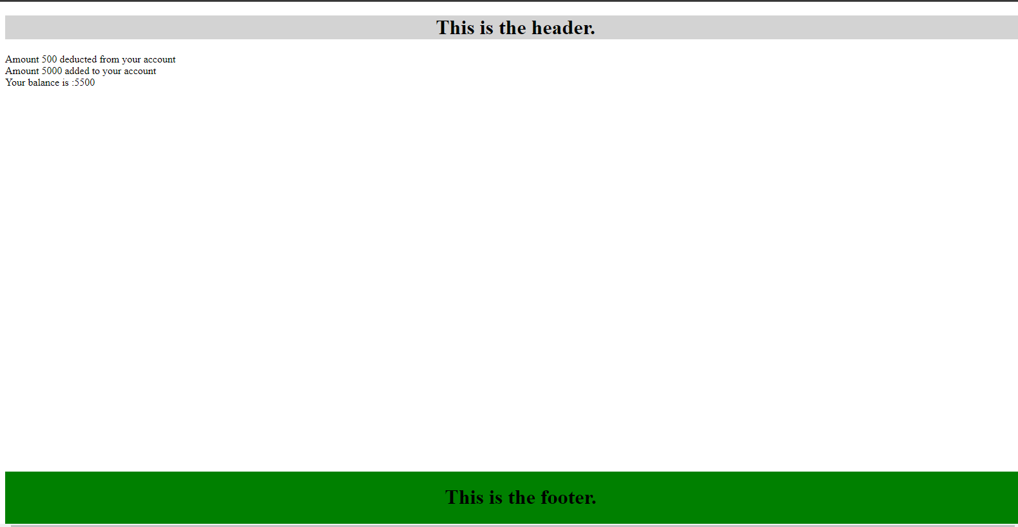

TASK NO 4

<?php

declare(strict_types = 1);   //variable can only take value accourding to data type

$candy = [

'Toffee' => ['price' => 3, 'stock' => 12],    // list of the stock items

'Mints' => ['price' => 2, 'stock' => 26],

'Fudge' => ['price' => 4, 'stock' => 8],

];

$tax = 20;

function get_reorder_message(int $stock): string    // the function with return type string

{

return ($stock < 10) ? 'Yes' : 'No';

}

function get_total_value(float $price, int $quantity): float  // the function with return type float

{

return $price * $quantity;

}

function get_tax_due(float $price, int $quantity, int $tax = 0): float  // the function with return type float

{

return ($price * $quantity) * ($tax / 100);     // calculate the due tex of an item

}

?>

<!DOCTYPE html>

<html>

<head>

<title>Functions Example</title>

<link rel="stylesheet" href="css/styles.css">

</head>

<body>

<h1>The Candy Store</h1>

<h2>Stock Control</h2>

<table>

<tr>

<th>Product</th><th>Stock</th><th>Re-order</th><th>Total value</th><th>Tax

due</th>

</tr>

<?php foreach ($candy as $product => $data) /*For each loop  array candy value assign to product*/  { ?>

<tr>

<td><?= $product ?></td>

<td><?= $data['stock'] ?></td>

<td><?= get_reorder_message($data['stock']) /*Getting the yes or no message of item according to stock */?></td>

<td>$<?= get_total_value($data['price'], $data['stock'])  /*Getting value by multiplying the quantity with price of an item*/  ?></td>

<td>$<?= get_tax_due($data['price'], $data['stock'], $tax) /*Calulating due tax on any item */?></td>

</tr>

<?php } ?>

</table>

</body>

</html>

Explains:

This is Stock control page of candy store which have information of the item like quantity, value, due tax etc. This page inform user to reorder an item or not by function (get_record_message produce message using stocks).