CREATE TABLE employee (
emp_id NUMBER(20) PRIMARY KEY,
ename VARCHAR2(30),
job_desc VARCHAR2(20),
salary NUMBER (8)
);

INSERT INTO employee VALUES(1,'Ram','ADMIN',1000000);
INSERT INTO employee VALUES(2,'Harini','MANAGER',2500000);
INSERT INTO employee VALUES(3,'George','SALES',2000000);
INSERT INTO employee VALUES(4,'Ramya','SALES',1300000);
INSERT INTO employee VALUES(5,'Meena','HR',2000000);
INSERT INTO employee VALUES(6,'Ashok','MANAGER',3000000);
INSERT INTO employee VALUES(7,'Abdul','HR',2000000);
INSERT INTO employee VALUES(8,'Ramya','ENGINEER',1000000);
INSERT INTO employee VALUES(9,'Raghu','CEO',8000000);
INSERT INTO employee VALUES(10,'Arvind','MANAGER',2800000);
INSERT INTO employee VALUES(11,'Akshay','ENGINEER',1000000);
INSERT INTO employee VALUES(12,'John','ADMIN',2200000);
INSERT INTO employee VALUES(13,'Abinaya','ENGINEER',2100000);
SELECT COUNT(*) FROM employee; -- total count of entries in the table


SELECT AVG(salary) FROM employee; -- avg salary of all employees
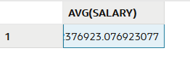

SELECT AVG(salary)
FROM employee
WHERE job_desc=’MANAGER’; -- avg salary of managers

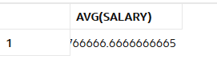

SELECT SUM(salary)
FROM employee
WHERE job_desc=’ADMIN’; -- total salary given to all ADMIN



SELECT * FROM employee
WHERE salary = (SELECT MAX(salary)
FROM employee); -- display the employee with

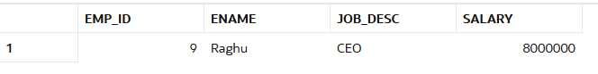

SELECT MIN(salary) FROM employee;


SELECT UPPER(ename),salary
FROM employee; -- uppercase
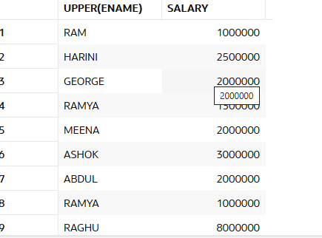

SELECT ename,LENGTH(ename)
FROM employee;
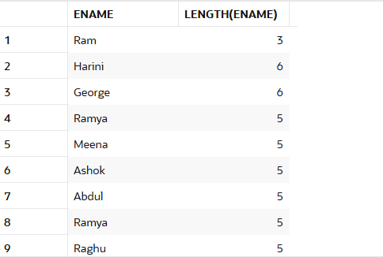

SELECT ename, '$' || salary AS salary_with_currency
FROM employee;
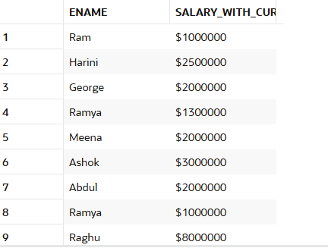

SELECT ename, SUBSTR(job_desc, 1, 4)
FROM employee;-- Take first 4 characters
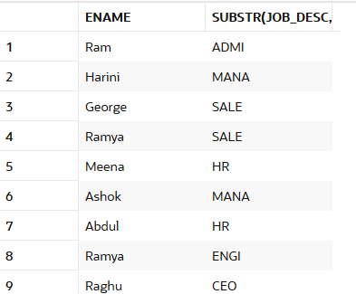

-- adding hire_date column
ALTER TABLE employee ADD Hire_Date DATE;



UPDATE employee
SET Hire_Date = DATE '2012-10-05';

Or using TO_DATE
UPDATE employee
SET Hire_Date = TO_DATE('2012-10-05', 'YYYY-MM-DD');

If you want to update only MANAGERS:
UPDATE employee
SET Hire_Date = DATE '2012-10-05'
WHERE job_desc = 'MANAGER';

SELECT *
FROM employee
WHERE Hire_Date = DATE '2012-10-05';
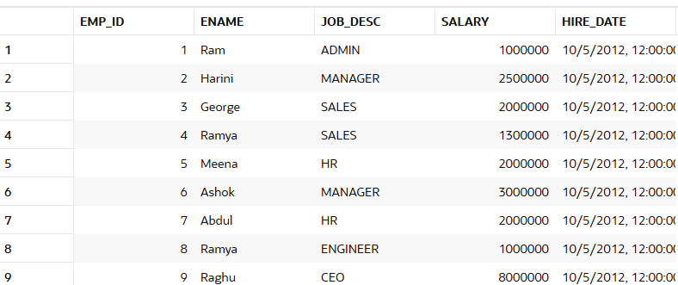

-- Updating hire_date only for employees whose job_desc is ADMIN
UPDATE employee
SET Hire_Date = DATE '2014-10-05'
WHERE job_desc = 'ADMIN';
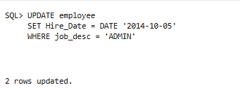
SELECT emp_id, ename, job_desc, hire_date
FROM employee
WHERE job_desc = 'ADMIN';
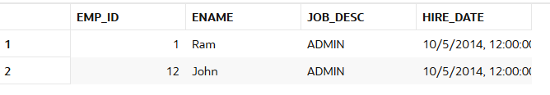

-- Current date and time
SELECT SYSDATE FROM dual;

You use DUAL when you want to run a SELECT statement without selecting from a real table.
In Oracle, DUAL is a special one-row, one-column dummy table that Oracle provides.

-- Current date (same as SYSDATE, but time still exists internally)
SELECT TRUNC(SYSDATE) AS current_date FROM dual;

Alternative way to show only the date
SELECT TO_CHAR(SYSDATE, 'YYYY-MM-DD') AS current_date
FROM dual;


-- Display current date in DD/MM/YYYY format
SELECT TO_CHAR(SYSDATE, 'DD/MM/YYYY') AS formatted_date
FROM dual;


-- Difference between today and 01-Jan-2020
SELECT TRUNC(SYSDATE - DATE '2020-01-01') AS days_difference
FROM dual;


Group by and having
WHERE is used before grouping
HAVING is used after grouping to filter grouped results

SELECT job_desc, AVG(salary) AS avg_sal
FROM employee
GROUP BY job_desc;

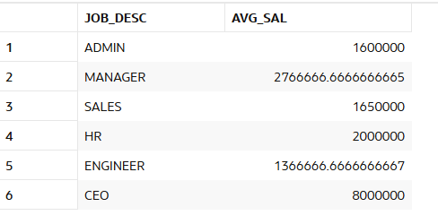
To format
SELECT
job_desc,
TO_CHAR(AVG(salary), '9,99,99,999') AS avg_sal
FROM employee
GROUP BY job_desc;

TO_CHAR() is converting the numeric average into formatted text (to display commas)
It is used to format numbers in Oracle.
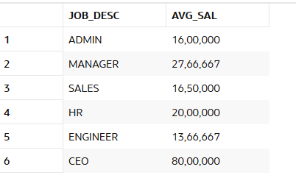

SELECT job_desc,COUNT(emp_id) count
FROM employee
GROUP BY job_desc; -- displays number of employees count in each job_desc category
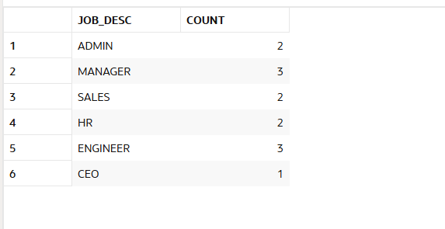

Show each job_desc and the total salary paid for that job
SELECT job_desc, SUM(salary) AS total_salary
FROM employee
GROUP BY job_desc;
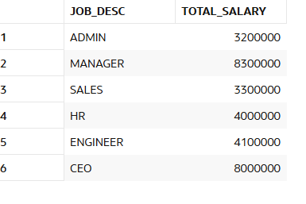
Show only those job_desc where total salary > 3,000,000
SELECT job_desc, SUM(salary) AS total_salary
FROM employee
GROUP BY job_desc
HAVING SUM(salary) > 3000000;
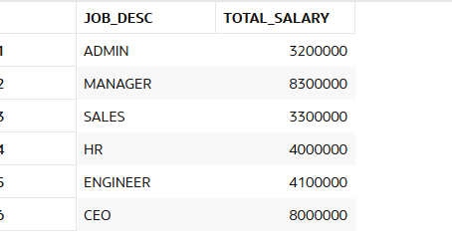

Count how many employees in each job_desc earning more than 2,000,000
SELECT job_desc, COUNT(emp_id) AS emp_count
FROM employee
WHERE salary > 2000000
GROUP BY job_desc;
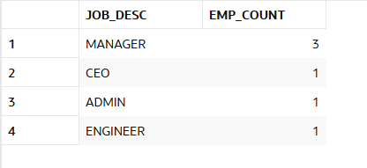
Show job_desc where average salary is more than 2,000,000
SELECT job_desc, AVG(salary) AS avg_salary
FROM employee
GROUP BY job_desc
HAVING AVG(salary) > 2000000;
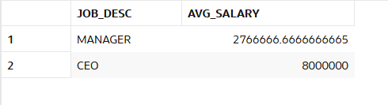
Show job_desc having more than 1 employee AND average salary above 1,500,000
SELECT job_desc, COUNT(emp_id) AS emp_count, AVG(salary) AS avg_salary
FROM employee
GROUP BY job_desc
HAVING COUNT(emp_id) > 1 AND AVG(salary) > 1500000;
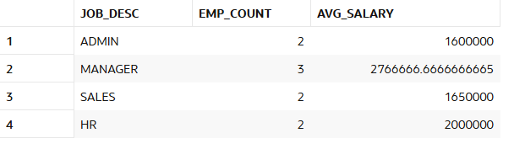
Show job_desc and max salary for each job, only where max salary > 2,500,000
SELECT job_desc, MAX(salary) AS max_salary
FROM employee
GROUP BY job_desc
HAVING MAX(salary) > 2500000;
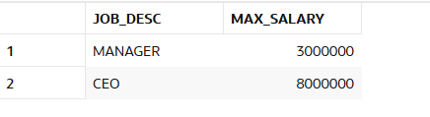
For each job_desc, show number of employees with salary below 2,000,000
SELECT job_desc, COUNT(emp_id) AS count_low_salary
FROM employee
WHERE salary < 2000000
GROUP BY job_desc;
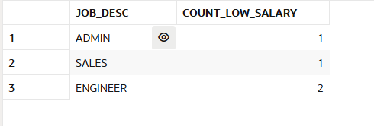
Show job_desc where minimum salary is above 1,000,000
SELECT job_desc, MIN(salary) AS min_salary
FROM employee
GROUP BY job_desc
HAVING MIN(salary) > 1000000;



