LO6 – SELECT Statement
Select is used to query the database. The result set is simply another table (dynamically created from our database).
- SELECT – Simplest form
  - SELECT *
FROM Table;
  - Selects all columns in the order created; all rows from the specified table.
- Specifying columns
  - SELECT expression [, expression]
FROM Table;
  - Expression can be the name of a column, or a constant, or an expression (function, calculations, etc)
  - Can use * for all columns, can also put columns in any order
  - Can give columns an alias: SELECT col1 AS someName FROM Table;
- Full syntax:
  - SELECT [DISTINCT | ALL] select_list
FROM the_tables_involved
[WHERE search_conditions]
[GROUP BY group_by_list [HAVING group_search_condition]]
[ORDER BY order_by_list];
- Operators in SQL
  - Typical operators (*,/,+,-)
  - String concatenation: ||
SELECT 'Hello' || ' ' || 'World' AS ConcatenatedString FROM dual;
This will result in the following output
ConcatenatedString
-----------------
Hello World
  - Relational operators:
    - = (not == like in Java)
    - +
    - >, <, >=, <=, <> (not equal to, Oracle also allows !=)
    - Relational operators can be applied to character strings (city > ‘London’), but how the evaluation is done is dependent on the DBMS
      - Oracle compares character strings position by position, starting at the left end, up to the first character that is different. Whichever string has the “greater” character in that position is considered the greater string. The collation sequence of the characters is dependent on the computer’s OS (ASCII or EBCDIC).
      - If two VARCHAR2’s are identical up to the end of the shorter one, the longer string is considered greater.
    - Compare 'Paris' and 'London'
P vs L → P comes after L → 'Paris' > 'London'
    - Compare 'Cat' and 'Caterpillar'
Cat is the same at the start, but 'Caterpillar' is longer → 'Caterpillar' > 'Cat'

  - Boolean operators – use words (don’t use !, &&, || etc)
    - NOT- reverses the condition
    - AND- both conditions must be true
    - OR- at least one condition must be true
    - Example
SELECT * FROM Students
WHERE grade = 'A' AND city = 'Regina';
  - Range operators
    - Column BETWEEN low AND high
      - Is inclusive = equivalent to: column >= low AND column <= HIGH
    - SELECT * FROM Products
WHERE price BETWEEN 10 AND 50;
  - Nulls

    - Column IS NULL
    - Column IS NOT NULL
WHERE middleName IS NULL;
  - Comparison operators:
    - Column IN (constant [, constant…])
    - Column NOT IN (constant [, constant …])
    - Example- SELECT * FROM Employees
WHERE department IN ('IT', 'HR', 'Finance');
    - Column LIKE pattern [ESCAPE ‘character’]
      - Wild card characters are, by default:
        - % → any number of characters (including 0)
        - _ → exactly one character

      - The ESCAPE clause can be used if you need to search for % or _
- Sorting the results
  - Use ORDER BY
  - Only affects the display order. Can order on multiple columns.
  - Oracle treats null values, by default, as high values. In other words, the default behavior is as follows:
    - NULLS LAST is the default for ASC. (nulls go to the bottom)
    - NULLS FIRST is the default for DESC. (nulls go to the top)
  - Default is ascending order. Can use ASC or DESC.

Single Row Functions ( “SQL Functions” PPT)

Group or Aggregate Functions
- Aggregate functions return a single result row based on groups of rows, rather than on single rows.
- These functions apply to groups of rows – for a group of rows, you get a single value.
- Mixing aggregate results and single row results doesn’t work in most implementations of SQL (including Oracle).
  - Usually you would have to use some kind of reporting tool to see individual and summary.
- Aggregate functions take some type of expression. The expression is usually a column name, but it can also be a constant or calculated value.
- The use of DISTINCT with the above means the system will SUM/AVG/COUNT on the distinct values and not include repeated values more than once.
- Aggregates cannot be used as conditions in the WHERE clause.
- Aggregates and NULLS
  - If there are any null values in the column on which the aggregate function is operating, they are ignored for the purpose of the function, except for COUNT(*), which counts each row.
  - Can use NVL or COALESCE in the argument of an aggregate to avoid nulls by substituting null for something else.
- The functions are:
  - SUM(expression)
    - Provides the total of the expression over the group of rows. The expression must evaluate to a number or null.
  - AVG(expression)
    - Averages the expression over the group of rows
  - COUNT(expression)
    - Provides the number of non-null values in the expression over the group of rows
  - COUNT(*)
    - Provides the number of rows in the group, regardless of nulls
  - Max/Min (expression)
    - Provides the highest (or lowest) value in the group of rows.
- GROUP BY and HAVING clauses
  - Specify the GROUP BY clause if you want Oracle to group the selected rows based on the value of expression(s) for each row and return a single row of summary information for each group.
  - Use the HAVING clause to restrict the groups of returned rows to those groups for which the specified condition is TRUE
  - GROUP BY Syntax
    - When you specify columns or expressions in the GROUP BY clause, then those columns/expressions *must* appear in the SELECT clause
    - Aliases do not work in Oracles’s GROUP BY
    - Multiple expressions can appear in the GROUP BY
    - NULLS and groups
      - If the grouping columns contains more than one NULL, all of them are put into a single group.

Joining Tables
- With normalization, we break related information into multiple tables. We use joins to put the tables back together.
General rules to get meaningful results
- All tables must be listed in order for the system to perform the join.
- The columns must have related meaning. For example, you could join the author’s age to numbers in the salesDetail table, but the results would be meaningless.
- Columns that we typically join will be through the Primary Key of the parent, and the Foreign Key in the child.
Join Syntax:
SELECT selectList
FROM table1 JOIN table2 ON condition [JOIN table3 ON condition…]

Join operator
- Usually equal, can be any relational operator
- Join columns do not have to appear in the SELECT list portion of the query
- ERD diagrams will help you figure out what join conditions are necessary
Types of Joins
- CROSS JOIN – A cross-product.
- INNER JOIN – or Equijoin, and the default
- OUTER JOIN
  - Data can be lost performing an INNER JOIN that can be regained using an OUTER JOIN.
  - LEFT JOIN – includes all the rows from the first table (the table on the left side of the JOIN operator), and all the matching records in the second table
  - RIGHT JOIN – same as LEFT but uses the right side table.
  - FULL JOIN – include all rows from both tables and all matching rows between the two tables.
- SELF JOIN
  - To join a table to itself, the table must appear more than once in the FROM clause. At least one table must be given an alias, so that we can distinguish one instance of the table from another.
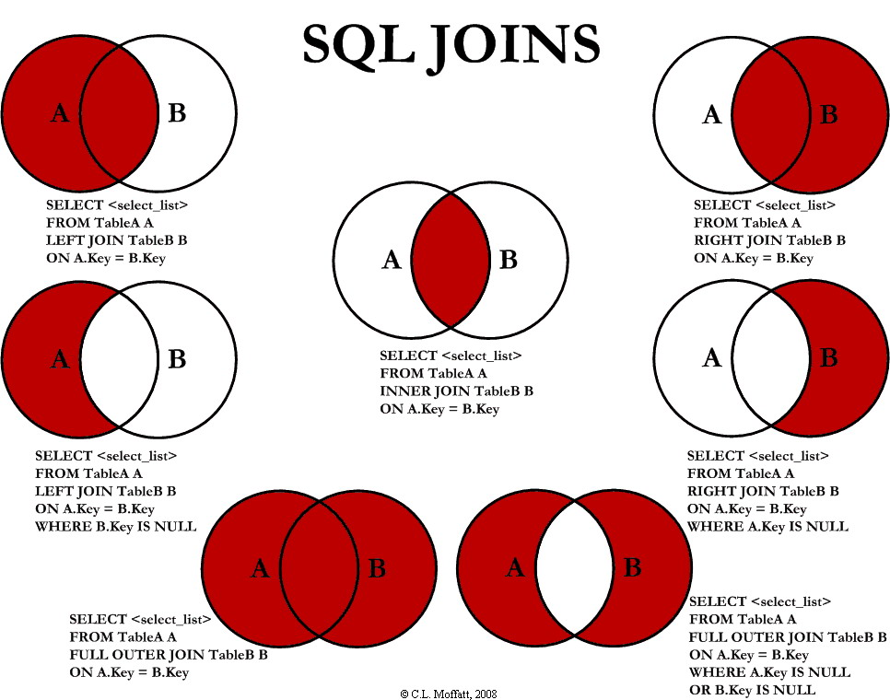

Set Operators – UNION, INTERSECT, and MINUS

- UNION – isn’t a join, but it is a way to combine data from multiple queries into one display
- UNION is useful when you want to see similar data from two or more queries in one display.
- Syntax:
  - SELECT statement
UNION
SELECT statement
- UNION rules
  - The columns in the select statements must contain the same number of items and the data types must be compatible
  - Each SELECT statement can have it’s own WHERE clause.
  - The query as a whole only has one ORDER BY
  - UNION removes duplicate rows, if you want the duplicates to appear you can use UNION ALL
  - If you use an ORDER BY, use the column number
- MINUS
  - Returns rows in one result set that aren’t in the other
- INTERSECT
  - Return rows that are in common.

