8. Design Views

8.1 Create views to store queries in the database
http://docs.oracle.com/cd/B19306_01/server.102/b14200/statements_8004.htm
Views in SQL are a kind of virtual table. We can create a view by selecting fields from one or more tables present in the database. A View can either have all the rows of a table or specific rows based on certain conditions.

What is a view?
- A view is a data object that contains no data of its own – a virtual table whose contents are taken from other tables (or other views) through the execution of a query.
- The tables we've created so far (with CREATE TABLE statements) contain data persistently stored in the database (a permanent base table).
- Once created, views can be used like a table – for SELECT, INSERT, etc. The query that makes up the view is executed whenever the view is used in such a statement.

Advantages of Views
- Security
  - Hide things from users.
  - Allow the system to give different permissions for the same table.
- Simplicity
  - Display results of computed columns.
  - Simplify queries and hide SQL syntax.

Extendibility
This helps in extending the system's functionality without directly impacting the underlying tables and their structures. As a result, the database schema can evolve and grow more easily, facilitating the addition of new features or changes to the system.
- Maintain Data Integrity
- Views can be used to restrict direct access to sensitive information, ensuring that data manipulation occurs in a controlled and secure manner.

Disadvantages of Views
- Performance

  - Complex queries can be run on views. Views can be created with a complex queries. If this is the case they can take a long time to run/complete.

  - Since the complexity of the view is hidden, users are not aware of the additional complexity they are creating by running queries.

- Manageability
  - Views make it easy to create many different layers adding to the complexity of the database. This makes debugging problems difficult.
- Update Restrictions
- When you have a simple view of a database, you can directly access and change the rows and columns of the table it's based on. This means you can easily update the information in the original table using the view.

- On the other hand, if the view is more complicated or has other views within it, you might only be able to read the information from the view. In this case, you won't be able to make any direct changes to the underlying table structure through that view.

How Views Work.
- Essentially a view is just a query with a name. A view is stored in the database without any data.
- When you call or use a view, you are accessing the data stored in the underlying tables. As the data in the underlying tables changes, so too do the values you see through the view.
- When a view is created, the SELECT statement is not actually run at that time – the SELECT statement gets stored and is run when called usually within another SELECT statement.

CREATE VIEW Syntax
- The CREATE VIEW statement:
CREATE [OR REPLACE] VIEW view name As

SELECT statement [WITH { READ ONLY | CHECK OPTION } ]

CREATE [OR REPLACE] VIEW: This part of the statement is used to create a new view. If the OR REPLACE option is included, it means that if a view with the same name already exists, it will be replaced. Otherwise, without it, an error will occur if the view already exists.

view_name: This specifies the name of the view you are creating.
AS SELECT statement: Here, you provide the SELECT statement that defines the data that will populate the view. This can be a simple or complex query, including joins, aggregations, and other operations.

[WITH { READ ONLY | CHECK OPTION } ]: This part is also optional. If you specify WITH READ ONLY, it means that the view is read-only, and you cannot perform any INSERT, UPDATE, or DELETE operations on it. If you use WITH CHECK OPTION, it ensures that any data manipulation (through the view) follows the condition specified in the WHERE clause of the defining SELECT statement.

Overall, the CREATE VIEW statement allows you to create a virtual table that represents the result set of the specified SELECT statement. This is useful for simplifying complex queries, providing security, and managing access to specific data within a database.

CREATE [OR REPLACE] VIEW view_name [(column1, column2, ...)] AS
SELECT column1, column2, ...
FROM table_name
[WHERE condition];

DROP VIEW Syntax
- To get rid of a view: DROP VIEW:
DROP VIEW viewname;

8.2 Describe circumstances under which data can be updated through a view

Modifying data through views
- Commands to modify data through a view may not be understood by SQL in an unambiguous way, so there are some occasions when data cannot be changed through a view.
Before we get into how to determine whether data is updatable in a view, we need to understand
Base table(s): Original tables that the view is created from.
Key preserved table: A key-preserved table is a table in a database where each row from that table will appear in the output of a view at most once, meaning the data won't be repeated in the view. It also means that any unique key or primary key in the original table will also be a unique key in the result of the view. In other words, the keys of the key-preserved table are preserved through a join operation.

To ensure a table is key-preserved, you don't need to include all of its key columns in the view. You just need to make sure that the values in the view are unique for the keys of the table. So, even if you don't select all the key columns in the view, it's important that the values in the view are unique for the keys of the table, just like they are in the original table. This ensures that the integrity of the key values is maintained in the view, preventing duplicates and maintaining the uniqueness of keys.
The key-preserved table will generally be on the "many" side of a one-to-many relationship. And it is often a joining table

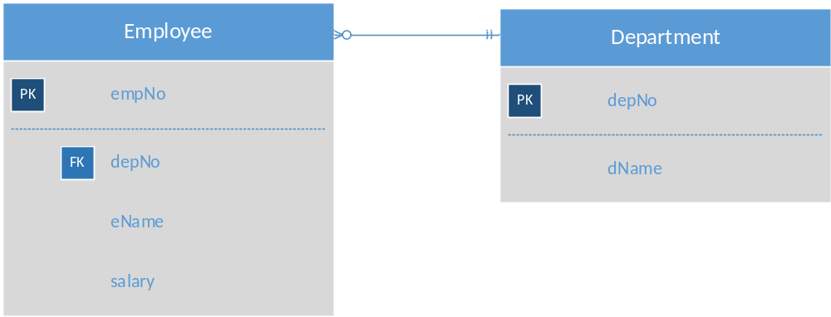

Code:
SQL> CREATE VIEW emp_dept AS
SELECT a.empNo, a.eName, a.salary, a.deptNo, b.dName
FROM Employee a, Department b
WHERE a.deptNo = b.deptNo;

View created.

SQL> SELECT * FROM emp_dept;

EMPNO ENAME SALARY DEPTNO DNAME
--------- ---------- --------- --------- --------------
7369 SMITH 5000 20 RESEARCH
7499 ALLEN 2129.6 30 SALES
7521 WARD 1663.75 30 SALES
7566 JONES 3959.73 20 RESEARCH
7654 MARTIN 1663.75 30 SALES
7698 BLAKE 3793.35 30 SALES
7782 CLARK 3260.95 10 ACCOUNTING
7788 SCOTT 3993 20 RESEARCH
7839 KING 6655 10 ACCOUNTING
7844 TURNER 1996.5 30 SALES
7876 ADAMS 1464.1 20 RESEARCH
7900 JAMES 1264.45 30 SALES
7902 FORD 3993 20 RESEARCH
7934 MILLER 1730.3 10 ACCOUNTING

14 rows selected.
ANSI rules – A view is not updatable if it has any of the following items in the select clause of the View:
- DISTINCT
- An aggregate or analytical function (sum, min, max, count, etc)
  - Note: The computed expression cannot be updated. Other values may be updatable.
- GROUP BY, Order BY or HAVING clause
- References to more than one table (FROM clause, subquery or UNION, etc.)
  - Oracle supports the idea of Updatable Join Views, with restrictions.
    - Can only update one base table at a time.
    - Must have a "Key preserved table"
- References to a view that is not updateable
Rules per Oracle Database 11g: The Complete Reference
http://library.books24x7.com/book/id_26827/viewer.asp?bookid=26827&chunkid=498234295
If a view is based on a single underlying table, you can insert, update, or delete rows in the view. This will actually insert, update, or delete rows in the underlying table. There are restrictions on your ability to do this:
- You cannot insert if the underlying table has any NOT NULL columns that don't appear in the view.
- You cannot insert or update if any one of the view's columns referenced in the insert or update contains functions or calculations.
- You cannot insert, update, or delete if the view contains group by, distinct, or a reference to the pseudo-column RowNum.
You can insert into a view based on multiple tables if Oracle can determine the proper rows to insert. In a multitable view, Oracle determines which of the tables are key-preserved. If a view contains enough columns from a table to identify the primary key for that table, the key is preserved and Oracle may be able to insert rows into the table via the view.
Bottom line: For a view to be updateable, the DBMS must be able to trace any row or column back to its row or column in the source table.
DO Analyzing Views

Creating copies of data
- Rather than create a view, that doesn't make a copy of the data, you may want an independent copy of some data stored in a separate table.

Useful for
- Creating test tables, with sample data
- Extracting information for static reporting, when the querying process is time consuming.

Two options for copying data/tables:
  - Create the table, then use the INSERT … SELECT … syntax
INSERT INTO newTable
SELECT * FROM oldTable;
INSERT INTO newTable (columns)
SELECT columns
FROM oldTable;
  - Use the CREATE TABLE … AS SELECT … syntax
CREATE TABLE newTABLE AS
SELECT Columns
FROM oldTable; (can also add where clause)

Materialized Views
A materialized view differs from an ordinary view because it caches the query results in a concrete table. This table may be updated from the original base tables from time to time. Often referred to as a snapshot.
Not all databases support materialized views.

Advantages:
- more efficient access
This allows for a quick response to even complex queries against this table since the database does not need to go back to the original tables in order to obtain the information.

Disadvantages:
- some data being potentially out-of-date
- updates done to the materialized view are usually logged and performed on the underlying tables on either a scheduled basis or when the view is dropped.

Used when:
- in a data warehousing scenario, where frequent queries of the actual base tables can be expensive.
- the queries that define the view are complicated.

