BioMorphic Instruction Architecture (BIA) – The Constitutional Kernel

# Abstract

This third installment in the BioMorphic Instruction Architecture (BIA) series introduces the concept of compile-time constitutional governance for behavioral expression.

It formalizes the separation of powers within a compile-time sandbox, strictly dividing legislative, judicial, and executive roles.

Unlike traditional architectures where override and behavior control are distributed without structural constraint, BIA enforces a compile-time constitution where no behavior is permitted to exist without passing through structural and permission-based regulation.

This paper defines not only the roles of governance but also where 'the law' resides and how new laws can be introduced without breaking sovereignty.

# 1. Introduction: From Structure to Sovereignty

In the BioMorphic Instruction Architecture, behavior is not written—it is expressed through permission.

No class or module may override, instantiate, or access data behaviorally unless it passes through a structured, multi-branch system.

This system embodies the principles of constitutional governance, where power is divided across three domains:

- Interface: Legislative branch

- Wrapper: Judicial branch

- MemoryAccess: Executive branch

These branches are not metaphors. They are structurally enforced through C++ compile-time features including `friend`, `final`, `private`, and restricted pointer movement.

The result is a closed behavioral system: behavior cannot manifest without approval.

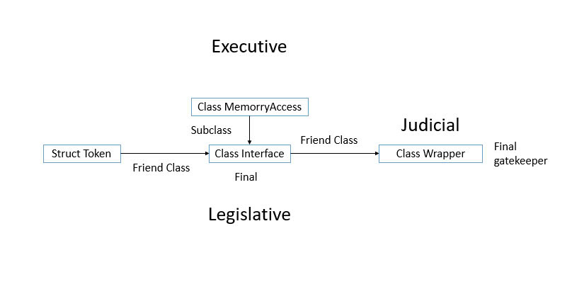

*Figure 1*. Compile-time separation of powers in BIA

# 2. The Three Branches of Compile-Time Power

# 2.1 Legislative Power – Interface

Interface defines which modules are allowed to override what behaviors. It does this through `friend` declarations and controlled token generation.

Importantly, Interface contains the behavioral logic, but does not execute it directly. Instead, it delegates execution authority to the Wrapper.

This ensures the separation of powers: Interface governs what may be done, but never performs it directly.

This delegation makes Interface structurally legislative while still owning the logic that must be conditionally expressed.

# 2.2 Judicial Power – Wrapper

Wrapper evaluates incoming requests (labels) and determines whether they match known permission patterns.

It passes these to Interface for verification and receives behavior logic back, which it may then trigger under structural conditions.

Wrapper acts as both verifier and gatekeeper—its execution is contingent on verified tokens.

# 2.3 Executive Power – MemoryAccess

MemoryAccess acts only when permission has been granted via tokens.

It does not verify logic or grant rights—it only executes, based on tokens that prove verified behavior.

# 3. Where is the Law?

The law in BIA is not a file, function, or constant. It is a structure. It emerges from the system's architecture itself:

- Label formatting defines the naming and identity space of behavior.

- Token architecture encodes rights, origin, and boundaries of power.

- Access specifiers (`friend`, `private`, `final`) create structural enforcements that cannot be bypassed.

These structural decisions constitute a compile-time constitution.

Unlike runtime permission systems, this law cannot be bent, forged, or accidentally violated.

# 4. How to Add New Laws?

New laws are added within the Interface. This is the only class permitted to define new tokens, extend friend access, or authorize new labels.

To introduce a new behavior:

1. The developer must register the label format in Interface.

2. Define which modules may request this label.

3. Issue the token logic and permission rules.

The Judiciary (Wrapper) will recognize it. The Executive (MemoryAccess) will act only if the token aligns.

This ensures all law flows from the correct authority.

# 5. On the Strength of Law: The Token as Legal Power

The strength of a law in BIA corresponds directly to the strength of the token.

A weak token may authorize limited read-only access. A powerful token may grant override permissions or memory redirection.

Tokens should be:

- Structurally unforgeable.

- Issuable only from Interface.

- Strictly typed and non-copyable outside scope.

Thus, token design is law design. Changing token rules means re-writing legislative structure.

# 6. Constitutional Closure

With Interface as the sole lawmaker, Wrapper as its interpreter and executor under delegation, and MemoryAccess as executor of final stateful behavior, BIA becomes a closed legal system.

This eliminates behavioral ambiguity, unapproved override, and architectural corruption.

Behavior does not exist until law says it can. And law exists only in one place.

This separation of power does not merely model politics; it embodies it in software.

# License

CC-BY 4.0

# Acknowledgements

This work was authored by Nguyen Hong Phuc.

GPT-4.5 assisted in language optimization and structural editing under full conceptual direction of the author.