**Title:**

BioMorphic Instruction Architecture (BIA) – System Rules and Pointer-Only Data Flow

**Author:**

Nguyen Hong Phuc

**Abstract:**

This paper extends the BioMorphic Instruction Architecture (BIA) by formalizing its core system rules and data flow design. BIA is a compile-time behavior gating framework inspired by biological gene regulation and CPU instruction control. This second installment outlines the constitutional constraints that govern behavior execution and memory access within BIA. By enforcing token-based permission, strict layer separation, and pointer-only access to memory, BIA eliminates behavioral leakage and runtime ambiguity. This paper clarifies how data is instantiated, accessed, and protected, and why these constraints are essential for constructing a secure and evolvable logic architecture.

1. Introduction

BioMorphic Instruction Architecture (BIA) was introduced as a secure compile-time framework that mimics biological gene expression to control object-oriented behavior. Unlike traditional object-oriented programming in C++, where subclassing and overriding are open by default, BIA requires explicit labeling, permission tokens, and layer verification before any behavior can be expressed.

This paper, with structural and linguistic assistance from GPT-4.5 under the author’s supervision, expands on the rule system and data flow model of BIA. It formalizes the logic that underpins BIA’s behavioral gating and shows how pointer-only memory access is enforced throughout the system.

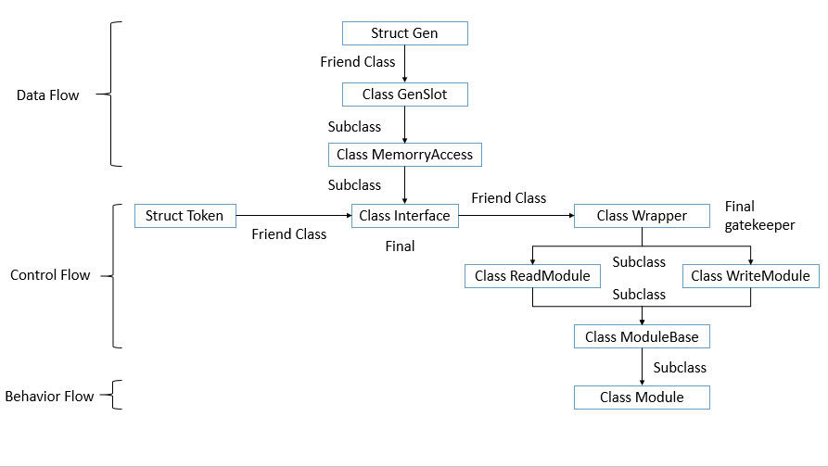

Figure 1: The compile-time structural pipeline in BIA.

2. Rule System: Constitutional Control of Behavior

BIA defines a strict compile-time governance structure composed of immutable rules. These rules are categorized across three architectural layers: Data Flow, Control Flow, and Behavior Flow.

2.1 Data Flow Rules

- Struct Gen defines schema only; it does not perform value assignment or allow access control.

- GenSlot represents a memory container but imposes no behavioral logic.

- MemoryAccess is the only mechanism allowed to allocate and expose RAM to modules.

- Each module has its own isolated RAM. No cross-module access is allowed.

2.2 Control Flow Rules

- Interface is the only unit allowed to generate tokens. It cannot perform execution or verification.

- Token must remain internal to Interface. It cannot be cloned or passed.

- Wrapper evaluates behavior requests and returns a binary decision: pass or reject.

- ReadModule and WriteModule classify requests and route them to Wrapper.

2.3 Behavior Flow Rules

- ModuleBase contains the only overridable interface: getValue() and setValue().

- Module is a final subclass. It implements logic only after Wrapper approval.

- No class may override behavior beyond its tier or access another tier’s memory.

2.4 Absolute Invariant

- Only pointers may be passed. No value transmission is allowed across any boundary.

- Any violation of tier boundaries collapses the architecture.

3. Data Flow: Pointer-Only Access Model

Unlike traditional systems where data flows through values or object copying, BIA enforces pointer-only access to static memory regions instantiated at compile time.

3.1 Data Instantiation

- MemoryAccess initializes memory for a given GenSlot.

- No module may own or reallocate memory. It may only request pointer access through Wrapper.

3.2 Write Flow

- Write permission must be verified by token through Wrapper.

- Upon verification, modules receive pointers to allocated memory regions. Writes occur strictly via indirect pointer access.

3.3 Read Flow

- Read logic mirrors the write process. After Wrapper verification, pointer access is granted.

- Modules may read memory indirectly, ensuring no direct data transmission.

3.4 Rationale

- Ensures memory isolation

- Prevents accidental mutation

- Aligns with biological expression: no signal = no effect

4. Security and Architectural Benefits

**BIA's rule system and pointer-only design provide:**

- Compile-time behavior rejection

- No runtime permission ambiguity

- Zero value-copy errors

- Clean separation between structure, control, and execution

These benefits make BIA suitable for AI logic units, embedded systems, and secure computational sandboxes.

5. Conclusion

By codifying behavior as a compile-time gated expression, and enforcing access only via token-approved pointers, BIA models a biologically inspired and computation-secure architecture. Its rule-based segregation of roles ensures that no module oversteps its domain, and no data is accessed without explicit verification.

Acknowledgements

This paper was written with structural and linguistic assistance from GPT-4.5, under the author’s complete supervision and conceptual control.

**Authorship & Copyright Notice**

This work is solely authored by Nguyen Hong Phuc. The author retains full copyright over the content and grants arXiv and readers the right to distribute and cite the work under standard academic fair use. All concepts, models, and system designs presented are original unless explicitly referenced.

Licensed under the Creative Commons Attribution 4.0 International (CC BY 4.0). You are free to share and adapt the material for any purpose, with proper attribution. More information: https://creativecommons.org/licenses/by/4.0/

**Authorial Note**

While GPT-4.5 was used as a linguistic assistant for refining expression and structure, the entire conceptual framework, system design, and theoretical constructs of the BioMorphic Instruction Architecture (BIA) were solely conceived, authored, and verified by Nguyen Hong Phuc. No generative model contributed to the architectural or philosophical content of this work.