Project for Gesture Based UI Development

**Gesture Controlled Robot**



Muhammad Noman Junaid

Student ID – G00351754

[GITHUB REPOSITORY](https://github.com/Nomijee/Gesture-Based-UI-Project-2021.git)

B.Sc. (Hons) in Computing in Software Development Y4

Galway Mayo Institute of Technology

**Table of Contents**

Purpose of the application 2

Gestures identified as appropriate for this application 3

Hardware used in creating the application 3

Arduino UNO 3

Arduino Nano 3

MPU Accelerometer 4

Motor Controller 5

DC Motor 5

RF Transmitter and receiver 6

Other Components: 6

Architecture for the solution 6

Conclusions & Recommendations 7

FUTURE SCOPE 7

# Purpose of the application

Gesture Controlled Car is a robot which can be controlled by simple human hand gesture. My objective is to make this device simple as well as cheap so it can be produced and used for number of purposes like remote surveillance, military, physically challenged in wheelchairs, eliminate a lot of manual labour in construction field or industries to control trolly and lift etc.

In this project user is able to control motions of the car by wearing controller glove and performing predefined gestures.

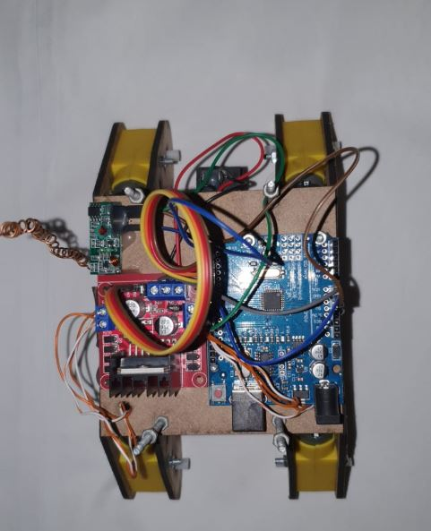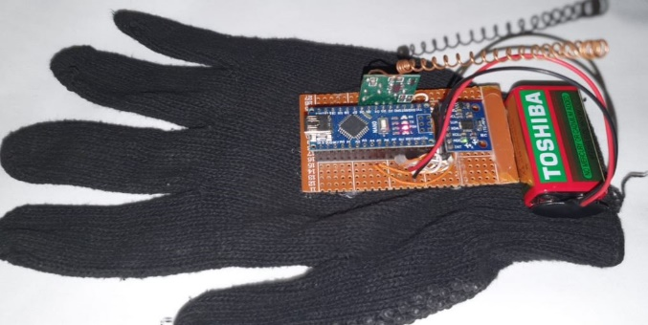

# Gestures identified as appropriate for this application

This gestures-controlled car is developed using MPU6050, which is a 3-axis Accelerometer and 3-axis Gyroscope sensor and the controller part is Arduino Nano. Instead of using a remote control with buttons or a joystick, the gestures of the hand are used to control the motion of the robot. The project is based on wireless communication, where the data from the hand gestures is transmitted to the robot over RF link (RF Transmitter – Receiver pair).

The accelerometer which will detect the gestures of my hand after wearing glove and make the car move accordingly as

* When the hand (accelerometer) tilts forward the car will move forward.
* When the hand (accelerometer) tilts backward the car will move backward.
* When the hand (accelerometer) tilts to the right the car should turn right.
* When the hand (accelerometer) tilts to the left the car should turn left.
* It should stop when it is not tilted in any direction.

As mentioned earlier, the Gesture Controlled Car is a wireless operated robot and has two parts: Transmitter and Receiver. When the car is powered on, the transmitter part, which consists of Arduino, MPU6050, Encoder and RF Transmitter, will continuously monitor the MPU6050 sensor.

This data is captured by the Arduino, which then transmits a corresponding data to the Encoder, based on the orientation of the MPU6050 Sensor. The parallel data received by the encoder is converted into serial data and this serial data is transmitted by the RF Transmitter.

At the receiver section, the RF Receiver receives the serial data and transmits it to the Decoder IC. The Decoder will convert the serial data to parallel data and this parallel data is given to the motor driver IC. Based on the data, the movement of the motors, and hence the movement of the robot is defined.

# Hardware used in creating the application

## Arduino UNO

The [arduino module](https://www.elprocus.com/different-types-of-arduino-boards/) plays an important role in the design of the obstacle avoidance robot using arduino kit. The receiver pin of the arduino is connected to the second pin of ultrasonic sensor and the 1st, 2nd, & 3rd pin of arduino module is connected to the DC motor driver. The common components capacitor and diode are also connected to the arduino module with the help of the battery power supply.

## Arduino Nano

The **Arduino Nano** is a small, complete, and breadboard-friendly board based on the ATmega328 (**Arduino Nano** 3. x). It has more or less the same functionality of the **Arduino** Duemilanove, but in a different package. It lacks only a DC power jack and works with a Mini-B USB cable instead of a standard one.

## MPU Accelerometer

The**MPU6050 IMU**has both **3-Axis accelerometer** and **3-Axis gyroscope** integrated on a single chip.

The gyroscope measures rotational velocity or rate of change of the angular position over time, along the X, Y and Z axis.

The outputs of the gyroscope are in degrees per second, so in order to get the angular position we just need to integrate the angular velocity.

On the other hand, the MPU6050 accelerometer measures acceleration by measuring gravitational acceleration along the 3 axes and using some trigonometry math we can calculate the angle at which the sensor is positioned. So, if we fuse, or combine the accelerometer and gyroscope data we can get very accurate information about the sensor orientation.

**The MPU-6050 module has 8 pins,**

**INT:** Interrupt digital output pin.

**AD0:** I2C Slave Address LSB pin. This is 0th bit in 7-bit slave address of device. If connected to VCC then it is read as logic one and slave address changes.

**XCL:** Auxiliary Serial Clock pin. This pin is used to connect other I2C interface enabled sensors SCL pin to MPU-6050.

**XDA:** Auxiliary Serial Data pin. This pin is used to connect other I2C interface enabled sensors SDA pin to MPU-6050.

**SCL:** Serial Clock pin. Connect this pin to microcontrollers SCL pin. SDA: Serial Data pin. Connect this pin to microcontrollers SDA pin.

**GND:** Ground pin. Connect this pin to ground connection.

**VCC:**Power supply pin. Connect this pin to +5V DC supply. MPU-6050 module has Slave address (When AD0 = 0, i.e. it is not connected to Vcc) as,

**Slave Write address(SLA+W):** 0xD0

**Slave Read address(SLA+R):** 0xD1

## Motor Controller

A Motor Controller is a device that acts as intermediary between your robot's microcontroller, batteries and motors. Some DC Motor Controllers control two motors independently and it is important to note that often only ONE supply voltage can be used to supply both motors (the current can be different)

## DC Motor

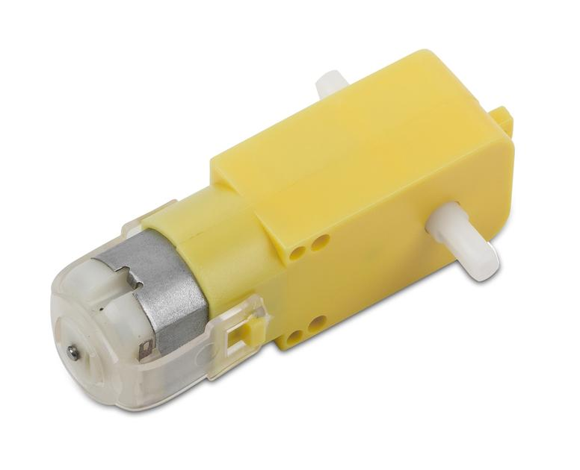

A DC motor consists of an stator, an armature, a rotor and a commutator with brushes. Opposite polarity between the two magnetic fields inside the motor cause it to turn. DC motors are the simplest type of motor and are used in household appliances, such as electric razors, and in electric windows in cars.

## RF Transmitter and receiver

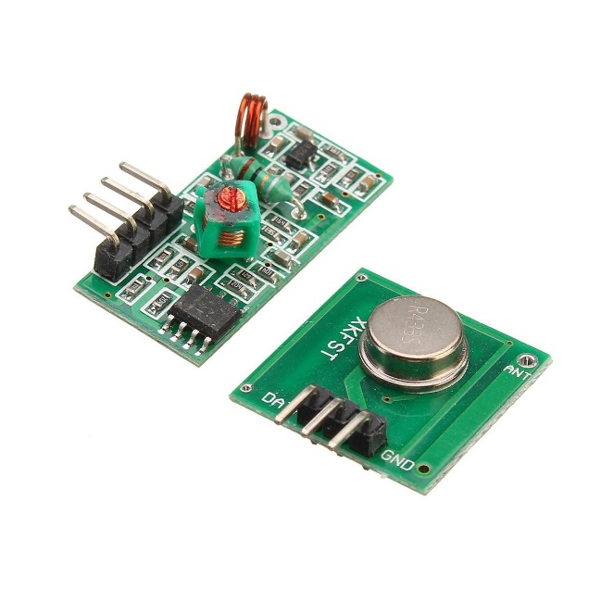

The transmitter/receiver (Tx/Rx) pair operates at a frequency of 433 MHz. The RF transmitter receives serial data and transmits it wirelessly through through its RF antenna. RF receiver receives the transmitted data and it is operating at the same frequency as that of the transmitter.

## Other Components:

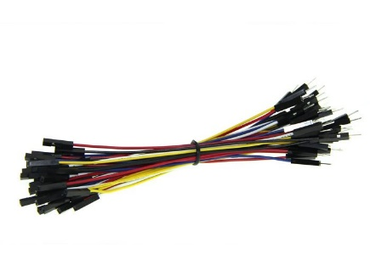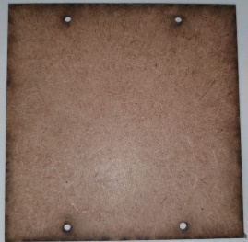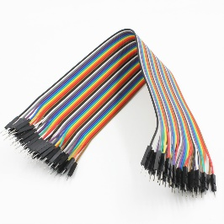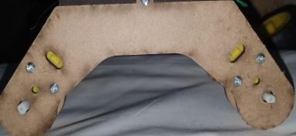

# Architecture for the solution

MPU Accelerometer Sensor

Arduino Nano

Encoder IC

Decoder IC

Arduino UNO

Motor Controller

Motor move Car accordingly

# Conclusions & Recommendations

User can interact with the robot in a more friendly way due to the wireless communication. We can control the car using accelerometer sensors connected to a hand glove. The sensors are intended to replace the remote control that is generally used to run the car. It will allow user to control the forward, backward, leftward and rightward movements, while using the same accelerometer sensor to control the throttle of the car. Movement of car is controlled by the differential mechanism. The mechanism involves the rotation of both forth & rear wheels of left or right side to move in the anticlockwise direction and the other pair to rotate in the clockwise direction which makes the car to rotate about its own axis without any kind of forward or backward motion.

Hand Gesture Controlled Robot System gives a more natural way of controlling devices. Without using any external hardware support for gesture input unlike specified existing system, user can control a robot from his software station.

## FUTURE SCOPE

1) The on board batteries occupy a lot of space and are also quite heavy. We can either use some alternate power source for the batteries or replace the current DC Motors with ones which require less power.

2) The proposed system is applicable in hazardous environment where a camera can be attached to the robot and can be viewed by the user who is in his station. This system can also be employed in medical field where miniature robot are created that can help doctors for efficient surgery operations For more efficient response, threshold values can be used to detect gesture and advanced features such as finger counts that provide different functional commands can be used.

3) Entertainment applications – Most videogames today are played either on game consoles, arcade units or PCs, and all require a combination of input devices. Gesture recognition can be used to truly immerse a players in the game world like never before.

4) Automation systems – In homes, offices, transport vehicles and more, gesture recognition can be incorporated to greatly increase usability and reduce the resources necessary to create primary or secondary input systems like remote controls, car entertainment systems with buttons or similar.