Lab 5 – Support Vector Machine
CS582 – Machine Learning Professor: Emdad Khan, PhD
Team 8
ID | Name
618649 | Nomin Nergui
618048 | Tumenjargal Altanginj
619957 | Temuujin Bat Amgalan
618643 | Temuulen Khuchit

- Suppose that the following are a set of points in two classes:

Plot them and find the optimal separating line. What are the support vectors, and what is
the margin?
Answer 1 – Optimal separating line, support vectors and margin
Code: task1_svm_linear.py → task1_result.png. A hard-margin linear SVM (C = 10⁶) was fitted to the six points.
Optimal separating line
2x₁ + 2x₂ − 3 = 0 i.e. x₁ + x₂ = 1.5
so w = (2, 2) and b = −3.
Support vectors
These are the three points lying exactly on the margin lines:
Point | Class | w · x + b
(1, 1) | +1 | +1
(1, 0) | −1 | −1
(0, 1) | −1 | −1

The remaining points (1, 2), (2, 1) and (0, 0) give +3, +3 and −3. They lie beyond the margin and have no influence on the solution — removing them from the training set produces the identical line.
Margin
M = 2 / ‖w‖ = 2 / (2√2) = 1/√2 ≈ 0.7071
The distance from the boundary to the nearest point is half of this, ≈ 0.3536.
Verification by hand
The closest approach between the two classes is between (1, 1) and the segment joining (1, 0) and (0, 1); the nearest point on that segment is its midpoint (0.5, 0.5), at a distance of 1/√2 ≈ 0.7071. The maximum-margin boundary is the perpendicular bisector of this shortest connection: it passes through (0.75, 0.75) with direction w ∝ (1, 1), which gives x₁ + x₂ = 1.5 — matching the SVM output exactly.
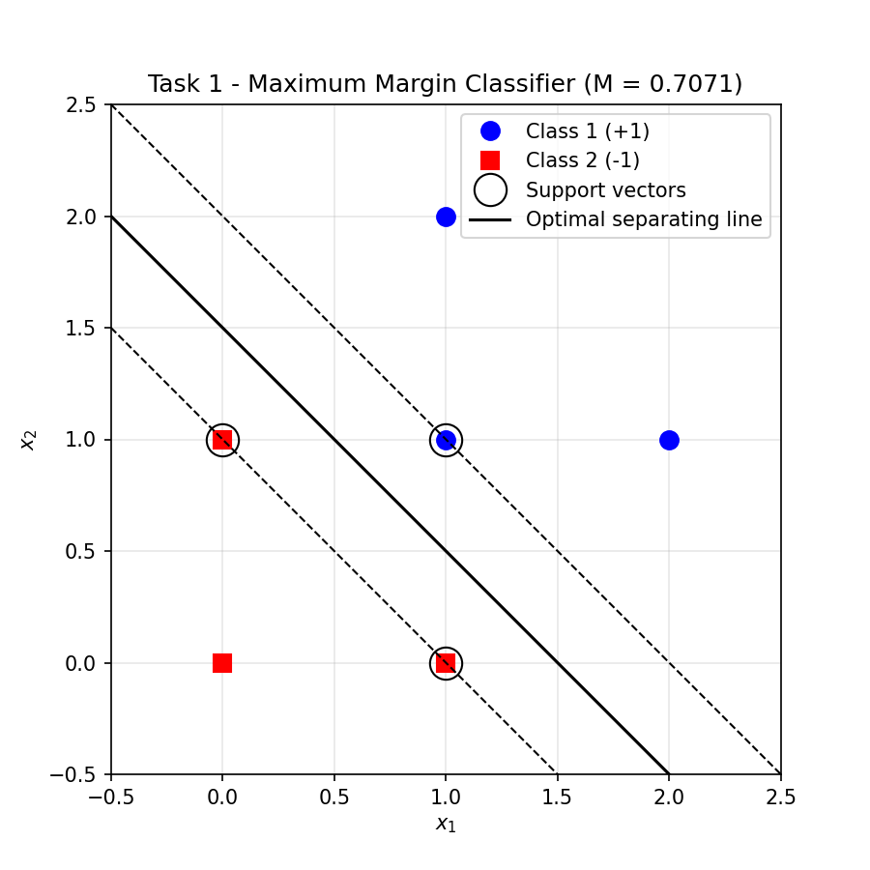
Figure 1 – Maximum margin classifier. Support vectors are circled; the dashed lines are the margin boundaries.

- Use Perceptron code to classify the data in #1. Compare the classification line with the corresponding classification line that you obtained with SVM in problem 1. Explain the differences between the classification line and corresponding M’s for both cases.
Answer 2 – Perceptron compared with the SVM
Code: task2_perceptron.py → task2_result.png. The perceptron (Marsland, Chapter 3; η = 0.25, 20 iterations) was trained five times from different random initial weights.
Run | Line found | Errors | Margin M
0 | 0.5049x₁ + 0.2715x₂ − 0.7603 = 0 | 0 | 0.0563
1 | 0.4917x₁ + 0.5220x₂ − 0.7000 = 0 | 0 | 0.4964
2 | 0.4936x₁ + 0.4526x₂ − 0.5050 = 0 | 0 | 0.0339
3 | 0.5051x₁ + 0.5208x₂ − 0.7291 = 0 | 0 | 0.5742
4 | 0.0467x₁ + 0.0047x₂ − 0.0473 = 0 | 0 | 0.0241
SVM | 2x₁ + 2x₂ − 3 = 0 | 0 | 0.7071

Difference between the classification lines
The perceptron’s line is not unique. All five runs classify every training point correctly, yet each one settles on a different boundary. The SVM returns the same line on every run, whatever the initialisation.
The reason is that the two algorithms optimise different objectives:
• The perceptron only minimises misclassifications. Its weight update is driven by the error term (y − t), so once every point is on the correct side the error is zero, the weights stop changing and training halts. Any one of the infinitely many separating lines is an acceptable stopping point, and which one is reached depends on the random initial weights, the learning rate and the order of the data.
• The SVM minimises ½‖w‖² subject to yᵢ(w · xᵢ + b) ≥ 1. Zero training error is only the constraint; the quantity actually being maximised is the margin. This is a convex quadratic programme with a single global optimum, so the solution is unique.
Difference between the margins M
Every perceptron margin (0.0241 to 0.5742) is smaller than the SVM margin of 0.7071, and none can ever exceed it, because 0.7071 is the maximum attainable for this data.
This is what matters for generalisation. The boundary from run 4 passes within 0.012 of a training point, so a small amount of noise in a new test point would flip its predicted label. The SVM deliberately places the boundary as far from both classes as the geometry allows, which makes it considerably more robust even though both classifiers score identically on the training set.
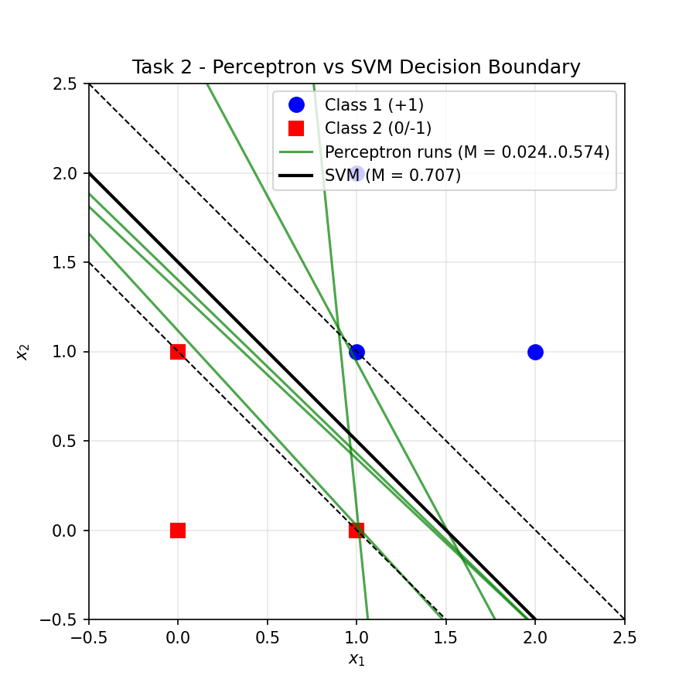
Figure 2 – Five perceptron boundaries (green) against the unique SVM boundary (black) with its margin.

- Now consider the following non-linear labeled data:

Positive labels –
Negative Labels

Now use the following transformation function to transform the data so that it becomes linear:

Show your transformed data and classify using straight lines.
Answer 3 – Transformed data and linear classification
Code: task3_transform.py → task3_result.png.
All four positive points have radius √8 ≈ 2.83 > 2, so the first branch of Φ₁ applies. The negative points have radius √2 ≈ 1.41 ≤ 2 and are left unchanged.
Transformed data
Original (positive) | |x₁ − x₂| | Transformed
(2, 2) | 0 | (2, 2)
(2, −2) | 4 | (10, 6)
(−2, −2) | 0 | (6, 6)
(−2, 2) | 4 | (6, 10)

Original (negative) | Transformed
(1, 1) | (1, 1)
(1, −1) | (1, −1)
(−1, −1) | (−1, −1)
(−1, 1) | (−1, 1)

Classification with a straight line
z₁ + z₂ − 3 = 0 i.e. z₁ + z₂ = 3
Support vectors: (2, 2) from the positive class and (1, 1) from the negative class. Margin: M = √2 ≈ 1.4142.
Check: z₁ + z₂ evaluates to 4, 16, 12 and 16 for the positives (all > 3) and to 2, 0, −2 and 0 for the negatives (all < 3), so the line separates them correctly.
In the original space the positive points sit at the corners of a large square surrounding the negative points at the corners of a small one, so no straight line can separate them. After applying Φ₁ the problem becomes linearly separable. This is the principle behind SVM kernels: change the space rather than the classifier.
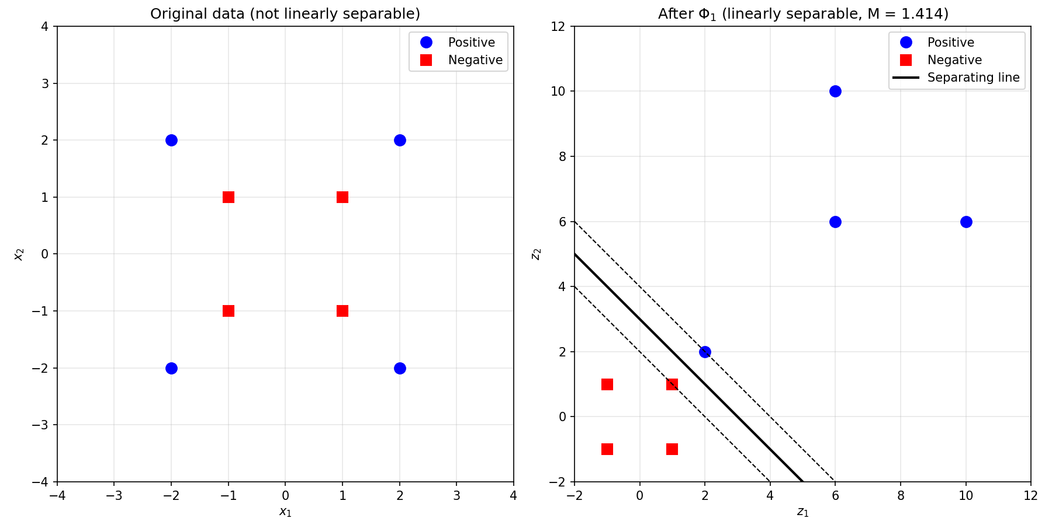
Figure 3 – The data before (left) and after (right) the transformation Φ₁.

- Consider 2 circles – an inner circle surrounded by an outer circle. Obviously, they cannot be classified with SVM. However, you can apply the Kernel Trick (use a polynomial K) to convert the data into a higher dimensional space (3 in this case) – you can use np.dot etc to transform the data.

- Use equations for an outer circle and make say 10 data points on the circle. Do the same for an inner circle.

- Apply a polynomial Kernel to convert the data. Then plot the data.
Answer 4 – Two circles and the Kernel Trick
Code: task4_kernel_trick.py → task4_result.png.
Data
Ten points were generated on each circle using x = (r cos θ, r sin θ) with θ evenly spaced over [0, 2π): the inner circle with r = 1 (label −1) and the outer circle with r = 3 (label +1).
Polynomial kernel
The polynomial kernel K(x, z) = (x · z)² has the three-dimensional feature map
φ(x₁, x₂) = ( x₁² , √2·x₁x₂ , x₂² )
The script verifies the kernel identity numerically: max |K(x, z) − φ(x) · φ(z)| = 2.8 × 10⁻¹⁴, that is, equality to floating-point precision. This identity is exactly the kernel trick — the dot product in the higher-dimensional space can be computed without ever constructing the higher-dimensional vectors. For example (1, 0) ↦ (1, 0, 0) and (3, 0) ↦ (9, 0, 0).
Why this separates the two circles
In the new space the first and third coordinates always sum to the squared radius:
z₁ + z₃ = x₁² + x₂² = r²
Every inner-circle point therefore lands on the plane z₁ + z₃ = 1 and every outer-circle point on the plane z₁ + z₃ = 9. What were two concentric rings in 2D become two parallel sheets in 3D, and any plane between them separates the classes.
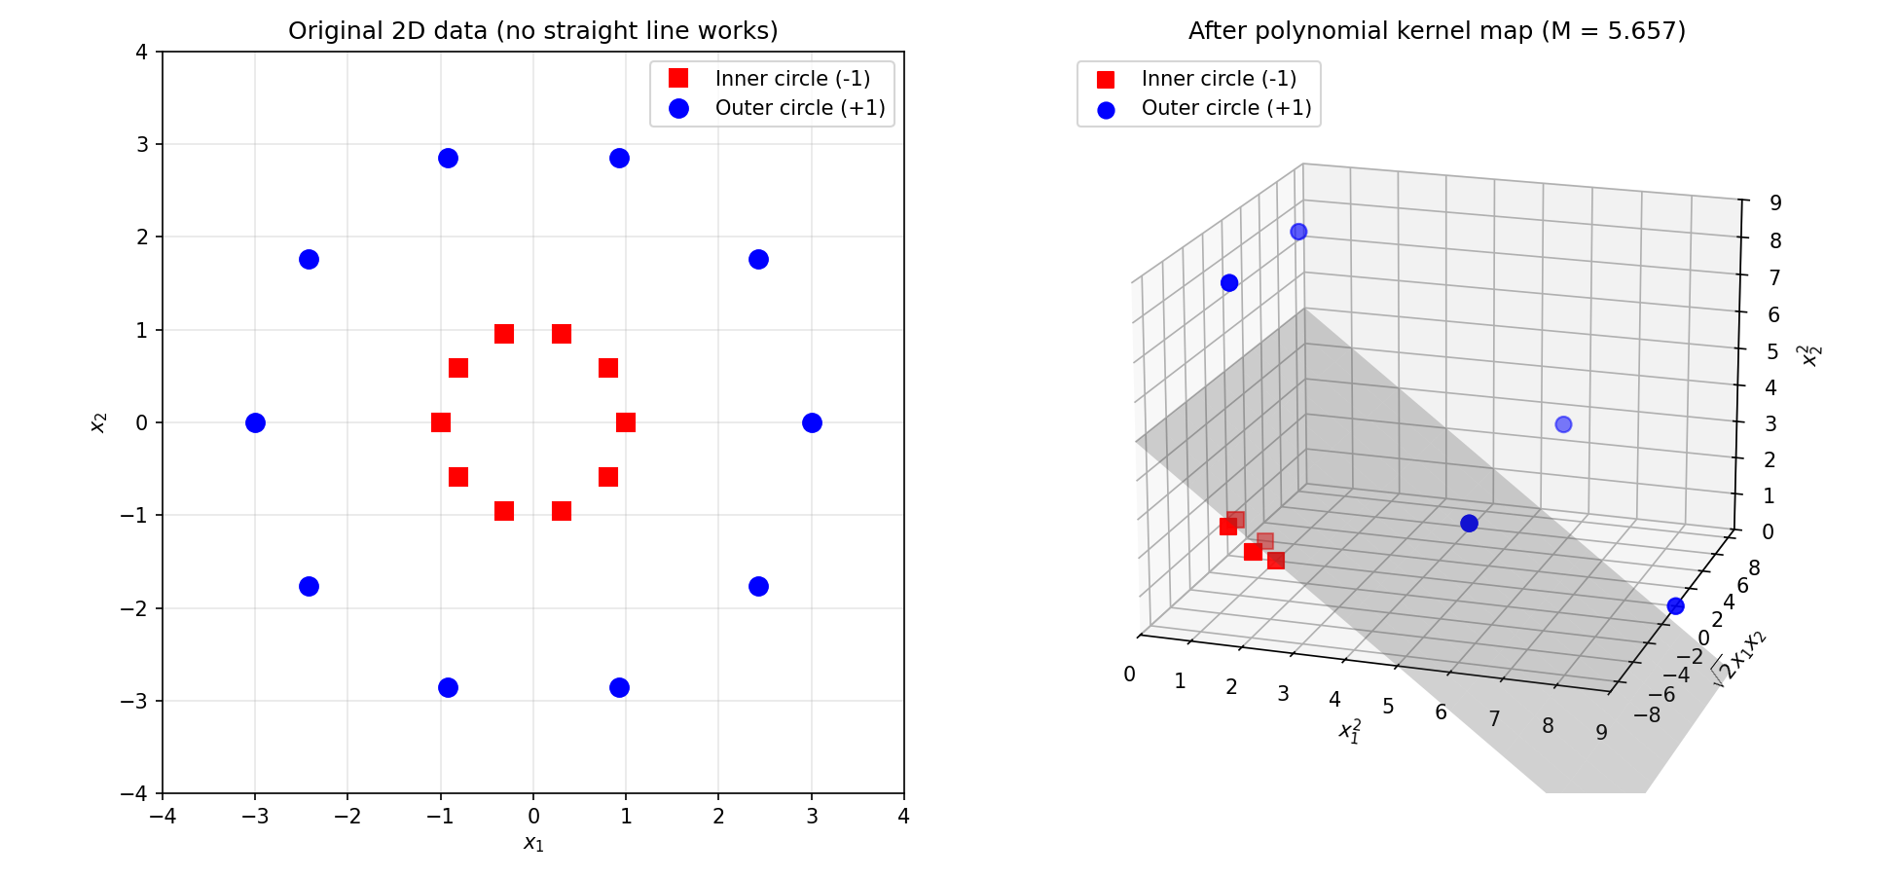
Figure 4 – The two circles in 2D (left) and after the polynomial kernel map, with the separating plane found by the SVM (right).

- Run SVM on data in 4b (optional).
Answer 4b – SVM on the transformed data
A linear SVM fitted in the 3D feature space gives:
Separating plane | 0.25z₁ + 0z₂ + 0.25z₃ − 1.25 = 0
Support vectors | 8
Margin | M = 5.6569 = 4√2
Training accuracy | 1.00

The coefficient of z₂ is zero, as expected: the √2·x₁x₂ direction carries no information about which circle a point lies on, so the SVM ignores it. Dividing through by 0.25 gives
z₁ + z₃ = 5 i.e. x₁² + x₂² = 5
Mapped back to the original 2D space the plane becomes a circle of radius √5 ≈ 2.236 lying between the two rings — midway in squared radius between r² = 1 and r² = 9. A linear boundary in the feature space is therefore a non-linear (circular) boundary in the input space, which is precisely what was required.

