# 

# 

# 

# 

# INSANITY FROGS

# V1.0

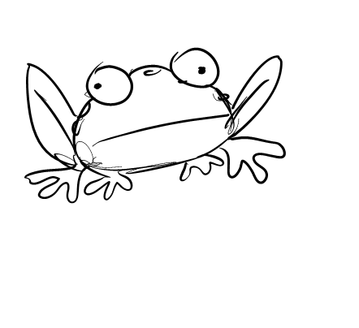

V1.0 - Rough Outline and high concept.

### **Introduction**

Insanity Frogs is a 2D board like game where the player simultaneously controls frogs to jump from square to square in search of their Pond.

The player controls all the frogs at the same time with the arrow keys.

There are many different types of Frogs each behaving differently in reaction to the control of the player.

### **Game Play**

The goal of Insanity Frogs is to safely return the required number of frogs to the safety of their pond.

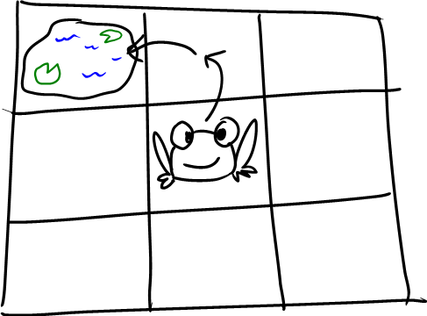

The controls of the game are simply the Arrow Keys or similar:

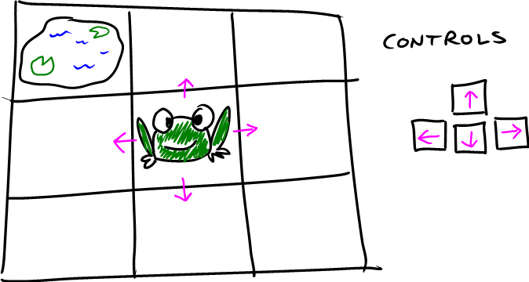

The Green Frog movement it shown above.

The challenge and complexity in the game comes from different types of frogs behaving differently in reaction to the simple controls.



The frogs must be controlled so that the required number of them can jump into the pond (the goal).

The frogs (or the required number of them) must also avoid the deadly squares (such as the lava pits, or spikes).

The game’s challenge and complexity arises from the ability of the designer to create complex gameplay using only the simple mechanics of the different frogs and squares.

Each step in the complexity of the interaction between frogs and squares is revealed to the player incrementally thus being compelling and challenging for the player.

This incremental delivery also teaches the player how the game works and how to play it.

### **Types of Frogs**

#### Green Frog

|  |  |
| --- | --- |
| UP = | UP |
| DOWN = | DOWN |
| LEFT = | LEFT |
| RIGHT = | RIGHT |

The green frog has ‘normal’ controls.

#### Red Frog

|  |  |
| --- | --- |
| UP = | DOWN |
| DOWN = | UP |
| LEFT = | RIGHT |
| RIGHT = | LEFT |

The Red Frog has the inverse controls of the Green Frog.

#### Blue Frog

|  |  |
| --- | --- |
| UP = | UP |
| DOWN = | DOWN |
| LEFT = | RIGHT |
| RIGHT = | LEFT |

The Blue Frog has the inverse X controls and normal Y controls.

#### Yellow Frog

|  |  |
| --- | --- |
| UP = | DOWN |
| DOWN = | UP |
| LEFT = | LEFT |
| RIGHT = | RIGHT |

The Yellow Frog has the inverse controls of the Blue Frog.

#### Purple Frog

|  |  |
| --- | --- |
| UP = | Diag. up/right |
| DOWN = | Diag. down/left |
| LEFT = | Diag. up/left |
| RIGHT = | Diag. down/right |

The Purple Frog jumps diagonally.

#### Rainbow Frog

|  |  |
| --- | --- |
| UP = | RND*up,down,left,right |
| DOWN = | RND*up,down,left,right |
| LEFT = | RND*up,down,left,right |
| RIGHT = | RND*up,down,left,right |

The Rainbow Frog jumps randomly in any straight direction.

#### Yellow & Black Spots Frog

|  |  |
| --- | --- |
| UP = | UP*2 |
| DOWN = | DOWN*2 |
| LEFT = | LEFT*2 |
| RIGHT = | RIGHT*2 |

The YBS Frog jumps with normal controls, but jumps over one square at a time.

#### Green TOAD

|  |  |
| --- | --- |
| UP = | Up every 2nd press |
| DOWN = | Down every 2nd press |
| LEFT = | Left every 2nd press |
| RIGHT = | Right every 2nd press |

The Green TOAD jumps with normal controls, but only on every 2nd button press.

#### Brown TOAD

|  |  |
| --- | --- |
| UP = | Downevery 2nd press |
| DOWN = | Upevery 2nd press |
| LEFT = | Right every 2nd press |
| RIGHT = | Left every 2nd press |

The Brown TOAD is the inverse of the Green TOAD.

### **Types of Squares**

##### Pond:

This is the goal.

Spikes:

Kills the frogs instantly.

##### Mud:

Frogs get “stuck in the mud” for one or more turns.

Rocks:   
Frogs can't jump on these squares.

Portals:   
Set of two portals acting like an instantaneous doorway across the board.

Magic Mushrooms:   
Changes the colour and thus behaviour of the Frogs.

Cages:   
Locks a frog until another Frog can jump into the cage door, freeing the original frog.

Totem Stones:   
Rock squares that can be removed by using switches.

Toggle switches:   
Activates/deactivates Totem Stones.

Pressure Switches:   
Activates/deactivates Totem Stones, but only whilst a Frog is sitting on the switch.

Lava Pits:  
Kills the frogs instantly.

Spikes:

Kills the frogs instantly.

Poisoned Squares:

Slowly kills the frogs over time, depleting their health.

-------------------------------------------------------------------------------------------

ROUGHS:

**** If a toad lands on frog it squishes it?

Boards can be very large starting with many types of frogs.

Frogs could be added during gameplay?

Black toads that take 3 to 5 moves to jump.

Frogs with bombs in their mouths , bombs have numbers on them, must get to pond before the number counts down.