Transportation Systems Analysis
Data Report
Noah Morland
Department of Civil & Environmental Engineering, University of Nebraska-Lincoln
CIVE 202: Civil Engineering Analysis II
Dr. Kaycie Lane
March 31, 2026

Contents
1. Introduction and Background 3
2. Methods 3
2.1 NGSIM 3
2.2 NHTS 4
3. Results and Discussion 5
3.1 Vehicle Type Composition 5
3.3 Vehicle Age by Make 6
3.4 Vehicle Age by Household Location 7
3.5 Time-Series 8
3.7 Practical Interpretation 9
4. References 10

1. Introduction and Background
Transportation planning depends heavily on understanding how people travel and how vehicles behave on roadways. To support this, the Federal Highway Administration (FHWA) collects and maintains several large datasets that describe both vehicle ownership trends and real-world driving behavior. Two of the most widely used datasets are the National Household Travel Survey (NHTS) and the Next Generation Simulation (NGSIM) dataset (FHWA).
The NHTS dataset provides information on household vehicles and travel characteristics across the United States. It includes data such as vehicle type, fuel type, vehicle age, and whether households are in urban or rural areas. This dataset is useful for identifying overall trends for the area. Which is important for future planning, funding, and finding potential impacts on the environment. The NGSIM dataset focuses on vehicle movements collected at different time intervals. It includes position, speed, and acceleration data (FHWA).
The objective of this project was to use Python for both the NHTS and NGSIM datasets in order to create visuals to help understand the data. Visualizations were created to highlight key trends in vehicle characteristics from the NHTS data and to examine driving behavior using time-series analysis from the NGSIM data. A simulation using the Intelligent Driver Model (IDM) was performed to compare observed vehicle behavior with modeled follower behavior (FHWA).

2. Methods

2.1 NGSIM
The analysis for this project used the Next Generation Simulation (NGSIM) dataset, which contains time-based data describing the motion of a lead vehicle and a following vehicle. The main variables selected were time (s), leader position (m), follower position (m), leader speed (m/s), follower speed (m/s), leader acceleration (m/s²), and follower acceleration (m/s²). Time was used as the x-axis on each plot. Position, speed, and acceleration were chosen because they describe how each vehicle moves over time. In addition, the vehicle gap (m) was calculated as the difference between the leader and follower positions. This was included because it represents the spacing between vehicles, which is important for understanding car-following behavior.
The dataset was loaded into Python using pandas, and the structure of the data was checked using functions such as .head(), .info(), and .describe() to make sure the data was organized correctly and contained no errors. A single vehicle pair was selected by filtering the dataset using a specific trajectory number. This was done by creating a subset of the data where the trajectory number matched the chosen value. This step allowed the analysis to focus on one leader-follower interaction instead of multiple overlapping trajectories. The gap distance was then calculated by subtracting the follower position from the leader position at each time step.
Several plots were created to visualize the data. For the position vs. time graph, the seaborn lineplot function was used to plot both the leader and follower positions against time on the same graph. Time was placed on the x-axis and position on the y-axis, with separate lines for each vehicle. The same approach was used for the speed vs. time and acceleration vs. time plots, again using sns.lineplot to show how each variable changed over time for both the leader and follower vehicles.
The vehicle gap was plotted against time using plt.plot from matplotlib, since the gap was calculated separately from the original dataset. Time was placed on the x-axis and gap distance on the y-axis, and a single line was used to show how the spacing between vehicles changed over the observation period.
To compare all variables at once, a dashboard-style plot was created using plt.subplots to organize multiple plots into a 2x2 layout. This included position, speed, acceleration, and gap distance plots in one figure, making it easier to see how the variables relate to each other. Each subplot was labeled with axis titles and legends to clearly distinguish between the leader and follower data. The same sequence of steps: importing the dataset, selecting a trajectory, calculating the gap, and generating time-series visualizations.

2.2 NHTS
The National Household Travel Survey (NHTS) dataset was used to explore general transportation trends. This dataset includes a mix of categorical and numerical information related to households, vehicles, and travel behavior. After loading the data into Python using pandas, the dataset was examined using functions such as .head(), .describe(), and .isnull().sum() to understand the structure of the data, identify important variables, and check for missing values. In some cases, rows with missing values in specific columns like as vehicle make were removed using .dropna() so that certain plots could be created correctly.
A variety of graphs were created to visualize both categorical and continuous variables. A count plot was created using sns.countplot to show how frequently each vehicle type appears in the dataset. Boxplots were made using the pandas boxplot function to compare vehicle age across different vehicle makes, and additional formatting such as rotating axis labels was applied to improve readability. A violin plot was created using sns.violinplot to compare the distribution of vehicle age between urban and rural households, showing both the spread and density of the data.
Histograms were also created using plt.hist to show the distribution of vehicle age, including an overlayed version where urban and rural data were plotted together for comparison using transparency. Bar charts were constructed by first counting values with .value_counts() and then plotting them using .plot() to show distributions such as fuel type. A pie chart was also created using plt.pie to show the proportion of different vehicle types in the dataset. All plots were created using matplotlib and seaborn, with consistent formatting such as figure size, labels, and titles to improve clarity.
Because all of this was done in Python, the process can be repeated by following the same sequence of steps for similar projects.

3. Results and Discussion

3.1 Vehicle Type Composition
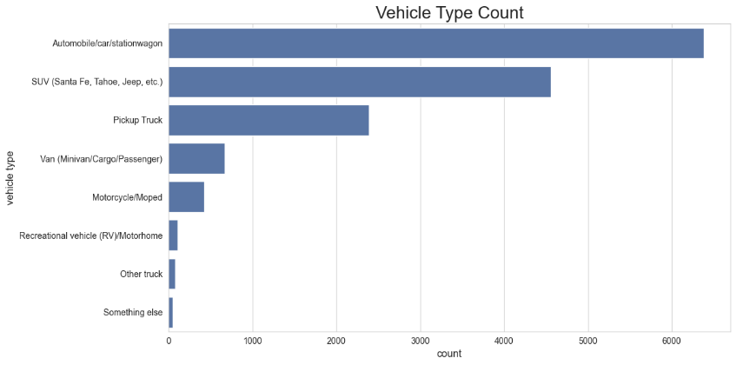
Figure 1 Vehicle Type Count bar chart
Figure one shows the distribution of Vehicle types. From the graph it is visible that station wagons are the largest category at about 6,400. SUVs are second at about 4,500. Pickup Trucks are third at about 2,400. Overall, the distribution is concentrated these three categories. Motorcycles and Van’s both have more than 500 each and the remaining types make up only a small share of observations.
3.2 Vehicle Fuel Type Distribution
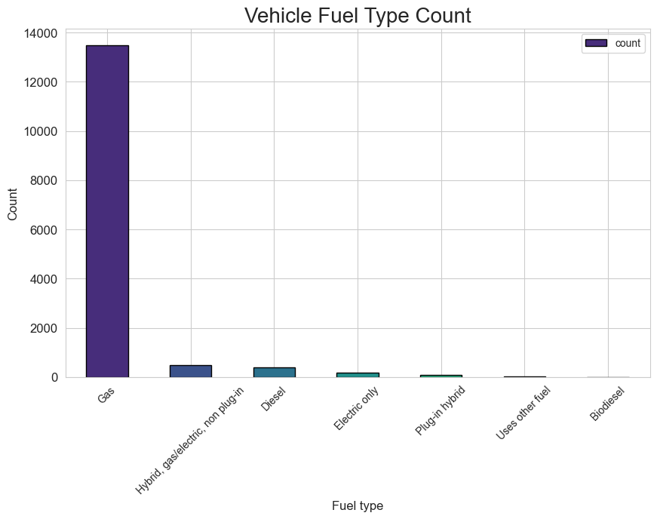
Figure 2 Distribution of fuel types
Figure two shows the distribution of fuel types. Gas is the largest category at about 13,500 vehicles. It can also be seen that there are about the same amount of Hybrid and Diesel vehicles on the road. Overall, the distribution is dominated by Gas and the remaining fuel types make up a much smaller observation of all the vehicles.

3.3 Vehicle Age by Make
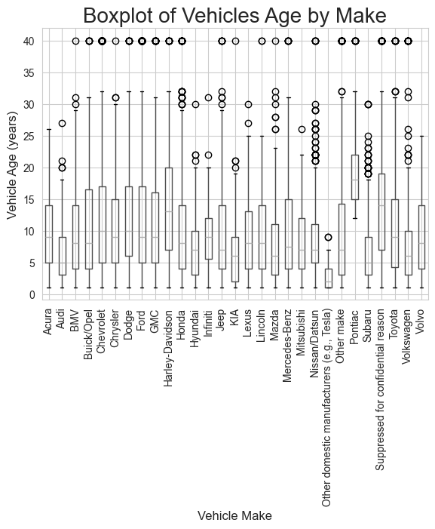
Figure 3 Distribution of vehicle age by make

Figure three shows the distribution of vehicle age for vehicle make. From the boxplot it is visible that most vehicle makes have similar age ranges, with median vehicle ages generally falling in the 5-to-15-year range. Several vehicle makes show wide spreads and higher outliers, indicating that while many vehicles are relatively new, there are also many older vehicles still on the road. The boxplot shows that vehicle age distribution is consistent across makes, but older vehicles are present for nearly every manufacturer. Tesla vehicles are exempt from the regular trend as many of them are less than 5 years old. Pontiacs are also exempt from the regular trend, but for the opposite reason as most of them are older than 20 years old.

3.4 Vehicle Age by Household Location

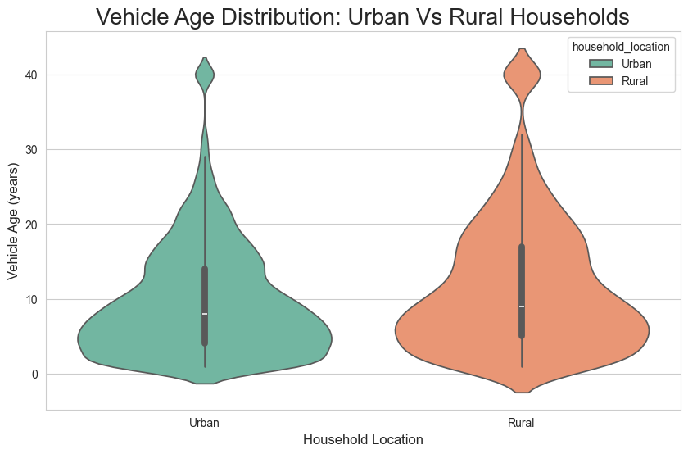
Figure 4 Distribution of vehicle for urban and rural areas
Figure four shows the distribution of vehicle age by household location. From the violin plot it is visible that both urban and rural households have similar overall age ranges, with most vehicles falling between about 0 and 20 years old. Rural households show a slightly wider spread toward older vehicle ages compared to urban households, meaning that older vehicles are more common in rural areas. Urban households appear to have a higher concentration of newer vehicles, with more density in the lower age range. The plot shows that vehicle ages are broadly similar between urban and rural households, but rural households tend to keep vehicles on the road for a longer period, and urban households have newer vehicles.

3.5 Time-Series
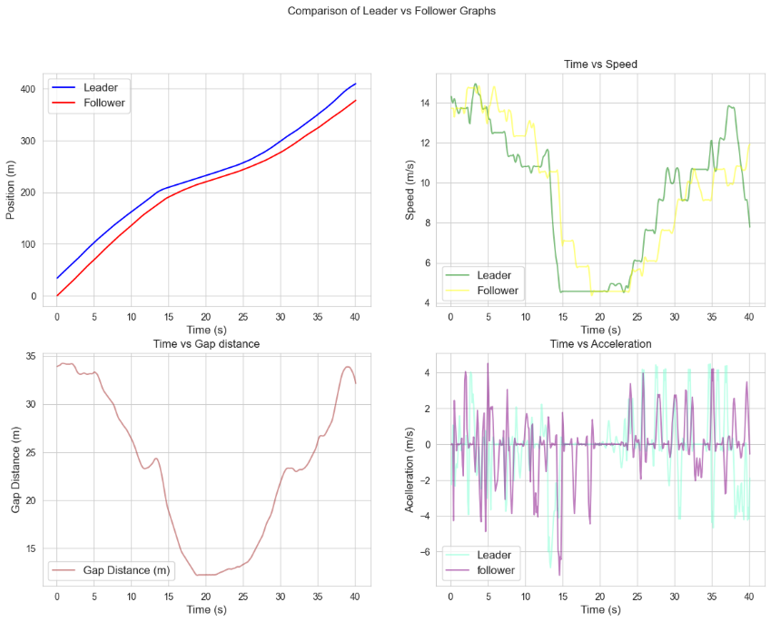
Figure 5 TIme series data for trajectory number 2
Figure five shows the time-series comparison between the leader and follower vehicles for trajectory number 2. From the plots it is visible that the follower closely tracks the leader’s position over time, maintaining a relatively consistent separation. In the speed plot, both vehicles follow similar trends, with noticeable periods of deceleration where speeds drop significantly before increasing again. The gap distance decreases steadily during the middle of the trajectory, reaching a minimum before increasing again toward the end, indicating that the follower closes in on the leader and then falls back. The acceleration plot shows frequent fluctuations for both vehicles, suggesting constant adjustments by the follower in response to the leader’s behavior. The time-series plots show that the follower responds directly to changes in the leader’s speed and acceleration while maintaining a reasonable following distance throughout the trajectory. This trend indicates that there is an obstruction causing traffic around the 20 to 25 second mark before picking back up to regular speed.
3.6 IDM Simulation vs Observed Follower

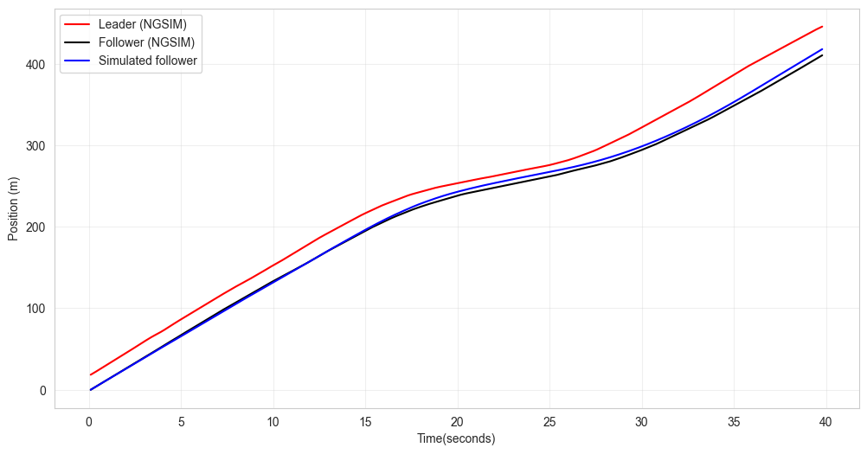
Figure 6 IDM simulation for leader and follower position
Figure six shows the comparison between the observed leader and follower positions and the simulated follower position from the IDM. The simulated follower closely follows the observed follower position throughout most of the trajectory. The simulated follower maintains a similar shape and slope to the observed follower, indicating that the model is capturing the main movement trends of the vehicle. Small gaps between the simulated and observed followers appear during periods of changing slope, suggesting slight delays in the model response during speed changes. The figure shows that the IDM provides a reasonable approximation of follower position for this trajectory while smoothing out some of the sharper changes seen in the real data.

3.7 Practical Interpretation
The NHTS results provide useful insight into the composition and characteristics of the vehicle fleet that transportation agencies must plan for. Because the NHTS is designed to represent household vehicles and travel patterns at a national scale, it allows agencies to base planning decisions on how people actually own and use vehicles across the United States. Knowing that most vehicles are passenger cars, SUVs, and pickup trucks helps planners prioritize roadway design standards, parking dimensions, pavement loading assumptions, and safety considerations around these vehicle types. Fuel type information is useful for understanding current energy use and for planning future infrastructure investments, such as where electric vehicle charging stations may or may not be necessary based on current adoption levels (Federal Highway Administration [FHWA]).
Vehicle age information is important for understanding the condition of the fleet using the transportation system. The EPA Automotive Trends Report shows that vehicle age and technology are closely tied to emissions performance and fuel use, making fleet age an important factor in evaluating environmental and energy impacts of transportation systems Older vehicles tend to have fewer safety features and higher emissions, which can influence maintenance planning, emissions reduction strategies, and enforcement or incentive programs. Differences between urban and rural vehicle age distributions highlight how transportation needs and vehicle replacement behavior vary by location, which can lead to more targeted planning (U.S. Environmental Protection Agency [EPA], 2026).
The NGSIM time-series analysis is useful for understanding how drivers respond to changing traffic conditions in real time. Observing how speed, acceleration, and vehicle spacing change helps identify how congestion forms and dissipates on roadways. This type of information can be used traffic operations, signal timing, and evaluating roadway performance under different conditions.
The IDM simulation demonstrates how real driving behavior can be approximated using mathematical models. This is especially useful for traffic simulation software and planning studies when collecting real-world data is costly or impractical. Being able to simulate vehicle behavior allows engineers to test roadway designs, traffic control strategies, and safety improvements before they are implemented in the field in a way that is replicable and cost efficient.

4. References
U.S. Environmental Protection Agency (EPA). (2026). Automotive Trends Report. Office of Transportation and Air Quality.
https://www.epa.gov/system/files/documents/2026-02/420s26001.pdf
Federal Highway Administration (FHWA). National Household Travel Survey (NHTS).
U.S. Department of Transportation. https://www.fhwa.dot.gov/policyinformation/nhts.cfm

