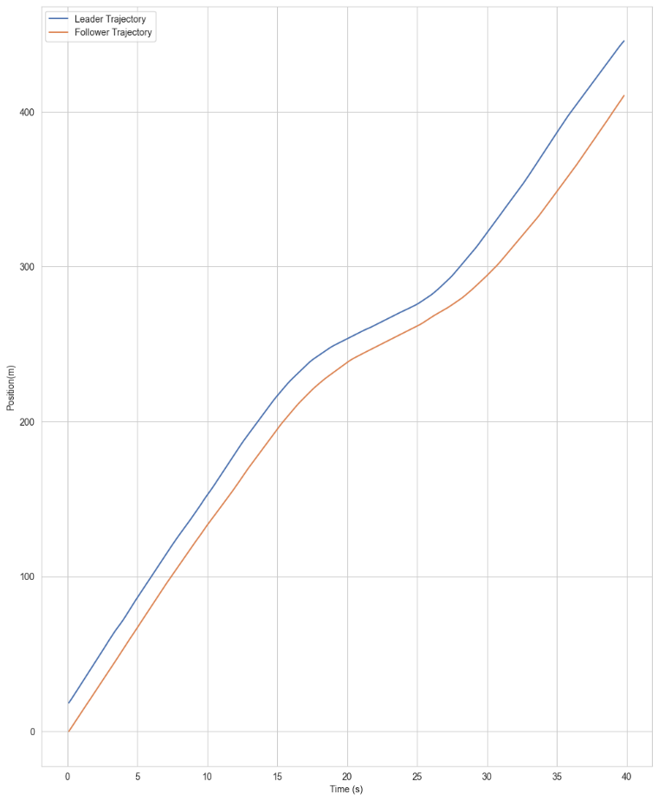

Professional Engineers
The graph shows position versus time trajectories for a lead vehicle and a following vehicle over a forty second period. Both trajectories are smooth and continuous, indicating uninterrupted traffic flow conditions. The vehicle gap between the leader and follower remains relatively consistent throughout the observation period, which reflects stable car following behavior. Changes in speed occur gradually and are closely tracked by the following vehicle. The position does not stop at any point during the graph, which indicates consistently low traffic and no stops during the test.
Town Board
The graph shows how two vehicles move along the same road over time, with one vehicle traveling ahead of the other. The distance between the two vehicles, called the vehicle gap, represents how much space a driver keeps from the vehicle in front. This gap stays about the same size throughout the observation, which means drivers have enough time and space to react safely. Both vehicles move smoothly without stopping or suddenly sloing down. This pattern would show that traffic on this road flows efficiently and safely under the conditions shown.

