**🥥🍫 1. Chocolate Coconut Smoothie**

**Ingredients:**

* 1 cup coconut milk (or any milk)
* 1 frozen banana
* 2 tbsp cocoa powder
* 2 tbsp shredded coconut
* 1 tbsp honey or maple syrup
* A handful of ice cubes

**Instructions:**  
Blend everything until smooth and creamy. Serve chilled!  
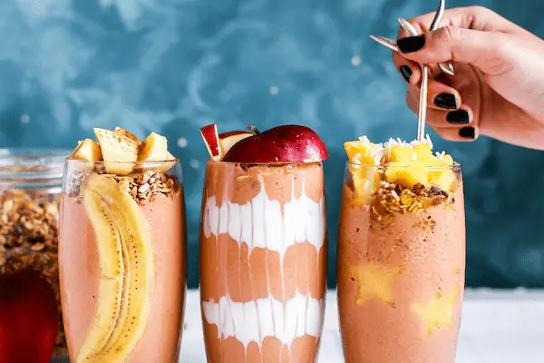

**🥥🍌🍫 2. Chocolate Banana Coconut Smoothie**

**Ingredients:**

* 1 cup coconut water
* 1 ripe banana
* 1 tbsp cocoa powder
* 2 tbsp Greek yogurt or coconut yogurt
* 1 tbsp almond butter (optional)
* Ice cubes as needed

**Instructions:**  
Blend until silky smooth. Perfect for a quick breakfast or snack!

**🥥🍯🍫 3. Coconut Chocolate Protein Smoothie**

**Ingredients:**

* 1 cup coconut milk
* 1 scoop chocolate protein powder
* 1 tbsp shredded coconut
* 1 tbsp chia seeds
* 1 tsp vanilla extract
* Ice cubes

**Instructions:**  
Blend all ingredients until smooth and creamy. Great for post-workout fuel!

Want me to help you make a **recipe card**, or suggest more smoothie combos?

**You said:**

straberru

**ChatGPT said:**

Looks like you meant **strawberry** — here are some tasty strawberry smoothie recipes that blend perfectly with chocolate and coconut!

**🍓🥥🍫 1. Strawberry Coconut Chocolate Smoothie**

**Ingredients:**

* 1 cup fresh or frozen strawberries
* 1 cup coconut milk
* 1 tbsp cocoa powder
* 1 tbsp shredded coconut
* 1 tbsp honey or maple syrup
* Ice cubes

**Instructions:**  
Blend everything until smooth and creamy. Enjoy chilled!  
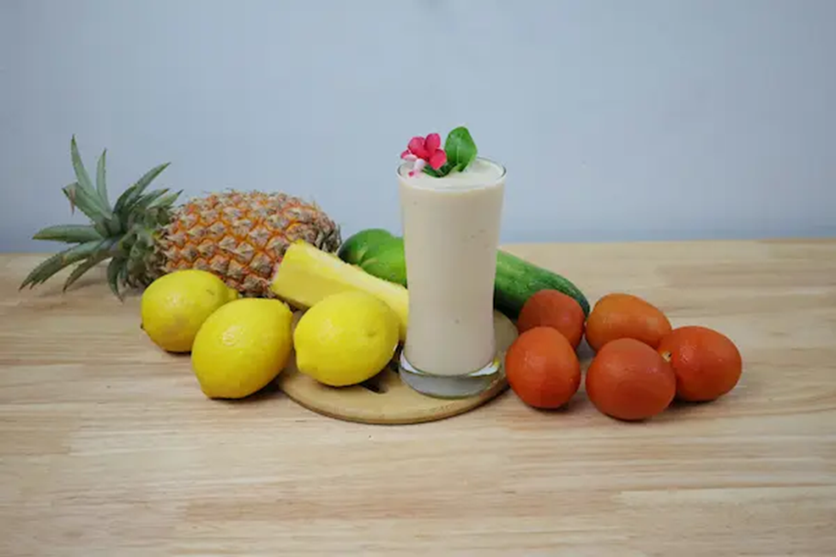

**🍓🍌🥥 2. Strawberry Banana Coconut Smoothie**

**Ingredients:**

* 1 cup strawberries
* 1 ripe banana
* 1 cup coconut water or milk
* 2 tbsp Greek or coconut yogurt
* Ice cubes

**Instructions:**  
Blend until silky smooth. Refreshing and energizing!

**🍓🥤 3. Strawberry Protein Smoothie**

**Ingredients:**

* 1 cup strawberries
* 1 scoop vanilla or chocolate protein powder
* 1 cup almond or coconut milk
* 1 tsp honey
* Ice cubes

**Instructions:**  
Blend well and serve cold.

