**Project Specification Document**

**Flyaway An Airline Booking Portal**

*End of Phase 2-Become a back-end expert Project*

**Student: Nomula Devendhar**

devendharreddy.n@gmail.com

*Full Stack Java Developer*

*Master’s Program*

**Table of Contents**

1.Project Details and Objective

2.Sprint Planning

3.Project Overview

4.Implemented Concepts

5.Flow Chart

6.GitHub Link

7.Web Output Screenshots

# Project Objective

As a Full Stack Developer, design and develop an airline booking portal named as

FlyAway

# Project Details

FlyAway is a ticket-booking portal that lets people book flights on their website. As a Full Stack Developer, design and develop an airline booking portal named as FlyAway. Use the GitHub repository to manage the project artefacts.

The Website should meet the following requirements

* A search form in the homepage to allow entry of travel details, like the date of travel, source, destination, and the number of persons.
* Based on the travel details entered, it will show the available flights with their ticket prices.
* Once a person selects a flight to book, they will be taken to a register page where they must fill in their personal details. In the next page, they are shown the flight details of the flight that they are booking, and the payment is done via a dummy payment gateway. On completion of the payment, they are shown a confirmation page with the details of the booking.

For the above features to work, there will be an admin backend with the following features:

* An admin login page where the admin can change the password after login, if he wishes
* A master list of places for source and destination
* A master list of airlines
* A list of flights where each flight has a source, destination, airline, and ticket price

The goal of the company is to deliver a high-end quality product as early as possible.

# Sprint Planning and Tasks Achieved

The project is planned to be completed in 1 sprint. Tasks assumed to be completed in the sprint are:

* Creating the flow of the application
* Initializing git repository to track changes as development progresses.
* Writing the Java program to fulfill the requirements of the project. • Testing the program with different kinds of User input • Pushing code to GitHub.
* Creating this specification document highlighting application capabilities, appearance, and user interactions.

# Project Overview

The main objectives of this Projects are

* To gain an understanding of core concepts of the Java Programming

Language (abstraction, polymorphism, inheritance, and encapsulation),

* Embrace the Eclipse Integrated Development Environment (IDE),
* Understand the Agile software development life cycle
* Gain familiarity with Java data structures for object-oriented applications.
* Familiarize with concepts of Servlets , Servlet Filter, HTTP Methods
* Familiarize with concepts of Web Application Development using Servlets
* Learn Maven, A build Automation tool and handle dependencies
* To learn SQL and do CRUD Operation(Create, Read, Update, Delete)
* To learn Hibernate and design a Web Application with Servlets and perform CRUD Operation (Create, Read, Update, Delete).
* To learn Hibernate’s Association and perform @OnetoOne , @OnetoMany

@ManytoMany Associations with different tables of a database

* Learn Cookie and HTTP Session Management and Perform User’s Session

Management in a Web Application

* Learn MVC Architecture and build a Web Application using Servlets, JSP, Hibernate and perform CRUD Operations

# Implemented Concepts

This section will highlight the Java concepts used to create the FlyAway .

HTML, CSS, JSP,JSTL, Servlets, Servlet Filters, HTTP Methods, SQL, JDBC Connection for SQL , Java Persistence API, Hibernate, HTTP Sessions and Cookie , Servlet MVC Architecture ,Collections framework, Flow Control,

Exception Handling.

# Flow Chart

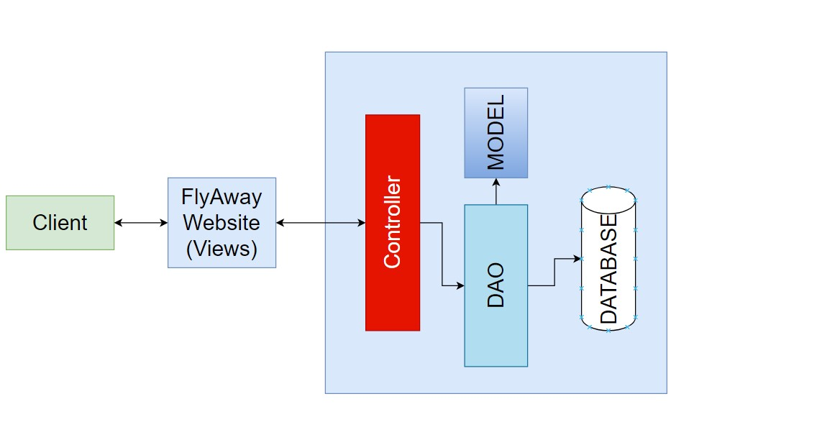

# GitHub link

I have pushed my code and associated documentation to the following GitHub link:

https://github.com/NomulaDevendhar/Simplilearn-Flayaway.git

**Web Output Screenshots**

# Web Application Screenshots Home Page

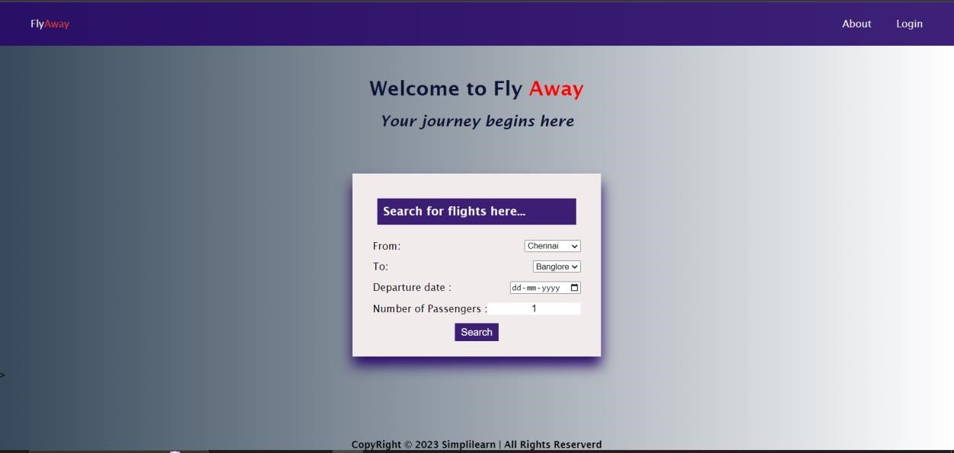

# Default Credentials of Admin

**Email Id: admin@flyaway.com**

**Password: admin**

# However admin should change his password after login

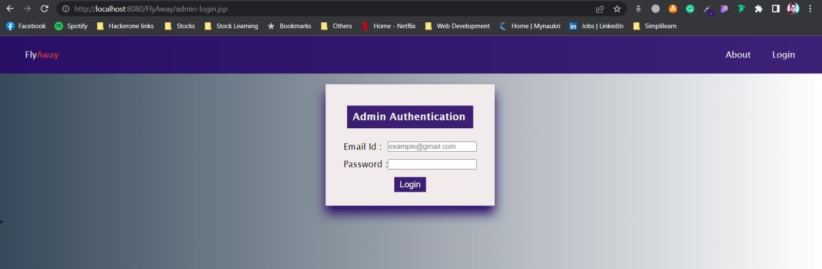

# Admin Dashboard

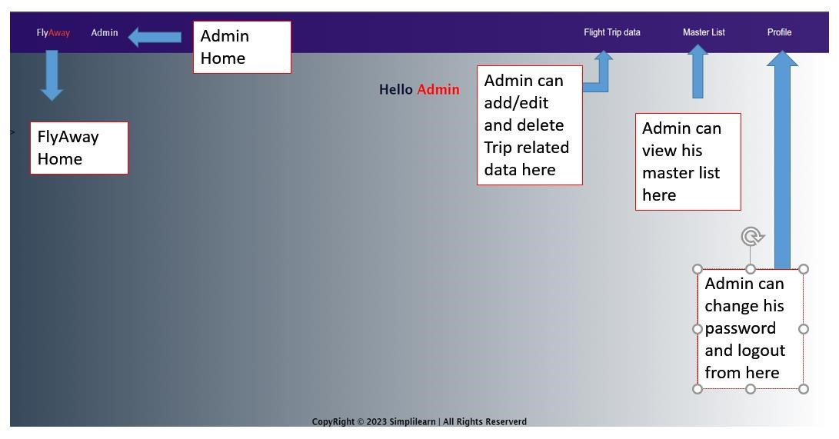

# Admin Navigation Bar Drop Down menu

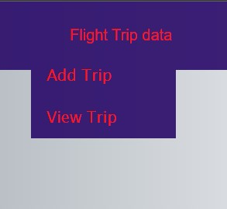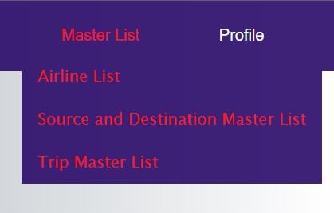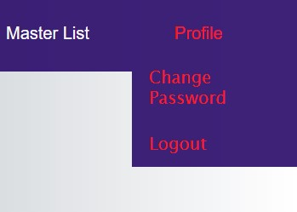

# Flight Trip Data

**Admin can add trip details here:**

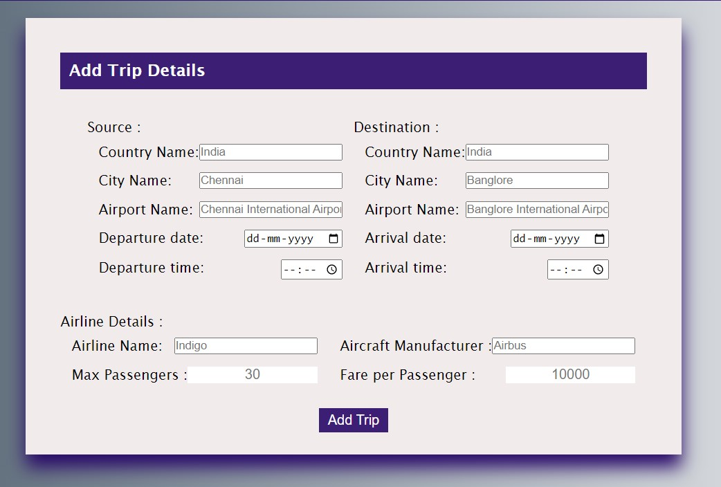

# View Trip data Admin can edit / delete trips from here. He can also use search by to narrow the results

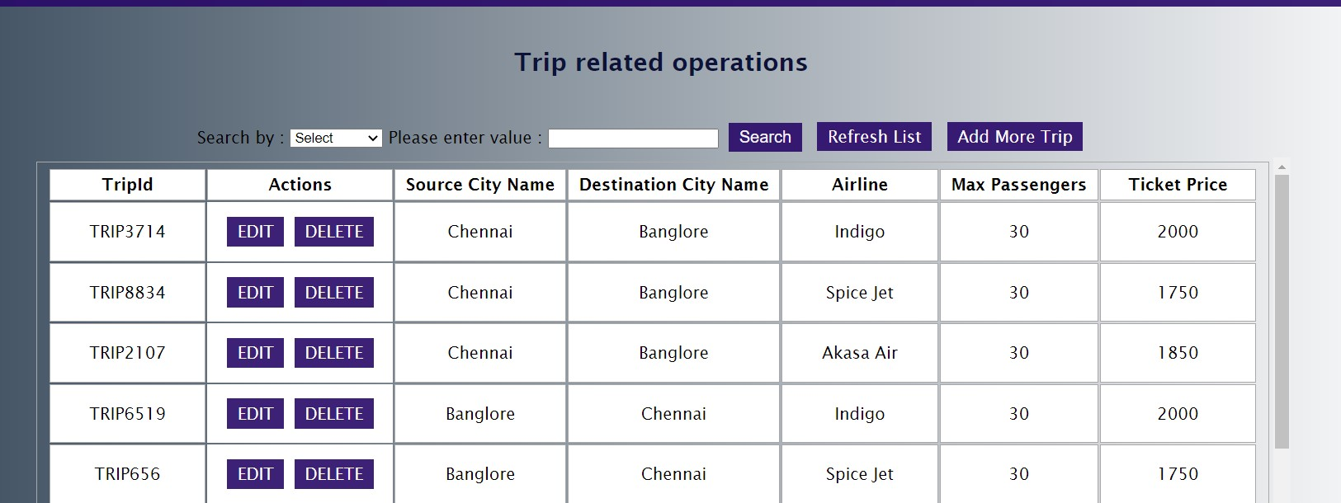

# Edit Trip data If admin clicks on edit respective trip data will be retrieved and can be edited

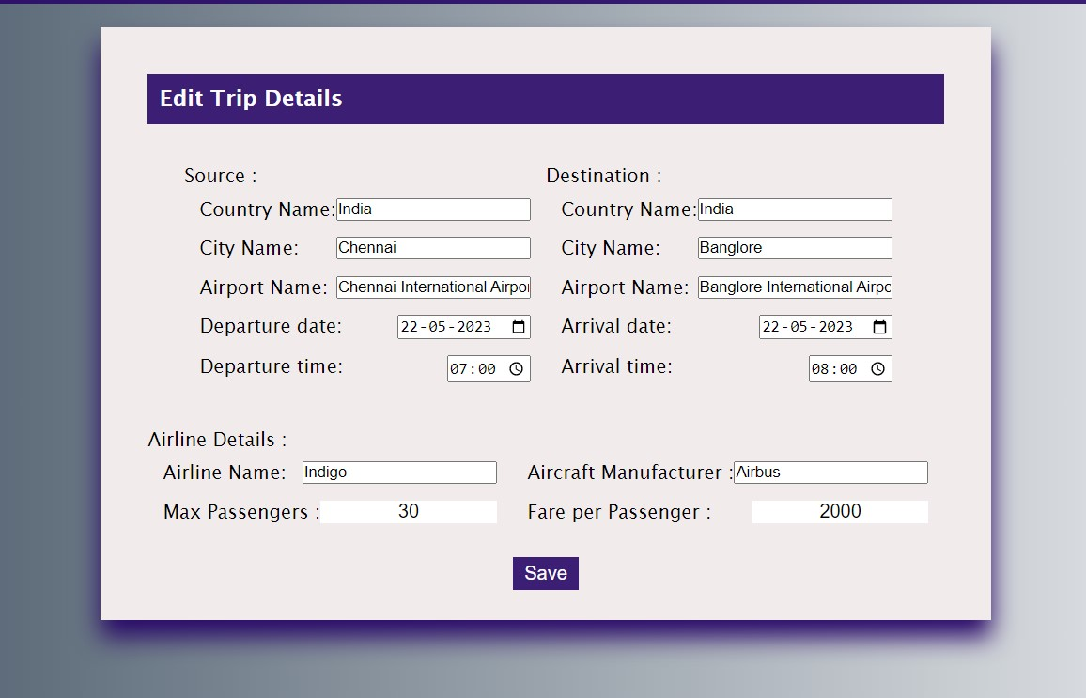

# Airline Master List

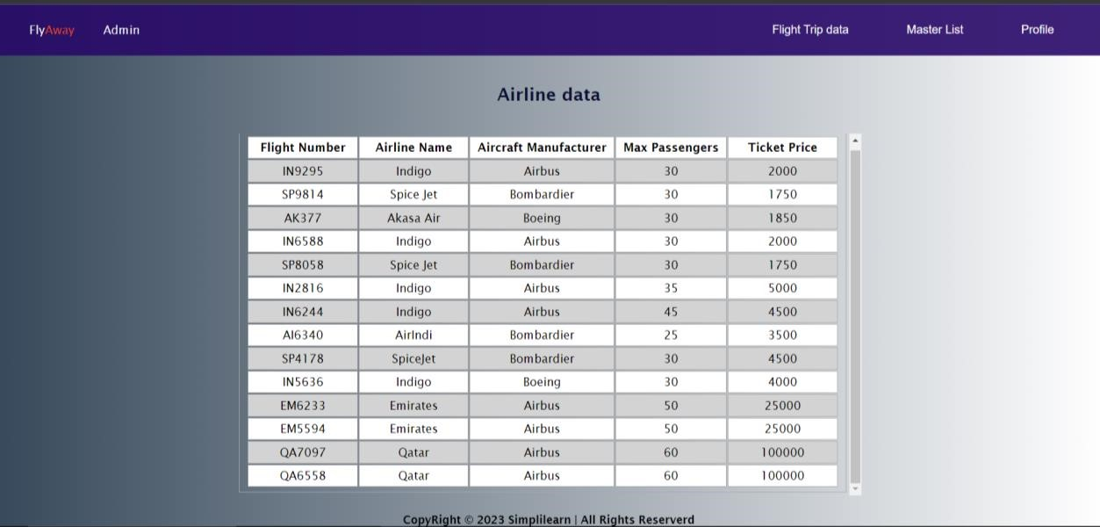

# Source and Destination Master List

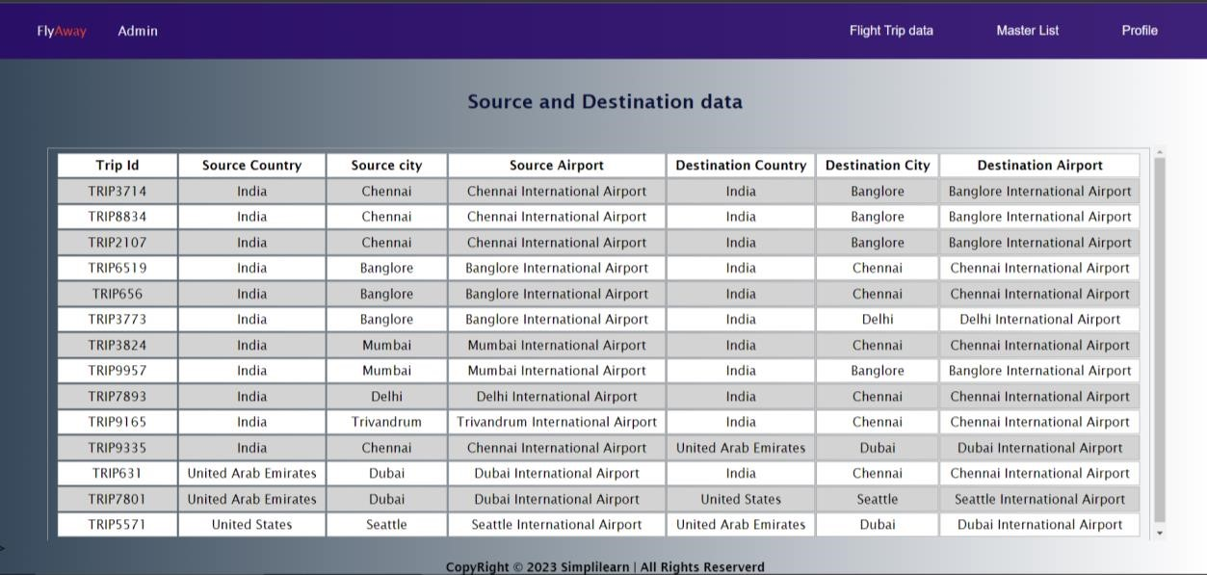

# Trip Master List

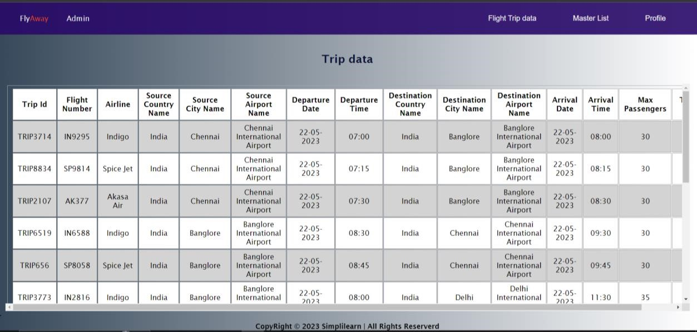

# Change Password If the admin changes his password he will be logged out and prompted that he is logged out and redirected to login page.

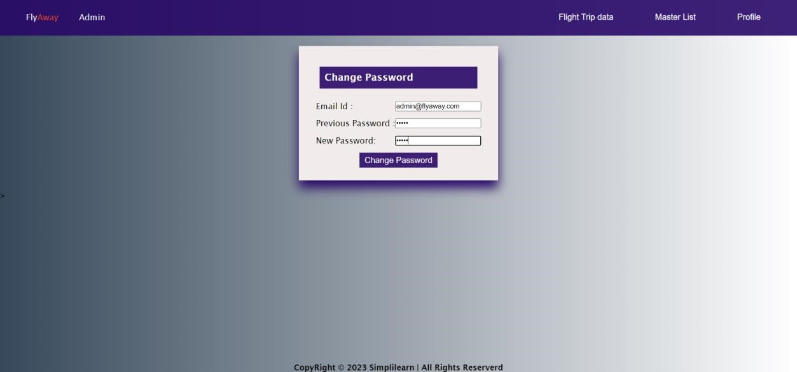

# After Changing Password

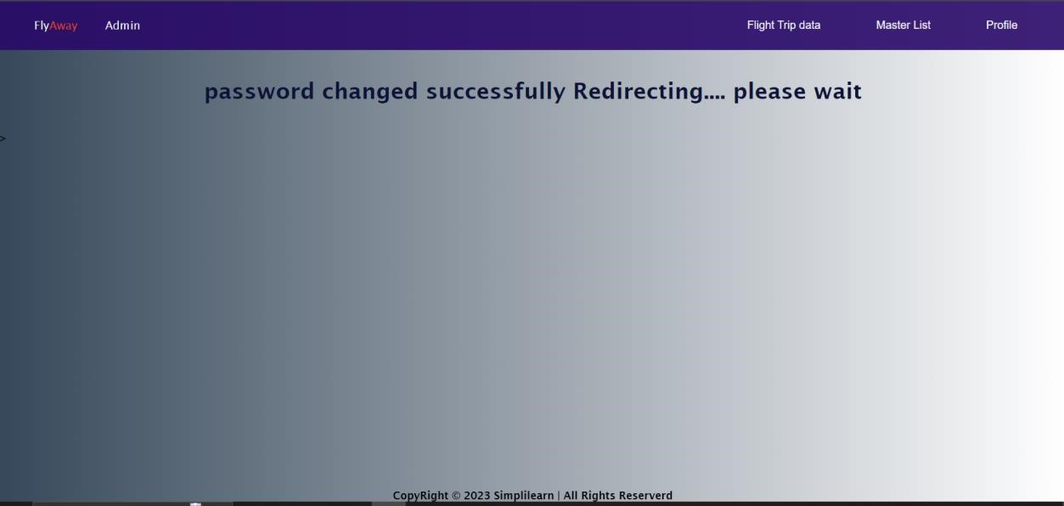

# Logout If admin clicks logout he will be prompted and automatically redirected to login page within 3 sec timer

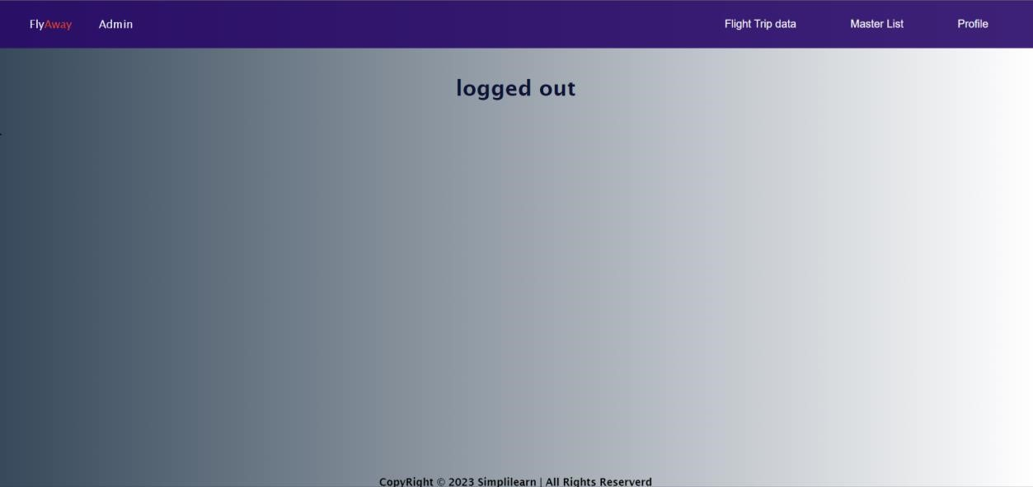

# FlyAway Home Page

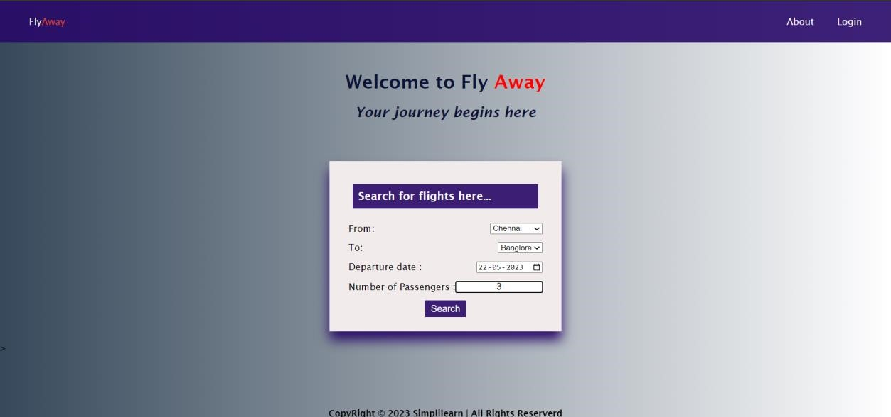

# FlyAway Search Results

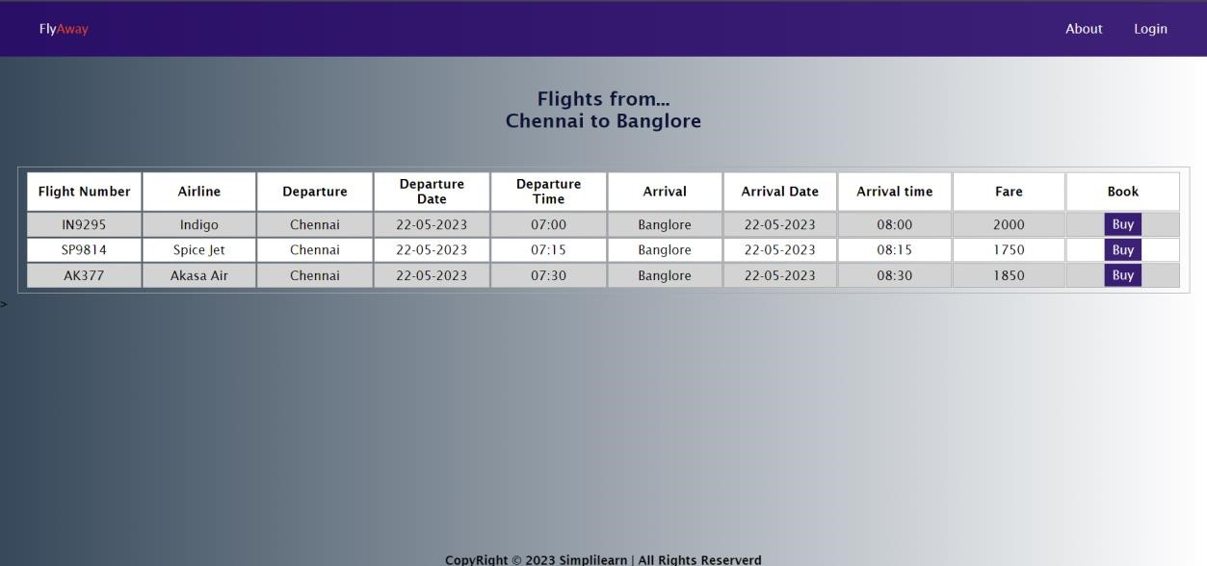

# Buying tickets = when user clicks “Buy” he will be automatically asked to either login or register himself.

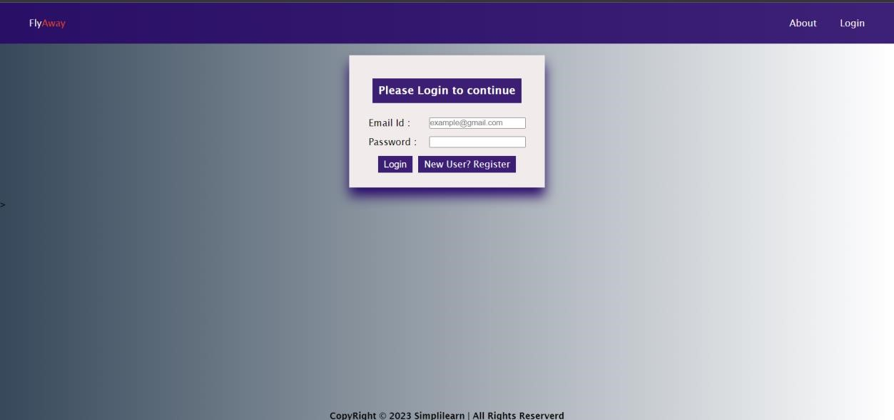

# User Registration.

# 

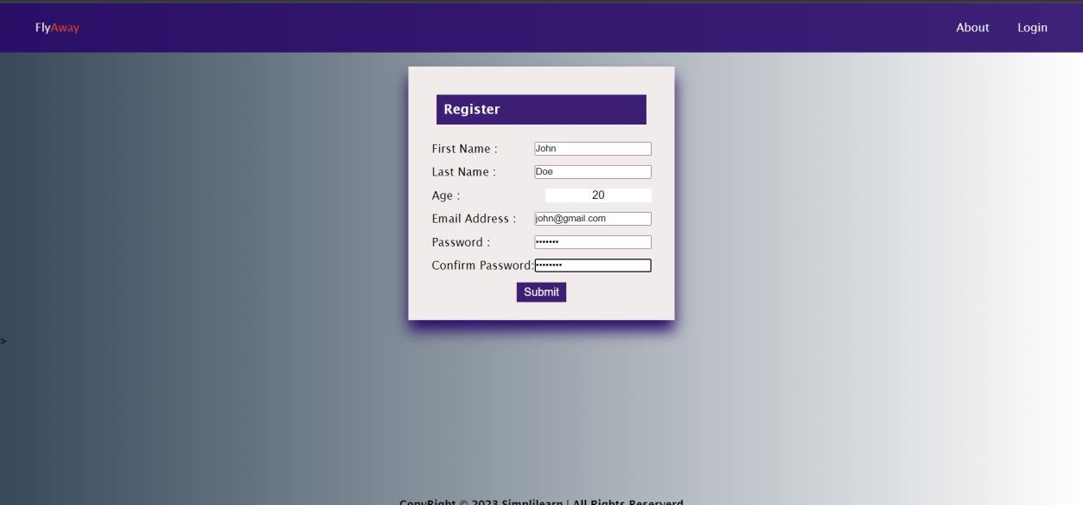

# When I click register I will be logged in with the same credentials and redirected to proceed with my ticket booking. As I am logged in, Note that navigation bar has changed.

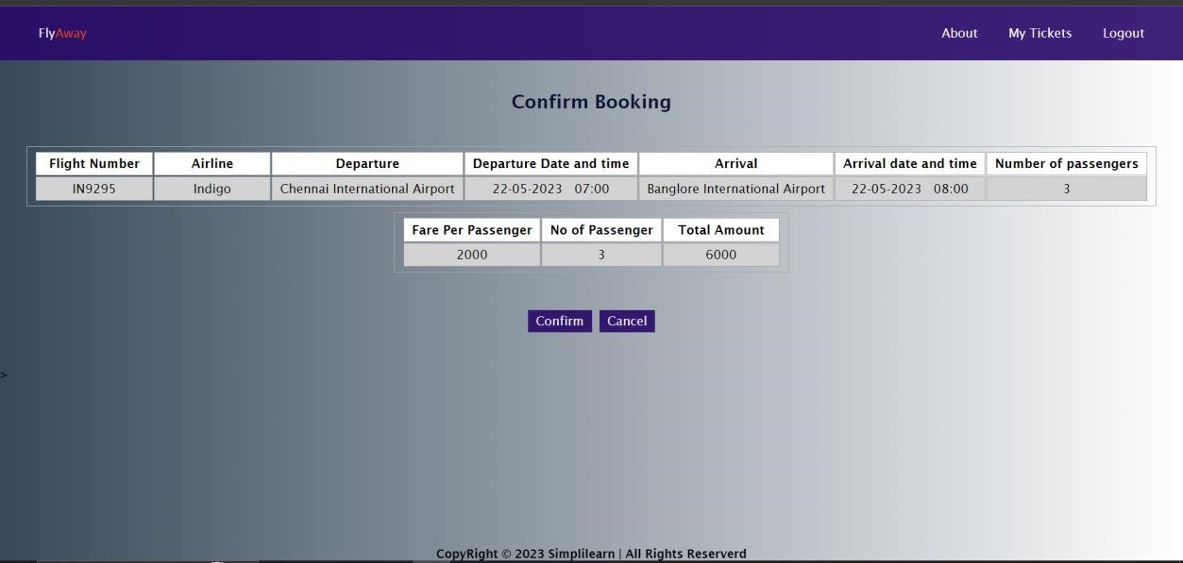

# Register Payment Gateway

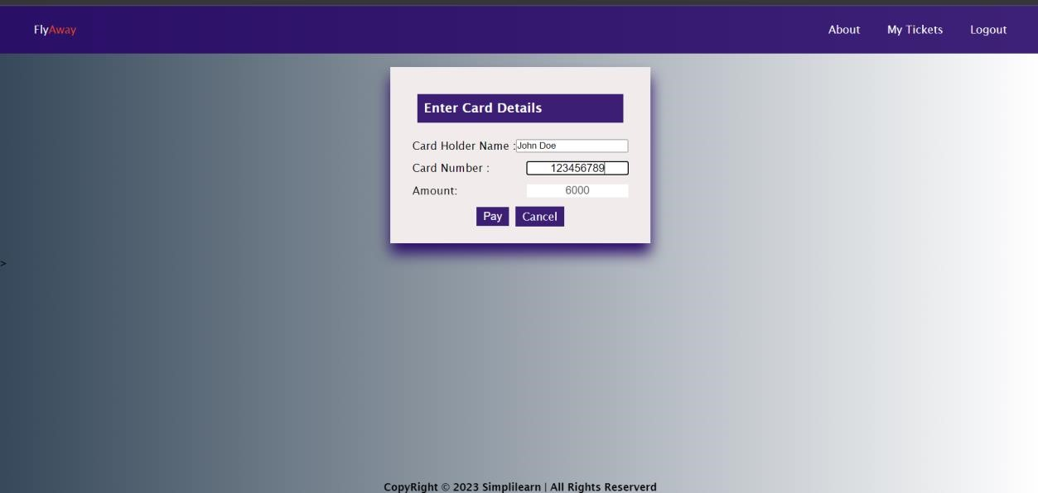

# Confirm booking and confirmation status

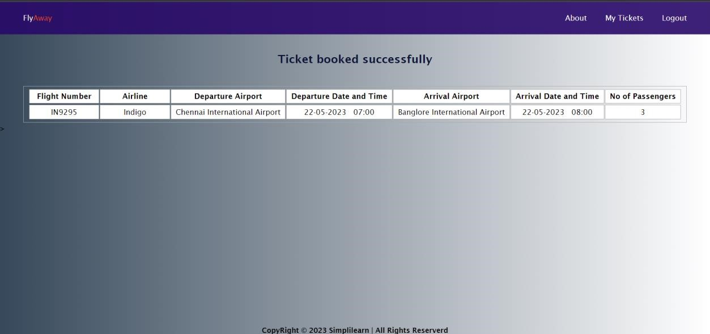

# User can also see the ticket details reflected in his My Tickets page

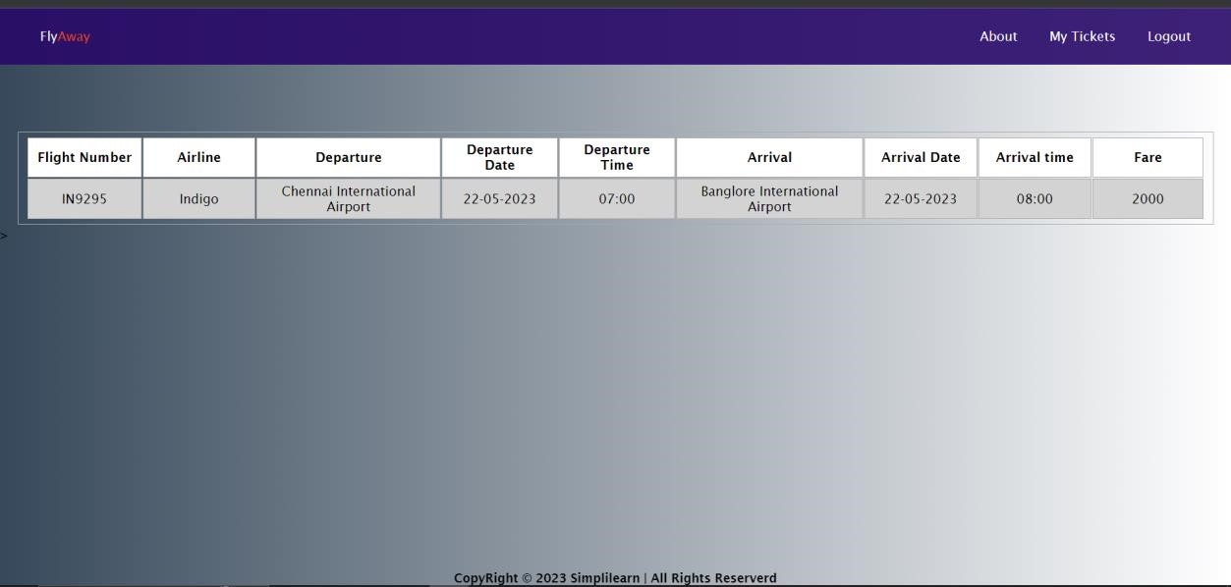

# Logout When user clicks logout he will be logged out and prompted and the navigation bar changes automatically

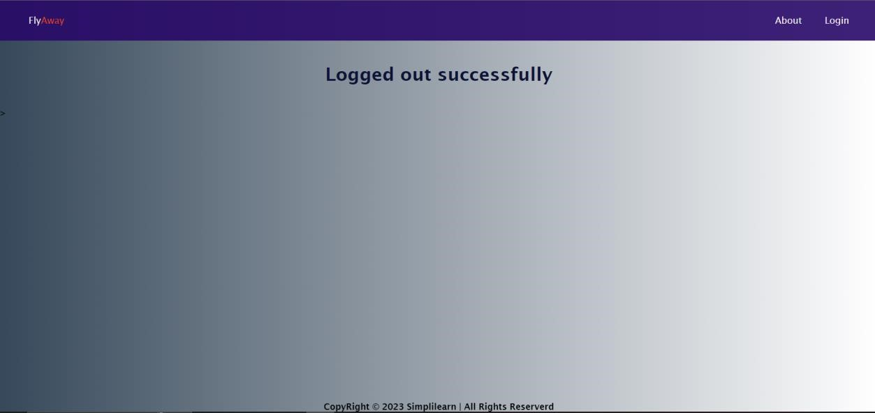

# Miscellaneous and Error Pages, If user query flight details are not available

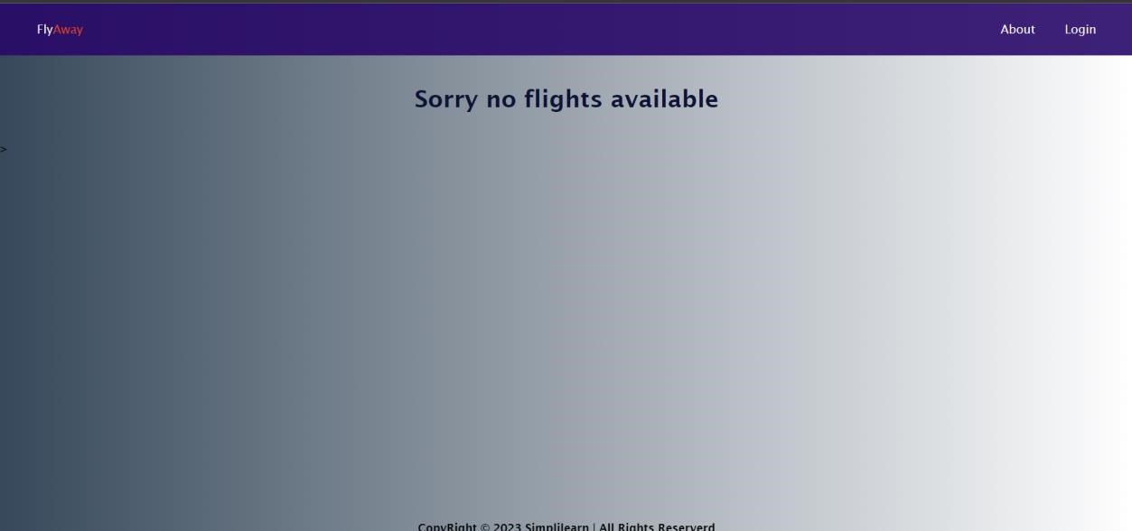

# Ticket History

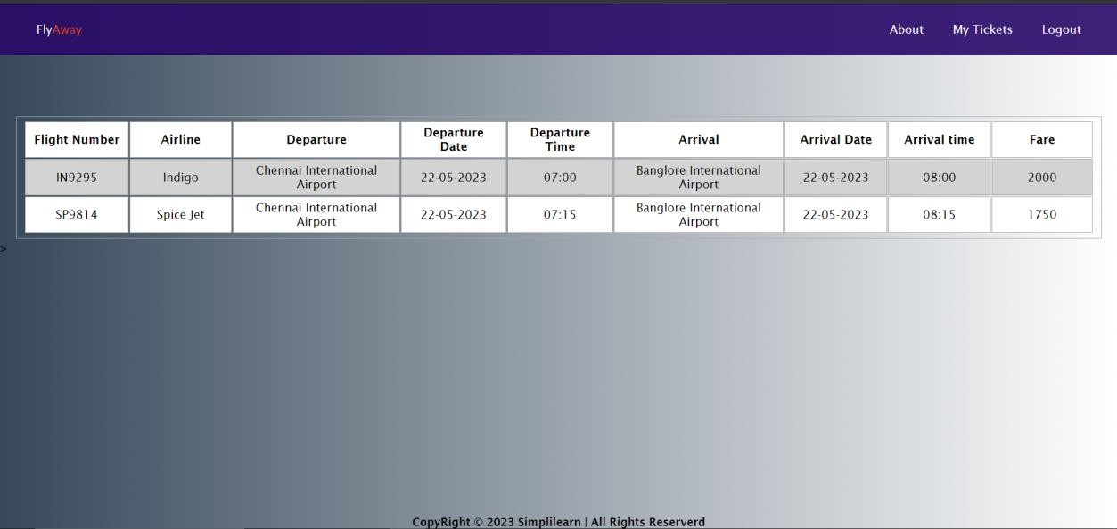

# While login in user can enter a wrongpassword he will be prompted the same

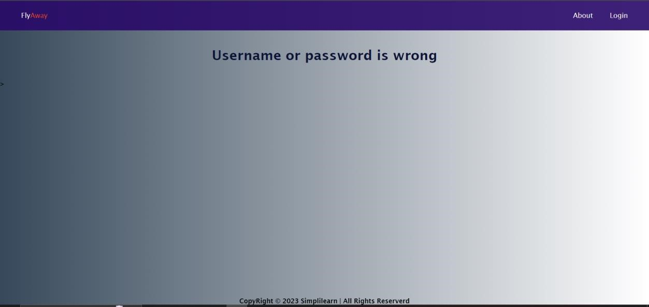

# While registering user can enter password and confirm password different

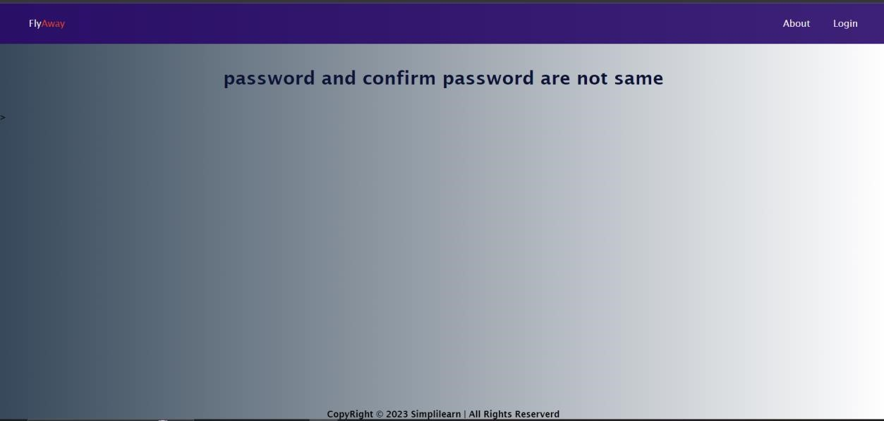

# About Page

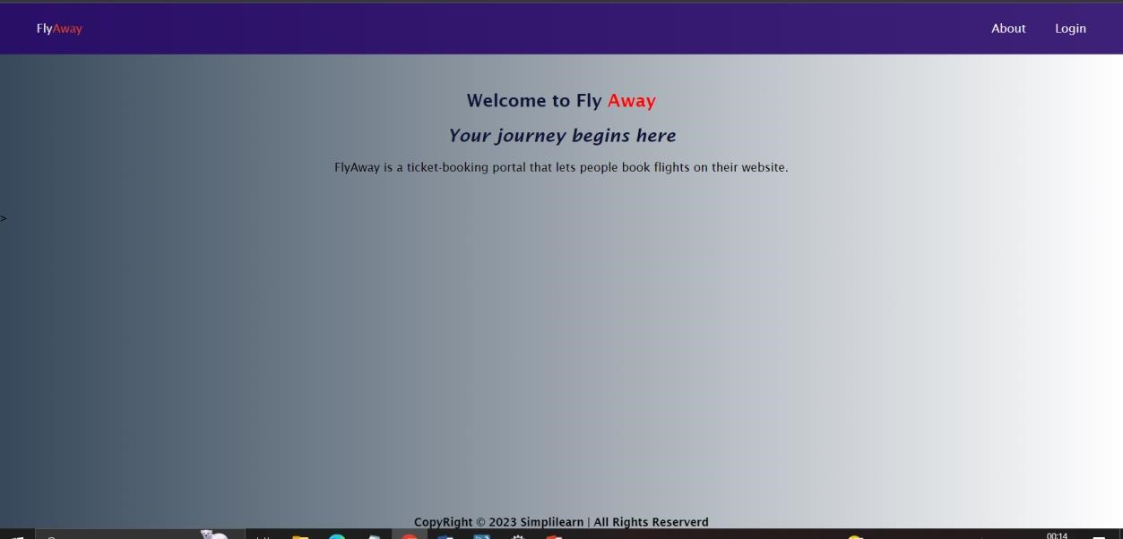

# Search Query When Admin adds Trip data in the backend distinct cities are displayed respectively

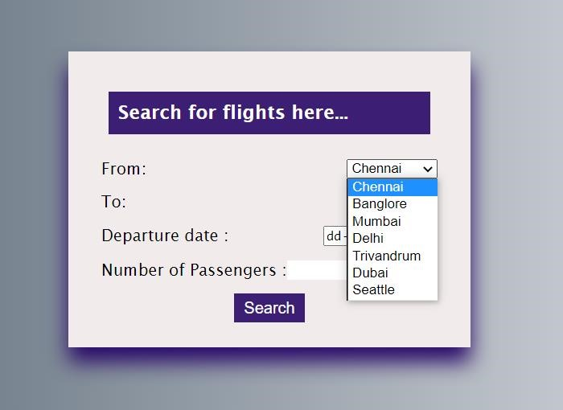

**Form Date field:**

# User and Admin can only use present date, past dates are greyed out

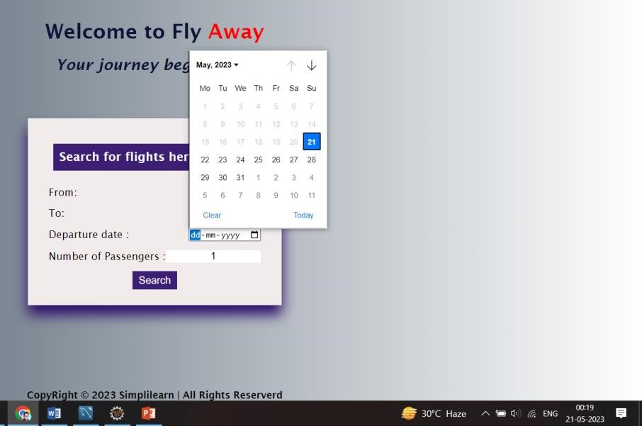

Today’s date

# Search Operations in Admin field

