Week 3 RAG Architecture Diagram

Overview
This diagram shows the RAG (Retrieval-Augmented Generation) pipeline for the UtiliCare Help-Desk Triage Agent, demonstrating how the system retrieves relevant knowledge from a controlled corpus to provide grounded responses.

Architecture Diagram
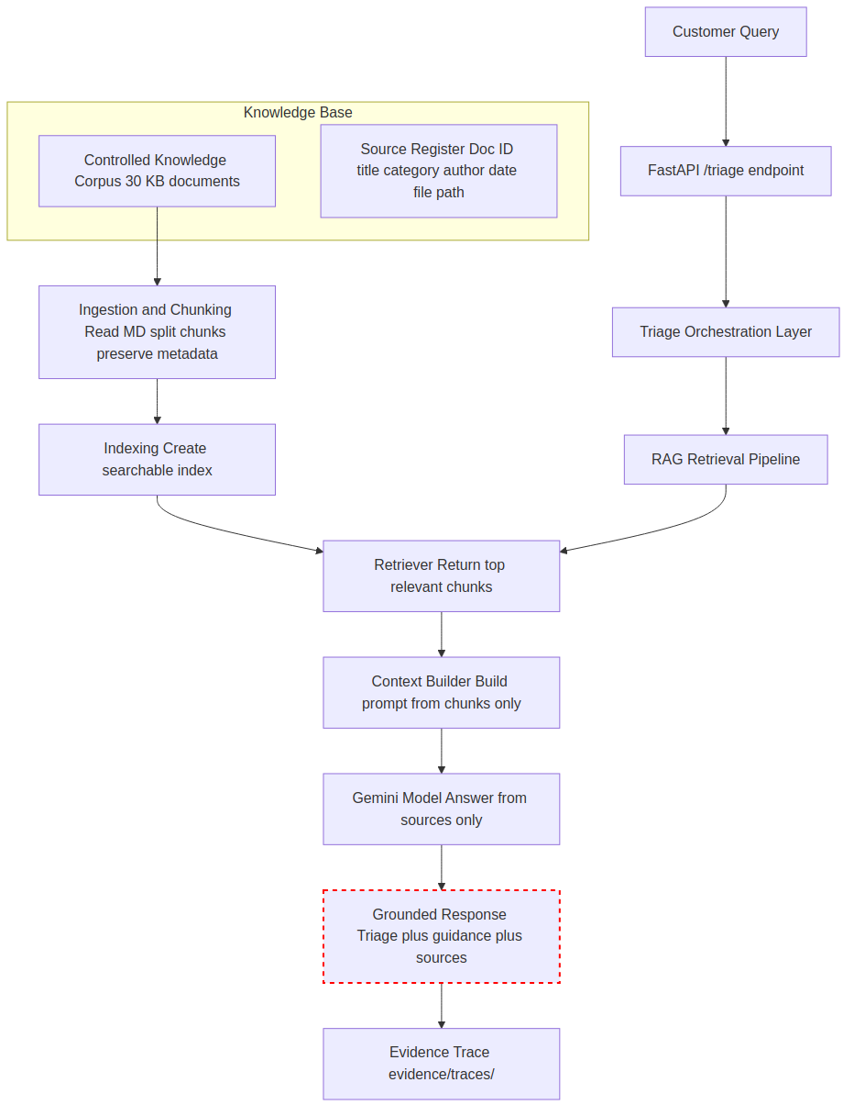
Figure 1. RAG pipeline data flow, from customer query through retrieval to grounded, cited response.

Component Details

1. Controlled Knowledge Corpus
- 30 synthetic KB documents (KB-001 to KB-030)
- Categories: power_outage, meter_fault, water_leak, billing_query, other
- Location: knowledge/corpus/
- Format: Markdown files with structured metadata

2. Source Register
- Doc ID, title, category, author, date, file path
- Location: knowledge/source_register.csv
- Purpose: Provenance tracking and metadata lookup

3. Ingestion and Chunking
- Process: Read Markdown → split into traceable chunks → preserve document metadata
- Chunk size: Configurable (e.g., 200-500 characters)
- Metadata: Doc ID, title, category, chunk index

4. Indexing
- Process: Create searchable index from chunk text and metadata
- Index type: Vector embeddings or keyword-based (TF-IDF)
- Purpose: Fast retrieval of relevant chunks

5. Retriever
- Process: Return top relevant chunks for the customer query
- Ranking: Similarity score (cosine similarity for vectors, TF-IDF for keywords)
- Output: Top N chunks with metadata

6. Context Builder
- Process: Build model prompt using retrieved chunks only
- Constraint: Model must answer from provided sources only
- Format: Structured prompt with chunk content and source references

7. Gemini Model
- Process: Classify issue and provide grounded guidance
- Constraint: Answer only from retrieved sources
- Model: models/gemini-flash-latest
- Temperature: 0.1 (low for consistency)

8. Grounded Response
- Triage result (category)
- Guidance from KB
- Source IDs (KB-xxx)
- Source titles
- Retrieval trace

Safety Boundaries (Red Dashed Boundary)
AI MUST NOT DO THESE ACTIONS
- No ticket submission
- No billing changes
- No infrastructure control
- No invented sources or unsupported answers
- Human approval remains required for any high-impact action

Key Data Flow Arrows
- Corpus → Ingestion/Chunking → Index — Documents are read, split into chunks, and indexed for retrieval
- Customer Message → Retriever → Relevant Chunks — Query is processed to find the most relevant knowledge chunks
- Relevant Chunks → Context Builder → Gemini — Retrieved chunks are used to build a grounded prompt for the model
- Gemini → Response with Cited KB-xxx Sources — Model provides answers with explicit source citations
- Retrieval Details → evidence/traces/ — All retrieval operations are logged for audit and debugging

Notes
- The RAG pipeline ensures all responses are grounded in the controlled knowledge base
- Source citations (KB-xxx) are included in every response for traceability
- Retrieval traces are stored in evidence/traces/ for audit and evaluation
- The model is constrained to answer only from retrieved sources, preventing hallucination

