Week 1 Progress Report

Work Completed Against Weekly Objectives
- Selected the Utility/Service Help-Desk Triage Agent use case and defined a single primary end-to-end workflow.
- Drafted a 2-page Project Charter covering the problem, user, pain point, AI value, scope, assumptions and constraints.
- Wrote 10 testable user stories with acceptance criteria.
- Produced an AI Boundary Matrix distinguishing autonomous AI actions, human-confirmed AI suggestions, and deterministic/human-only decisions.
- Created an initial architecture diagram.
- Set up GitHub repository and Click Up project with Week 1 tasks fully assigned.

Key Engineering Decisions
- Chose a synthetic utility scenario so the team can legally and quickly build a realistic corpus without needing institutional data access which satisfies the Week 1 data availability constraint.
- Decided ticket routing/creation and escalation will always require explicit human approval.

Challenges and Response
- Still deciding on the exact taxonomy of issue categories and will validate against the synthetic corpus we will build next.
- No foundational model chosen but model selection note is scheduled next.

Links to Repository / ClickUp Evidence
- GitHub repository: https://github.com/Nomwesigwa-Keith/Utilitycare-Help-Desk-Agent.git
- ClickUp board:
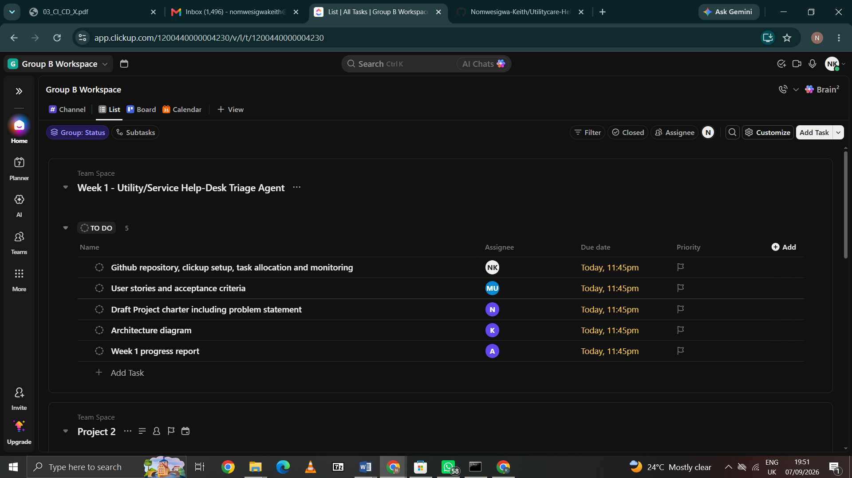

Individual Contribution Summary
Names | Tasks | Evidence
Nomwesigwa Keith | GitHub repository & ClickUp setup | Repo initialised with recommended folder structure, ClickUp list created with 5 tasks assigned
Mubiru Umar | User stories and acceptance criteria | User_Stories_and_Acceptance_Criteria.docx
Nankunda Lilian | Project Charter | Project_Charter.docx 2 page charter
Khot Adet Majuong | Architecture diagram | Initial architecture diagram (workflow + tool boundaries)
Arok John Mayen | Week 1 progress report | This document

