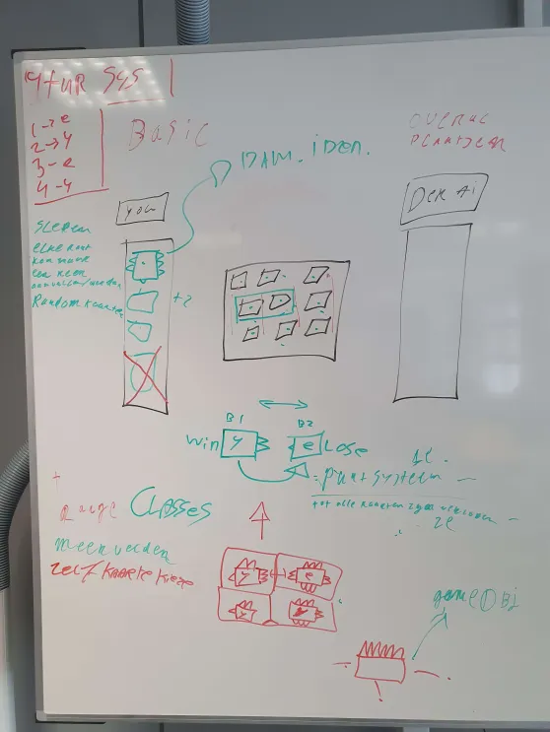

## Game logistics

Game system 4-turn system

Meaning-> 1round you -> 2nd -> enemy -> 3th you 4th -> enemy

5 cards in the deck.

3 cards visible from the start.

3X3 grid

Player can put card everywhere.

Every card has fangs on each side the card with most fangs wins.

When a card has played in a battle the fangs will fade away on the side of the battle.

Point based system for every card on the screen you get an point.

The one with the most points wins.