Introduction

Parallel Robots
This aim of this project was to design, construct, and control the New UWA Robot (NUWAR). The NUWAR robot is a parallel mechanism; "parallel", in this case, pertains to the class of mechanisms which have at least two independent kinematic chains (which contain at least one actuated joint) linking the base to the end-effector.
With parallel manipulators, the motors can be fixed onto the base, meaning that such manipulators have a much lower mobile mass than their serial counterparts. With this set-up, the arms purely transmit the forces applied by the motors (they do not need any actuated joints in them). This leads to several other advantages over serial manipulators:
- The bending stresses in the arm-links are much lower; in the case of the DELTA and NUWAR robots, purely axial forces exist in the forearms whilst the machine is static;
- Deflections, due to the stresses in the arms, are much smaller and hence parallel mechanisms have far superior stiffness and accuracy;
- Since the mobile mass is much lower, these robots are very well suited to fast, light-weight tasks;
- Because parallel mechanisms have more than one serial chain supporting a given load (at the end-effector), the amount they can carry is much greater for a particular size.
There is, however, the major disadvantage that the workspace of parallel manipulators is smaller than that of serial manipulators for the same size. Also, obstacle avoidance is much more difficult with parallel robots. This seems to make them unsuitable for applications which require a robot to reach around (or through) something.

History [Guglie94]
Mathematicians, such as Cuachy, studied parallel mechanisms more than a century ago, but is was not until 1938 that their usefulness was realised when Pollard [Poll38] patented a car painting robot. However, the available electronic technology was insufficient to control his invention at the time. Then, in 1947, Mc Gough [Gough62] proposed a mechanism with six prismatic actuators which had six degrees of freedom. This is commonly known as the "Stewart platform" (even though he didn't invent it) and is one of the best known parallel architectures. Stewart [Stew65], in fact, proposed a robot for controlling a flight simulator platform.
Most parallel robots, were designed for heavy load and high accuracy tasks; speed was not a primary concern. Then the DELTA robot was invented by R. Clavel in 1985 and a working model was built a few years later. It was primarily designed for fast, pick-and-place tasks and has since been manufactured for use in the packaging industry.
The NUWAR robot is based on the DELTA robot and has the same geometric ratios as those for the DELTA.

Future
Nearly all of the robots currently used in industry are serial mechanisms; parallel mechanisms have yet to make a significant impression. There are, however, many applications for parallel mechanisms such as the DELTA and NUWAR robots. An example that springs to mind is the processing of mico-chips and other electronic circuitry.

Motivation Behind the Project
During 1997, Karol Miller and his assistant, Matthew Jayarama, investigated the effect of rotating the motors (which were normally in the standard DELTA set-up) on the workspace of the robot [Miller97]. They constructed a model using ADAMS which is a multi-functional, mathematical, simulation, and analysis package. They defined the robot parametrically by entering the dimensions of the various bodies which constituted the robot and then defining the constraints between them. Certain angular/joint limits were allowed for in determining the workspace. One such limit was a 30 allowance around the line where a forearm was at right angles to the control arm plane. On this line, the forearm rods become collinear and some of the robot's stability is lost. These singularities and safety regions are discussed further in the sections on kinematics. For a more complete review of their effects on the workspace, see [Parker98].
In modelling the kinematics of the robot, the motors were offset inwards (towards the centre of the base plate) by an amount 'Rb', which is the distance from the ends of each of the forearms to the centre of the travelling plate. This offset ensured that the forearms would meet at a point for the purpose of solving the kinematics. The motors were then rotated by set amounts about there own axes in the '' and '' directions. The '' and '' values were defined as being zero when the motors were in the DELTA configuration. '' rotation referred to the rotation of the motors about the horizontal line from the motor to the centre of the base plate. '' rotation referred to rotation of the motors in the vertical plane (at right angles to both the '' direction and the motor axes). These names and their sign conventions have been preserved throughout this work, however, the pivot point for the '' direction has been offset for reasons which are described in the section, "Kinematic Structure of the NUWAR Robot".
The results indicated that for some configurations of '' and '', the total workspace volume was greater than that of the DELTA configuration ('' and '' = 0). The optimum value for the upper workspace (above the base plane) was achieved when  = 35.26 and  = 60. At these values, the motor axes are orthogonal. A picture showing the comparison of this workspace with that produced by the DELTA configuration is shown below.

Fig. 1: Workspace of the DELTA Configuration vs that of the Orthogonal Configuration [Miller97]

Because the NUWAR robot is to be set up so that the arms hang down, below the base plane, it is desirable to invert the effect achieved by the above shown '' and '' values about the base-plane. This can be done by setting  to -35.26. The motor axes are still orthogonal is this orientation.
It is important to note the effect of the orthogonal motor configuration on the shape of the workspace. With the orthogonal configuration, the workspace is greater than for the DELTA configuration close to the base plane, in the vertical z-direction. As the distance in the z-direction away from the base plate increases, the DELTA's workspace starts to improve in comparison to the orthogonal configuration. This effect is shown below.

Fig 2: Sections of the Workspace for both the DELTA and Orthogonal Configurations for Various Values of Z [Miller97]

Roles and Responsibilities for the NUWAR Project
Robotics is a multi-disciplinary field requiring skills in mechanical engineering, electronic engineering and computer science. The relationship between the different components which make up a robotic system is shown below.

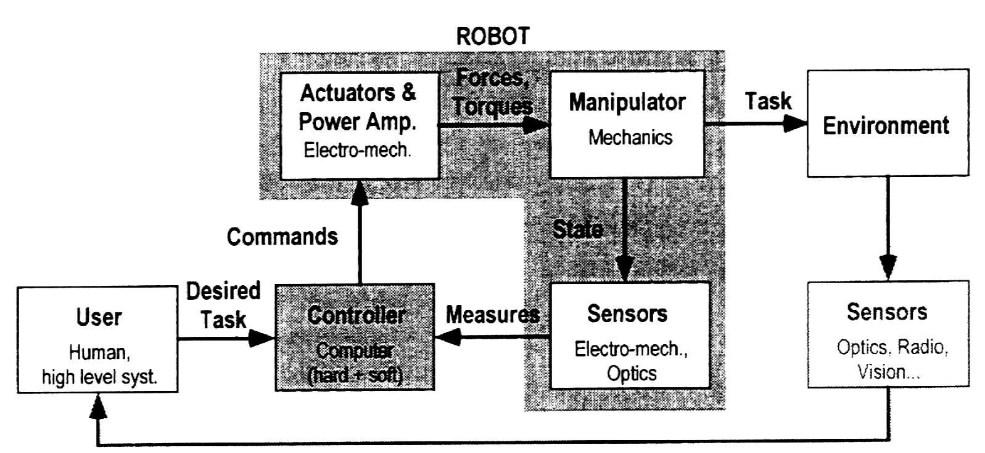

Fig 3: Relationship Between the Components of a Robotic System [Guglie94]

The NUWAR project was undertaken by four people, including the author. Two people worked on the mechanical design of the robot, whist the other two (including myself) worked on the interfacing and control system. The basic structure of responsibilities is shown below. It was anticipated that the project would take two years to complete with additional enhancements taking place after that.

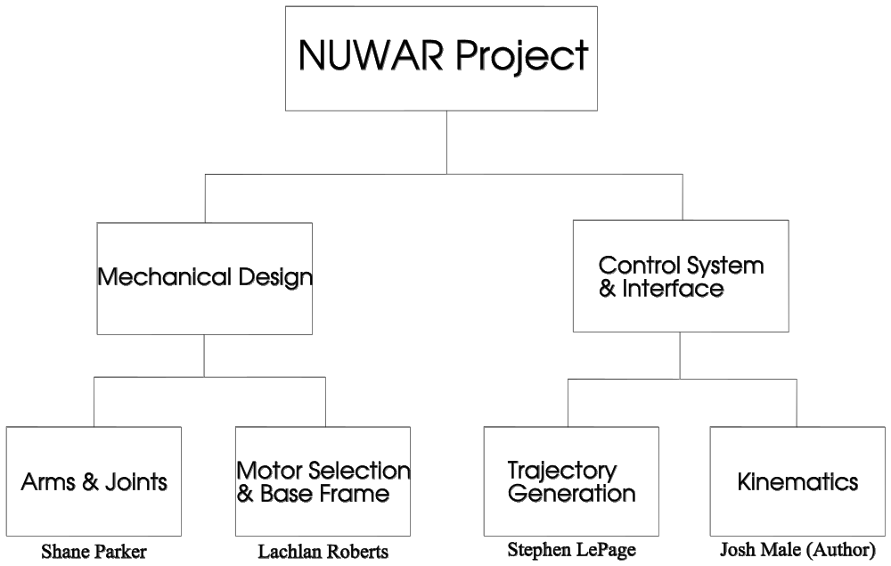
Fig. 4: Areas of Responsibility for the NUWAR Project

Mechanical Design for the NUWAR Robot
The mechanical design areas identified above are now elaborated upon, identifying there main features.

Arms & Joints
The dimensions of all the mechanical components were based on those of a DELTA robot that was built in Switzerland. However, these dimensions were scaled up by a factor of about 1 1/2.
Materials had to be selected for the control arms, forearm rods, motor hubs and joint housings.
The compound joints connecting the control arms to the forearms, and the forearms to the travelling plate, had to be designed. Some of the factors which needed consideration were:
- The amount of available rotation available from each individual joint;
- The likelihood that segments of the arms would clash in certain positions - eg between the forearm rods and the control arms;
- The system was required to have three degrees of freedom.

Some of the factors requiring consideration for the design of the arms were:
- The nature of the loading on them;
- The maximum forces that they had to endure;
- Their mode of fracture/failure;
- Their weight.

For a complete discussion of the design of the arms and joints, refer to [Parker98].

Motors, Motor Mounting and Base Frame
The motor mounts were required to be rigid and able to support a heavy motor (about 20kg - bending hence being significant). It was desirable to allow for rotation of the motors in both the '' and '' direction, such that the rig would be a test bed for investigating the effect of these rotations. This required a method of fastening the motors in a particular '' and '' configuration.
Some considerations for the design of the base frame were:
- Strength and stiffness - important for robot accuracy;
- Natural Frequency - since the robot has been designed for high acceleration and velocity;
- Accessibility - for attaching tools to the end-effector and for changing the motor angles.

Some desirable features to be considered for motor selection are:
- High torque - up to 40Nm;
- High acceleration;
- Low rotor inertia;
- Hardware/software interface.

For a complete discussion on the selection of motors and the construction of the motor mounts and base frame, see [Roberts98]

Control and Interfacing
Below is a brief description of the control and interfacing components for this project.

Kinematics - Forward and Inverse
The kinematics relate the actuated variables to the position and orientation of the end-effector.
The forward kinematics are described by the function 'ƒ' which is defined as:
ƒ:   V
The inverse kinematics are described by the function 'ƒ⁻¹' which is defined as:
ƒ⁻¹: V  
where:
V ≡ the position and orientation vector for the end-effector
❑ ≡ the vector of actuated variables
For the NUWAR robot, 'V' represents the position of the gripper plate in Cartesian space. '' represents the three motor angles. The kinematics for the NUWAR robot were solved and implemented by the author in MATLAB for simulation and interfacing purposes.

Trajectory Generation
Trajectory Generation involves defining a time history of a robot's configuration between two points which have been specified (by the user) for the end-effector. Thus it involves defining position/angle, velocity and acceleration as a function of time. The main desirable features of a particular trajectory include:
- Zero start and end acceleration and velocity;
- Continuous acceleration along the defined path to ensure that the applied motor torques, and hence currents fed into them, are continuous.
These features ensure a smooth trajectory with no "jerks" or "clunks" is achieved.
Below, various methods for defining a trajectory between two points are described along with their relevance to the NUWAR project:

Joint space schemes - quick and easy to do but the end-effector path is not directly defined.

Cartesian space schemes - the type of path in space for end-effector movement between two points is decided. Let this path be parameterised by 's', such that the path is defined by 'F(s)'. Then a set of control points is generated along this path such that the above desired features for a trajectory are met. This involves defining a time history for movement along the path. Let this time history be defined by 's(t)', where 's' is the parameter for the path. The control points can then be generated by selecting a time interval and calculating F(s(t)). Joint space interpolation can then be carried out between each of the control points. Obviously, the smaller the time interval (and hence the closer the control points are), the more accurately the end-effector will "stick" to the path.
This method was chosen and simulated for the NUWAR robot.

Bezier Curves - a method for defining a path in Cartesian space. Multiple control points can be placed at the start and ends to ensure zero start and end acceleration and velocity. This was implemented, but is not expected to be used.

Jacobian Motion Rate Control - uses the best linear approximation to move to a nearby point. It is a useful method for serial arms because it avoids the complexity of solving the inverse kinematics. However, for parallel robots, the inverse kinematics is generally simpler to calculate than the forward kinematics, meaning that this method is of limited value in this case.

The author helped in implementing the elliptical trajectory in MATLAB. An ellipse defined by three points, two of which formed the major semi-axes, was parameterised in two-space and then mapped into three-space using a homogeneous matrix representing its local planar coordinate system. Refer to [Zeid91] for description of how this is achieved.
For a complete discussion of trajectory generation for the NUWAR project refer to [LePage98].

Dynamics
Dynamics refer to the relationship between the applied actuator forces/torques and the acceleration of the end-effector as well as the joint angular accelerations (for the case of revolute joints).
This was not accomplished this year, and is expected to be solved by next year's honours team.

Control
Control for robots refers to the servo-loop which ensures that the motors respond quickly to given commands and move accurately to the specified positions. A hardware card which was inserted into the computer provided this control as well as many other functions. It could also perform joint space interpolation, and this feature was used this year. In future years, a personalised control system is expected to be designed, where a feedforward term predicting the necessary motor currents required, based on the dynamics, could be included. This would improve the robot's performance.

Robot Interface
This involves creating a (software) interface which allows a user to specify a task for the robot to perform, and then sends the appropriate signals to the motors to achieve it. The main factors for consideration here are:
- the interface should be ergonomic and conceal from the user the complexities of the hardware and software;
- error checking for erroneous or dangerous requests needs to be performed to prevent injury and damage to the machine;
- It should provided efficient communication with the hardware.
The interface was not completed this year. This thesis describes the work completed and recommendations for future work.

Simulation
Simulation, in this case, refers to the description of the robot's response to task specifications graphically for demonstration purposes and for the purpose of checking and verifying movements. The chosen simulation environment was MATLAB. The functions that were written for MATLAB, as well as the results gleaned from them, are presented in a later section. It is hoped that much of the code that was written can be used in creating the interface.

