Results from the MATLAB Simulation

Introduction
In this section, a set of the simulated results (that can be produced from the suite of functions that have been written for MATLAB) are presented.
The results demonstrate how the motor angles vary with time along two different trajectories - a straight line and a sheared semi-ellipse. This is done for two motor configurations - the DELTA configuration where α and β are equal to zero, and the orthogonal configuration which maximises the workspace volume beneath the base plane in which α = -35.26° and β = 60°.
For each of the trajectories demonstrated:
Start point = [-0.1, 0, -0.7]^{T}
End point = [0.3, 0, -0.5]^{T}
Total time for the move = 1 (s)
Sampling rate / Segment time = 0.05 (s)

As previously stated, trajectory generation for the NUWAR robot consists of two parts:
- defining a geometric path for the robot to follow parameterised by 's' - F(s)
- a time scheme for traversing this path - s(t).
The time scheme, s(t), is referred to as the "time ramp type" in the MATLAB functions. With the following trajectories, a "sine on ramp" scheme has been used which basically consists of two back-to-back sinusoids for the tangential acceleration - s''(t). For the case of an ellipse, 's' is only approximately proportional to the arc length along the trajectory. However, this is not thought to be detrimental. For more information, refer to [LePage98].

For a listing of the dialogue from MATLAB corresponding to the following two trajectories, refer to Appendix A.

Sheared Semi-Elliptical Trajectory
The length of this trajectory is about 0.6361m.

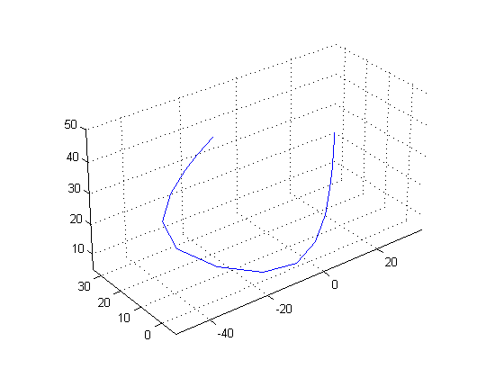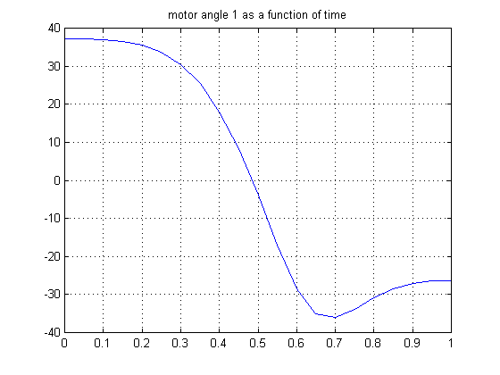

(a) (b)

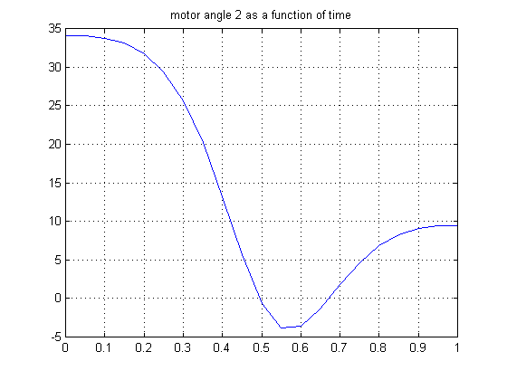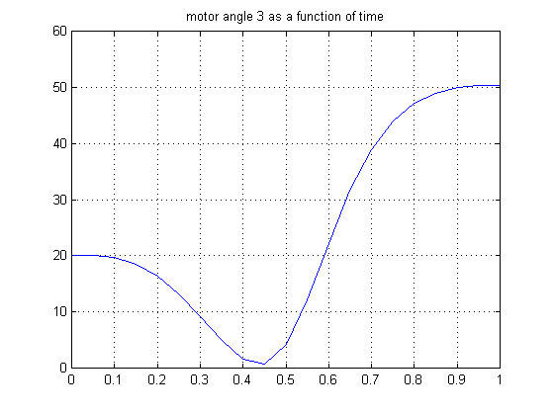

(c) (d)

Fig 1: Motor Angle Graphs for a Sheared Ellipse (Ortho-Configuration:
α = -36.26°, β = 60°) where:
(a) trajectory in joint space (θ₁, θ₂, θ₃), (b) θ₁ vs time, (c) θ₂ vs time, (d) θ₃ vs time.

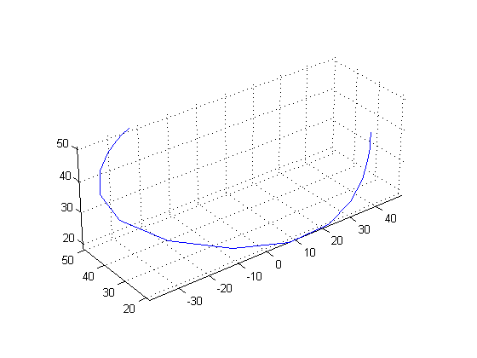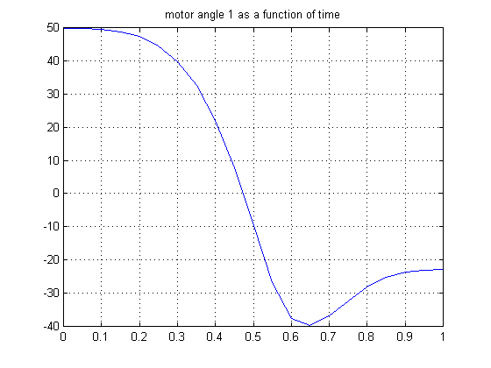

(a) (b)
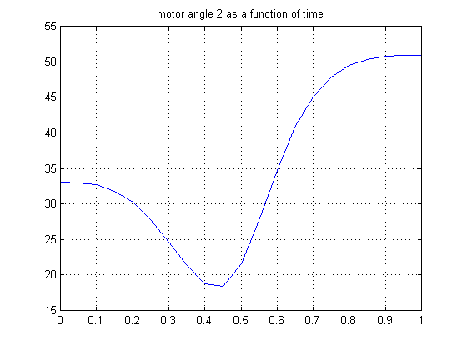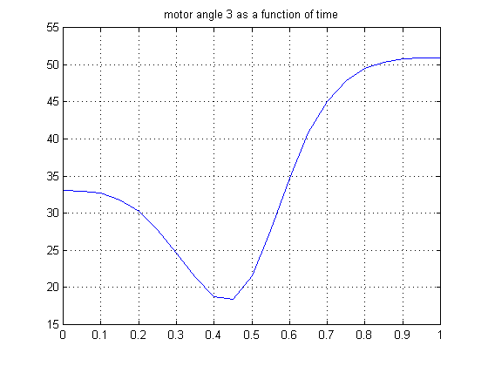

(c) (d)

Fig 1: Motor Angle Graphs for a Sheared Ellipse (DELTA-Configuration:
α = 0, β = 0) where:
(a) trajectory in joint space (θ₁, θ₂, θ₃), (b) θ₁ vs time, (c) θ₂ vs time, (d) θ₃ vs time.

A couple of things can be seen by comparing the above two sets of graphs. One point is that the motor (motor 1) has had to rotate through a smaller range to traverse the trajectory when the motors were in the orthogonal configuration rather than in the DELTA configuration (about 20° less). Another point is that the second and third motors have rotated into the negative angle region when in the orthogonal configuration. Thus, it was important in the mechanical design to allow a wide range of motor rotation without having collisions between the control arms and other parts, eg base frame.
An important thing to note here is that much of the the trajectory is in the region which can be considered close to the base plane. In this region, the orthogonal configuration has a significantly greater workspace volume than DELTA configuration. This helps to explain the observed smaller average motor rotation range. Comparing the graphs showing the joint space plots for the orthogonal and DELTA configurations, one can see that the graph for the orthogonal case is "tighter" in curvature and occupies less volume than for the DELTA case. This also gives a good illustration of the performance of the two configurations.
If the robot was made to traverse a trajectory which was predominantly further away from the base plane in the z-direction, it would be possible that the DELTA robot would show superior performance in regard to the average motor angle range needed.
In general however, elliptical trajectories used for pick-and-place tasks would most probably lead to the robot moving into the region considered as being close to the base plane. Thus, it appears that the orthogonal motor configuration could be useful for such tasks.

MATLAB Pictures of the Robot Traversing the Sheared Semi- Ellipse (Ortho-Configuration)

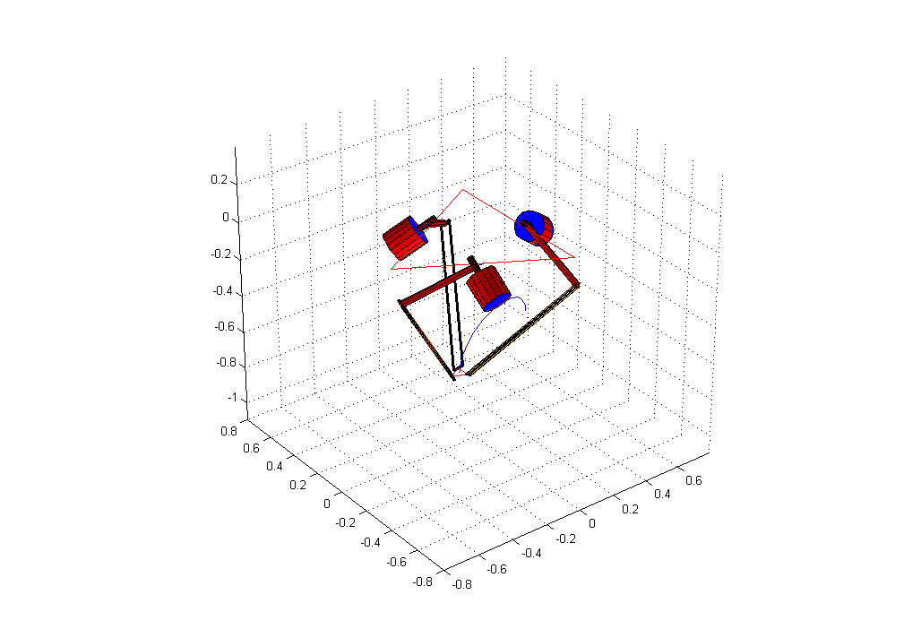
(a)

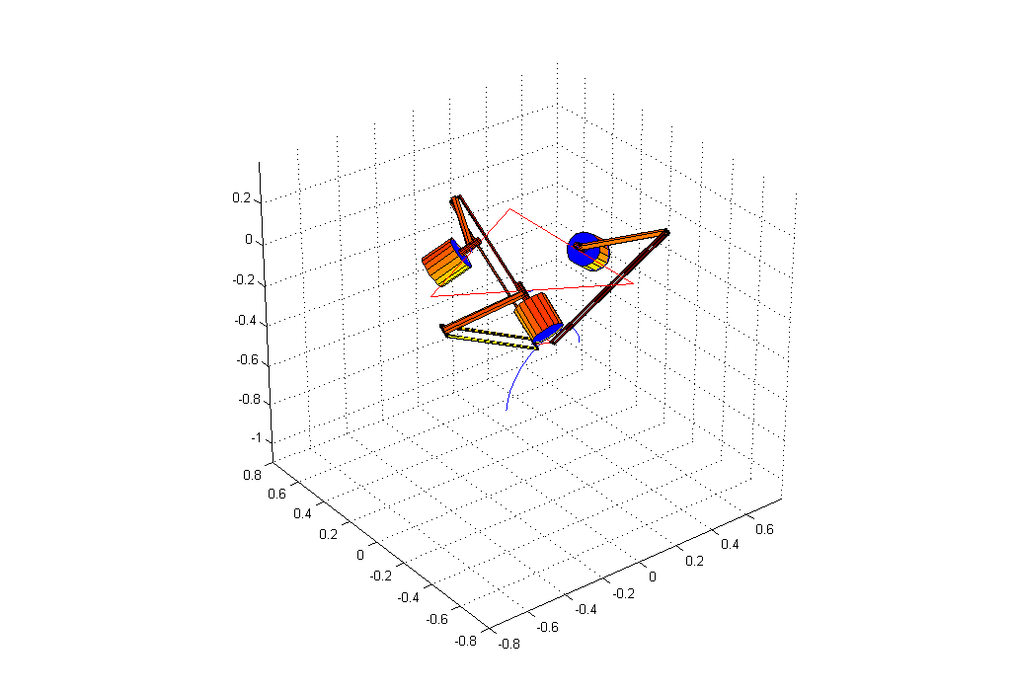
(b)

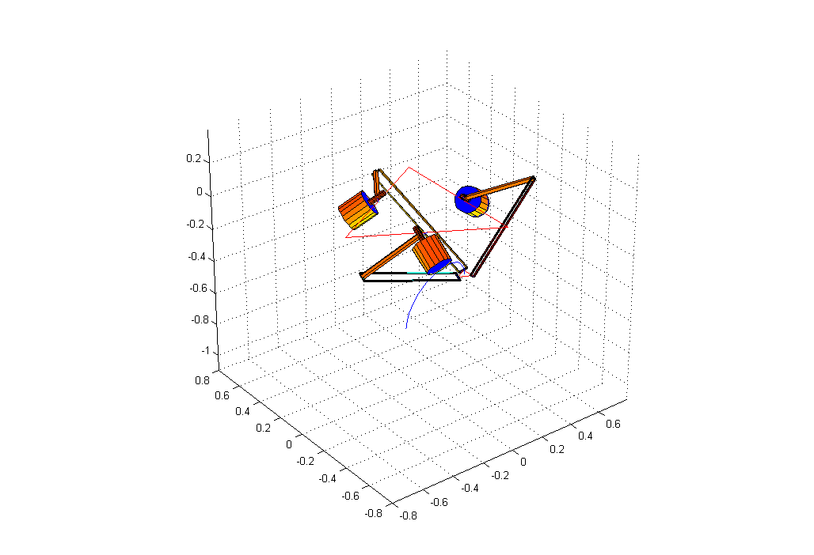
(c)

Fig 2: MATLAB Pictures of the NUWAR Robot Traversing a Sheared Semi-Elliptical Trajectory in the Orthogonal Configuration

Straight Line Trajectory

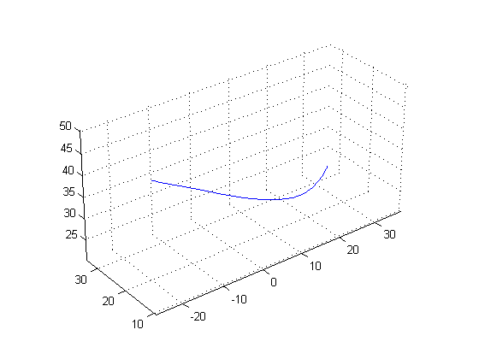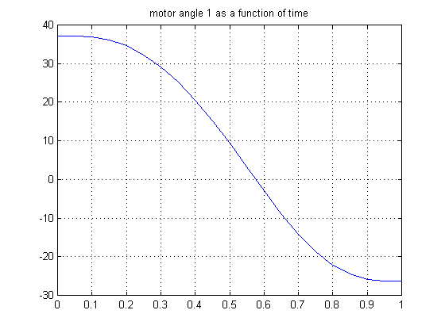

(a) (b)

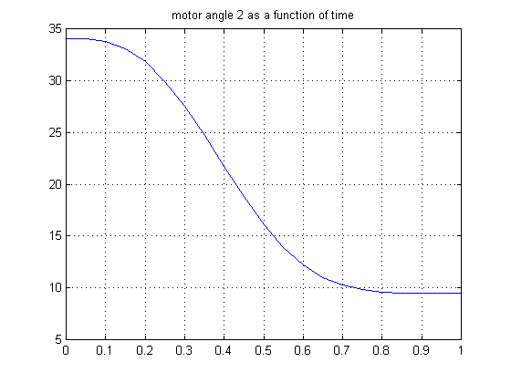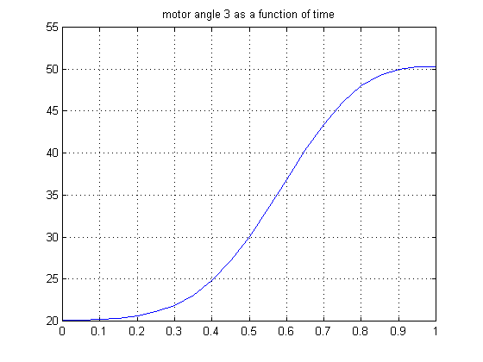

(c) (d)

Fig 1: Motor Angle Graphs for a Straight Line (Ortho-Configuration:
α = -35.26°, β = 60°) where:
(a) trajectory in joint space (θ₁, θ₂, θ₃), (b) θ₁ vs time, (c) θ₂ vs time, (d) θ₃ vs time.

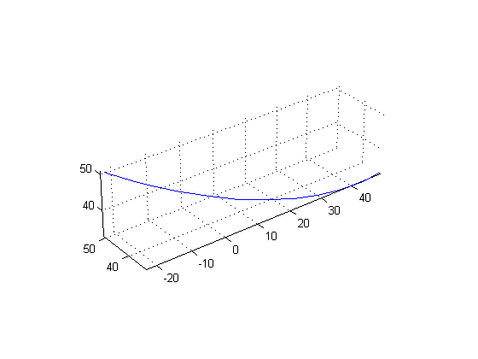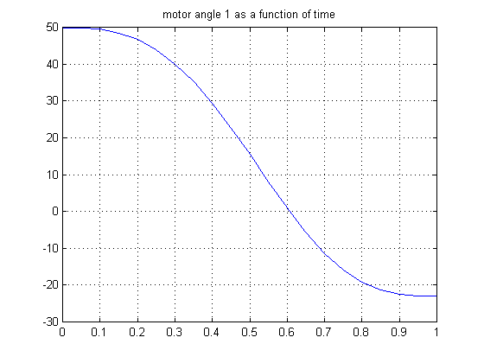

(a) (b)

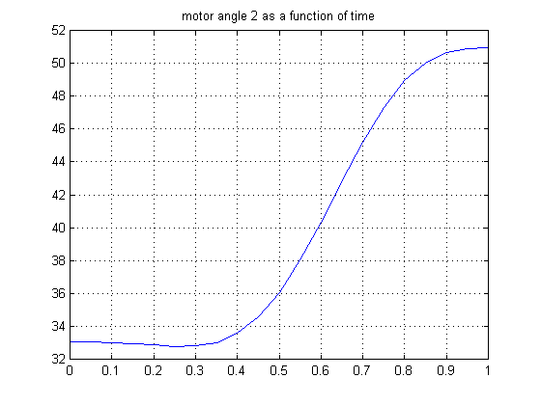

(c) (d)

Fig 1: Motor Angle Graphs for a Straight Line (DELTA-Configuration:
α = 0, β = 0) where:
(a) trajectory in joint space (θ₁, θ₂, θ₃), (b) θ₁ vs time, (c) θ₂ vs time, (d) θ₃ vs time.

The above graphs show the same trends as was exhibited by the sheared semi-elliptical trajectory. The orthogonal configuration has caused the motor angles ranges for each motor to become "more equal", where as in the DELTA configuration, the first motor turns through a much greater angle than the other two do.

MATLAB Pictures of the Robot Traversing the Sheared Semi-Ellipse (Ortho-Configuration)

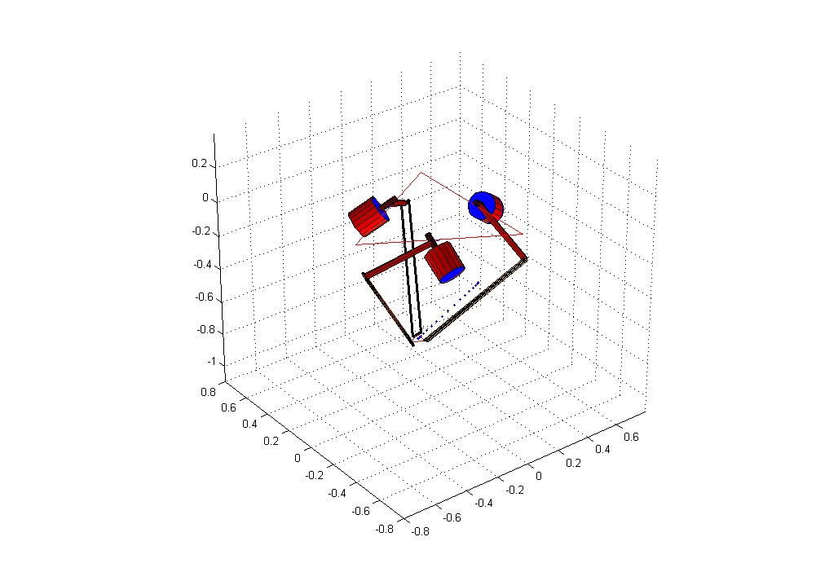
(a)

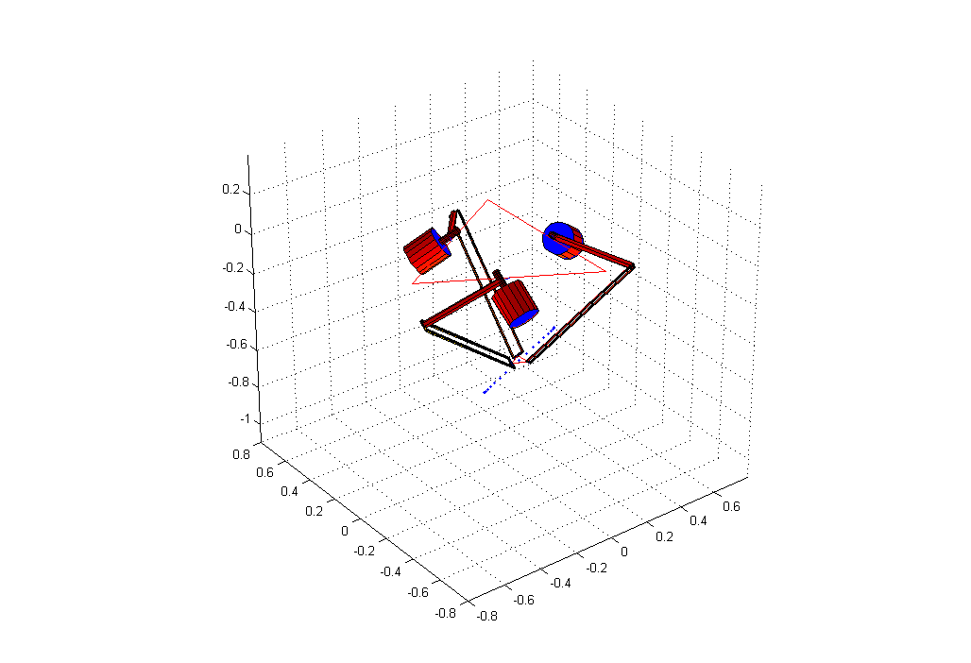
(b)

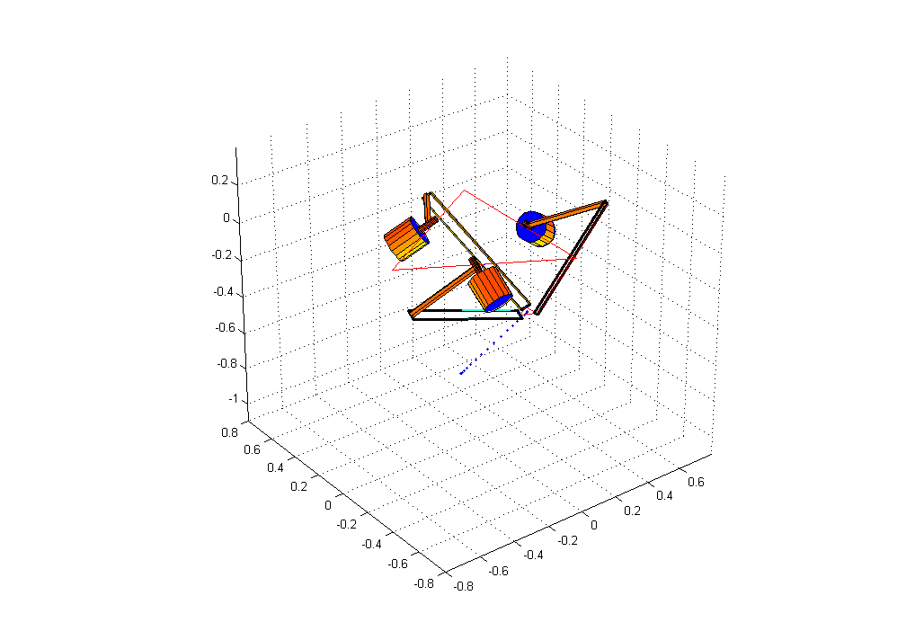

(c)

Fig 2: MATLAB Pictures of the NUWAR Robot Traversing a Straight Line Trajectory in the Orthogonal Configuration

Conclusion
[Guglie94] stipulates that the kinematic functions for the DELTA robot are smooth. This implies that ensuring that the end-effector has continuous acceleration in turn ensures that the motors will have continuous angular acceleration. The graphs appear to back up this theory.
Thus it can be concluded that the trajectory schemes that have been proposed will allow for continuous current to be supplied to the motors, and will ensure that the motors start and end smoothly with zero angular velocity and acceleration.

