Control System and Interface for the NUWAR Robot

Introduction
As stated in the "Introduction" section, a servo-control system is required to ensure that the motors quickly and accurately respond to specified tasks.
Robotic mechanisms are generally non-linear in that the relationship between applied torques and end-effector acceleration is nearly always non-linear. This is not a hugely significant problem for slow moving robots where linear approximations seem to work effectively. With fast robots such as the DELTA and NUWAR robots, these non-linearities become significant, meaning that the modelling of an appropriate control system becomes much more complex and classical methods cannot be applied. There are still methods for designing effective control systems. One such design is shown below, where a feedback servo-loop has been combined with a dynamic feedforward term. This does most of the work, improving the performance of the control system [Miller95]. This scheme was proposed for the DELTA robot and so would have equal application to the NUWAR robot, providing that the dynamics are solvable.
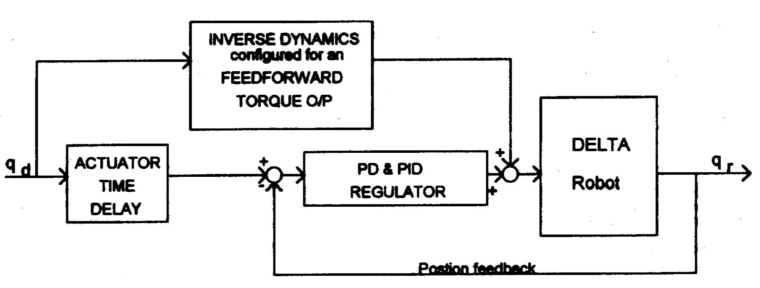
Fig 23: Proposed Control Scheme for the DELTA Robot [Miller95]

Creating a personalised control system was outside the scope of this year's project (1998). The dynamics for the NUWAR robot are also expected to be solved next year (1999).

Another issue pertinent to designing a control system, is whether it is to act in joint space, or in Cartesian space (or task space). These two options are illustrated below.

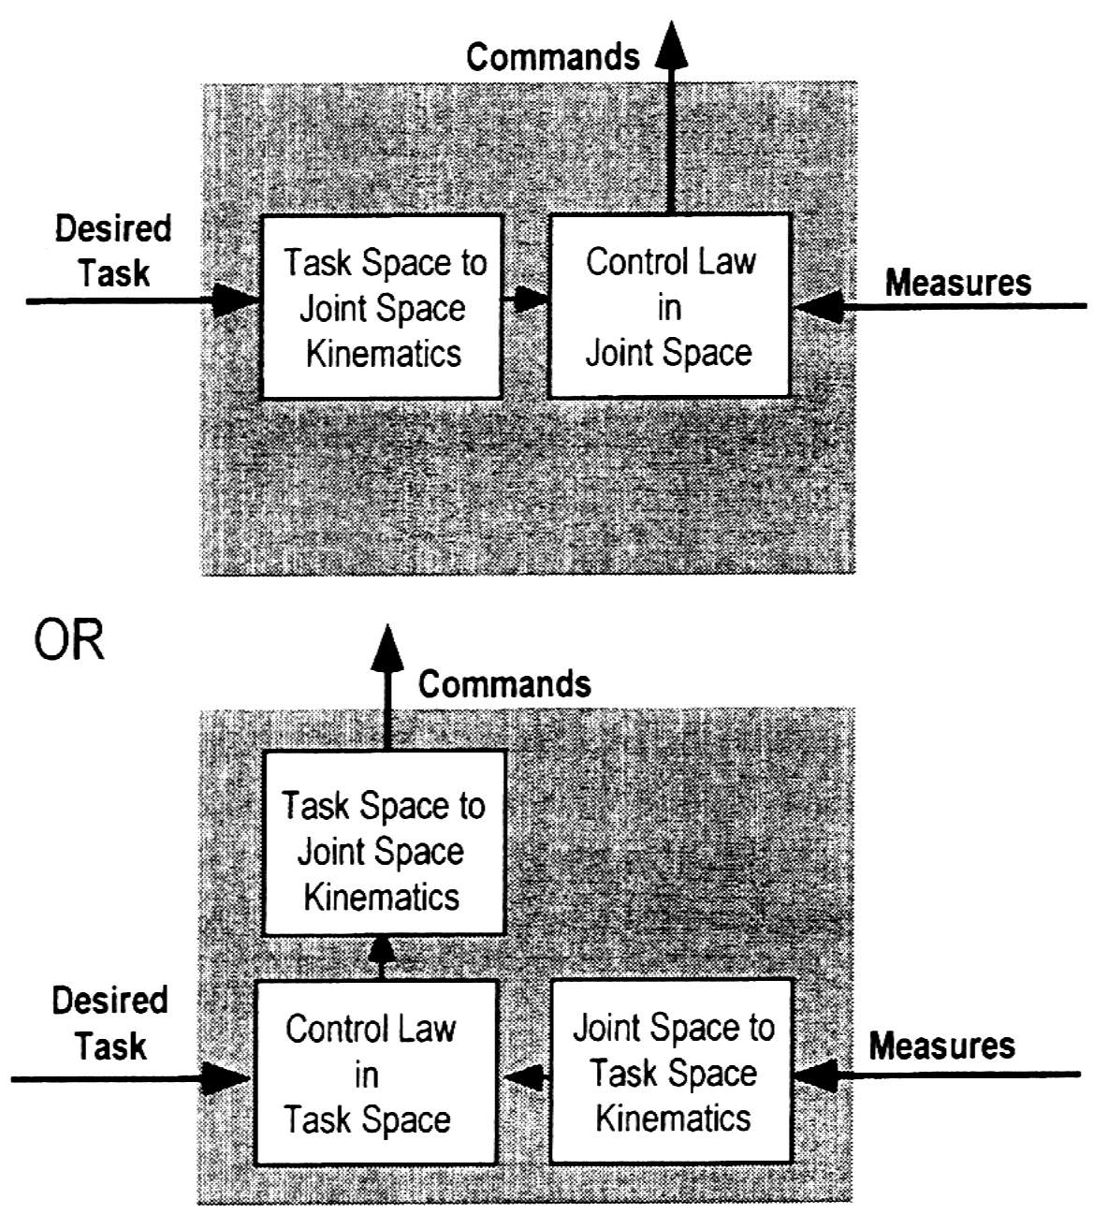
Fig. 24: Joint Space and Task Space Control [Guglie94]

For the purposes of controlling the robot and interfacing with the motors, a hardware card was purchased (PMAC card) which could be inserted into the PC used for the project. Since the PMAC card could provide the necessary servo-control for the motors, and because it could perform joint-space interpolation, the scheme shown on the top of Figure 24 was chosen for this year. Although the computer to motor interfacing has not been completed, it is thought that using the PMAC card in this way will allow the trajectories which have been simulated to be tested on the real robot without the need to implement a personalised control system. In this way, the control issues can be separated from the other components of the project.

Proposed Set-up for the NUWAR Robot Interface and Control System
The diagram below shows the interaction which occurs between the robot control system components. This system is based on using the PMAC to control the robot in joint space with the desired tasks being entered into a computer.

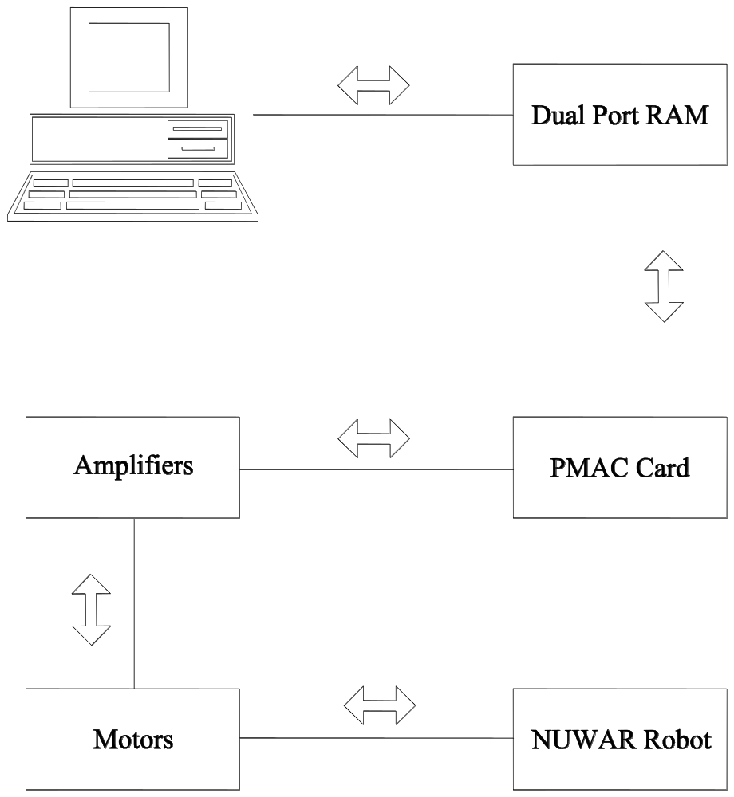

Fig 3: Components of the NUWAR Control System

NOTE: at the time of writing, the interface between the computer (PC) and the PMAC had not been completed. However, the author's partner, Stephen LePage received an extension and may get this up and running after the submission of this thesis.

Possible enhancements to the above system include sensors on the robot itself, such as angular sensors at the joints to ensure that they are not rotated outside their working range. Also, some sort of collision sensor which measures sudden impulses of force could be used to guard against damage caused by foreign objects in the robot's path.

Description of the Components

Motors & Amplifiers
The brand of the motors chosen was Baldor®. The reason for this choice was that they were distributed locally by a company called Mechatronics, and thus advice and assistance was close at hand. Baldor® also has an office in Sydney making them more accessible. Other motors, though more suitable for the NUWAR project, were only available from overseas manufacturers.
At the time of writing, the three motors to be used for the robot have still yet to arrive. The two motors shown below were provided for "try-before-you-buy" purposes to see if they could handle the inertias of the NUWAR robot. The one shown on the right in Figure 26 is a rare-earth magnet motor and has very low rotor inertia. Both are AC brushless servo motors. Refer to [Roberts98] for a detailed description of these motors.

. 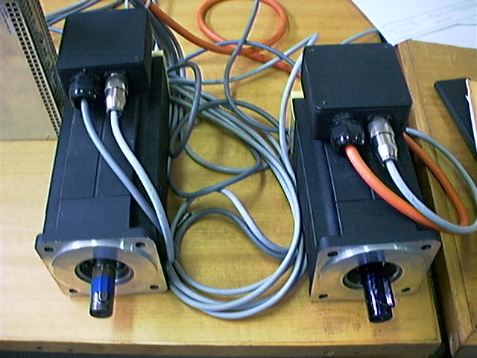

Fig 4: AC Brushless Servo Motors

On the extreme left of figure 4, a 10 Amp amplifier can be seen. The other amplifier used during the project was a 5 Amp amplifier which was connected to the rare-earth magnet motor shown on the right. The amplifiers were also made by Baldor® and distributed by Mechatronics. At the time of writing, the 5 Amp amplifier has been returned to Mechatronics and two more 10 Amp amplifiers have been ordered (along with the three motors) but have yet to arrive. The amplifiers are from the DBSC Series 1000/1100 produced by Baldor®. The 10 Amp amplifiers are the model: DBSC1110-AAAW. Refer to [DBSC95] for instructions and specifications. The amplifiers are capable of performing servo-control for the motors attached to them. In addition, they provide a range of facilities to protect the motor against excessive currents or voltages.
Shown below is the small (5 Amp) amplifier and the large (10 Amp) amplifier.

Fig. 27: 5 Amp Amplifier

