Control System and Interface for the NUWAR Robot

Introduction
As stated in the "Introduction" section, a servo-control system is required to ensure that the motors quickly and accurately respond to specified tasks.
Robotic mechanisms are generally non-linear in that the relationship between applied torques and end-effector acceleration is nearly always non-linear. This is not a hugely significant problem for slow moving robots where linear approximations seem to work effectively. With fast robots such as the DELTA and NUWAR robots, these non-linearities become significant, meaning that the modelling of an appropriate control system becomes much more complex and classical methods cannot be applied. There are still methods for designing effective control systems. One such design is shown below, where a feedback servo-loop has been combined with a dynamic feedforward term. This does most of the work, improving the performance of the control system [Miller95]. This scheme was proposed for the DELTA robot and so would have equal application to the NUWAR robot, providing that the dynamics are solvable.
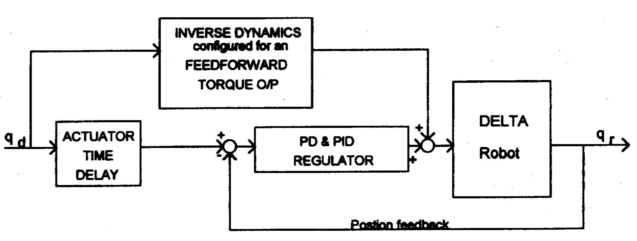
Fig 23: Proposed Control Scheme for the DELTA Robot [Miller95]

Creating a personalised control system was outside the scope of this year's project (1998). The dynamics for the NUWAR robot are also expected to be solved next year (1999).

Another issue pertinent to designing a control system, is whether it is to act in joint space, or in Cartesian space (or task space). These two options are illustrated below.

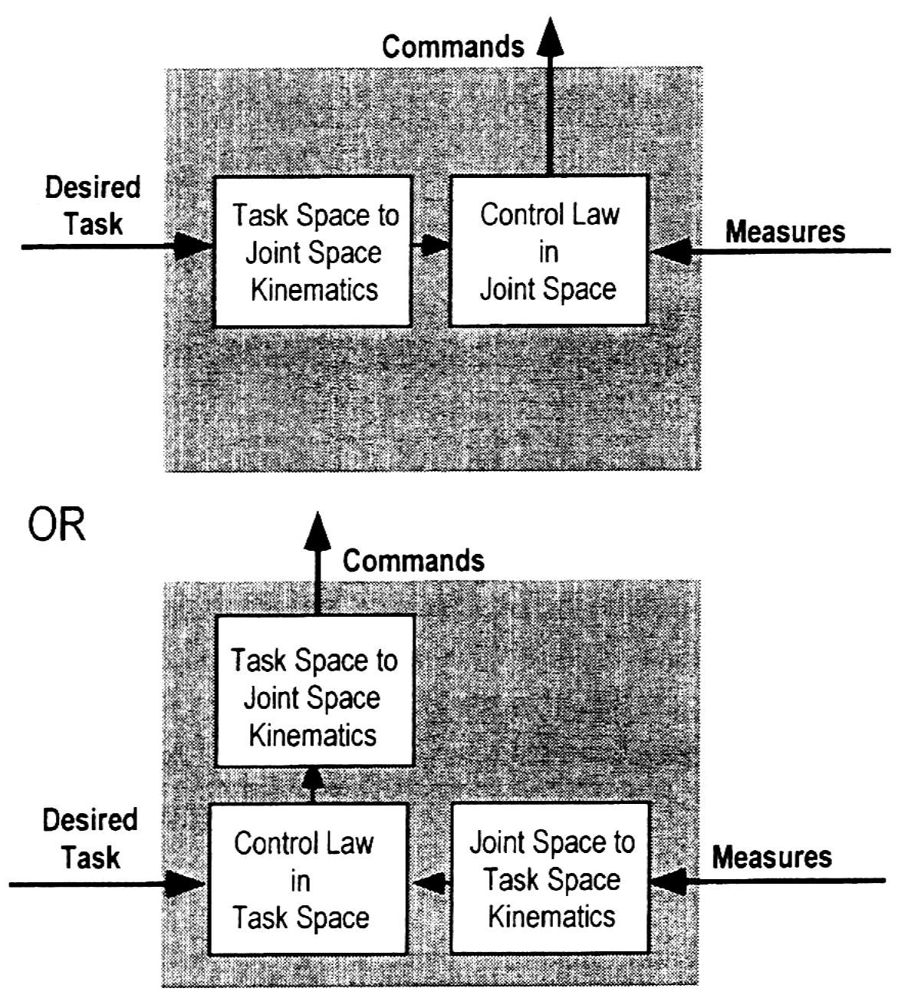
Fig. 24: Joint Space and Task Space Control [Guglie94]

For the purposes of controlling the robot and interfacing with the motors, a hardware card was purchased (PMAC card) which could be inserted into the PC used for the project. Since the PMAC card could provide the necessary servo-control for the motors, and because it could perform joint-space interpolation, the scheme shown on the top of Figure 24 was chosen for this year. Although the computer to motor interfacing has not been completed, it is thought that using the PMAC card in this way will allow the trajectories which have been simulated to be tested on the real robot without the need to implement a personalised control system. In this way, the control issues can be separated from the other components of the project.

Proposed Set-up for the NUWAR Robot Interface and Control System
The diagram below shows the interaction which occurs between the robot control system components. This system is based on using the PMAC to control the robot in joint space with the desired tasks being entered into a computer.

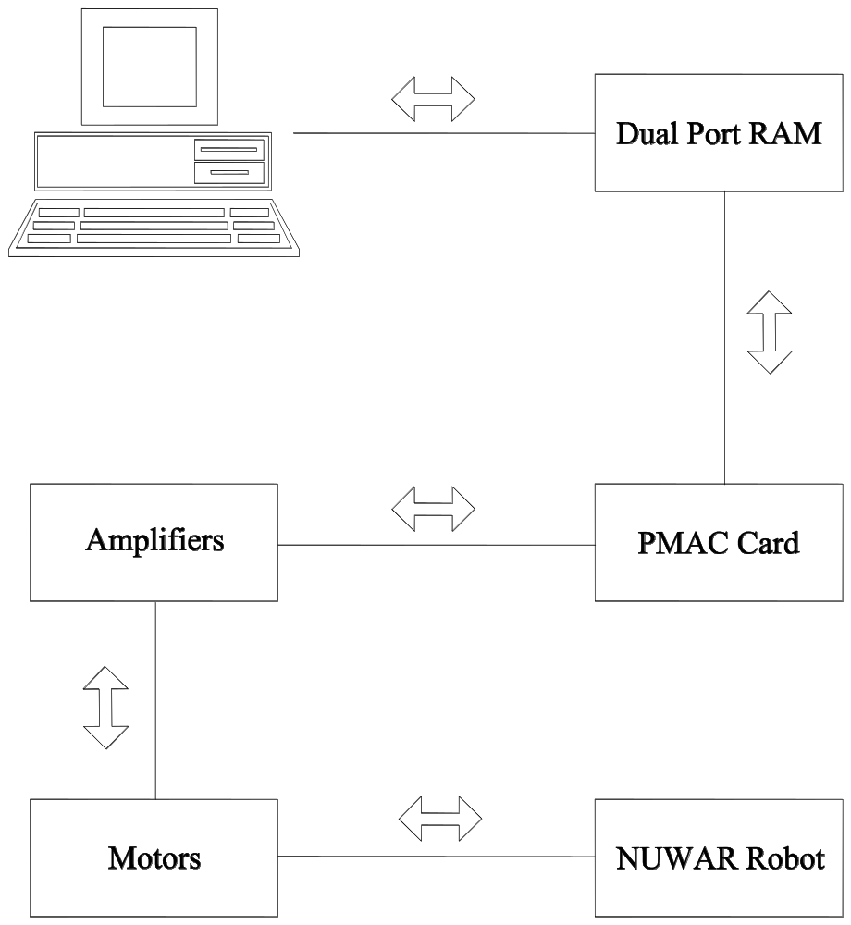

Fig 3: Components of the NUWAR Control System

NOTE: at the time of writing, the interface between the computer (PC) and the PMAC had not been completed. However, the author's partner, Stephen LePage received an extension and may get this up and running after the submission of this thesis.

Possible enhancements to the above system include sensors on the robot itself, such as angular sensors at the joints to ensure that they are not rotated outside their working range. Also, some sort of collision sensor which measures sudden impulses of force could be used to guard against damage caused by foreign objects in the robot's path.

Description of the Components

Motors & Amplifiers
The brand of the motors chosen was Baldor®. The reason for this choice was that they were distributed locally by a company called Mechatronics, and thus advice and assistance was close at hand. Baldor® also has an office in Sydney making them more accessible. Other motors, though more suitable for the NUWAR project, were only available from overseas manufacturers.
At the time of writing, the three motors to be used for the robot have still yet to arrive. The two motors shown below were provided for "try-before-you-buy" purposes to see if they could handle the inertias of the NUWAR robot. The one shown on the right in Figure 26 is a rare-earth magnet motor and has very low rotor inertia. Both are AC brushless servo motors. Refer to [Roberts98] for a detailed description of these motors.

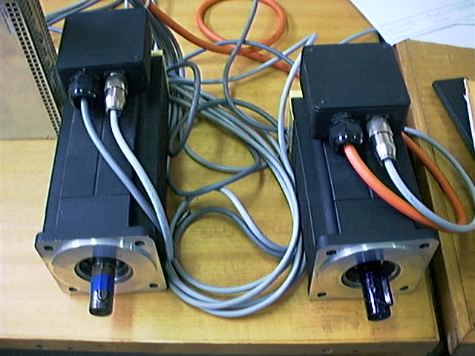

Fig 4: AC Brushless Servo Motors

On the extreme left of figure 4, a 10 Amp amplifier can be seen. The other amplifier used during the project was a 5 Amp amplifier which was connected to the rare-earth magnet motor shown on the right. The amplifiers were also made by Baldor® and distributed by Mechatronics. At the time of writing, the 5 Amp amplifier has been returned to Mechatronics and two more 10 Amp amplifiers have been ordered (along with the three motors) but have yet to arrive. The amplifiers are from the DBSC Series 1000/1100 produced by Baldor®. The 10 Amp amplifiers are the model: DBSC1110-AAAW. Refer to [DBSC95] for instructions and specifications. The amplifiers are capable of performing servo-control for the motors attached to them. In addition, they provide a range of facilities to protect the motor against excessive currents or voltages.
Shown below is the small (5 Amp) amplifier and the large (10 Amp) amplifier.
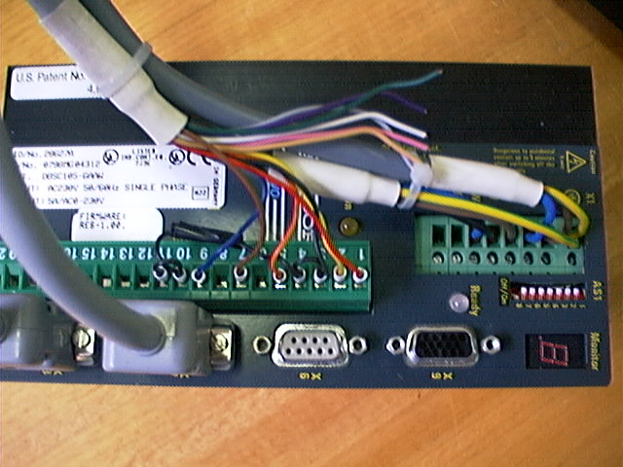

Fig. 27: 5 Amp Amplifier

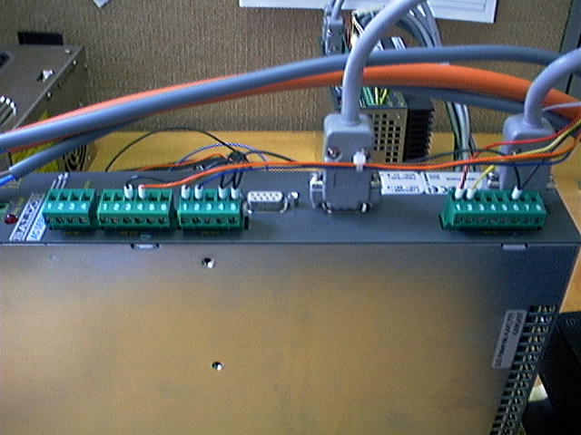

Fig. 28: 10 Amp Amplifier
The amplifiers also came with a software package called DBSC which acts as an interface between a computer and the amplifiers. With this interface, the motors can be run using jog commands and certain amplifier parameters can be set. There are two basic options for the operating mode:
- Velocity control - velocity and position data are given to the amplifiers which then convert these specifications into currents, which inturn, use their servo-control system to control the motors.
- Current control - raw currents are sent to the amplifiers which are amplified for the motors. No servo-loop control is performed within the amplifiers.
The amplifiers have been set in current mode because, as the current is controlled by the PMAC, secondary control in the amplifiers is unnecessary.
A picture of the DBSC interface screen is shown below.

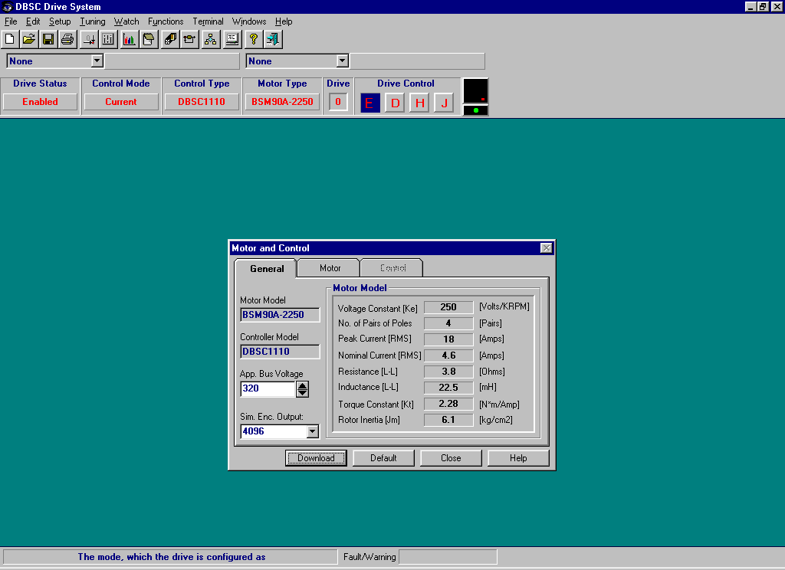

Fig 29: DBSC Interface for the Amplifiers

PMAC - Programmable Multi-Axes Controller
The manufacturer of this piece of equipment is Delta Tau Data Systems, Inc.
As the name implies, the PMAC is capable of controlling more than one axes (motor) at a given time. It is a versatile piece of equipment that can be used in many situations and with many different types of servo-motors. It is essentially a multi-process operating system implemented in hardware and is very efficient for performing mathematical calculations and time slicing. Thus, it ensures that the motors are synchronised when multiple commands to each motor are issued to it.
The PMAC card has about 1000 I-variables which can be tailored to suit specific applications. Programs can be written for the PMAC to perform compound or complex manoeuvres.
There are several pieces of software which complement (but are not necessarily packaged with) the PMAC card. These are [DeltaTau1]:
- PEWIN32 - the executive program which provides the user interface. I-variables can be set, loop tuning can be performed, and motion programs can be written to name only some of the operations which can be performed using this interface.
- PCOMM, PCOMM32 - the API library which contains functions for communicating with the PMAC through Serial, VME, PC bus or Dual Port RAM. This is necessary for creating a user interface for the NUWAR robot.
- PTalk(OCX32) - employed for creating 32 bit applications using Windows 95 or NT. It can be utilised in conjunction with programs such as Visual Basic to create an interface. This piece of software is not a requirement, but it is recommended that its usefulness for this project should be determined.
Of this software, PEWIN32 and PCOMM have been obtained. It is strongly recommended that PCOMM32 be aquired as it works in a 32 bit operating system such as Windows NT, and would be required if Windows 95 was upgraded to NT.
Please refer to [DeltaTau2] and [DeltaTau3] for a complete description of the PMAC's capabilities and settings.
The PMAC which has been purchased for this project runs at 60MHz. A Dual Port RAM card has also been purchased for the purposes of rapid communication between the robot's user interface and the PMAC.
A picture of the PMAC card is shown below.

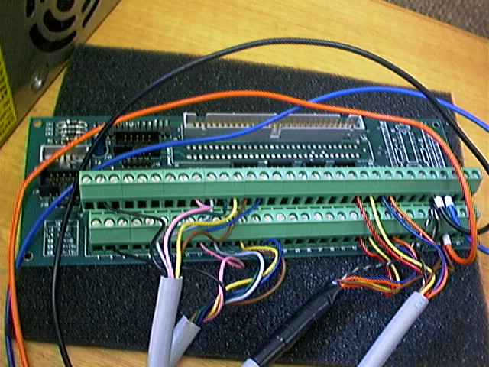

Fig 7: PMAC Card

Motor Tuning and Testing
The motors could easily be tuned with no load on them using Pewin32. Pewin32 allows various gains (proportional, integral, derivative etc.) to be toggled and step response tests to be carried out. A view of this feature is shown below.

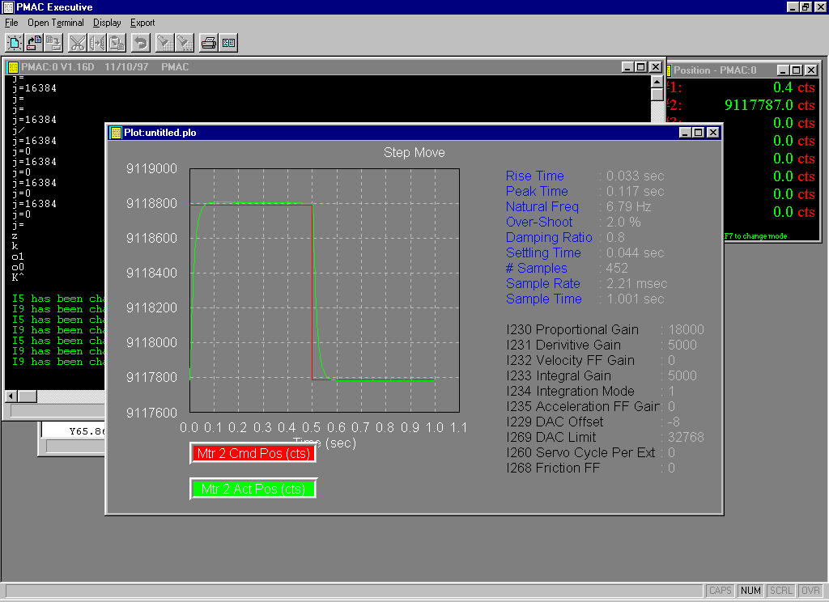
Fig 8: Control Loop Tuning in Pewin32

Co-team members Shane Parker and Stephen LePage constructed a test rig which enabled the motors to be tested using an inertial load which represented the NUWAR robot. This rig is shown below.

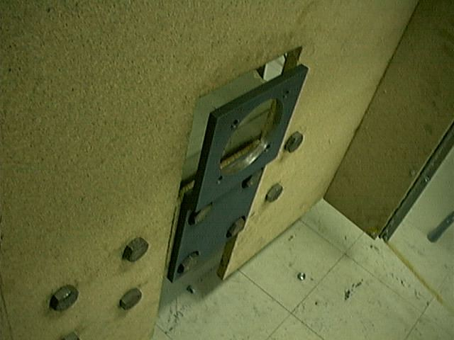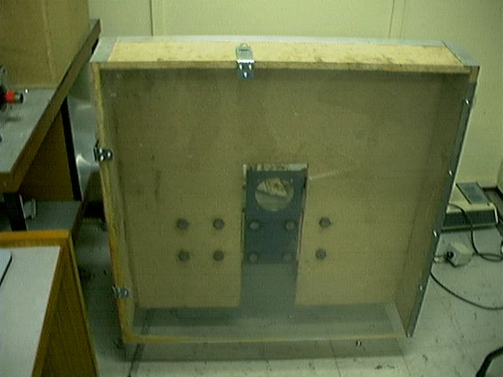

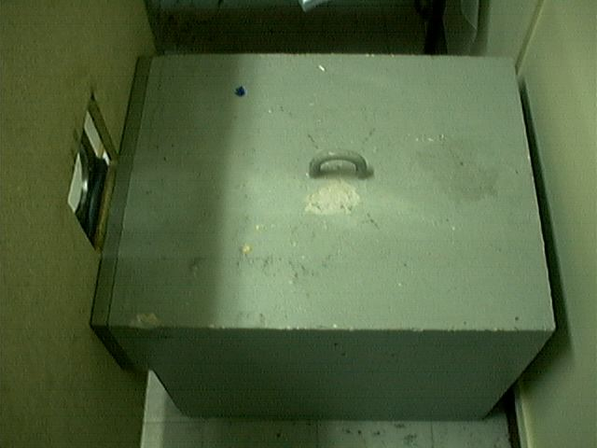

Fig. 32: Motor Test Rig

Difficulty was experienced in stabilising the motor once the control loop had been closed (no movement). High pitched noise and high frequency vibration were evident in the system. It appeared impossible to set the gains such that the test arm moved in a stable manner during the step test. Often, the movement became unstable, and various limits (such as the following error limit) were exceeded. When the movement was stable, the damping was so poor that the arm oscillated wildly about the end point. This was attributed to the following possibilities:
- The rotor inertia was too small in comparison to the load inertia - this was the diagnosis of the representative from Mechatronics who suggested that this ratio should be no higher than about ten;
- The motor possessed insufficient torque, meaning that the gains had to be set too high (outside the stability range) to achieve a good response.
In response to these findings, Dr Karol Miller (our supervisor) decided to order three larger motors capable of delivering more torque. Delivery of these, however, has not taken place at the time of writing.

Trajectory Control using the PMAC
As stated in the introduction, the chosen trajectory scheme was to generate a set of control points in Cartesian space which the gripper plate had to pass through.
The PMAC can take these points and perform joint space interpolation between them to create a smooth trajectory.
The PMAC in fact has five main joint space trajectory algorithms implemented in it. These are as follows:
- LINEAR mode - Specifications required: the peak velocity ("feedrate") or time for a move, the acceleration time (TA), the part of the acceleration time spent in "S-Curve" acceleration (TS), and the portion of the acceleration which is linear (TL). Linear acceleration in this case means constant acceleration and linear velocity. Setting an S-Curve time ensures that the acceleration will be continuos. The capability to select constant acceleration, pure S-Curve acceleration, or any combination allows the user to balance high acceleration rates with minimum "jerk" (the time derivative of acceleration). This mode is effective point-to-point movement where smooth acceleration is required.

- CIRCLE mode - mainly used for CNC machining purposes where the geometry of the manipulator is incorporated in the algorithm such that a circular movement is achieved in Cartesian space.

- RAPID mode - each motor moves at its preset maximum velocity and acceleration. This mode is intended for minimum-time, point-to-point movements; the intermediate path is not well defined.

- SPLINE mode - a set of points (motor angles) are specified along with a segment time. Cubic splines are computed automatically to interpolate between the points such that there are no velocity or acceleration discontinuities at the segment boundaries.

- PVT mode - a more complicated version of SPLINE. Each point is accompanied by a velocity to be reached at that point and a segment time given to reach it.

In both the SPLINE and PVT modes, the result is a series of segments with constant jerk, linear acceleration, parabolic velocity and a cubic position profile.

A set of motor angles, corresponding to an elliptical trajectory for the end-effector of the NWUAR robot, was entered into a motion program using Pewin32. The SPLINE mode was successfully used to achieve the joint space trajectory for the motors. The set of motor angles was generated using the MATLAB functions which were written by the author and his colleague, Stephen LePage.
It seems clear that using this method would be a good starting point to "get the robot moving".
The next step is to work out how to interface with the PMAC using PCOMM or PCOMM32 so that data can be transferred automatically between MATLAB and the PMAC using the Dual Port RAM.

Motion Programs
Motion programs are used to specify movement regimes for the motors. The described movement modes can be implemented in such a program.
Up to 256 motion programs can be stored in the memory of the PMAC Controller. Any program can be run simultaneously with itself, having been called by two different coordinate systems. Coordinate system, in this case, refers simply to a grouping of axes (motors) defined for the PMAC. The number of programs which can be run simultaneously is only limited by the number of defined systems. The PMAC does all the time slicing necessary to achieve this.
The motion control language has many of the basic features of languages such as C and BASIC as well as being compatible with G-Code which is utilised in the machining industry.

PLC Programs
The PMAC can run up to 32 asynchronous PLC programs in the background whilst motion programs are running synchronously in the foreground. These programs are based on the functionality of Programmable Logic Controllers (PLC's). They share the same logical constructs as motion programs but cannot be used to directly control the motor axes.
Apparently, PLC programs are useful for setting and changing various parameters as well as monitoring motion parameters and sending messages. One stipulated use for PLC programs is setting up an adaptive control system where the PLC program alters gain values on the basis of monitored parameters.

The User Interface
The user interface in this case refers to the Graphical User Interface (GUI) which is to be utilised by an operator to specify a task for the robot to complete.
Three major components necessary for the NUWAR GUI are:

- The GUI should hide the complexity of the PMAC's operations, and should give the impression of direct operator/robot interaction. That is, the data to be entered should represent a physical picture of the robot's required task.

- The GUI should be ergonomically designed for ease of use where buttons etc are grouped according to their function.

- The GUI should guard against erroneous or inappropriate data entered by the user. Feedback should be presented (eg via a dialogue window) which relays to the user the response of the system to their command.

Due to time constraints, the GUI that has been created does not yet contain many of the above desired features and is merely presented here as a starting point for future developments. It was created using MATLAB and uses the functions which were written in MATLAB code. Currently, it is only useful for quick demonstration purposes such as changing the 'α' and 'β' angles of the motors - it removes the need for repeated running of the functions at the MATLAB command prompt. To run the GUI, type "nuwargui" at the MATLAB prompt whilst in the "nuwar" directory.

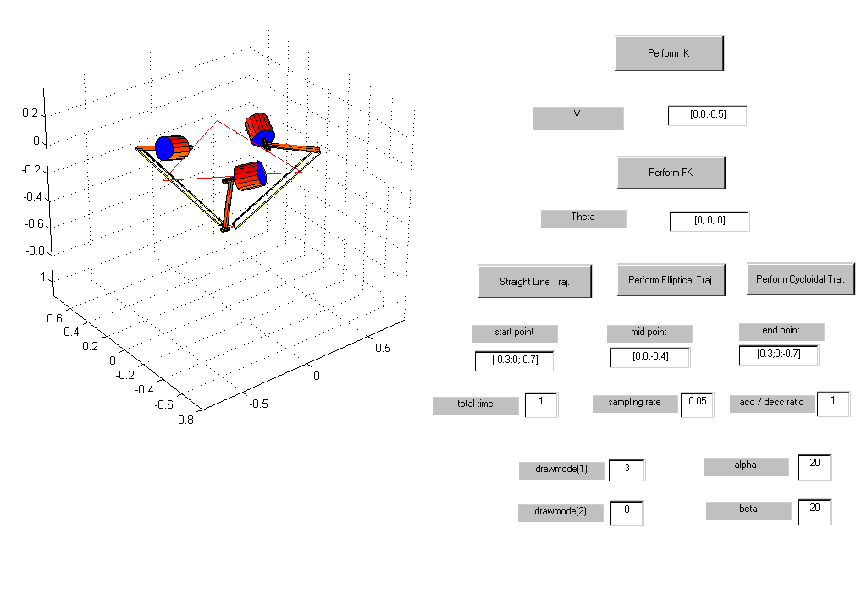
Fig 8: MATLAB GUI for the NUWAR Robot

An obvious enhancement to the above design is replacing the text boxes used for entering the "drawmode" parameters with checkboxes and radar buttons which would avail users with all the available options and prevent them from entering erroneous values.

