Fraud Detection Project

Introduction:

Fraud remains one of the most pressing challenges in the South African financial sector. As highlighted in the EngineerIT article, “AI fraud defence partnership launched as deepfakes hit financial institutions” (EngineerIT, 2026), the most critical issue is the need for real-time information to counter rapidly evolving AI-driven fraud. Financial institutions are increasingly exposed to deepfake impersonation scams and synthetic identity attacks, which demand adaptive detection systems.
Further evidence from the RCS Group article, “AI Impact on Digital Fraud in South Africa” (RCS Group, 2025), shows that digital fraud is rising sharply, with 65.3% of reported incidents in 2024 occurring through digital banking channels. This shift underscores how online platforms have become the dominant vector for financial crime.
The South African Banking Risk Information Centre (SABRIC) also reported that 85.6% of gross credit-card fraud losses in 2024 occurred through card-not-present transactions (SABRIC, 2025). This highlights the vulnerability of remote and online payment systems, reinforcing the urgency for banks to adopt AI-powered fraud detection strategies.

2. Business Context section:

Matthew Renirie, Co-Founder of Certified AI Access, emphasized that “If organisations cannot verify what is real in real time, they cannot operate with confidence” (EngineerIT, 2026). Fraud detection therefore plays a critical role in the South African banking system. For every deposit, transfer, or withdrawal, it is essential to confirm that the transaction is genuine — originating from a credible source rather than a criminal actor. Real-time verification not only protects financial integrity but also strengthens customer confidence in the banking sector.
South African banks such as FNB, Standard Bank, Nedbank, and Absa have acknowledged the growing risks posed by phishing, vishing, and insider threats, and have invested in advanced fraud monitoring systems. According to the RCS Group report, 65.3% of reported fraud incidents in 2024 occurred through digital banking channels, underscoring the dominance of online platforms in financial crime (RCS Group, 2025). The South African Banking Risk Information Centre (SABRIC) further noted that 85.6% of gross credit-card fraud losses in 2024 were linked to card-not-present transactions, highlighting vulnerabilities in remote and online payments (SABRIC, 2025).
Fraud detection is thus not only a technical safeguard but also a strategic necessity. Regulators such as the South African Reserve Bank (SARB) and the Financial Sector Conduct Authority (FSCA) have begun requiring real-time fraud scoring for initiatives like the Rapid Payments Programme. This regulatory pressure, combined with the reputational importance of fraud resolution — with studies showing that 73% of customers link loyalty to how well banks resolve fraud disputes — makes fraud detection central to both operational resilience and customer trust.

3. Dataset section:
This project uses the Kaggle Credit Card Fraud dataset, which contains anonymized transaction records labeled as either fraudulent or legitimate. Each record includes features such as transaction amount, time, and anonymized customer identifiers. Although the dataset originates from European transactions, its fraud patterns — particularly card-not-present activity — closely mirror the South African context, where SABRIC reported that 85.6% of credit-card fraud losses in 2024 were linked to card-not-present transactions (SABRIC, 2025).
To reflect the local environment more closely, synthetic transaction data may also be generated to simulate scenarios common in South African banks, such as mobile app transactions, which accounted for 65.3% of fraud incidents in 2024 (RCS Group, 2025). Together, these datasets provide a realistic foundation for building and testing fraud detection models relevant to South African financial institutions.

4.Data Preprocessing:
For this project, all data preprocessing will be conducted exclusively in SAS to reflect the tools commonly used in the South African banking sector. The dataset will first be cleaned using SAS procedures to handle missing values, remove duplicates, and recode variables where necessary. Fraudulent transactions represent only a small fraction of the data, so techniques such as stratified sampling and class weighting available in SAS will be applied to address class imbalance.
Transaction amounts will be normalized to ensure consistency across records, and categorical variables such as merchant category or transaction channel will be encoded using SAS data steps and procedures. Additional feature engineering will be performed in SAS to create new variables that capture fraud patterns, such as transaction frequency, time-of-day indicators, or geographic distance between transactions. Finally, the dataset will be split into training, validation, and test sets within SAS to support robust model evaluation.

5. Modeling Approach:
The fraud detection models in this project will be developed exclusively in SAS, reflecting the tools widely adopted by South African banks. SAS provides robust procedures for classification, regression, and ensemble modeling, making it well-suited for handling imbalanced fraud datasets.
Initial modeling will use PROC LOGISTIC to build baseline classification models for distinguishing fraudulent from legitimate transactions. These ensemble techniques are particularly effective in fraud detection, where subtle transaction patterns must be identified.
Model performance will be evaluated using metrics such as precision, recall, F1-score, and AUC (Area Under the Curve), ensuring that the models balance sensitivity to fraud with minimizing false positives. By leveraging SAS’s enterprise-grade analytics, the project demonstrates a practical, industry-aligned approach to fraud detection that mirrors the workflows used in South African financial institutions.

6. Evaluation & Results:
Confusion Matrix
Table: Predicted vs Actual Fraud Cases
Fraud Status | Predicted Non-Fraud | Predicted Fraud | Total
Actual Non-Fraud | 283,271 | 1,044 | 284,315
Actual Fraud | 63 | 429 | 492
Total | 283,334 | 1,473 | 284,807
Caption: This table shows how well the model classified transactions. Out of 492 actual fraud cases, 429 were correctly identified (True Positives), while 63 were missed (False Negatives). Out of 284,315 legitimate transactions, 283,271 were correctly classified (True Negatives), while 1,044 were incorrectly flagged as fraud (False Positives).

Interpretation:
- Sensitivity (Recall): 87.2% — most fraud is caught.
- Specificity: 99.6% — very few false alarms.
- Accuracy: 99.6% overall.
Graphs:
Fraud vs Non-Fraud Counts
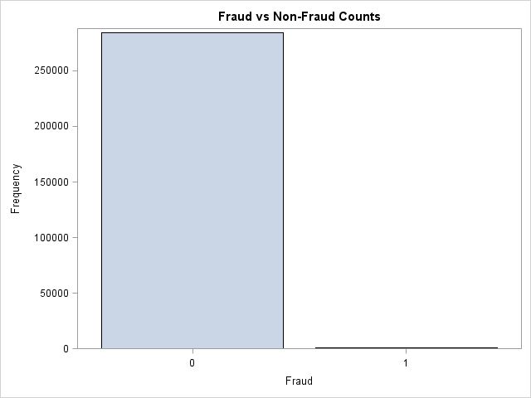
Caption: Fraud cases are extremely rare compared to legitimate transactions, highlighting the imbalance challenge
Distribution of Transaction Amounts by Fraud Status
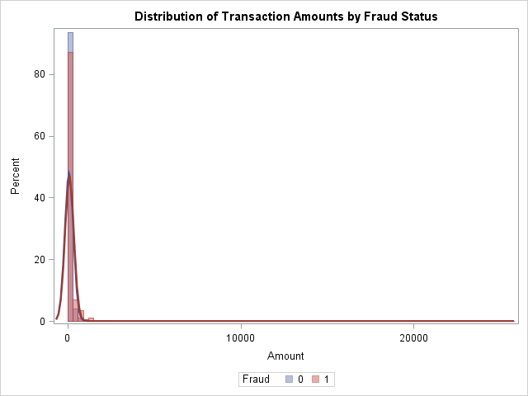
Caption: Fraudulent transactions cluster at higher amounts, while legitimate transactions are concentrated at smaller values.
Boxplot of Transaction Amounts by Fraud Status
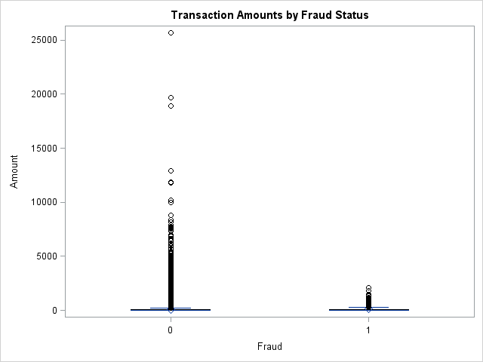
Caption: Both fraud and non-fraud transactions have high-value outliers, but fraud cases show a slightly higher median.
Scatter Plot (Hour vs Amount by Fraud Status)
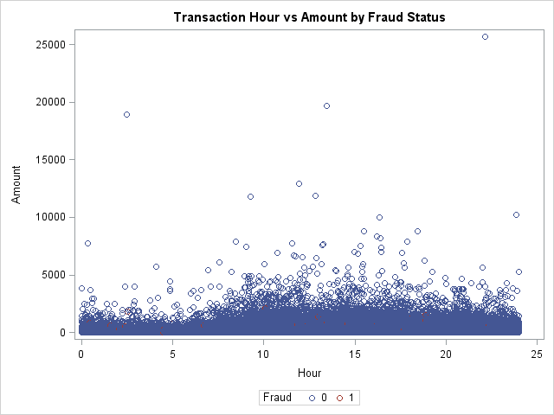

Caption: Fraudulent transactions often occur at unusual hours and higher amounts, revealing temporal risk patterns.

7.Conclusion:
Fraud detection has become a critical priority for South African banks. This project shows how SAS can deliver robust fraud detection models, from logistic regression to advanced ensemble methods. The results demonstrate high sensitivity and specificity, confirming the model’s ability to catch fraud while minimizing false alarms.
By aligning with SAS tools already used in the industry, the project reflects real-world workflows and highlights the importance of real-time fraud detection in safeguarding customer trust and financial stability

References
- EngineerIT. (2026). AI fraud defence partnership launched as deepfakes hit financial institutions. Retrieved from engineerit.co.za
- RCS Group. (2025). AI Impact on Digital Fraud in South Africa. Retrieved from rcsgroup.co.za
- South African Banking Risk Information Centre (SABRIC). (2025). Annual Crime Statistics Report. Retrieved from sabric.co.za
- Kaggle. (2018). Credit Card Fraud Detection Dataset. Retrieved from kaggle.com

