BeatSyncToolkit
Beat/Bar‑Synced Adaptive Music Conductor (Blueprint‑First)
User Guide & Setup Documentation
Version: v1.1
Build: State + Playlist + Zones + Event Layers + Quantization + Track Lock + Start/Stop + Multi-Layer Add
Engine: Unreal Engine 5.5.x (Blueprint)
Date: 2026-02-01
Includes: Roadmap (Upcoming Intensity & more)

1. What BeatSyncToolkit Does
BeatSyncToolkit lets you drive adaptive music in Unreal Engine using gameplay-friendly Blueprint nodes. It provides beat/bar timing, state-based music selection (with per-state playlists), optional stem layers, and a zone system that can override the global music state and add extra layers—all without requiring a custom GameInstance.

Key Features (Current Build)
- Beat/bar clock (Timer-based) with an OnBar event for quantized changes (no Quartz dependency).
- State system (E_BST_MusicState): switch music by gameplay state, optionally quantized to the next bar.
- Per-state playlist: each state can contain multiple tracks; auto-advance to the next track when the current ends.
- Two-base crossfade playback (Base A / Base B) for smooth transitions between tracks/states.
- Optional stem layers (E_BST_MusicLayer: Drums, Bass, Harmony, Melody, FX). Layers are always started muted and faded in/out (no restart).
- Event-based layers: add/remove/clear layers via global Blueprint nodes (BFL_BST) with optional next-bar quantization.
Multi-layer event calls: add any number of layers in one node (array input), with optional next-bar quantization.
Start/Stop Music: optionally start silent and trigger BST_StartMusic / BST_StopMusic from gameplay or demo interactions.
- Zone system (BP_BST_MusicZone): priority-based TopZone selection, zone state override, extra layers, and optional per-zone profile override.
- Zone + event layer arbitration: effective layers are the OR combination (zone layers + event layers).
- Quantized zone layer updates: zone layer changes can be applied immediately or on the next bar (optional).
- Playlist Track Lock: lock the currently playing track so it will restart instead of advancing (event-based + optional zone-based lock).
- Low-friction UX: all gameplay calls are made through a Blueprint Function Library; no manual Conductor references required.

What You Need to Place in Your Level
- BP_BST_Conductor: exactly one Conductor Actor in the level (required).
- Optional: one or more BP_BST_MusicZone actors for zone-based overrides and layer additions.

2. Quick Start (10 Minutes)

Step 1 — Add Content
- Add/import the BeatSyncToolkit content folder into your project (keep the folder structure).
- Open (or create) a test level.
- Drag BP_BST_Conductor into the level.
Step 2 — Assign a Profile & Start Behavior
Figure 1 — Drag BP_BST_Conductor into the level.

Step 2 — Assign a Profile & Auto-Start
- Select BP_BST_Conductor in the level.
If you want music to start automatically, enable bStartOnBeginPlay. If you want the level to start silent (recommended for demos), disable it and call BST_StartMusic when the player is ready.
- In Details → BST → Profile, set ActiveProfile to a profile asset (start with DA_BST_MusicProfile_Default).
- Set AutoStartState (for example: Explore).
- Press Play. If bStartOnBeginPlay is enabled, the Conductor will start AutoStartState, start the beat clock (BPM/BPB from the chosen track), and begin playback. If disabled, use BST_StartMusic to begin.
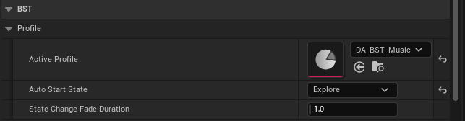
Figure 2 — Press Play: the Conductor will start the chosen state, start the beat clock (BPM/BPB from…

Step 3 — Drive Music from Gameplay (No References)
From any Blueprint, call the global nodes in BFL_BST:
BST_StartMusic(WorldContextObject) — starts music playback (use this if you disabled bStartOnBeginPlay).
BST_StopMusic(WorldContextObject) — fades out and stops all music (resets the beat clock).
- BST_SetMusicState(WorldContextObject, NewState) — request a state change.
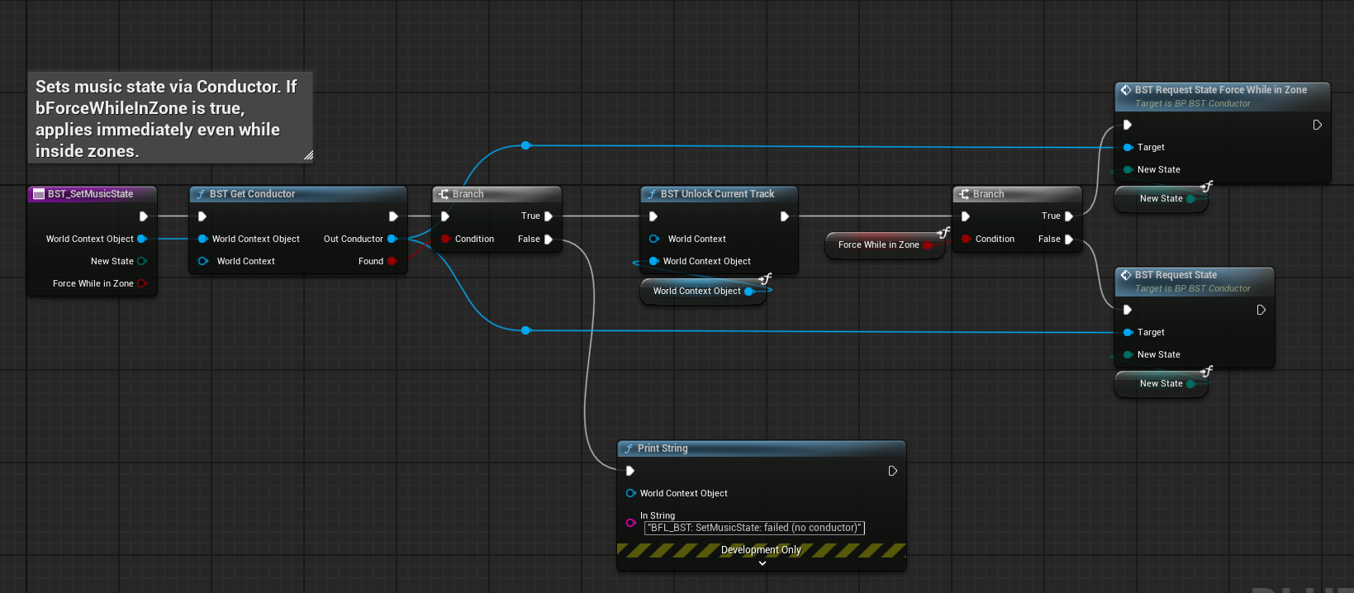
Figure 3 — BST_SetMusicState(WorldContextObject, NewState) — request a state change.
- BST_AddLayer(WorldContextObject, Layer, QuantizeToNextBar) — fades a single layer in (optionally quantized to the next bar).
BST_AddLayers(WorldContextObject, Layers[], QuantizeToNextBar) — adds multiple layers in one node (use Make Array to supply the list).
- BST_RemoveLayer(WorldContextObject, Layer, QuantizeToNextBar) — fades a single layer out (optionally quantized; zone-required layers remain enabled).
- BST_ClearLayers(WorldContextObject, QuantizeToNextBar) — clears all event layers (optionally quantized; zone layers remain).
- BST_LockCurrentTrack(WorldContextObject) / BST_UnlockCurrentTrack(WorldContextObject) — lock/unlock current track auto-advance.
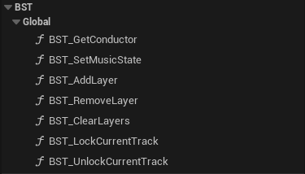
Figure 4 — BST_LockCurrentTrack(WorldContextObject) / BST_UnlockCurrentTrack(WorldContextObject) — l…

Step 4 — Add Zones (Optional)
- Drag BP_BST_MusicZone into the level and scale its Box Collision to cover an area.
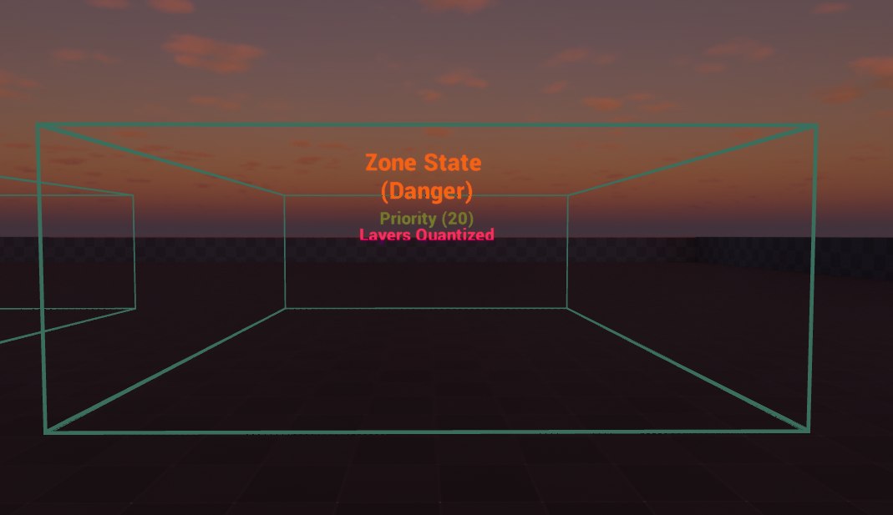
Figure 5 — Drag BP_BST_MusicZone into the level and scale its Box Collision to cover an area.
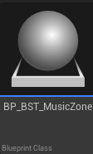
Figure 6 — Drag BP_BST_MusicZone into the level and scale its Box Collision to cover an area.
- Set ZonePriority (higher wins when zones overlap).
- Optionally set ZoneState to override the global state while inside the zone (ZoneState can be NONE to not override state).
- Optionally fill ExtraLayers to add layers while inside the zone.
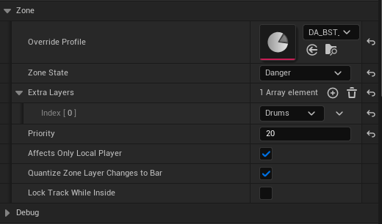
Figure 7 — Optionally fill ExtraLayers to add layers while inside the zone.
- Press Play and walk into the zone to see state/layer changes.

3. Included Assets & Files
Type | Name | Purpose
Blueprint Actor | BP_BST_Conductor | Main runtime brain. Holds the beat clock, current state/track, playback components, layers, zones, and arbitration logic.
Blueprint Actor | BP_BST_MusicZone | Overlap-triggered zone that can override state, add extra layers, override profile, and optionally influence zone quantization/track lock.
Blueprint Function Library | BFL_BST | Global gameplay-facing API. Finds the Conductor and forwards state/layer/lock requests.
Data Asset | DA_BST_MusicProfile_Default | Example profile containing StateConfigs and Track playlists.
Blueprint Class (Base) | PDA_BST_MusicProfile_Base | Base class type used by the Conductor for profile assets.
Enum | E_BST_MusicState | Music states (e.g., Explore, Combat, etc.). Expandable by advanced users.
Enum | E_BST_MusicLayer | Fixed layer set: Drums, Bass, Harmony, Melody, FX.
Internal (No Asset) | Pending Layer Queues | Quantized layer operations are implemented via pending arrays/flags (PendingAddLayers / PendingRemoveLayers / PendingClearEventLayers / HasPendingLayerOps) processed on BST_OnBar.
Struct | F_BST_TrackEntry | One track entry: BaseSound + BPM/BPB + optional layer defs (Drums/Bass/Harmony/Melody/FX).
Struct | F_BST_StateConfig | One state configuration: the state + its playlist of TrackEntry items.
Struct | F_BST_LayerDef | Per-layer definition used inside TrackEntry (at minimum: an optional Sound asset and a target volume).

Folder Expectations
Keep the content folder structure intact so references (profiles, actors, enums, structs) remain valid. The system is Blueprint-first and does not require a plugin build step.

4. Core Concepts

4.1 Conductor Actor
BP_BST_Conductor is the single authority that decides what music is playing. You manually place it in the level (it does not auto-spawn). Gameplay code never stores references—it calls BFL_BST, which finds the Conductor in the current world.
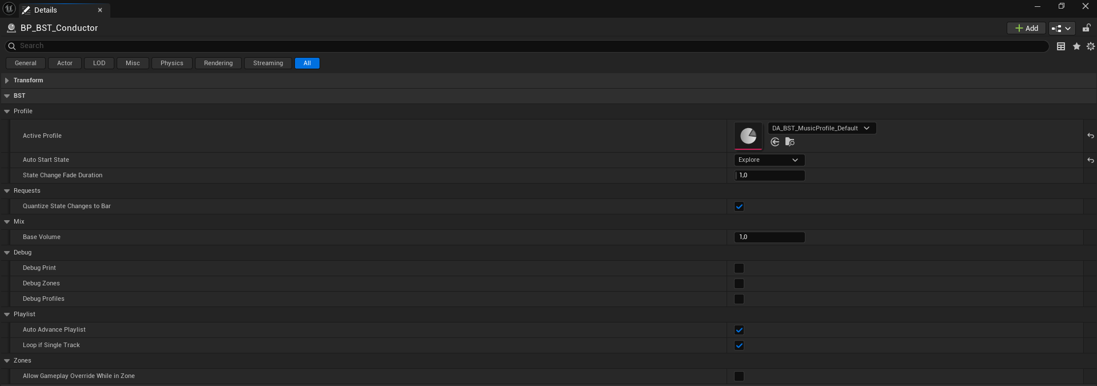
Figure 8 — BP_BST_Conductor is the single authority that decides what music is playing. You manually…

4.2 Profiles → States → Playlists → Tracks
A Music Profile is a data asset that maps each Music State to a playlist of TrackEntry items.
- State (E_BST_MusicState): a gameplay-friendly label such as Explore or Combat.
- StateConfig (F_BST_StateConfig): holds the playlist for one state.
- Playlist: an array of TrackEntry items for that state.
- TrackEntry (F_BST_TrackEntry): contains BaseSound, BPM, BeatsPerBar, and optional layer defs for each layer.

4.3 Layers (Stems)
Layers are optional stem audio components. If a TrackEntry provides a sound for a layer, the Conductor will start that layer immediately when the track begins, but at a muted standby volume. Add/Remove operations only adjust volume (fade up/down) and do not restart audio.
- Fixed layers (E_BST_MusicLayer): Drums, Bass, Harmony, Melody, FX.
- If a track has no stem for a layer, that layer cannot be armed/added for that track (it is ignored).

Gameplay Layer Control (Event-Based)
Use BFL_BST layer nodes to add/remove/clear layers from any Blueprint without keeping references to the Conductor. Each call includes a 'QuantizeToNextBar' boolean to apply the change exactly on the next bar, or to fade right away.

Add Multiple Layers (Single Node)
Use BST_AddLayers with an array input to add 2, 3, or all layers at once. In Blueprints, supply the array using Make Array (E_BST_MusicLayer) and list the layers you want (e.g., Drums + Bass + Harmony). Duplicates are ignored.

4.4 Beat/Bar Clock (No Quartz)
The Conductor maintains a beat clock using timers. Each beat advances CurrentBeat, and each bar fires BST_OnBar. Quantized operations (state changes and optional layer changes) are applied on BST_OnBar.

4.5 Zones
BP_BST_MusicZone is an overlap-based control layer. The Conductor tracks all zones the player is currently inside, selects a single TopZone using ZonePriority, and applies that zone’s state override, extra layers, profile override, and optional track lock/quantization behavior.

5. Creating & Editing Music Profiles

5.1 Create a Custom Profile
- In the Content Browser, duplicate DA_BST_MusicProfile_Default.
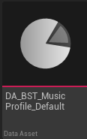
Figure 9 — In the Content Browser, duplicate DA_BST_MusicProfile_Default.
- Rename it (example: DA_BST_MusicProfile_MyGame).
- Open your new profile asset.
- For each state you want to support, add or edit a StateConfig entry.

5.2 Fill a StateConfig (Playlist)
In each StateConfig:
- Set the State (E_BST_MusicState).
- Add one or more TrackEntry items to the Tracks/Playlist array.
- For best results, provide accurate BPM and BeatsPerBar for each track.

5.3 Fill a TrackEntry
Each TrackEntry is the complete definition for one piece of music in a playlist.
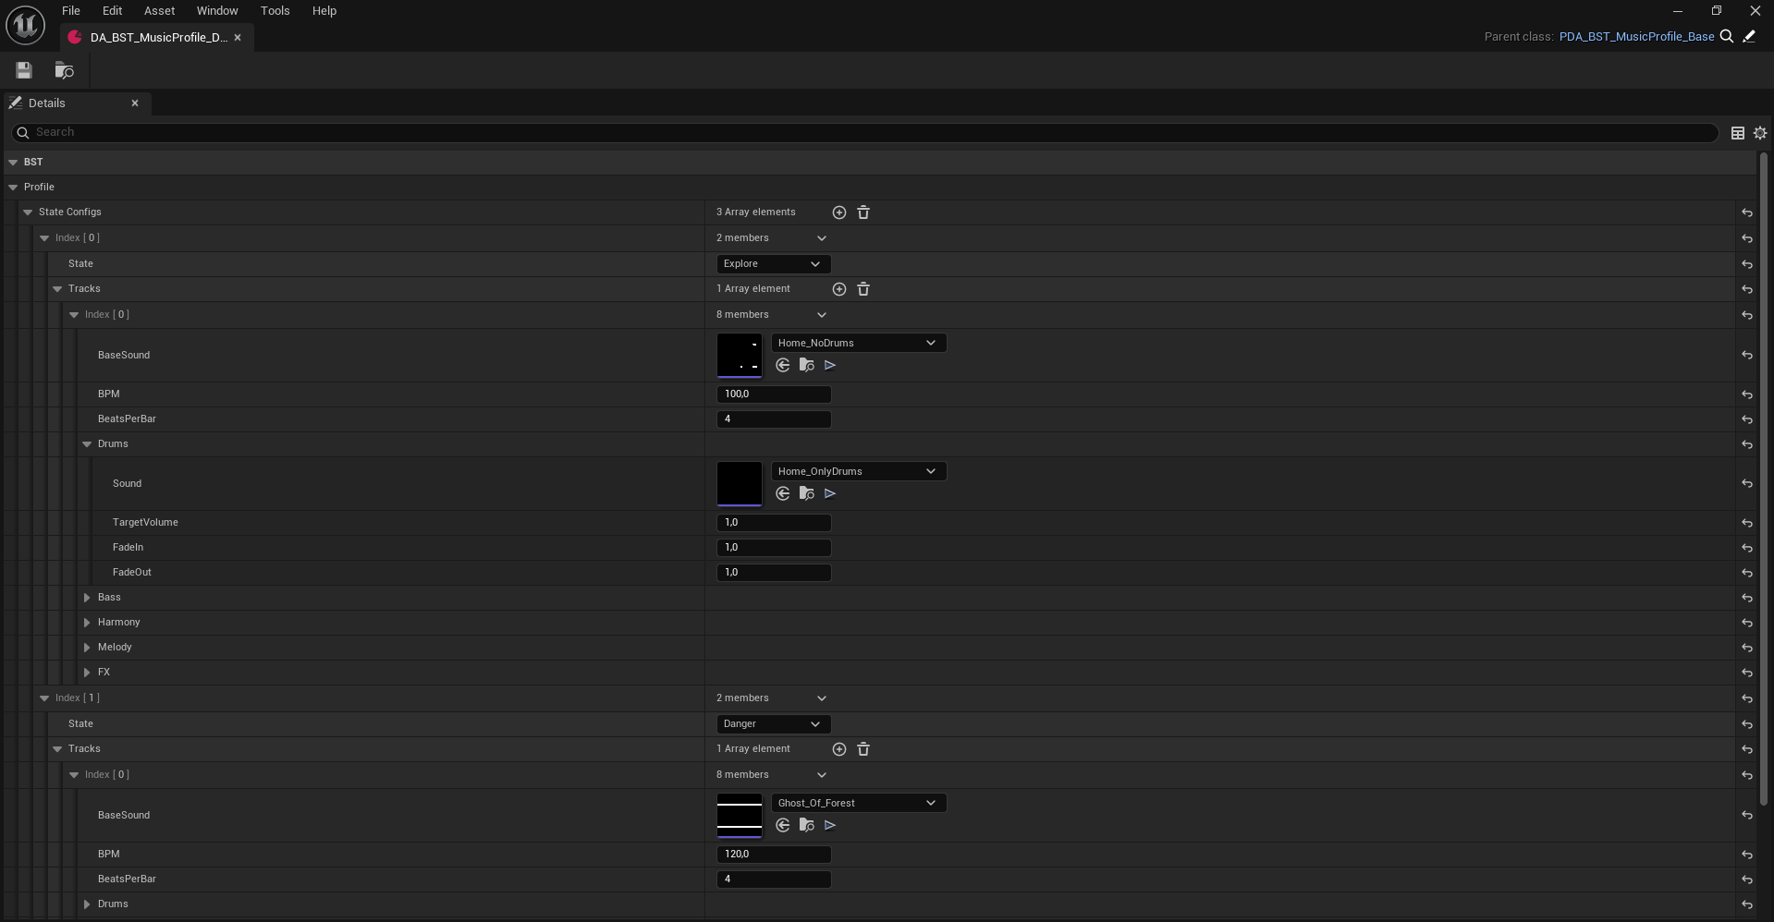
Figure 10 — Each TrackEntry is the complete definition for one piece of music in a playlist.
Field | Type | Meaning
BaseSound | SoundWave/SoundCue | Main full mix (or main stem). Always required.
BPM | Float | Beats per minute for beat/bar timing. Drives quantization.
BeatsPerBar | Integer | Time signature in beats per bar (commonly 4).
Drums / Bass / Harmony / Melody / FX | F_BST_LayerDef (optional) | Optional stems for each layer. Leave empty if you don’t have that stem.

Single WAV Use Case (No Stems)
- Set BaseSound only, leave all layer sounds empty.
- You can still switch states and use playlists.
- Layer add/remove calls will be safely ignored if the current track has no matching stem.

5.4 Assign Profile to the Conductor
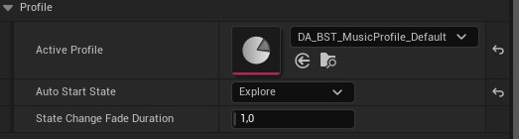
Figure 11 — 5.4 Assign Profile to the Conductor
- Select BP_BST_Conductor in your level.
- Set ActiveProfile to your custom profile asset.
- Set AutoStartState to the initial state you want.
- Play the level.

6. Gameplay API (BFL_BST)
BFL_BST is the only thing your gameplay Blueprints need to call. It internally finds the BP_BST_Conductor in the current world and forwards the request.
Node | What it does
BST_GetConductor | Finds the placed BP_BST_Conductor in the current world. Returns Found=false if missing.
BST_StartMusic | Starts music playback. Use this when bStartOnBeginPlay is disabled (demo-friendly start silent).
BST_StopMusic | Fades out and stops all music, stops the beat clock, and resets runtime state (safe to call anytime).
BST_SetMusicState | Requests a music state change. Obeys zone override rules unless you use the force variant.
BST_AddLayer | Adds a single event layer (fade in). The QuantizeToNextBar input applies the change on the next bar when enabled.
BST_AddLayers | Adds multiple event layers in one call (array input). Use Make Array to supply 2/3/all layers. Supports QuantizeToNextBar.
BST_RemoveLayer | Removes a single event layer (fade out). If the same layer is required by the active zone, it remains enabled.
BST_ClearLayers | Clears all event layers (zone layers remain). Supports QuantizeToNextBar.
BST_LockCurrentTrack | Locks the currently playing track (prevents playlist auto-advance; restarts the same track on finish).
BST_UnlockCurrentTrack | Releases the lock so the playlist can auto-advance again.

Important Behavior Notes
- No manual references: the WorldContextObject input is enough for the toolkit to find the Conductor.
- If no Conductor exists in the level, nodes do nothing (Found=false).
- Layer nodes operate on Event Layers (ActiveEventLayers). Zone Layers are managed by zones and are not cleared by BST_ClearLayers.

7. Conductor Settings & Variables (BP_BST_Conductor)
These are the main user-facing variables shown in the Conductor’s Details panel / variable list.
Variable | Meaning
ActiveProfile | Profile asset used to resolve StateConfigs. Zones may temporarily override this via OverrideProfile.
AutoStartState | State to start automatically when the level begins.
StateChangeFadeDuration | Crossfade duration when switching states/tracks (base crossfade).
bQuantizeStateChangesToBar | If true, BST_SetMusicState requests are held and applied on the next bar.
bStartOnBeginPlay | If true, the Conductor starts music automatically on BeginPlay using AutoStartState (or active zone override). If false, the level starts silent until you call BST_StartMusic.
BaseVolume | Master volume multiplier for the base mix.
bAutoAdvancePlaylist | If true, when the active base finishes, the Conductor advances to the next track in the current state playlist.
bLoopIfSingleTrack | If true and the playlist has only 1 track, restart that track when it finishes (single-track loop).
bAdvanceLock | Internal safety lock to prevent double-advance triggers (set briefly during transitions).
bAllowGameplayOverrideWhileInZone | If true, a special force request node can switch state even while a zone override is active.
bQuantizeZoneLayerChangesToBar | If true, zone layer set updates can be queued and applied on the next bar.
bDebugPrint / bDebugZones / bDebugProfiles | Prints debug info for troubleshooting.
Layer Quantize (per call) | Layer add/remove/clear operations are quantized per call using the 'QuantizeToNextBar' input on the BFL nodes. When enabled, ops are queued and applied on the next bar.

Runtime Variables (FYI)
At runtime, the Conductor maintains CurrentState, CurrentTrack, beat clock values (BPM/BeatsPerBar/CurrentBeat), pending requests (PendingState, Pending layer ops, Pending zone layers), zone tracking (ActiveZones, TopZone, ActiveZoneLayers), and track lock flags (bEventTrackLock, bZoneTrackLock, bTrackLockActive).

8. Zone System (BP_BST_MusicZone)
Zones are overlap-based. When the player enters/exits zones, the Conductor maintains an ActiveZones array and selects the TopZone (highest ZonePriority). Only the TopZone’s settings are applied.

8.1 Zone Properties
Property | Meaning
ZonePriority | Higher value wins when multiple zones overlap.  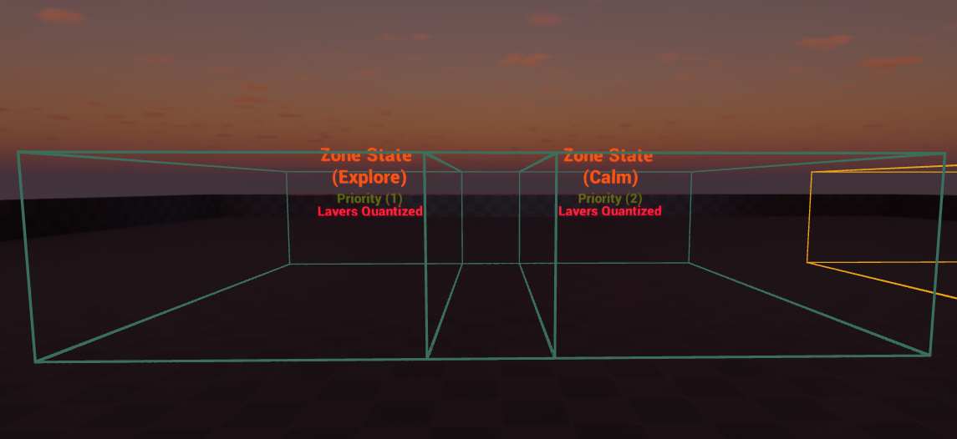
ZoneState | If not NONE, overrides the global requested state while inside the TopZone.
ExtraLayers | Array of E_BST_MusicLayer to add while inside the zone.
OverrideProfile | Optional: use a different profile while this zone is TopZone (only used when ZoneState is not NONE).
bZoneTrackLock | Optional: request Track Lock while inside this zone (lower priority than Event Track Lock).
QuantizeZoneLayerChangesToBar | Instance-editable toggle that can drive the Conductor’s zone-layer quantization behavior when this zone becomes TopZone.
AffectsOnlyLocalPlayer | If enabled, the zone only reacts to the local player (useful for single-player testing).

8.2 Overlapping Zones & Priority
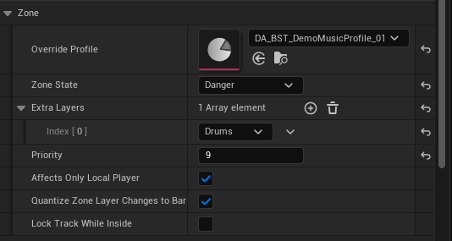
Figure 12 — 8.2 Overlapping Zones & Priority
- When you are inside multiple zones, the Conductor chooses TopZone by the highest ZonePriority.
- If TopZone changes, the Conductor reapplies zone override (state/profile) and zone layers.
- Leaving a TopZone will reselect the next best zone, or disable zone override if none remain.

8.3 Zone + Gameplay State Interaction
- Gameplay requests via BST_SetMusicState set GlobalRequestedState.
- If ZoneOverrideActive is true, TopZone.ZoneState can override what is actually playing.
- When you leave zones, the Conductor returns to GlobalRequestedState automatically.
- Optional: BST_RequestState_ForceWhileInZone can force a state change while inside zones (if enabled).

9. Arbitration Rules (State, Profile, Layers)

9.1 State Resolution Priority
Source | Priority
TopZone.ZoneState (if ZoneOverrideActive and not NONE) | Highest priority. Overrides the effective playing state.
GlobalRequestedState (from gameplay) | Used when no zone override is active, or when TopZone.ZoneState is NONE.

9.2 Profile Resolution Priority
- ProfileInUse is resolved each time a zone override is applied.
- If ZoneOverrideActive and TopZone.OverrideProfile is valid AND TopZone.ZoneState is not NONE: ProfileInUse = OverrideProfile.
- Otherwise: ProfileInUse = ActiveProfile.

9.3 Layer Resolution (OR Combination)
A layer is considered desired/active if ANY source requests it:
Layer Source | Description
ActiveZoneLayers | Layers coming from the current TopZone’s ExtraLayers (or pending zone layer set if quantized).
ActiveEventLayers | Layers added/removed by gameplay through BFL_BST nodes (or pending ops if quantized).
Because layers are combined with OR, removing a layer from Event Layers will not turn it off if the active zone still requests that layer.

10. Quantization (Next-Bar Changes)
Quantization means applying changes exactly on the next bar boundary. BeatSyncToolkit supports quantization for:
- State changes (bQuantizeStateChangesToBar).
- Event layer operations (queued Add/Remove/Clear, applied on bar).
- Zone layer set updates (bQuantizeZoneLayerChangesToBar).

10.1 State Quantization
- When bQuantizeStateChangesToBar is ON, BST_RequestState stores PendingState and sets bHasPendingState=true.
- BST_OnBar checks bHasPendingState and applies the PendingState using BST_SwitchStateNow, then clears the flag.

10.2 Event Layer Ops Quantization
When layer ops are queued, the Conductor uses these runtime variables:
- PendingAddLayers (array of E_BST_MusicLayer).
- PendingRemoveLayers (array of E_BST_MusicLayer).
- PendingClearEventLayers (bool).
- HasPendingLayerOps (bool).
On each bar, BST_ApplyPendingLayerOps_OnBar applies the queue in a deterministic order:
1) optional Clear, 2) Remove queued layers, 3) Add queued layers (only if the current track has that stem), then clears the pending arrays/flags and calls BST_ApplyEventLayersNow.

10.3 Zone Layer Set Quantization
- When zone layer changes are quantized, the Conductor stores PendingZoneLayers and sets bHasPendingZoneLayerSet=true.
- On bar, BST_ApplyPendingZoneLayers_OnBar copies PendingZoneLayers into ActiveZoneLayers, clears the pending flag, then calls BST_ApplyEventLayersNow.

11. Playlist, Auto-Advance, and Track Lock

11.1 Base Playback & Crossfade
- The Conductor uses two base AudioComponents (Base A and Base B).
- When switching tracks/states, it crossfades from the currently active base to the other base (BST_CrossfadeBaseTo).
- bUsingBaseA indicates which base is currently active; OnAudioFinished events ignore the inactive base.

11.2 Auto-Advance (Play Next Track)
- If bAutoAdvancePlaylist is ON, when the active base finishes, BST_PlayNextTrack_SameState is called.
- The next track is chosen from the current state’s playlist, avoiding immediate repeats when possible.
- After choosing a track, the beat clock is restarted (BPM/BPB), base is crossfaded, layer components are ensured playing muted, and active layers are re-applied.

11.3 Track Lock (Lock the Currently Playing Track)
- Track Lock prevents playlist auto-advance for the current track.
- When locked, if the active base finishes, the Conductor restarts the same CurrentTrack instead of advancing.
- Event-based lock (from BFL_BST) has priority over zone-based lock (from TopZone).
- A note is included in the Conductor’s Finished handlers: “This action only locks the currently playing track.”

11.4 Advance Lock (Anti Double-Advance)
The Conductor briefly sets an internal Advance Lock during transitions/finishes to prevent double-advance (for example, if both base finished events fire near a switch). This lock auto-clears after AdvanceLockSeconds.

12. Practical Usage Examples

Example A — Exploration/Combat with Quantized Transitions
- Set bQuantizeStateChangesToBar = true on the Conductor.
- Call BST_SetMusicState(Explore) during normal gameplay.
- When combat starts, call BST_SetMusicState(Combat). The change will occur cleanly on the next bar.
- When combat ends, call BST_SetMusicState(Explore) again.

Example B — Layered Tension (Event Layers)
- Ensure your Combat tracks include a Drums stem (Drums LayerDef has a Sound).
- Call BST_AddLayer(Drums) to fade in drums.
- Call BST_RemoveLayer(Drums) to fade them out.
- If the current track has no Drums stem, the request is ignored safely.

Example C — Zone Overrides + Extra Layers
- Place a BP_BST_MusicZone for a ‘Danger Area’. Set ZonePriority high.
- Set ZoneState = Danger (or Combat) and ExtraLayers = [FX].
- Walk into the zone: the state is overridden (if ZoneState is not NONE) and FX layer is enabled.
- Walk out: music returns to GlobalRequestedState and FX layer turns off (unless still requested by event layers).

Example D — Overlapping Zones (TopZone Selection)
- Place Zone A (Priority 10) and Zone B (Priority 20) overlapping.
- While inside both, Zone B becomes TopZone.
- When leaving Zone B but staying in Zone A, the Conductor switches back to Zone A behavior automatically.

Example E — Track Lock during a Boss Fight
- When boss fight begins, call BST_LockCurrentTrack().
- The current playing combat track will restart on finish instead of advancing to another playlist item.
- When boss fight ends, call BST_UnlockCurrentTrack(). Auto-advance resumes.

13. Debugging & Troubleshooting

Most Common Setup Issues
- Nothing plays: you forgot to place BP_BST_Conductor in the level, or ActiveProfile/AutoStartState is not set.
- Layers do nothing: your current track has no stem for that layer (LayerDef sound is empty).
- Zone changes don’t apply: your player isn’t overlapping the zone’s collision, or ZonePriority/TopZone selection is not what you expect.
- State changes seem delayed: bQuantizeStateChangesToBar is enabled, so changes apply on the next bar.
- Layer changes seem delayed: you enabled QuantizeToNextBar on your layer call, so it applies on the next bar.

Helpful Debug Flags
- bDebugPrint: general prints (state switches, picks, bars).
- bDebugZones: zone enter/exit, TopZone changes, applied overrides.
- bDebugProfiles: profile resolution and state config lookup.

Sanity Checklist
- Exactly one Conductor exists in the level.
- ActiveProfile contains an entry for the target state.
- Each TrackEntry has BaseSound set and correct BPM/BPB.
- Your desired layer’s LayerDef sound is valid for that track.
- Zones have collision enabled and overlap events firing.

14. Not Included in the Current Build (For Clarity)
Note: Some items below are planned. See section 16 (Roadmap) for details.

To avoid confusion, the following ideas were discussed but are not implemented in the current build:
- Intensity system (continuous 0..1 mixing or threshold-based layer logic).
- Manual looping of an arbitrary chosen track via event/zone (beyond the single-track playlist loop option).
- State pause/resume (returning to a previous state at the exact playback position).
- Multi-base or additional base processing features beyond the current A/B crossfade.

15. Advanced Reference: Conductor Function Map
This section is for power users who want to understand internal responsibilities. Most games only need the BFL nodes and profile/zone setup.
Category | Functions
Profile | BST_GetStateConfig, BST_GetStateConfig_FromProfile, BST_PickTrackForState
Clock | BST_StartBeatClock, BST_OnBeatTick, BST_OnBar
Runtime | BST_SwitchStateNow, BST_CrossfadeBaseTo
Public | BST_RequestState, BST_RequestState_ForceWhileInZone
State (Internal) | BST_RequestState_Internal
Layers | BST_EnsureLayerComponentsPlayingMuted, BST_ApplyEventLayersNow, BST_CurrentTrackHasLayerSound, BST_AddEventLayer
Layers (Quantize) | BST_QueueAddLayer, BST_QueueRemoveLayer, BST_QueueClearLayers, BST_ApplyPendingLayerOps_OnBar
Playlist | BST_PlayNextTrack_SameState, BST_SetAdvanceLock, BST_ClearAdvanceLock
Zones | BST_NotifyZoneEntered, BST_NotifyZoneExited, BST_RecomputeTopZone, BST_ResolveProfileInUse, BST_ApplyZoneOverrideNow
Zones (Queued/Pending) | BST_RequestRecomputeTopZone, BST_RecomputeTopZone_Queued, BST_ApplyPendingZoneLayers_OnBar
Track Lock | BST_UpdateTrackLockActive, BST_RestartCurrentTrackLocked

16. Roadmap (Planned Updates)
BeatSyncToolkit is designed to be expandable. Below is a transparent roadmap of features we plan to add after v1.0. This list is intentionally optional‑friendly: upcoming systems will be toggles and will not break the current workflow.

16.1 Intensity System (Upcoming)
- A simple 0..1 Intensity input that maps to layer combinations (Drums/Bass/Harmony/Melody/FX) and/or per‑layer target volumes.
- Optional bar‑quantization (Intensity changes take effect on the next bar, similar to the current layer quantize system).
- Designed primarily for stem‑based tracks (tracks that actually contain the requested layer sounds).
- Clear, non‑conflicting rules with Zones + Events (Intensity will respect the same arbitration philosophy: no surprises).

16.2 Playback & Base Processing (Later)
- Multi‑base support (more than one base bus concept, beyond the current A/B crossfade).
- Optional base processing / intensity without stems (e.g., filtering/ducking/volume shaping on the base when only a single WAV exists).
- Optional “pause & resume per state” (switch away, then return to the previous state continuing from the same playback position).
- Optional “pin / loop a specific track” inside a state playlist (zone‑based or event‑based), beyond the current Track Lock (which locks the currently playing track).

16.3 Roadmap Summary Table
Feature | Why it matters | Planned in | Notes
Intensity (V1) | One input → musical build‑up/relax without manual layer juggling. | v1.x | Optional + bar‑quantizable. Stem‑aware (won’t “arm” missing layers).
Base processing (no stems) | Useful when you only have one WAV and still want intensity‑like movement. | v1.x+ | Exploration after Intensity V1.
Pause/Resume per state | Return to Exploration where it left off after a Combat interlude (optional). | v1.x+ | May depend on audio format/streaming constraints.
Pin/Loop specific track | Lock a chosen track, not only the currently playing one. | v1.x+ | Extends the existing Track Lock feature.
Polish & examples | Faster onboarding for buyers. | Continuous | More sample maps, presets, and troubleshooting docs.
End of document. (v1.0)

