1. select distinct ShipName,substr(ShipName,0,instr(ShipName,"-"))

from 'Order'

where ShipName like '%-%’ order by ShipName ;

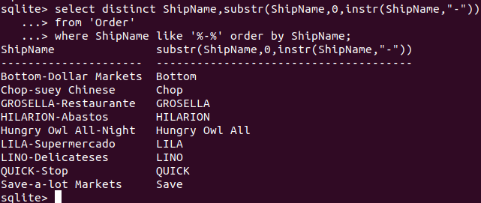

1. select id,ShipCountry,

case when ShipName in(‘USA’,’Mexico’,’Canada’)

then ‘NorthAmeraca’

else ‘OtherPlace’ end as IsNorth

from ‘Order’

where Id>=15445 order by Id limit 20;

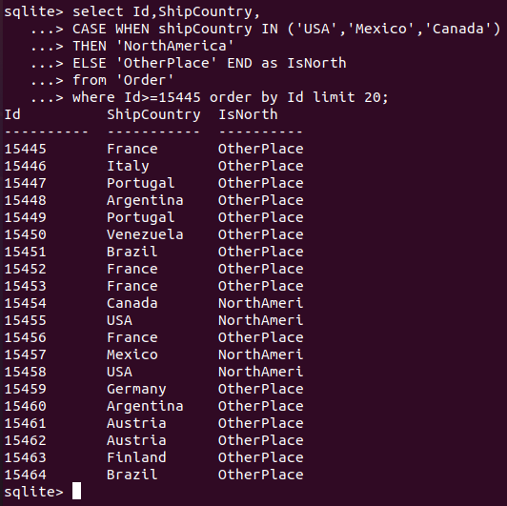

1. select Shipper.CompanyName,round(late*1.0/cnt*100,2) as DelayRate

...> from Shipper,(select ShipVia,count(Id)as late from 'Order' where ShippedDate>RequiredDate group by ShipVia) as C,(select ShipVia,count(Id) as cnt from'Order' group by ShipVia)as D

...> where Shipper.ID=C.ShipVia and C.ShipVia=D.ShipVia

...> order by DelayRate desc;

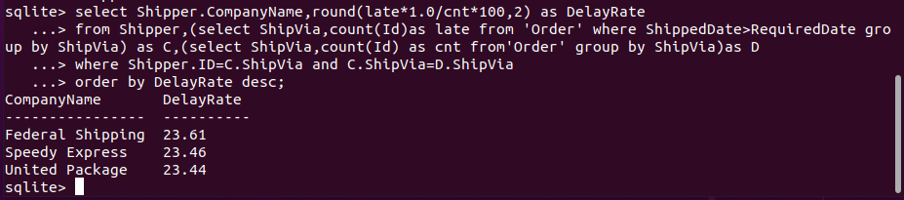

1. select CategoryName,count(*),sum(UnitPrice)/count(*),min(UnitPrice), max(UnitPrice)as averg,sum(UnitsOnOrder)

from Category,Product

where Category.Id=Product.CategoryId

group by(CategoryId)

having count(*)>10

order by CategoryId;

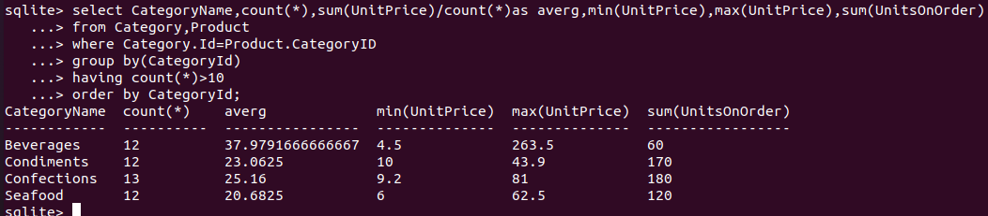

1. select ProductName,CompanyName,ContactName from

...> (select ProductName,min(OrderDate),CompanyName,ContactName from

...> (select Id,ProductName from Product where discontinued=1)as P

...> join OrderDetail as OD on OD.ProductId = P.Id

...> join 'Order' as O on O.Id = OD.OrderId

...> join Customer as C on C.Id = O.CustomerId

...> group by ProductName

...> ) as T

...> Order by ProductName asc;

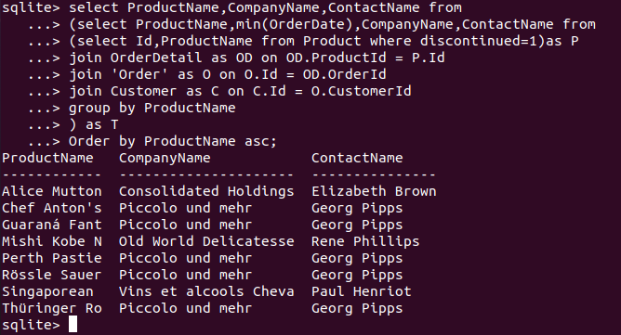

1. select Id,OrderDate,round(julianday(OrderDate)-julianday(PreOrderDate),2) as Difference

...> from (select Id,OrderDate,LAG(OrderDate,1,OrderDate) OVER (order by OrderDate)as PreOrderDate from 'Order' where CustomerId='BLONP')

...> order by OrderDate limit 10;

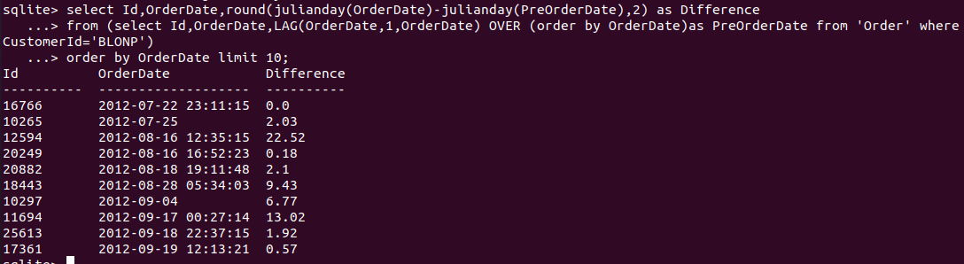

1. WITH expenses AS(select IFNULL(c.CompanyName,'MISSING_NAME') as ComPanyName,o.CustomerId as CustomerId,round(sum(od.Quantity*od.UnitPrice),2) as TotalCost

...> from 'Order' as o inner join OrderDetail as od on od.OrderId=o.Id left join Customer c on c.Id=o.CustomerId

...> group by o.CustomerId),

...> quartiles AS (select * ,NTILE(4) OVER(order by TotalCost) as expensesQ from expenses)

...> select CompanyName ,CustomerId,TotalCost from quartiles where expensesQ=1

...> order by TotalCost;

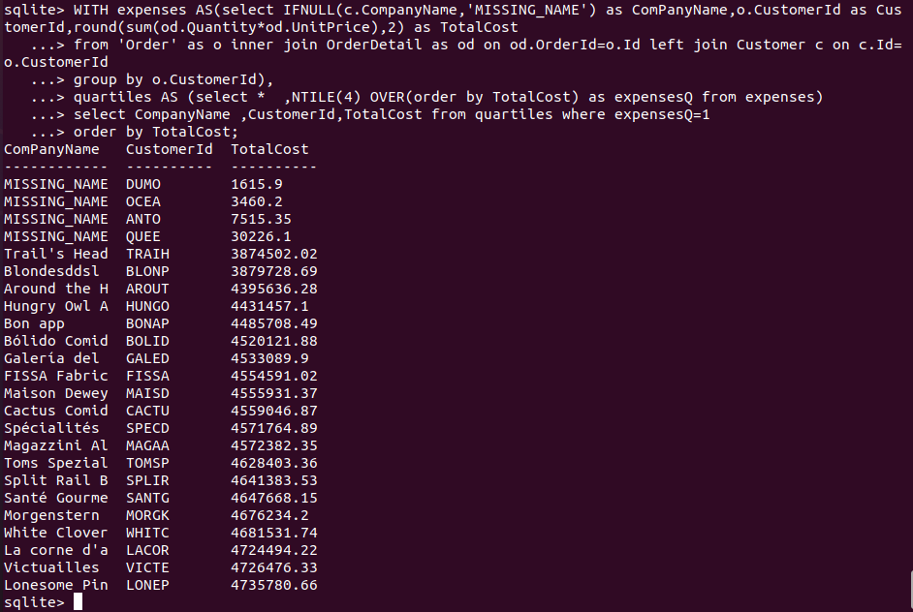

1. select RegionDescription,FirstName,LastName,Birthday

...> from(select RegionId ,EmployeeId,FirstName,LastName,Birthdate,max(Birthdate) as Birthday

...> from EmployeeTerritory join Territory on TerritoryId=Territory.Id join Employee on EmployeeId=Employee.Id group by RegionId order by RegionId) as A

...> join Region on Region.Id=A.RegionId;

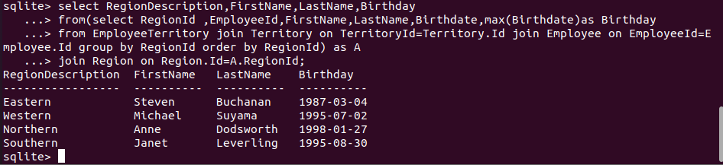

1. with p as( SELECT ProductName,Product.IdFROM 'Order'

...> INNER JOIN Customer on CustomerId = Customer.Id

...> INNER JOIN OrderDetail on 'Order'.Id = OrderDetail.OrderId

...> INNER JOIN Product on OrderDetail.ProductId = Product.Id

...> where CompanyName = 'Queen Cozinha' AND Date(OrderDate) = '2014-12-25'),

...> c as (select row_number() over (order by p.id asc) as seqnum,

...> p.ProductName as name from p ),

...> flattened as(select seqnum,name as name from c where seqnum = 1

...> union all

...> select c.seqnum,f.name || ',' || c.name

...> from c join flattened f on c.seqnum = f.seqnum + 1 )

...> select name from flattened

...> ORDER BY seqnum Desc limit 1;

