**AI MINI PROJECT**

**On**

**Recognition of the state of**

**Fruit/Vegetable using AI**

**Report-1**

**By**

**K Noniesh (cs21b2032)**

**MSR Pavan (cs21b2022)**

This report is about our AI mini project, in this we explain our problem and how AI is useful to solve the problem,

The problem statement is **Recognition of state of a fruit/vegetable using AI**

In this we are using various AI models and algorithms to solve the problem, based on to analyze the image and classify the image into different categories using different AI models

Ex: Deep learning models like CNN (Convolutional Neural Networks)

Why we use CNN (Convolutional Neural Networks) ?

Convolutional Neural Networks come under the subdomain of Machine Learning which is Deep Learning. Algorithms under Deep Learning process information the same way the human brain does, but obviously on a very small scale, since our brain is too complex (our brain has around 86 billion neurons).

using an ANN (Artificial Neural Networks) for the purpose of image classification would end up being very costly in terms of computation since the trainable parameters become extremely large. We use filters when using CNNs. Filters exist of many different types according to their purpose.

So, we are CNN for the classification of images for our project.

We know that our project based on image classification requires a large amount of pictures as data in different conditions. And there are several factors that affect these pictures such as brightness in images, quality of images, finding different images (so that our data set is vibrant and distinct so that our predictions are accurate) etc … are the challenges in collecting the data set.

There are so many projects on image classification using deep learning which are mainly focused on classifying different objects

Ex. Differentiating cat and dog images etc..

But our model does something different ,In our dataset for a respective fruit or vegetable pictures we have divided the respective image set into 3 categories

1.**Good:** In this category the images of the fruit/vegetable are in top quality. 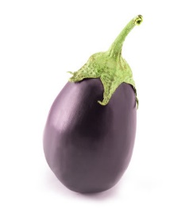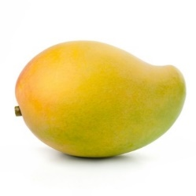

2.**Raw**: In this category the images of the fruit/vegetable are not in their top quality but the fruits/vegetable are not ripe yet.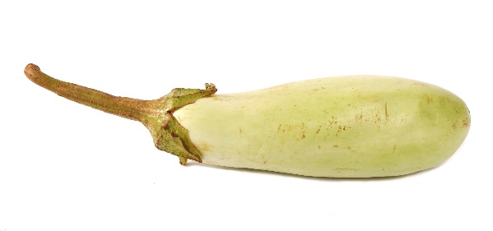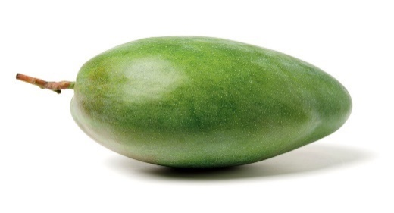

3.**Damaged**: In this category the images of the fruit/vegetable are damaged due to external reasons or pests.

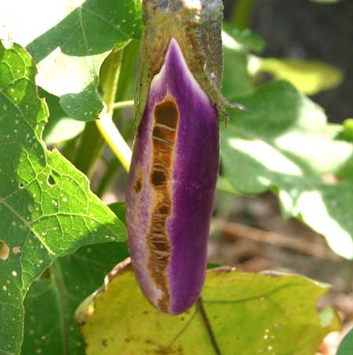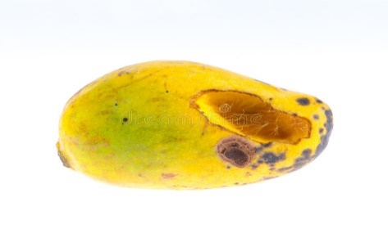

Overall, AI has the potential to revolutionize this image classification and help customers make more informed decisions about selection of fruits. However, it is important to ensure that these technologies are validated with real-world data and provide reliable recommendations that can be implemented in practice.

Every fruit/vegetable’s state can not be predicted using this model because

There exceptions and limitations for every thing ,but with this project we are trying to minimize those exceptions and give good predictions for the classification.

**Dataset**

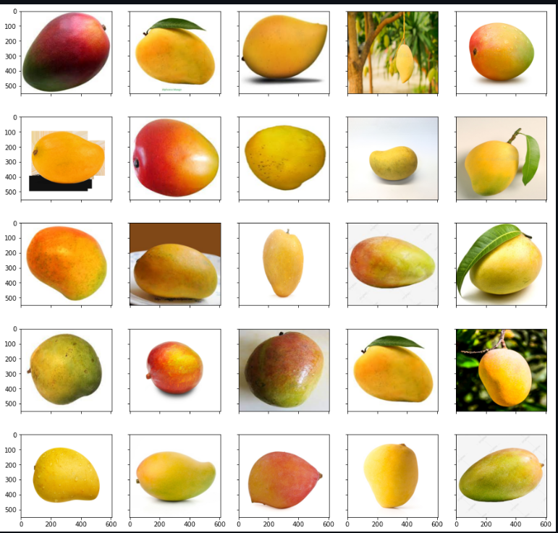

**Fruit Data**

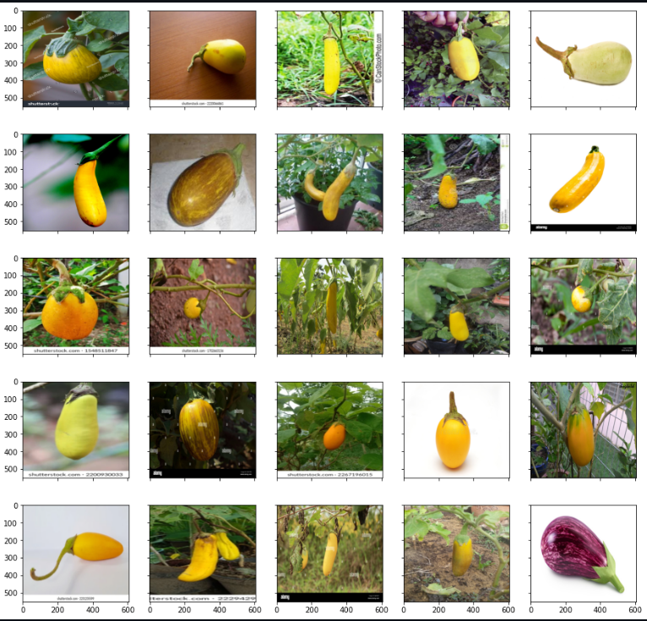 **Vegetable Data**

Working tools used for the project are:

1.CNN (Convolution neural Networks).

2.SKlearn.

3.Tensorflow.

4.Keras

5.Open CV

6.Numpy

7.Matplotlib

8.PIL(Python Image library)

These are the working tools we are using in this project. We are using open-cv for image detection . We are using convolution, pooling etc.. processes to process the image using the CNN model after the processing of the training data ,we test the data with our test data .Evaluation of the model is done after testing the images ,to improve the accuracy and detect the appropriate hyper parameters we are training the data with different hyper parameters (No. of neurons, No. of hidden layers ,epochs etc..).We handpicked the appropriate images from internet as there are no datasets related to it ,so at present we are training the model with one type of fruit and one type of vegetable. After this we are moving on for different types of fruits and vegetables.

