

**TABLE OF CONTENTS**

Table of contents

Cover page--------------------------------------------------0

Table of content--------------------------------------------1

Fields---------------------------------------------------------2

Before testing-----------------------------------------------3

After testing-------------------------------------------------4

If All Inputs Are Valid--------------------------------------5

Presence Check--------------------------------------------6

Type Check--------------------------------------------------7

Length Check-----------------------------------------------8

Help ---------------------------------------------------------9

Code--------------------------------------------------------10

|  |  |  |  |  |
| --- | --- | --- | --- | --- |
| Name and Types  of Fields | Input  Component | Reason for  Input  Component | Data Validation – Name of Rule(e.g. Format, length, presence, check digit, range, type, logic) | Reason for Data Validation |
| Name: String | Text Field | User can enter in their name | Presence Check  Type check | Name can’t be empty,  The name should be in Alphabetical letters |
| Surname : String | Text Field | User can enter in their surname | Presence Check  Type check | Surname can’t be empty,  The name should be in Alphabetical letters |
| ID: Integer | Text Field | User can enter in their ID | Presence Check  Type check  Length check | The ID should be filled in  The ID should have 13  numbers |
| Age : Integer | Text Field | User can enter in their age | Presence Check  Type check | User should enter valid  Age below 100 |
| Contact No: Integer | Text Field | User can enter in their phone number | Presence Check  Type check  Length check | The phone number should be filled in  It should be an integer  Phone No. should be less than 11 digits |
| Gender : Boolean | Radio Button | User can choose their gender | Presence Check | User should select one gender |
| Email :String | Text Field | User can enter in their email | Presence Check  Type check  Format check | User should put an email  In the field  E-mail should be in the correct format |

Before Testing

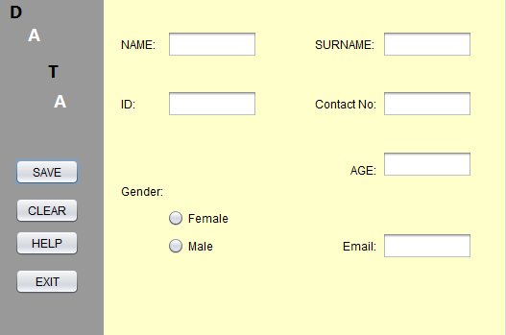

After Testing

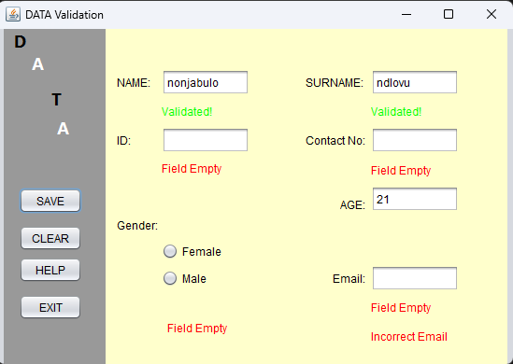

If All Input are Valid

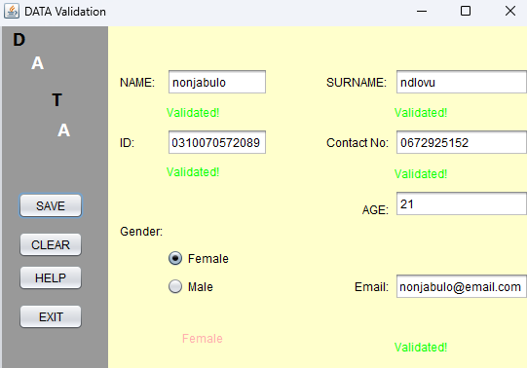

Presence Check

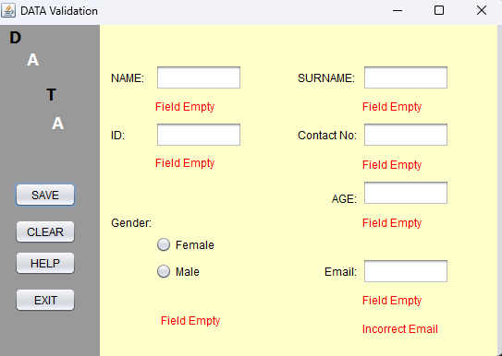

Type Check

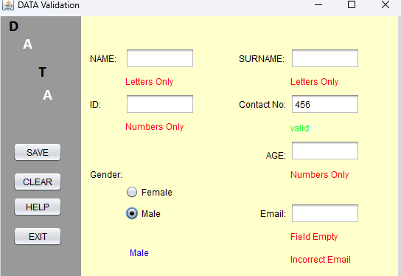

Length Check

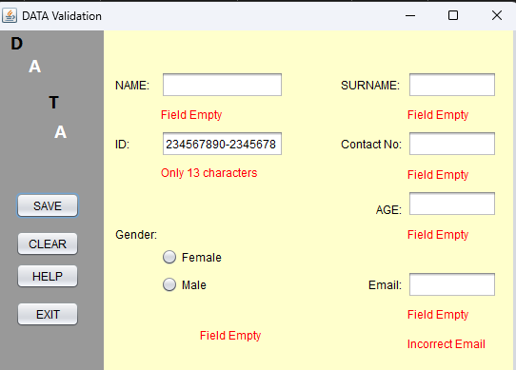

Help

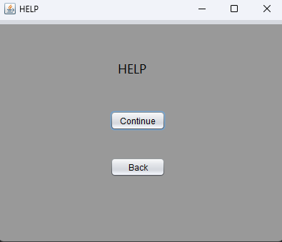

Help

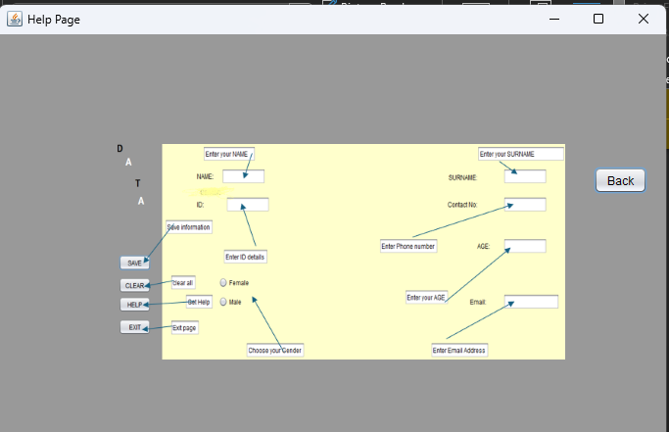

Code

