Linear Regression 2.1 : Predicting Goal Difference at the FIFA World Cup 2026
Analytic Question Formulation
This analysis examines whether information available before kick-off can predict the goal difference in a FIFA World Cup 2026 match. Goal difference is calculated as home goals minus away goals, so it may be negative, zero or positive. As a numeric outcome, it can be modelled using linear regression. Here, home and away generally refer only to the order in which FIFA lists the teams; the exception is when the USA, Mexico or Canada plays in its own country. Because actual goal differences are whole numbers but regression predictions may contain decimals, the model is more useful for estimating the relative strength of the two teams than for predicting an exact score.
Dataset and Explanatory Variables
The dataset combines four endpoints from FIFA's data service, the source also used for Task 3. The match calendar supplied the 104 fixtures and scores, while the ranking, squad and timeline endpoints supplied information available before each match. Each match forms one row. MatchID, Date, HomeTeam and AwayTeam identify the match but were excluded from the regression. The model uses exactly eight explanatory variables, each calculated as the home-team value minus the away-team value to match the definition of the response variable. When the teams have identical values on all eight measures, the explanatory variables are all zero and the predicted goal difference should be close to zero. Table 1 defines the variables and shows the coefficient sign expected before fitting the model.
All eight variables were available before kick-off. Ranking points were taken from the FIFA ranking published on 11 June 2026, the tournament's opening day. The form measures were calculated only from matches that a team had already played in the tournament, so the match being predicted could not influence its own predictors. Before a team's first match, I used the 2022 World Cup team averages of 1.34 goals and 1.38 points per match as starting values; these estimates were progressively replaced by the team's own record as it played more matches. The four variables marked with an asterisk are also used in Linear Regression 2.2, which is the maximum permitted overlap.
Table 1: Explanatory variables (all home minus away)
Variable | Description | Expected sign
RankPointsDiff * | FIFA ranking points (11 June 2026 ranking) | +
HostAdvantage * | +1 if the home team is a host in its own country, -1 if the away team is, else 0 | +
FormGoalsForDiff * | Goals scored per match in earlier 2026 matches | +
FormGoalsAgstDiff * | Goals conceded per match in earlier 2026 matches | -
FormPointsDiff | Points per match in earlier 2026 matches | +
SquadAgeDiff | Mean age of the registered squad (years) | unsure
RestDaysDiff | Days since the previous match (capped at 7) | +
StrongConfedDiff | 1 for a UEFA or CONMEBOL team, else 0 | +
Data Wrangling
The Excel file was read with pandas and checked against the brief, giving 104 rows, eight explanatory variables and no missing values. Listwise deletion was kept as the method for incomplete rows, as in Task 3, preserving true differences between matches rather than inserting false data to make up for missing values (Dwyer & Young, 2024). In this case no rows were dropped. Multicollinearity was checked with the variance inflation factor (VIF) before modelling, as variables that carry the same information make the coefficients unreliable. The largest VIF was 3.22 (FormPointsDiff), which is below the usual limit of 5, so all eight variables were kept.
Model Building
The 104 matches were split into a training set of 83 matches (80%) and a test set of 21 matches (20%), with random_state = 42 so that the split stays the same on every run. A multiple linear regression model was fitted on the training set with scikit-learn's LinearRegression, which finds the coefficients that make the squared errors as small as possible. The same model was then fitted on all 104 matches with statsmodels OLS to obtain p-values, which scikit-learn does not provide. For each coefficient the null hypothesis was H0: b = 0 against Ha: b ≠ 0, at α = 0.05.
Model Evaluation
Table 2 compares the model with a baseline that ignores all eight variables and always predicts the mean goal difference of the training matches. On the 21 test matches the model was off by 1.36 goals on average, compared with 1.84 for the baseline, and it picked the right winner in 13 of the 16 test matches that were not draws (81%). As a test set of 21 matches is small, 5-fold cross-validation was also used and gave an average R² of 0.30, which is a fairer estimate than one split.
Table 2: Performance on the test set
Measure | Model | Baseline
MAE (goals) | 1.36 | 1.84
RMSE (goals) | 1.82 | 2.37
Normalised RMSE | 0.18 | -
R² | 0.40 | -0.02
In the full-sample model, 45.8% of the variation in goal difference was explained (adjusted R² = 0.412), and the overall regression was significant, F(8, 95) = 10.02, p < .001. RankPointsDiff was the only individually significant predictor (b = 0.0051, p < .001, 95% CI [0.0034, 0.0069]). Holding the other variables constant, a 100-point increase in the home team's ranking advantage was therefore associated with an increase of about 0.51 in predicted goal difference. HostAdvantage approached, but did not reach, the 5% significance threshold (b = 0.96, p = .069). FormGoalsForDiff and FormPointsDiff had signs opposite to those expected, but neither coefficient was significant. Their overlap with ranking points is one possible explanation: stronger teams tend to have both higher rankings and better form, leaving the form measures with little independent information after ranking is controlled for. The lower adjusted R² indicates that some predictors contributed limited additional explanatory value.
The residual checks did not provide strong evidence of assumption violations. The Shapiro-Wilk test did not reject normality (p = .460), and the Breusch-Pagan test did not reject constant variance at the 5% level (p = .087). The residuals-versus-fitted plot in Figure 1 also showed no obvious curvature. Together with the VIF results, these diagnostics suggest that the regression assumptions are reasonable for this dataset, although they do not prove that every assumption holds.
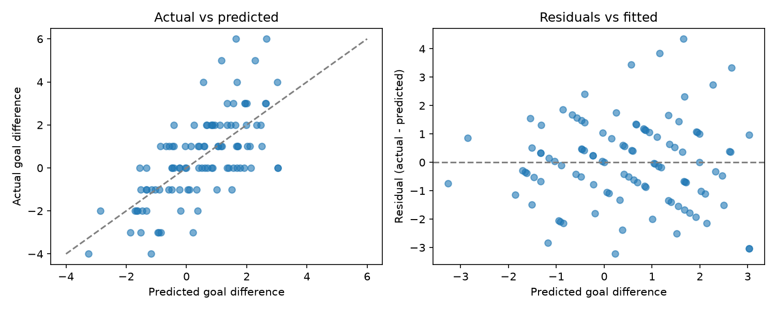
Figure 1: Actual vs predicted goal difference (left) and residuals vs fitted values (right)
Conclusion
The analysis shows that the goal difference of a World Cup 2026 match can be predicted to a moderate extent using only pre-match information. Most of the predictive power comes from how strong the teams were before the tournament, measured by FIFA ranking points, and recent form adds little once the ranking is known. One limitation is the small dataset, as the cross-validation R² ranged from 0.08 to 0.50 across the five folds depending on which matches were tested. Another is that the four knockout matches decided on penalties are recorded as a goal difference of zero. Finally, the model cannot capture events such as red cards, penalties or a goalkeeper's great day, which play a large part in football results.

