Target KPI:Number of weekly matches between dog owners and dog walkers

User Statistics:

Number of booking requests made by dog owners per week

Number of booking requests accepted by dog walkers per week

Relevant KPI:

Number of Matching Dog Owners and Dog Walkers per Week

This KPI measures the effectiveness of the dogwalker web platform in facilitating successful matches between dog owners and dog walkers. It indicates the level of engagement and satisfaction of users on the platform.

KPI Calculation:

To calculate the KPI of the number of matching dog owners and dog walkers per week.

Formula:

Number of Matching Dog Owners and Dog Walkers per Week = Number of Booking Requests Accepted by Dog Walkers

Tracking and Analysis:

Track the user statistics and calculate the KPI on a weekly basis.

Monitor the trends and changes in the number of matching dog owners and dog walkers per week.

Analyze the factors that contribute to successful matches and identify any areas for improvement.

Measurement:

Website:<https://647c920c87b25e2ced351fb7--heartfelt-axolotl-bf35c1.netlify.app/>

Date range: [2023.06.02] - [2023.06.04]

Target KPI: 14 pairs of dog walker and dog owner pairs per week

The cumulative number of pairs util [2023.06.04] is 15 pairs

We have our website to our friends as well as posted it on Facebook. We already have some registered users as well as transaction volume. But the google analysis page report is not updated, it takes some time, but the number of users has been updated in the last 30 minutes, it may prove that we do have users and transactions.

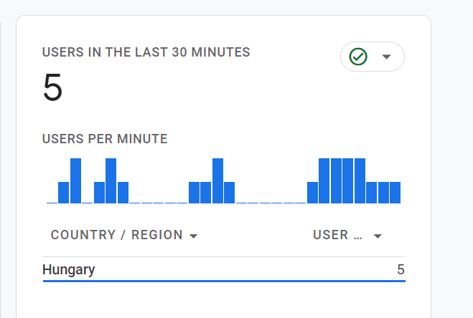

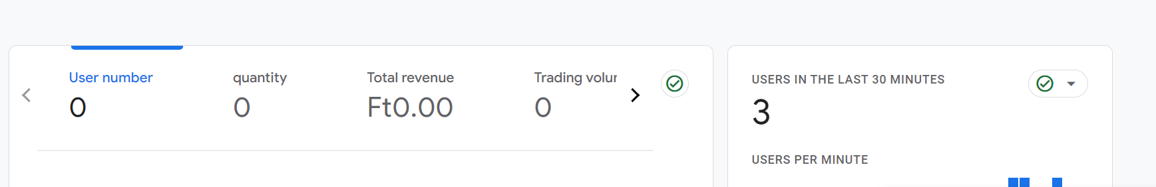

Recommendations and Action Plan:

Based on the results of our current KPI testing, we make the following recommendations and action plans:

Continue to promote our dog walker and dog owner matching service to attract more user engagement.

Enhance marketing and promotional activities to increase user awareness and engagement.

Work with communities and related organizations to find more potential dog walkers and dog owners.

Analyze user feedback and needs to continuously improve and optimize the matching process and provide a better user experience.