**Healwire**

**PRODUCT DESIGN SPECIFICATION**

***Version 1.0***

**24th May 2016**

**TABLE OF CONTENTS**

* OVERVIEW
  + FEATURES
* SERVER REQUIREMENTS
* INSTALLATION
* PROJECT INTERFACES
  + ADMIN PANEL
  + CUSTOMER / MEDICAL PROFESSIONAL PANEL
* FUTURE UPDATES

#### **OVERVIEW**

Healwire is a PHP powered online medical store built and optimized using [Laravel framework](https://laravel.com/)(4.2) to offer the most convenient way of dispensing medicines to customers. No more queuing in front of medical shops and no more missed deliveries, you will get the prescribed medicines right at your doorstep through smart delivery services.

The store incorporates a user-friendly and visually pleasing layout with responsive navigation, making it very much workable and accessible even for the non tech – savvy people. The whole process of order placing and processing is simple and trouble free, increasing your conversions giving you more of what you want out of your website. If you are unsure of your medicinal prescription simply upload the image or scanned copy of your prescription and your cart will be updated with prescribed medicines by the pharmacist on admin side. Or else you can browse for medicines by brand or trade name using the Search bar and add it to your cart. All relevant details regarding the drug like active ingredients, drug type, warnings, alternate medicines and directions of usage will be made available to you before the order placement.

Healwire comes with a powerful admin panel with enough features to handle any possible backend operation. Give the right drug, in the right dose, to the right person, at the right time and in the right way through Heal Wire.

##### **FEATURES**

* Simplistic responsive design developed using SASS.
* Email templates for multiple basic operations.
* Easy installation process similar to famous wordpress 5 minute install.
* Interactive Admin Theme.
* Alternative medicine suggestions.
* One click option to upload medicine list.

#### **SERVER REQUIREMENTS**

* PHP >= 5.4
* MCrypt PHP Extension
* Fileinfo Extension
* GD Library (>=2.0) … or …
* Imagick PHP extension (>=6.5.7)
* PHP extension mod_ rewrite enabled
* PHP extension php_zip enabled
* PHP extension php_xml enabled
* Mysql

#### **INSTALLATION**

Similar to the famous 5 minute installation of Wordpress, Heal Wire comes with its own tailored installation process out of the box.

* Copy the files to your localhost server.
* Access the project using browser, you will be automatically redirected to the Customisation Screen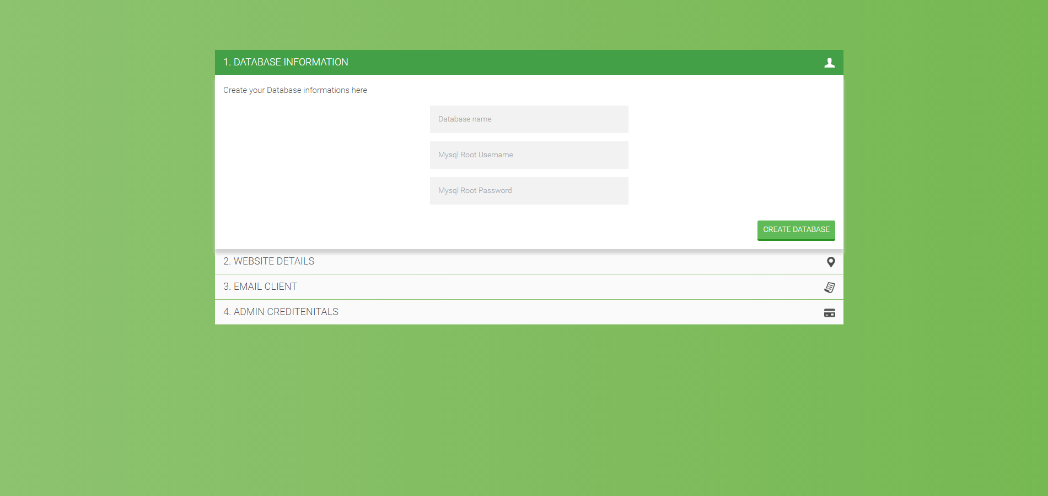
* Step_1 : By providing the name for your Database and mysql user credentials, your database will be automatically created and seeded with necesary details.
* Step_2 :Customise the your web-app with your details 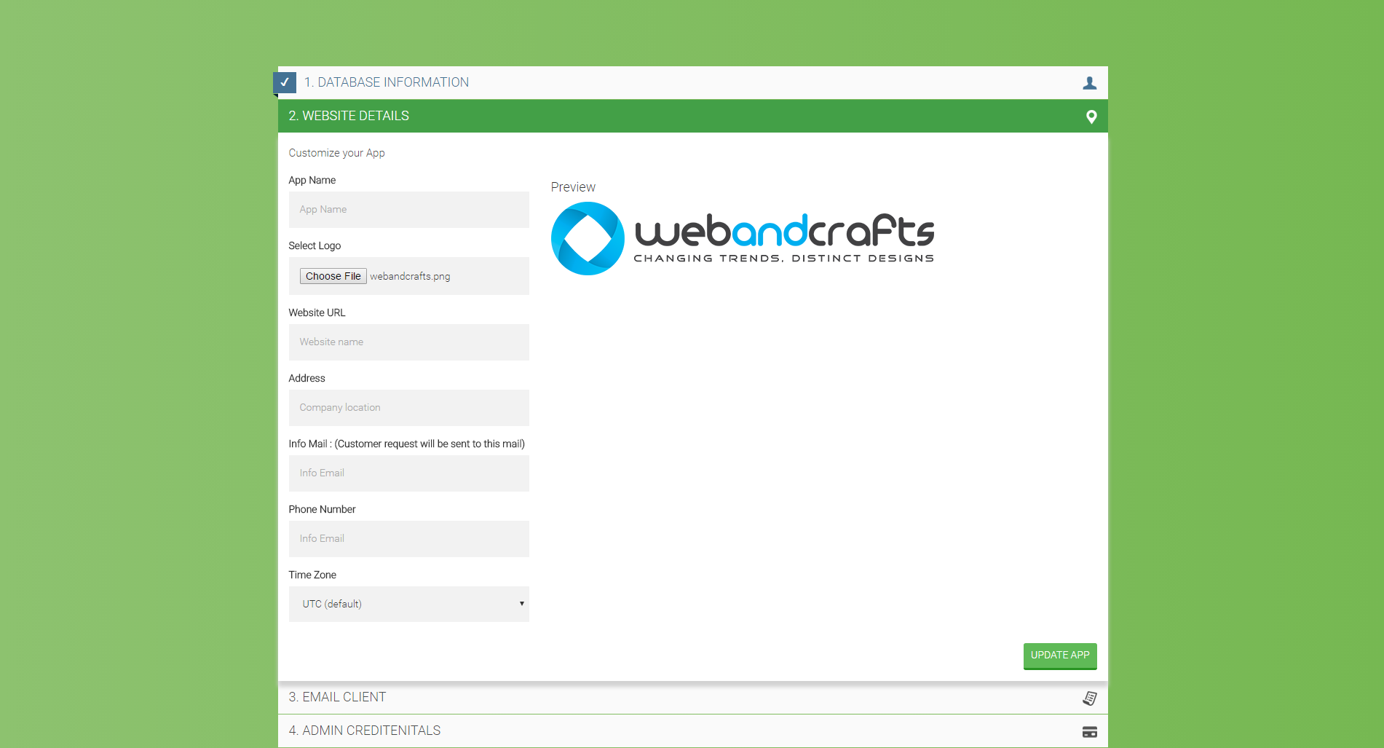
* Step_3 : Fill the mail server details. This is mandatory for the website to work. For more details regarding supported mail drivers and configuration refer to the following [documentation](https://laravel.com/docs/4.2/mail#configuration) 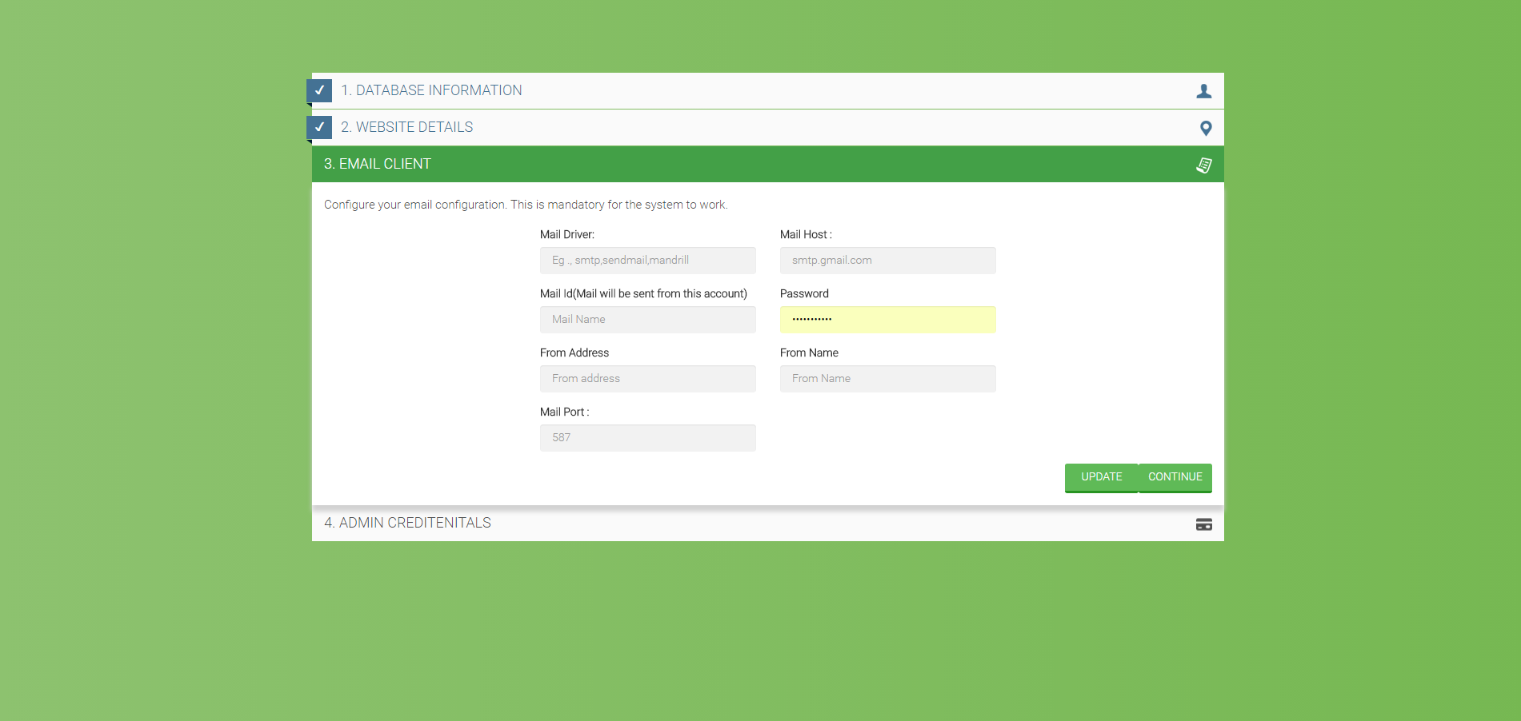
* Step_4 : Create the site admin, once you have successfully configured server you will be redirected to the admin login screen.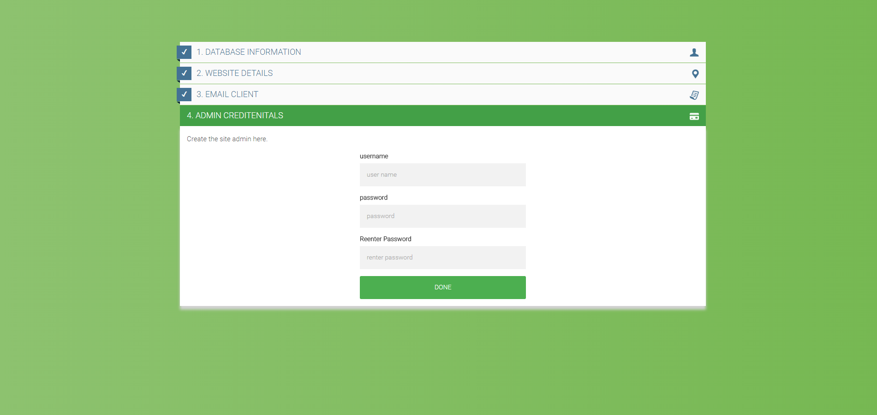

#### **PROJECT INTERFACES**

##### **ADMIN PANEL**

Basic administration of website is done from this end. Following are the functionalities currently available.

1. **Admin Dashboard**
   1. Basic information related to web-app like user informations, stock, sales statistics and Shipping status

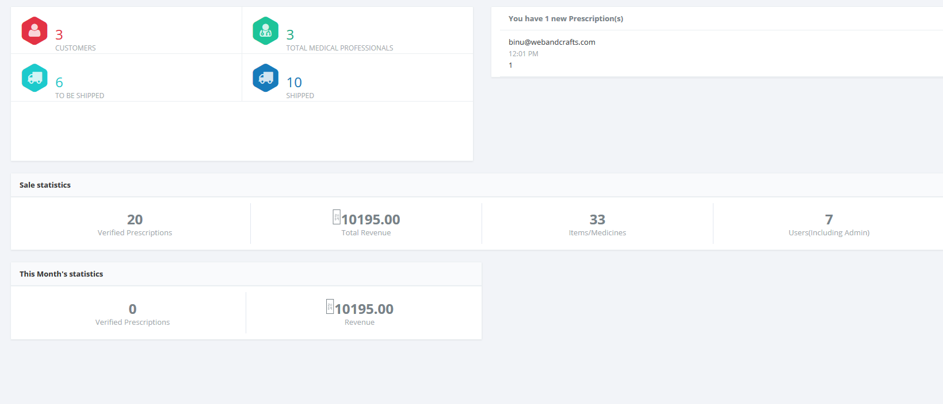

1. **Medicine Management**
   1. CRUD operations related to medicines
   2. Add,edit or delete medicines
   3. Upload medicine list.
   4. View requested medicine list
   5. Discount management for each medicines.
2. **User Management**
3. **Cart Management**
   1. Verification of cart requested by customers
   2. Updating the cart with items along with shipping cost
   3. Sending updated carts to the customers and medical professionals
4. **Invoice Management**
   1. Creating Invoice and updating payment status
   2. Updating Shipping Details

##### **CUSTOMER / MEDICAL PROFESSIONAL PANEL**

Basic site operations by normal users

1. **Profile Page**
   1. Update basic details related to profile actions
   2. User can register as Customer or Medical Professional
2. **Cart Page**
   1. Search for a medicine and add to cart
   2. Remove medicines from the cart
   3. Request for medicines and upload prescriptions
   4. User can view the billing table updated with the discount amount before uploading the prescription

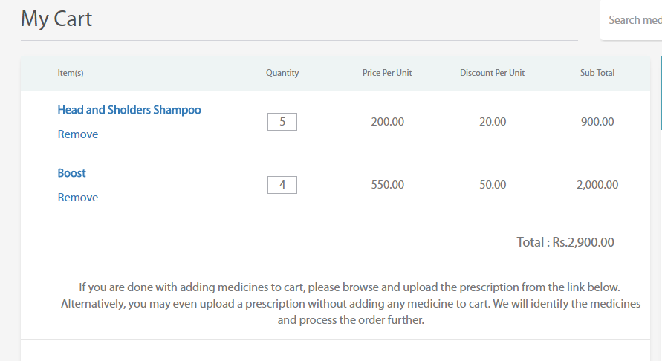

1. **Prescription**
   1. View Prescriptions
   2. Track the status of prescriptions.
   3. Download prescriptions and purchase items
2. **Paid Prescriptions**
   1. View all paid prescriptions along with the invoice
3. **Shipped Prescriptions**
   1. View all shipped prescriptions

#### **FUTURE UPDATES**

1. Integrated Payment Channel
2. Stock Management
3. iOS and Android Apps
4. Shipment Tracking