**Healwire**

**PRODUCT DESIGN SPECIFICATION**

***Version 2.1***

**22th June 2016**

**VERSION HISTORY**

|  |  |  |
| --- | --- | --- |
| **Version Number** | **Date** | **Version Notes** |
| 1.0 | 24th May 2016 | First Stable Build |
| 2.1 | 22nd June 2016 | Payment Channel Integration |

**TABLE OF CONTENTS**

* OVERVIEW
  + FEATURES
* SERVER REQUIREMENTS
* INSTALLATION
* PROJECT INTERFACES
  + ADMIN PANEL
  + CUSTOMER / MEDICAL PROFESSIONAL PANEL
* FUTURE UPDATES

#### OVERVIEW

Healwire is a PHP powered online medical store built and optimized using [Laravel framework](https://laravel.com/)(4.2) to offer the most convenient way of dispensing medicines to customers. No more queuing in front of medical shops and no more missed deliveries, you will get the prescribed medicines right at your doorstep through smart delivery services.

The store incorporates a user-friendly and visually pleasing layout with responsive navigation, making it very much workable and accessible even for the non tech – savvy people. The whole process of order placing and processing is simple and trouble free, increasing your conversions giving you more of what you want out of your website. If you are unsure of your medicinal prescription simply upload the image or scanned copy of your prescription and your cart will be updated with prescribed medicines by the pharmacist on admin side. Or else you can browse for medicines by brand or trade name using the Search bar and add it to your cart. All relevant details regarding the drug like active ingredients, drug type, warnings, alternate medicines and directions of usage will be made available to you before the order placement.

Healwire comes with a powerful admin panel with enough features to handle any possible backend operation. Give the right drug, in the right dose, to the right person, at the right time and in the right way through Heal Wire.

##### FEATURES

* Simplistic responsive design developed using SASS.
* Email templates for multiple basic operations.
* Easy installation process similar to famous wordpress 5 minute install.
* Interactive Admin Theme.
* Alternative medicine suggestions.
* One click option to upload medicine list.

#### **SERVER REQUIREMENTS**

* PHP >= 5.4
* MCrypt PHP Extension
* Fileinfo Extension
* GD Library (>=2.0) … or …
* Imagick PHP extension (>=6.5.7)
* PHP extension mod_ rewrite enabled
* PHP extension php_zip enabled
* PHP extension php_xml enabled
* Mysql

#### INSTALLATION

**Prerequisites:**

**1.Composer :** Please follow the install process provided in below link

* **Linux-Unix :** [https://getcomposer.org/doc/00-intro.md#installation-linux-unix-osx](https://getcomposer.org/doc/00-intro.md%23installation-linux-unix-osx)
* **Windows :** [https://getcomposer.org/doc/00-intro.md#installation-windows](https://getcomposer.org/doc/00-intro.md%23installation-windows)

**2.PHP**

**Further docuementation is written based on the belief that you have successfully installed the above prerequisites and can access them.**

* Similar to the famous 5 minute installation of Wordpress, Heal Wire comes with its own tailored installation process out of the box.
* Copy the files to your localhost server and go to the project root folder and run the following command to load all the packages required for the site to work.

**composer update**

* Once done, In the command terminal run the following command to publish the packages offered by laravel.

***php artisan vendor:publish***

* Access the project path from browser, you will be automatically redirected to the Customisation Screen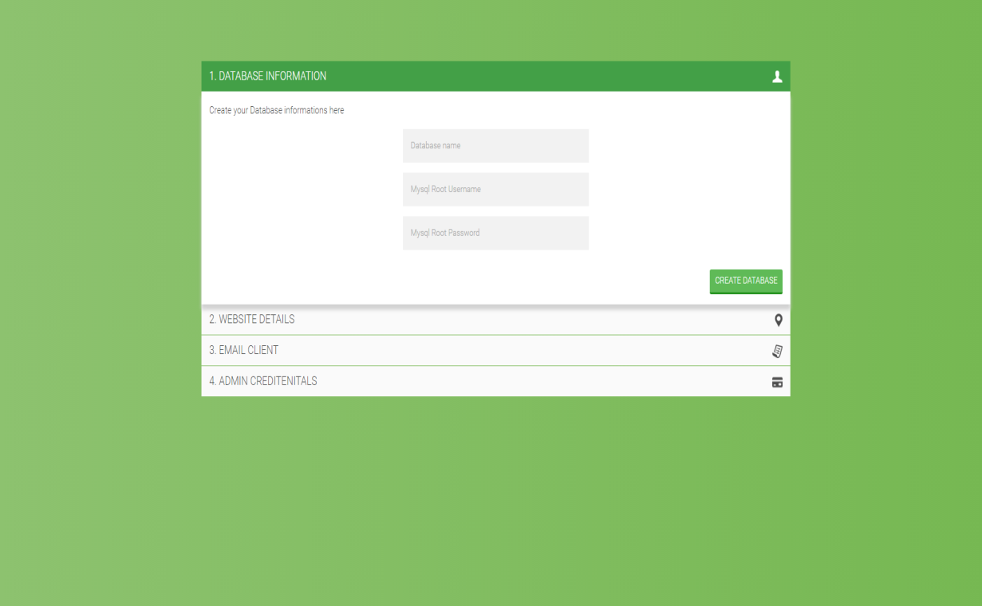
* Step_1 : By providing the name for your database and mysql user credentials, your database will be automatically created and seeded with necesary details. Default mysql username would be "root" with no password.
* Step_2 :Customise the your web-app with basic system settings. 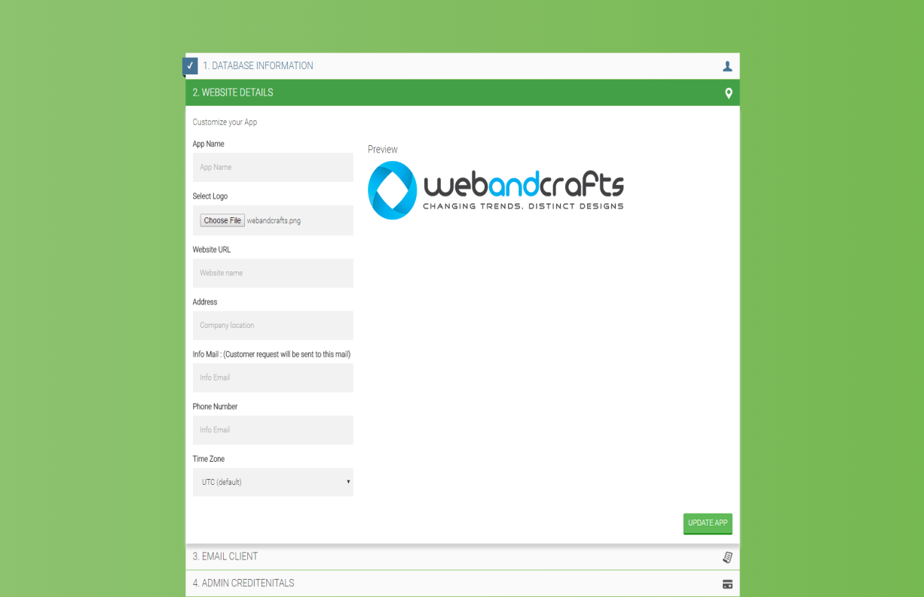
  + App name
* Step_3 : Fill the mail server details.( **This is mandatory for the website to work**). For more details regarding supported mail drivers and configuration refer to the following [documentation](https://laravel.com/docs/4.2/mail#configuration) 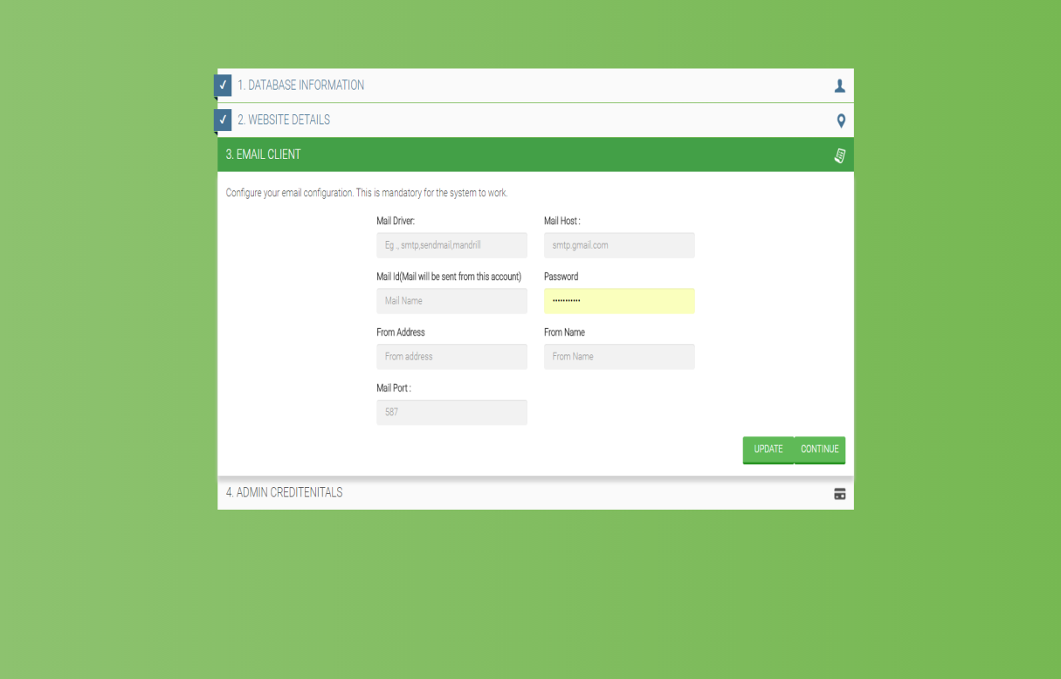
* Step_4 : Create the site admin, once you have successfully configured server you will be redirected to the admin login screen.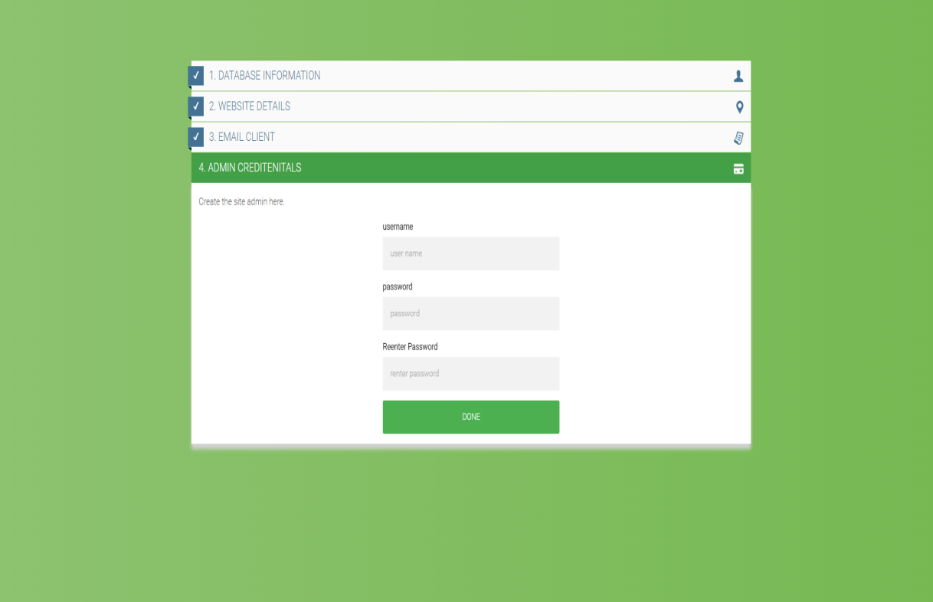

BASIC WORKFLOW

1. Typically there are 3 types of users available in our system
   1. Admin
   2. Customer
   3. Medical Professional
2. Any user can access the website and search for medicines available in our system.
3. To make any other actions, User has to register to the site either as **Customer** or **Medical Professional.** Verifcation email would be sent to respective persons.
4. The user can choose to add the medicines to his cart. If he wishes to place an order, he is mandated to upload the image of the medical prescription for verification.
5. He can place order by posting the prescription, even if doesn't find the medicine he is looking for.
6. Once the order is placed, a request notification is sent to the system admin.
7. Admin once choose the medicine, shall start verifying the prescription and can reject or accept the order placed.
8. Once verified, admin can start accessing the funcationalites of the cart, like adding medicines, modifying quantities, price and other features.
9. He can choose to add the shipping cost and send the updated cart to the user for purchase.
10. The user recieves the notification of the verified prescription, User can just view the cart alone, as no other actions are permitted other than buying.
11. Once Payment is made, the system automatically updates the invoice is to PAID, and informs the admin to ship the particular order.

#### PROJECT INTERFACES

##### **ADMIN PANEL**

Basic administration of website is done from this end. Following are the functionalities currently available.

1. **Admin Dashboard**
   1. Basic information related to web-app like user informations, stock, sales statistics and Shipping status

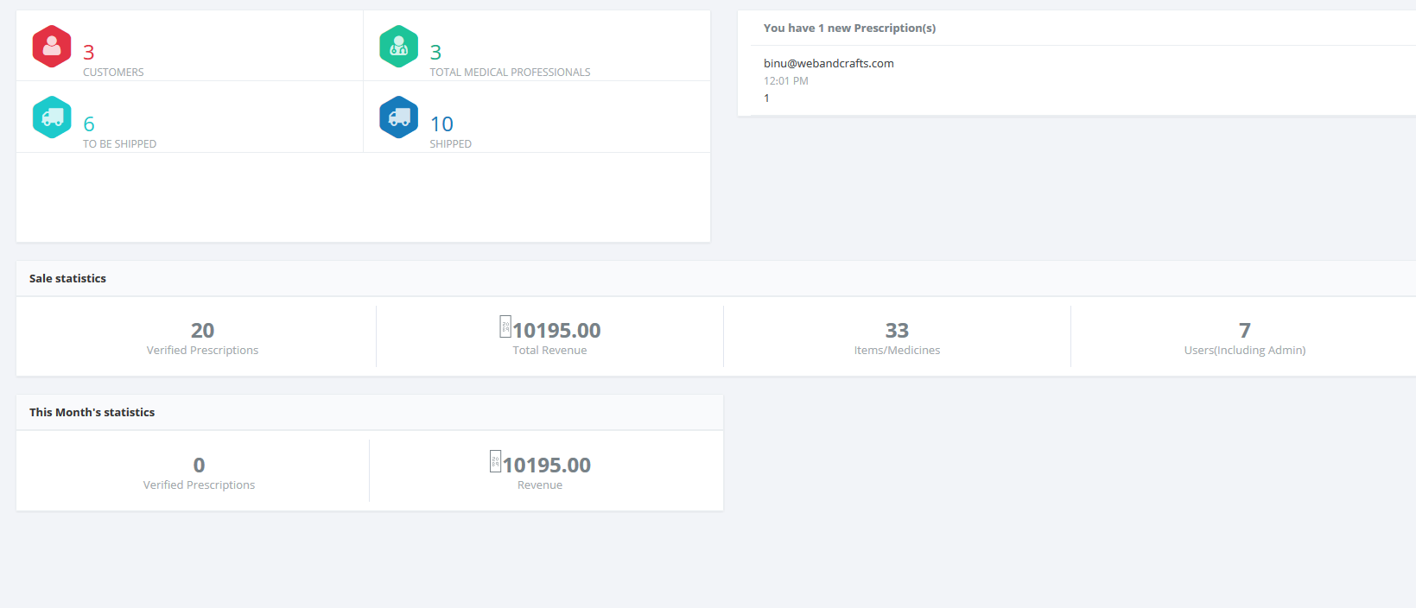

1. **Medicine Management**
   1. CRUD operations related to medicines
   2. Add,edit or delete medicines
   3. Upload medicine list.
   4. View requested medicine list
   5. Discount management for each medicines.
2. **User Management**

3.1 View Customer and Medical Professionals

3.2 Publish Customer / Medical Professionals

3.3 Remove Customer/ Medical Professionals

1. **Cart Management**
   1. Verification of cart requested by customers
   2. Updating the cart with items along with shipping cost
   3. Sending updated carts to the customers and medical professionals
2. **Invoice Management**
   1. Creating Invoice and updating payment status
   2. Updating Shipping Details
3. **Updating System Settings**

6.1 Updating Application Name, Logo, website link, currency format, system time

6.2 Email settings

6.3 Adding Mulitple Admin's

##### **CUSTOMER / MEDICAL PROFESSIONAL PANEL**

Basic site operations by normal users

1. **Profile Page**
   1. Update basic details related to profile actions
   2. User can register as Customer or Medical Professional
2. **Cart Page**
   1. Search for a medicine and add to cart
   2. Remove medicines from the cart
   3. Request for medicines and upload prescriptions
   4. User can view the billing table updated with the discount amount before uploading the prescription

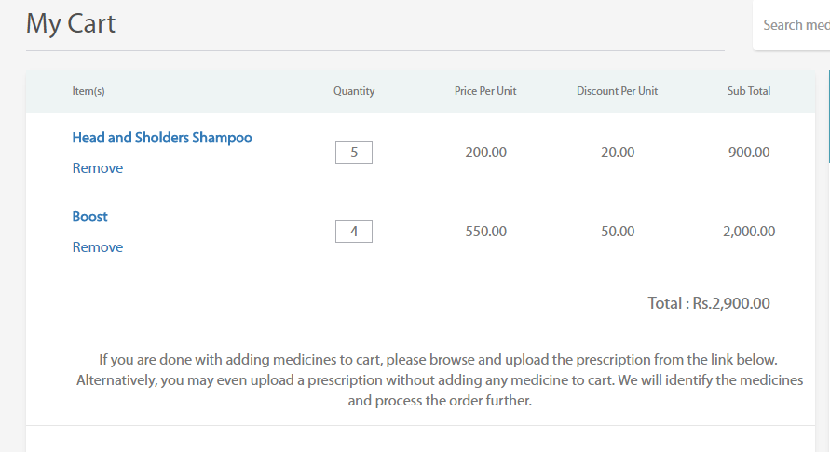

1. **Prescription**
   1. View Prescriptions / Orders
   2. purchase the Prescriptions / Orders
   3. Track the status of Prescriptions / Orders.
   4. Download prescriptions and purchase items
2. **Paid Prescriptions**
   1. View all paid prescriptions along with the invoice
3. **Shipped Prescriptions**
   1. View all shipped prescriptions

PAYMENT CHANNELS

Healwire comes with two integrated payments channels and feature to test the version before going live. The payment channel setting can be accessed in the system set-up.

1. Classic Paypal Standard : [https://www.**paypal**.com/](https://www.paypal.com/)

This is focused for outside India, Please follow the instructions to create paypal account if not available

**General Instruction :**  [**https://www.paypal.com/in/cgi-bin/webscr?cmd=xpt/Marketing/general/how-to-set-up-a-paypal-account-outside**](https://www.paypal.com/in/cgi-bin/webscr?cmd=xpt/Marketing/general/how-to-set-up-a-paypal-account-outside)

* Follow the given link to create Paypal business account

[**https://www.paypal.com/in/webapps/mpp/account-selection**](https://www.paypal.com/in/webapps/mpp/account-selection)

* Currently following currency are supported by this method :
  + Australian Dollar
  + Brazilian Real
  + Canadian Dollar
  + Czech Koruna
  + Danish Krone
  + Euro
  + Hong Kong Dollar
  + Hungarian Forint
  + Israeli NewSheqel
  + Japanese Yen
  + Malaysian Ringgit
  + Mexican Peso
  + Norwegian Krone
  + New Zealand Dollar
  + Philippine Peso
  + Polish Zloty
  + Pound Sterling
  + Russian Ruble
  + Singapore Dollar
  + Swedish Krona
  + Swiss Franc
  + Taiwan NewDollar
  + Thai Baht
  + Turkish Lira
  + U.S. Dollar

2. PayUMoney India: <https://www.payumoney.com/>

This is focused for India.

***General Instruction :***

<https://www.payumoney.com/whyseller.html>

#### CHANAGE LOGS

version 2.1

* Payment Channels - PayUMoney & Paypal
* UI responsive issues.

#### FUTURE UPDATES

1. Stock Management
2. iOS and Android Apps
3. Shipment Tracking