Lab 02. Building an ASP.NET Core Web API with OData

1. Introduction
Imagine you're an employee of a store named CosmeticsStore. Your manager has asked you to develop a Web application for product management. The application has to support adding, viewing, modifying, and removing products—a standardized usage action verbs better known as Create, Read, Update, Delete (CRUD).
- Cosmetic Name: The name of the cosmetic product.
- Ingredients: List of ingredients used in the cosmetic product.
- Skin Type: Suitable skin types (e.g., oily, dry, sensitive, combination).
- Size: Size or volume of the product (e.g., 30ml, 15g).
- Price: Retail price of the product.
- ExpirationDate: Shelf life or expiration date.
- Category Name: The name of the category (e.g., skincare, makeup, haircare).
- Subcategories: Specific types within the main category (e.g., under makeup: foundation, lipstick, eyeshadow).
- Usage Purpose: Intended use or function (e.g., moisturizing, coverage, enhancing).
- Formulation Type: How the product is formulated (e.g., liquid, cream, powder, gel).
This lab explores creating an application using ASP.NET Core Web App (Razor Pages). An SQL Server Database will be created to persist the car's data that will be used for reading and managing product data by Entity Framework Core.
Authentication/Authorization - Note that: Role: Administrator=1; Manager = 2; Staff=3; Member= 4.
- Administrator role will have a permission to all actions (CRUD and search).
- Staff or Member role will have only permission to search information.
- Other roles do not have any permissions.

2. Lab Objectives
In this lab, you will:
- Use the Visual Studio.NET to create ASP.NET Core Web API with OData and Class Library (.dll) projects.
- Create a SQL Server database named CosmeticsDB that has a CosmeticInformation, CosmeticCategory, SystemAccount tables.
- Apply Repository pattern in a project.
- Work with Realtime Communication Web application
- Run the project and test the application actions.

3. Database Design (CosmeticsDB)
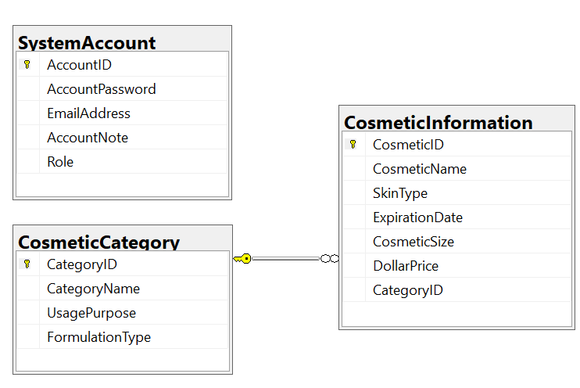

Activity 01: Build a solution by Visual Studio.NET
Create a Blank Solution named Lab01.sln then add new a Class Library project named BusinessObjects, DataAccessObjects, Repositories, Services and an ASP.NET Core Web App (Razor Pages) project named ProductManagementRazorPages

Step 01. Create a Blank solution.

Step 02. Create 4 Class Library projects.

Step 03. Create a project (ASP.NET Core Web App (Razor Pages).

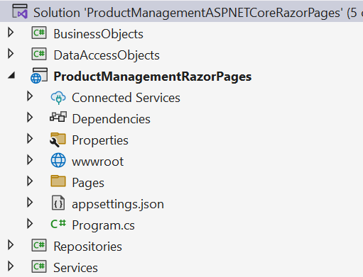
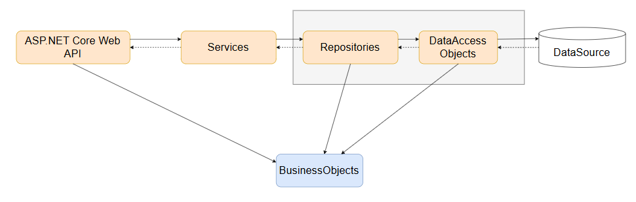
Note:
- Data Source in this case is the SQL Server Database
- Services Project – This project represents a layer or component responsible for implementing the business logic of an application.
- Repository Project – This project provides an abstraction layer between the application’s business logic and the underlying data source.
- Data Access Layer Project – This project used to abstract and encapsulate the logic for accessing data from a data source, such as a database.

Activity 02: Write codes for the BusinessObjects project

Step 01. Install the following packages from NuGet:
- Microsoft.EntityFrameworkCore.SqlServer --version 8.0.2
- Microsoft.EntityFrameworkCore.Tools --version 8.0.2
- Microsoft.Extensions.Configuration.Json --version 8.0.0

Check the tool for EFCore (install/uninstall tool if needed) (dotnet SDK 8.0.202)

dotnet tool install --global dotnet-ef --version 8.0.2
dotnet tool uninstall --global dotnet-ef

Step 02. Right-click on project , select Open In Terminal. On Developer PowerShell dialog execute the following commands to generate model:
- Implement ORM
dotnet ef dbcontext scaffold “Server=(local); Database=CosmeticsDB; Uid=sa; Pwd=1234567890” Microsoft.EntityFrameworkCore.SqlServer --output-dir ./

- Change the connection string in OnConfiguring() function of MyStoreContext.cs
using System.IO;
using Microsoft.Extensions.Configuration.Json;

private string GetConnectionString()
{
IConfiguration configuration = new ConfigurationBuilder()
.SetBasePath(Directory.GetCurrentDirectory())
.AddJsonFile("appsettings.json", true, true).Build();
return configuration["ConnectionStrings:DefaultConnectionString"];
}

protected override void OnConfiguring(DbContextOptionsBuilder optionsBuilder)
{
optionsBuilder.UseSqlServer(GetConnectionString());
}
- Move the CosmeticsDbContext.cs to DataAccessLayer Project
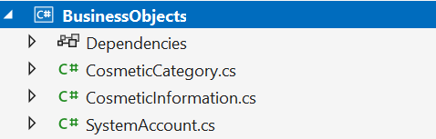

Activity 03: Write codes for the DataAccessLayer project
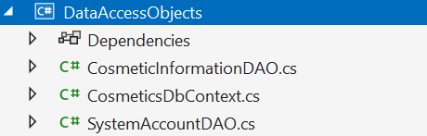

Step 01. On the DataAccessObjects project, add a class named CosmeticInformationDAO.cs and write codes as follows:
using BusinessObjects;
using Microsoft.EntityFrameworkCore;

namespace DataAccessObjects;
public class CosmeticInformationDAO
{
private static CosmeticInformationDAO? instance = null;

private CosmeticInformationDAO() { }

public static CosmeticInformationDAO Instance
{
get
{
if (instance == null)
{
instance = new CosmeticInformationDAO();
}
return instance;
}
}
public async Task<List<CosmeticInformation>> GetAllCosmetics()
{
try
{
using (var context = new CosmeticsDbContext())
{
var listComestics = await context.CosmeticInformations.Include(x => x.Category).ToListAsync();
return listComestics;
}
}
catch (Exception ex)
{
throw new Exception(ex.Message);
}
}

public async Task<List<CosmeticCategory>> GetAllCategories()
{
using (var context = new CosmeticsDbContext())
{
var listCategories = await context.CosmeticCategories.ToListAsync();
return listCategories;
}
}

public async Task<CosmeticInformation> AddCosmeticInformation(CosmeticInformation cosmeticInformation)
{
using (var context = new CosmeticsDbContext())
{
var categoryObject = await context.CosmeticCategories.FirstOrDefaultAsync(x => x.CategoryId.Equals(cosmeticInformation.CategoryId));
if (categoryObject == null)
{
throw new Exception("Category is not found");
}

cosmeticInformation.CosmeticId = GenerateId();
await context.CosmeticInformations.AddAsync(cosmeticInformation);
await context.SaveChangesAsync();
return cosmeticInformation;
}
}

public async Task<CosmeticInformation> GetById(string id)
{
using (var context = new CosmeticsDbContext())
{
var resultObject = await context.CosmeticInformations.Include(x => x.Category)
.FirstOrDefaultAsync(x => x.CosmeticId.Equals(id));
return resultObject;
}
}

public async Task<CosmeticInformation> Update(CosmeticInformation cosmeticInformation)
{
using (var context = new CosmeticsDbContext())
{
var updateObject = await context.CosmeticInformations.FirstOrDefaultAsync(x => x.CosmeticId == cosmeticInformation.CosmeticId);
if (updateObject == null)
{
throw new Exception("CosmeticInformations not found");
}

var cate = await context.CosmeticCategories.FirstOrDefaultAsync(x => x.CategoryId.Equals(cosmeticInformation.CategoryId));
if (cate == null)
{
throw new Exception("Cate not found");
}

updateObject.CosmeticName = cosmeticInformation.CosmeticName;
updateObject.SkinType = cosmeticInformation.SkinType;
updateObject.ExpirationDate = cosmeticInformation.ExpirationDate;
updateObject.CosmeticSize = cosmeticInformation.CosmeticSize;
updateObject.DollarPrice = cosmeticInformation.DollarPrice;
updateObject.CategoryId = cosmeticInformation.CategoryId;

context.CosmeticInformations.Update(updateObject);

await context.SaveChangesAsync();
return updateObject;
}
}

public async Task<CosmeticInformation> Delete(string id)
{
using (var context = new CosmeticsDbContext())
{
var deleteObject = await context.CosmeticInformations.FirstOrDefaultAsync(p => p.CosmeticId.Equals(id));
if (deleteObject == null)
{
throw new Exception("CosmeticInformations not found");
}

context.CosmeticInformations.Remove(deleteObject);

await context.SaveChangesAsync();
return deleteObject;
}
}

private string GenerateId()
{
var random = new Random();
var id = random.Next(100000, 999999);
return "PL" + id.ToString();
}
}

Step 02. On the DataAccessObjects project, add a class named SystemAccounrDAO.cs and write codes as follows:
using BusinessObjects;
using Microsoft.EntityFrameworkCore;

namespace DataAccessObjects
{
public class SystemAccountDAO
{
private static SystemAccountDAO? instance = null;

private SystemAccountDAO() { }

public static SystemAccountDAO Instance
{
get
{
if (instance == null)
{
instance = new SystemAccountDAO();
}
return instance;
}
}
public async Task<SystemAccount> Login(string email, string password)
{
using (var context = new CosmeticsDbContext())
{
var account = await context.SystemAccounts.FirstOrDefaultAsync(account => account.EmailAddress == email && account.AccountPassword == password);
return account;
}
}
}
}

Step 03. The codes for CosmeticsDbContext.cs:
using System;
using System.Collections.Generic;
using Microsoft.EntityFrameworkCore;
using Microsoft.Extensions.Configuration;
using BusinessObjects;

namespace DataAccessObjects;

public partial class CosmeticsDbContext : DbContext
{
public CosmeticsDbContext()
{
}

public CosmeticsDbContext(DbContextOptions<CosmeticsDbContext> options)
: base(options)
{
}

public virtual DbSet<CosmeticCategory> CosmeticCategories { get; set; }

public virtual DbSet<CosmeticInformation> CosmeticInformations { get; set; }

public virtual DbSet<SystemAccount> SystemAccounts { get; set; }

protected override void OnConfiguring(DbContextOptionsBuilder optionsBuilder)
=> optionsBuilder.UseSqlServer(GetConnectionString());

private string GetConnectionString()
{
IConfiguration configuration = new ConfigurationBuilder()
.SetBasePath(Directory.GetCurrentDirectory())
.AddJsonFile("appsettings.json", true, true).Build();
return configuration["ConnectionStrings:DefaultConnectionString"];
}

protected override void OnModelCreating(ModelBuilder modelBuilder)
{
modelBuilder.Entity<CosmeticCategory>(entity =>
{
entity.HasKey(e => e.CategoryId).HasName("PK__Cosmetic__19093A2BA2750A62");

entity.ToTable("CosmeticCategory");

entity.Property(e => e.CategoryId)
.HasMaxLength(30)
.HasColumnName("CategoryID");
entity.Property(e => e.CategoryName).HasMaxLength(120);
entity.Property(e => e.FormulationType).HasMaxLength(250);
entity.Property(e => e.UsagePurpose).HasMaxLength(250);
});

modelBuilder.Entity<CosmeticInformation>(entity =>
{
entity.HasKey(e => e.CosmeticId).HasName("PK__Cosmetic__98ED527E67429B69");

entity.ToTable("CosmeticInformation");

entity.Property(e => e.CosmeticId)
.HasMaxLength(30)
.HasColumnName("CosmeticID");
entity.Property(e => e.CategoryId)
.HasMaxLength(30)
.HasColumnName("CategoryID");
entity.Property(e => e.CosmeticName).HasMaxLength(160);
entity.Property(e => e.CosmeticSize).HasMaxLength(400);
entity.Property(e => e.DollarPrice).HasColumnType("decimal(18, 0)");
entity.Property(e => e.ExpirationDate).HasMaxLength(160);
entity.Property(e => e.SkinType).HasMaxLength(200);

entity.HasOne(d => d.Category).WithMany(p => p.CosmeticInformations)
.HasForeignKey(d => d.CategoryId)
.OnDelete(DeleteBehavior.Cascade)
.HasConstraintName("FK__CosmeticI__Categ__3C69FB99");
});

modelBuilder.Entity<SystemAccount>(entity =>
{
entity.HasKey(e => e.AccountId).HasName("PK__SystemAc__349DA58646609DFA");

entity.ToTable("SystemAccount");

entity.HasIndex(e => e.EmailAddress, "UQ__SystemAc__49A14740597553D5").IsUnique();

entity.Property(e => e.AccountId)
.ValueGeneratedNever()
.HasColumnName("AccountID");
entity.Property(e => e.AccountNote).HasMaxLength(240);
entity.Property(e => e.AccountPassword).HasMaxLength(100);
entity.Property(e => e.EmailAddress).HasMaxLength(100);
});

OnModelCreatingPartial(modelBuilder);
}

partial void OnModelCreatingPartial(ModelBuilder modelBuilder);
}

Activity 04: Write codes for the Repositories project
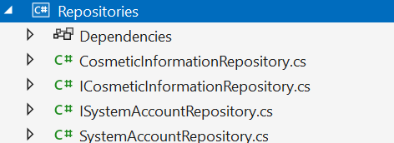

Step 01. On the Repositories project, add an interface named ICosmeticInformationRepository.cs and write codes as follows:

Step 02. On the Repositories project, add an interface named IProductRepository.cs and write codes as follows:
using BusinessObjects;

namespace Repositories
{
public interface ICosmeticInformationRepository
{
Task<List<CosmeticInformation>> GetAllCosmetics();
Task<CosmeticInformation> GetOne(string id);
Task<CosmeticInformation> Add(CosmeticInformation cosmeticInformation);
Task<CosmeticInformation> Update(CosmeticInformation cosmeticInformation);
Task<CosmeticInformation> Delete(string id);
Task<List<CosmeticCategory>> GetAllCategories();
}
}

Step 03. On the Repositories project, add an interface named ISystemAccountRepository.cs and write codes as follows:
using BusinessObjects;

namespace Repositories
{
public interface ISystemAccountRepository
{
Task<SystemAccount> Login(string email, string password);
}
}

Step 04. Write codes for class CosmeticInformationRepository.cs as follows:
using BusinessObjects;
using DataAccessObjects;

namespace Repositories
{
public class CosmeticInformationRepository : ICosmeticInformationRepository
{
public async Task<CosmeticInformation> Add(CosmeticInformation cosmeticInformation)
{
return await CosmeticInformationDAO.Instance.AddCosmeticInformation(cosmeticInformation);
}

public async Task<CosmeticInformation> Delete(string id)
{
return await CosmeticInformationDAO.Instance.Delete(id);
}

public async Task<List<CosmeticCategory>> GetAllCategories()
{
return await CosmeticInformationDAO.Instance.GetAllCategories();
}

public async Task<List<CosmeticInformation>> GetAllCosmetics()
{
return await CosmeticInformationDAO.Instance.GetAllCosmetics();
}

public async Task<CosmeticInformation> GetOne(string id)
{
return await CosmeticInformationDAO.Instance.GetById(id);
}

public async Task<CosmeticInformation> Update(CosmeticInformation cosmeticInformation)
{
return await CosmeticInformationDAO.Instance.Update(cosmeticInformation);
}
}
}

Step 05. Write codes for class SystemAccountRepository.cs as follows:
using BusinessObjects;
using DataAccessObjects;

namespace Repositories
{
public class SystemAccountRepository : ISystemAccountRepository
{
public async Task<SystemAccount> Login(string email, string password)
{
return await SystemAccountDAO.Instance.Login(email, password);
}
}
}

Activity 05: Write codes for the Services project
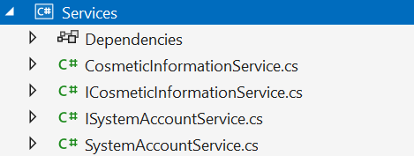

Step 01. On the Services project, add an interface named ICosmeticInformationService.cs and write codes as follows:
using BusinessObjects;

namespace Services
{
public interface ICosmeticInformationService
{
Task<List<CosmeticInformation>> GetAllCosmetics();
Task<CosmeticInformation> GetOne(string id);
Task<CosmeticInformation> Add(CosmeticInformation cosmeticInformation);
Task<CosmeticInformation> Update(CosmeticInformation cosmeticInformation);
Task<CosmeticInformation> Delete(string id);
Task<List<CosmeticCategory>> GetAllCategories();
}
}

Step 02. On the Services project, add an interface named ISystemAccountService.cs and write codes as follows:
using BusinessObjects;

namespace Services
{
public interface ISystemAccountService
{
Task<SystemAccount> Login(string email, string password);
}
}

Step 03. Write codes for class CosmeticInformationService.cs as follows:
using BusinessObjects;
using Repositories;

namespace Services
{
public class CosmeticInformationService : ICosmeticInformationService
{
private readonly ICosmeticInformationRepository _repository;
public CosmeticInformationService(ICosmeticInformationRepository repository)
{
_repository = repository;
}
public async Task<CosmeticInformation> Add(CosmeticInformation cosmeticInformation)
{
return await _repository.Add(cosmeticInformation);
}

public async Task<CosmeticInformation> Delete(string id)
{
return await _repository.Delete(id);
}

public async Task<List<CosmeticCategory>> GetAllCategories()
{
return await _repository.GetAllCategories();
}

public async Task<List<CosmeticInformation>> GetAllCosmetics()
{
return await _repository.GetAllCosmetics();
}

public async Task<CosmeticInformation> GetOne(string id)
{
return await _repository.GetOne(id);
}

public async Task<CosmeticInformation> Update(CosmeticInformation cosmeticInformation)
{
return await _repository.Update(cosmeticInformation);
}
}
}

Step 04. Write codes for class SystemAccountService.cs as follows:
using BusinessObjects;
using Repositories;

namespace Services
{
public class SystemAccountService : ISystemAccountService
{
private readonly ISystemAccountRepository _repo;
public SystemAccountService(ISystemAccountRepository repo)
{
_repo = repo;
}
public async Task<SystemAccount> Login(string email, string password)
{
return await _repo.Login(email, password);
}
}
}

Activity 06: Work with ASP.NET Core Web App (Razor Pages)

Step 01. Create the ASP.NET Core Web API project, the result as the following
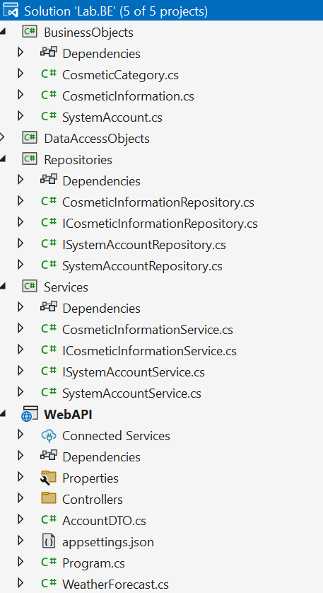

Step 02. Add connection string to appsettings.json.
{
"Logging": {
"LogLevel": {
"Default": "Information",
"Microsoft.AspNetCore": "Warning"
}
},
"AllowedHosts": "*",
"ConnectionStrings": {
"DefaultConnectionString": "Server=(local); Database= CosmeticsDB; Uid=sa; Pwd=1234567890;TrustServerCertificate=True"
},
"Jwt": {
"SecretKey": "SecretKeySecretKeySecretKeySecretKeySecretKeySecretKeySecretKeySecretKeySecretKeySecretKeySecretKey",
"Issuer": "FU Lab Issuer",
"Audience": "FU Lab Audience"
}
}

Step 03. Add Business Objects and Services projects as references for the ASP.NET Core Web API

Step 04. Add packages for OData and JwtBearer

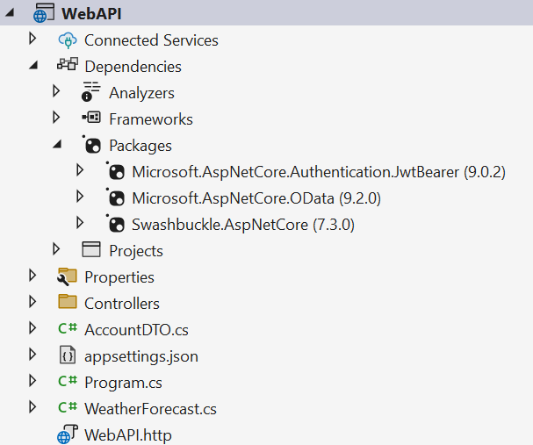

Step 05. Create DTO class for Login processing
AccountDTO.cs (AccountRequestDTO for sending objects đi, AccounResponsetDTO (with Token for responding object to Client)
namespace WebAPI
{
public class AccountRequestDTO
{
public string Email { get; set; }
public string Password { get; set; }
}
public class AccountResponseDTO
{
public string Token { get; set; }
public string Role { get; set; }
public string AccountId { get; set; }
}
}

Step 06. Program.cs – Configure OData, JWT and other services
using BusinessObjects;
using Microsoft.AspNetCore.Authentication.JwtBearer;
using Microsoft.AspNetCore.OData;
using Microsoft.IdentityModel.Tokens;
using Microsoft.OData.ModelBuilder;
using Microsoft.OpenApi.Models;

using Repositories;
using Services;
using System.Text;
using System.Text.Json.Serialization;

var builder = WebApplication.CreateBuilder(args);

var modelBuilder = new ODataConventionModelBuilder();
modelBuilder.EntitySet<CosmeticInformation>("CosmeticInformations");
modelBuilder.EntitySet<CosmeticCategory>("CosmeticCategories");

// Add services to the container.
builder.Services.AddControllers()
.AddJsonOptions(options =>
{
options.JsonSerializerOptions.ReferenceHandler = ReferenceHandler.IgnoreCycles;
options.JsonSerializerOptions.DefaultIgnoreCondition = JsonIgnoreCondition.Never;
})
.AddOData(
options => options.Select().Filter().OrderBy().Expand().Count().SetMaxTop(null).AddRouteComponents(
"odata",
modelBuilder.GetEdmModel()));
// Learn more about configuring OpenAPI at https://aka.ms/aspnet/openapi
//builder.Services.AddOpenApi();

IConfiguration configuration = new ConfigurationBuilder()
.SetBasePath(Directory.GetCurrentDirectory())
.AddJsonFile("appsettings.json", true, true).Build();

builder.Services.AddScoped<ISystemAccountRepository, SystemAccountRepository>();
builder.Services.AddScoped<ICosmeticInformationRepository, CosmeticInformationRepository>();
builder.Services.AddScoped<ISystemAccountService, SystemAccountService>();
builder.Services.AddScoped<ICosmeticInformationService, CosmeticInformationService>();

// Learn more about configuring Swagger/OpenAPI at https://aka.ms/aspnetcore/swashbuckle
builder.Services.AddEndpointsApiExplorer();

builder.Services
.AddAuthentication(x =>
{
x.DefaultAuthenticateScheme = JwtBearerDefaults.AuthenticationScheme;
})
.AddJwtBearer(x =>
{
x.SaveToken = true;
x.TokenValidationParameters = new TokenValidationParameters
{
ValidateIssuer = false,
ValidateAudience = false,
ValidateLifetime = false,
ValidIssuer = configuration["JWT:Issuer"],
ValidAudience = configuration["JWT:Audience"],
IssuerSigningKey = new SymmetricSecurityKey(Encoding.UTF8.GetBytes(configuration["JWT:SecretKey"]))
};
});

// Add Swagger JWT configuration
builder.Services.AddSwaggerGen(c =>
{
var jwtSecurityScheme = new OpenApiSecurityScheme
{
Name = "JWT Authentication",
Description = "JWT Authentication for Cosmetics Management",
In = ParameterLocation.Header,
Type = SecuritySchemeType.Http,
Scheme = "Bearer",
BearerFormat = "JWT"
};

c.AddSecurityDefinition("Bearer", jwtSecurityScheme);

var securityRequirement = new OpenApiSecurityRequirement
{
{
new OpenApiSecurityScheme
{
Reference = new OpenApiReference
{
Type = ReferenceType.SecurityScheme,
Id = "Bearer"
}
},
new string[] {}
}
};

c.AddSecurityRequirement(securityRequirement);
});

builder.Services.AddAuthorization(options =>
{

options.AddPolicy("AdminOnly",
policyBuilder => policyBuilder.RequireAssertion(
context => context.User.HasClaim(claim => claim.Type == "Role") &&
context.User.FindFirst(claim => claim.Type == "Role").Value == "1"));

options.AddPolicy("AdminOrStaffOrMember",
policyBuilder => policyBuilder.RequireAssertion(
context => context.User.HasClaim(claim => claim.Type == "Role")
&& (context.User.FindFirst(claim => claim.Type == "Role").Value == "1"
|| context.User.FindFirst(claim => claim.Type == "Role").Value == "3"
|| context.User.FindFirst(claim => claim.Type == "Role").Value == "4")));
});

var app = builder.Build();

app.UseRouting();
// Configure the HTTP request pipeline.
if (app.Environment.IsDevelopment())
{
//app.MapOpenApi();
app.UseSwagger();
app.UseSwaggerUI();
}

app.UseAuthorization();

app.MapControllers();

app.Run();

Role: Administrator=1; Manager = 2; Staff=3; Member= 4.
- Administrator role will have a permission to all actions (CRUD and search).
- Staff or Member role will have only permission to search information.
- Other roles do not have any permissions.

Step 07. Controller for processing login process. This controller has 4 type of action methods: POST, PUT, DELETE, GET

using Microsoft.AspNetCore.Mvc;
using Services;
using Microsoft.IdentityModel.Tokens;
using System.IdentityModel.Tokens.Jwt;
using System.Security.Claims;
using System.Text;

namespace WebAPI.Controllers
{
[Route("api/[controller]")]
[ApiController]
public class SystemAccountsController : ControllerBase
{

private readonly ISystemAccountService _systemAccountService;

public SystemAccountsController(ISystemAccountService systemAccountService)
{
_systemAccountService = systemAccountService;
}

// POST: api/SystemAccounts
// To protect from overposting attacks, see https://go.microsoft.com/fwlink/?linkid=2123754
[HttpPost("Login")]
public async Task<ActionResult> Login([FromBody] AccountRequestDTO loginDTO)
{
try
{
var account = await _systemAccountService.Login(loginDTO.Email, loginDTO.Password);
if (account == null)
{
return Unauthorized("Invalid email or password.");
}

IConfiguration configuration = new ConfigurationBuilder()
.SetBasePath(Directory.GetCurrentDirectory())
.AddJsonFile("appsettings.json", true, true).Build();

var claims = new List<Claim>
{
new Claim(ClaimTypes.Email, account.EmailAddress),
new Claim("Role", account.Role.ToString()),
new Claim("AccountId", account.AccountId.ToString()),
};

var symetricKey = new SymmetricSecurityKey(Encoding.UTF8.GetBytes(configuration["JWT:SecretKey"]));
var signCredential = new SigningCredentials(symetricKey, SecurityAlgorithms.HmacSha256);

var preparedToken = new JwtSecurityToken(
issuer: configuration["JWT:Issuer"],
audience: configuration["JWT:Audience"],
claims: claims,
expires: DateTime.Now.AddMinutes(16),
signingCredentials: signCredential);

var generatedToken = new JwtSecurityTokenHandler().WriteToken(preparedToken);
var role = account.Role.ToString();
var accountId = account.AccountId.ToString();

return Ok(new AccountResponseDTO
{
Role = role,
Token = generatedToken,
AccountId = accountId
});
}
catch (Exception e)
{
return BadRequest(e.Message);
}
}

}
}

Step 08. Controller for CRUD cosmetics information.

using Microsoft.AspNetCore.Mvc;
using BusinessObjects;
using Services;
using Microsoft.AspNetCore.Authorization;
using Microsoft.AspNetCore.OData.Query;
using Microsoft.AspNetCore.OData.Routing.Controllers;

namespace WebAPI.Controllers
{
//[Route("api/[controller]")]
[ApiController]
public class CosmeticInformationsController : ODataController
{
private readonly ICosmeticInformationService _cismeticInformationService;
public CosmeticInformationsController(ICosmeticInformationService cismeticInformationService)
{
_cismeticInformationService = cismeticInformationService;
}

[EnableQuery]
[Authorize(Policy = "AdminOrStaffOrMember")]
[HttpGet("/api/CosmeticInformations")]
public async Task<ActionResult<IEnumerable<CosmeticInformation>>> GetCosmeticInformations()
{
try
{
var result = await _cismeticInformationService.GetAllCosmetics();
return Ok(result);
}
catch (Exception ex)
{
return StatusCode(400, $"{ex.Message}");
}
}

[Authorize(Policy = "AdminOrStaffOrMember")]
[HttpGet("/api/CosmeticCategories")]
public async Task<ActionResult<List<CosmeticCategory>>> GetCategories()
{
try
{
var result = await _cismeticInformationService.GetAllCategories();
return Ok(result);
}
catch (Exception ex)
{
return StatusCode(400, $"{ex.Message}");
}
}

[Authorize(Policy = "AdminOnly")]
[HttpPost("/api/CosmeticInformations")]
public async Task<ActionResult<CosmeticInformation>> AddCosmeticInformation([FromBody] CosmeticInformation cosmeticInformation)
{
try
{
var result = await _cismeticInformationService.Add(cosmeticInformation);
return Ok(result);
}
catch (Exception ex)
{
return StatusCode(400, $"{ex.Message}");
}
}

[Authorize(Policy = "AdminOnly")]
[HttpPut("/api/CosmeticInformations/{id}")]
public async Task<ActionResult<CosmeticInformation>> UpdateCosmeticInformation(string id, [FromBody] CosmeticInformation cosmeticInformation)
{
try
{
cosmeticInformation.CosmeticId = id;
var result = await _cismeticInformationService.Update(cosmeticInformation);
return Ok(result);
}
catch (Exception ex)
{
return StatusCode(400, $"{ex.Message}");
}
}

[Authorize(Policy = "AdminOnly")]
[HttpDelete("/api/CosmeticInformations/{id}")]
public async Task<ActionResult<CosmeticInformation>> DeleteCosmeticInformation(string id)
{
try
{
var result = await _cismeticInformationService.Delete(id);
return Ok(result);
}
catch (Exception ex)
{
return StatusCode(400, $"{ex.Message}");
}
}

[Authorize(Policy = "AdminOrStaffOrMember")]
[HttpGet("/api/CosmeticInformations/{id}")]
public async Task<ActionResult<CosmeticInformation>> AddCosmeticInformation(string id)
{
try
{
var result = await _cismeticInformationService.GetOne(id);
return Ok(result);
}
catch (Exception ex)
{
return StatusCode(400, $"{ex.Message}");
}
}
}
}

Activity 07: Run the ASP.NET Core Web API project and test all actions

