Explainable, Agent-Based Triage Support Tool for Hospital Patient Flow
Challenge proposal, prepared August 2026

1. The real-world problem
Ireland's hospital waiting lists hit a record 1,008,600 people at the end of May 2026, an increase of almost 10,000 in a single month, with 669,506 people waiting for a first outpatient appointment, up 14 percent in the past year [2]. This is not purely a capacity gap. The IHCA has tied the growth directly to elective cancellations driven by emergency department overcrowding, pointing to almost 24,500 hospital appointments and operations cancelled in January alone, 30 percent of them in the HSE Dublin and Midland Region, on top of more than 286,500 cancellations across the whole of last year, up 7 percent on 2024 [3]. The IHCA has warned that cancelling elective care cannot be the go to solution to the trolley crisis, because it does nothing to fix the underlying capacity and overcrowding problem [3].
Underneath the numbers sits a decision quality problem. Who gets seen next, on what basis, and how that reasoning is recorded, is largely opaque to patients, clinicians, and management alike.

2. Who would pay and why
HSE Regional Executive Officers and individual hospital or group management are now formally accountable for reducing regional variation and improving planned care delivery under the Waiting Time Action Plan 2026, which gives HSE Regional Executive Officers a leadership role in driving productivity and performance improvements across each of the six HSE Health Regions [4]. There is also a live budget line for this work. The HSE is actively funding AI enabled operational tools as part of the AI for Care strategy, whose Operations pillar is explicitly about streamlining patient flow, reducing administrative burden, and improving system efficiency [5].

3. Potential buyers
Beyond the primary public sector buyer, several categories of organisation have a concrete reason to adopt or fund a tool like this:
- HSE Regional Executive Officers and the six HSE Health Regions. The primary buyer. Directly accountable for scheduled care performance under WTAP 2026, and able to draw on AI for Care operations funding.
- The National Treatment Purchase Fund. Commissions care, manages the national waiting list protocols, and already owns the Clinical Prioritisation Category and Clinically Recommended Timeframe rules this system would need to respect and could help audit.
- Private hospital groups. Blackrock Health (Blackrock Clinic, Galway Clinic, Hermitage Clinic, Limerick Clinic), Mater Private Network, Beacon Hospital, Bon Secours Health System, and UPMC Ireland are mid-transition to shared electronic health record platforms such as Meditech Expanse. These groups already participate in HSE insourcing and capacity sharing arrangements during overcrowding periods, which is exactly where an explainable, shared prioritisation layer would add value across the public and private boundary [18, 19].
- The National Ambulance Service. The stated post challenge extension, for prioritising 999 and 112 calls, sits with an organisation that already runs a formal, auditable dispatch protocol and could plausibly pilot a complementary decision support layer [16].
- Health tech and medtech vendors. Companies bidding into the National Electronic Health Record procurement and the HSE AI Implementation Framework need a reference pattern for explainable, human in the loop agent architectures that will pass HIQA and EU AI Act scrutiny. A validated prototype is a sellable component, not just a demo [6, 7].
- Health insurers. VHI, Laya Healthcare, and Irish Life Health are a weaker, longer horizon secondary buyer, relevant mainly where capacity sharing and insourcing initiatives affect private capacity utilisation and claims. This is worth naming as a possibility but should not be treated as a near term buying case.

4. Challenge statement
Design a multi-agent system that turns fragmented referral, bed flow, and urgency data into a ranked, explainable, auditable prioritisation, one a clinician can trust, interrogate, and override, without the reasoning ever being a black box.

5. Why this is agent-shaped
- Structurally. Clinical urgency scoring and bed or capacity constraint reasoning are genuinely different problem types, clinical risk stratification versus operations research style resource allocation, that do not collapse well into one model. They need separate specialist agents whose outputs a coordinator can reconcile and rank, rather than one monolithic scorer.
- Institutionally. The HSE's own AI governance now demands this shape. The AI for Care framework requires a human in the loop approach that enables rather than replaces clinicians, and a decomposed agent architecture is what makes a full audit trail, showing which agent flagged what and why, possible. A single end to end model cannot produce that same traceability [7].

6. What success could look like
A working prototype that ingests a simulated referral and bed status feed, produces a ranked list with a per patient rationale (which urgency signals, which capacity constraints), and lets a clinician accept, reorder, or override any ranking, with the override logged. Success is not the agent deciding. It is a measurably faster, more consistent, and fully explainable shortlist that a human still signs off on.

7. Possible prototype inputs
- NTPF Open Data, historical waiting list by hospital group CSV files, for realistic list structure and volume
- HSE and INMO daily trolley and overcrowding figures, for bed pressure simulation
- Synthetic EHR generators such as Synthea, or de-identified public datasets such as MIMIC-IV, for clinical urgency features, since no real patient level Irish referral data is publicly available
- Published urgency and triage scoring rubrics, such as the Manchester Triage System and NEWS2, as a starting ontology for the knowledge graph

8. Data sources and synthesis strategy
There is no single Irish dataset that links referrals, urgency, and live bed capacity together. That gap is exactly why simulation is necessary, and the same real datasets can be used to keep that simulation grounded.

Real Irish datasets, structural ground truth
- NTPF Open Data (data.gov.ie and ntpf.ie), monthly waiting list volumes by hospital, specialty, and time band, useful for calibrating list sizes and specialty mix [1].
- HIPE, the Hospital In-Patient Enquiry, held by the Healthcare Pricing Office, covering 98 percent of public acute hospitals and around 1.7 million discharges annually, coded in ICD-10-AM, ACHI, and ACS. Aggregate or anonymised extracts are requestable from the HPO, and it is the best available source for realistic diagnosis mix, admission type, and length of stay distributions [8, 9, 10].
- HSE and INMO daily trolley watch figures, public daily overcrowding numbers, useful for calibrating a synthetic bed occupancy time series.
- CSO Open Data health statistics, built from HIPE, for county and age level context.

External datasets for urgency features
- MIMIC-IV-ED, a de-identified United States emergency department dataset with vitals, chief complaint, and triage acuity. Structurally close to what an urgency agent would consume, even though it is not Irish.
- Synthea, a synthetic patient generator that produces full longitudinal encounters, conditions, vitals, and procedures, and is commonly used for exactly this situation, where no real data is available.

Synthesis approach
- Parameterise a synthetic patient and referral generator using HIPE's published specialty mix, age and sex distribution, and length of stay statistics, so the case mix looks Irish even though no individual record is real.
- Score each synthetic case using the actual Irish triage rubrics, the Manchester Triage System categories and NEWS2, so urgency labels are grounded in real clinical standards rather than arbitrary.
- Simulate bed occupancy and arrivals as a discrete event queue, for example with SimPy, calibrated to published HSE occupancy and trolley figures, so the capacity agent is stress tested against realistic contention.
- Use the NTPF's own Clinical Prioritisation Category timeframes as a validation target, checking whether the system's ranking respects the 28 day and 13 week rules clinicians are already bound by.

9. Multi-agent information flow
Referral, bed capacity, and vitals or triage data all land in a shared knowledge graph. The urgency agent and the capacity agent each read from that graph independently and write their scores back as graph nodes and edges, not just as messages passed between agents, which is what keeps the trail auditable. The coordinating or orchestrator agent merges both sets of outputs into a ranked list, and every element of that ranking traces back through the graph to the evidence that produced it. The clinician sits at the end as the actual decision maker, and any override is logged back into the graph, closing the loop so future rankings account for clinician corrections rather than repeating the same reasoning.
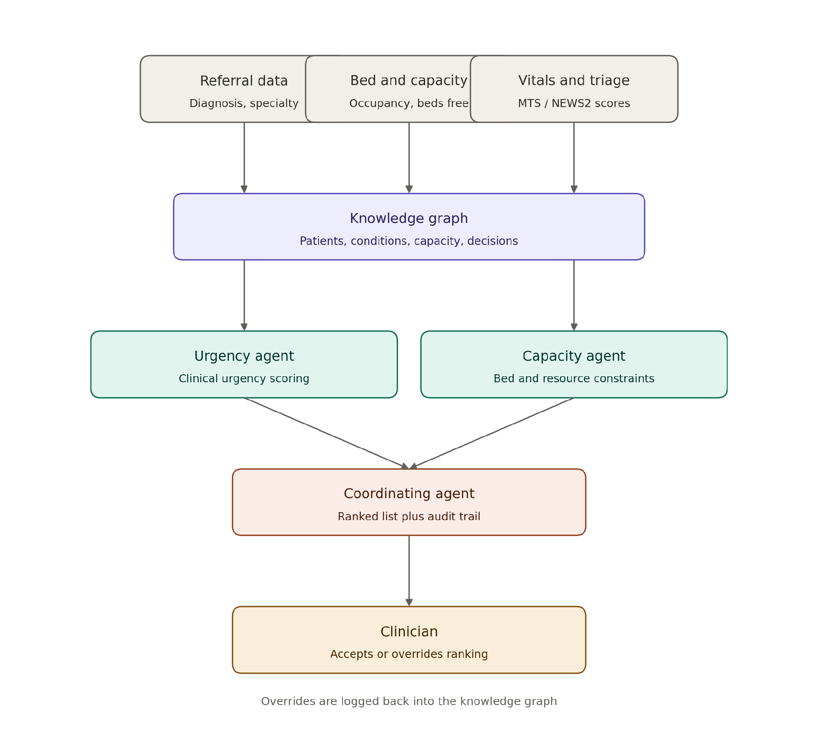
Figure 1. Information flows through the multi-agent triage system.

10. Applying the knowledge graph
The graph is not just a data store here, it is the explainability mechanism itself, so the schema needs to double as an audit log.

Entities
Patient, Referral, Condition (ICD-10-AM coded, matching HIPE), UrgencySignal (vitals, MTS or NEWS2 category), ClinicalPrioritisationCategory (urgent, semi-urgent, or routine, matching the NTPF's own CPC scheme), Specialty, Hospital or Ward, BedStatus, Agent, Decision (a ranking event), and Clinician.

Relationships
Patient presents with Condition. Referral has signal UrgencySignal. Referral is assigned to Specialty. Specialty is located at Ward, which has status BedStatus. Agent scored Referral, with the score stored as an edge property rather than a free floating number. Decision ranks Referral. Decision cites UrgencySignal or BedStatus, and this last relationship is the audit trail itself, since walking backward from any ranked position in the list reconstructs exactly which evidence nodes produced it.

Practical build
An RDF and OWL stack is the practical build here, using a free, open source triple store such as Apache Jena with its Fuseki SPARQL server, or Eclipse RDF4J. SNOMED CT and HL7 FHIR already publish RDF representations, so layering them onto the graph for conditions and for patient and encounter structure is close to native, which also positions the prototype to plug into the HSE's Shared Care Record work later. An OWL ontology formalises the entity classes above (Patient, Referral, Condition, and so on) and the rules a Decision must satisfy, for example that a Decision citing an urgent Referral cannot rank it behind a semi-urgent one that is still inside its Clinically Recommended Timeframe. The urgency agent queries Patient to Condition to UrgencySignal via SPARQL, applies MTS or NEWS2 logic, and writes a scored triple back to the store. The capacity agent queries Specialty to Ward to BedStatus the same way. The coordinator's ranking is a SPARQL query over both sets of triples, and its output stays traceable because the cites relationship is itself a triple, so walking backward from any ranked position reconstructs the evidence without leaving the store.

11. Existing prioritisation regulations and guidelines
There is more formal structure here than the opaque framing in section one might suggest. The challenge is less about inventing a new prioritisation scheme and more about making an existing, fragmented one explainable and consistent.

Emergency department, walk-in, triage
- The National Emergency Medicine Programme mandates the Manchester Triage System for all adult emergency department patients, a recommendation reinforced by the HIQA Tallaght Report's finding that the Manchester Triage System must be implemented, managed, and periodically evaluated across all hospitals [11].
- The Irish Children's Triage System is the paediatric equivalent, built to feel consistent with the Manchester Triage System [11].
- EMEWS, the Emergency Medicine Early Warning System, interfaces with the Manchester Triage System and aligns with the National Early Warning Score, NEWS2, for detecting deterioration in emergency department waiting rooms [11].
- The National Emergency Department Triage Quality Improvement Framework, 2025 to 2027, is a strategy aimed specifically at restoring triage to its core function of prioritising relative clinical urgency, alongside the wider National Clinical Programme for Emergency Medicine Model of Care 2025 [12, 13].

Scheduled or elective care
- The National Outpatient Waiting List Management Protocol and the equivalent radiology protocol define a formal Clinical Prioritisation Category. An urgent referral should be booked within a Clinically Recommended Timeframe of 28 days or less, and a semi-urgent referral within 13 weeks, with patients sharing the same category otherwise ordered oldest referral first [14].
- The National Waiting List Management Policy, developed in 2014, is the standardised approach HSE hospitals follow for managing inpatient, day case, and planned procedure lists [15].
- These Clinical Prioritisation Category and timeframe rules are a natural ground truth for validating the coordinating agent's output. A ranking that silently reorders two urgent patients ahead of a semi-urgent patient past its 13 week window would be a clear rule violation to catch.

Ambulance dispatch
- The National Ambulance Service's National Emergency Operations Centre uses the Advanced Medical Priority Dispatch System, AMPDS, an internationally recognised protocol based standard used in 46 countries, to triage and prioritise every 112 and 999 call [16].
- The formal standard is set out in PHECC's EMS Priority Dispatch Standard, under which calls are prioritised through ProQA and AMPDS into six priority classifications, Echo, Delta, Charlie, Bravo, Alpha, and Omega, with dispatchers retaining discretion to override the system's assigned priority. That override provision is a useful precedent for this project's own human in the loop design [17].

12. Responsible AI and implementation boundary
This has to be built as decision support, not decision making, from day one, which aligns with where Irish policy already sits rather than against it. Ireland's AI for Care strategy, 2026 to 2030, makes human oversight and compliance with the EU AI Act central safeguards for any AI deployed in health and social care [5, 7]. HIQA is preparing national guidance on responsible and safe AI use to sit alongside the HSE's forthcoming AI Implementation Framework [6].
The practical boundary for the prototype: the coordinating agent may only rank and explain. It cannot admit, discharge, schedule, or auto action anything. Any diagnosis support extension is explicitly non-diagnostic output requiring clinician validation before use, and no synthetic urgency score should be presented without its contributing evidence attached.

13. Post-challenge opportunity
There is a real, funded pathway here rather than a dead end demo. The HSE is actively standing up governance and pilot mechanisms, an AI Implementation Framework, a National Shared Care Record, and a National Electronic Health Record moving through procurement with vendor shortlisting completed in the first quarter of 2026, that a prioritisation tool like this could plug into as a regional pilot [6]. The stated extensions, ambulance and National Ambulance Service call prioritisation and a diagnosis support agent, map directly onto AI for Care's own Clinical Care and Operations pillars, giving a credible route from prototype to a sanctioned regional trial.

14. One-week implementation plan for TechIreland 2026
This project is intended for the TechIreland National AI Challenge 2026. The Challenge runs over two weeks, from 28 August to 14 September 2026, with teams presenting their work at coordinated regional events on 14 September, and the strongest teams continuing to the National AI Meet at the Galmont Hotel in Galway on 24 September 2026 [20, 21]. The 2026 theme, AI and Agents, Strategy, Processes and Roles, and the emphasis on responsible, people centred AI, line up directly with this proposal's agent architecture and its audit trail [20, 21].
The plan below compresses a working, demo ready prototype into the first week of that window, using a team of at most nine people, and leaves the second week for judge and mentor feedback, refinement, and rehearsal ahead of the 14 September regional presentation.

Team roles
Role | Focus area | Primary output
Team lead and clinical liaison | Scope, task board, stakeholder framing, links agent outputs back to clinical plausibility | Daily standup, final narrative ownership
Knowledge graph engineer | Schema design and RDF implementation for the entities and relationships in section 10 | Seeded, queryable knowledge graph
Data and simulation engineer | Synthetic patient and referral generator calibrated to HIPE and NTPF statistics, bed occupancy queue | Synthetic dataset and SimPy bed model
Urgency agent developer | MTS and NEWS2 based clinical urgency scoring logic | Urgency agent, writing scored edges to the graph
Capacity agent developer | Bed and resource constraint reasoning against the simulated occupancy model | Capacity agent, writing scored edges to the graph
Coordinating agent and orchestration developer | Merges both agents into a ranked list with the Decision and cites relationships | Ranked list with a traceable audit trail
Frontend and clinician UI developer | Ranked list view with accept, reorder, and override controls | Working clinician facing interface
Responsible AI and compliance lead | Checks rankings against CPC and CRT rules, documents the human in the loop boundary | Validation report and boundary documentation
Pitch and business lead | Deck, buyer narrative, and demo script drawn from sections 1 to 3 of this proposal | Submission deck and rehearsed demo script

Day-by-day schedule
Day | Focus | Key deliverable
Day 1 | Kickoff and scoping. Confirm the health track framing, lock the knowledge graph schema, choose the stack (RDF, a Python agent framework, a lightweight web front end), set up the shared repository and environments. | Agreed schema, working environment, task board
Day 2 | Data foundation. Build the synthetic patient and referral generator calibrated to HIPE specialty mix and NTPF list structure, and load schema plus seed data into the knowledge graph. | Seeded knowledge graph with a first batch of synthetic referrals
Day 3 | Specialist agents, first pass. Build the urgency agent on MTS and NEWS2 logic and the capacity agent on the SimPy bed and resource queue, in parallel. | Both agents producing independent scores, written back as graph edges
Day 4 | Coordination and audit trail. Merge both agents into a ranked list, implement the Decision and cites relationships, and begin checking outputs against CPC and CRT timeframe rules. | End to end ranked list with a traceable rationale per patient
Day 5 | Clinician interface and override loop. Build the ranked list view with accept, reorder, and override controls, with overrides written back into the graph. | Working demo path from data ingestion to clinician decision
Day 6 | Validation, hardening, and narrative. Run CPC and CRT rule checks across a larger synthetic batch, fix violations, document the responsible AI boundary, and draft the pitch deck. | Validated prototype and a first pitch deck draft
Day 7 | Rehearsal and submission. Rehearse the demo end to end, refine the explanation shown at each handoff point, and prepare the submission package with buffer time for last minute fixes. | Submission ready package for the regional presentation

Two working assumptions sit behind this schedule. First, agent development on days 3 and 4 depends on the schema and seed data from days 1 and 2, so those earlier steps should not slip. Second, the responsible AI and compliance lead works across the whole week rather than only on day 6, reviewing each agent's output against the Clinical Prioritisation Category and Clinically Recommended Timeframe rules as soon as it exists, so that validation on day 6 is a final check rather than a first one.

15. Glossary
Acronyms used across this proposal, in alphabetical order.
Term | Definition
ACHI | Australian Classification of Health Interventions
ACS | Australian Coding Standards
AI | Artificial Intelligence
AMPDS | Advanced Medical Priority Dispatch System
CPC | Clinical Prioritisation Category
CRT | Clinically Recommended Timeframe
CSO | Central Statistics Office
ED | Emergency Department
EHR | Electronic Health Record
EMEWS | Emergency Medicine Early Warning System
EMP | Emergency Medicine Programme (National Clinical Programme for Emergency Medicine)
EU | European Union
FHIR | Fast Healthcare Interoperability Resources
HIPE | Hospital In-Patient Enquiry
HIQA | Health Information and Quality Authority
HPO | Healthcare Pricing Office
HSE | Health Service Executive
ICD-10-AM | International Statistical Classification of Diseases and Related Health Problems, Tenth Revision, Australian Modification
ICTS | Irish Children's Triage System
IHCA | Irish Hospital Consultants Association
INMO | Irish Nurses and Midwives Organisation
MTS | Manchester Triage System
NAS | National Ambulance Service
NEOC | National Emergency Operations Centre
NEWS2 | National Early Warning Score, version 2
NTPF | National Treatment Purchase Fund
PHECC | Pre-Hospital Emergency Care Council
RCSI | Royal College of Surgeons in Ireland
SNOMED CT | Systematized Nomenclature of Medicine, Clinical Terms
UI | User Interface
UPMC | University of Pittsburgh Medical Center (UPMC Ireland)
VHI | Voluntary Health Insurance Board
WTAP | Waiting Time Action Plan

16. References
- National Treatment Purchase Fund, waiting list data
- Irish Medical Times, record one million people on hospital waiting lists
- Medical Independent, consultants express extreme concern over waiting list figures
- Department of Health, monthly waiting list figures, June 2026
- HSE, the AI for Care strategy for healthcare in Ireland
- Minister for Health, publication of Ireland's first national AI for Care strategy
- Ireland launches first national AI strategy for health and social care, with mandatory human oversight
- HIQA, Hospital In-Patient Enquiry data collection
- Data Catalogue Ireland, Hospital In-Patient Enquiry dataset
- eHealth Ireland, Healthcare Pricing Office HIPE open data
- emNow, National Emergency Medicine Programme clinical tools
- RCSI, National Clinical Programme for Emergency Medicine Model of Care 2025
- National Quality Improvement Framework for Emergency Department Triage, 2025 to 2027
- HSE, National Outpatient Waiting List Management Protocol 2022
- Oireachtas, National Waiting List Management Policy
- National Ambulance Service, accreditation for emergency dispatch
- PHECC, EMS Priority Dispatch Standard
- Blackrock Health
- Irish Times, private hospitals at the forefront of Ireland's digital health transformation
- TechIreland National AI Challenge 2026, event page
- TechCentral, TechIreland launches National AI Challenge 2026

