Conception Phase: Habit App backend
- Project Aim
The aim of the project is to develop the backend of a habit tracking app, using both object oriented and functional programming paradigms in Python. This will also feature a command line interface (CLI) allowing users to create, read, update and delete their daily and weekly habits.

To achieve this, a Habit Class was designed, that will act as the blueprint for every habit the user creates. The Habit Class has the following attributes and methods in the CRUD framework:
Class/ File | Function | Justification
Habit class | Individual habit object manipulation | Individual tracking
HabitManager class | Collective habit object manipulation | Manages all habit objects collectively, enabling operations  that require access to multiple habits simultaneously such as  finding the longest streak and filtering by periodicity
analytics.py | Analyzes habit data | Uses functional programming paradigm to analyses habit data without modifying it i.e. it uses pure functions and does not change the data.
db.py | Data persistence layer | Stores habit data beyond live sessions using SQLite.
main.py | CLI entry point | User interaction layer-provides the menu system allowing users to create, complete, view and analyse habits
test_habits.py | Unit testing | Verifies app works correctly

- System Design
The main components of the system are the Habit Class, HabitManager, analytics.py and main.py. The user interacts with the app through the CLI via main.py, which provides menu options such as creating habits, viewing habits and accessing predefined habits. Each habit is created as an instance of the Habit class, collectively managed by HabitManager class. Habit object data is persisted between sessions through db.py using SQLite. Habits can also be analysed through analytics.py using functional programming principles.

- Data Storage/ Persistence
The data storage layer of the app will use SQLite to allow habit data to persist beyond live sessions. SQLite was chosen because it is built into Python, and using it aids in learning the integration between an app and a storage layer, as databases have been studied separately - integrating this backend with SQL bridges that gap. Apart from that, SQLite is industry relevant.

What gets stored are the instance attributes of each Habit object when a habit is created, specifically: the habit name, periodicity and creation date, as well as completion records including the date and time of each completion. When the app closes, whatever was created or updated during that session will be stored in SQLite via db.py, and can be queried back when the app is opened.

- Analytics Module
The analytics component (analytics.py) uses the functional programming paradigm to analyze data from the Habit objects managed by the HabitManager. It does this using pure functions that don't alter the data. It is used for analytics here to give the user insight into their habits when queried, and to serve that function for a habit tracker - showing a user their progress or opportunities for improvement.
The following four functions are implemented:
- get_all_habits() - returns a list of all currently tracked habits
- get_habits_by_periodicity() - returns a list of habits filtered by periodicity (e.g. all daily habits or all weekly habits)
- get_longest_streak_overall() - returns the longest streak across all defined habits
- get_longest_streak_for_habit() - returns the longest streak for a specific given habit.

It is important to note the distinction between three types of functions in this system:
Type | Location | Purpose
HabitInstance methods | habit.py | Work on a single Habit object’s own data using self-e.g. mark_complete(), get_current_streak()
HabitManager instance methods | Habit_manager.py | Manage the collective Habit objects e.g. add_habit(), delet_habit()
Analytics functions | analytics.py | Pure functions that receive Habit data and return results without changing it.

- Tools
Tool | Version/ library | Justification
Programming language | Python 3.11.7 | -Project requirement and Python offers the datetime and sqlite3 libraries eliminating the need for installation.  -Large community and documentation
Built-in libraries | - datetime-handling dates for completion tracking  - sqlite3 – database storage | -Essential for tracking when habits are created and completed  -datetime handles all date and time operations  -sqlite3 is perfect for a single-user app like a habit tracker
External libraries | Pytest- unit testing | - The only external library currently required is pytest for unit testing, as recommended by the project brief.  -All other functionality is handled by Python's built-in libraries, keeping the project lightweight with minimal dependencies
For CLI | Python’s built in input() function | Additional libraries such as questionary may be introduced during the development phase to enhance the CLI interface if needed.

- User Interaction/Flow
User step | What’s happening in the program
User opens app | Main.py starts executing

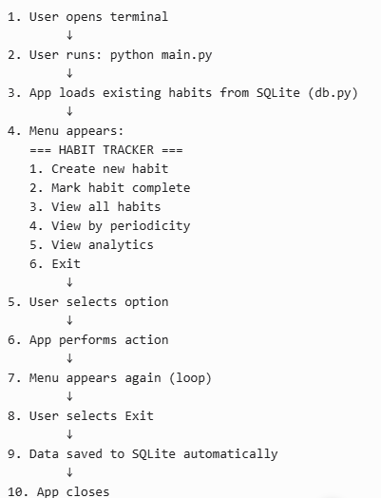

- Predefined Habits
- UML Class Diagram

