**SOFTWARE SPECIFICATION**

LMSs are software programs that assist libraries in managing their operations and collection management. We have modules for circulation, purchases, serials administration, reporting, and cataloguing. Automating library activities including cataloguing, circulation, acquisitions, membership management, and reporting is the major goal of a library management system. It strives to provide superior experiences for both library personnel and users while enhancing the accessibility, tracking, and consumption of library resources.

**System Overview**

**System Name: Library Management System (LMS)**

**Purpose**:

The university implements a robust LMS, allowing students and faculty to access the library's resources seamlessly. The LMS addresses the challenges by offering the following benefits:

* **Efficient Book Management:** Books are digitally catalogued and categorized based on various criteria (title, author, subject, etc.), enabling quick and accurate searches.
* **Streamlined Transactions:** Borrowing and returning books are simplified through an online portal, reducing the time and effort required for these transactions.
* **Enhanced Accessibility:** The LMS is accessible remotely, enabling users to search for and reserve books from their homes or other locations. They can also receive notifications and reminders for due dates.

**System Architecture Diagram:**

*USE-CASE DIAGRAM*

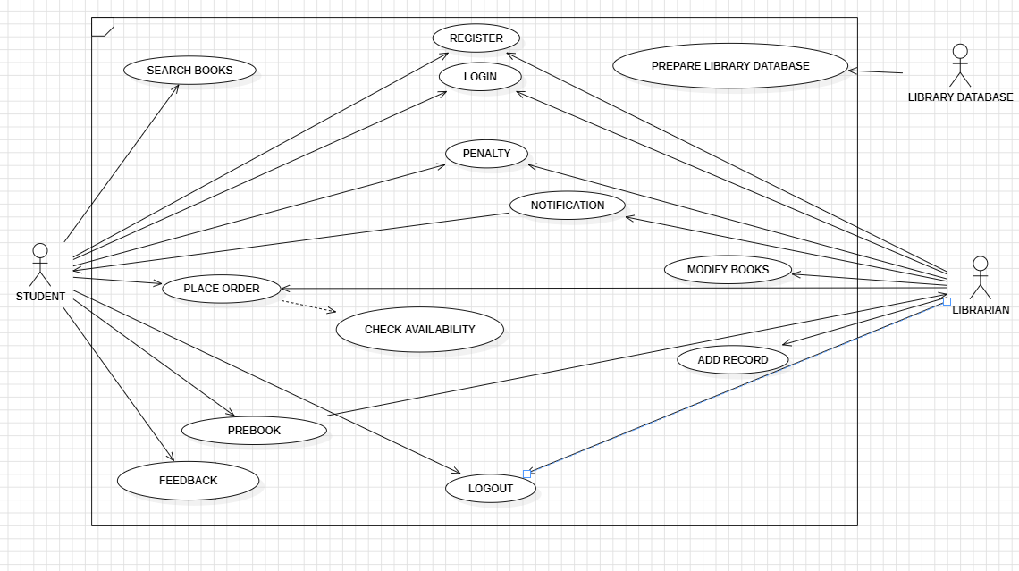

*CLASS DIAGRAM*

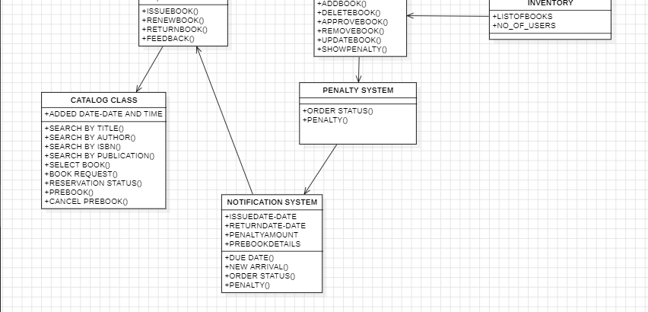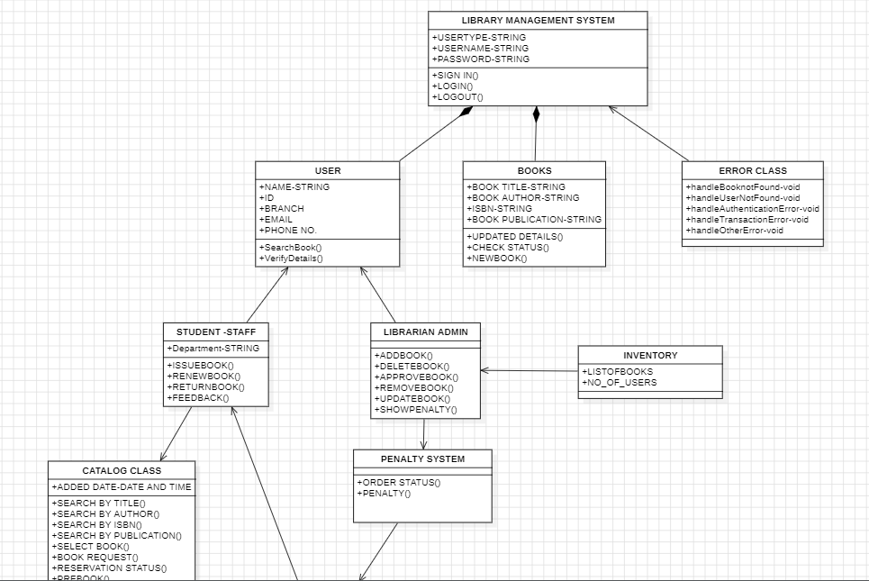

*ACTIVITY DIAGRAM*

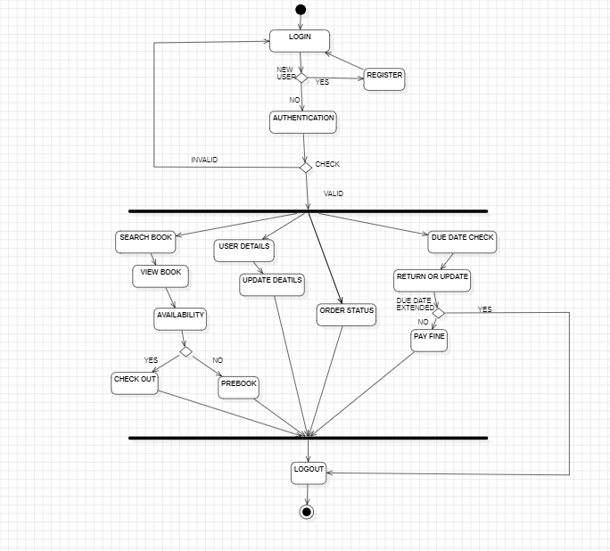

*SEQUENCE DIAGRAM*

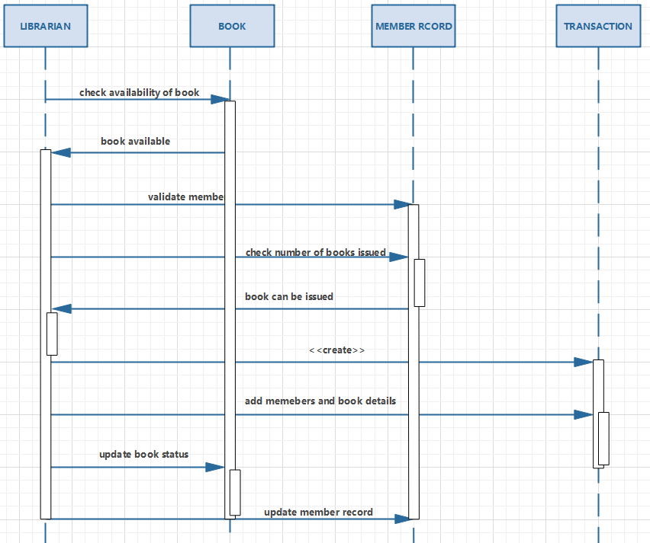

*DATABASE SCHEMA*

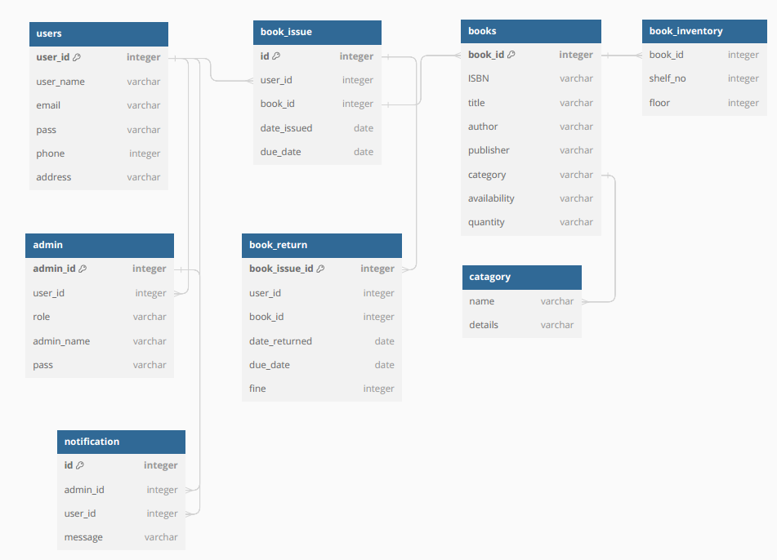

*DEPLOYMENT DIAGRAM*

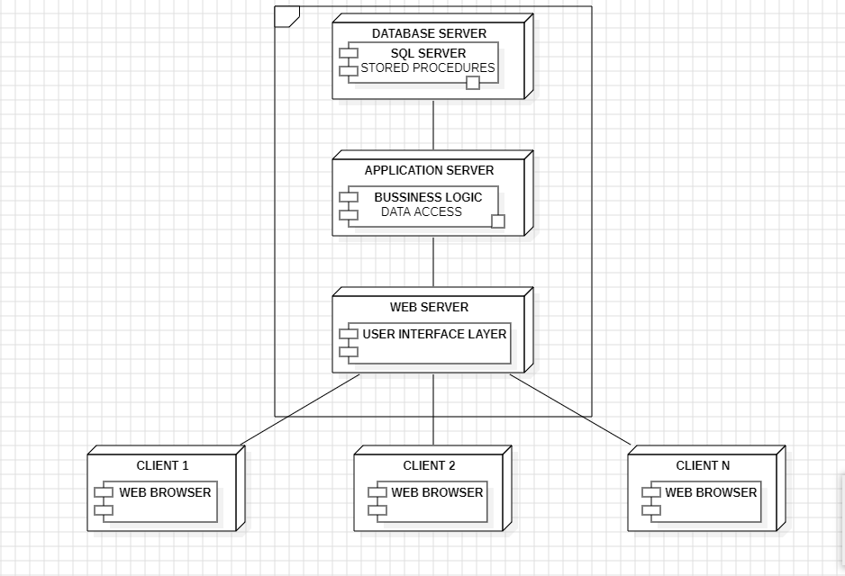

*FLOWCHART DIAGRAM*

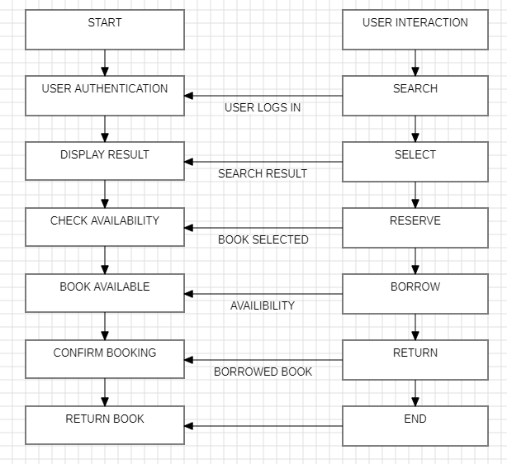

In this simplified flowchart:

* The process starts with the user interacting with the system.
* The user is authenticated (e.g., through a login system).
* The user can search for materials (e.g., books) in the library's collection.
* The system displays the search results.
* The user can select a book and check its availability.
* If available, the user can either reserve or borrow the book.
* If borrowed, the user can confirm borrowing and then choose to return the book later.
* The process ends after the book is returned.

**Classes of Library Management System:**

* **Library Management System –** The main class that manages all the other class.
* **User –** The class that stores the details of all the users.
* **Books –** It stores the details of the books.
* **Error Class –** It handles the various types of errors that are encountered.
* **Student Class –** It manages all operations of students.
* **Librarian Class –** It manages all operations of Librarian.
* **Inventory Class –** It manages all operations of the inventory database.
* **Catalogue class –** It manages the operations related to the books present in the catalogue of the library management system including the details related to book title, book author, etc.
* **Penalty Class-** It stores and regulates the information related to penalty.
* **Notification System –** Manages all the notifications such as that of issue date, return date etc.

**Attributes of Library Management System :**

* **Library Management System –** UserType, UserName, Password
* **User –** Name, ID, Branch, Email, PhoneNo
* **Books –** BookTitle, BookAuthor, ISBN, BookPublication
* **Error Class –** HandleBookNotFound, HandleUserNotFound, HandleAuthenticationError, HandleTransactionError, HandleOtherError
* **Student Class –** Department
* **Inventory Class –** ListOfBooks, NoOfUsers
* **Catalogue class –**  Added Date.
* **Notification-** IssueDate, ReturnDate, PenaltyAmount, PreBookDetails

**Methods of Library Management System :**

* **Library Management System –** SignIn(), LogIn(), LogOut()
* **User –** SearchBook(), VerifyDetails()
* **Books –** UpdatedDetails(), CheckStatus(), NewBook()
* **Student Class –** IssueBook(), RenewBook(), ReturnBook(), Feedback()
* **Librarian Class –** AddBook(), DeleteBook(), ApproveBook(), RemoveBook(), UpdateBook(), ShowPenalty()
* **Catalogue class –** SearchByTitle(), SearchByAuthor(), SearchByISBN(), SearchByPublication(), SelectBook(), BookRequest(), ReservationStatus(), PreBook(), CancelPreBook()
* **Penalty Class-** OrderStatus(), Penalty()
* **Notification System –** DueDate(), NewArrival(), OrderStatus(), Penalty()

**Technology Stack:**

* **Backend:** PHP
* **Database Management System:** MySQL
* **Frontend:** HTML, CSS, JavaScript
* **Deployment and Hosting:** Apache