Security Architecture Documentation
Secure & Compliant ML Security Pipeline — Milestone 3: Secure Deployment
Author: Ali Yasser — Security & DevSecOps Engineer

1. Purpose
This document describes the target production security architecture for deploying the fraud-detection inference service (built on Milestone 2's trained model) to Azure, following Zero Trust principles: no implicit trust between network zones, every identity is verified, and every secret is centrally managed. It covers the network topology, Key Vault integration, and a STRIDE threat model for the deployed system.

2. Network Architecture
The diagram below shows the trust boundaries between the public internet, the DMZ (Application Gateway with WAF), the private AKS workload subnet, and the private-endpoint subnet reserved for Azure Key Vault. No component other than the Application Gateway has a public IP.
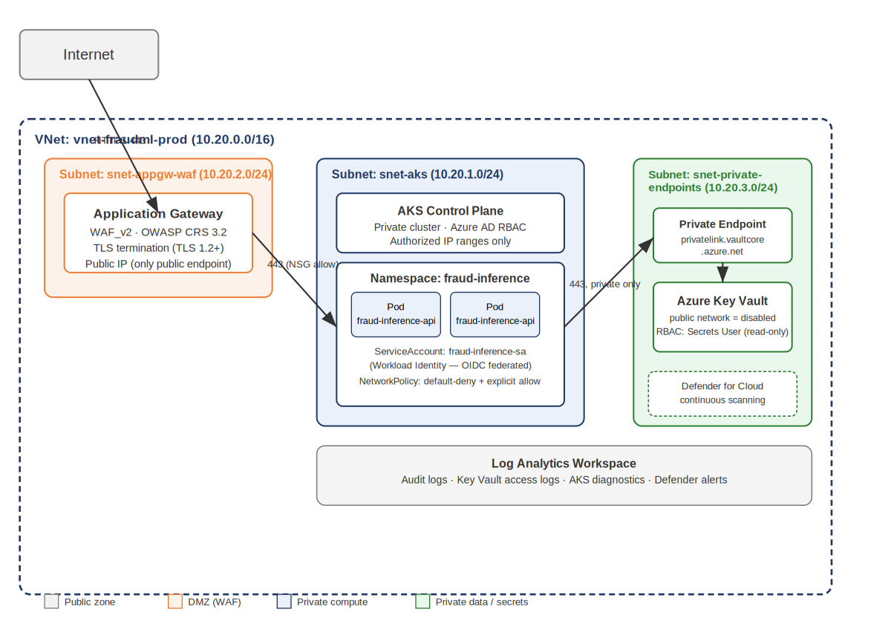

2.1 Trust boundaries and controls
From | To | Trust boundary crossed | Control
Internet | Application Gateway (WAF_v2) | Public → DMZ | TLS 1.2+ terminated at the gateway; OWASP CRS 3.2 + custom rate-limit/geo rules inspect every request before it reaches AKS.
Application Gateway | AKS inference pods (ClusterIP) | DMZ → Private subnet | NSG allows only 443 from the AppGW subnet; Kubernetes NetworkPolicy default-denies all other ingress.
AKS inference pods | Azure Key Vault | Private subnet → Private endpoint | No public network path exists to Key Vault; traffic stays on the private endpoint subnet; pods authenticate via Workload Identity (OIDC federation), never a stored secret.
AKS control plane | Administrators | Private API server → Allow-listed IPs | Private cluster (no public API server FQDN); authorized IP ranges restrict kubectl/admin access; Azure AD RBAC governs cluster actions.

3. Azure Key Vault Integration Guide

3.1 What is stored in Key Vault
- jwt-secret-key — signs and validates inference-API access tokens
- allowed-origins — the CORS allow-list, comma-separated
- field-encryption-key — the Fernet key from Milestone 1 used to encrypt PII fields (CustomerName, Email, PhoneNumber, Address, NationalID, CreditCardNumber)
- appgw-tls-cert — the TLS certificate used by Application Gateway for HTTPS termination

3.2 How the application authenticates to Key Vault
The FastAPI service never stores a client secret. Instead, it uses Azure AD Workload Identity: the AKS cluster is configured with an OIDC issuer, and each pod's Kubernetes ServiceAccount is federated to a dedicated Azure AD user-assigned identity (see iac/terraform/modules/aks). At runtime, the Azure SDK's DefaultAzureCredential automatically exchanges the pod's Kubernetes-issued token for an Azure AD token scoped to Key Vault — with zero credentials stored in code, environment variables, or container images.
Access is scoped with Azure RBAC (enable_rbac_authorization = true on the vault) rather than legacy access policies. The workload identity is granted only the "Key Vault Secrets User" role — read-only, no create/update/delete — consistent with the least-privilege policy defined in Milestone 1.

3.3 Network isolation
public_network_access_enabled is set to false on the Key Vault resource; the vault is reachable only through a private endpoint placed in a dedicated subnet, with a private DNS zone (privatelink.vaultcore.azure.net) resolving the vault's hostname internally. This closes off the public internet as an attack surface for secret exfiltration entirely.

3.4 Secret rotation
Because the application reads secrets from Key Vault at process startup (config.py) rather than baking them into the image, rotating a secret in Key Vault and restarting/rolling the deployment is sufficient to pick up a new value — no code change or redeploy of a new image is required.

4. STRIDE Threat Model
The table below applies the STRIDE framework to the deployed inference service, its data flows, and its trust boundaries.
STRIDE Category | Threat in this system | Mitigation
Spoofing | An attacker impersonates a legitimate service account to call the inference API. | OAuth2/JWT authentication on every endpoint; short-lived tokens (15 min); planned migration to Azure AD (Entra ID) client-credentials flow removes static passwords entirely.
Tampering | Request payloads are modified in transit, or a compromised node alters model inputs/outputs. | TLS 1.2+ enforced end-to-end (Application Gateway WAF_v2 SSL policy); strict Pydantic schema validation rejects unexpected/out-of-range fields; container images run read-only root filesystems.
Repudiation | A user or service denies having made a request that led to a fraud decision. | Structured audit logging of every inference call (request ID, subject, role, timestamp) sent to Log Analytics; Key Vault AuditEvent logging captures every secret access.
Information Disclosure | Sensitive data (PII, model internals, secrets, stack traces) leaks to an unauthorized party. | Field-level encryption from Milestone 1 preserved end-to-end; Key Vault stores all secrets (no hardcoded credentials); generic error responses (no stack traces); server-fingerprinting header removed; Key Vault has no public network access.
Denial of Service | An attacker floods the API or auth endpoint to exhaust resources or lock out legitimate users. | WAF rate-limiting custom rule (60 req/min on auth path) plus application-level SlowAPI limits (30/min general, 5/min login); AKS autoscaling; Application Gateway WAF_v2 autoscale (2–6 instances).
Elevation of Privilege | A low-privilege caller (or compromised pod) gains ml_engineer/admin-level access. | Role-based access control via JWT role claims (require_role dependency); Kubernetes NetworkPolicies enforce default-deny micro-segmentation; Key Vault RBAC grants only "Secrets User" (read-only) to the workload identity, never write/delete.

5. Compliance Alignment
This architecture extends the privacy controls established in the Milestone 1 Data Privacy Impact Assessment (field-level encryption, least privilege, access control) into the production network and identity layer, supporting the same GDPR- and HIPAA-inspired principles: confidentiality (private networking + encryption), integrity (TLS + strict validation), and availability (WAF + autoscaling + rate limiting).

6. Open Items
- Replace the local demo user store with Azure AD (Entra ID) app registration for service authentication.
- Provision a dedicated (non-reused) managed identity for Application Gateway's certificate access, scoped to Key Vault Certificate User only.
- Tighten the AKS NetworkPolicy ingress rule to the exact Application Gateway subnet CIDR once the target CNI's IP-block support is confirmed.
- Finalize TLS 1.3-only policy on Application Gateway once available as a predefined policy in the target region.

