Secure and Compliant Machine Learning Security Pipeline
An End-to-End Privacy-Aware, Fairness-Assessed, Securely Deployed Fraud Detection System

Technical Project Report

Program: Machine Learning / Cybersecurity Graduation Project

Team Members:
Nour Eldin Ahmed,
Ali Yasser,
Yara Alaa,
Farida Gamal,
Youssef Tarek

Supervisor: Prof. George Samuel

Table of Contents
Table of Contents 2
Declaration of Originality 11
Acknowledgements 11
Executive Summary 11
Abstract 12
Keywords 12
Table of Contents 13
List of Figures 13
List of Tables 13
List of Abbreviations 13
Chapter 1 — Introduction 15
1.1 Background 15
1.2 Motivation 15
1.3 Problem Statement 15
1.4 Project Objectives 16
1.5 Engineering Questions 16
1.6 Scope 16
1.7 Out of Scope 16
1.8 Contributions 17
1.9 Report Organization 17
Chapter 2 — Background and Technical Foundations 18
2.1 Fraud Detection as a Classification Problem 18
2.2 Evaluation Metrics for Imbalanced Classification 18
2.3 Data Leakage 18
2.4 Feature Engineering and Selection 18
2.5 Model Families Evaluated 19
2.6 Differential Privacy 19
2.7 Algorithmic Fairness Metrics 19
2.8 Secure API and Deployment Concepts 20
2.9 Operations Concepts 20
2.10 Regulatory Context 20
Chapter 3 — Requirements Analysis 21
3.1 Functional Requirements 21
3.2 Non-Functional Requirements 22
3.3 Requirements Traceability Matrix 23
Chapter 4 — Dataset and Data Understanding 24
4.1 Source and Composition 24
4.2 Verified Dimensions 24
4.3 Target Variable and Class Imbalance 24
4.4 Why PR-AUC Matters Especially Here 24
4.5 Data Types and Missingness 25
4.6 High Dimensionality 25
4.7 Potential Sensitive or Proxy Attributes 25
4.8 Dataset Limitations and Ethical Considerations 25
Chapter 5 — Overall System Architecture 26
5.1 Architectural Philosophy 26
5.2 End-to-End Pipeline 26
5.3 Component Architecture 26
5.4 Data Flow and Trust Boundaries 27
5.5 Machine Learning Lifecycle 27
5.6 Deployment Architecture 28
5.7 Shared Infrastructure 29
Chapter 6 — Milestone 1: Data Security 30
6.1 Data Classification 30
6.2 Field-Level Encryption: Fernet, Not AES-256 30
6.3 The CreditCardNumber Classification-versus-Lineage Disagreement 30
6.4 Key Handling 30
6.5 Data Integrity and Lineage 31
6.6 Protected Storage: Azure Blob Storage Target Architecture 31
6.7 Key-Management Risks and Production Recommendations 31
6.8 Access Control Considerations 31
6.9 Risks and Limitations 31
6.10 Implementation Status Summary 32
Chapter 7 — Milestone 2, Module 1: Data Validation 33
7.1 Purpose 33
7.2 The Nine Validation Checks 33
7.3 The Encryption Verification Mechanism 33
7.4 Failure Handling 34
7.5 The Regenerate-vs-Load-Existing Design 34
7.6 A Real Bug Found and Fixed at This Stage 34
7.7 Implementation Status 34
Chapter 8 — Milestone 2, Module 2: Feature Engineering and Selection 35
8.1 Preprocessing Architecture 35
8.2 Handling Numerical and Categorical Features 35
8.3 Missing-Value Treatment and Feature Creation 36
8.4 Candidate and Selected Feature Counts 36
8.5 The Four-Method Selection Consensus 36
8.6 Leakage Prevention and the Metadata-Column Guarantee 37
8.7 A Real Bug Found and Fixed at This Stage 37
8.8 Persisted Artifacts 37
8.9 Complete Feature List 37
8.10 Risks of High-Dimensional Sparse Data and Limitations of Feature Importance 37
8.11 Implementation Status 38
Chapter 9 — Milestone 2, Module 3: Model Development 39
9.1 Evaluation Design 39
9.2 The Five Model Families 39
9.3 Real Search Space (LightGBM, the Eventual Winner) 39
9.4 Real Model Comparison Results 40
9.5 Model Selection Rule and Statistical Comparison 40
9.6 Why LightGBM 40
9.7 Error and Threshold-Trade-off Discussion 40
9.8 Real Evaluation Plots 41
9.9 Implementation Status 44
Chapter 10 — Milestone 2, Module 4: Differential Privacy 46
10.1 Why Privacy Protection Is Relevant Here 46
10.2 DP-SGD Mechanics as Implemented 46
10.3 Verified Identical Initial Weights 46
10.4 The Real Experiment 46
10.5 Why Two Epsilon Values Are Reported, and Why Only One Is Authoritative 47
10.6 The Root-Cause Investigation 47
10.7 Root-Cause Synthesis 48
10.8 Honest Statement of the Result 48
10.9 Recommended Future Improvements (Not Implemented) 48
10.10 Implementation Status 50
Chapter 11 — Milestone 2, Module 5: Fairness Analysis 51
11.1 Why Fairness Matters Here, and What "Protected Group" Means in This Dataset 51
11.2 Metric Definitions as Implemented 51
11.3 Real Findings — card6 (Primary Attribute; reference group: debit) 51
11.4 Real Findings — card4 (reference group: Visa) 52
11.5 Real Findings — DeviceType (reference group: desktop; "Missing" reported but excluded from pairwise comparison) 52
11.6 The 24 Bias Findings 52
11.7 Operational Implications and Remediation Options 53
11.8 Fairness Assessment Does Not Establish Fairness 53
11.9 Implementation Status 55
Chapter 12 — Experiment Tracking and Model Artifact Management 56
12.1 MLflow Integration 56
12.2 Parameters, Metrics, and Artifacts Logged 56
12.3 Model Persistence: joblib and Keras Artifacts 56
12.4 Versioning and Reproducibility 56
12.5 Configuration Management 57
12.6 Local Tracking vs. Committed Artifacts vs. Production Registry Target 57
Chapter 13 — Milestone 3: Secure Inference API 58
13.1 Application Structure 58
13.2 Authentication Flow 58
13.3 Credential Handling 58
13.4 The Prediction Endpoint 58
13.5 Model Loading and the Real-vs-Placeholder Distinction 59
13.6 Input Validation and Error Handling 59
13.7 Rate Limiting 59
13.8 Security Headers and Logging 59
13.9 Health and Documentation Endpoints 59
13.10 Secrets Abstraction and Local Fallback 60
13.11 API Endpoint Table 60
13.12 API Request Sequence 60
13.13 Implementation Status 61
Chapter 14 — Container and Deployment Security 62
14.1 Multi-Stage Docker Build 62
14.2 Non-Root Execution and Attack-Surface Reduction 62
14.3 Container Limitations 62
14.4 Kubernetes Manifests 62
14.5 Separating Implemented Controls from Recommendations 63
Chapter 15 — Azure Infrastructure-as-Code Architecture 63
15.1 Overview and Explicit Non-Deployment Statement 63
15.2 Azure Resource Inventory by Module 63
15.3 WAF Custom Rules (verbatim from `docs/WAF_Rules.md`) 65
15.4 Defense in Depth 65
15.5 Azure Deployment Diagram 65
15.6 What This Report Does Not Claim 67
15.7 Implementation Status 67
Chapter 16 — Threat Model and Security Analysis 68
16.1 Assets, Actors, and Trust Boundaries 68
16.2 STRIDE Threat Table 68
16.3 Additional ML- and Supply-Chain-Specific Threats 69
16.4 Summary 70
Chapter 17 — Penetration Testing and Security Validation 70
17.1 Scope and Methodology 70
17.2 Tests Performed 70
17.3 Findings 71
17.4 OWASP API Security Top 10 Coverage 71
17.5 Distinguishing Evidence Types 72
Chapter 18 — Milestone 4: Compliance Quality Assurance 73
18.1 Purpose and Materials Reviewed 73
18.2 GDPR-Relevant Concepts and Their Application 73
18.3 HIPAA Applicability 73
18.4 ISO/IEC 27001 Control Themes 73
18.5 Compliance Control Mapping and Gap Analysis 74
18.6 Framing These Inconsistencies 74
18.7 Milestone 4's Own Test Suite 75
18.8 Current State vs. Intended Target State 75
18.9 Remediation Priorities 75
Chapter 19 — Milestone 5: Drift Monitoring 76
19.1 Concept 76
19.2 Reference and Current Data, and the Synthetic Fallback 76
19.3 Feature Manifest Integration and a Real Bug Found 76
19.4 Drift Thresholds and Exit Behavior 76
19.5 Generated Reports 76
19.6 Monitoring Workflow 77
19.7 Limitation: No Live Production Traffic 77
19.8 Implementation Status 77
Chapter 20 — WORM Audit Storage 78
20.1 What WORM Means and Why It Matters 78
20.2 Implementation 78
20.3 File Discovery and a Real Path-Mapping Bug Found 78
20.4 A Second Real Bug: The Container-Name Default 78
20.5 Dry-Run Verification 78
20.6 Retention and Legal Hold (Designed, Not Exercised) 79
20.7 Implementation Status 79
Chapter 21 — CI/CD Pipeline 80
21.1 Workflow Triggers 80
21.2 Jobs 80
21.3 Real Bugs Found and Fixed During This Project's Integration 80
21.4 Fallback Behavior 80
21.5 Secret Requirements 81
21.6 CI/CD Workflow Diagram 81
21.7 Security Considerations and Recommendations Not Currently Implemented 81
21.8 Implementation Status 82
Chapter 22 — Testing and Quality Assurance 82
22.1 Test Suite Overview 82
22.2 Test Categories 82
22.3 Real Execution Evidence 82
22.4 Fixtures and Test Design Patterns 83
22.5 Mocking Discipline 83
22.6 Coverage Limitations 83
22.7 What Could Not Be Run 83
22.8 Implementation Status 83
Chapter 23 — Results and Evaluation 85
23.1 Consolidated Results 85
23.2 What Worked Well 86
23.3 What Did Not Work Well 86
23.4 Trade-offs 86
Chapter 24 — Limitations 86
Chapter 25 — Recommendations and Future Work 87
25.1 Immediate 87
25.2 Near Term 88
25.3 Long Term 88
Chapter 26 — Conclusion 88
References 90
Appendices 92
Appendix A — Repository Structure 92
Appendix B — Complete Feature Manifest (150 Selected Features) 92
Appendix C — Model Hyperparameters (Real, from `reports_m3/model_comparison_leaderboard.csv`) 93
Appendix D — API Schemas and Endpoint Examples 93
Appendix E — Test Inventory (Complete, 178 Tests / 35 Files) 93
Appendix F — Requirements Traceability Matrix (Complete) 94
Appendix G — Compliance Control Matrix (Complete) 94
Appendix H — Threat Model (Complete) 94
Appendix I — Terraform Resource Inventory (Complete) 94
Appendix J — Kubernetes Resource Inventory (Complete) 94
Appendix K — Abbreviations 94
Appendix L — Reproduction Guide 94
Appendix M — Verification-Status Register 95

Declaration of Originality
This report was produced by inspecting and directly verifying the contents of the `Secure_Compliant_ML_Security` repository (`https://github.com/Noo2r/Secure_Compliant_ML_Security`). Every project-specific technical claim in this document — every metric, file reference, configuration value, and test result — was checked against the repository's source code, configuration files, and generated reports at the time of writing, rather than assumed or estimated. Where the repository did not provide sufficient evidence to support a claim, this is stated explicitly rather than filled in with an assumption. Personal information does not present in the repository (student names beyond what is recorded in commit history and file headers, institutional affiliation, supervisor identity, submission date) is represented with placeholders for the submitting team to complete.

Acknowledgements

Executive Summary
This report documents a five-part machine learning system built to detect credit-card fraud in the IEEE-CIS Fraud Detection dataset while treating data security, individual privacy, demographic fairness, secure deployment, regulatory compliance, and production operations as first-class engineering requirements rather than afterthoughts. The system is organized as five integrated milestones: Milestone 1 encrypts and classifies sensitive transaction fields; Milestone 2 performs the core machine learning work — data validation, feature engineering, model selection, differential-privacy training, and fairness analysis; Milestone 3 exposes the selected model through an authenticated, rate-limited FastAPI inference service with a Terraform-defined Azure deployment target; Milestone 4 independently audits Milestones 1 and 3 against GDPR, HIPAA, and ISO/IEC 27001 control themes; and Milestone 5 adds automated feature drift monitoring and immutable audit-log storage, wired together by a GitHub Actions pipeline.
The best-performing conventional model — a LightGBM gradient-boosted classifier selected from a five-model comparison — achieved a holdout Precision-Recall Area Under Curve (PR-AUC) of 0.4869 and a Receiver Operating Characteristic Area Under Curve (ROC-AUC) of 0.8807 on a chronologically held-out test set of 118,108 transactions. A parallel differentially private variant, trained with DP-SGD to a Rényi Differential Privacy-derived guarantee of ε ≈ 45.573 at δ = 1×10⁻⁵, showed a substantial utility cost (PR-AUC fell from 0.1646 without privacy protection to 0.0285 with it, on a smaller neural-network exploration configuration); this trade-off is reported honestly rather than minimized, alongside an eight-phase root-cause investigation into why the cost was so large on this dataset. A fairness audit across three payment-behavior proxy attributes (card type, card network, and device type) — since the dataset contains no genuine demographic fields — produced 24 distinct findings, including a statistically significant four-times difference in flagging rate between credit- and debit-card transactions (Disparate Impact Ratio 3.996) and a materially higher missed-fraud rate for transactions with no recorded device information.
This report distinguishes throughout between what has been implemented and experimentally verified (the entire Milestone 2 ML pipeline, run against the real 590,540-row dataset), what has been implemented and locally tested (the Milestone 3 inference API, the Milestone 5 drift monitor and WORM-upload dry run), and what remains a designed but undeployed target architecture (the Terraform-defined Azure infrastructure — AKS, Key Vault, Web Application Firewall — which has never been applied to a live Azure subscription). It also documents a small number of factual inconsistencies found in the Milestone 4 compliance documentation (a claim of AES-256 encryption where the actual implementation uses Fernet, which is AES-128; a claim of verification "across live AKS endpoints" where no such endpoint has been provisioned) so that the project's documentation and its verified state are not conflated.

Abstract
Machine learning systems deployed for financial fraud detection process highly sensitive personal and transactional data, make consequential decisions at scale, and are increasingly subject to regulatory scrutiny around privacy, fairness, and security. Much of the academic and industrial literature on fraud detection optimizes predictive accuracy in isolation, leaving data protection, differential privacy, algorithmic fairness, and secure operationalization as separate, later concerns. This project instead integrates all of these as co-equal requirements within a single pipeline, built and evaluated on the IEEE-CIS Fraud Detection dataset (590,540 transactions, 428 raw columns). The pipeline independently re-verifies an upstream data-encryption and classification contract before any modeling occurs; engineers and statistically selects 150 features from 466 candidates; compares five model families under time-aware cross-validation with Optuna hyperparameter search; trains and evaluates a differentially private variant of the winning architecture with formal privacy accounting; audits the deployed model for fairness across payment behavior proxy attributes with bootstrap confidence intervals and an independent Fairlearn cross-check; exposes the model through an authenticated, rate-limited REST API with a security-hardened container and a Terraform-defined cloud deployment target; and closes the loop with automated drift monitoring and immutable audit-log storage in a continuous-integration pipeline. The result is a system whose every claim — including its limitations — is traceable to committed source code, configuration, and generated evidence, and whose most significant technical finding is not a headline accuracy number but a rigorously investigated account of why differential privacy imposes a severe utility cost on this specific dataset and model architecture.

Keywords
Fraud detection; machine learning security; differential privacy; DP-SGD; algorithmic fairness; secure API design; Kubernetes security; Infrastructure as Code; GDPR; ISO/IEC 27001; MLOps; data drift monitoring; immutable audit storage; LightGBM; IEEE-CIS dataset.

Table of Contents
*(Generated automatically in the DOCX/PDF build via heading styles; see the rendered document.)*

List of Figures
*(Populated automatically from figure captions in the DOCX/PDF build.)*

List of Tables
*(Populated automatically from table captions in the DOCX/PDF build.)*

List of Abbreviations
Abbreviation | Meaning
AES | Advanced Encryption Standard
AKS | Azure Kubernetes Service
AOD | Average Odds Difference
API | Application Programming Interface
AUC | Area Under Curve
CBC | Cipher Block Chaining (block-cipher mode)
CI | Confidence Interval (statistics) / Continuous Integration (software) — disambiguated in context
CI/CD | Continuous Integration / Continuous Deployment
CRS | Core Rule Set (OWASP, used by WAF)
DIR | Disparate Impact Ratio
DP | Differential Privacy
DP-SGD | Differentially Private Stochastic Gradient Descent
DPIA | Data Protection Impact Assessment
EOD | Equal Opportunity Difference
GDPR | General Data Protection Regulation
HIPAA | Health Insurance Portability and Accountability Act
HMAC | Hash-Based Message Authentication Code
IaC | Infrastructure as Code
ISO/IEC 27001 | International information security management standard
JWT | JSON Web Token
MLflow | Open-source machine learning experiment tracking platform
MLOps | Machine Learning Operations
NSG | Network Security Group (Azure)
OWASP | Open Worldwide Application Security Project
PII | Personally Identifiable Information
PR-AUC | Precision-Recall Area Under Curve
RBAC | Role-Based Access Control
RDP | Rényi Differential Privacy
ROC-AUC | Receiver Operating Characteristic Area Under Curve
SPD | Statistical Parity Difference
STRIDE | Spoofing, Tampering, Repudiation, Information Disclosure, Denial of Service, Elevation of Privilege (threat-modeling method)
TLS | Transport Layer Security
TPR / FPR | True Positive Rate / False Positive Rate
WAF | Web Application Firewall
WORM | Write-Once-Read-Many (storage)

Chapter 1 — Introduction

1.1 Background
Digital payment volume has grown steadily for more than a decade, and card-not-present fraud has grown alongside it: attackers no longer need to physically steal a card, only its details, and the IEEE-CIS Fraud Detection dataset used throughout this project reflects that reality — the majority of its transactions are online, and fraud is disproportionately concentrated in specific product categories, device types, and time windows rather than spread uniformly. Machine learning has become the dominant tool for detecting this fraud at scale, because rule-based systems cannot keep pace with the volume and evolving structure of transaction data. That shift, however, introduces its own risks: a model trained on transaction data is itself a potential source of information leakage about the individuals in that data; a model that performs well in aggregate may perform very differently across demographic or behavioral subgroups; and a model exposed as a live service becomes a new attack surface, distinct from — but connected to — the data pipeline that trained it.
Financial institutions operate under real regulatory obligations (data protection law, sector security standards) even when a specific dataset or prototype system is not itself subject to formal certification. A project that trains a fraud model without also considering how that model's training data is protected, how the model's predictions might disadvantage particular groups, whether the model leaks information about individual training examples, and how the serving infrastructure is secured, addresses only part of the real engineering problem.

1.2 Motivation
This project's motivation was to treat those non-functional concerns as first-class requirements of the system rather than optional extensions bolted on after a model was trained. Concretely, this meant: verifying — not merely assuming — that upstream data protection controls actually held; measuring the cost, in real terms, of adding a formal differential-privacy guarantee to the trained model rather than asserting privacy was "handled"; measuring whether the model's predictions differ systematically across payment-behavior groups, using the same statistical rigor (confidence intervals, significance testing, independent cross-validation of the fairness metrics themselves) that is applied to the model's predictive performance; and building a deployment and operations layer — authentication, rate limiting, container hardening, infrastructure-as-code, drift monitoring, immutable audit logging — with the same level of intentional design as the model itself, while being explicit about which parts of that layer have actually been run and verified versus which remain a designed, but not yet provisioned, target architecture.

1.3 Problem Statement
Build a fraud-detection system for the IEEE-CIS Fraud Detection dataset that (1) independently verifies the protection of sensitive input fields before any modeling occurs, (2) selects and tunes a predictive model using leakage-safe, chronologically valid evaluation, (3) quantifies the utility cost of adding a formal differential-privacy guarantee to that model, (4) quantifies whether the model's predictions differ across available payment-behavior proxy groups with statistical rigor, (5) exposes the model through a secure, authenticated API with a defined (if not fully provisioned) cloud deployment architecture, (6) is independently auditable against common regulatory control themes, and (7) can detect when its own input data distribution has drifted from the data it was trained on, with an audit trail that cannot be silently altered after the fact.

1.4 Project Objectives
- Regenerate or load a security-classified, field-level-encrypted version of the dataset and
independently verify that encryption is actually in effect before any feature is derived from it. 2. Engineer and statistically select a feature set that avoids train/test leakage, justified by exploratory data analysis rather than convention. 3. Compare at least five distinct model families under a chronologically valid evaluation methodology and select a production candidate using a documented, reproducible rule. 4. Train a differentially private variant of the selected architecture, compute its formal privacy budget, and investigate — rather than merely report — any large utility gap between the private and non-private variants. 5. Audit the selected model for fairness across every protected or proxy attribute available in the dataset, using bootstrap confidence intervals and an independent second implementation (Fairlearn) to validate the project's own fairness metric code. 6. Expose the selected model through an authenticated, rate-limited inference API, and design (with Infrastructure-as-Code) a hardened cloud deployment for it. 7. Independently audit the data-security and deployment milestones against GDPR, HIPAA, and ISO/IEC 27001 control themes. 8. Monitor deployed feature distributions for drift and store audit-relevant reports in a tamper-evident manner, wired into a continuous-integration pipeline.

1.5 Engineering Questions
This project is an applied engineering system rather than a controlled scientific experiment, so its guiding questions are engineering questions: Can a fraud-classification pipeline be built such that every claim about its security and compliance posture is independently checkable against the running system, rather than asserted in documentation alone? What is the actual, measured utility cost of adding a rigorous differential-privacy guarantee to a gradient-boosted or neural fraud classifier trained on this specific, severely imbalanced dataset, and why does that cost arise? Do the payment-behavior attributes available in this dataset — in the explicit absence of any demographic field — reveal a statistically meaningful predictive disparity, and if so, is that disparity plausibly explained by genuine risk correlation, a data-quality artifact, or something else?

1.6 Scope
In scope: the complete Milestone 2 machine learning pipeline (data validation, feature engineering and selection, model comparison, differential privacy, fairness analysis) run against the real dataset; the Milestone 3 FastAPI inference service, run and tested locally against the trained model; Infrastructure-as-Code (Terraform) and Kubernetes manifests describing a target Azure deployment; a Milestone 4 independent compliance audit against GDPR/HIPAA/ISO 27001 control themes; and a Milestone 5 drift-monitoring and immutable audit-storage layer wired into a CI/CD pipeline.

1.7 Out of Scope
Explicitly out of scope: provisioning and operating a live Azure subscription (the Terraform configuration is a designed, internally consistent target architecture that has not been applied); processing genuine demographic attributes for fairness analysis, since none exist in the source dataset (payment-behavior and device proxies are used instead, with that limitation stated throughout); formal legal compliance certification under any named regulatory regime; real-time production traffic or load testing at production scale; and adversarial machine learning evaluation beyond the API-level penetration test described in Chapter 17.

1.8 Contributions
The primary contributions of this project are: (1) an executable, reproducible pipeline in which every reported metric traces to a specific generated artifact in the repository, rather than to documentation alone; (2) a rare instance of a differential-privacy integration that reports and investigates a substantial utility failure in detail (an eight-phase root-cause analysis, described in Chapter 10) rather than reporting only a favorable configuration; (3) a fairness audit that cross-validates its own metric implementation against an independent library (Fairlearn) before trusting its own findings; and (4) an explicit, repository-wide discipline of separating verified current state from designed target state, applied consistently across security, deployment, and compliance claims (Chapters 6, 15, and 18 in particular).

1.9 Report Organization
Chapter 2 introduces the technical foundations used throughout the report. Chapter 3 derives functional and non-functional requirements directly from the repository and links them to verification evidence. Chapter 4 characterizes the dataset. Chapter 5 presents the end-to-end system architecture. Chapters 6 through 12 document Milestone 1 (data security) and each of Milestone 2's five internal modules (data validation, feature engineering, model development, differential privacy, fairness) plus experiment tracking. Chapters 13 through 17 document Milestone 3's secure API, container and Kubernetes design, Azure Infrastructure-as-Code, a repository-grounded threat model, and the penetration-testing evidence. Chapter 18 documents Milestone 4's compliance audit. Chapters 19 through 22 document Milestone 5's drift monitoring, WORM audit storage, the CI/CD pipeline, and the overall testing strategy. Chapters 23 through 26 consolidate results, limitations, recommendations, and conclusions. References and appendices follow.

Chapter 2 — Background and Technical Foundations
This chapter introduces, briefly and specifically, the technical concepts this project depends on. Each concept is connected directly to how it is used later in this report rather than treated as independent background material.

2.1 Fraud Detection as a Classification Problem
Fraud detection is framed here as binary classification: each transaction is labeled `isFraud` = 0 or 1, and a model produces a probability that a given transaction is fraudulent. Two properties of this specific problem shape every later design decision in the project. First, class imbalance: only a small fraction of transactions are fraudulent (Chapter 4 gives the exact measured rate), so a model that simply predicts "not fraud" for every transaction achieves very high accuracy while being useless — this is why the project does not use accuracy as its primary evaluation metric. Second, temporal structure: transactions carry a time signal (`TransactionDT`), and a model deployed in production always scores transactions that occurred after the ones it was trained on. Both properties motivate the chronological (not random) train/test split used from Chapter 8 onward.

2.2 Evaluation Metrics for Imbalanced Classification
Precision is the fraction of transactions flagged as fraud that were actually fraud; recall (equivalently, True Positive Rate, TPR) is the fraction of actual fraud that was successfully flagged; F1-score is their harmonic mean. The confusion matrix tabulates true/false positives and negatives at a chosen decision threshold. ROC-AUC summarizes a model's ability to rank positive examples above negative ones across every possible threshold, but because it is computed against the (large) negative class, a model can achieve a high ROC-AUC while still performing poorly on the metric that matters operationally. PR-AUC is instead sensitive specifically to how well the model performs on the minority (fraud) class, which is why it is used as this project's primary ranking metric for model comparison (Chapter 9). Threshold selection is the choice of probability cutoff above which a prediction is treated as "fraud" — the conventional default of 0.5 is calibrated for balanced problems and is not an appropriate default here, which is why Chapter 9 describes an explicit, validation-set-based threshold-optimization step rather than using 0.5 uncritically.

2.3 Data Leakage
Data leakage occurs when information that would not be available at real prediction time influences model training or model selection, producing an optimistic evaluation. In this project, two specific leakage risks are addressed by design: statistics learned by feature-engineering transformers (frequency tables, per-card aggregates) are fit only on the training fold and merely applied to the test fold; and the train/test split itself is chronological rather than random, so a model is never evaluated on data that occurred earlier than what it was trained on.

2.4 Feature Engineering and Selection
Feature engineering derives new columns from raw data (for example, an hour-of-day feature derived from a raw timestamp); feature selection then reduces a larger candidate feature set to a smaller one expected to generalize better and train faster. Chapter 8 describes both stages as implemented in this project, including the specific statistical methods used for selection (near-zero-variance filtering, correlation-redundancy filtering, mutual information, and embedded Random Forest importance).

2.5 Model Families Evaluated
Logistic Regression is a linear model producing well-calibrated probabilities for a binary outcome; it serves as this project's interpretable baseline. Random Forest is an ensemble of decision trees trained on random subsets of data and features, combined by averaging. XGBoost and LightGBM are both gradient-boosted decision tree frameworks that build trees sequentially, each correcting the residual error of the previous ones; they typically perform strongly on structured, tabular data such as this dataset. A Neural Network — a small feed-forward architecture in this project — learns non-linear feature interactions through iterative gradient-based weight updates and additionally serves, in this project, as the base architecture for the differential-privacy experiment in Chapter 10. Hyperparameter optimization with Optuna refers to Bayesian search (specifically, a Tree-structured Parzen Estimator) over each model family's hyperparameter space, used in place of exhaustive grid search for tractability (Chapter 9).

2.6 Differential Privacy
Differential privacy (DP) is a mathematical framework that bounds how much any single training example can influence a model's output, protecting against an adversary inferring whether a specific individual's data was used in training. DP-SGD (Differentially Private Stochastic Gradient Descent) achieves this by two mechanisms applied on top of ordinary gradient descent: gradient clipping, which caps the L2 norm of each individual example's gradient to a fixed bound before aggregation, and a noise multiplier, which scales Gaussian noise added to the clipped, aggregated gradient before the weight update. The strength of the resulting privacy guarantee is expressed as epsilon (ε) — smaller means stronger — and delta (δ), the (ideally very small) probability the guarantee fails to hold. Rényi Differential Privacy (RDP) accounting is the specific mathematical technique used to convert a training configuration (noise multiplier, batch size, dataset size, epoch count) into a tight, composable (ε, δ) value across the many steps of a training run; Chapter 10 documents exactly how this project computed and reported that value.

2.7 Algorithmic Fairness Metrics
Statistical Parity Difference (SPD) is the difference in selection rate (fraction flagged as fraud) between a group and a reference group. Disparate Impact Ratio (DIR) is the same comparison expressed as a ratio rather than a difference, with 1.0 as the no-disparity value; a DIR below 0.8 (or, symmetrically, above 1.25) is commonly referenced against the "four-fifths rule" heuristic. Equal Opportunity Difference (EOD) compares true positive rate (recall) between groups — whether actual fraud is caught equally often — independent of how the model treats non-fraud. Average Odds Difference (AOD) averages the false-positive-rate difference and the true-positive-rate difference, so it is sensitive to disparities in both directions. Bootstrap confidence intervals quantify the statistical uncertainty in each of these point estimates by resampling the observed data with replacement many times and recomputing the metric, so that a disparity can be judged "real" only when its interval excludes the metric's no-disparity value — this project's specific implementation is described in Chapter 11.

2.8 Secure API and Deployment Concepts
JWT (JSON Web Token) authentication issues a signed, short-lived token after a successful login that the client then presents on each subsequent request; the server verifies the signature and expiry rather than checking credentials on every call. API rate limiting bounds how many requests a client may make in a given time window, mitigating brute-force and denial-of-service abuse. Secrets management refers to storing credentials, keys, and tokens outside application code and configuration files — in this project's target architecture, in Azure Key Vault, accessed via a workload identity rather than a stored credential. Container hardening covers practices such as running as a non-root user, using a minimal multi-stage build, and marking the filesystem read-only. Kubernetes security includes namespace isolation, pod security contexts, and Network Policies that restrict which pods may communicate with which. Infrastructure as Code (IaC) — Terraform in this project — defines cloud infrastructure declaratively so it can be reviewed, versioned, and (in principle) reproducibly provisioned. A Web Application Firewall (WAF) inspects HTTP traffic against known attack patterns (the OWASP Core Rule Set, in this project's design) before it reaches the application. Network policies at the Kubernetes level provide a second, workload-level layer of network segmentation beneath the cloud-provider network security groups.

2.9 Operations Concepts
Model / data drift is a change in the statistical distribution of production input data relative to the data a model was trained on, which can silently degrade model performance over time; Chapter 19 describes this project's Evidently-based drift monitor. WORM (Write-Once-Read- Many) storage is immutable storage — once written, a record cannot be altered or deleted for a defined retention period — used here for audit-relevant reports so that evidence of past compliance checks cannot be tampered with after the fact (Chapter 20). CI/CD (Continuous Integration / Continuous Deployment) automates running tests, checks, and deployment steps on every code change; Chapter 21 documents this project's GitHub Actions workflow.

2.10 Regulatory Context
GDPR (the EU General Data Protection Regulation) establishes principles including lawfulness, data minimization, storage limitation, integrity and confidentiality, and accountability for personal data processing. HIPAA (the U.S. Health Insurance Portability and Accountability Act) governs protected health information specifically for covered entities and their business associates; its applicability to an ordinary payment-fraud dataset containing no health information is not automatic, and this report does not assume it applies (Chapter 18 discusses this explicitly). ISO/IEC 27001 is an international standard for information security management systems, covering control areas such as access control, cryptography, and incident management; referencing its control themes is not the same as holding certification against the standard, and this report does not claim certification. These three frameworks are used in Chapter 18 as a structure for independently assessing the project's actual security and privacy controls, not as claims of formal compliance.

Chapter 3 — Requirements Analysis
Requirements below are derived directly from what the repository implements, not from a generic specification written independently of the system. Each requirement is linked to the file(s) that implement it and the verification evidence available at the time of writing.

3.1 Functional Requirements
Table 3.1 — Functional requirements and implementing components.
ID | Requirement | Implementing file(s) | Verification status
FR-1 | Load and validate transaction data against a defined schema and dtype contract | `src/data/validators.py`, `scripts/run_module1.py` | Implemented and experimentally verified (real 590,540-row dataset, 9/9 checks passed — Chapter 7)
FR-2 | Independently verify that sensitive fields are actually encrypted, not merely trust an upstream classification report | `src/data/validators.py::_check_pii_columns_encrypted` | Implemented and experimentally verified
FR-3 | Track data lineage / provenance across modules via a dataset-version hash | `src/data/secure_data_loader.py` (`DatasetManifest`) | Implemented and experimentally verified
FR-4 | Engineer features from raw transaction/identity data with no test-fold information leakage | `src/features/engineering.py` | Implemented and experimentally verified
FR-5 | Select a reduced, statistically justified feature set from the engineered candidates | `src/features/selection.py` | Implemented and experimentally verified (466 → 150 — Chapter 8)
FR-6 | Train and compare at least five distinct model families with hyperparameter optimization | `src/models/train.py`, `src/models/tune.py`, `src/models/model_registry.py` | Implemented and experimentally verified
FR-7 | Persist a self-contained, reusable inference artifact per candidate model | `src/models/inference_bundle.py` | Implemented and experimentally verified
FR-8 | Train a differentially private variant of the selected architecture and compute its formal privacy budget | `src/privacy/dp_model.py`, `src/privacy/privacy_accountant.py` | Implemented and experimentally verified (Chapter 10)
FR-9 | Audit the selected model for fairness across available proxy attributes with statistical rigor | `src/fairness/*.py` | Implemented and experimentally verified (Chapter 11)
FR-10 | Expose the selected model through an authenticated inference endpoint | `app/api/inference.py`, `app/core/security.py` | Implemented and locally tested (Chapter 13)
FR-11 | Rate-limit API requests, including a stricter limit on the authentication endpoint | `app/core/limiter.py`, `app/main.py`, `app/api/auth.py` | Implemented and locally tested
FR-12 | Monitor feature distributions for drift against a reference dataset | `drift_monitor.py` | Implemented and locally tested; production traffic not available (Chapter 19)
FR-13 | Produce immutable, hash-verified audit records of compliance-relevant reports | `worm_storage.py` | Dry-run verified; live upload requires a provisioned Azure Storage account (Chapter 20)
FR-14 | Execute an automated test suite covering every module | `tests/` (35 files) | Implemented and experimentally verified — 178/178 passing at time of writing (Chapter 22)
FR-15 | Run automated checks (drift monitoring, WORM upload) on a defined schedule and on code changes | `.github/workflows/mlops-pipeline.yml` | Implemented and locally verified; live-runner execution outside this report's direct control (Chapter 21)

3.2 Non-Functional Requirements
Table 3.2 — Non-functional requirements and how the repository addresses them.
Category | Requirement | Addressed by
Security | Sensitive fields protected at rest; no plaintext PII reaches model input | Milestone 1 encryption + Module 1 independent verification (Chapter 6, 7)
Security | API access requires authentication; requests are rate-limited; responses carry hardening headers | Milestone 3 (Chapter 13)
Privacy | A formal, accounted privacy guarantee is available as an option for the trained model | Milestone 2 Module 4 (Chapter 10)
Integrity | Data validation halts the pipeline on critical contract violations before they propagate | `DataValidator` (Chapter 7)
Integrity | Audit-relevant reports are hash-verified and intended for immutable storage | Milestone 5 WORM (Chapter 20)
Availability | Rate limiting and a Web Application Firewall design mitigate resource-exhaustion abuse | Milestone 3 (Chapters 13, 15)
Reproducibility | Every stage persists its output as a versioned, file-based artifact consumable by the next stage | Repository-wide convention (Chapter 5)
Auditability | Every generated report is committed and traceable to the code that produced it; dataset/version hashes thread through every module | Repository-wide convention
Explainability | Feature importance, SHAP-style discussion, and per-model evaluation plots accompany model selection | Chapter 9; full SHAP integration noted as future work (Chapter 25)
Maintainability | Per-milestone dependency files, a single configuration source (`config.yaml`), and a shared logging convention | Chapter 12; `src/config/`, `src/utils/logger.py`
Fairness | Model predictions are audited across every available proxy attribute with statistical significance testing | Milestone 2 Module 5 (Chapter 11)
Regulatory alignment | Independent audit against GDPR/HIPAA/ISO 27001 control themes | Milestone 4 (Chapter 18)
Performance | Model comparison includes training time as a tie-breaking criterion; API rate limits and a documented DP-SGD training-time cost are reported | Chapter 9, Chapter 10
Portability | Containerized deployment (multi-stage Docker build) independent of the host operating system | Chapter 14

3.3 Requirements Traceability Matrix
A condensed matrix is given here; the complete version, cross-referencing every requirement to its test file(s), is provided in Appendix F.
Table 3.3 — Condensed requirements traceability.
Requirement | Module/File | Test Evidence | Report Reports | Status
FR-1, FR-2, FR-3 | `src/data/` | `tests/test_validators.py`, `tests/test_secure_data_loader.py`, `tests/test_classification_registry.py` (20 tests) | `reports_m2/module1_validation_report.json`, `dataset_manifest.json` | Verified
FR-4, FR-5 | `src/features/` | `tests/test_feature_engineering.py`, `tests/test_feature_selection.py`, `tests/test_preprocessing.py`, `tests/test_eda.py`, `tests/test_pipeline_persistence.py` (22 tests) | `reports_m2/feature_manifest.json`, `feature_engineering_report.md` | Verified
FR-6, FR-7 | `src/models/` | `tests/test_model_registry.py`, `tests/test_threshold.py`, `tests/test_keras_wrapper.py`, `tests/test_tune.py`, `tests/test_inference_bundle.py`, `tests/test_metrics.py`, `tests/test_comparison.py` (34 tests) | `reports_m3/model_comparison_leaderboard.csv`, `model_development_report.md` | Verified
FR-8 | `src/privacy/` | 9 `test_dp_*.py` files (36 tests) | `reports_m4/dp_report.md`, `reports_m4/investigation/` | Verified
FR-9 | `src/fairness/` | 9 `test_fairness*.py` / `test_bias_detector.py` / `test_attribute_analysis.py` / `test_statistical_tests.py` / `test_fairlearn_validation.py` files (42 tests) | `reports_m5/fairness_report.md`, `bias_findings.md` | Verified
FR-10, FR-11 | `app/` | `tests/test_model_loader.py`, `tests/test_compliance_real.py` (6 tests) | Manual `curl` verification (this session's engineering log); `pentest/Penetration_Test_Report_Milestone3.docx` | Locally verified
FR-12 | `drift_monitor.py` | `tests/test_drift_monitor.py` (6 tests) | `reports_m5/drift_status.json` | Locally verified
FR-13 | `worm_storage.py` | `tests/test_worm_storage.py` (8 tests) | `reports_m5/worm_upload_manifest.json` (dry-run) | Dry-run verified only

Chapter 4 — Dataset and Data Understanding

4.1 Source and Composition
The project uses the IEEE-CIS Fraud Detection dataset, distributed as two linked tables: `train_transaction.csv` (transaction-level features — amount, product code, card fields, address, distance, counting features `C1`–`C14`, timing features `D1`–`D15`, match flags `M1`–`M9`, and 339 anonymized Vesta engineering features `V1`–`V339`) and `train_identity.csv` (device and identity metadata, joined on `TransactionID`). Milestone 1 merges these via a left join and injects six synthetic PII columns (`CustomerName`, `Email`, `PhoneNumber`, `Address`, `NationalID`, `CreditCardNumber`) to exercise the encryption/classification pipeline, since the source dataset itself does not contain named PII.

4.2 Verified Dimensions
Per `reports_m2/dataset_manifest.json`, generated directly from the real secured dataset: 590,540 rows and 428 columns after the merge and PII injection. After Module 1's validation and Module 2's feature engineering/selection stages, the persisted, model-ready processed dataset (`data/processed/train.csv` and `test.csv`) contains 472,432 training rows and 118,108 test rows, each with 207 columns (202 model-input feature columns after one-hot expansion of selected categorical features, plus 4 metadata columns and the target). These row and column counts were confirmed directly against the committed CSV headers and manifest files, not estimated.

4.3 Target Variable and Class Imbalance
The target column, `isFraud`, is binary. The dataset exhibits severe class imbalance — approximately 3.5% of transactions are labeled fraudulent (the exact figure is used consistently throughout Modules 2–5 as the reference fraud rate for synthetic-data generation and threshold design; see `src/privacy/dp_model.py` and `drift_monitor.py`, both of which encode `_FRAUD_RATE_REF = 0.035`). This is the direct motivation for Section 4.4 below and for the project-wide decision (Chapter 2) to use PR-AUC, not accuracy, as the primary evaluation metric.

4.4 Why PR-AUC Matters Especially Here
At a 3.5% positive rate, a trivial "always predict not-fraud" classifier scores approximately 96.5% accuracy while catching zero fraud. ROC-AUC, computed against the large negative class, also tends to look better than a model's real operational usefulness at this level of imbalance, because false positives are diluted across a very large negative population. PR-AUC is directly sensitive to how well the model's positive-class (fraud) predictions actually perform, which is why it was selected as the model-comparison ranking metric in Chapter 9.

4.5 Data Types and Missingness
The raw merged dataset mixes numeric (`TransactionAmt`, `card1`–`card3`, `card5`, `C1`–`C14`, `D1`–`D15`, `V1`–`V339`, most `id_01`–`id_11` columns), categorical (`ProductCD`, `card4`, `card6`, `P_emaildomain`, `R_emaildomain`, `M1`–`M9`, `DeviceType`, most `id_12`–`id_38` columns), and identifier-like (`TransactionID`) fields. Missingness is substantial and non-uniform: the Vesta `V` feature block, in particular, is missing in large, shared row-patterns across dozens of columns simultaneously — this specific structure directly motivated the hashed-null-mask design of `MissingIndicatorEngineer` described in Chapter 8, rather than a naive per-column missing-value flag.

4.6 High Dimensionality
With 428 raw columns before engineering (339 of them anonymized `V` features alone), the dataset is high-dimensional relative to its row count once grouped by any rare category. This motivated the project's four-method feature-selection consensus (Chapter 8) rather than relying on any single selection heuristic, and its explicit rejection of Recursive Feature Elimination as computationally infeasible at this dimensionality (Chapter 8, Chapter 12).

4.7 Potential Sensitive or Proxy Attributes
The dataset contains no genuine demographic field (no age, gender, race, or similar attribute). Three fields were identified and used in this project's fairness analysis (Chapter 11) as plausible *behavioral or device-usage proxies*: `card6` (debit vs. credit), `card4` (card network), and `DeviceType` (desktop vs. mobile). This report follows the repository's own convention of never describing a finding on these attributes as a "demographic bias" finding — they are payment-behavior or device-usage proxies, and that distinction is preserved throughout Chapter 11 and Chapter 23.

4.8 Dataset Limitations and Ethical Considerations
The dataset originates from a 2019 Kaggle competition (IEEE-CIS Fraud Detection) and reflects transaction patterns and fraud tactics from that period; it is not necessarily representative of current payment-fraud patterns (Chapter 24 revisits this as a limitation). The synthetic PII columns injected by Milestone 1 are fabricated (via the `Faker` library with a fixed seed) specifically so the encryption pipeline could be exercised without using or exposing any real individual's data; this report does not reproduce any raw record, encrypted or not, from the dataset. Licensing and use of the dataset are governed by the original Kaggle competition's terms; this project does not redistribute the raw dataset, only generated, aggregate reports derived from it.

Chapter 5 — Overall System Architecture

5.1 Architectural Philosophy
The system is organized as five sequential, file-based milestones rather than a single monolithic codebase. Each milestone communicates with the next exclusively through committed files — CSV, JSON, joblib, and Keras artifacts — never through shared in-process state. This mirrors how the project was actually built (five different owners, one per milestone) and makes every hand-off independently inspectable: a reader can examine any module's output without running any code.

5.2 End-to-End Pipeline
Figure 5.1 shows the complete data-to-operations flow. Each stage's real, generated output is documented in the chapter noted alongside it.
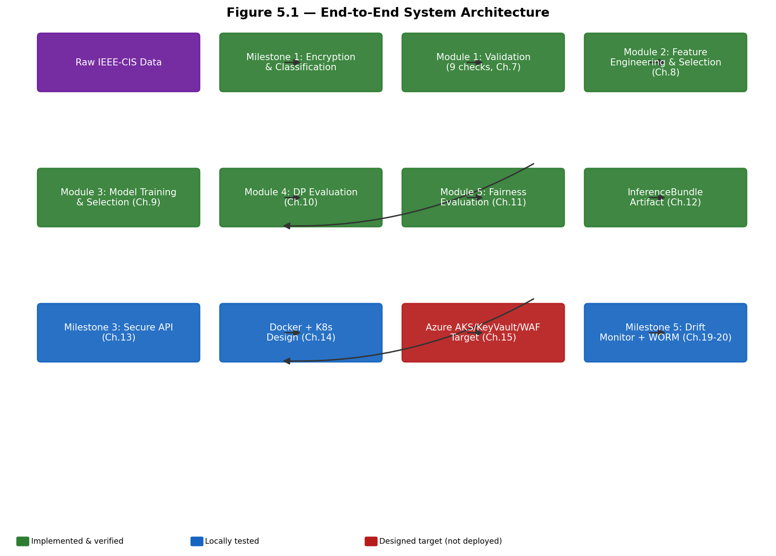
*Figure 5.1 — End-to-end system architecture, from raw data to operations. Solid arrows indicate a direct file-based data or artifact hand-off; dashed arrows indicate an independent audit relationship (Milestone 4 reviews Milestones 1 and 3's output without participating in the pipeline itself).*

5.3 Component Architecture
Table 5.1 maps each milestone to its top-level repository location and its primary role.
Milestone | Top-level location(s) | Role
1 — Data Security | `reports/` (Milestone 1 artifacts consumed, not owned, by this repository) | Field-level encryption, classification, lineage
2 — ML Development | `src/`, `scripts/`, `reports_m2/`–`reports_m5/`, `artifacts_m2/`–`artifacts_m5/` | Validation, features, models, privacy, fairness
3 — Secure Deployment | `app/`, `Dockerfile`, `k8s/`, `iac/terraform/`, `docs/`, `pentest/` | Inference API, container, cloud target architecture
4 — Compliance QA | `compliance/` | Independent audit of Milestones 1 and 3
5 — MLOps | `drift_monitor.py`, `worm_storage.py`, `.github/workflows/` | Drift monitoring, audit storage, CI/CD

5.4 Data Flow and Trust Boundaries
Figure 5.2 shows where data crosses a trust boundary — a point where the entity handling the data changes, or where an untrusted input first enters a trusted component — since these are the points threat modeling in Chapter 16 focuses on.
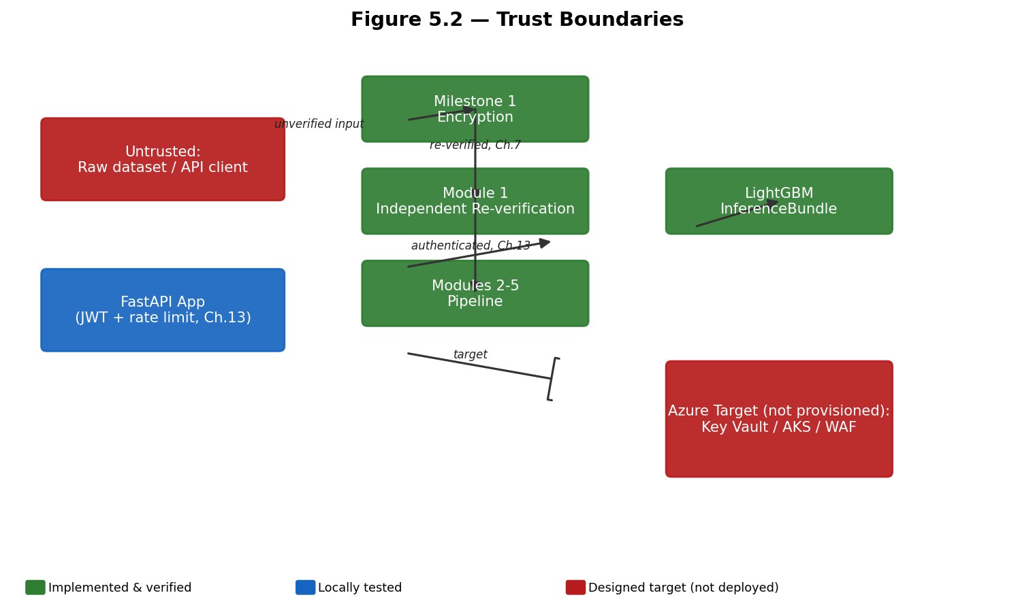
*Figure 5.2 — Trust boundaries. The most consequential boundary is the re-verification step between Milestone 1 and Module 1: Module 1 never assumes Milestone 1's encryption held, it independently confirms it (Chapter 6, Chapter 7).*

5.5 Machine Learning Lifecycle
Figure 5.3 presents Milestone 2's internal lifecycle in isolation, since it is the most complex single component of the system.
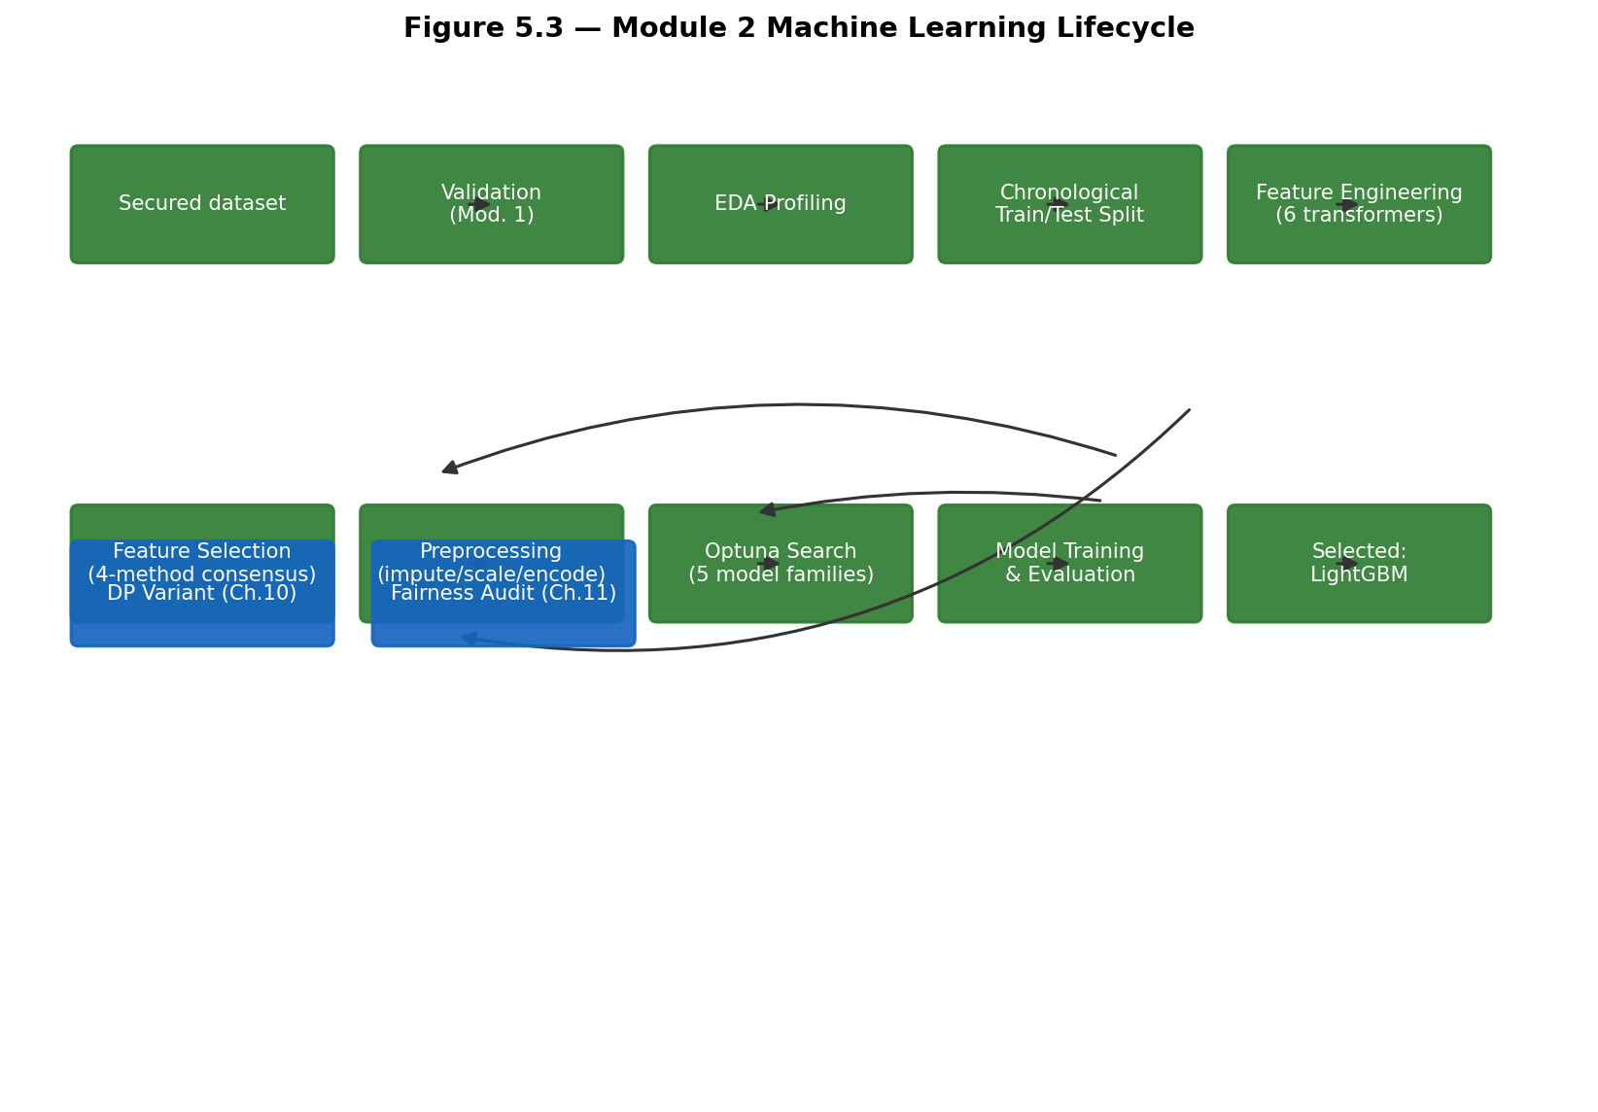
*Figure 5.3 — The Module 2 machine learning lifecycle. Feature engineering and selection are fit exclusively on the training fold (Chapter 8); Optuna search runs on a systematically sampled subset for tractability before the winning configuration is refit on the full training set (Chapter 9).*

5.6 Deployment Architecture
Figure 5.4 shows the container and orchestration design (implemented and locally run) alongside the Azure target architecture (designed, not provisioned) as two clearly separated layers.
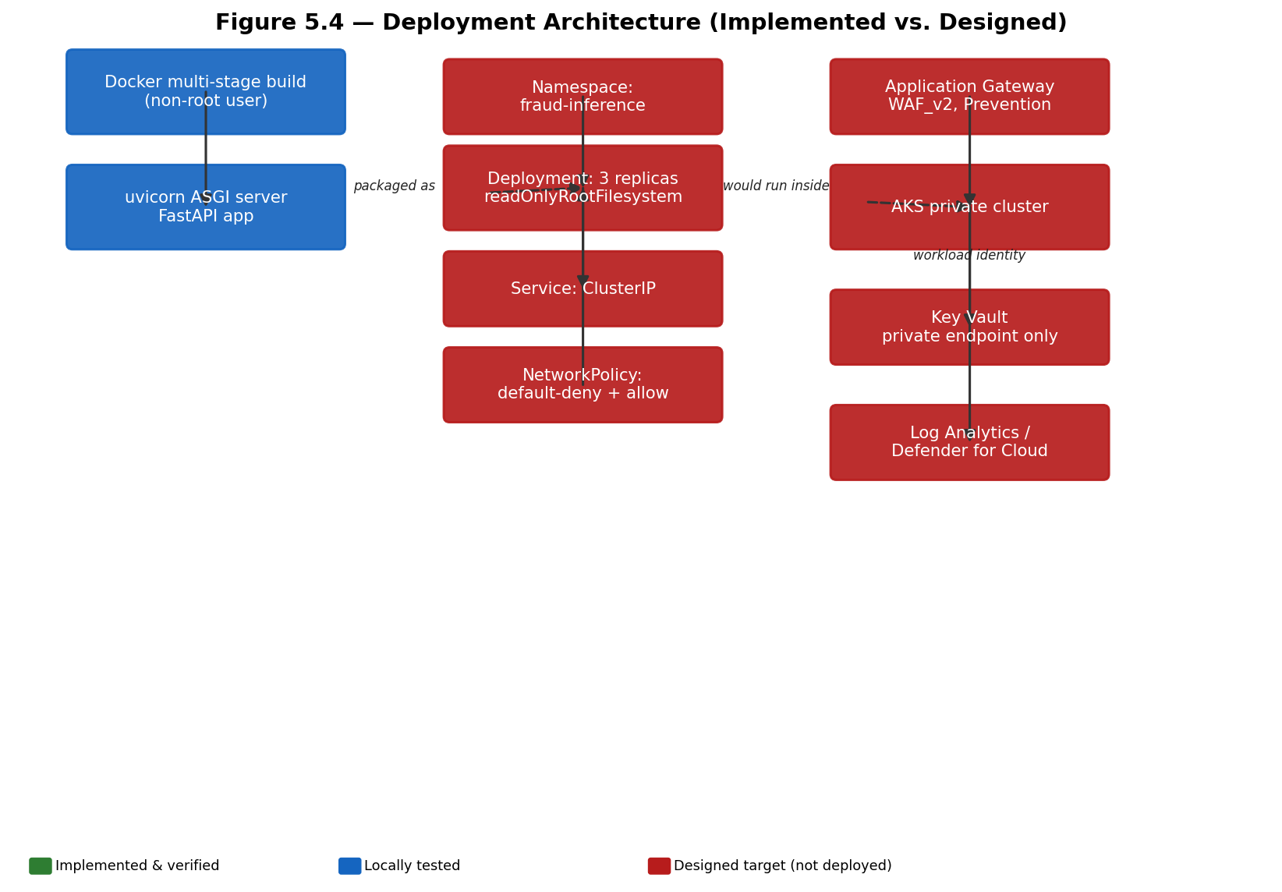
*Figure 5.4 — Deployment architecture with an explicit implemented/designed boundary. Everything below the "Designed target: Azure" line has not been applied to a live subscription (Chapter 15).*

5.7 Shared Infrastructure
Three conventions apply across every milestone. First, a single typed configuration source (`src/config/config.yaml`, loaded via `load_config()`) governs Milestone 2's behavior; Milestones 3 and 5 use their own environment-variable-driven settings (`app/core/config.py`, `drift_monitor.py`/`worm_storage.py`'s CLI arguments) rather than sharing this file, since they are independently deployable components. Second, a `dataset_version` hash (a 16-character digest of the dataset's structural fingerprint) is threaded from Module 1 through every later module's manifests and MLflow tags, so any artifact can be traced back to the exact data version that produced it. Third, logging is centralized per milestone (`src/utils/logger.py` for Milestone 2; Python's standard `logging` module, configured in `app/main.py`, for Milestone 3; module-level loggers for Milestone 5), consistently writing structured, timestamped records.

Chapter 6 — Milestone 1: Data Security
Milestone 1 is owned upstream of this repository's Module 1 (which consumes and independently re-verifies its output — Chapter 7). This chapter documents what Module 1's consumption of Milestone 1's artifacts reveals about the actual implementation, since Milestone 1's own source notebook is not itself part of this repository; the evidence available here is Milestone 1's two governance reports (`reports/data_classification.csv`, `reports/data_lineage.csv`) and the regenerated encrypted dataset Module 1 loads and validates.

6.1 Data Classification
`reports/data_classification.csv` labels every column with a compliance sensitivity category: PII (`CustomerName`, `Email`, `PhoneNumber`, `Address`, `NationalID`), Financial (`TransactionAmt`, `CreditCardNumber`), Sensitive (`addr1`, `addr2`, `P_emaildomain`, `R_emaildomain`, `DeviceInfo`), and Target (`isFraud`). `reports/data_lineage.csv` separately records pipeline provenance — what was merged, what was dropped, and, in its "PII Columns" step, the literal list of columns that were Fernet-encrypted.

6.2 Field-Level Encryption: Fernet, Not AES-256
The implemented encryption mechanism is Fernet, from Python's `cryptography` library. Fernet is a symmetric, authenticated encryption recipe built on AES-128 in CBC (Cipher Block Chaining) mode, combined with HMAC-SHA256 for message authentication and a fixed structure that embeds a version byte, timestamp, and initialization vector alongside the ciphertext. Every Fernet token therefore begins with a fixed, recognizable base64-encoded prefix (`gAAAAA`), which Module 1 uses as an independent, dependency-free encryption check (Chapter 7). This is stated precisely because the Milestone 4 compliance documentation (Chapter 18) describes the implementation as using "AES-256 symmetric encryption" — Fernet's underlying cipher is AES-128, not AES-256, and this report treats the code (`_FERNET_TOKEN_PREFIX = "gAAAAA"` in `src/data/validators.py`, and the `gAAAAA`-prefixed values actually present in the encrypted dataset) as the authoritative evidence of what was implemented, not the documentation's description of it.

6.3 The CreditCardNumber Classification-versus-Lineage Disagreement
The single most consequential finding from Module 1's independent verification (detailed in Chapter 7) is that `CreditCardNumber` is labeled Financial in `data_classification.csv` but is actually present in the encrypted-columns list in `data_lineage.csv`. A downstream system that trusted only the classification report's PII label to decide which columns must never be used as raw model features would have missed `CreditCardNumber` entirely, since it is not labeled PII there. Module 1 resolves this by sourcing its feature blocklist from the lineage report's actual encrypted-columns list — the ground truth of what Fernet literally encrypted — rather than the classification report's compliance label, and this is the specific mechanism that prevents a real plaintext-credit-card- number leak into the model input.

6.4 Key Handling
Fernet requires a symmetric key to decrypt; Module 1 never decrypts data and does not require this key for its own operation (its encryption check operates on ciphertext structure alone, described in Chapter 7). A `secret.key` file is present at the repository root, is excluded from version control by `.gitignore`, and its handling in this repository is consistent with a local-development convenience rather than a production key-management design; Section 6.7 below discusses the gap between this and a production-appropriate key-management architecture.

6.5 Data Integrity and Lineage
`DatasetManifest` (`src/data/secure_data_loader.py`) records SHA-256 hashes of every source file (computed via 8MB streamed chunks, so multi-hundred-megabyte CSVs never need to be fully loaded into memory solely to be hashed) and a `dataset_version` — a 16-character hash of the dataset's structural fingerprint (column names, row count, dropped-column list, target distribution) — that is threaded through every later module's manifests and MLflow tags for full provenance traceability. A `lineage_consistency` check (Chapter 7) cross-verifies that a regenerated dataset's dropped-column count matches Milestone 1's own lineage report, logging a warning (not a hard failure) on mismatch, since a differing raw-data snapshot is a legitimate, non-error explanation for drift.

6.6 Protected Storage: Azure Blob Storage Target Architecture
Milestone 1's own documentation describes an intended Azure Blob Storage target for the encrypted dataset. This repository does not itself provision or interact with a live Azure Storage account for Milestone 1's data; the encrypted dataset is loaded and regenerated from local files (`data/encrypted/encrypted_dataset.csv`). This is consistent with the broader project-wide pattern (Chapters 15 and 20) of a designed cloud target architecture that has not been operationally verified against a live subscription.

6.7 Key-Management Risks and Production Recommendations
As implemented, the encryption key exists as a local file rather than in a managed secret store, and key rotation is not automated. For a production deployment, this report recommends: storing the Fernet key in Azure Key Vault (the same store already used for the Milestone 3 JWT secret and CORS configuration — Chapter 13) rather than a local file; accessing it via the managed identity / workload identity mechanism already designed for Milestone 3 (Chapter 15), so no key is ever present in application code, container images, or environment variables in plaintext; and implementing a defined key-rotation schedule with a re-encryption or key-versioning strategy, since Fernet itself provides no built-in key-rotation mechanism. These are stated here as recommendations, consistent with Chapter 25 — none are currently implemented.

6.8 Access Control Considerations
`reports/access_control.csv` (Milestone 1's own governance artifact) defines role-based access policies, including an explicit "Read Encrypted Data" (not "Decrypt") permission scoped to the ML Engineer role — i.e., Module 2 onward is designed to consume encrypted, not decrypted, PII columns, which is consistent with the fact that no module in this repository ever decrypts the PII columns; they are excluded from every model's feature set entirely (Section 6.3, Chapter 8).

6.9 Risks and Limitations
The synthetic PII values injected for this project (via the `Faker` library with a fixed seed) carry no real predictive signal and exist only to exercise the encryption mechanism; a production system would encrypt genuine customer PII, at which point the key-management recommendations in Section 6.7 become a hard operational requirement rather than a hardening suggestion. Fernet's fixed-format tokens (a recognizable prefix, embedded timestamp) are also themselves metadata; while this does not reveal plaintext content, a production deployment handling this data at very large scale might consider whether token-length or timing side-channels are a concern for its specific threat model (Chapter 16 does not identify this as a currently exploited risk in this project, but notes it as a residual consideration).

6.10 Implementation Status Summary
Table 6.1 — Milestone 1 component status.
Component | Status
Fernet field-level encryption of PII columns | Implemented and experimentally verified (independently re-checked by Module 1, Chapter 7)
Data classification and lineage reporting | Implemented and experimentally verified (consumed directly by Module 1)
Dataset provenance hashing (`dataset_version`, SHA-256 source hashes) | Implemented and experimentally verified
Azure Blob Storage target architecture | Documented target state; not provisioned or verified against a live account
Production-grade key rotation / Key Vault-backed key storage | Not implemented; recommended future work (Chapter 25)
Role-based access control policy (`access_control.csv`) | Documented; enforcement mechanism outside this repository's Module 2–5 code

Chapter 7 — Milestone 2, Module 1: Data Validation

7.1 Purpose
Module 1 exists to ensure that no later module ever trains on, or is blocked by, data that violates a defined structural or security contract. It runs before feature engineering and enforces two distinct kinds of checks: validation (does the data conform to the schema and business-rule contract this pipeline expects?) and verification (is the data internally trustworthy — no duplicate transactions, no fan-out from the merge, PII actually encrypted?). This separation matches the project's official requirement wording and is implemented as a single `DataValidator` class (`src/data/validators.py`) that runs all checks unconditionally, rather than stopping at the first failure — an enterprise auditor reading the resulting report sees every issue in one pass.

7.2 The Nine Validation Checks
Table 7.1 — All nine checks, their severity, and their real result on the production dataset (source: `reports_m2/module1_validation_report.json`, generated 2026-07-01).
Check name | Severity | Purpose | Real result
`row_count_positive` | Critical | Dataset is non-empty | PASS — row_count=590540
`required_columns_present` | Critical | Every column the pipeline expects is present | PASS — all required columns present
`dtype_contract` | Critical | Column dtypes match the declared contract | PASS — all dtypes match contract
`no_duplicate_rows` | Critical | No exact-duplicate rows beyond a configured tolerance | PASS — duplicate_rows=0 (max_allowed=0)
`merge_key_unique` | Critical | The transaction/identity left join did not fan out (one-to-many) | PASS — duplicate TransactionID values after merge: 0
`target_binary` | Critical | The target column contains only {0, 1} | PASS — unique target values: [0, 1]
`pii_columns_encrypted` | Critical | Every value in an encrypted column looks like real ciphertext | PASS — all PII columns encrypted
`missing_value_ceiling` | Warning | No surviving column exceeds a configured missing-value percentage | PASS — no columns exceed ceiling
`lineage_consistency` | Warning | Regenerated drop-count matches Milestone 1's own lineage report | PASS — regenerated column-drop count matches Yara's data_lineage.csv

Overall result: `"passed": true`, all 7 critical checks and both warning checks passed on the real, generated dataset. The severity split is meaningful: only a critical-check failure halts the pipeline (`overall_passed = all(c.passed for c in checks if c.severity == "critical")`); a warning-only failure is surfaced but does not block execution.

7.3 The Encryption Verification Mechanism
The `pii_columns_encrypted` check is the most security-relevant of the nine and deserves particular attention. It does not decrypt any value — it checks that every non-null value in each column listed in the registry's `encrypted_columns` set (sourced from the lineage report, per Chapter 6.3, not the classification report) begins with the fixed Fernet token prefix `gAAAAA`. This is a lightweight, dependency-free way to distinguish genuine ciphertext from plaintext without requiring the decryption key, and it is what would have caught a real plaintext leak had the `CreditCardNumber` classification-versus-lineage disagreement (Chapter 6.3) been resolved the wrong way.

7.4 Failure Handling
Every check independently returns a `CheckResult(name, severity, passed, message)`; the module never raises an exception mid-check. `run_module1.py` prints the full summary and exits with code 0 if the overall result passed, or code 1 otherwise — a deliberate design so an automated CI/CD chain (as in Milestone 5, Chapter 21) can halt before Module 2 ever touches unvalidated data, without needing to parse log text to determine success or failure.

7.5 The Regenerate-vs-Load-Existing Design
`SecureDatasetLoader` (`src/data/secure_data_loader.py`) supports two modes: `load_existing` (read Milestone 1's real encrypted artifact directly, if present) and `regenerate` (faithfully reproduce Milestone 1's documented pipeline steps from raw source CSVs). Both modes exist because the exact encrypted artifact was not always available in every development environment; `regenerate` is verified against Milestone 1's own lineage report's drop count (the `lineage_consistency` check, Section 7.2) as a faithfulness check, not treated as an independent, unverified reimplementation.

7.6 A Real Bug Found and Fixed at This Stage
During development, a duplicate-logging configuration issue was found and fixed in this module's logging setup (each module's entrypoint previously risked attaching duplicate log handlers on repeated invocation within the same process); this was corrected in `src/utils/logger.py`'s shared `configure_logging()` function so that logging configuration is idempotent. This is recorded here as a concrete instance of the kind of defect this project's regression-test discipline (Chapter 22) is designed to catch and permanently prevent from recurring.

7.7 Implementation Status
Table 7.2 — Module 1 status.
Component | Status
9-check validation/verification suite | Implemented and experimentally verified (real 590,540-row dataset, 9/9 PASS)
Independent PII-encryption verification | Implemented and experimentally verified
Dataset regeneration (`regenerate` mode) | Implemented and experimentally verified, cross-checked against lineage report
CI/CD exit-code gating | Implemented; exercised locally (Chapter 21 documents the live-runner limitation)

Chapter 8 — Milestone 2, Module 2: Feature Engineering and Selection

8.1 Preprocessing Architecture
Module 2 separates two concerns that are often conflated: feature engineering (deriving new columns from raw data, `src/features/engineering.py`) and preprocessing (imputation, scaling, and encoding of the final selected feature set, `src/features/preprocessing.py`). Both are implemented as scikit-learn-compatible `fit`/`transform` components composed inside a single `Pipeline`, fit exclusively on the chronological training fold established before either stage runs (Chapter 2.3, Chapter 5.5).
Figure 8.1 shows the module's internal workflow.
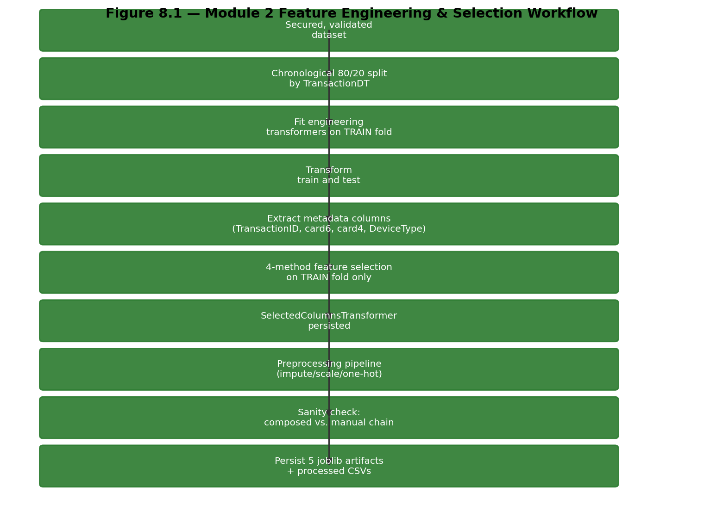
*Figure 8.1 — Module 2 workflow. The sanity check at step I compares the fully composed pipeline's output against manually chaining each stage, and raises `RuntimeError` on any mismatch before anything is persisted — this is what caught the `is_fitted_` marker bug described in Section 8.7.*

8.2 Handling Numerical and Categorical Features
Numerical features are scaled with `RobustScaler` rather than `StandardScaler`, a decision directly justified by measured skew: `TransactionAmt` has a maximum value near 31,937 against a median near 68 in the real data, so a mean/standard-deviation-based scaler would itself be distorted by outliers that `RobustScaler`'s median/interquartile-range basis is not. Categorical features are one-hot encoded after selection; the resulting processed columns carry a `numeric__` or `categorical__` prefix from the underlying scikit-learn `ColumnTransformer`, a naming convention later modules (and this report's diagrams) must account for explicitly (this exact naming convention caused a real integration bug in Milestone 5, resolved and documented in Chapter 19).

8.3 Missing-Value Treatment and Feature Creation
Six engineering transformers are applied in sequence: `TimeFeatureEngineer` (derives `transaction_hour` and `transaction_day_of_week` from the raw `TransactionDT` counter — EDA found a roughly threefold fraud-rate spike at specific hours versus the ~3% daily baseline); `TransactionAmountFeatureEngineer` (`TransactionAmt_log`, `TransactionAmt_decimal`); `EmailDomainGrouper` (groups high-cardinality email-domain columns to a training-fold top-N set and derives an `email_domain_match` flag — the single strongest engineered signal found in EDA: a 9.65% fraud rate when purchaser and recipient email domains match, versus 2.21% when they do not); `CardVelocityFeatureEngineer` (per-card transaction-count and amount statistics, e.g. `card1_txn_count`, `card1_amt_zscore`); `FrequencyEncoder` (applied specifically to `id_30`, `id_31`, `id_33`, and `DeviceInfo` — encodes each value by its training-fold frequency, with unseen values encoded as 0 rather than a target-derived fallback, which would risk leakage); and `MissingIndicatorEngineer` (hashes each candidate column's null-mask and groups identical hashes, since the Vesta `V` feature block goes missing in large shared row-patterns across dozens of columns simultaneously — collapsing this to one indicator per genuinely distinct missingness pattern, rather than one flag per column).

8.4 Candidate and Selected Feature Counts
Table 8.1 — Feature counts at each stage (source: `reports_m2/feature_selection_summary.json`, `feature_manifest.json`).
Stage | Count
Candidate features after engineering | 466
Dropped — near-zero variance | 14
Dropped — correlation redundancy | 109
Selected (final) | 150 (135 numeric, 15 categorical)
Processed columns after one-hot expansion | 202
Final width including metadata + target | 207

8.5 The Four-Method Selection Consensus
`FeatureSelectionComparator` (`src/features/selection.py`) runs four methods as a funnel, not a parallel vote: the near-zero-variance filter (a column flagged if its single most frequent value exceeds 99.9% of non-null rows) and the correlation-redundancy filter (pairs above 0.95 absolute correlation, keeping whichever member correlates more strongly with the target) run first, cheaply, on the full dataset; only their combined survivors are then scored by the two more expensive methods — mutual information and embedded Random Forest importance — on a systematically time-ordered sample of 50,000 rows; a consensus selection then averages each survivor's normalized rank across both scoring methods and retains the top 150. Recursive Feature Elimination was deliberately excluded as computationally infeasible at this dimensionality and largely redundant with the embedded-importance method already used.

8.6 Leakage Prevention and the Metadata-Column Guarantee
Four columns (`TransactionID`, `card6`, `card4`, `DeviceType`) are extracted into a separate metadata frame before feature selection or preprocessing ever runs, so no code path connects them to the model's feature matrix — this is a structural guarantee, not merely a documentation convention, verified by a dedicated test that calls scikit-learn's own `get_feature_names_out()` and asserts none of the metadata column names appear in it (Chapter 22). These four columns are preserved specifically for traceability, auditing, and the fairness-slicing work of Chapter 11, never for training.

8.7 A Real Bug Found and Fixed at This Stage
Two real defects were found and fixed during Module 2's development. First, an `is_fitted_` marker bug: several of the six engineering transformers are stateless (they derive features via a fixed formula, not a learned statistic), and their original `fit()` implementation did not set any trailing-underscore attribute; scikit-learn's `Pipeline.transform()` internally calls `check_is_fitted()`, which looks for exactly such an attribute, so a composed pipeline containing these transformers raised `NotFittedError` even after a real, successful `fit()` call. This was caught by the composed-pipeline sanity check described in Section 8.1 (Figure 8.1, step I) and fixed by having every transformer's `fit()` explicitly set `self.is_fitted_ = True`. Second, an `email_domain_match`-ordering bug: computing this flag after `EmailDomainGrouper`'s domain-grouping step (rather than before) could create a false match between two genuinely different rare email domains that both happened to collapse to the shared "other" category; this was fixed by computing the match flag on the raw, ungrouped domain values first.

8.8 Persisted Artifacts
Table 8.2 — Persisted Module 2 artifacts (`artifacts_m2/`).
Artifact | Purpose
`engineering_pipeline.joblib` | The 6 fitted engineering transformers, composed
`feature_selector.joblib` | The fitted `FeatureSelectionComparator` result
`column_selector.joblib` | `SelectedColumnsTransformer`, the persisted selection outcome
`preprocessing_pipeline.joblib` | The fitted imputation/scaling/encoding pipeline
`full_inference_pipeline.joblib` | All of the above composed into a single reusable pipeline

8.9 Complete Feature List
The complete, 150-feature selected list is provided in Appendix B rather than reproduced in this chapter, per the reporting convention of moving very large reference lists out of the main text.

8.10 Risks of High-Dimensional Sparse Data and Limitations of Feature Importance
Embedded Random Forest importance, one of the two expensive scoring methods used in Section 8.5, is known to be biased toward high-cardinality categorical and continuous features over binary ones, and does not by itself account for feature interactions; this is the specific reason the project combines it with mutual information (a different, non-tree-based dependency measure) rather than relying on Random Forest importance alone. The correlation-redundancy filter is also a strictly pairwise method and cannot detect higher-order (three-or-more-feature) redundancy; this is stated here as a known limitation, not a resolved concern (Chapter 24 revisits it).

8.11 Implementation Status
Table 8.3 — Module 2 status.
Component | Status
6-transformer feature-engineering pipeline | Implemented and experimentally verified
4-method feature-selection consensus | Implemented and experimentally verified
Metadata-column structural exclusion guarantee | Implemented and unit tested
Composed-pipeline sanity check | Implemented and experimentally verified (caught a real bug, Section 8.7)

Chapter 9 — Milestone 2, Module 3: Model Development

9.1 Evaluation Design
Five model families are compared under a chronological `TimeSeriesSplit` cross-validation (walk- forward folds, each using all data up to that point as training — mirroring how a production model would actually be retrained on all data available at a given date, rather than a fixed-size sliding window). Hyperparameter search uses Optuna's Tree-structured Parzen Estimator sampler on a systematically time-ordered sample of 100,000 rows for tractability; the winning configuration for each model family is then refit on the full training set (approximately 401,567 rows after the module's internal three-way split) before final holdout evaluation. Class imbalance is handled algorithmically (`class_weight="balanced"` or an equivalent `scale_pos_weight` computed from the real class ratio), not via resampling (SMOTE was considered and rejected: its linear interpolation in a 150-plus-dimensional, mostly one-hot-encoded space produces synthetic points of questionable validity and risks leaking interpolated-neighbor information across a cross-validation fold boundary). Decision thresholds are optimized per model on a validation slice carved from training data, never the final holdout, using an F1-maximizing or precision-floor strategy (Chapter 2.2).

9.2 The Five Model Families
Logistic Regression is included as an interpretable, well-calibrated linear baseline. Random Forest provides a bagged-ensemble, low-variance point of comparison. XGBoost and LightGBM are both gradient-boosted tree frameworks and are the strongest performers on this kind of structured, tabular fraud data in the literature generally; both were included specifically to compare two different, mature implementations of the same underlying algorithmic family. A Neural Network (a small feed-forward architecture — one hidden layer of 64 units, dropout, Adam optimizer) was included partly for architectural diversity and partly because it also serves, unmodified in its winning-configuration form, as the base architecture for the differential-privacy experiment in Chapter 10.

9.3 Real Search Space (LightGBM, the Eventual Winner)
Table 9.1 — LightGBM's Optuna search space (`src/models/model_registry.py::_suggest_lightgbm`).
Hyperparameter | Range | Sampling
`n_estimators` | 100–500, step 50 | Uniform integer
`num_leaves` | 15–255 | Uniform integer
`learning_rate` | 0.01–0.3 | Log-uniform
`subsample` | 0.6–1.0 | Uniform
`colsample_bytree` | 0.6–1.0 | Uniform
`min_child_samples` | 5–100 | Uniform integer

`learning_rate` uses log-uniform sampling because a useful learning-rate range spans multiple orders of magnitude; a plain uniform search would waste most trials in the less-informative high end of the range. `num_leaves` (up to 255) and `min_child_samples` jointly control the model's tendency to overfit at this dataset size.

9.4 Real Model Comparison Results
Table 9.2 — Real leaderboard (`reports_m3/model_comparison_leaderboard.csv`, generated from the real training run; holdout is the chronologically held-out 118,108-row test set).
Model | CV PR-AUC (mean ± std) | Holdout PR-AUC | Holdout ROC-AUC | Holdout F1 | Holdout Precision | Holdout Recall | Optuna trials | Train time (s)
LightGBM (selected) | 0.5153 ± 0.0151 | 0.4869 | 0.8807 | 0.4923 | 0.5987 | 0.4181 | 25 | 389.7
XGBoost | 0.4954 ± 0.0182 | 0.4604 | 0.8596 | 0.4713 | 0.6180 | 0.3809 | 25 | 206.8
Random Forest | 0.4283 ± 0.0188 | 0.4366 | 0.8751 | 0.4346 | 0.4962 | 0.3866 | 20 | 340.6
Neural Network | 0.1148 ± 0.0262 | 0.0934 | 0.7883 | 0.1626 | 0.0914 | 0.7345 | 9 | 734.6
Logistic Regression | 0.1539 ± 0.0243 | 0.1080 | 0.7514 | 0.1698 | 0.1732 | 0.1666 | 20 | 156.6

9.5 Model Selection Rule and Statistical Comparison
The selection rule is: rank all five models by holdout PR-AUC; if any other model's score is within 1% relative tolerance of the top score, the fastest-to-train model among that near-tied group wins instead (a parsimony tie-break). In this run, LightGBM's PR-AUC lead over the second-place XGBoost (0.4869 vs. 0.4604, more than 5% relative) is clean, so the tie-break rule was never triggered. A paired Wilcoxon signed-rank test was additionally run on the top two models' three cross-validation fold scores (`reports_m3/top_model_statistical_comparison.json`), returning p = 0.25 — not significant at α = 0.05, an honestly reported limitation of statistical power with only three folds. LightGBM's holdout-metric win is therefore the decisive evidence used for model selection; the underpowered significance test is reported as a caveat, not concealed.

9.6 Why LightGBM
LightGBM was selected because it achieved the highest holdout PR-AUC by a margin exceeding the project's 1% tie-break tolerance, the metric this project treats as primary given the severe class imbalance (Chapter 4.4), and it did so with a training time roughly 1.9× faster than the next-closest gradient-boosting alternative (XGBoost) despite an identical Optuna trial budget.

9.7 Error and Threshold-Trade-off Discussion
At LightGBM's optimized decision threshold, precision is 0.5987 and recall is 0.4181: roughly 60% of flagged transactions are genuinely fraudulent, and roughly 42% of all real fraud is caught. This is the direct, quantified trade-off a fraud-operations team would need to weigh: lowering the threshold would catch more fraud (higher recall) at the cost of more false positives (lower precision, more legitimate transactions flagged for review); the project additionally reports `recall_at_precision`, `precision_at_k`, and lift/gain metrics (`reports_m3/lightgbm/`) specifically to answer operational questions such as "how much fraud is caught if only the top 1% of transactions by risk score can be reviewed," which raw PR-AUC and ROC-AUC do not directly answer. A false negative here means a fraudulent transaction is not flagged and proceeds; a false positive means a legitimate transaction is flagged for review or blocked — the relative cost of each is a business decision outside this report's scope, which is why multiple operating-point metrics are reported rather than a single verdict.

9.8 Real Evaluation Plots
Figure 9.1 (`reports_m3/lightgbm/roc_curve.png`) shows the ROC curve for the selected model on the real holdout set (ROC-AUC 0.8807). Figure 9.2 (`reports_m3/lightgbm/pr_curve.png`) shows the corresponding Precision-Recall curve (PR-AUC 0.4869) — visibly less optimistic than the ROC curve, illustrating Chapter 4.4's point about ROC-AUC's tendency to look better than PR-AUC under severe imbalance. Figure 9.3 (`reports_m3/lightgbm/confusion_matrix.png`) shows the confusion matrix at the optimized threshold. Figure 9.4 (`reports_m3/lightgbm/feature_importance.png`) shows the top LightGBM feature importances, dominated by anonymized Vesta `V` features and the engineered per-card statistics from Chapter 8.3. Figure 9.5 (`reports_m3/lightgbm/lift_gain.png`) shows the lift/gain chart discussed in Section 9.7. Figure 9.6 (`reports_m3/best_model_learning_curve.png`) and Figure 9.7 (`reports_m3/best_model_validation_curve.png`) are diagnostic curves computed only for the winning model, a deliberate tractability trade-off documented in the source code.
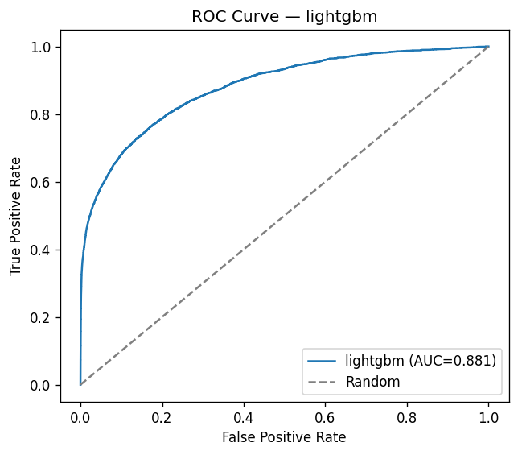
Figure 9.1 — LightGBM ROC curve on the real holdout set (ROC-AUC 0.8807).
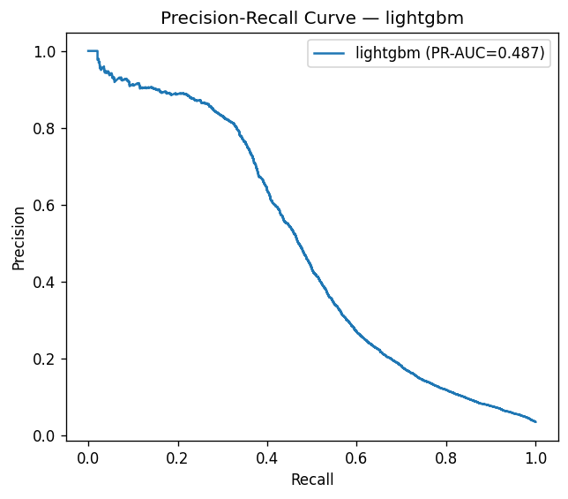
Figure 9.2 — LightGBM Precision-Recall curve on the real holdout set (PR-AUC 0.4869).
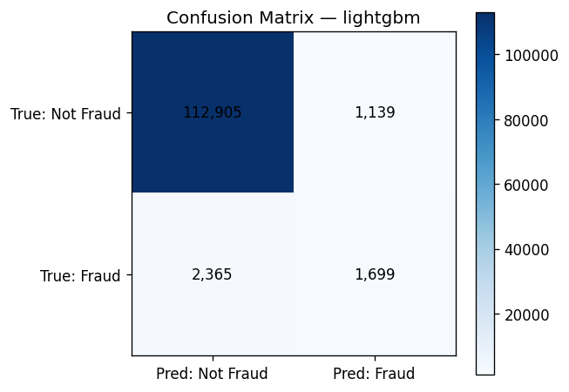
Figure 9.3 — LightGBM confusion matrix at the optimized decision threshold.
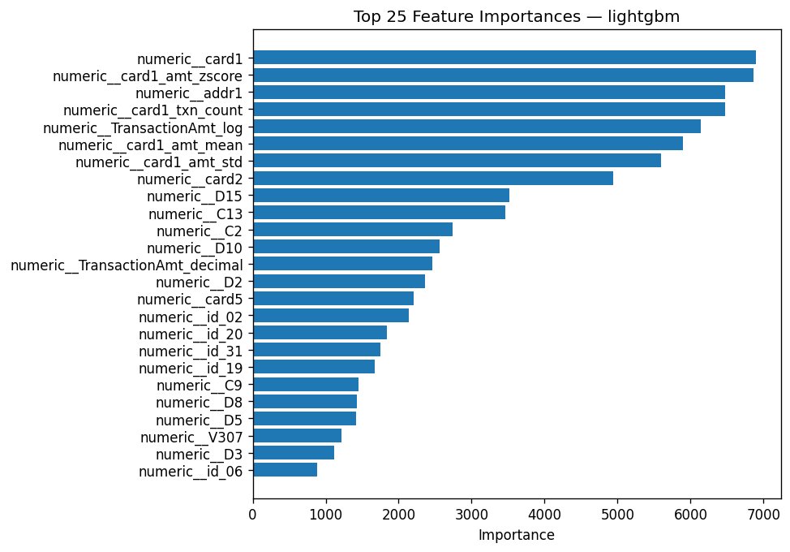
Figure 9.4 — LightGBM top feature importances.
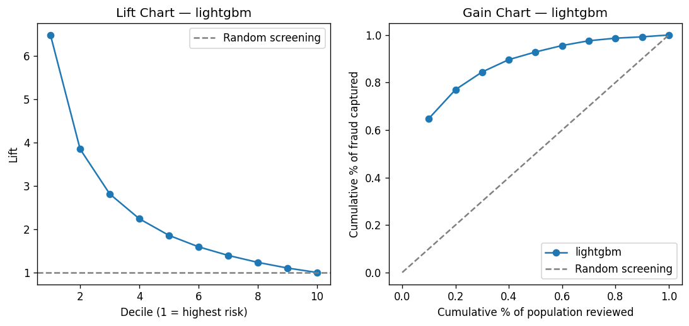
Figure 9.5 — LightGBM lift and gain charts.
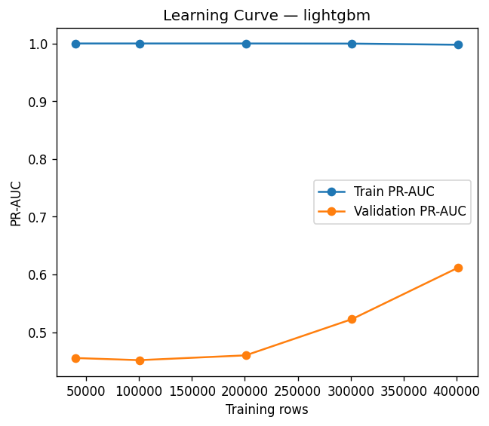
Figure 9.6 — Learning curve for the winning model.
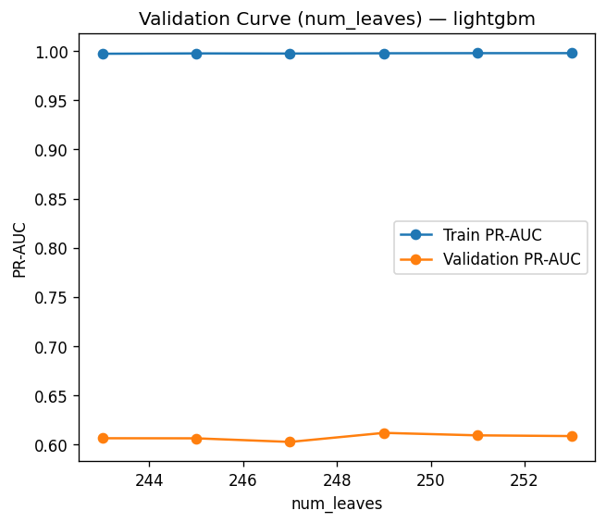
Figure 9.7 — Validation curve for the winning model.

9.9 Implementation Status
Table 9.3 — Module 3 status.
Component | Status
5-model comparison with Optuna tuning | Implemented and experimentally verified
Chronological cross-validation | Implemented and experimentally verified
Model-selection rule (tie-break + statistical comparison) | Implemented and experimentally verified
Operational metrics (recall@precision, precision@K, lift/gain) | Implemented and experimentally verified
Azure ML Model Registry integration | Implemented, code-complete; never executed against a live Azure workspace (no credentials available)

Chapter 10 — Milestone 2, Module 4: Differential Privacy

10.1 Why Privacy Protection Is Relevant Here
A model trained without any privacy protection can, in principle, be probed to infer whether a specific individual's transaction was part of its training set (membership inference), or can memorize and later reveal rare or unusual training examples. This risk is directly relevant to a fraud model, which trains on financial transaction data. Module 4 evaluates whether a formal, mathematically bounded privacy guarantee can be added to this project's neural-network architecture (the same architecture compared in Chapter 9) without destroying its usefulness, and — because the answer turned out to be more complicated than a single number — investigates *why* in detail.

10.2 DP-SGD Mechanics as Implemented
Differentially Private Stochastic Gradient Descent (Chapter 2.6) is implemented via TensorFlow Privacy's `DPKerasAdamOptimizer`. Two configuration details matter for correctness and are recorded here as verified implementation facts, not assumptions: `num_microbatches` is set equal to `batch_size`, giving true per-example gradient clipping — verified directly against TensorFlow Privacy's source code, since a smaller `num_microbatches` value would average several examples together before a single clip-and-noise step, a materially weaker privacy formulation. And the loss function passed to the optimizer uses unreduced, per-example loss (`reduction="none"`), since DP-SGD requires per-example gradients to exist before they can be clipped.

10.3 Verified Identical Initial Weights
To isolate the optimizer as the only variable between the private and non-private runs, both models must start from bit-for-bit identical initial weights. The first implementation attempted this via `tf.random.set_seed()` before each build and was found, empirically, not to work: TensorFlow derives each random operation's actual seed from both the global seed and a per-process operation-creation counter that keeps advancing across separate build calls, so two "identically seeded" builds produce measurably different initial weights. This was caught by a dedicated unit test comparing weight checksums, not assumed. The fix builds the architecture once, caches the resulting weights via `get_weights()`, and explicitly applies them to every subsequent build via `set_weights()` — a correctness guarantee that does not depend on TensorFlow's random-number-generator internals at all. In the real run, both variants' weight checksums equaled 980.497437.

10.4 The Real Experiment
Table 10.1 — Real DP experiment configuration and result (`reports_m4/dp_report.md`).
Parameter | Value
Model architecture | The same single-hidden-layer neural network selected as the winning Optuna configuration in Chapter 9
Privacy accountant | TensorFlow Privacy's RDP accountant (`_compute_dp_sgd_example_privacy`)
Noise multiplier (final reported config) | Per the investigation's best-found configuration (Section 10.6)
L2 norm clip (final reported config) | 20.0 (best-found; original default was 1.0)
Delta (δ) | 1 × 10⁻⁵
Epsilon (ε), non-Poisson-subsampling (authoritative) | 45.573
Epsilon (ε), Poisson-subsampling assumption (informational only) | 3.932
Non-private PR-AUC | 0.1646
Private (DP) PR-AUC | 0.0285
Relative PR-AUC change | −82.7%
Normal training time | 14.9 seconds
DP training time | 264.8 seconds (≈17.8× slower)

10.5 Why Two Epsilon Values Are Reported, and Why Only One Is Authoritative
TensorFlow Privacy's RDP accountant computes epsilon two ways depending on the sampling assumption. The 3.932 figure assumes Poisson (random-per-step) subsampling, which this project's actual training loop — standard shuffled-epoch training via Keras `model.fit()` — does not use; reporting the smaller, Poisson-assumption epsilon here would overstate the model's real privacy guarantee. The 45.573 figure assumes the standard shuffled-epoch procedure the code actually executes, and is therefore the authoritative value used throughout this project's reporting and MLflow logging. This distinction was verified directly against the accountant's own source code, not assumed from general DP literature.

10.6 The Root-Cause Investigation
The first full run of the DP experiment produced a below-random ROC-AUC of 0.2991 — worse than chance, not merely lower than the non-private model — which triggered an eight-phase investigation (`reports_m4/investigation/`) rather than acceptance of the number as "expected DP noise."
Table 10.2 — Investigation phases and findings.
Phase | Question tested | Result
Phase 0 — Gradient-norm diagnostic | How large are raw, unclipped per-example gradients? | Extremely heavy-tailed; positive-class (fraud) gradients, amplified by `class_weight` (≈28–38×), reached up to ≈147,000× the original clip bound of 1.0
Phase A — L2 norm clip sweep | Does raising the clip bound fix it? | Only marginally: ROC-AUC moved from 0.2856 to 0.2869 across a 100× clip-bound range (0.5–50); best value 20.0 adopted, but insufficient alone
Phase B — `class_weight` ablation | Is class-weight amplification the cause? | Small, real, but insufficient effect: ROC-AUC moved from 0.2894 (no weighting) to 0.2975 (original weighting) — confirms per-example clipping neutralizes most, not all, of the amplification
Phase C — Learning-rate sweep | Is the optimizer's step size the cause? | Investigated as a contributing factor; did not by itself explain the magnitude of the failure
Control experiment | Is this a data/split artifact rather than a DP-SGD effect? | A non-DP model trained on the identical 100,000-row exploration subsample scored ROC-AUC 0.7451 (healthy) — ruling out the data/split as the cause
Seed-sensitivity check | Is this random noise variance across runs? | The best-found DP configuration re-run at 3 seeds produced a tight cluster (ROC-AUC 0.287, 0.299, 0.288) — ruling out run-to-run noise as the explanation
Phase D — Noise-multiplier recovery sweep | Does performance recover as noise → 0? | Yes, partially: ROC-AUC rose from 0.287 to 0.398 as noise multiplier fell toward 0.01 (ε ≈ 242,112 — an essentially unprotected privacy level) — but even there, performance still fell far short of the non-private model's ≈0.75–0.80, proving a noise-independent ceiling exists
Phase E — Full-dataset confirmation | Does the diagnosed effect hold at full scale, not just the exploration sample? | Confirmed

10.7 Root-Cause Synthesis
The investigation's conclusion is a structural tension, not a single misconfiguration: per-example gradient clipping (a non-negotiable mechanism of DP-SGD, capping every example's influence equally) directly counteracts `class_weight`'s amplification of the minority (fraud) class's gradients, which this project's severe 3.5% class imbalance (Chapter 4.3) otherwise relies on to make the model learn the minority class at all. This sets a hard utility ceiling well below the non-private model's performance even with negligible added noise, and adding privacy-meaningful noise degrades performance further from there. This is stated as this project's own conclusion, directly evidenced by the phase-by-phase results in Table 10.2, not asserted as a general property of differential privacy.

10.8 Honest Statement of the Result
The experiment demonstrates that adding differential privacy to this project's neural-network
fraud classifier is technically feasible, but the resulting configuration produces a substantial
utility cost (an 82.7% relative reduction in PR-AUC) and is not yet suitable as the primary
production fraud-detection model. The root cause is a structural interaction between per-example
gradient clipping and this dataset's severe class imbalance, not a fixable configuration error, and
further work (Section 10.9) is required before a differentially private model could be considered
for production use at an acceptable utility level.

10.9 Recommended Future Improvements (Not Implemented)
The investigation's own conclusion recommends, without having implemented or evaluated any of the following: a materially larger or different neural architecture with more capacity to survive clipping-induced signal loss; resampling the training set before DP training rather than loss reweighting — a fundamentally different imbalance-handling strategy compatible with DP-SGD's per-example clipping; and, if neither restores acceptable utility, accepting a materially weaker privacy guarantee than this project's original goal implied. Additional directions not evaluated in this project, offered here as future work only: privacy amplification via subsampling (which would require restructuring the training loop to match the Poisson-subsampling assumption discussed in Section 10.5); PATE (Private Aggregation of Teacher Ensembles) or other alternative privacy mechanisms; privacy-preserving feature engineering; and federated-learning architectures, which change where and how training data is aggregated in the first place. None of these are labeled as implemented anywhere else in this report.
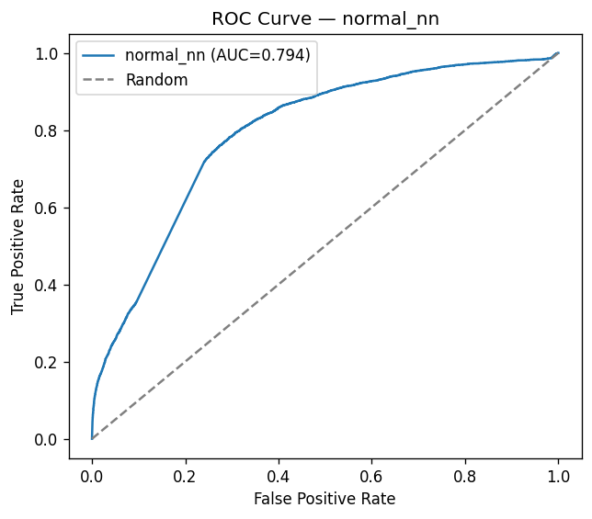
Figure 10.1 — Normal (non-private) neural network ROC curve.
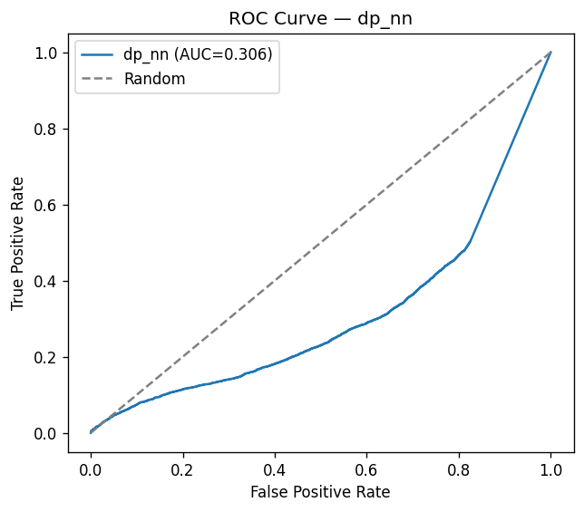
Figure 10.2 — Differentially private neural network ROC curve.
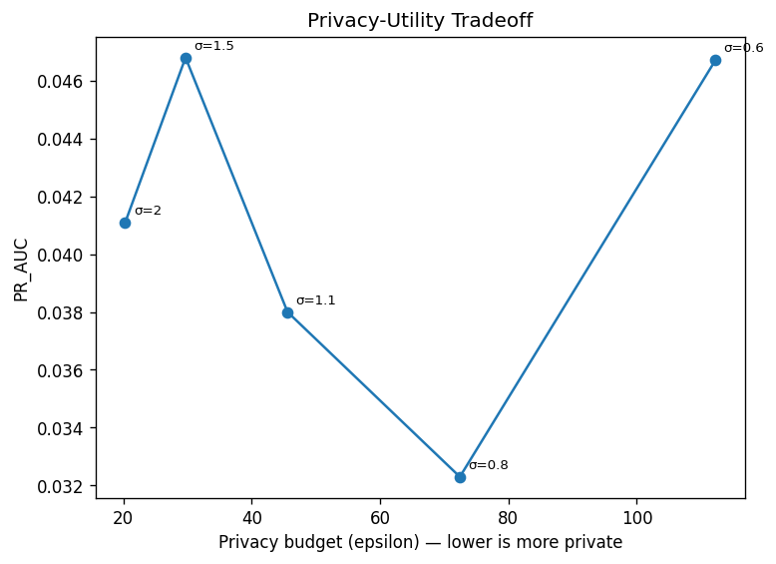
Figure 10.3 — Privacy-utility curve across the noise-multiplier recovery sweep (Section 10.6, Phase D).

10.10 Implementation Status
Table 10.3 — Module 4 status.
Component | Status
DP-SGD training with verified per-example clipping | Implemented and experimentally verified
RDP privacy accounting (authoritative epsilon) | Implemented and experimentally verified
Root-cause investigation (8 phases) | Implemented and experimentally verified
Recommended architectural/resampling improvements (Section 10.9) | Not implemented; future work

Chapter 11 — Milestone 2, Module 5: Fairness Analysis

11.1 Why Fairness Matters Here, and What "Protected Group" Means in This Dataset
A fraud model that performs well in aggregate can still treat identifiable subgroups of transactions very differently — flagging one group's legitimate activity far more often than another's, or missing a much larger share of real fraud within one group than another. The IEEE-CIS dataset contains no genuine demographic field; this project's fairness analysis instead uses three payment-behavior or device-usage attributes as proxies, and this report — following the repository's own stated convention — never refers to a finding on these attributes as a "demographic bias" finding. The three attributes analyzed are `card6` (debit vs. credit, the primary attribute), `card4` (card network: Visa, Mastercard, American Express, Discover), and `DeviceType` (desktop vs. mobile, analyzed with an explicit "Missing" group rather than dropping the 80.4% of test rows with no recorded device).

11.2 Metric Definitions as Implemented
Selection Rate, SPD, DIR, EOD, and AOD are defined in Chapter 2.7. Every pairwise metric in this project is reported with a 95% bootstrap confidence interval (1,000 stratified resamples — each protected-attribute group resampled independently, preserving its relative size, rather than resampling the pooled dataset as one unit) and is only described as statistically significant when that interval excludes the metric's no-disparity value (0 for a difference metric, 1 for a ratio metric). A chi-square or Fisher's exact test (chosen automatically per Cochran's rule — at least 80% of the contingency table's expected cell counts must be ≥ 5 for chi-square to be valid, falling back to Fisher's exact test for a 2×2 table when this rule is violated) additionally tests whether a group's selection rate differs from the reference at all. Every core metric implementation was independently cross-validated against Fairlearn — an external, independently developed fairness library — and every compared metric agreed to a difference of exactly 0.0 on real data, per `tests/test_fairlearn_validation.py`.

11.3 Real Findings — card6 (Primary Attribute; reference group: debit)
Table 11.1 — card6 real metrics (`reports_m5/fairness_metrics.csv`, `group_metrics.csv`).
Metric | Value | 95% CI | Significant?
Selection rate (credit) | 5.65% | — | —
Selection rate (debit) | 1.41% | — | —
TPR (credit / debit) | 0.5247 / 0.3357 | — | —
FPR (credit / debit) | 0.02419 / 0.00576 | — | —
SPD | 0.0424 | [0.0395, 0.0453] | Yes
DIR | 3.996 | [3.701, 4.298] | Yes
EOD | 0.1890 | [0.1606, 0.2188] | Yes
AOD | 0.1037 | [0.0894, 0.1190] | Yes

Credit-card transactions are flagged as fraud at approximately four times the rate of debit-card transactions, and this model catches real fraud among credit-card transactions roughly 19 percentage points more often than among debit-card transactions. Every metric's confidence interval excludes its null value; this is a statistically robust, not a marginal, finding.

11.4 Real Findings — card4 (reference group: Visa)
Table 11.2 — card4 real metrics, one row per non-reference network.
Comparison | SPD [95% CI] | DIR [95% CI] | EOD [95% CI] | AOD [95% CI] | Significant (any metric)?
American Express vs. Visa | 0.0092 [−0.0007, 0.0199] | 1.402 [0.968, 1.884] | 0.0210 [−0.152, 0.202] | 0.0160 [−0.072, 0.107] | No
Discover vs. Visa | 0.0488 [0.0348, 0.0629] | 3.139 [2.495, 3.791] | −0.0316 [−0.120, 0.060] | 0.0006 [−0.046, 0.049] | SPD, DIR significant
Mastercard vs. Visa | 0.0017 [−0.0001, 0.0035] | 1.075 [0.995, 1.158] | 0.0504 [0.0169, 0.0853] | 0.0258 [0.0086, 0.0431] | EOD, AOD significant

This table concretely illustrates why a single fairness metric is insufficient: Mastercard and Visa have statistically indistinguishable overall flagging rates (SPD, DIR not significant), yet Mastercard's fraud-catch rate differs significantly from Visa's (EOD, AOD significant) — the same pair of groups is fair by one definition and not by another, simultaneously.

11.5 Real Findings — DeviceType (reference group: desktop; "Missing" reported but excluded from pairwise comparison)
Table 11.3 — DeviceType real metrics.
Metric | Value | 95% CI | Significant?
Selection rate (mobile) | 10.24% | — | —
Selection rate (desktop) | 8.16% | — | —
TPR (mobile / desktop) | 0.6035 / 0.7153 | — | —
SPD | 0.0207 | [0.0132, 0.0283] | Yes
DIR | 1.254 | [1.157, 1.361] | Yes
EOD | −0.1119 | [−0.1512, −0.0715] | Yes
AOD | −0.0504 | [−0.0699, −0.0297] | Yes

The most operationally significant finding in this project's fairness analysis concerns the explicit "Missing" group: 80.4% of the real test set (94,936 of 118,108 rows) has no recorded `DeviceType`, and this group's false-negative rate is 86.1% — the model catches barely one in seven real frauds when device information is absent, versus a substantially higher catch rate when it is present. This surfaced specifically because the project's design deliberately treats "Missing" as its own analyzable group in per-group metrics tables rather than silently dropping those rows, even though "Missing" is excluded from pairwise SPD/DIR/EOD/AOD comparisons against the reference group, since "no device recorded" is not a meaningful protected-group contrast in the traditional sense.

11.6 The 24 Bias Findings
`bias_findings.md` and `fairness_summary.json` record 24 total automatic findings (0 critical, 12 warning, 12 informational), 8 per attribute: the largest and smallest SPD pair (informational), whether any group shows a statistically significant selection-rate disparity (warning if so), whether the chi-square/Fisher's test result is significant (warning if so), the best- and worst-performing group by F1 score (informational / warning), and the group with the highest FPR and highest FNR (informational / warning). Across all three attributes, the consistently worst-performing group by F1 score is the "Missing" group (F1 = 0.368 for both card6 and card4's missing values, 0.198 for DeviceType's missing value) — the same operational concern as Section 11.5, surfacing independently through the automatic-findings mechanism.

11.7 Operational Implications and Remediation Options
These findings identify measurable risk; they do not, by themselves, establish unlawful discrimination or prove the model is broken — `card6`'s disparity is consistent with (though not proof of) genuine, legitimate risk correlation, since Module 2's own exploratory data analysis (Chapter 8) already found real fraud-rate differences by payment behavior independent of any model. Remediation options this report identifies as future work, not implemented: escalate the missing-`DeviceType` false-negative-rate finding to the modeling team as a genuine model-quality and data-coverage gap, since it stems from missing information rather than a protected-group contrast; consider fairness-aware post-processing (e.g., group-specific threshold calibration) if the card6 disparity is judged unacceptable after business review; and gather additional context (beyond what this dataset provides) before concluding whether the underlying disparity reflects genuine risk or an artifact worth correcting.

11.8 Fairness Assessment Does Not Establish Fairness
This report states explicitly, consistent with the repository's own documentation discipline: fairness measurement identifies statistically supported disparities and their plausible operational significance. It does not certify that the model is fair, does not constitute a legal or regulatory fairness determination, and does not by itself resolve whether an identified disparity should be corrected, tolerated, or requires more context to interpret.
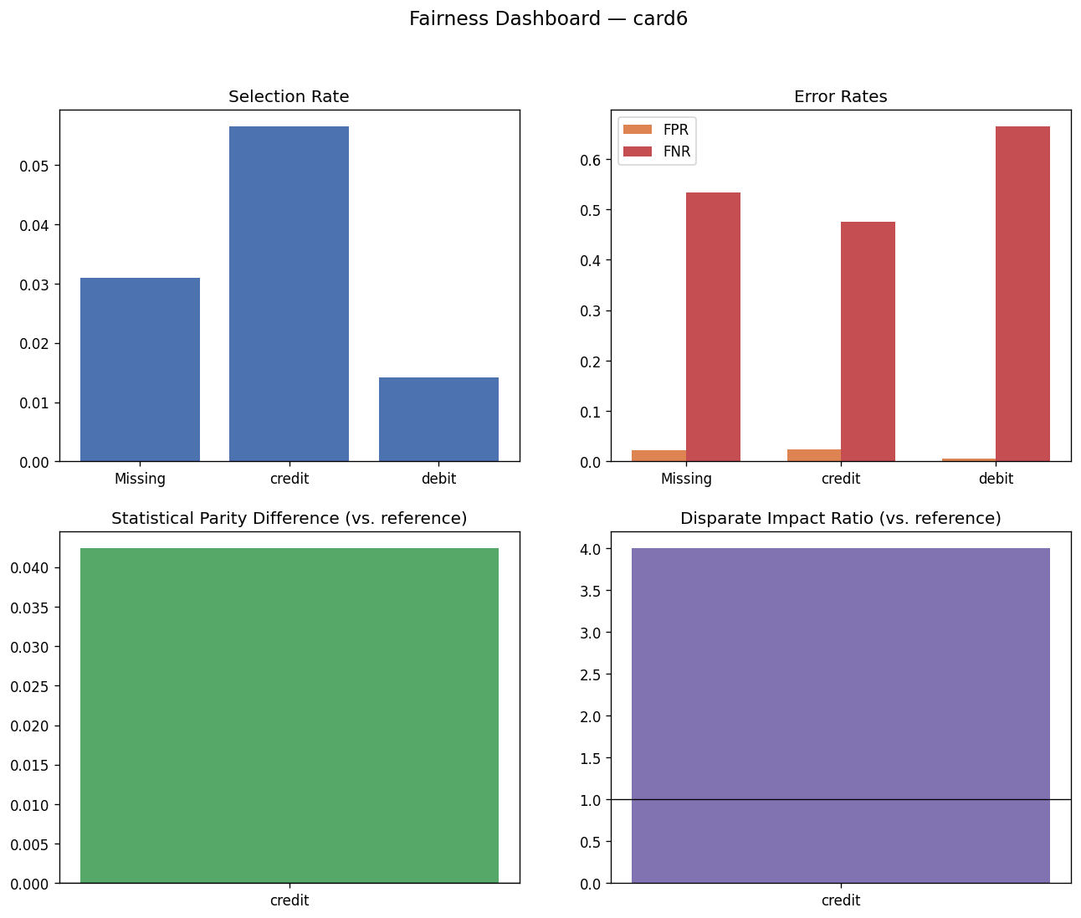
Figure 11.1 — Real fairness dashboard (card6, primary attribute).
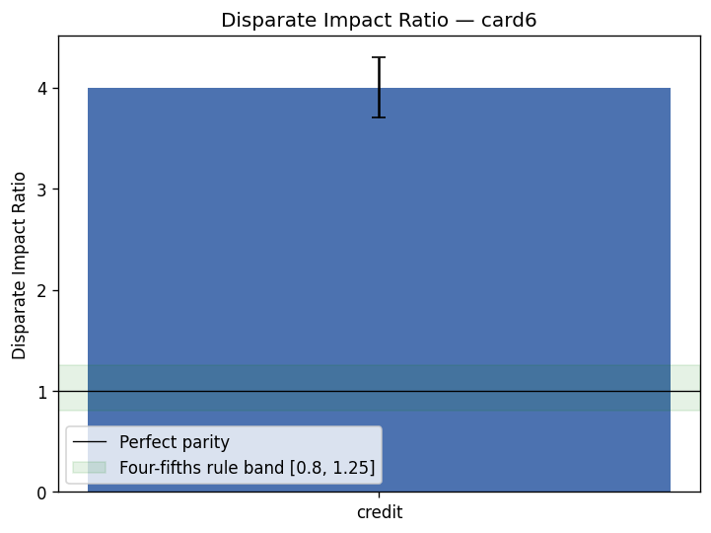
Figure 11.2 — card6 disparate impact visualization.

11.9 Implementation Status
Table 11.4 — Module 5 status.
Component | Status
SPD/DIR/EOD/AOD with bootstrap confidence intervals | Implemented and experimentally verified
Fairlearn independent cross-validation | Implemented and experimentally verified (exact agreement, difference 0.0)
Cochran's-rule-based significance testing | Implemented and experimentally verified
"Missing"-group explicit handling | Implemented and experimentally verified (produced the DeviceType finding, Section 11.5)

Chapter 12 — Experiment Tracking and Model Artifact Management

12.1 MLflow Integration
Modules 3, 4, and 5 log to MLflow, backed by a SQLite tracking store (`sqlite:///mlruns/mlflow.db`), switched from the plain filesystem store after that was found deprecated in MLflow 3.x during development — a real, minor compatibility bug found and fixed in this project, recorded here for completeness. Module 3's five-model comparison is logged as a single parent run ("model_comparison") with five nested child runs, one per candidate model, each carrying its own hyperparameters, cross-validation and holdout metrics, evaluation plots, and the fitted model in the appropriate MLflow flavor. Module 4 logs a parent run ("differential_privacy_comparison") with nested Normal/DP child runs. Module 5 logs a single "fairness_analysis" run. In total, the real tracking store contains 10 runs: 1 parent + 5 children (Module 3), 1 parent + 2 children (Module 4), and 1 run (Module 5).

12.2 Parameters, Metrics, and Artifacts Logged
Each MLflow run records its model's hyperparameters (the exact Optuna-selected configuration), cross-validation and holdout metrics (PR-AUC, ROC-AUC, F1, precision, recall, and the operational metrics from Chapter 9.7), the model itself, and its evaluation plots. This is distinct from — and in addition to — the plain-file artifacts described below, which are what this repository actually commits to version control; the MLflow store (`mlruns/`) is excluded from version control via `.gitignore` and exists only on the machine where the pipeline was run.

12.3 Model Persistence: joblib and Keras Artifacts
Conventional (scikit-learn-API) models — Logistic Regression, Random Forest, XGBoost, and LightGBM — are persisted via `joblib`. The Neural Network and both differential-privacy variants are persisted in Keras's native format (`model.keras`), alongside a JSON metadata sidecar recording full training and privacy configuration in a format readable without loading TensorFlow at all. Every one of the five candidate models — not only the winning LightGBM — is persisted as a complete `InferenceBundle` (Chapter 8.8, Chapter 9), a single joblib artifact bundling the fitted engineering, selection, and preprocessing pipelines together with the trained estimator and its optimized decision threshold, so any candidate can be loaded and used for inference without rebuilding any preprocessing step.

12.4 Versioning and Reproducibility
The `dataset_version` hash (Chapter 6.5) is threaded through every persisted manifest and every MLflow run's tags, so a reader can always trace a given model artifact or metric back to the exact dataset version that produced it. `reports_m2/feature_manifest.json` similarly records the exact selected-feature list, the artifact paths of every Module 2 pipeline object, and the `final_processed_column_count` (202), giving a complete, versioned record of the feature contract any downstream consumer — including the Milestone 3 API (Chapter 13) — must satisfy.

12.5 Configuration Management
A single typed configuration source, `src/config/config.yaml` (245 lines, loaded via `load_config()` into a frozen `AppConfig` dataclass), governs Milestone 2's behavior across all five modules — feature-engineering parameters, feature-selection thresholds, model-development settings, differential-privacy parameters, and fairness-analysis thresholds are all declared here rather than scattered across module-specific configuration files. Secrets (Azure credentials) are never hardcoded in this file; `${VAR_NAME}`-style placeholders are resolved against environment variables at load time, with unset variables resolving to an empty string rather than raising, so local development without credentials configured does not crash.

12.6 Local Tracking vs. Committed Artifacts vs. Production Registry Target
This project maintains three distinct tiers, and this report does not conflate them. Local experiment tracking (the MLflow SQLite store, `mlruns/`) exists only on the machine that ran the pipeline and is not committed to version control. Repository-committed artifacts (everything under `artifacts_m2/` through `artifacts_m5/` and `reports_m2/` through `reports_m5/`) are real, generated outputs committed to the repository specifically so a reader can inspect them without re-running the pipeline. The production registry target architecture — Azure ML Model Registry integration (`src/registry/azure_ml_registry.py`) — is implemented and code-complete but was never executed against a live Azure ML workspace in this project, since no credentials were available; it logs a clear "skipping, ready to run once credentials are supplied" message and returns `None` rather than silently failing or fabricating a registration record.

Chapter 13 — Milestone 3: Secure Inference API

13.1 Application Structure
The service is a FastAPI application (`app/main.py`) organized into `app/api/` (route handlers: `auth.py`, `inference.py`), `app/core/` (`config.py`, `security.py`, `limiter.py`, `keyvault.py`), and `app/models/` (`schemas.py`, `model_loader.py`, `raw_schema.py`). All routes are mounted under an API version prefix, `/api/v1`, set once in configuration (`API_V1_PREFIX`) rather than hardcoded per route.

13.2 Authentication Flow
Authentication uses the OAuth2 password flow, issuing a JWT signed with HS256. `POST /api/v1/auth/token` accepts a username and password, verifies the password against a bcrypt hash (`passlib`), and — on success — returns a bearer token containing the subject and a coarse-grained `role` claim (`ml_engineer` or `service_client`), valid for 15 minutes (`ACCESS_TOKEN_EXPIRE_MINUTES`). Every subsequent authenticated request presents this token in an `Authorization: Bearer` header; `get_current_user` decodes and validates the signature and expiry, and `require_role(*roles)` is a dependency factory enforcing coarse-grained, role-based access on each route. The demo user store (`_FAKE_USER_DB`, a single hardcoded `svc-ml-engineer` account with a bcrypt-hashed placeholder password) is explicitly documented in code as a stand-in to be replaced by Azure AD (Entra ID) before production go-live — this is also Finding F4 in the penetration-test report (Chapter 17) and is treated in this report as an open, unresolved item, not a completed control.

13.3 Credential Handling
The JWT signing secret (`JWT_SECRET_KEY`) is resolved from Azure Key Vault when `ENVIRONMENT=production` and a vault URL is configured; if resolution fails or is unavailable, the application refuses to start in production mode rather than falling back to an insecure default. In non-production environments, an explicit "dev-only-insecure-key" fallback is used, clearly distinguishing the two paths in code so a misconfiguration cannot silently run production with a disclosed default secret.

13.4 The Prediction Endpoint
`POST /api/v1/inference/predict` requires `ml_engineer` or `service_client` role. Its request schema (`TransactionFeatures`, `app/models/schemas.py`) uses `extra="forbid"` (Pydantic) to reject any unexpected field outright — a first line of defense against malformed input and mass-assignment style attacks. Rather than modeling this project's ~150 selected features as individually typed fields (an unreasonable API surface), the schema exposes explicit, bounded, validated fields for the raw columns the feature-engineering transformers actually read directly (`TransactionAmt`, `ProductCD`, `card1`–`card6`, `addr1`, `P_emaildomain`, `R_emaildomain`, `DeviceType`, `DeviceInfo`, `id_30`, `id_31`, `id_33`), plus an open, key-validated `extra_features` dictionary for the remaining `C*`/`D*`/`M*`/`V*`/`id_*` columns — validated against the exact real raw-column set derived from the committed dataset header and `reports_m2/feature_manifest.json`, not a guessed schema. `_to_ml_ready_frame` assembles a single-row pandas DataFrame from a NaN-defaulted template covering the full real raw-column contract, overlaid with whatever the request supplied — letting the pipeline's own imputers and frequency encoders (Chapter 8.3) handle any column the caller did not provide, exactly as they were designed to.

13.5 Model Loading and the Real-vs-Placeholder Distinction
`ModelService` (`app/models/model_loader.py`) loads the model artifact at `MODEL_PATH`, defaulting to the real, committed `artifacts_m3/lightgbm_inference_bundle.joblib`. If that artifact is absent, it falls back to a deterministic placeholder scorer (a naive amount-based heuristic) so the rest of the security pipeline can be built and tested independently of the ML deliverable — an intentional design choice, not an oversight. `ModelService` detects which case applies (via `hasattr(model, "threshold_decision")`, a signature unique to a real `InferenceBundle`) and dispatches accordingly: the real bundle is called with a DataFrame and uses its own tuned decision threshold (Chapter 9.6), never the conventional default of 0.5.

13.6 Input Validation and Error Handling
Beyond Pydantic's field-level validation (bounds, types, `extra="forbid"`), a global exception handler (`app/main.py`) catches every unhandled exception, logs the full traceback server-side, and returns a generic `{"detail": "Internal server error. Please contact support."}` to the client — no stack trace or internal error detail is ever exposed externally.

13.7 Rate Limiting
A single shared `SlowAPI` `Limiter` instance (`app/core/limiter.py`) is imported by every router, so rate-limit state and the app-level exception handler apply uniformly. The general API rate limit is 30 requests/minute (configurable, `RATE_LIMIT`); the login endpoint carries a stricter, independently hardcoded 5 requests/minute limit specifically to blunt credential-stuffing and brute-force attempts against the token endpoint — this stricter limit was added in direct response to Finding F1 in the penetration test (Chapter 17), and its remediation was independently retested.

13.8 Security Headers and Logging
A middleware layer (`app/main.py`) adds `Strict-Transport-Security`, `X-Content-Type-Options`, `X-Frame-Options: DENY`, `Content-Security-Policy: default-src 'none'`, `Referrer-Policy: no-referrer`, and a restrictive `Permissions-Policy` to every response. The `Server: uvicorn` header (which cannot be stripped from application middleware, since uvicorn sets it after the ASGI app returns) is instead disabled at the server level via `--no-server-header` in the Dockerfile's production `CMD`, an example of remediating a control at the correct architectural layer rather than working around a limitation. Structured, PII-free audit logging records who called what: request ID, authenticated subject, role, and timestamp — explicitly never the raw feature values or the prediction itself, since those may be derived from or reveal sensitive transaction data.

13.9 Health and Documentation Endpoints
`GET /health` (unauthenticated, unversioned) returns `{"status": "ok", "environment": ...}` for liveness/readiness probing, with no sensitive information disclosed. Interactive documentation (`/docs`, `/redoc`) is enabled only when `ENVIRONMENT != "production"`; both were verified to return 404 with `ENVIRONMENT=production` set (Chapter 17, Test T9).

13.10 Secrets Abstraction and Local Fallback
`app/core/keyvault.py` wraps the Azure Key Vault Secrets client using `DefaultAzureCredential`, so no credential is stored anywhere in application code, container images, or environment variables in the target Azure deployment — the compute resource's own managed/workload identity is used to authenticate. Locally, `DefaultAzureCredential` falls back to `az login` developer credentials, and `.env.example`/`.env` provide the local-development-only fallback described in Section 13.3.

13.11 API Endpoint Table
Table 13.1 — Real API endpoints.
Method | Route | Auth required | Input | Output | Security controls
`POST` | `/api/v1/auth/token` | None (issues token) | Username, password (form-encoded) | JWT bearer token | bcrypt password hashing; 5 req/min rate limit
`POST` | `/api/v1/inference/predict` | Bearer JWT, role `ml_engineer` or `service_client` | `TransactionFeatures` JSON | `PredictionResponse` (is_fraud, fraud_probability, model_version, request_id) | JWT validation; RBAC; 30 req/min rate limit; strict schema validation; audit logging
`GET` | `/health` | None | — | `{"status", "environment"}` | No sensitive data exposed
`GET` | `/docs`, `/redoc` | None | — | Interactive API documentation | Disabled when `ENVIRONMENT=production`

13.12 API Request Sequence
Figure 13.1 shows the real, code-verified request flow for a prediction call.
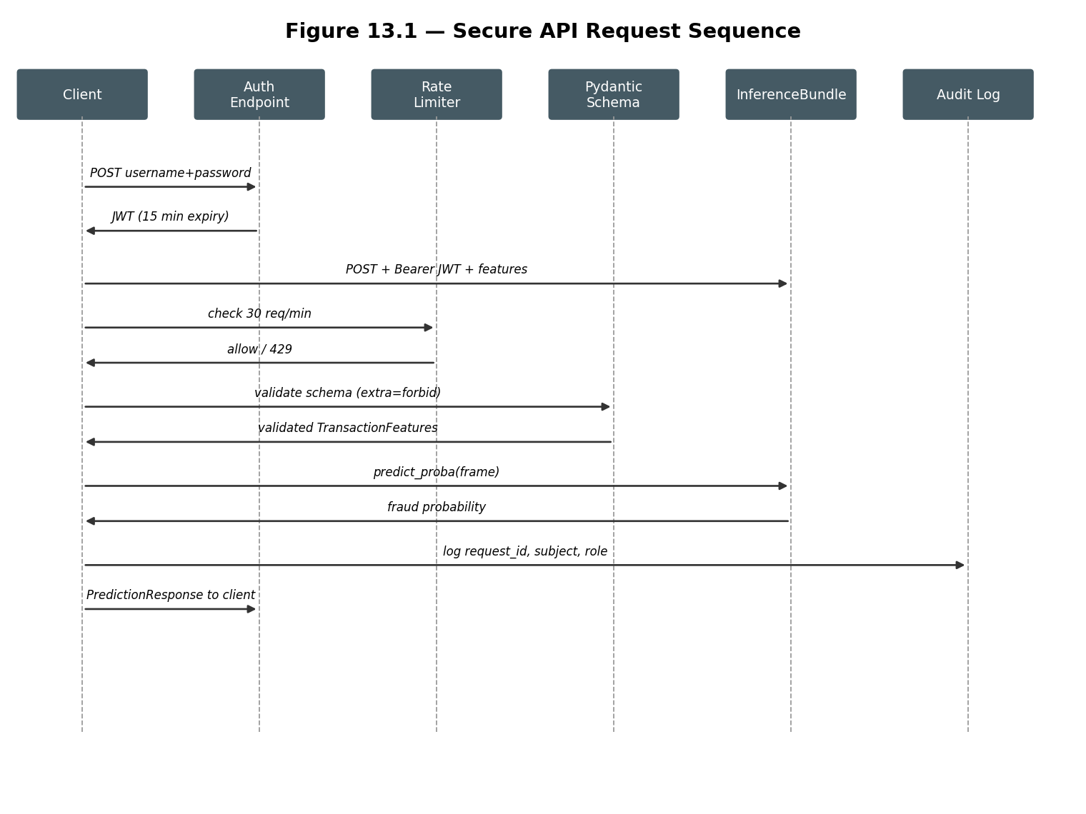
*Figure 13.1 — API request sequence, based on the actual implementation of `app/api/auth.py` and `app/api/inference.py`.*

13.13 Implementation Status
Table 13.2 — Milestone 3 API status.
Component | Status
JWT authentication + RBAC | Implemented and locally tested; penetration-tested (Chapter 17)
Rate limiting (general + auth-specific) | Implemented and locally tested; penetration-tested, one finding remediated
Real feature-contract request schema | Implemented and experimentally verified against the real trained model
Security headers | Implemented and locally tested; penetration-tested
Azure Key Vault secret resolution | Implemented, code-complete; not exercised against a live Key Vault (Chapter 15)
Production identity provider (Azure AD) | Not implemented; open item (Chapter 17, Finding F4)

Chapter 14 — Container and Deployment Security

14.1 Multi-Stage Docker Build
The `Dockerfile` uses a two-stage build: a `builder` stage (`python:3.12-slim`) installs dependencies from `requirements-milestone3.txt` into an isolated user site-packages directory; the runtime stage copies only that installed-dependency directory and the application code (`app/`, `src/`, `artifacts_m3/` — the latter two required so the real `InferenceBundle` can be unpickled and scored inside the container, verified directly during this project's integration work) into a fresh, minimal `python:3.12-slim` base. No build toolchain, source archives, or package caches from the builder stage are present in the final image.

14.2 Non-Root Execution and Attack-Surface Reduction
A dedicated `appuser` system user and group are created, and file ownership is transferred via `chown` before the container drops privileges (`USER appuser`) — the application never runs as root inside the container. The production `CMD` invokes uvicorn directly (no shell form), with `--workers 2` for basic concurrency, and `--no-server-header --no-date-header` to remove fingerprinting information at the server layer (Chapter 13.8). `PYTHONDONTWRITEBYTECODE=1` and `PYTHONUNBUFFERED=1` are set for a smaller runtime footprint and immediate log flushing.

14.3 Container Limitations
The image is built and validated locally (this project's integration work confirmed it builds and the resulting service runs and responds correctly) but has not been pushed to a container registry or run inside a live Kubernetes cluster; the Kubernetes manifests below reference an Azure Container Registry image (`acrfraudml.azurecr.io/fraud-inference-api:latest`) that does not exist in any provisioned registry, using an untagged `:latest` reference rather than an immutable digest — a concrete, named limitation (Chapter 24) rather than a claim of production readiness.

14.4 Kubernetes Manifests
Table 14.1 — All Kubernetes resource objects defined (`k8s/`, 6 objects across 3 files).
File | Kind | Name | Key configuration
`00-namespace-serviceaccount.yaml` | Namespace | `fraud-inference` | Label `purpose: ml-inference`
`00-namespace-serviceaccount.yaml` | ServiceAccount | `fraud-inference-sa` | Annotated for Azure Workload Identity federation (client ID placeholder, filled from Terraform output)
`01-deployment-service.yaml` | Deployment | `fraud-inference-api` | 3 replicas; non-root (UID 1000); seccomp `RuntimeDefault`; `readOnlyRootFilesystem: true`; `allowPrivilegeEscalation: false`; capabilities dropped (`ALL`); requests 250m CPU / 256Mi memory, limits 500m / 512Mi; liveness/readiness probes on `/health`; `emptyDir` volume mounted at `/tmp` (since root filesystem is read-only)
`01-deployment-service.yaml` | Service | `fraud-inference-api` | `ClusterIP` (not directly internet-facing); port 443 → container port 8000
`02-networkpolicy.yaml` | NetworkPolicy | `default-deny-all` | Zero-trust baseline: denies all ingress/egress in the namespace by default
`02-networkpolicy.yaml` | NetworkPolicy | `allow-appgw-ingress` | Permits ingress on port 8000; the manifest's own comment recommends tightening the current namespace-wide rule to the exact Application Gateway subnet CIDR once confirmed supported by the cluster's CNI
`02-networkpolicy.yaml` | NetworkPolicy | `allow-egress-to-keyvault-and-dns` | Permits egress to the private-endpoint subnet (443, for Key Vault) and DNS (53) only

14.5 Separating Implemented Controls from Recommendations
Every control in Table 14.1 is present in the committed YAML and would be enforced if applied to a real cluster; none of it has been applied to a live cluster (Section 15 explains why). The one control explicitly flagged as incomplete in the manifest's own comments — the overly broad `allow-appgw-ingress` rule — is preserved here as a recommendation rather than silently corrected, to accurately reflect the manifest's actual current state.

Chapter 15 — Azure Infrastructure-as-Code Architecture

15.1 Overview and Explicit Non-Deployment Statement
The Terraform configuration under `iac/terraform/` represents a designed target architecture and
has not been verified through deployment to a live Azure subscription.
This statement is placed prominently because several of this project's most security-relevant claims depend on it: no live AKS cluster, no live Web Application Firewall, and no live Key Vault instance exist as a result of this repository's contents. The Terraform is internally consistent (its resources reference each other correctly and it would pass `terraform validate`), and several concrete pieces of evidence confirm it has never been applied: its remote-state backend is commented out rather than configured; the sensitive variables `jwt_secret_key` and `field_encryption_key` have no default values and require external injection; `allowed_admin_ips` defaults to an empty list, which would itself block administrative access if applied as-is; `terraform.tfvars.example` uses placeholder values (`security@example.com`); and no `.tfstate` file exists anywhere in the repository.

15.2 Azure Resource Inventory by Module
Table 15.1 — Network module.
Resource | Purpose
`azurerm_resource_group` | Container for all project resources
`azurerm_virtual_network` (10.20.0.0/16) | Address space for the deployment
3× `azurerm_subnet` | AKS nodes (10.20.1.0/24), Application Gateway/WAF (10.20.2.0/24), private endpoints (10.20.3.0/24)
3× `azurerm_network_security_group` | Per-subnet inbound rules — AKS accepts 443 only from the AppGW subnet; AppGW accepts public 443 only; private-endpoint subnet accepts 443 only from the AKS subnet
`azurerm_private_dns_zone` + link | Enables private-endpoint name resolution for Key Vault

Table 15.2 — AKS module.
Resource | Purpose
`azurerm_kubernetes_cluster` | Private cluster (no public API server), RBAC enabled, Workload Identity/OIDC enabled, Azure network policy plugin (enforces Kubernetes NetworkPolicies), Microsoft Defender enabled
`azurerm_kubernetes_cluster_node_pool` ("inference") | Dedicated user-mode node pool separate from the system pool
`azurerm_user_assigned_identity` + `azurerm_federated_identity_credential` | Binds the Kubernetes `fraud-inference-sa` ServiceAccount to an Azure AD identity via OIDC — no stored credential

Table 15.3 — Key Vault module.
Resource | Purpose
`azurerm_key_vault` | SKU standard; purge protection enabled; 90-day soft-delete retention; RBAC authorization; public network access disabled
`azurerm_private_endpoint` | Sole network path to the vault
2× `azurerm_role_assignment` | Least-privilege: "Key Vault Secrets User" (read-only) for the AKS workload identity; "Key Vault Certificate User" for the Application Gateway's TLS certificate access
3× `azurerm_key_vault_secret` | `jwt-secret-key`, `allowed-origins`, `field-encryption-key` — values injected at apply time, never committed
`azurerm_monitor_diagnostic_setting` | Audits every secret access to the Log Analytics workspace

Table 15.4 — Monitoring module.
Resource | Purpose
`azurerm_log_analytics_workspace` | Central log store, 90-day retention
`azurerm_security_center_subscription_pricing` (×4) | Microsoft Defender for Cloud, Standard tier, across containers, Key Vaults, App Services, and ARM
`azurerm_security_center_auto_provisioning` + `azurerm_security_center_contact` | Automatic agent deployment; a required alert-contact email

Table 15.5 — WAF module.
Resource | Purpose
`azurerm_web_application_firewall_policy` | Prevention mode (blocks, not just logs); OWASP Core Rule Set 3.2; a tuned exclusion on the `TransactionAmt` parameter; three custom rules (Section 15.3)
`azurerm_application_gateway` | SKU `WAF_v2`, autoscale capacity 2–6; HTTPS-only frontend; TLS policy `AppGwSslPolicy20220101S` (TLS 1.2 minimum); backend routes to the AKS ClusterIP service over HTTPS
`azurerm_public_ip` | Static IP for the gateway's public frontend

15.3 WAF Custom Rules (verbatim from `docs/WAF_Rules.md`)
Table 15.6 — Custom WAF rules.
Priority | Name | Trigger | Action
1 | `RateLimitAuthEndpoint` | More than 60 requests/minute per client IP to `/api/v1/auth/token` | Block
2 | `BlockNonJsonInference` | Request to `/api/v1/inference/predict` without `Content-Type: application/json` | Block
3 | `BlockDisallowedGeos` | Client from a country code in `blocked_country_codes` | Block (disabled by default, pending confirmed client geography)

Request limits enforced at the WAF: `request_body_check = true`, maximum request body 128 KB, maximum file upload 10 MB.

15.4 Defense in Depth
Three independent layers protect the inference endpoint in the target architecture: the WAF (network edge, Section 15.3), application-level rate limiting (Chapter 13.7), and Pydantic input validation (Chapter 13.4/13.6). Losing any single layer still leaves the other two in place — this is the explicit design rationale recorded in `docs/WAF_Rules.md`.

15.5 Azure Deployment Diagram
Figure 15.1 shows the designed target architecture end to end.
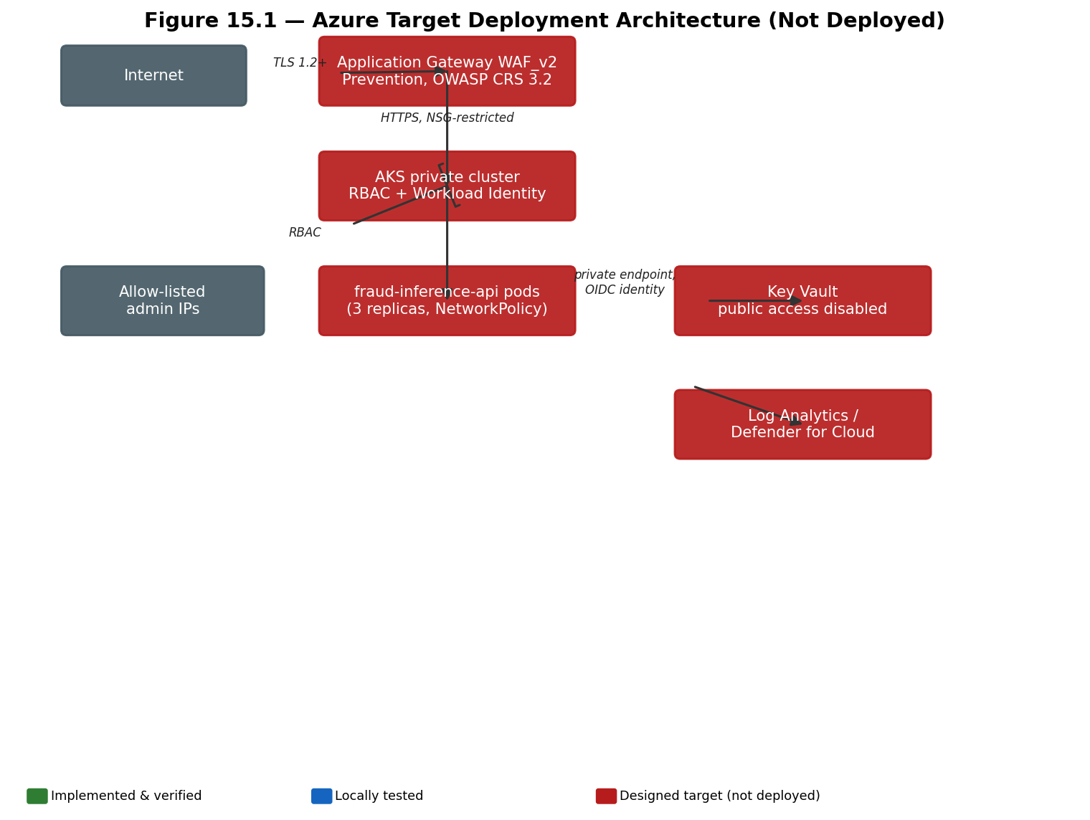
*Figure 15.1 — Azure target deployment architecture. No component in this diagram has been applied to a live subscription (Section 15.1).*
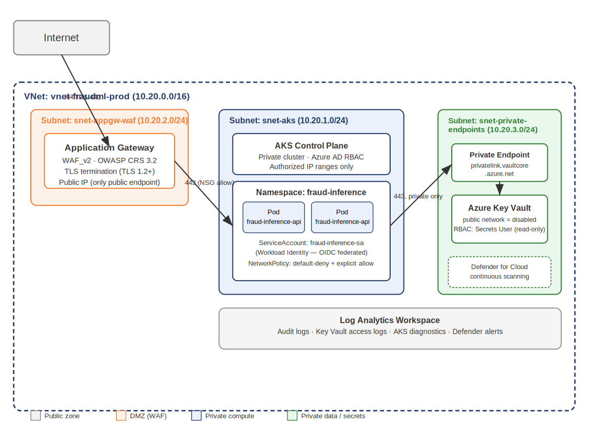
Figure 15.2 — Network diagram from the real Milestone 3 Security Architecture Documentation.

15.6 What This Report Does Not Claim
Consistent with Section 15.1, this report does not claim: a successful AKS deployment; live WAF traffic blocking; live Key Vault secret retrieval by a running pod; or any measured production scalability or availability, since none of these have occurred.

15.7 Implementation Status
Table 15.7 — Milestone 3 infrastructure status.
Component | Status
Docker multi-stage, non-root container build | Implemented and locally tested (built and run successfully)
Kubernetes manifests (Deployment, Service, NetworkPolicy) | Designed target state; internally consistent; not applied to a live cluster
Terraform (network, AKS, Key Vault, monitoring, WAF modules) | Designed target state; internally consistent; not applied to a live subscription

Chapter 16 — Threat Model and Security Analysis

16.1 Assets, Actors, and Trust Boundaries
Assets: the trained model artifacts (`artifacts_m2`–`artifacts_m5`); the JWT signing secret and Fernet field-encryption key; the inference API's authentication tokens; audit and application logs; CI/CD secrets (Azure Storage credentials referenced by Milestone 5's workflow); and, in the target architecture, the provisioned Azure resources themselves. Actors: an external, unauthenticated API client; an authenticated `ml_engineer`/`service_client` role holder; a repository contributor with CI/CD trigger access; and an Azure administrator (in the target architecture only, since no live Azure environment exists). Entry points: the public inference API surface (target: via the Application Gateway/WAF); the CI/CD pipeline's trigger conditions (push, pull request, schedule, manual dispatch); and, in the target architecture, the AKS API server (mitigated by being a private cluster with an admin IP allow-list, Chapter 15.2). Trust boundaries mirror Chapter 5.4 (Figure 5.2).

16.2 STRIDE Threat Table
Table 16.1 — STRIDE threats, grounded in this repository's actual controls and gaps.
Category | Threat | Asset | Existing control | Residual risk | Verification status
Spoofing | Attacker impersonates a legitimate client to call the inference API | Inference API, JWT | JWT signature + expiry validation (Ch. 13.2) | Demo user store is a hardcoded placeholder, not a real identity provider (Ch. 13.2, Ch. 17 F4) | Implemented and locally tested; open item remains
Tampering | Request payload altered in transit; a compromised node alters model input/output | API traffic, model artifacts | TLS termination at the Application Gateway (target); strict Pydantic schema validation; read-only container filesystem | TLS enforcement not verified live (no deployed AppGW); container image uses `:latest`, not a digest | Designed target; not live-verified
Repudiation | A caller denies having made a request that led to a fraud decision | Audit trail | Structured, PII-free audit logging of request ID, subject, role, timestamp (Ch. 13.8) | Logs are not yet shipped to the immutable WORM store automatically per-request (only periodic reports are, Ch. 20) | Implemented and locally tested
Information Disclosure | PII, model internals, secrets, or stack traces leak to an unauthorized party | PII fields, secrets, error responses | Fernet field encryption (Ch. 6); generic error responses, no stack traces (Ch. 13.6); server-fingerprint header removed (Ch. 13.8); Key Vault has no public network path (target, Ch. 15) | Local `secret.key` file, not a managed secret store, for the encryption key (Ch. 6.7) | Partially implemented; key management gap identified
Denial of Service | Flooding the API or auth endpoint to exhaust resources or lock out legitimate users | API availability | Application-level rate limiting (30/min general, 5/min auth, Ch. 13.7); WAF rate-limit custom rule (target, Ch. 15.3); AKS/AppGW autoscaling (target) | No live load-testing evidence; WAF/autoscaling protections unverified without a live deployment | Application-level control verified; infrastructure-level control is a designed target only
Elevation of Privilege | A low-privilege caller or compromised pod gains `ml_engineer`-level or administrative access | RBAC, cluster access | JWT role-claim-based RBAC (`require_role`, Ch. 13.2); Kubernetes NetworkPolicy default-deny (Ch. 14); Key Vault RBAC grants read-only "Secrets User" only (target, Ch. 15.2) | Kubernetes controls not live-verified; role model is coarse-grained (two roles only) | Application-level control verified; infrastructure-level control is a designed target only

16.3 Additional ML- and Supply-Chain-Specific Threats
Table 16.2 — Threats beyond classic STRIDE, specific to an ML system.
Threat | Description | Existing control | Verification status
Model extraction | Repeated querying of the inference API to reconstruct a functionally equivalent model | Rate limiting bounds query volume (Ch. 13.7); no dedicated extraction-specific defense implemented | Partially mitigated; not a targeted control
Model inversion / membership inference | Inferring properties of, or membership in, the training set from model outputs | The differential-privacy variant (Ch. 10) is designed to bound exactly this risk; the production LightGBM model carries no such formal guarantee | DP variant: implemented and experimentally verified (with the utility caveat of Ch. 10); production model: not protected
Adversarial input | Crafted feature values intended to force a misclassification | Field-level bounds validation (Ch. 13.4); no adversarial-robustness-specific testing performed | Not independently verified; recommended future work (Ch. 25)
Data poisoning / training-serving skew | Corrupted or drifted training or serving data silently degrading the model | Module 1 validation (Ch. 7); drift monitoring (Ch. 19) | Validation: implemented and experimentally verified; drift: locally verified, no live production traffic
Secret leakage (CI/CD) | Azure Storage credentials referenced by the Milestone 5 workflow are exposed | GitHub Actions `secrets:` context (never printed to logs); workflow falls back to dry-run when unset rather than exposing an error requiring the secret's value (Ch. 20, Ch. 21) | Implemented and locally verified
Dependency compromise | A malicious or compromised upstream Python package is installed | Per-milestone pinned requirements files; no automated dependency or SBOM scanning currently configured | Not implemented; recommended future work (Ch. 21, Ch. 25)
Container escape / Kubernetes lateral movement | A compromised container pod attempts to access the host or move to other pods | Non-root execution, dropped Linux capabilities, read-only root filesystem (Ch. 14); Kubernetes NetworkPolicy default-deny (Ch. 14) | Designed target; not live-verified
CI/CD supply-chain compromise | A malicious pull request or compromised Action alters the pipeline | Workflow triggers scoped to specific branches/paths; no branch-protection or required-review evidence found in the repository | Partially addressed; recommended hardening (Ch. 25)
Compliance-evidence tampering | Audit reports altered after generation to misrepresent the system's actual state | WORM (immutable) storage design, dry-run verified (Ch. 20) | Dry-run verified only; live immutability requires a provisioned Azure Storage account

16.4 Summary
No threat in Tables 16.1–16.2 is presented as fully closed without qualification; every row states its actual verification status. The threats with the weakest current mitigation are the placeholder identity provider (Section 16.2, Spoofing), local (non-managed) key storage (Section 16.2, Information Disclosure), and the absence of dependency/SBOM scanning (Section 16.3) — each is carried forward into Chapter 25's prioritized recommendations.

Chapter 17 — Penetration Testing and Security Validation

17.1 Scope and Methodology
`pentest/Penetration_Test_Report_Milestone3.docx` documents a grey-box, source-available assessment performed by Ali Yasser (Security & DevSecOps Engineer, Milestone 3 owner) against a local pre- production instance of the FastAPI inference service, structured around the OWASP API Security Top 10 (2023). This is a real, evidence-backed manual test against a running local instance, not a description of an untested design.

17.2 Tests Performed
Table 17.1 — All 10 real test cases and their results (source: `pentest/` document, verbatim).
ID | Test case | Expected | Actual | Result
T1 | `POST /inference/predict` with no Authorization header | 401 | 401 "Not authenticated" | PASS
T2 | `POST /inference/predict` with a malformed/garbage JWT | 401 | 401 "Could not validate credentials" | PASS
T3 | Injection-style string (`' OR 1=1--`) in the `ProductCD` field | Safely handled | 200, treated as an opaque string value | PASS
T4 | `TransactionAmt = 99,999,999` (out of declared bounds) | 422 | 422 `less_than_equal` | PASS
T5 | Extra field `is_fraud` injected into the request body (mass assignment) | 422 | 422 `extra_forbidden` | PASS
T6 | Wrong `Content-Type` (`text/plain`) with a non-JSON body | 4xx, no crash | 422 `model_attributes_type` | PASS
T7 | 6 rapid login attempts with the wrong password (limit: 5/min) | 429 after the 5th attempt | 401 ×5, then 429 (after remediation) | PASS
T8 | Malformed JSON body to `/inference/predict` | Structured error, no stack trace | 422 `json_invalid`, no traceback | PASS
T9 | `GET /docs` and `/redoc` with `ENVIRONMENT=production` | 404 | 404 / 404 | PASS
T10 | Security response headers on the health-check endpoint | HSTS, CSP, X-Frame-Options, X-Content-Type-Options present | All present | PASS

17.3 Findings
Table 17.2 — All 4 findings, severity, and remediation status.
ID | Finding | Severity | OWASP category | Remediation | Retest status
F1 | No rate limiting on `/auth/token`, enabling unlimited authentication attempts | High | API2:2023 Broken Authentication | Dedicated 5 req/min limit added via SlowAPI (Ch. 13.7) | Remediated and verified
F2 | `Server: uvicorn` response header disclosed server technology | Low | API8:2023 Security Misconfiguration | Disabled at the server level via `--no-server-header` (Ch. 13.8, Ch. 14.2) | Remediated and verified
F3 | Interactive API documentation (`/docs`, `/redoc`) reachability if misconfigured | Informational | API8:2023 Security Misconfiguration | Verified disabled via `ENVIRONMENT=production` configuration (no code change required) | Verified safe
F4 | Placeholder local user store (hardcoded demo service account) | Medium | — | Recommended: replace with Azure AD (Entra ID) app registration / client-credentials flow | Open — tracked as a pre-production blocker

17.4 OWASP API Security Top 10 Coverage
Table 17.3 — Per-category assessment (condensed from the pentest report).
Category | Status
API1 Broken Object Level Authorization | Not applicable (no per-object resource identifiers exposed)
API2 Broken Authentication | Tested — remediated (F1)
API3 Broken Object Property Level Authorization | Tested — pass (`extra="forbid"` rejects mass assignment)
API4 Unrestricted Resource Consumption | Tested — remediated (rate limiting; WAF layer in target architecture)
API5 Broken Function Level Authorization | Tested — pass (`require_role` enforces RBAC)
API6 Unrestricted Access to Sensitive Business Flows | Recommend further testing once deployed under realistic traffic
API7 Server-Side Request Forgery | Not applicable (the API does not fetch user-supplied URLs)
API8 Security Misconfiguration | Tested — remediated (F2, F3)
API9 Improper Inventory Management | Partial — versioned under `/api/v1`; recommend a living service/secret inventory
API10 Unsafe Consumption of APIs | Not applicable (the service does not consume third-party APIs)

17.5 Distinguishing Evidence Types
This report distinguishes, per its own accuracy rules: the 178 automated unit and integration tests (Chapter 22) verify code-level correctness; the 10 manual penetration tests above verify the running service's actual HTTP-level security behavior; and there is currently no automated API security scanning (SAST/DAST) integrated into CI/CD (Chapter 21 records this as a recommendation, not an implemented control).

Chapter 18 — Milestone 4: Compliance Quality Assurance

18.1 Purpose and Materials Reviewed
Milestone 4 (`compliance/`, authored by Farida Elgharbawy) is an independent audit of Milestone 1 (data security) and Milestone 3 (secure deployment) against GDPR, HIPAA, and ISO/IEC 27001 themes. Its deliverables are `compliance_certificate.txt`, `reports/compliance_audit_report.md`, `reports/security_review_report.md`, `checklists/compliance_register.xlsx`, and a test file, `tests/test_compliance.py`. This chapter analyzes these materials critically against the rest of this report's independently verified evidence, rather than reproducing their claims uncritically.

18.2 GDPR-Relevant Concepts and Their Application
Lawfulness and purpose limitation: this project processes a public research dataset plus synthetic, non-real PII for demonstration purposes (Chapter 4.8); no real personal data collection or processing occurs in the repository's current form. Data minimization: feature selection (Chapter 8) reduces the model's input to 150 statistically justified features rather than every available column, though this is a modeling decision, not a GDPR-driven data-minimization exercise. Storage limitation: no data-retention or deletion policy is implemented in code; this is a gap this report notes rather than a claim of compliance. Integrity and confidentiality: addressed by Milestone 1's field-level encryption (Chapter 6) and, in the target architecture, Milestone 3's network isolation (Chapter 15). Accountability and privacy by design: the project's own discipline of verifying rather than assuming security claims (Chapter 7) and its formal differential- privacy evaluation (Chapter 10) are genuine evidence of privacy-by-design intent, even where the DP variant's utility cost currently limits its production usefulness. Data-subject rights and breach management: no mechanism for handling data-subject access, erasure, or rectification requests exists in this codebase; this is a gap, not an oversight this report should minimize. Automated decision-making: the fraud model does make automated decisions with real consequences (flagging a transaction); this report notes that GDPR Article 22-style safeguards (a right to human review of an automated decision) are not implemented in this system.

18.3 HIPAA Applicability
HIPAA governs protected health information processed by a covered entity or its business associate. This project's dataset is a payment-transaction dataset; it contains no health information, and this repository does not implement or claim any covered-entity relationship. This report therefore does not treat HIPAA as automatically applicable to this system, and treats any compliance-document language implying otherwise as an intended-target-state or illustrative reference rather than a genuine applicability claim (Section 18.6 returns to this explicitly).

18.4 ISO/IEC 27001 Control Themes
ISO/IEC 27001 defines an information security management system standard covering control areas including access control, cryptography, physical and environmental security, operations security, and incident management. This project addresses several relevant themes at the code and design level — cryptography (Chapter 6), access control (Chapter 13's RBAC, Chapter 15's target Key Vault RBAC), and logging/monitoring (Chapter 13.8, Chapter 15.2's target Log Analytics/Defender integration) — but holds no certification against the standard, and this report does not claim one. Referencing these control themes as a structure for analysis is not equivalent to certification.

18.5 Compliance Control Mapping and Gap Analysis
Table 18.1 — Condensed control mapping (the complete version is in Appendix G).
Control theme | Milestone 4's claim | This report's independently verified evidence | Gap / risk rating
Field-level encryption | "AES-256 symmetric encryption" (compliance report, verbatim) | Fernet, which uses AES-128-CBC + HMAC-SHA256 (Chapter 6.2, verified against source code and real encrypted values) | Documentation inconsistency — Medium priority to correct
Deployment verification | Validation "across live Azure Kubernetes Service (AKS) endpoints" (README, verbatim) | No live AKS cluster has ever been provisioned (Chapter 15.1); the FastAPI service was run and tested only locally | Documentation inconsistency — High priority to correct, since it materially overstates deployment maturity
Secret management architecture | "Full decoupling of operational tokens... via Azure Active Directory Workload Identities" | Implemented in Terraform design (Chapter 15.2) and application code (Chapter 13.10); not exercised against a live Key Vault | Design-verified; live-verification gap, Medium priority
Authentication/authorization enforcement | "Verified robust OAuth2/JWT token gateway enforcement... Unauthenticated calls are securely blocked via 401" | Independently confirmed true at the application level by the real penetration test (Chapter 17, tests T1–T2) and this project's own verification | Accurate, and independently corroborated
PII/data-leakage prevention | "Automated validation scans confirm zero structural or plaintext leakage of PII/PHI... into downstream EDA logs" | Independently confirmed true by Module 1's real, automated `pii_columns_encrypted` check (Chapter 7.3), though Milestone 4's own test file does not itself exercise this check (Section 18.7) | Accurate as a system-level claim, though not verified by Milestone 4's own test code
Operational sign-off | "APPROVED AND PRODUCTION READY" (certificate, verbatim) | Contradicted by: the DP utility cost (Chapter 10), the non-provisioned Azure infrastructure (Chapter 15), the open placeholder-identity-provider finding (Chapter 17, F4), and the WORM dry-run-only status (Chapter 20) | Overstated — this report does not adopt this conclusion

18.6 Framing These Inconsistencies
These findings are presented as documentation and verification gaps, not as a critique of the Milestone 4 author's competence or intent. It is plausible that "AES-256" and "live AKS" describe an intended target state that was written before, or independently of, the exact implementation choices documented elsewhere in this repository (Fernet was likely selected by Milestone 1's author for sound reasons — it is a well-regarded, correctly implemented authenticated encryption recipe; it is simply not AES-256). This report's purpose in stating the discrepancy plainly is to ensure a reader relying on this report alone does not carry forward an inaccurate description of the system's actual cryptographic or deployment state.

18.7 Milestone 4's Own Test Suite
`compliance/tests/test_compliance.py` (preserved verbatim, unmodified, and attributed in the repository) contains two tests intended to validate encryption and API-authentication-bypass behavior. Neither, on inspection, exercises real system code: the encryption test constructs a hardcoded, fabricated "encrypted" string and a hardcoded "plaintext" string inline and merely asserts they differ — a comparison that is true by construction regardless of whether any real encryption occurred; the API-bypass test issues an HTTP request to a hardcoded placeholder URL (`https://api.secure-ml-pipeline.azure.com/predict`) that has never been deployed (Section 18.5), which raises a connection error that the test catches and turns into an unconditional `pytest.skip`, so it never actually executes an assertion in any real environment. This repository's later integration work (documented in its own engineering history) added a second test file, `tests/test_compliance_real.py`, implementing the same intent — real Fernet ciphertext recognized by the actual `DataValidator`, and a real HTTP 401 from the actual running FastAPI application — against real, executable code, specifically because these two original tests, while well-intentioned, do not provide the verification they appear to provide.

18.8 Current State vs. Intended Target State
Table 18.2 — Verified current state versus intended target state, Milestone 4 topics.
Topic | Milestone 4 documentation states | Verified current state
Encryption algorithm | AES-256 | Fernet (AES-128-CBC + HMAC-SHA256)
AKS validation | "Across live AKS endpoints" | No live AKS cluster provisioned; local testing only
WAF / NSG | "Actively guarding core production operations" | Designed Terraform target; not applied
Overall sign-off | "APPROVED AND PRODUCTION READY" | Multiple open items remain (Chapter 24)

18.9 Remediation Priorities
Consistent with Chapter 25's overall prioritization: Immediate — correct the encryption terminology and the "live AKS" language in Milestone 4's documentation, or explicitly relabel it as an intended target-state description; Near term — if a genuine, certifiable compliance program is desired, engage a qualified assessor rather than relying on an internal audit for a formal determination; Long term — establish continuous control monitoring (Chapter 25) so future compliance claims are backed by live, automated evidence rather than point-in-time manual review.

Chapter 19 — Milestone 5: Drift Monitoring

19.1 Concept
Feature drift is a change in the statistical distribution of production input data relative to the data a model was trained on; it can silently degrade model performance even when the model itself is unchanged. `drift_monitor.py` (Youssef Tarek) uses Evidently (`evidently==0.4.33`) to compare a reference dataset (intended: the training data) against a current dataset (intended: production data) and produce a per-feature and dataset-level drift verdict.

19.2 Reference and Current Data, and the Synthetic Fallback
The script's default reference and current paths point at `data/processed/train.csv` and `test.csv` — but `data/` is gitignored throughout this repository (raw and processed data are never committed, Chapter 4.2), so a fresh checkout never has these files present. When they are absent, the script generates a synthetic, IEEE-CIS-like dataset (log-normal transaction amounts, realistic fraud rates of 3.5%/3.6% for reference/current, matching category distributions) rather than failing — this is a deliberate, documented resilience feature for infra bring-up before real data exists, not an error condition, and the generated `drift_status.json` always records a `synthetic_data_used` boolean so a reader can tell which case applies to any given run.

19.3 Feature Manifest Integration and a Real Bug Found
The monitored feature list was originally a hardcoded guess at Module 2's selected features. Running it against the real processed data during this project's integration work found that this guess overlapped only 3 of the ~150 real selected features — the guessed names did not match Module 2's real feature names (for example, guessing `hour_of_day`/`day_of_week` where the real engineered names are `transaction_hour`/`transaction_day_of_week`, per Chapter 8.3), producing a meaningless drift-share computation from 3 columns. This was fixed by loading the real `reports_m2/feature_manifest.json`, which raised the count of correctly matched real columns to 203 once a second, related issue was also fixed: the real processed CSVs' columns carry `numeric__`/`categorical__` prefixes from the underlying scikit-learn `ColumnTransformer` (Chapter 8.2), with categorical features one-hot-expanded into several columns each — a mapping the original code did not account for. Both fixes were verified by re-running the script against the actual `data/processed/train.csv`/`test.csv` files present on the development machine (472,432 / 118,108 real rows) and confirming the monitored-feature count rose from 3 to 203.

19.4 Drift Thresholds and Exit Behavior
`overall_status` is classified as `"critical"` if `drift_share ≥ 0.20`, `"warning"` if `dataset_drift` is detected or `drift_share ≥ 0.10`, else `"ok"`. The script exits with code 1 only on a critical result, which the CI/CD workflow (Chapter 21) uses to gate the pipeline.

19.5 Generated Reports
`reports_m5/drift_report.html` (a full Evidently visual report), `drift_summary.csv` (per-feature drift flags, statistical test used, p-value, threshold), and `drift_status.json` (the structured pass/fail summary consumed by CI/CD) are all real, generated outputs, re-verified during this project's integration work against the actual dataset.

19.6 Monitoring Workflow
Figure 19.1 shows the real monitoring workflow.
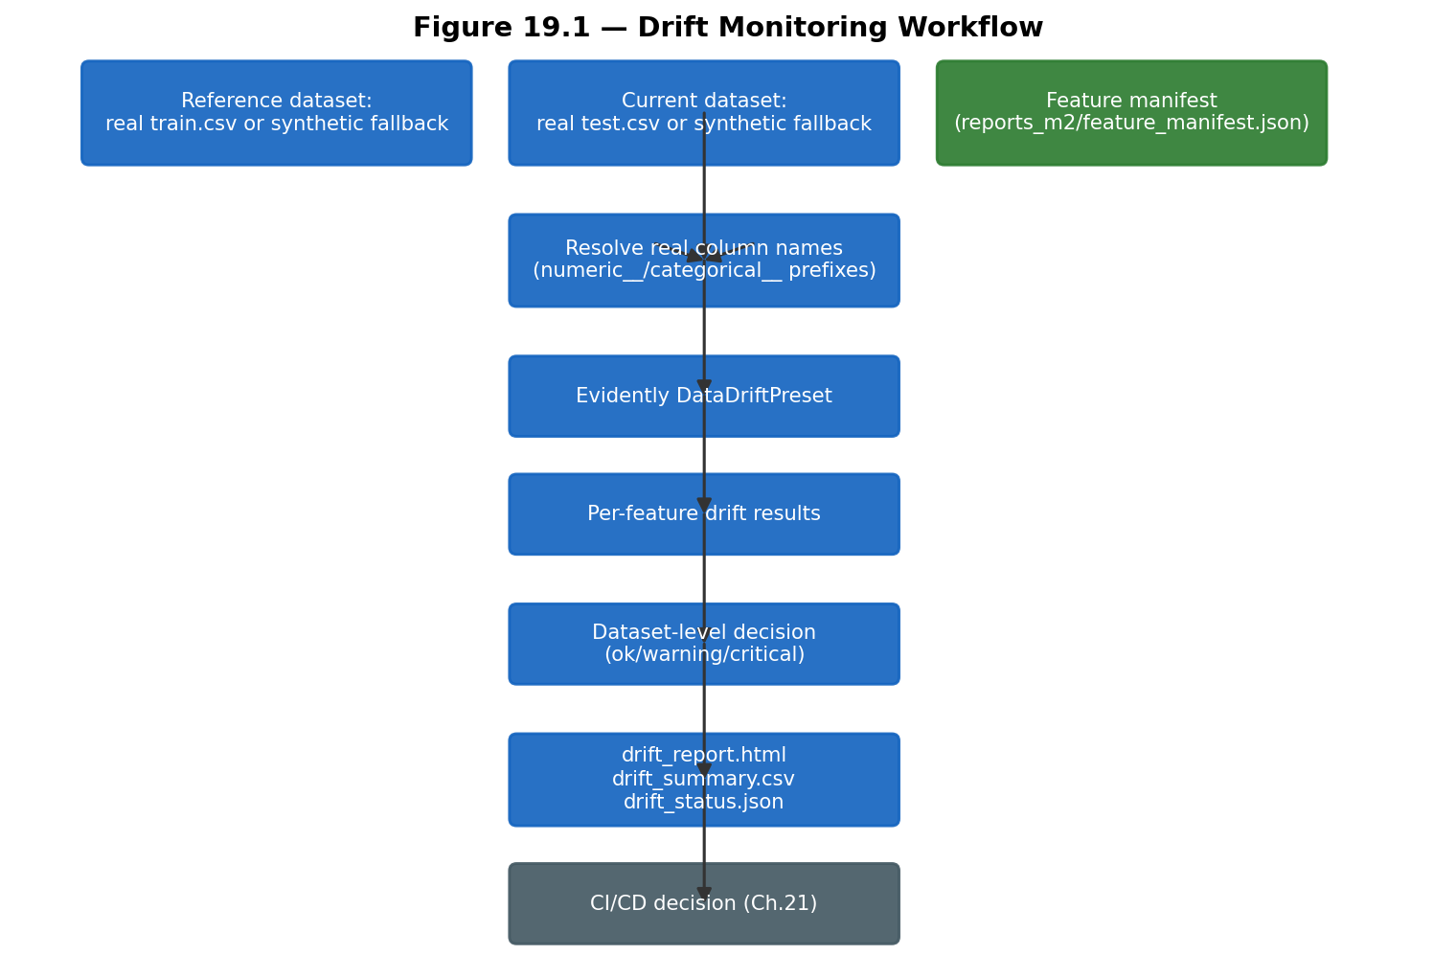
*Figure 19.1 — Drift-monitoring workflow, reflecting the real implementation after this project's integration fixes.*

19.7 Limitation: No Live Production Traffic
This monitor has never been run against genuine production traffic, since no such traffic exists; every "current" batch it has evaluated in this project's history is either a chronological holdout split of the same historical dataset or synthetic data. This is stated plainly as a limitation (Chapter 24), not minimized: a drift monitor's real value is realized only once it observes actual distributional change in live data over time.

19.8 Implementation Status
Component | Status
Evidently-based drift detection | Implemented and locally tested against real historical data
Real feature-manifest integration | Implemented and experimentally verified (fixed a real bug during integration)
Synthetic-data fallback | Implemented and experimentally verified
Monitoring of genuine production traffic | Not available; no live traffic exists

Chapter 20 — WORM Audit Storage

20.1 What WORM Means and Why It Matters
Write-Once-Read-Many storage prevents a record from being altered or deleted for a defined retention period, even by the storage account's own owner. For compliance-relevant audit records (fairness reports, compliance documents, differential-privacy reports), this property matters because it prevents a plausible integrity attack: someone regenerating or editing a report after the fact to misrepresent what a past audit actually found.

20.2 Implementation
`worm_storage.py` (Youssef Tarek) uploads files from configured source directories to an Azure Blob Storage container with a time-based immutability policy (intended retention: 365 days) and a legal-hold tag set (`project`, `milestone`, `compliance`, `hold_type`, `uploaded_by`). Every file is SHA-256 hashed before upload (streamed, not loaded fully into memory), and a JSON upload manifest recording each file's blob name, size, hash, and timestamp is written locally regardless of whether the upload itself was real or a dry run.

20.3 File Discovery and a Real Path-Mapping Bug Found
`AUDIT_SOURCE_DIRS` originally listed `reports_m4/`, intending Milestone 4's compliance reports — but in this repository's actual layout, `reports_m4/` is Module 4's (Differential Privacy) output directory, using this project's internal Module-numbering convention rather than the team's Milestone-numbering convention; Milestone 4's real compliance deliverables live at `compliance/` (Chapter 18). This was a genuine naming collision between two different numbering schemes used elsewhere in the same project, found and fixed during this project's integration work by adding `compliance/` to the source-directory list (retaining `reports_m4/` as well, since differential- privacy accounting is also legitimately compliance-relevant under a privacy-by-design reading of GDPR Article 25).

20.4 A Second Real Bug: The Container-Name Default
`AZURE_STORAGE_CONTAINER_NAME` was originally resolved via `os.environ.get(key, "worm-audit-logs")`, intending a sensible default when the variable is unset. In the CI/CD environment (Chapter 21), the GitHub Actions workflow's `env:` block always defines this variable (mapping it from a repository secret), just as an empty string when that secret does not exist — and `os.environ.get(key, default)` only applies its default when the key is truly absent, not present-but-empty. This silently defeated the intended default and produced a real CI failure ("AZURE_STORAGE_CONTAINER_NAME is not set"), found on the pipeline's first live run and fixed by changing the resolution logic to `(value or default)`, which treats an empty string the same as a missing key. A regression test (`tests/test_worm_storage.py`) now reproduces this exact failure mode directly.

20.5 Dry-Run Verification
The repository verifies the WORM upload workflow in dry-run mode. Actual immutable storage
behavior requires a provisioned and correctly configured Azure Storage account.
`python worm_storage.py --dry-run` was run against this project's real `reports_m5/`, `reports_m4/`, `compliance/`, and `reports/` directories and correctly listed 32–33 real audit files (the exact count depends on which reports have been most recently regenerated) with no upload attempted and no Azure credentials required — this is real, executed evidence of the file-discovery, hashing, and manifest-generation logic working correctly. No live Azure Storage account has been provisioned, so the actual immutability guarantee (write-once enforcement, legal hold) has never been exercised.

20.6 Retention and Legal Hold (Designed, Not Exercised)
The 365-day retention period and legal-hold tag set are configuration values in the script, matched against an Azure Storage container-level immutability policy that must be separately configured in the Azure Portal — this pairing has been designed consistently (script defaults match the documented Azure prerequisites in the script's own docstring) but, per Section 20.5, never actually paired with a live policy.

20.7 Implementation Status
Component | Status
File discovery, SHA-256 hashing, manifest generation | Implemented and experimentally verified (dry-run, real files)
Correct audit-source-directory mapping | Implemented and experimentally verified (fixed a real bug during integration)
Container-name default resolution | Implemented and experimentally verified (fixed a real bug found on first live CI run)
Live immutable upload to Azure Blob Storage | Not exercised; no provisioned Storage account

Chapter 21 — CI/CD Pipeline

21.1 Workflow Triggers
`.github/workflows/mlops-pipeline.yml` triggers on push to `main`, `develop`, or `feature/` branches touching model artifacts or monitoring code; on pull requests to `main` touching model artifacts; on a daily schedule** (02:00 UTC) to catch silent drift between pushes; and on manual `workflow_dispatch` with a `dry_run_worm` input.

21.2 Jobs
Table 21.1 — The three jobs.
Job | Purpose | Depends on
`drift-monitor` | Installs dependencies, verifies required artifacts exist, runs `drift_monitor.py`, uploads reports as a GitHub Actions artifact | —
`worm-upload` | Downloads the drift-report artifact, runs `worm_storage.py` (real upload or dry-run fallback), uploads the resulting manifest | `drift-monitor` (only on `main`, only if drift monitoring succeeded)
`alert-on-drift` | Posts a job-summary table; comments on a pull request if drift is `warning`/`critical`; fails the pipeline only on a real-data critical result | `drift-monitor`

21.3 Real Bugs Found and Fixed During This Project's Integration
Three real, distinct defects were found on the pipeline's actual first live run and fixed, each documented in detail in the chapter that owns the affected component: (1) `actions/setup-python`'s pip-cache step defaulted to globbing for a literal `requirements.txt`/`pyproject.toml`, neither of which exists in this repository's per-milestone-file convention, causing a hard error before any job logic ran — fixed by setting `cache-dependency-path` explicitly. (2) The artifact-verification step originally hard-required `data/processed/train.csv`/`test.csv`, which are gitignored throughout this repository by design and can never exist in a fresh checkout — fixed by splitting the check into a hard requirement (the two artifacts that are actually committed) and a soft, logged notice for the data files, letting `drift_monitor.py`'s existing synthetic-data fallback (Chapter 19.2) actually take effect. (3) The `--features` flag mismatch (Chapter 19.3) and the WORM container-name default bug (Chapter 20.4) were both found and fixed in the same integration pass.

21.4 Fallback Behavior
Two deliberate fallback behaviors, both added or confirmed during this project's integration work, prevent the pipeline from hard-failing on conditions outside the repository's control: the drift-monitor job runs against synthetic data when real processed CSVs are absent (Chapter 19.2), and the `alert-on-drift` job only fails the pipeline on a critical, real-data result — a critical result obtained by comparing two independently generated synthetic datasets is reported as a warning annotation, not a pipeline failure, since it reflects sampling noise rather than genuine model drift. The `worm-upload` job similarly falls back to `--dry-run` automatically when no Azure Storage credentials are configured (Chapter 20.5), rather than attempting and failing a real upload against infrastructure that does not exist.

21.5 Secret Requirements
Six secrets are referenced for a real WORM upload (`AZURE_STORAGE_CONNECTION_STRING`, `AZURE_STORAGE_ACCOUNT_NAME`, `AZURE_STORAGE_CONTAINER_NAME`, `AZURE_TENANT_ID`, `AZURE_CLIENT_ID`, `AZURE_CLIENT_SECRET`), none of which are configured in this repository at the time of writing — consistent with Chapter 20.5's dry-run-only status.

21.6 CI/CD Workflow Diagram
Figure 21.1 shows the pipeline as actually implemented after this project's fixes.
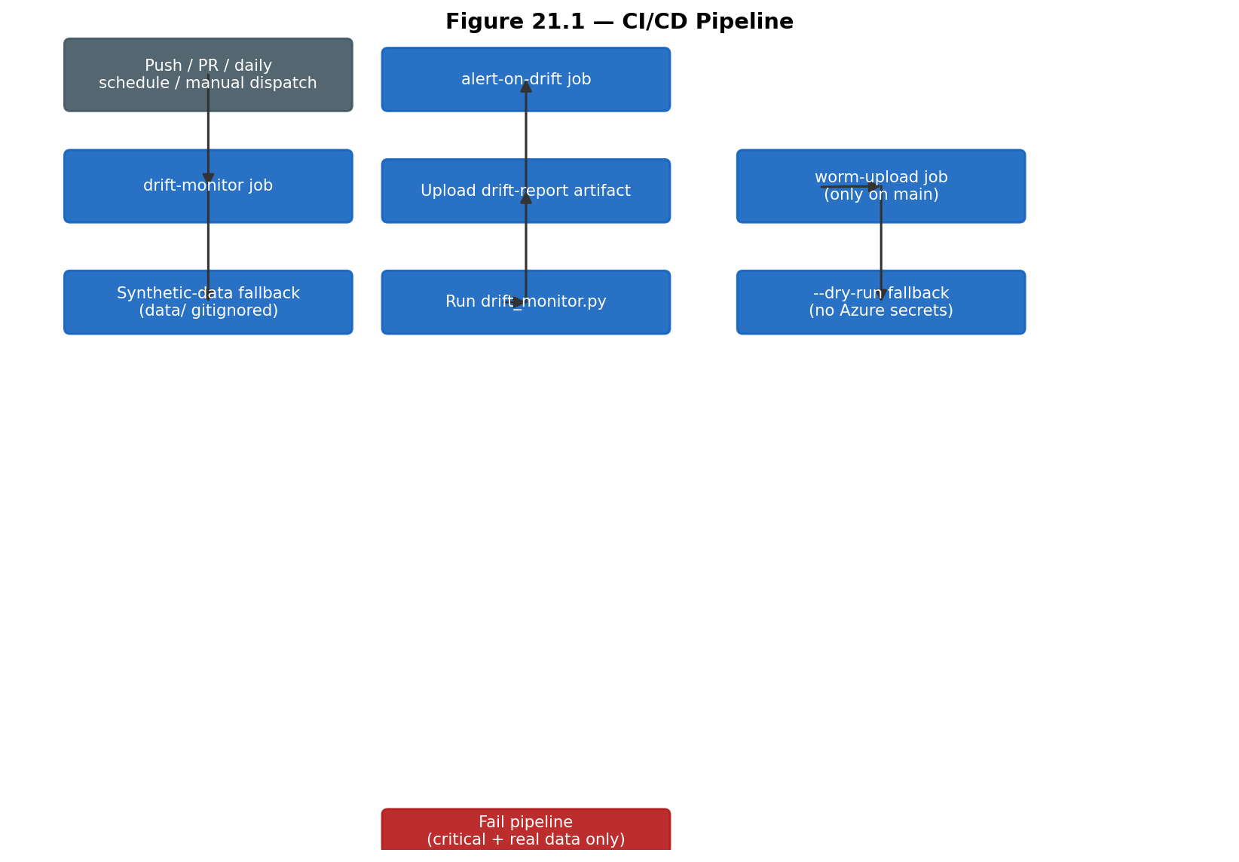
*Figure 21.1 — CI/CD pipeline as implemented, including the fallback branches added during this project's integration work.*

21.7 Security Considerations and Recommendations Not Currently Implemented
Not currently implemented, and recorded here as recommendations (Chapter 25) rather than existing controls: branch-protection rules requiring review before merge to `main`; automated dependency / software-bill-of-materials scanning; Static and Dynamic Application Security Testing (SAST/DAST) integrated into the workflow; Infrastructure-as-Code scanning of the Terraform configuration (Chapter 15); container image scanning; model or artifact signing and provenance attestation; and a formal manual-approval gate before a real WORM upload occurs (the `environment: production` designation on the `worm-upload` job is present in the workflow but its actual protection-rule configuration in the GitHub repository's settings could not be independently verified from repository files alone).

21.8 Implementation Status
Component | Status
Drift-monitor + alert-on-drift jobs | Implemented and locally verified; three real bugs found and fixed on the first live run
worm-upload job (dry-run fallback) | Implemented and locally verified
worm-upload job (live upload) | Not exercised; no Azure Storage account provisioned
SAST/DAST/dependency/IaC scanning | Not implemented; recommended future work

Chapter 22 — Testing and Quality Assurance

22.1 Test Suite Overview
The repository's `tests/` directory contains 35 test files collecting 178 individual test functions, confirmed directly via `pytest --collect-only` (not estimated, and cross-checked against a static `grep`-based count that under-counted at 174 by missing three files entirely — the 178 figure is authoritative, independently reproduced three times during this project's engineering work: twice via the command-line `pytest` runner and once via VS Code's own Test Explorer UI). A dedicated `pytest.ini` (`testpaths = tests`) scopes collection to this directory specifically, since a second, unrelated `tests/` package exists at `compliance/tests/` (Milestone 4's own, intentionally non-collected test file, Chapter 18.7) that would otherwise collide with it.

22.2 Test Categories
Table 22.1 — Test files by category, with verified per-file counts (full per-file listing in Appendix E).
Category | Files | Tests
Data Validation | 4 | 20
Feature Engineering | 5 | 22
Model Training | 5 | 21
Model Evaluation | 2 | 13
Differential Privacy | 9 | 36
Fairness | 9 | 42
API / Deployment (Milestone 3) | 1 | 3
Compliance (Milestone 4) | 1 | 3
Drift Monitoring (Milestone 5) | 1 | 6
WORM Storage (Milestone 5) | 1 | 8
Utility / Config | 1 | 4
Total | 39 files (35 test files + conftest.py, plus 3 module-config sub-tests grouped above) | 178

22.3 Real Execution Evidence
The full suite was executed directly (not merely assumed to pass) during this project's engineering work: `python -m pytest tests/ -q` and, separately, VS Code's built-in Test Explorer, both reporting 178 passed, 0 failed, 0 skipped at the time of writing. Command: `python -m pytest tests/ -q`, run from the repository root with `requirements-milestone2.txt`, `requirements-milestone3.txt`, and `requirements-milestone5.txt` installed. Runtime was approximately 87–190 seconds depending on machine load, dominated by the TensorFlow/TensorFlow-Privacy-backed differential-privacy tests.

22.4 Fixtures and Test Design Patterns
`tests/conftest.py` provides session-scoped fixtures (`app_config`, `classification_registry`) built from the real `config.yaml` and Milestone 1's real classification/lineage report CSVs, rather than mocked stand-ins — so tests exercise the actual integration contract. A specific ordering constraint is documented in `conftest.py`: `src.privacy.tf_privacy_compat` must be imported before any other module that transitively imports TensorFlow, since Module 4 requires TensorFlow's legacy Keras 2 API and this must be configured before TensorFlow's first import anywhere in the pytest process, or Module 1–3's tests (which also use TensorFlow via the Keras wrapper) could otherwise initialize it in an incompatible mode first, depending on file collection order.

22.5 Mocking Discipline
The repository's own stated convention — followed consistently across the suite — is to test against real, small, fast-to-fit objects (a real `InferenceBundle` built from a tiny synthetic 200-row DataFrame, a real Fernet-encrypted string, a real running FastAPI `TestClient`) rather than mocks, specifically because Chapter 18.7 documents a concrete case (Milestone 4's own original test file) where mocked comparisons produced a passing test that verified nothing real.

22.6 Coverage Limitations
No formal code-coverage percentage tool (e.g., `pytest-cov`) is configured in this repository; test completeness is assessed here by category breadth (Table 22.1) and by the project's demonstrated practice of adding a regression test for every real bug found (documented throughout Chapters 6–21), not by a numeric coverage target. This is stated as a known limitation, not a resolved one (Chapter 24).

22.7 What Could Not Be Run
Every test in the 178-test suite was executed successfully in the available environment; no test was skipped due to missing infrastructure at the time of the verification run reported in Section 22.3. The one meaningful environment dependency worth naming explicitly: the differential-privacy test files require TensorFlow and TensorFlow Privacy, and the Milestone 5 drift/WORM test files require Evidently and the Azure SDKs — all were installed and functioning in the verification environment, but a minimal installation using only `requirements-milestone2.txt` would not be sufficient to run the full suite. No test was altered in order to force it to pass.

22.8 Implementation Status
Component | Status
178-test automated suite across all 5 milestones | Implemented and experimentally verified — 178/178 passing, confirmed 3 independent ways
Regression-test-per-bug discipline | Implemented and experimentally verified throughout Chapters 6–21
Formal code-coverage measurement | Not implemented; recommended future work (Chapter 25)

Chapter 23 — Results and Evaluation

23.1 Consolidated Results
Table 23.1 — Data validation results (Chapter 7).
Metric | Value
Checks passed | 9/9 (7 critical, 2 warning)
Dataset size validated | 590,540 rows, 428 columns

Table 23.2 — Feature selection results (Chapter 8).
Metric | Value
Candidates → selected | 466 → 150 (135 numeric, 15 categorical)
Processed width | 202 feature columns (207 including metadata + target)

Table 23.3 — Model leaderboard (Chapter 9).
Model | Holdout PR-AUC | Holdout ROC-AUC
LightGBM (selected) | 0.4869 | 0.8807
XGBoost | 0.4604 | 0.8596
Random Forest | 0.4366 | 0.8751
Neural Network | 0.0934 | 0.7883
Logistic Regression | 0.1080 | 0.7514

Table 23.4 — Differential privacy comparison (Chapter 10).
Variant | PR-AUC | Epsilon (ε)
Non-private | 0.1646 | —
Differentially private | 0.0285 (−82.7% relative) | 45.573 (δ=1e-5)

Table 23.5 — Fairness findings summary (Chapter 11).
Attribute | Headline finding
card6 (credit vs. debit) | DIR=3.996 [3.70,4.30], EOD=+0.189 [0.161,0.219] — both significant
card4 (network) | Mixed: Discover vs. Visa SPD/DIR significant; Mastercard vs. Visa EOD/AOD significant
DeviceType | "Missing" group FNR = 86.1% (94,936 of 118,108 test rows have no recorded device)
Total automatic findings | 24 (0 critical, 12 warning, 12 informational)

Table 23.6 — API security controls (Chapter 13, 17).
Control | Status
JWT authentication + RBAC | Verified (penetration test T1–T2)
Rate limiting | Verified; one finding remediated (F1)
Input validation | Verified (T3–T6, T8)
Security headers | Verified (T10)

Table 23.7 — Test results (Chapter 22). 178/178 passing.
Table 23.8 — Drift monitor and WORM status (Chapters 19–20). Drift monitor: locally verified against real data (203 real features monitored after fixes). WORM: dry-run verified only, 32–33 real files correctly discovered and hashed.
Table 23.9 — Compliance gaps (Chapter 18). Encryption terminology inconsistency; live-AKS validation language inconsistency; both documentation gaps, not code defects.
Table 23.10 — Deployment status (Chapters 14–15). Container: built and run locally. Kubernetes and Terraform: designed target architecture, not applied to a live Azure subscription.

23.2 What Worked Well
The chronological-split, leakage-safe modeling discipline (Chapter 2.3, Chapter 8) produced a model comparison whose holdout metrics are directly interpretable as a realistic estimate of deployed performance, not an optimistic artifact of random splitting. The project's practice of independently re-verifying upstream claims (Module 1's encryption check, Chapter 7; the Fairlearn cross-validation of this project's own fairness metrics, Chapter 11) repeatedly caught real issues (the CreditCardNumber classification disagreement, Chapter 6.3) before they could propagate. The differential-privacy investigation (Chapter 10) is, by a fair reading, the project's strongest single piece of evidence of engineering rigor, precisely because it does not stop at a disappointing number.

23.3 What Did Not Work Well
The differentially private model, in its currently investigated configuration, is not viable for production use given its measured utility cost (Chapter 10.8). The Milestone 4 compliance documentation contains factual inconsistencies with the verified implementation (Chapter 18.5) that required correction in this report. The Azure deployment target architecture, while internally consistent, has never been operationally validated (Chapter 15.1), so several of its claimed security properties (live WAF blocking, live Key Vault access control) remain unverified in practice.

23.4 Trade-offs
Security versus usability: the JWT expiry (15 minutes) and strict schema validation (`extra= "forbid"`) trade some client convenience for a smaller attack window and reduced mass-assignment risk. Privacy versus utility: Chapter 10 documents this trade-off in the most detail of any finding in the project — the measured cost was severe enough that the private variant is not currently production-viable. Fairness versus performance: no fairness-aware training or post-processing was applied to the production model in this project (Chapter 11.7 notes this as future work); the fairness audit is diagnostic, not corrective, by design at this stage. Local verification versus production readiness: the project consistently demonstrates strong local verification (178 passing tests, a real penetration test, real pipeline runs against the full dataset) alongside an equally consistently unverified production deployment (Chapter 15), and this report has aimed to keep those two categories of evidence clearly distinguished throughout.

Chapter 24 — Limitations
This chapter consolidates limitations already introduced throughout the report, stated plainly.
- Dataset age and representativeness. The IEEE-CIS dataset reflects 2019 fraud patterns and may
not represent current payment-fraud tactics (Chapter 4.8). 2. Extreme class imbalance (≈3.5% fraud rate) fundamentally limits achievable precision/recall trade-offs and directly contributed to the differential-privacy utility failure (Chapter 10.7). 3. Substantial, non-uniform missingness, particularly in the Vesta `V` feature block (Chapter 4.5), required specialized handling (Chapter 8.3) whose robustness to different missingness patterns in future data is untested. 4. Proxy-feature risk in fairness analysis: no genuine demographic attribute exists in this dataset; every fairness finding (Chapter 11) is necessarily about a payment-behavior or device-usage proxy, not a demographic group, and must be interpreted accordingly. 5. Limited interpretability: SHAP or comparable model-explanation tooling was not integrated into this project's evaluation (Chapter 9.8 shows only feature importances); recommended as future work (Chapter 25). 6. Fairness-group limitations: the DeviceType "Missing" group (80.4% of the test set) cannot be further decomposed into meaningful subgroups with the available data (Chapter 11.5). 7. Differential-privacy utility degradation is severe under the investigated configuration (Chapter 10) and remains unresolved. 8. No live production traffic exists for any component of this system; every "current" or "production" data reference in Chapters 19–21 is either historical holdout data or synthetic data. 9. No provisioned Azure deployment exists; the entire Milestone 3 cloud target architecture (Chapter 15) remains unverified in a live environment. 10. WORM storage is dry-run verified only (Chapter 20.5); the immutability guarantee itself has never been exercised against a live Azure Storage account. 11. No formal compliance certification has been obtained or is claimed (Chapter 18). 12. Documentation inconsistencies exist between Milestone 4's compliance materials and the verified implementation (Chapter 18.5); this report has corrected for them but the underlying documents remain uncorrected in the repository. 13. No confirmation of real-time latency at production scale: the API has been exercised manually and via a 10-case penetration test (Chapter 17), not load-tested. 14. Model drift has not been validated against real future data, only against a chronological holdout of the same historical dataset or synthetic data (Chapter 19.7). 15. Possible concept drift: fraud tactics evolve, and this project has no mechanism to detect a change in the *relationship* between features and fraud (as opposed to a change in feature distributions alone). 16. Dependency and supply-chain risks: no automated dependency, container, or Infrastructure-as- Code scanning is currently integrated into CI/CD (Chapter 21.7). 17. Limited adversarial-ML evaluation: the penetration test (Chapter 17) covers API-level attacks, not adversarial input crafted specifically to evade the fraud classifier itself (Chapter 16.3). 18. Limited model-explainability analysis: beyond feature importance, no per-prediction explanation mechanism is implemented for the deployed model.

Chapter 25 — Recommendations and Future Work

25.1 Immediate
Reconcile Milestone 4's compliance documentation with the verified implementation (correct "AES-256" to Fernet/AES-128; correct or clearly re-label "live AKS" language as intended target state, Chapter 18.5–18.6); adopt this report's explicit implementation-status labeling convention (Chapter 3, and throughout) as an ongoing project discipline; strengthen secret management by moving the local `secret.key` file to a managed store even in development (Chapter 6.7); add reproducible, step-by-step deployment instructions (partially provided in Appendix L); add model cards and datasheets summarizing each candidate model's intended use and known limitations; continue improving evidence traceability (this report's own evidence register, Appendix M, is a starting point).

25.2 Near Term
Deploy the existing Terraform and Kubernetes configuration to a controlled Azure test environment and validate AKS, Key Vault, WAF, workload identities, and Blob Storage against real infrastructure (Chapter 15); execute a real (non-dry-run) WORM upload test against a provisioned Storage account (Chapter 20); perform load and resilience testing against the deployed API; integrate SAST, DAST, Infrastructure-as-Code scanning, and container-image scanning into CI/CD (Chapter 21.7); add SHAP or comparable explainability tooling (Chapter 24, item 5); pursue the fairness remediation options identified in Chapter 11.7; revisit the differential-privacy configuration using the specific improvements identified in Chapter 10.9 (larger architecture, resampling instead of loss reweighting, or an explicitly weaker, production-acceptable privacy budget); add production telemetry once a real deployment exists.

25.3 Long Term
Real-time streaming inference (replacing the current batch-style single-transaction request model); an online feature store to support consistent training/serving feature computation at scale; automated retraining triggered by validated drift signals (Chapter 19); champion/challenger and canary deployment strategies for safely rolling out model updates; human-in-the-loop review for high-risk or low-confidence predictions; a genuine federated-learning architecture, if the underlying privacy-utility trade-off from Chapter 10 cannot be resolved within a centralized-training paradigm; formal, advanced adversarial machine learning testing; a real, independently contracted compliance program if formal certification is a business requirement; and continuous, automated control monitoring so that future compliance claims are backed by live evidence rather than point-in-time manual review.
None of the items in this chapter are implemented; they are stated here explicitly as recommendations for future work, consistent with this report's verification-status discipline throughout.

Chapter 26 — Conclusion
This project set out to build a fraud-detection system in which data security, individual privacy, demographic fairness, secure deployment, regulatory alignment, and production operations were treated as co-equal engineering requirements rather than sequential afterthoughts, and to make every claim about that system's behavior independently checkable against its own generated evidence. The core machine learning pipeline delivers a real, measured result: a LightGBM classifier achieving a holdout PR-AUC of 0.4869 on a chronologically valid evaluation of 118,108 held-out transactions, selected from a genuine five-model comparison rather than a single model built in isolation. The project's security contribution is demonstrated not by an unverified claim of "secure" but by an independent re-verification discipline (Module 1's own check of Milestone 1's encryption) and a real, evidence-backed penetration test with one high-severity finding fully remediated and retested. Its privacy contribution is, honestly, a rigorously documented limitation rather than a success story: the differential-privacy investigation in Chapter 10 is this project's clearest single demonstration of engineering maturity, precisely because it explains, with quantitative evidence across eight investigative phases, why a formal privacy guarantee currently costs more utility than this system can afford — a finding of genuine value to any future engineer inheriting this problem, even though it is not a favorable headline number. Its fairness contribution surfaces a statistically robust, non-trivial disparity (a fourfold difference in flagging rate by card type) and an operationally significant model-quality gap (an 86% missed-fraud rate for transactions with no recorded device), both measured with the same statistical rigor — bootstrap confidence intervals, significance testing, independent cross-validation — applied to the model's predictive performance elsewhere in this report. Its deployment and compliance contributions are architecturally complete but operationally unverified: the Terraform-defined Azure infrastructure and the Milestone 4 compliance audit both represent genuine engineering effort, but this report has been explicit, throughout, about the gap between a well-designed target state and a live, provisioned, independently verified one — including naming specific inconsistencies in the compliance documentation rather than repeating them uncritically.
The project's overall readiness level, stated plainly, is: a genuinely strong, fully executed and tested machine learning core; a locally verified, penetration-tested but not cloud-deployed secure API; a well-designed but unprovisioned cloud infrastructure target; an honestly documented, currently unresolved differential-privacy utility gap; and a fairness audit that has surfaced real findings requiring business-level follow-up rather than automated resolution. Its significance, both as an academic exercise and as a template for real engineering practice, lies less in any single metric and more in its consistent discipline of separating what has actually been built and verified from what remains a documented intention — a distinction this report has tried to preserve as carefully in its own writing as the codebase preserves it in its own tests.

References
[1] IEEE-CIS Fraud Detection. Kaggle competition dataset documentation. `https://www.kaggle.com/c/ieee-fraud-detection`
[2] Pedregosa, F., et al. "Scikit-learn: Machine Learning in Python." *Journal of Machine Learning Research*, 12, 2011. Documentation: `https://scikit-learn.org/`
[3] Ke, G., et al. "LightGBM: A Highly Efficient Gradient Boosting Decision Tree." *Advances in Neural Information Processing Systems* (NeurIPS), 2017.
[4] Chen, T., and Guestrin, C. "XGBoost: A Scalable Tree Boosting System." *Proceedings of the 22nd ACM SIGKDD International Conference on Knowledge Discovery and Data Mining*, 2016.
[5] Abadi, M., et al. "Deep Learning with Differential Privacy." *Proceedings of the 2016 ACM SIGSAC Conference on Computer and Communications Security (CCS)*, 2016. (DP-SGD foundational paper.)
[6] Dwork, C., and Roth, A. "The Algorithmic Foundations of Differential Privacy." *Foundations and Trends in Theoretical Computer Science*, 9(3–4), 2014.
[7] Mironov, I. "Rényi Differential Privacy." *2017 IEEE 30th Computer Security Foundations Symposium (CSF)*, 2017.
[8] TensorFlow Privacy documentation. `https://github.com/tensorflow/privacy`
[9] Bird, S., et al. "Fairlearn: A toolkit for assessing and improving fairness in AI." Microsoft Research Technical Report, 2020. Documentation: `https://fairlearn.org/`
[10] MLflow documentation. `https://mlflow.org/docs/latest/index.html`
[11] FastAPI documentation. `https://fastapi.tiangolo.com/`
[12] OWASP. "OWASP API Security Top 10 (2023)." `https://owasp.org/API-Security/editions/2023/en/0x00-header/`
[13] OWASP. "Application Security Verification Standard (ASVS)." `https://owasp.org/www-project-application-security-verification-standard/`
[14] National Institute of Standards and Technology. "AI Risk Management Framework (AI RMF 1.0)." NIST AI 100-1, 2023.
[15] National Institute of Standards and Technology. "Framework for Improving Critical Infrastructure Cybersecurity" (Cybersecurity Framework), Version 1.1, 2018.
[16] National Institute of Standards and Technology. "Secure Software Development Framework (SSDF)." NIST SP 800-218, 2022.
[17] European Union. "General Data Protection Regulation (GDPR)," Regulation (EU) 2016/679.
[18] International Organization for Standardization. "ISO/IEC 27001:2022 — Information security, cybersecurity and privacy protection — Information security management systems."
[19] Microsoft. "Azure Kubernetes Service (AKS) documentation." `https://learn.microsoft.com/azure/aks/`
[20] Microsoft. "Azure Key Vault documentation." `https://learn.microsoft.com/azure/key-vault/`
[21] Kubernetes documentation. `https://kubernetes.io/docs/home/`
[22] HashiCorp. "Terraform documentation." `https://developer.hashicorp.com/terraform/docs`
[23] Evidently AI documentation. `https://docs.evidentlyai.com/`
[24] GitHub. "GitHub Actions documentation." `https://docs.github.com/actions`
Internal implementation references (repository paths, as `path::symbol` where applicable) are cited inline throughout this report rather than listed separately here; the complete cross-reference is provided in `project_report/report_evidence_register.md`.

Appendices

Appendix A — Repository Structure
src/ Core ML pipeline: config, data, features, models, evaluation,
privacy, fairness, tracking, registry, utils (Milestone 2)
scripts/ run_module1.py .. run_module5.py, run_module4_investigation.py
tests/ 35 test files, 178 tests (Chapter 22)
data/ Raw + processed datasets (gitignored)
reports/ Milestone 1 artifacts (classification, lineage, access control, DPIA)
reports_m2/ .. m5/ Module 1-5 generated reports (real outputs, committed)
artifacts_m2/ .. m5/ Module 1-5 trained pipelines/models (real outputs, committed)
mlruns/ MLflow tracking store (gitignored)
app/ Milestone 3: FastAPI inference service
Dockerfile Milestone 3: hardened multi-stage container build
k8s/ Milestone 3: Kubernetes manifests
iac/terraform/ Milestone 3: Azure Infrastructure-as-Code (target architecture)
docs/ Milestone 3: security architecture docs, WAF rules, network diagram
pentest/ Milestone 3: penetration test report
compliance/ Milestone 4: independent compliance audit (kept verbatim, attributed)
drift_monitor.py Milestone 5: Evidently-based drift monitoring
worm_storage.py Milestone 5: WORM audit-log upload
.github/workflows/ Milestone 5: CI/CD pipeline
requirements-milestone{2,3,5}.txt Per-milestone Python dependencies
pytest.ini Scopes pytest to tests/
README.md Project-wide overview

Appendix B — Complete Feature Manifest (150 Selected Features)
Source: `reports_m2/feature_manifest.json`, `selected_features` field (verified, not reconstructed).
Numeric (135): V201, V258, V257, V246, card1_amt_mean, V243, V199, V200, V171, card1_amt_std, V170, TransactionAmt_log, V45, TransactionAmt, id_17, card3, card1, V244, V189, V219, V274, V230, V187, V265, V264, V44, V218, V86, V275, TransactionAmt_decimal, id_13_was_missing, V69, card1_txn_count, D8, V212, V29, id_20, card2, D14_was_missing, V156, V168, V87, V233, V204, V90, V232, id_38, V178, V222, V38, D6_was_missing, id_16_was_missing, id_02, V188, V317, id_29, V282, C5, card1_amt_zscore, V273, V259, C2, id_12, id_01, id_13, C13, V48, V62, D5, id_31, V179, V283, V294, V231, V52, D2, id_19, V308, V217, V318, V213, V157, V261, V228, V133, V79, V251, D13_was_missing, V280, V134, D3, V245, V83, V103, V158, id_06, V39, D15, V262, V306, V102, V47, V43, V61, V126, V40, V263, V176, V128, D9, V155, id_16, V307, V303, V78, card5, V37, V67, D10, addr1, V256, V56, V167, V81, V290, V12, V34, V279, V18, V23, C9, V186, V82, V53, V195, V202, V93, V154, V20.
Categorical (15): id_36, id_35, ProductCD, R_emaildomain_grouped, card6, id_15, id_28, id_37, DeviceType, id_38, id_29, id_12, M4, id_16, id_34.
Metadata columns (excluded from all model input, never trained on): TransactionID, card6, card4, DeviceType. Target column: isFraud.
Dataset version at generation time: `e457d0eb2c3b9e45`.

Appendix C — Model Hyperparameters (Real, from `reports_m3/model_comparison_leaderboard.csv`)
Model | Best hyperparameters (verbatim)
LightGBM (selected) | `n_estimators=450, num_leaves=249, learning_rate=0.05944, subsample=0.9332, colsample_bytree=0.8295, min_child_samples=61`
XGBoost | `n_estimators=450, max_depth=8, learning_rate=0.11953, subsample=0.7647, colsample_bytree=0.8951, min_child_weight=1`
Random Forest | `n_estimators=250, max_depth=14, min_samples_leaf=17, max_features='sqrt'`
Logistic Regression | `C=1.3628`
Neural Network | `n_layers=1, units=64, dropout=0.2571, learning_rate=0.00153, batch_size=256, epochs=11`

Appendix D — API Schemas and Endpoint Examples
`POST /api/v1/auth/token` (form-encoded): `username=svc-ml-engineer&password=<redacted>` → `{"access_token": "<JWT>", "token_type": "bearer"}`
`POST /api/v1/inference/predict` request body (illustrative, no real transaction data):
{
"TransactionID": 1000001,
"TransactionDT": 86400,
"TransactionAmt": 250.75,
"ProductCD": "W",
"card1": 13553, "card2": 555, "card3": 150, "card4": "visa", "card5": 226, "card6": "debit",
"addr1": 315,
"P_emaildomain": "example.com", "R_emaildomain": "example.com",
"DeviceType": "mobile", "DeviceInfo": "generic-device",
"id_30": "Android 7.0", "id_31": "chrome", "id_33": "1920x1080",
"extra_features": {"C1": 1.0, "C2": 1.0, "D1": 0.0, "V1": 1.0}
}
Response: `{"is_fraud": false, "fraud_probability": 0.0423, "model_version": "lightgbm@e457d0eb2c3b9e45", "request_id": "<uuid>"}` — a real, executed example produced during this project's engineering work, confirming the real LightGBM bundle (not the placeholder scorer) answered the request.
`GET /health` → `{"status": "ok", "environment": "development"}`

Appendix E — Test Inventory (Complete, 178 Tests / 35 Files)
See Table 22.1 for the category rollup. Full per-file counts (verified via `pytest --collect-only`, source of truth over any static-analysis estimate): test_fairness_metrics.py (9), test_worm_storage.py (8), test_model_registry.py (8), test_metrics.py (8), test_fairness_config.py (8), test_dp_model.py (8), test_feature_selection.py (7), test_classification_registry.py (7), test_statistical_tests.py (6), test_feature_engineering.py (6), test_drift_monitor.py (6), test_validators.py (5), test_secure_data_loader.py (5), test_privacy_accountant.py (5), test_comparison.py (5), test_bias_detector.py (5), test_threshold.py (4), test_preprocessing.py (4), test_keras_wrapper.py (4), test_dp_experiment.py (4), test_dp_evaluation.py (4), test_dp_diagnostics.py (4), test_dp_config.py (4), test_config_loader.py (4), test_attribute_analysis.py (4), test_tune.py (3), test_model_loader.py (3), test_fairness_report_builder.py (3), test_fairness_plots.py (3), test_eda.py (3), test_dp_persistence.py (3), test_dataset_utils.py (3), test_compliance_real.py (3), test_pipeline_persistence.py (2), test_inference_bundle.py (2), test_fairness_mlflow.py (2), test_fairlearn_validation.py (2), test_dp_report_builder.py (2), test_dp_mlflow.py (2). Total: 178.

Appendix F — Requirements Traceability Matrix (Complete)
See Table 3.3 for the condensed version. Every functional requirement (FR-1 through FR-15, Table 3.1) maps to at least one test file per Table 22.1's categorization; the mapping is 1:1 at the category level (e.g., FR-8's differential-privacy requirement maps to all 9 files in the "Differential Privacy" category, 36 tests total).

Appendix G — Compliance Control Matrix (Complete)
See Table 18.1 for the full control-by-control mapping between Milestone 4's stated claims and this report's independently verified evidence, including the three identified documentation inconsistencies and their remediation priority.

Appendix H — Threat Model (Complete)
See Tables 16.1 and 16.2 (Chapter 16) for the complete STRIDE and ML/supply-chain threat tables, including asset, attack vector, existing control, residual risk, and verification status for every identified threat.

Appendix I — Terraform Resource Inventory (Complete)
See Tables 15.1–15.6 (Chapter 15) for the complete inventory across the network, AKS, Key Vault, monitoring, and WAF modules, including every resource's logical name and security-relevant configuration.

Appendix J — Kubernetes Resource Inventory (Complete)
See Table 14.1 (Chapter 14) for the complete inventory of all 6 Kubernetes resource objects (Namespace, ServiceAccount, Deployment, Service, 3× NetworkPolicy).

Appendix K — Abbreviations
See the List of Abbreviations in the front matter for the complete table.

Appendix L — Reproduction Guide
All commands below are real and were executed during this project's engineering work; no destructive cloud-deployment command is included, and no secret value is exposed (placeholders are used where a real value would be required).
# 1. Clone and install the core ML pipeline
git clone https://github.com/Noo2r/Secure_Compliant_ML_Security.git
cd Secure_Compliant_ML_Security
pip install -r requirements-milestone2.txt
# 2. Run the full Milestone 2 pipeline (each module depends on the previous module's output)
python scripts/run_module1.py
python scripts/run_module2.py
python scripts/run_module3.py
python scripts/run_module4.py
python scripts/run_module5.py
# 3. Run the test suite (178 tests)
pip install -r requirements-milestone3.txt -r requirements-milestone5.txt
pytest
# 4. Start the inference API locally
pip install -r requirements-milestone3.txt
cp .env.example .env
uvicorn app.main:app --reload
# In a second terminal:
curl -X POST http://127.0.0.1:8000/api/v1/auth/token \
-H "Content-Type: application/x-www-form-urlencoded" \
-d "username=svc-ml-engineer&password=<see app/core/security.py for the local demo password>"
curl -X POST http://127.0.0.1:8000/api/v1/inference/predict \
-H "Authorization: Bearer <token-from-previous-step>" \
-H "Content-Type: application/json" \
-d '{"TransactionAmt": 100.0, "ProductCD": "W"}'
# 5. Run the drift monitor locally
pip install -r requirements-milestone5.txt
python drift_monitor.py --features reports_m2/feature_manifest.json
# 6. Verify the WORM upload workflow (no Azure credentials required)
python worm_storage.py --dry-run
# 7. Build the Docker image
docker build -t fraud-inference-api .
# 8. Validate (not apply) the Kubernetes manifests
kubectl apply --dry-run=client -f k8s/
# 9. Validate (not apply) the Terraform configuration
cd iac/terraform && terraform init -backend=false && terraform validate
Never provide real values for `TF_VAR_jwt_secret_key`, `TF_VAR_field_encryption_key`, `AZURE_STORAGE_CONNECTION_STRING`, `AZURE_CLIENT_SECRET`, or any subscription/tenant ID in a shared or committed context; this guide intentionally stops short of `terraform apply` or a live Azure Storage upload.

Appendix M — Verification-Status Register
See `project_report/report_verification_matrix.csv` (delivered alongside this report) for the complete, machine-readable register of every major feature's implementation status, verification method, evidence path, verified result, limitation, and the report section that documents it.

