Daily Scrum Log

# Sprint 0

The goal of this Sprint is to start setting up the project and get a better understanding of the product we, the team, will need to deliver. This includes creating a Team Plan, Daily Scrum and Client Communication Log, scrum board, Time registration sheet, Functional and Technical design, and Individual learning plan. These documents will be edited and worked on throughout the whole project. In the team plan, the team will decide under which principles/rules it will operate. In this Sprint, the first Client facing is planned. With this facing, the team will meet the client face-to-face and have the opportunity to ask questions about the product. This helps clarify what the client will want and expect the product to have and be able to do.

## Meeting 1 (Wednesday 23-11):

In the first meeting of the team, it was decided that the extra meetings outside of scheduled class hours would be held online on discord. Together we created the scrum boards for each Sprint and added a doing and testing list to each of them. After that, we created tasks that each one of the members could work on. Hai Ha was assigned to work on documenting the team plan. George on the Functional design, starting off with an introduction and problem description. Klaus on the start of setting up the work environment for the project. Tiffany on logging all the daily scrum meetings, so far. Adrien and Darius will be responsible for creating user stories on GitLab.

## Meeting 2 (Saturday 27-11):

This meeting was fast and simple. Each of the team members would update the others about the work they had done so far, how they planned to proceed and if they encountered any problems. Every team member was able to start working on their assigned tasks, but some encountered problems. These problems were communicated to the team.

Hai Ha had some unclarities on what the ‘quality’ part of the team plan needed to contain. He suggested asking the teacher for more clarity on this topic so he can proceed to finalize the team plan.

Georgs wrote the introduction of the Functional Design, consisting of an introduction and problem description. A problem he encountered was that he was not sure what the difference is between the Context Analysis and the problem description. Georgs plans to start setting up the Product Backlog and provide help if other members need it.

Klaus was able to create a start on setting up the work environment. He planned to work further on finishing the setup and wanted to create a start on any wireframe/mockup designs, but to start working on this he would need to know how the application needs to look like and what its functions would be.

Tiffany finished summarizing all the scrum meetings that were held till now documented them in the Daily Scrum Log. She plans to update the document after this meeting and work on expanding the scrum boards with more labels to create a clearer overview.

Adrien worked on creating user stories in Git Lab and read through all the created documents thus far to make changes if necessary. He plans to start working on creating the Product Backlog together with other team members.

Darius also worked on creating user stories together with Adrien. He did some more research on the project and then planned to help with the creation of the Product Backlog.

## Meeting 3 (Monday 28-11):

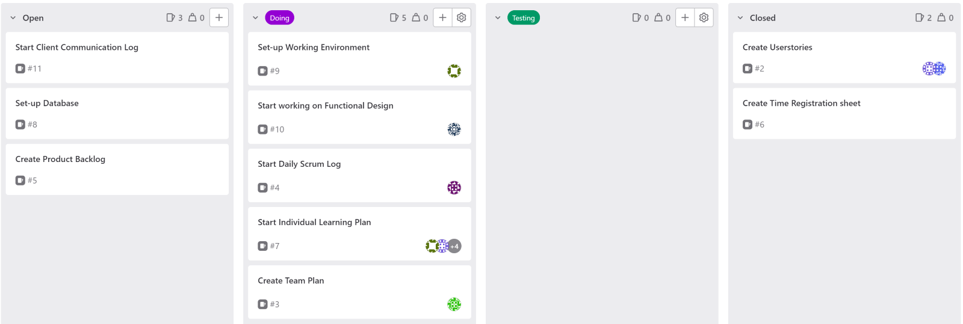In the image above, the current process on Sprint 0 can be seen. In this meeting, the team focused on helping each other with their tasks that they previously mentioned they had problems with. To get a better understanding of what to do next, we researched to find more information on the project. After having completed creating the user stories, the next step was to start working on the product backlog. The ones that were assigned to work on the backlog were Adrien, Darius and Georgs. In this meeting, we also discussed how we wanted to set up the database. We decided to focus on getting Microsoft Azure to work, but this was not set in stone. Most of the team members also started working on their individual learning plan.

## Meeting 4 (Wednesday 30-11):

For this meeting, not all of the team members were present, as there were some who were sick and stayed in contact from home. Hai Ha was able to finalize the Team Plan. Georgs worked on improving the functional design and started on the technical design. Adrien started to look at how to get Microsoft Azure to work and he would look to check if the functional and technical design were progressing as planned. Tiffany started to work on the client communication log and updated the scrum log. Klaus worked on his individual learning plan and Darius started looking to see if he could start creating wireframe designs for the application with Klaus’s help.

## Meeting 5 (Sunday 04-12):

The team got together, online, to see what had to be handed in by the end of this Sprint. We looked at what we still needed and divided the tasks to start completing the required documents/designs.

## Sprint Sum:

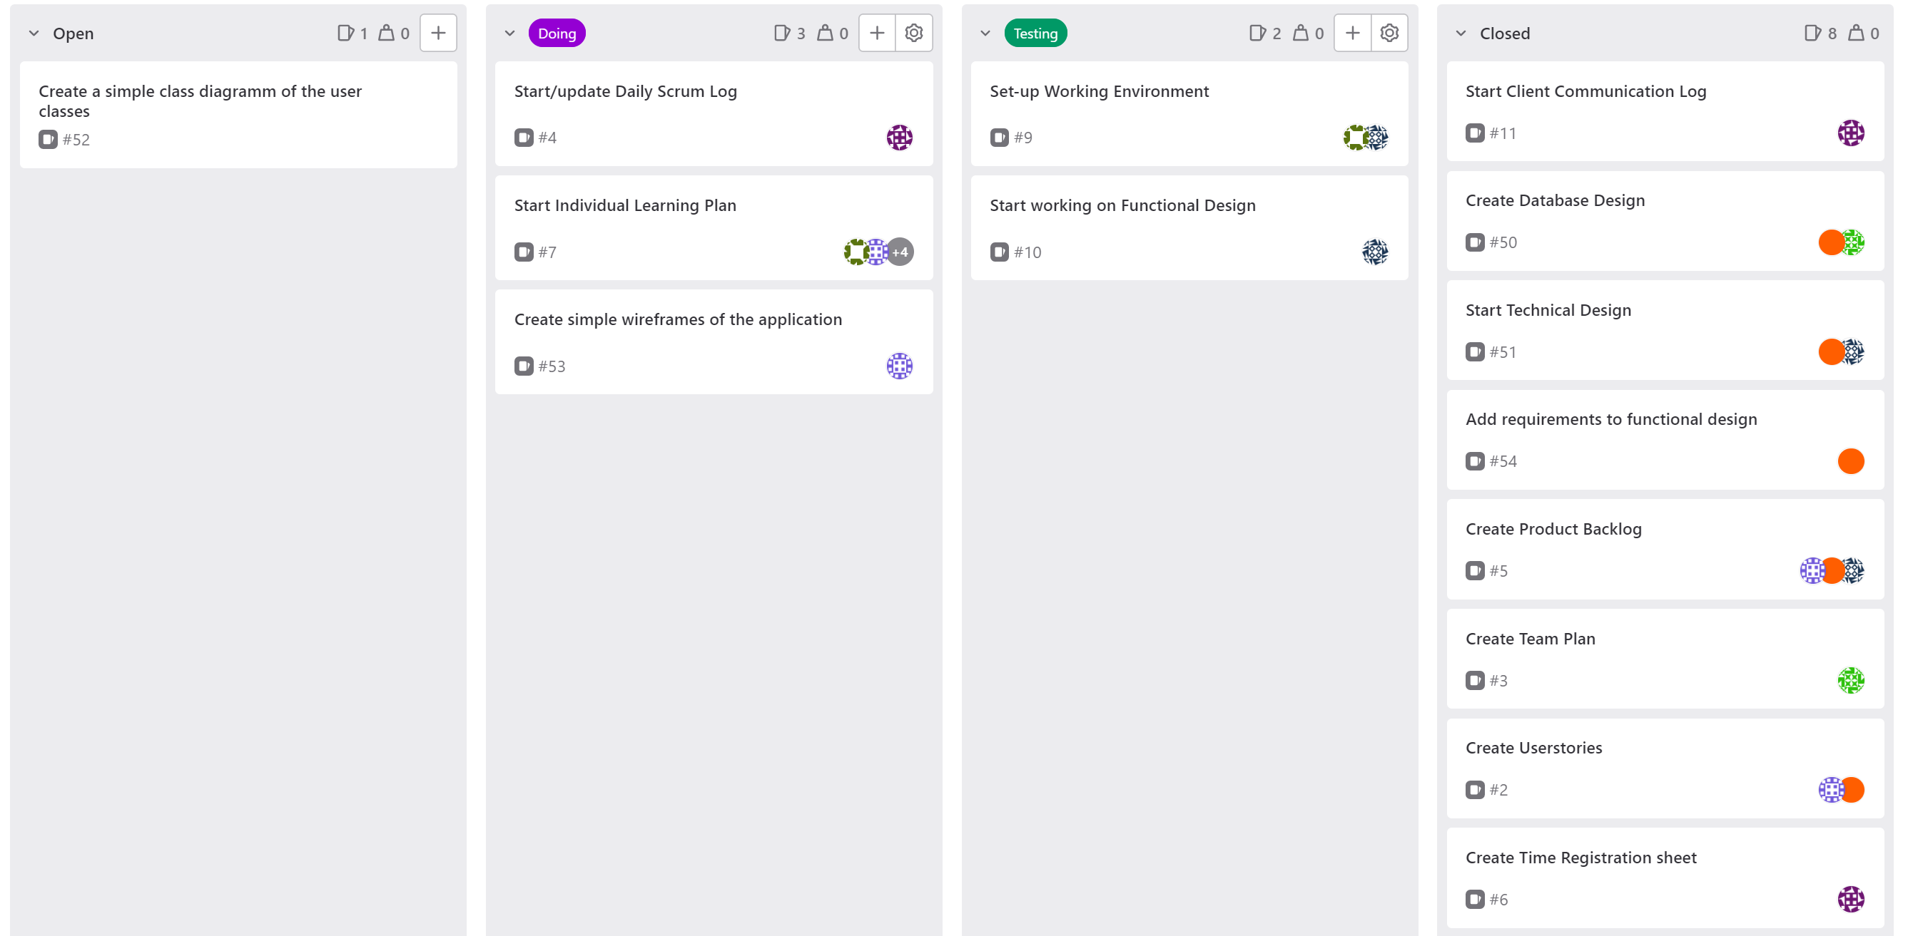

In the image above it, the scrum board of Sprint 0 is present. The goal of this Sprint was to create a start on the project and set up all of the necessary needs to start working on the product as a team. We also wanted to get a better understanding of what the client expects as the final product/proof of concept. In this Sprint we were able to set up the team plan, scrum board, time registration, and work environment. We created the functional-, technical design, daily scrum-, and client communication log. As for the process on the product, we first worked on creating user stories, and from those, we created the product backlog and wrote down the basic requirements of the product. The first meeting with the client also toke place in this Sprint. In this meeting, we learned more about what functionality the product will need to be focused on. While we were not able to finish all the tasks planned for this sprint. We will carry the tasks over to the next sprint and keep working and improving upon the design we created.

As for who worked/was responsible for what. Everyone has started working on their own individual learning plan.

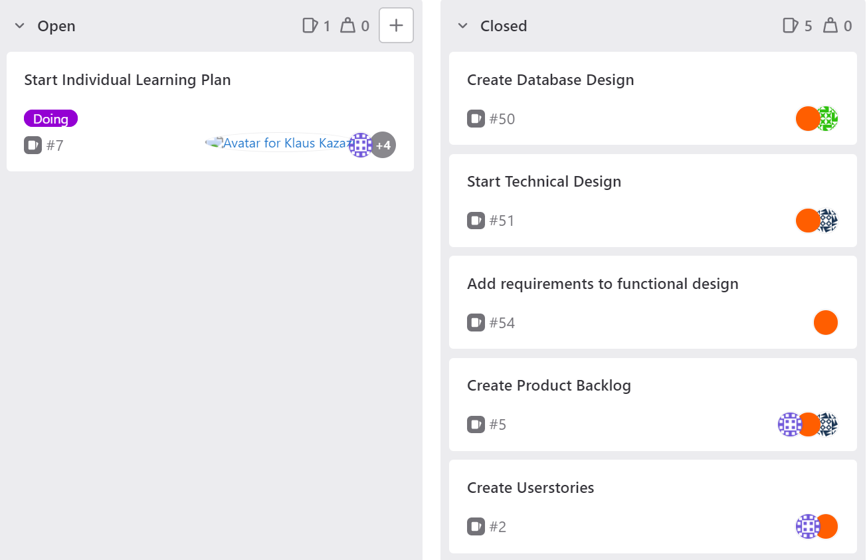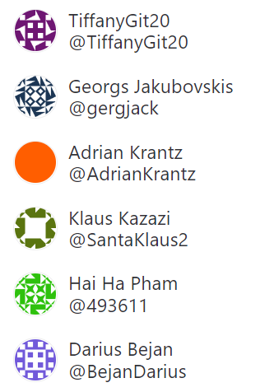

Adrien worked mostly on creating user stories, product backlog, and requirements. He also helped work on the technical design as well as the database design. He helped by giving feedback and improvement points on the designs.

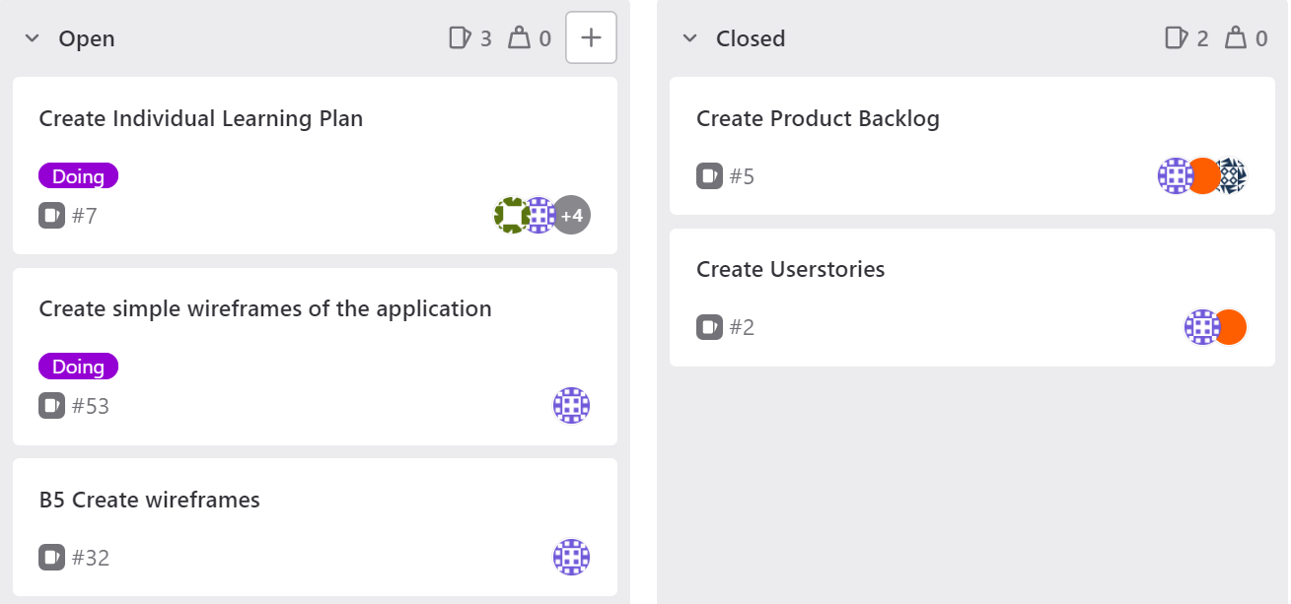

Darius was assigned to work on the user stories and backlog together with Adrien and Georgs but also worked on creating wireframes for the application.

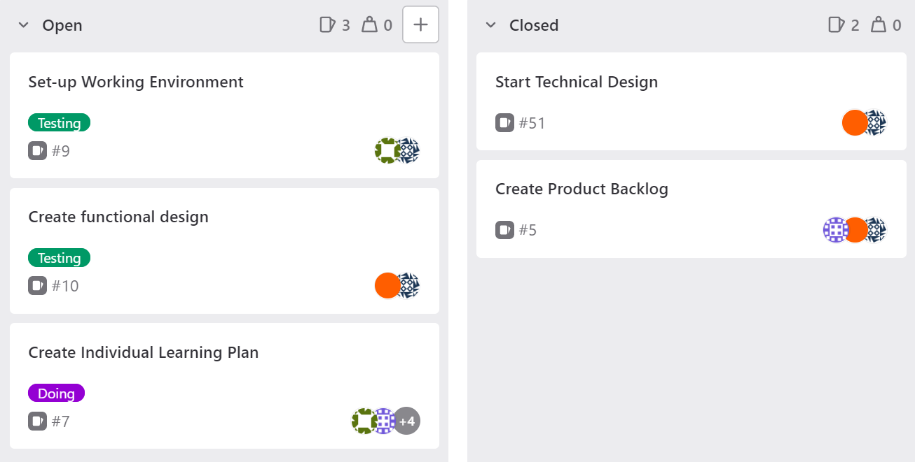

Georgs worked on the creation of the product backlog together with Adrien and Darius. He also was responsible for starting up the technical design and functional design, while also helping Klaus with the set-up of the working environment.

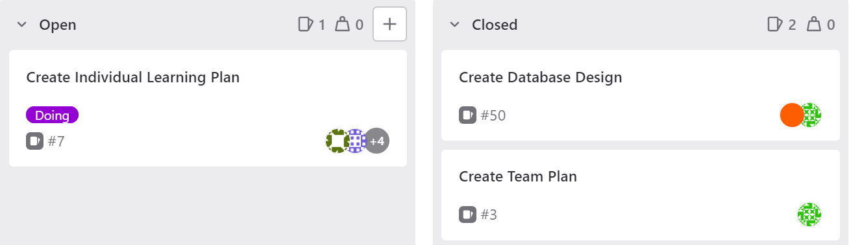

Hai Ha was mainly responsible for creating the team plan. He also worked on creating the database design with the help of Arien providing him with points for improvement.

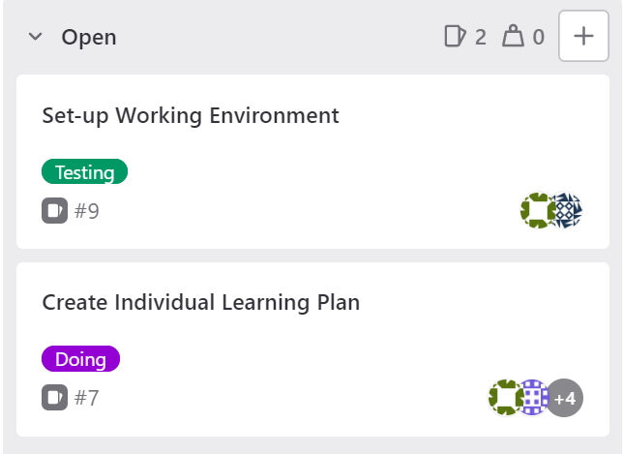

Klaus was responsible for setting up the working environment for the application. He did this with the help of Georgs.

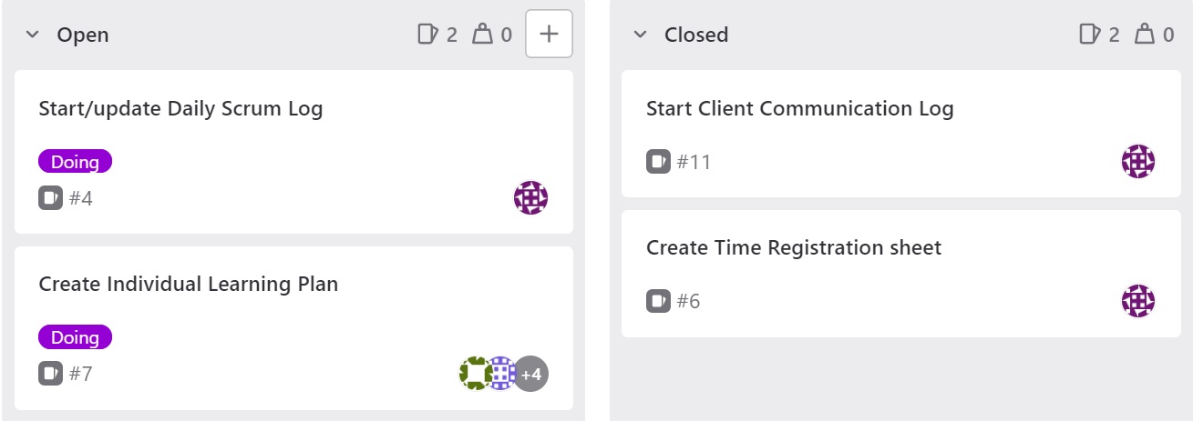

Tiffany worked on the creation of the Time registration sheet and was responsible for the client communication log. She also worked on creating the daily scrum log and updated the log after each daily scrum meeting.

# Sprint 1

# Sprint 2

# Sprint 3