**Neural Network Architecture**

Borrowing the idea from ResNet[1, 2], I use two mechanisms here, the skip connection and the pre-activation, to construct my own neural network (See Figure 1). It is supposed that we are training a multi-class classifier with the cross-entropy loss. It can be seen from Figure 1 that all the intermediate layers, except activation functions, are fully connected layers.

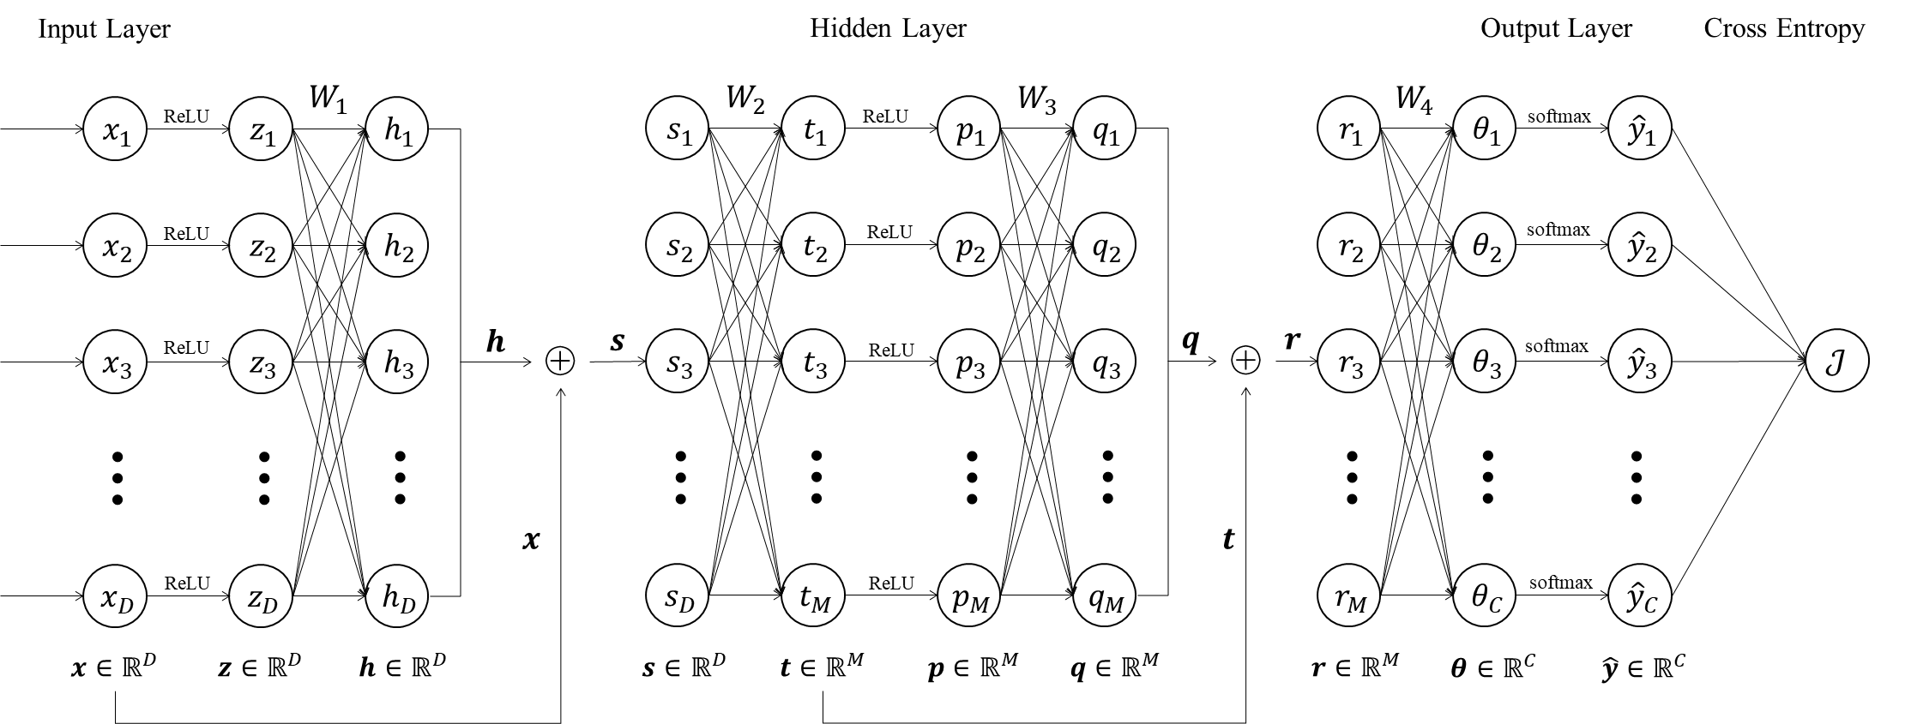

Figure 1: The architecture of this self-designed neural network.

A forward pass of a single input sample $x$ is as follows:

$$x∈R^{D} \\ z=ReLU(x)∈R^{D} \\ h=W_{1}z∈R^{D} \\ s=h+x∈R^{D} \\ t=W_{2}s∈R^{M} \\ p=ReLU(t)∈R^{M} \\ q=W_{3}p∈R^{M} \\ r=q+t∈R^{M} \\ θ=W_{4}r∈R^{C} \\ \hat{y}=softmax(θ)∈R^{C} \\ J=CrossEntropy\left(y,\hat{y}\right)∈R$$

where $W_{1}∈R^{D×D}$, $W_{2}∈R^{M×D}$, $W_{3}∈R^{M×M}$, $W_{4}∈R^{C×M}$ are weight matrices. $y∈R^{C}$ is the true label vector associated with $x$, that is, a one-hot vector indicting which class $x$ belongs to. The softmax activation of the $j$-th output unit is

${\hat{y}}_{j}=softmax\left(θ_{j}\right)=\frac{e^{θ_{j}}}{\sum_{j=1}^{C}{e^{θ_{j}}}}$.

The cross-entropy loss for this single input sample $x$ is

$J=-\sum_{j=1}^{C}{y_{j}log{\hat{y}}_{j}}=-y^{T}log\hat{y}$.

**Gradients Derivation**

First, let us start with calculating the common parts shared by all four target gradients. we can see that

$$\frac{∂J}{∂\hat{y}}=\frac{∂\left(-y^{T}log\hat{y}\right)}{∂\hat{y}}=-\left[\frac{y_{1}}{{\hat{y}}_{1}},⋯,\frac{y_{C}}{{\hat{y}}_{C}}\right]=-{\left(\frac{y}{\hat{y}}\right)}^{T}∈R^{1×C}$$

where the division in $\frac{y}{\hat{y}}$ is an element-wise operator.

For the gradient of softmax function, we look at a single entry first:

$$\frac{∂{\hat{y}}_{i}}{∂θ_{j}}=\frac{∂}{∂θ_{j}}\frac{e^{θ_{i}}}{\sum_{k=1}^{C}{e^{θ_{k}}}}=\left\{\begin{aligned}&\frac{e^{θ_{j}}\left(\sum_{k=1}^{C}{e^{θ_{k}}}-e^{θ_{j}}\right)}{{\left(\sum_{k=1}^{C}{e^{θ_{k}}}\right)}^{2}}={\hat{y}}_{j}\left(1-{\hat{y}}_{j}\right),i=j \\ &-\frac{e^{θ_{i}}e^{θ_{j}}}{{\left(\sum_{k=1}^{C}{e^{θ_{k}}}\right)}^{2}}=-{\hat{y}}_{i}{\hat{y}}_{j},i≠j\end{aligned}.\right.$$

By chain rule, we can compute

$$\frac{∂J}{∂θ_{j}}=\sum_{i=1}^{C}{\frac{∂J}{∂{\hat{y}}_{i}}\frac{∂{\hat{y}}_{i}}{∂θ_{j}}}=-\sum_{i=1}^{C}{\frac{y_{i}}{{\hat{y}}_{i}}\frac{∂{\hat{y}}_{i}}{∂θ_{j}}}=-\left(\frac{y_{j}}{{\hat{y}}_{j}}\frac{∂{\hat{y}}_{j}}{∂θ_{j}}+\sum_{i≠j}{\frac{y_{i}}{{\hat{y}}_{i}}\frac{∂{\hat{y}}_{i}}{∂θ_{j}}}\right) \\ =-\frac{y_{j}}{{\hat{y}}_{j}}{\hat{y}}_{j}\left(1-{\hat{y}}_{j}\right)+\sum_{i≠j}{\frac{y_{i}}{{\hat{y}}_{i}}{\hat{y}}_{i}{\hat{y}}_{j}}=-y_{j}\left(1-{\hat{y}}_{j}\right)+{\hat{y}}_{j}\sum_{i≠j}{y_{i}} \\ ={-y}_{j}+{\hat{y}}_{j}\sum_{i=1}^{C}{y_{i}}.$$

Recall that $y$ isa one-hot vector, that is, $\sum_{i=1}^{C}{y_{i}}=1$, we can get

$$\frac{∂J}{∂θ_{j}}={\hat{y}}_{j}-y_{j}$$

and

$$\frac{∂J}{∂θ}={\left(\hat{y}-y\right)}^{T}∈R^{1×C}.$$

Now we examine the gradient of ReLU function. Recall that $ReLU\left(x\right)=\max\left(x,0\right)$, by extending that its derivative at $x=0$ equals $0$, we get

$$ReLU^{'}\left(x\right)=\left\{\begin{aligned}&1,x>0 \\ &0,otherwise\end{aligned}\right.=I_{x>0}\left(x\right)∈\left\{0,1\right\}$$

where $I_{x>0}\left(x\right)$ is an indicator function. Furthermore, we can extend ReLU function to a vector-valued function by applying ReLU to each entry of an input vector $x∈R^{D}$ and calculate its gradient as

$$\frac{∂ReLU\left(x\right)}{∂x}=diag\left(I_{x_{1}>0}\left(x_{1}\right), ⋯, I_{x_{D}>0}\left(x_{D}\right)\right)∈R^{D×D}.$$

It is easy to see that $W_{1}, W_{2},W_{3}$ and $W_{4}$ contain all the network parameters. So we just need to derive their gradients to update the whole neural network.

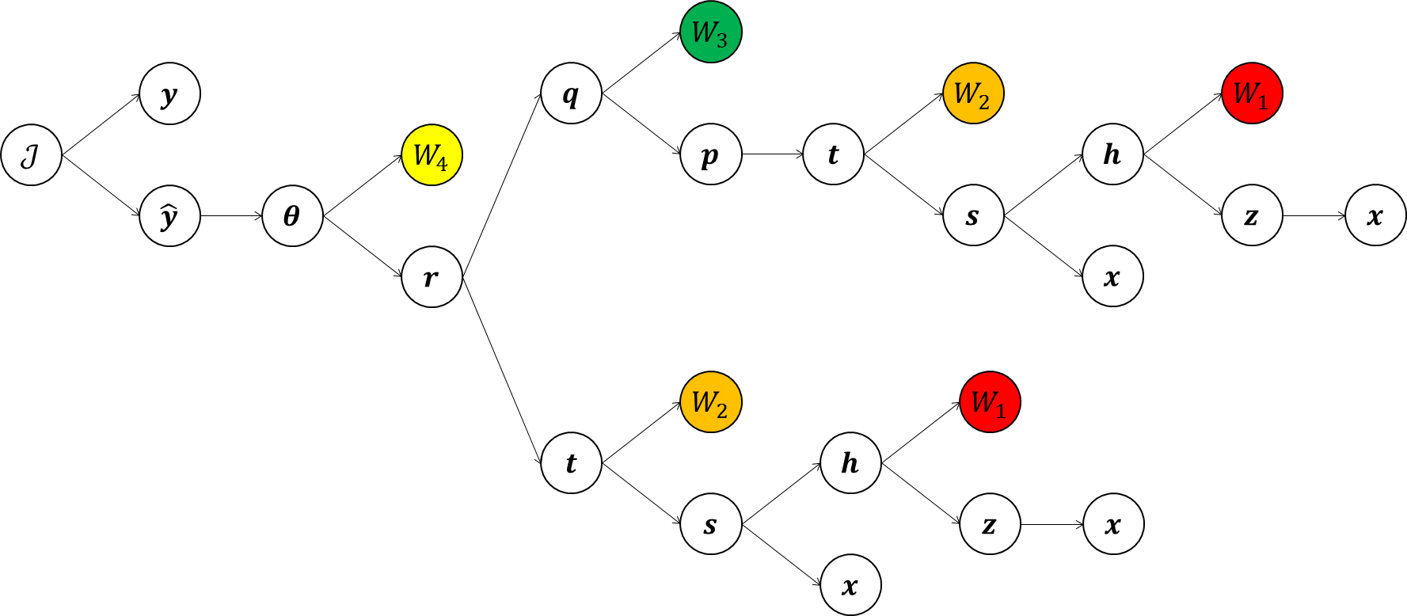

Figure 2: The computation graph of this self-designed neural network.

However, due to the complexity of this neural network, it is hard to capture directly how the gradients flow just by observing its architecture figure. So I show the computation graph of it to make the process of gradients derivation more clearly (See Figure 2).

It can be seen obviously from Figure 2 that there is only one path to approach $W_{3}$ and $W_{4}$, but two to approach $W_{1}$ and $W_{2}$. With the help of this computation graph, we can write down the gradients for all the network parameters by using the chain rule as

$$\frac{∂J}{∂W_{4}}=\frac{∂J}{∂θ}\frac{∂θ}{∂W_{4}} \\ \frac{∂J}{∂W_{3}}=\frac{∂J}{∂r}\frac{∂r}{∂q}\frac{∂q}{∂W_{3}}=\frac{∂J}{∂θ}\frac{∂θ}{∂r}\frac{∂r}{∂q}\frac{∂q}{∂W_{3}} \\ \frac{∂J}{∂W_{2}}=\frac{∂J}{∂r}\left({\left(\frac{∂r}{∂q}\frac{∂q}{∂p}\frac{∂p}{∂t}\right)}_{1}\frac{∂t}{∂W_{2}}+{\left(\frac{∂r}{∂t}\right)}_{2}\frac{∂t}{∂W_{2}}\right) \\ \frac{∂J}{∂W_{1}}=\frac{∂J}{∂r}\left({\left(\frac{∂r}{∂q}\frac{∂q}{∂p}\frac{∂p}{∂t}\right)}_{1}\frac{∂t}{∂s}\frac{∂s}{∂h}\frac{∂h}{∂W_{1}}+{\left(\frac{∂r}{∂t}\right)}_{2}\frac{∂t}{∂s}\frac{∂s}{∂h}\frac{∂h}{∂W_{1}}\right).$$

Subscript 1 means the gradient flows through the upper branch of the computation graph and subscript 2 the lower. We use subscripts here to avoid confusion, that is, ${\left(\frac{∂r}{∂q}\frac{∂q}{∂p}\frac{∂p}{∂t}\right)}_{1}≠{\left(\frac{∂r}{∂t}\right)}_{2}$.

It is noticed that $\frac{∂J}{∂r}$, ${\left(\frac{∂r}{∂q}\frac{∂q}{∂p}\frac{∂p}{∂t}\right)}_{1}$, $\frac{∂t}{∂s}\frac{∂s}{∂h}$ and ${\left(\frac{∂r}{∂t}\right)}_{2}$ are used multiple times, so it is convenient to calculate them firstly:

$$\frac{∂J}{∂r}=\frac{∂J}{∂θ}\frac{∂θ}{∂r}={\left(\hat{y}-y\right)}^{T}W_{4}∈R^{1×M} \\ {\left(\frac{∂r}{∂q}\frac{∂q}{∂p}\frac{∂p}{∂t}\right)}_{1}=I_{M}W_{3}diag\left(I_{t_{1}>0}\left(t_{1}\right), ⋯, I_{t_{M}>0}\left(t_{M}\right)\right)=W_{3}Λ_{t}∈R^{M×M} \\ \frac{∂t}{∂s}\frac{∂s}{∂h}=W_{2}I_{D}=W_{2}∈R^{M×D} \\ {\left(\frac{∂r}{∂t}\right)}_{2}=I_{M}∈R^{M×M}$$

where $Λ_{t}=diag\left(I_{t_{1}>0}\left(t_{1}\right), ⋯, I_{t_{M}>0}\left(t_{M}\right)\right)$.

Now we can rewrite the target gradients as

$$\frac{∂J}{∂W_{4}}={\left(\hat{y}-y\right)}^{T}\frac{∂θ}{∂W_{4}} \\ \frac{∂J}{∂W_{3}}={\left(\hat{y}-y\right)}^{T}W_{4}\frac{∂q}{∂W_{3}} \\ \frac{∂J}{∂W_{2}}={\left(\hat{y}-y\right)}^{T}W_{4}W_{3}Λ_{t}\frac{∂t}{∂W_{2}}+{\left(\hat{y}-y\right)}^{T}W_{4}\frac{∂t}{∂W_{2}} \\ \frac{∂J}{∂W_{1}}={\left(\hat{y}-y\right)}^{T}W_{4}W_{3}Λ_{t}W_{2}\frac{∂h}{∂W_{1}}+{\left(\hat{y}-y\right)}^{T}W_{4}W_{2}\frac{∂h}{∂W_{1}}.$$

Then we continue to calculate the rest parts. For the gradient $\frac{∂J}{∂W_{4}}$, let us start by analyzing the gradient $\frac{∂θ}{∂W_{4}}$. By definition, this gradient is the collection of the partial derivatives:

$$\frac{∂θ}{∂W_{4}}=\left[\begin{matrix}\frac{∂θ_{1}}{∂W_{4}} \\ ⋮ \\ \frac{∂θ_{C}}{∂W_{4}}\end{matrix}\right]∈R^{C×C×M}, \frac{∂θ_{i}}{∂W_{4}}∈R^{C×M}.$$

We can write $W_{4}$ in this form:

$$W_{4}=\left[\begin{matrix}w_{1}^{\left(4\right)} \\ ⋮ \\ w_{C}^{\left(4\right)}\end{matrix}\right]$$

where $w_{i}^{\left(4\right)}∈R^{1×M}$ is the $i$-th row of $W_{4}$. So we can explicitly write out $\frac{∂θ_{i}}{∂W_{4}}$ as

$$\frac{∂θ_{i}}{∂W_{4}}=\frac{∂}{∂W_{4}}w_{i}^{\left(4\right)}r=\left[\begin{matrix}0^{T} \\ ⋮ \\ 0^{T} \\ r^{T} \\ 0^{T} \\ ⋮ \\ 0^{T}\end{matrix}\right]∈R^{C×M}$$

that is, a matrix with $i$-th row being $r^{T}$ and other rows being $0^{T}$. Combining them together, we can get

$$\frac{∂J}{∂W_{4}}={\left(\hat{y}-y\right)}^{T}\frac{∂θ}{∂W_{4}}={\left(\hat{y}-y\right)}^{T}\left[\begin{matrix}\frac{∂θ_{1}}{∂W_{4}} \\ ⋮ \\ \frac{∂θ_{C}}{∂W_{4}}\end{matrix}\right]=\left[\begin{matrix}{\left(\hat{y}-y\right)}^{T}\frac{∂θ_{1}}{∂W_{4}} \\ ⋮ \\ {\left(\hat{y}-y\right)}^{T}\frac{∂θ_{C}}{∂W_{4}}\end{matrix}\right]=\left[\begin{matrix}\left({\hat{y}}_{1}-y_{1}\right)r^{T} \\ ⋮ \\ \left({\hat{y}}_{C}-y_{C}\right)r^{T}\end{matrix}\right]=\left(\hat{y}-y\right)r^{T}.$$

Similarly, we can get that

$$\frac{∂J}{∂W_{3}}={\left(\hat{y}-y\right)}^{T}W_{4}\frac{∂q}{∂W_{3}}={W_{4}}^{T}\left(\hat{y}-y\right)p^{T} \\ \frac{∂J}{∂W_{2}}={\left(\hat{y}-y\right)}^{T}W_{4}W_{3}Λ_{t}\frac{∂t}{∂W_{2}}+{\left(\hat{y}-y\right)}^{T}W_{4}\frac{∂t}{∂W_{2}} \\ =Λ_{t}{W_{3}}^{T}{W_{4}}^{T}\left(\hat{y}-y\right)s^{T}+{W_{4}}^{T}\left(\hat{y}-y\right)s^{T} \\ \frac{∂J}{∂W_{1}}={\left(\hat{y}-y\right)}^{T}W_{4}W_{3}Λ_{t}W_{2}\frac{∂h}{∂W_{1}}+{\left(\hat{y}-y\right)}^{T}W_{4}W_{2}\frac{∂h}{∂W_{1}}. \\ ={W_{2}}^{T}Λ_{t}{W_{3}}^{T}{W_{4}}^{T}\left(\hat{y}-y\right)z^{T}+{W_{2}}^{T}{W_{4}}^{T}\left(\hat{y}-y\right)z^{T}.$$

At the end, we show the final results as follows:

$$\frac{∂J}{∂W_{4}}=\left(\hat{y}-y\right)r^{T} \\ \frac{∂J}{∂W_{3}}={W_{4}}^{T}\left(\hat{y}-y\right)p^{T} \\ \frac{∂J}{∂W_{2}}=\left(Λ_{t}{W_{3}}^{T}+I_{M}\right){W_{4}}^{T}\left(\hat{y}-y\right)s^{T} \\ \frac{∂J}{∂W_{1}}={W_{2}}^{T}\left(Λ_{t}{W_{3}}^{T}+I_{M}\right){W_{4}}^{T}\left(\hat{y}-y\right)z^{T}.$$

**Training Equations**

In real practice, we never use just a single input to update the neural network. Instead, we train a neural network with a training set in most cases. To make this assignment more practical, we suppose that we use the training set ${\left\{\left(x_{i},y_{i}\right)\right\}}_{i=1}^{N}$ to train the neural network.

As a result, the final loss function needs to be modified as

$$L=\frac{1}{N}\sum_{i=1}^{N}{J_{i}\left(x_{i},y_{i}\right)}$$

where $J_{i}\left(x_{i},y_{i}\right)$ is the cross-entropy loss w.r.t a single input $\left(x_{i},y_{i}\right)$, whose gradients are shown in the above section. And the gradients of it are

$$\frac{∂L}{∂W_{4}}=\frac{1}{N}\sum_{i=1}^{N}{\frac{∂J_{i}}{∂W_{4}}}=\frac{1}{N}\sum_{i=1}^{N}{\left({\hat{y}}_{i}-y_{i}\right)r_{i}^{T}} \\ \frac{∂L}{∂W_{3}}=\frac{1}{N}\sum_{i=1}^{N}{\frac{∂J_{i}}{∂W_{3}}}=\frac{1}{N}{W_{4}}^{T}\sum_{i=1}^{N}{\left({\hat{y}}_{i}-y_{i}\right)p_{i}^{T}} \\ \frac{∂L}{∂W_{2}}=\frac{1}{N}\sum_{i=1}^{N}{\frac{∂J_{i}}{∂W_{2}}}=\frac{1}{N}\sum_{i=1}^{N}{\left(Λ_{t_{i}}{W_{3}}^{T}+I_{M}\right){W_{4}}^{T}\left({\hat{y}}_{i}-y_{i}\right)s_{i}^{T}} \\ \frac{∂L}{∂W_{1}}=\frac{1}{N}\sum_{i=1}^{N}{\frac{∂J_{i}}{∂W_{1}}}=\frac{1}{N}{W_{2}}^{T}\sum_{i=1}^{N}{\left(Λ_{t_{i}}{W_{3}}^{T}+I_{M}\right){W_{4}}^{T}\left({\hat{y}}_{i}-y_{i}\right)z_{i}^{T}}.$$

For the training process, we start by randomly generating $W_{1}$ ~ $W_{4}$. At step $t$, we use the following training equations to update the parameters:

$$W_{4}^{t}←W_{4}^{t-1}-α\frac{∂L}{∂W_{4}} \\ W_{3}^{t}←W_{3}^{t-1}-α\frac{∂L}{∂W_{3}}$$

$$W_{2}^{t}←W_{2}^{t-1}-α\frac{∂L}{∂W_{2}}$$

$$W_{1}^{t}←W_{1}^{t-1}-α\frac{∂L}{∂W_{1}}$$

where $α$ is the learning rate.

**Reference**

[1] He, Kaiming, et al. "Deep residual learning for image recognition." Proceedings of the IEEE conference on computer vision and pattern recognition. 2016.

[2] He, Kaiming, et al. "Identity mappings in deep residual networks." European conference on computer vision. Springer, Cham, 2016.