Yin Junyu G2101985L

1. Model Selection

After reading the original data, we first make first-order and second-order differences on it. Figure 1 shows the details of these 3 time series. We can see that the original time series are not stationary. Then we do ADF test on these 3 time series data. Results are shown in Figure 2.

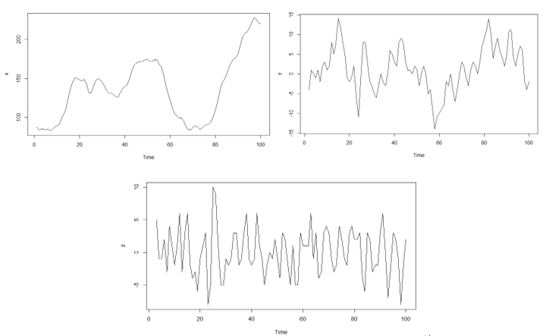

Figure 1. Time plot of the original time series and its first-order and second-order differences.

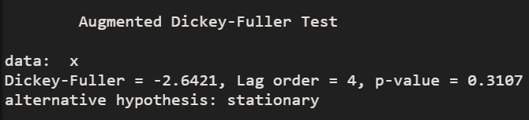

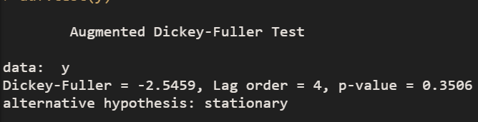

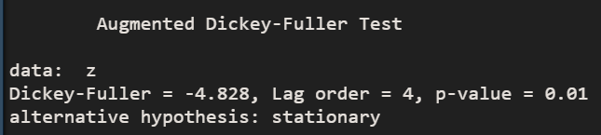

Figure 2. Results of ADF test.

The results tell us that only the second-order differential time series data are stationary statistically. Then we draw SACF plot and SPACF plot of it (Shown in Figure 3).

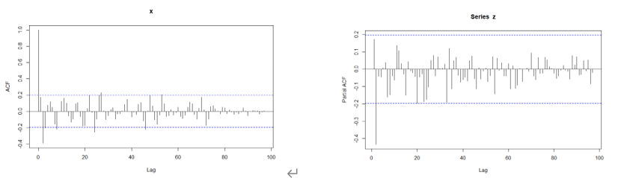

Figure 3. SACF plot and SPACF of the second-order differential time series data.

From Figure 3, we choose the ARIMA(2, 2, 0) to model the original time series.

2. The Fitted Model

The fitted model can be formulated as:

$$Z_{t}=0.2579Z_{t-1}-0.4407Z_{t-2}+ϵ_{t}$$

where $Z_{t}={\left(1-B\right)}^{2}X_{t}, \left\{ϵ_{t}\right\}\sim WN\left(0, 10.13\right)$. All details can be seen in Figrue 4.

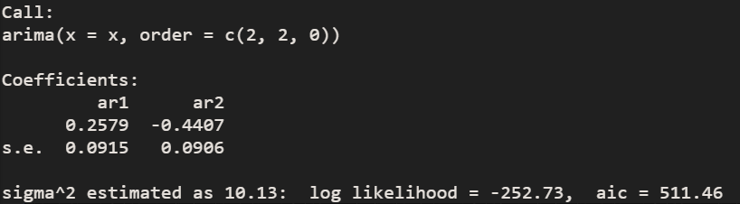

Figure 4. The fitted model for input data.

3. Diagnostic Checking

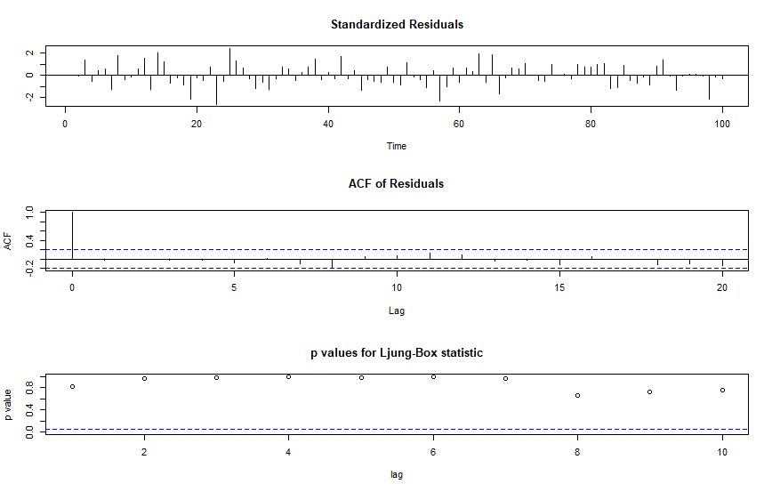

Figure 5. The diagnostic checking results of the fitted model.

Thus, the model is adequate. We can see there is no autocorrelation in the residuals.

4. Appendix

In fact, we can also use the function forecast::auto.arima() to automatically select the model.

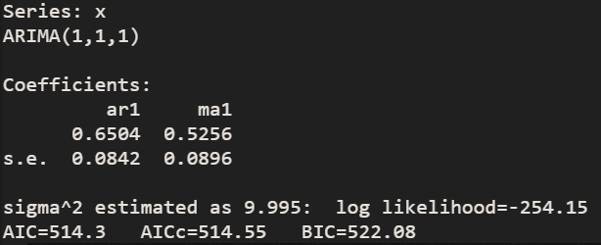

Figure 6. Results of forecast::auto.arima(x).

This function suggests us to use ARIMA(1, 1, 1) to model the original data. We can also do the diagnostic checking for this model. From Figure 7, we can see that this model is also adequate for the original data.

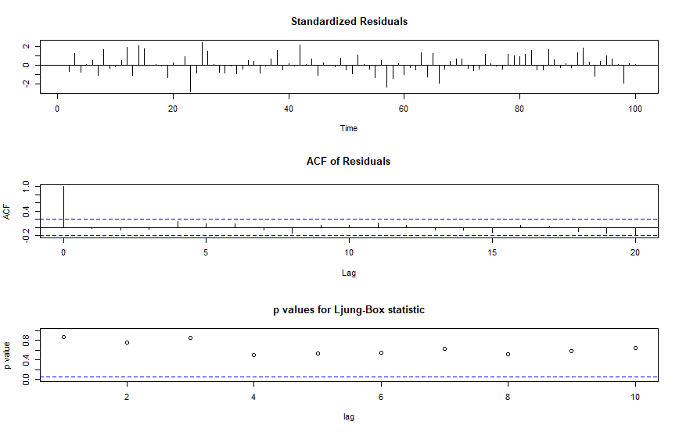

Figure 7. The diagnostic checking results of an another fitted model.

5. R code

x <- read.table("wwwusage.txt", header = TRUE)

x <- ts(x)

y <- diff(x)

z <- diff(y)

ts.plot(x)

ts.plot(y)

ts.plot(z)

adf.test(x)

adf.test(y)

adf.test(z)

acf(x, lag.max = 100)

pacf(x, lag.max = 100)

acf(y, lag.max = 100)

pacf(y, lag.max = 100)

acf(z, lag.max = 100)

pacf(z, lag.max = 100)

fit <- arima(x = x, order = c(2, 2, 0))

fit

tsdiag(fit)

acf(fit$residuals)

pacf(fit$residuals)

forecast::auto.arima(x)

fit2 <- arima(x = x, order = c(1, 1, 1))

fit2

tsdiag(fit2)

acf(fit2$residuals)

pacf(fit2$residuals)