**Batch 2: Group 1**

**Assignment 12**

**Aim:** Outcome of the project as copyright / Paper / Patent

**Outcome:**

The outcome of our project is a web application for to-do list.

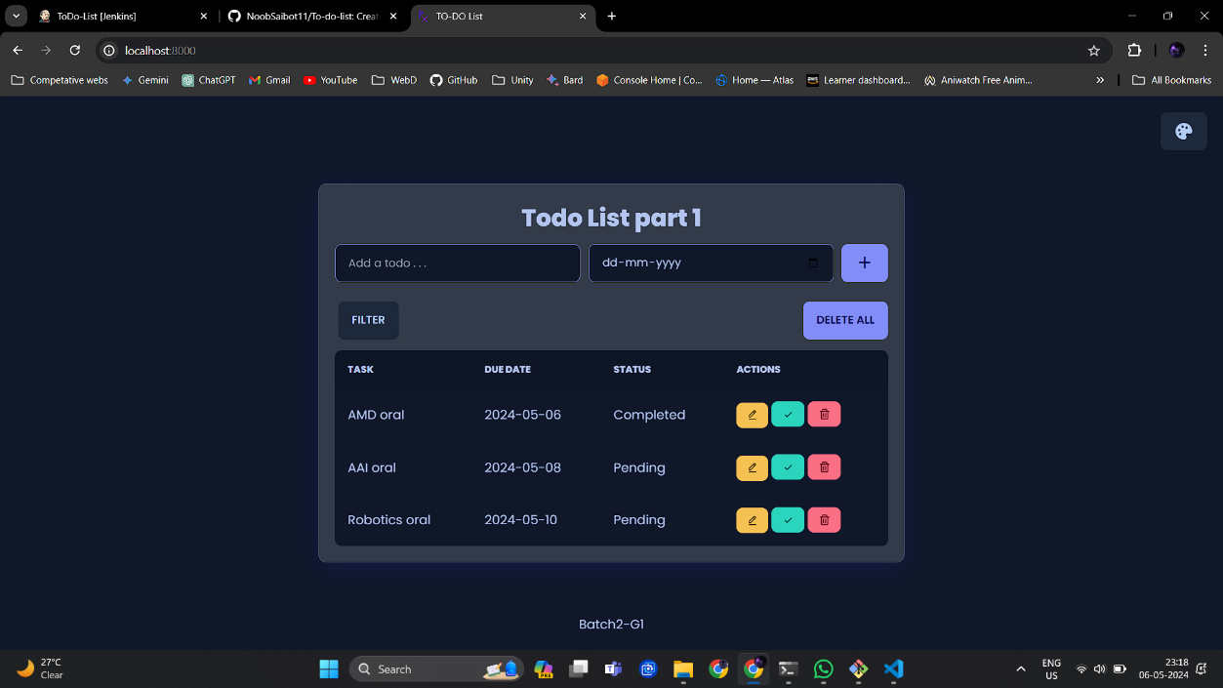

The tasks added by user are stored in local storage.

For the implementation of ci-cd pipeline using Jenkins, first the developer have to make changes in the repository copy in his local machine. In our case suppose developer makes changes in inde.html file by adding team name in footer in his local machine on VS code IDE.

Now we have added team name in footer i.e. made changes in project in local machine, let push it through git.

First, before pushing lets check out GitHub repository to see if changes are made.

As we can see there’s no team name added in footer in GitHub repository’s index.html file.

Let’s push the code through git now.

Now, let’s check if the code is updated or not on GitHub repository.

Now redirect to Jenkins software and build the project once again for updating the changes made into deployed project.

Let’s head to our project i.e. to port 8000 where we deployed our project.

We haven’t refreshed the page yet so the changes made aren’t deployed, refresh the page once to get the updated application.

As we can see after refreshing the footer have been updated with team name(Pixels).

Also when we made a new build and refreshed the website our tasks are still there because they are stored in local storage.

**Conclusion:**

The implementation of a CI/CD pipeline using Jenkins, Git, and GitHub marks a significant stride towards seamless software development and deployment. Jenkins orchestrates the automation process, continuously integrating code changes from Git repositories hosted on GitHub. This integration fosters collaboration, enhances version control, and accelerates the delivery of high-quality software. With robust testing, automated builds, and streamlined deployment workflows, teams can iterate rapidly, mitigate errors efficiently, and ensure consistent, reliable releases. Ultimately, this integration empowers teams to embrace agile methodologies, foster innovation, and meet the demands of today's dynamic software landscape.